Supplementary Information for
Oceanic Warming Has Lengthened Intense Tropical Cyclone Seasons Globally
Jimin Liu^{1,2,3,4#}, Jeremy Cheuk-Hin Leung^{1#}, Dingchi Zhao¹, Daosheng Xu⁵, Hong Huang¹, Zengliang Zang¹, Wenshou Tian⁴, Yaoming Ma^{3,4,6,7,8}, Yi Li¹*, Banglin Zhang^{1,4}*
Affiliations
¹ College of Meteorology and Oceanography, National University of Defense Technology, Changsha, China
² Northwest Institute of Eco-Environment and Resources, Chinese Academy of Sciences, Lanzhou, China
³ University of Chinese Academy of Sciences, Beijing, China
⁴ College of Atmospheric Sciences, Lanzhou University, Lanzhou, China
⁵ Guangzhou Institute of Tropical and Marine Meteorology / Guangdong Provincial Key Laboratory of Regional Numerical Weather Prediction, CMA, Guangzhou, China
⁶ Land-Atmosphere Interaction and Its Climatic Effects Group, State Key Laboratory of Tibetan Plateau Earth System, Environment and Resources, Institute of Tibetan Plateau Research, Chinese Academy of Sciences, Beijing, China
⁷ Key Laboratory of Land Surface Process and Climate Change in Cold and Arid Regions, Northwest Institute of Eco-Environment and Resources, Chinese Academy of Sciences, Lanzhou , China
⁸ Kathmandu Center of Research and Education, Chinese Academy of Sciences, Beijing, China
# These authors contributed equally to this work
* Correspondence to: zhangbanglin24@nudt.edu.cn (Banglin Zhang), liyiqxxy@163.com (Yi Li)

Contents of this file
Texts S1 to S8
Figures S1 to S6
Tables S1 to S3
References

Introduction
This supporting information provides supplementary texts, figures, and tables cited in the main text.

Text S1. Intense TC season and its climatology
In this study, the intense TC season is defined as the period in which 90% of intense TCs occur in a year. The start and end dates of an intense TC season correspond to the 5th and 95th percentile values of the intense TC occurrence time within a 3-year period (see Methods). According to the IBTrACS record from 1980–2023, intense TC seasons generally take place in late summer and autumn. This is when the climate system accumulates enough energy from the solar radiation following the summer solstice, providing more favorable conditions for TC development. In general, intense TC seasons are shorter than overall TC seasons (Fig. S2), because developing and maintaining the strength of intense TCs requires a significantly larger amount of energy.
The coverage of the intense TC season of each basin, as well as that of the overall TC season, is listed in Table S1. Specifically, the NA intense TC season starts on 28th August and ends on 9th October, lasting for 42 days; the ENP intense TC season starts on 7th July and ends on 9th October, lasting for 95 days; the WNP intense TC season starts on 6th June and ends on 25th November, lasting for 173 days; the SI intense TC season starts on 23rd December and ends on 30th March, lasting for 97 days; the SP intense TC season starts on 9th January and ends on 24th March, lasting for 74 days. If considering these basins as a whole, the NH intense TC season starts on 14th June and ends on 18th November, lasting for 157 days; meanwhile, the SH intense TC season starts on 18th December and ends on 6th April, lasting for 109 days.
For comparison, the NA overall TC season starts on 2nd July and ends on 5th November, lasting for 126 days; the ENP overall TC season starts on 8th June and ends on 23rd October, lasting for 137 days; the WNP overall TC season starts on 11th May and ends on 9th December, lasting for 212 days; the SI overall TC season starts on 12th November and ends on 26th April, lasting for 165 days; the SP overall TC season starts on 10th December and ends on 22nd April, lasting for 133 days. If considering these basins as a whole, the NH overall TC season starts on 31st May and ends on 21st November, lasting for 174 days; meanwhile, the SH overall TC season starts on 18th November and ends on 25th April, lasting for 158 days.

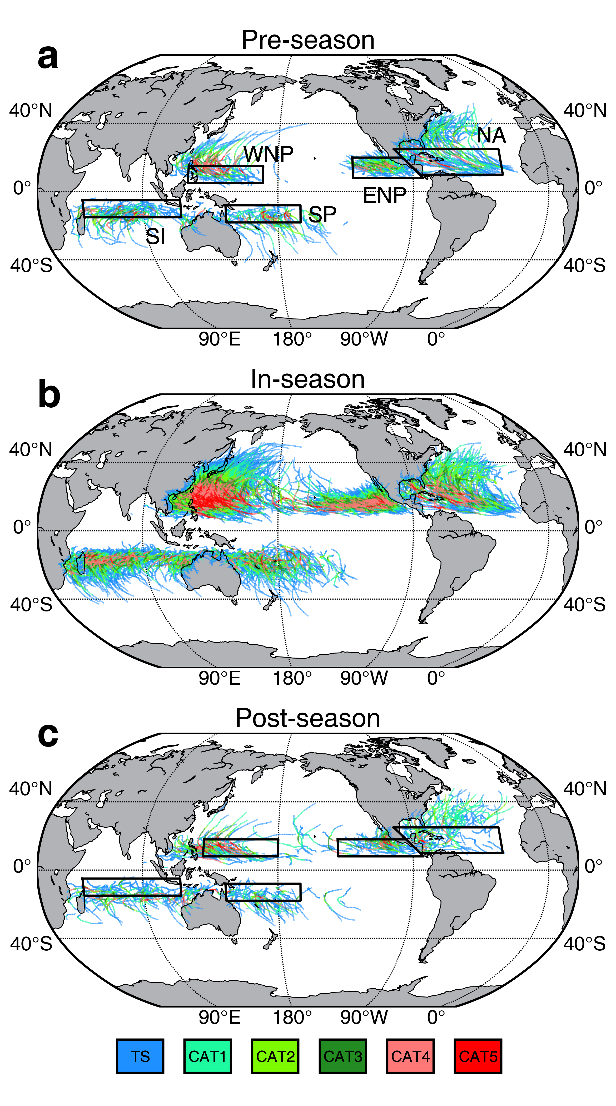
Fig. S1 | Climatological distributions of intense TCs. a–c, All intense TCs during the pre-season (a), in-season (b), and post-season (c) periods over 1980–2023. Black boxes denote the key areas where the off-season intense TCs formed and intensified. Colors of TC tracks indicate the categories of TCs, based on the Saffir–Simpson scale.

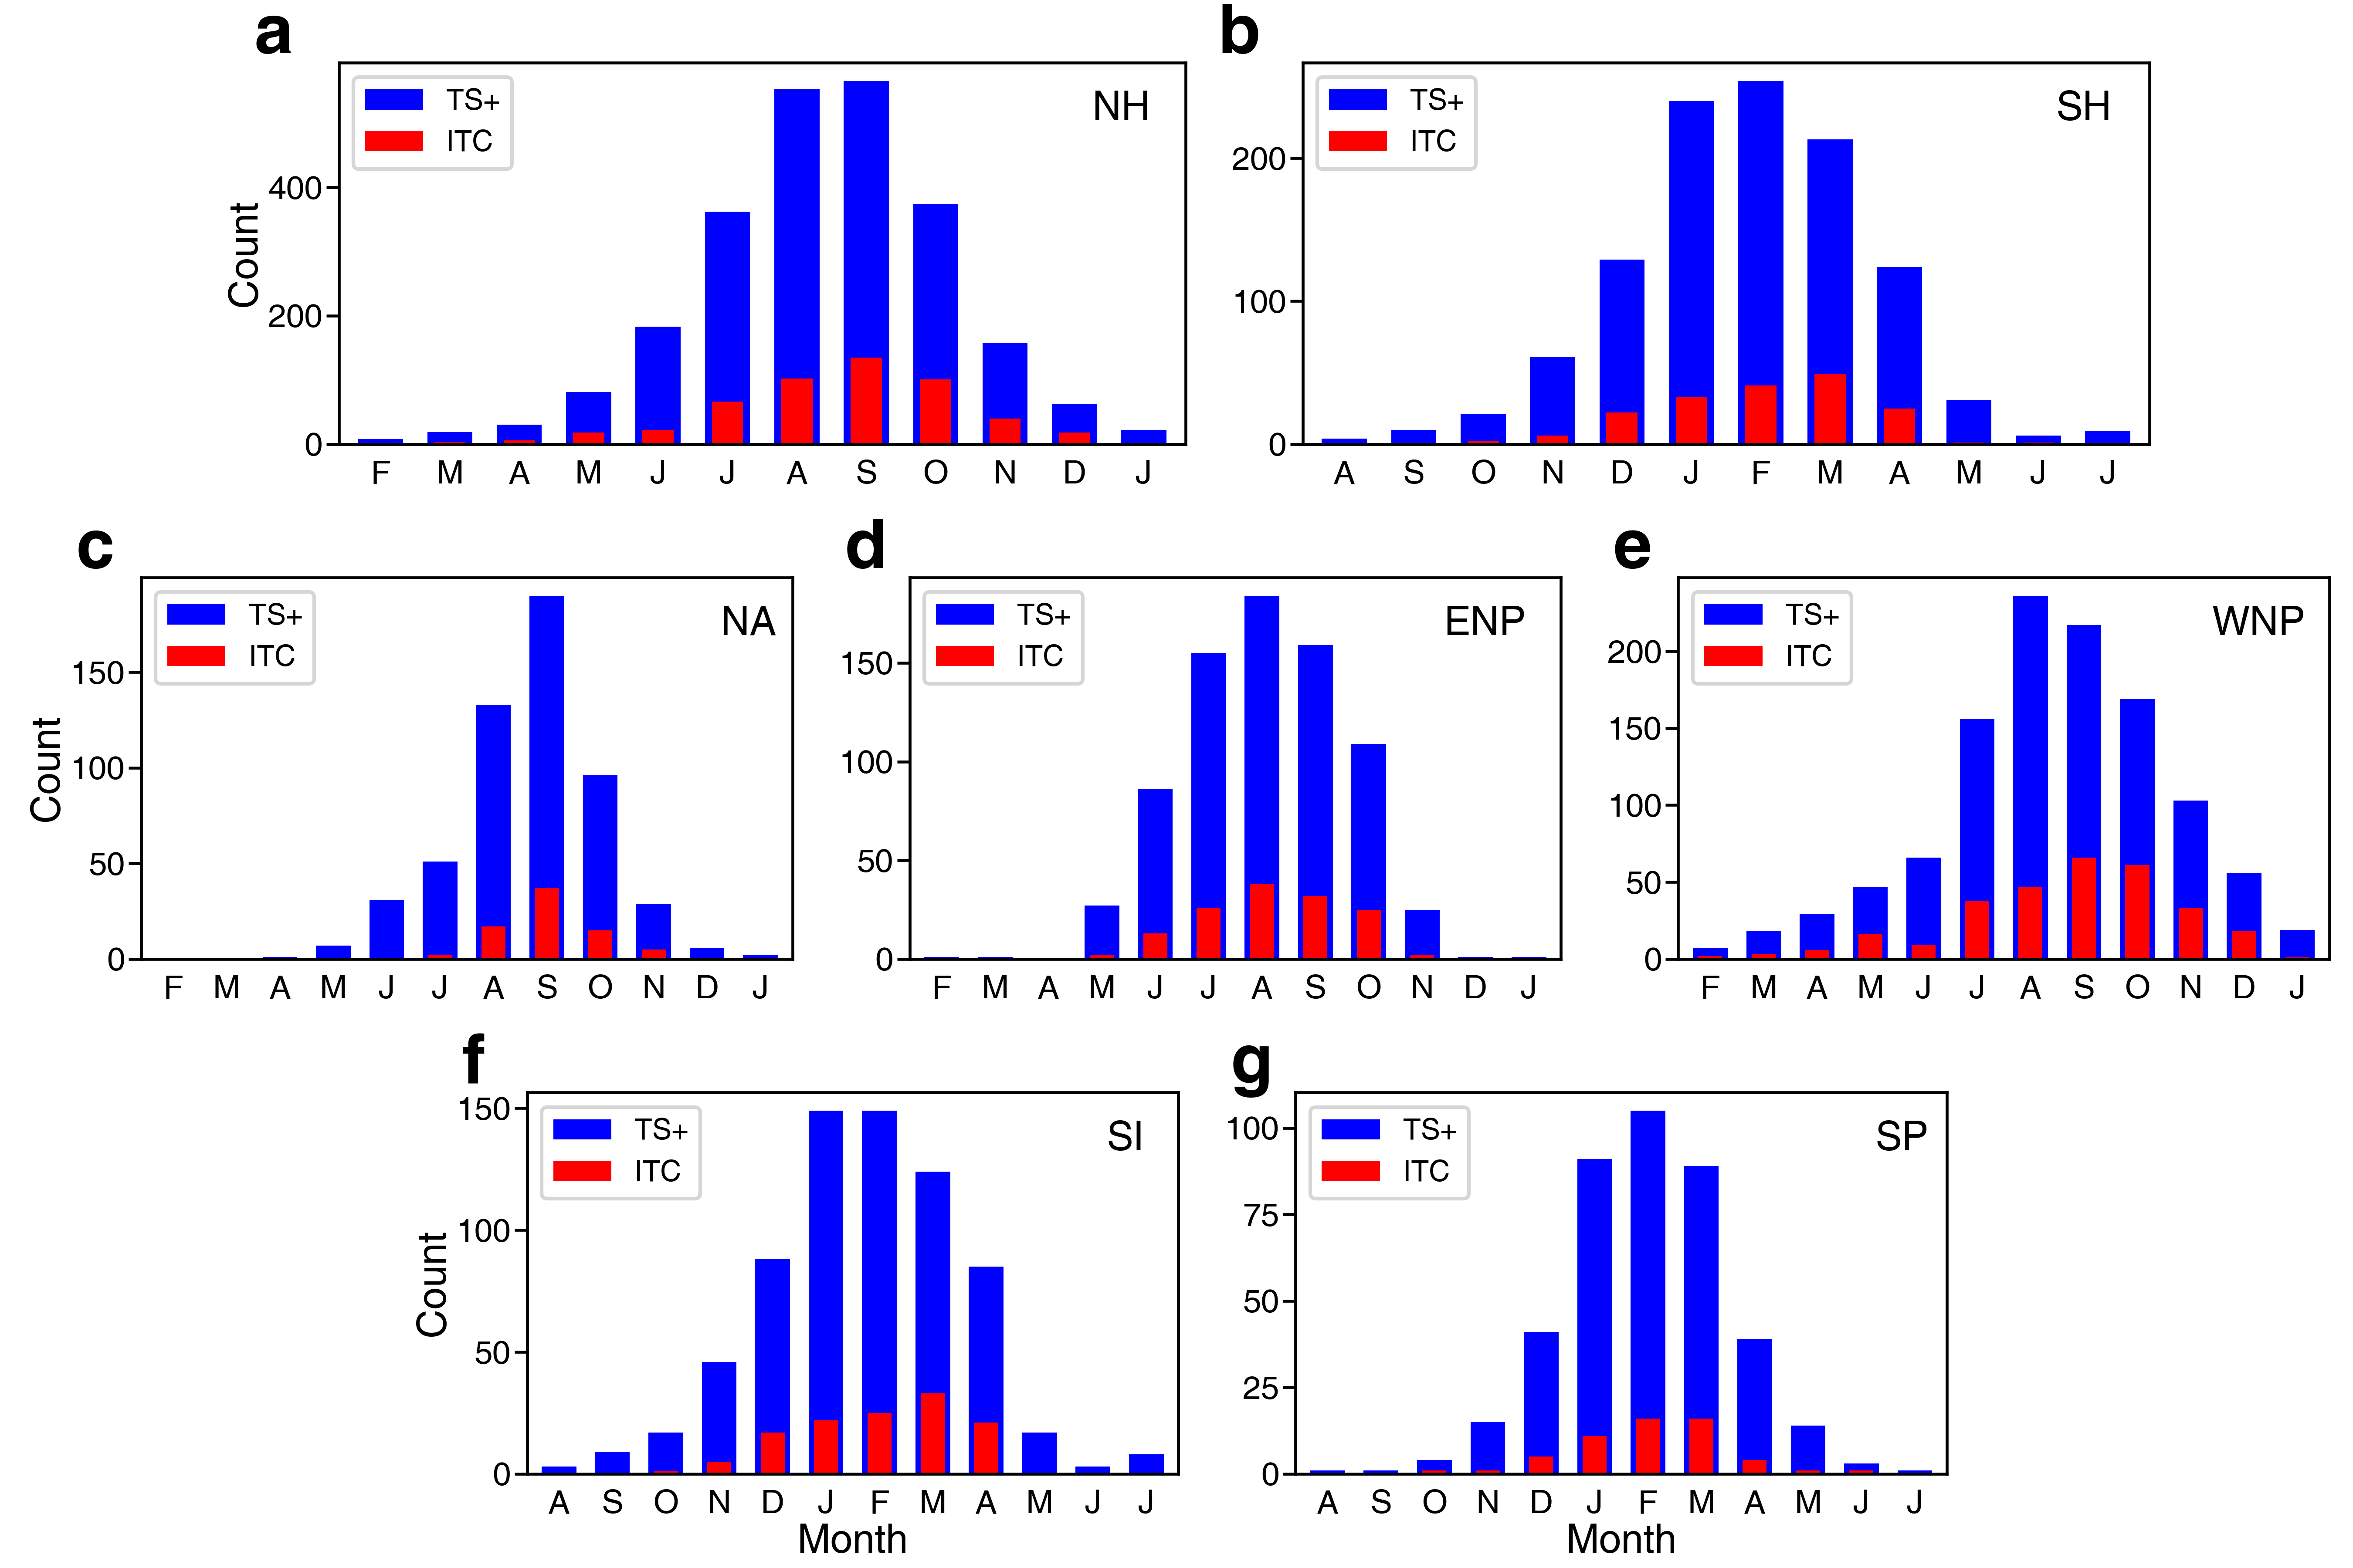
Fig. S2 | Monthly climatology of intense TC counts from 1979–20223. a–g, Distribution of monthly counts of all TCs (blue) and intense TCs (red) from 1980–2023 over the NH (a), SH (b), NA (c), ENP (d), WNP (e), SI (f), and SP (g). Results are based on TC records in the IBTrACS.

Table S1 | Intense TC season and overall TC season of each basin.
Basin | Start of overall TC season | Start of intense TC season | End of intense TC season | End of overall TC season
NH | 31st May | 14th June | 18th November | 21st November
SH | 18th November | 18th December | 6th April | 25th April
NA | 2nd July | 28th August | 9th October | 5th November
ENP | 8th June | 7th July | 9th October | 23rd October
WNP | 11th May | 6th June | 25th November | 9th December
SI | 12th November | 23rd December | 30th March | 26th April
SP | 10th December | 9th January | 24th March | 22nd April

Text S2. Three lengthening types of intense TC seasons
Although significant lengthening trends of intense TC seasons are observed in all basins, we find that the lengthening patterns vary across basins. Namely, the long-term trends in the start and end dates of intense TC seasons differ among the basins.
According to time series analyses in Fig. 2, apparent early-shifting trends in the start dates of intense TC seasons are observed in the ENP (-7.8 days/decade; Fig. 2c), SI (-6.5 days/decade; Fig. 2g), and SP (-11.1 days/decade; Fig. 2i), where negative trends denote an earlier onset of the intense TC season. Among these three basins, the linear trends in the end dates of intense TC seasons in the ENP, SI, and SP show statistically insignificant positive trends. This indicates that the lengthening of intense TC seasons in the ENP, SI, and SP is primarily because the intense TC seasons start earlier (Figs. S3b, d, e). We refer to this as TYPE I lengthening (Table S2).
Differently, while the start date of the WNP intense TC season also shifts earlier significantly (-14.8 days/decade), the season end date exhibits an insignificant decreasing trend (-3.6 days/decade, Fig. 2e). This suggests that both the onset and withdrawal of WNP intense TC season have been occurring earlier (Fig. S3c). In this case, because the earlier shift in the onset date is larger than that of the withdrawal date, the overall length of the intense TC season increases significantly (Fig. 1f). The earlier shift in the season end date plays an offsetting role in this trend. We refer to this as TYPE II lengthening (Table S2).
The NA, in contrast to the above four basins, does not experience an early onset trend. Instead, a significant positive trend (+7.6 days/decade) is observed in the end date of the intense TC season (Fig. 2a). This implies that the lengthening of the NA intense TC season is primarily due to a later withdrawal. We refer to this as TYPE III lengthening (Table S2).

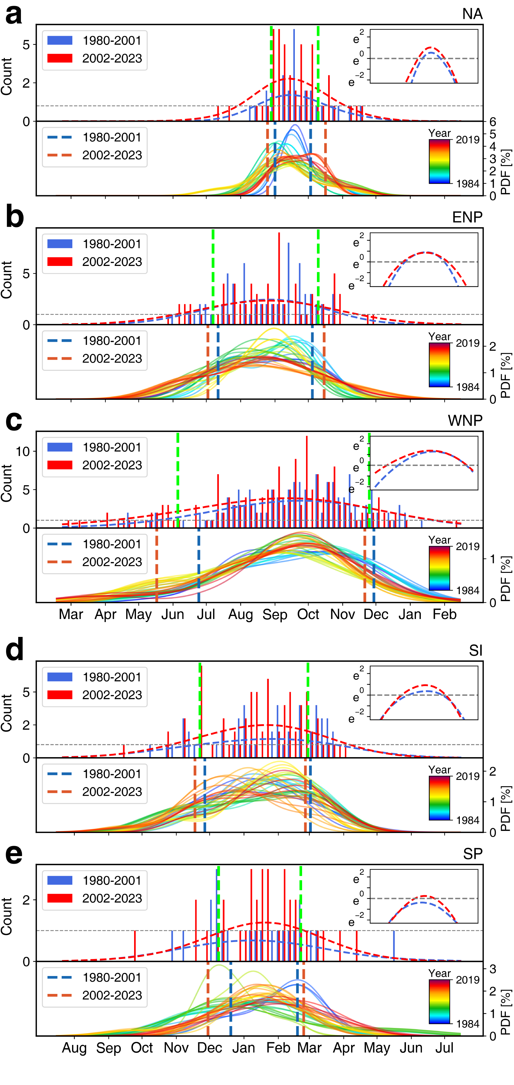
Fig. S3 | Lengthening trends of intense TC seasons across different basins. a, Upper panel: Statistical distributions of intense TC occurrence (bars, 5 days interval) during 1980–2001 (blue) and 2002–2023 (red) in the NA basin, where the dashed curves represent the Gaussian fit curves for each distribution and the green vertical dashed lines denote the climatological start and end dates of the intense TC seasons. Lower panel: Similar to the upper panel, but the Gaussian fitting is applied to data for every 9-year period. The blue and red vertical dashed lines denote the climatological start and end dates of the intense TC seasons during 1980–2001 and 2002–2023, respectively. b–e, Same as (a), except for the ENP (b), WNP (c), SI (d), and SP (e) basins. Results are based on intense TC records in the IBTrACS from 1980–2023.

Table S2 | Three lengthening types of intense TC seasons. Asterisks indicate the confidence levels, 1 asterisk (*) = 90%, 2 asterisks (**) = 95%, and 3 asterisks (***) = 99%. Bold fonts indicate trends that are statistically significant at the 90% confidence level.
Basin | Climatological length of intense TC season (days) | Trend of intense TC season length (days / decade) | Season start date (days / decade) | Season end date (days / decade) | Type of lengthening
NA | 42 | 8.9*** | -1.4 | 7.6*** | TYPE III
ENP | 95 | 10.9** | -7.8** | 3.1 | TYPE I
WNP | 173 | 11.2** | -14.8*** | -3.6 | TYPE II
SI | 97 | 8.5* | -6.5 | 2.0 | TYPE I
SP | 74 | 14.2** | -11.1* | 3.1 | TYPE I

Text S3. Sensitivity of lengthening trends of intense TC seasons to the definitions of start and end dates
Different definitions have been employed to study the variability of TC season lengths ^{1,2}. In this supplementary text, in order to verify the validity of the observed lengthening trends of intense TC seasons, we conduct linear trend analyses similar to that in the main text, but based on various definitions of start and end dates. In the main text, we define the start and end dates of intense TC seasons as the occurrence time of the 5th and 95th intense TCs within a year, which corresponds to the period when 90% of intense TCs occur in a year. Here, we additionally use 1st–5th and 95th–99th percentiles to define the onset and withdrawal dates, respectively, with an interval of 1. Apart from that, we also test results by defining intense TC seasons based on the occurrence time of the first and last intense TC in a given year (Fig. S4 and Table S3).
Results show that the statistically significant increasing trends in intense TC seasons are observed in all basins, regardless of the definitions used for intense TC seasons. In addition, the estimated trends tend to be larger in magnitude and more significant when the definitions are stricter. The lengthening trends of intense TC seasons in the NA, ENP, SP, and SI remain statistically significant even when intense TC seasons are defined as the period when 80% of intense TCs occur in a year. These results confirm that the conclusion regarding the lengthening of intense TC seasons from 1980–2023 is consistent and robust, and is insensitive to the choice of definitions for season start and end dates.

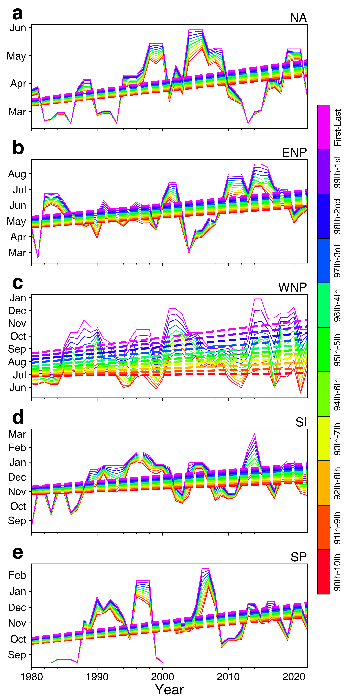
Fig. S4 | Sensitivity of trends in intense TC season lengths to definitions of start and end dates. a–g, Time series of intense TC season lengths (unit: days) over the NA (a), ENP (b), WNP (c), SI (d), and SP (e), NH (f), and SH (g), based on different definitions of intense TC seasons. Results are based on intense TC records in the IBTrACS from 1980–2023.

Table S3 | Trends in intense TC season lengths (days/decade) based on different definitions of start and end dates. Asterisks indicate the confidence levels, 1 asterisk (*) = 90%, 2 asterisks (**) = 95%, and 3 asterisks (***) = 99%. Results show that the lengthening trends of intense TC seasons are insensitive to the definitions of season start and end dates.
Definition of intense TC season | NA | ENP | WNP | SI | SP
Last–First | 10.2*** | 12.3** | 18.9*** | 11.6** | 16.1**
99th – 1st | 9.9*** | 12.1** | 17.1*** | 11.0* | 15.7**
98th – 2nd | 9.7*** | 11.8** | 15.3*** | 10.3* | 15.3**
97th – 3rd | 9.4*** | 11.5** | 13.5** | 9.7* | 15.0**
96th – 4th | 9.2*** | 11.2** | 12.2** | 9.1* | 14.6**
95th – 5th | 8.9*** | 10.9** | 11.2** | 8.5* | 14.2**

Text S4. Discrepancies in lengthening trends between overall TC season and intense TC season
The long-term trends in the lengths of overall TC seasons exhibit large discrepancies compared with those of intense TC seasons. While consistent lengthening trends are observed in the intense TC seasons across all basins, this is not the case for overall TC seasons. This is evident in the long-term variability in the lengths (Figs. 1f–j), start and end dates (Figs. 2b,d,f,h,j) of TC seasons defined based on all TCs with LMI greater than 34 knots.
In Text S2, we categorize the five basins into three groups according to the lengthening types of their intense TC seasons. For TYPE I basins (ENP, SI, SP), the lengthening of intense TC seasons is attributed to earlier onset. However, no statistically significant trends in the start dates of overall TC seasons are observed (Figs. 2h, 2j). As a result, the lengths of overall TC seasons in the SI and SP do not show significant changes (Figs. 1i, 1j). Although the lengthening trend of the ENP overall TC season is significant (+4.7 days/decade; Fig. 1g), it results from a later withdrawal of the season (+3.7 days/decade; Fig. 2d), which is inconsistent with the lengthening pattern of the ENP intense TC season.
The lengthening of intense TC season in the WNP (classified as TYPE II lengthening) is primarily attributed to an earlier onset, but is partly offset by an earlier withdrawal of the intense TC season. For the overall TC season in this basin, significant decreasing trends are observed in both the start (-4.5 days/decade) and end (-3.6 days/decade) dates (Fig. 2f). However, unlike the intense TC season, the earlier withdrawal trend of the overall TC season is greater in magnitude than the trend for earlier onset. As a result, this leads to a statistically insignificant trend in the length of the overall TC season (Fig. 1h).
The lengthening of the intense TC season in the NA (TYPE III lengthening) is attributed to a later withdrawal, with no significant changes in the start date of the intense TC season. In contrast, the overall TC season in this basin shows a significant decreasing trend in the start date (-6.0/per decade), while no significant change is observed in the end date (Fig. 2b). Although the length of NA overall TC season exhibits a significant increasing trend (5.4 days/decade; Fig. 1f), its magnitude is smaller than that of the intense TC season, and the lengthening pattern is also inconsistent.
The above results indicate that the lengthening trends and patterns of overall TC seasons are not necessarily consistent with those of intense TC seasons. As a whole, the NH overall TC season has shortened significantly (-3.4 days/decade; Fig. 1d), which is mainly due to the decrease in the WNP intense TC season length. Meanwhile, no significant change is observed in the SH. These observations contrast with the significant increase in intense TC season lengths, suggesting that the lengthening of intense TC seasons cannot be explained by the changes in overall TC seasons or trends in off-season TC genesis (TCG). The key factor contributing to changes in the lengths of intense TC seasons is the variation in efficiency (α) of TCs developing into intense TCs, which is discussed in the main text and Text S5.

Text S5. Contributions of changes in α and TCG to the increasing trend of N
Changes in the intense TC season lengths can be regarded as changes in intense TC numbers during the pre-season and post-season periods. And, changes in the number of intense TCs ($\frac{∆N}{∆t}$) can be decomposed into contributions from changes in the number of TCG ($\overline{α}×\frac{∆TCG}{∆t}$) and changes in the efficiency of TCs developing into intense TCs ($\overline{TCG}×\frac{∆α}{∆t}$) (Eq. 2 in Methods).
First of all, we examine the contributions of changes in TCG and α to TYPE I lengthening (ENP, SI, SP), where the increase in intense TC season lengths is attributed to earlier onset. As shown in Fig. 2k, the pre-season $\frac{∆N}{∆t}$ are +0.25, +0.32, and +0.03 per decade in the ENP, SI, and SP, respectively, corresponding to the earlier onset of the intense TC seasons. And, $\overline{TCG}×\frac{∆α}{∆t}$ in these three basins, with trend values of +0.23, +0.38, and +0.17 per decade, predominantly lead to the increase in pre-season intense TC count. $\overline{α}×\frac{∆TCG}{∆t}$ in the ENP and SI have only very small contributions. Notably, the contribution from $\overline{α}×\frac{∆TCG}{∆t}$ in the SP is negative, offsetting the increase in N by $\overline{TCG}×\frac{∆α}{∆t}$. The results indicate that TYPE I lengthening is primarily attributed to the pre-season $\overline{TCG}×\frac{∆α}{∆t}$.
For the WNP (TYPE II lengthening), where significant early shifts are observed in both the start and end dates of its intense TC season, $\overline{TCG}×\frac{∆α}{∆t}$ is also the main contributor to the lengthening of intense TC season. During the pre-season period, $\frac{∆N}{∆t}$ is +0.48 per decade, with $\overline{TCG}×\frac{∆α}{∆t}$ and $\overline{α}×\frac{∆TCG}{∆t}$ contributing by 99.8% and 1.6%, respectively (Fig. 2k). On the contrary, in the post-season period, $\frac{∆N}{∆t}$ shows a decreasing trend of -0.16 per decade, corresponding to the earlier withdrawal of the intense TC season. In this case, $\overline{TCG}×\frac{∆α}{∆t}$ and $\overline{α}×\frac{∆TCG}{∆t}$ contribute by -105% and 182%, respectively (Fig. 2k). These suggest that TYPE II lengthening, similar to TYPE I lengthening, is primarily attributed to the pre-season $\overline{TCG}×\frac{∆α}{∆t}$, while the post-season $\overline{α}×\frac{∆TCG}{∆t}$ partially offsets the lengthening trend.
In the NA (TYPE III lengthening), the significant later withdrawal of its intense TC season is the main reason for the increase in intense TC season length. In this basin, the post-season $\frac{∆N}{∆t}$ is +0.33 per decade. The $\overline{TCG}×\frac{∆α}{∆t}$ and $\overline{α}×\frac{∆TCG}{∆t}$ are +0.24 and +0.13 per decade, respectively, contributing to $\frac{∆N}{∆t}$ by 74.2% and 40.4% (Fig. 2k). The result indicates that TYPE III lengthening is primarily attributed to the post-season $\overline{TCG}×\frac{∆α}{∆t}$. However, unlike TYPE I and TYPE II lengthening, the post-season $\overline{α}×\frac{∆TCG}{∆t}$ also has an effect on the lengthening of intense TC season.
The above findings suggest that the increasing efficiency of off-season TCs developing into intense TCs ($\overline{TCG}×\frac{∆α}{∆t}$) is the primary contributor to the lengthening trends of intense TC seasons. Technically speaking, the pre-season $\overline{TCG}×\frac{∆α}{∆t}$ accounts for the lengthening of intense TC seasons in the ENP, WNP, SI, and SP basins. On the other hand, the post-season $\overline{TCG}×\frac{∆α}{∆t}$ is responsible for the lengthening of the NA intense TC season. In other words, the intense TC seasons in the ENP, WNP, SI, and SP are becoming longer because pre-season TCs in these basins can more easily develop into intense TCs. Meanwhile, the lengthening of the NA intense TC season is due to post-season TCs in this basin being more likely to strengthen to LMIs greater than 113 knots.

Text S6. Changes in vertical wind shear and DGPI over the NA
In the main text, we show that $V_{shear}$ is the dominating factor contributing to the increase in post-season TCG over the NA domain, which explains 67.9% of the increase in DGPI (Fig. 3a). Here, Fig. S5 plots the spatial distribution of trends in $V_{shear}$ from 1980–2023. Results show that there is a general decline in $V_{shear}$ over the domain where post-season NA intense TCs typically form, which is associated with the reduction in upper-tropospheric wind speeds. This weakening trends in $V_{shear}$ a more favorable atmospheric environment for the formation and development of TCs. Consequently, this leads to an increase in the number of TCG, which in turn contributes to the delay in the withdrawal of the NA intense TC season (Fig. 2k).

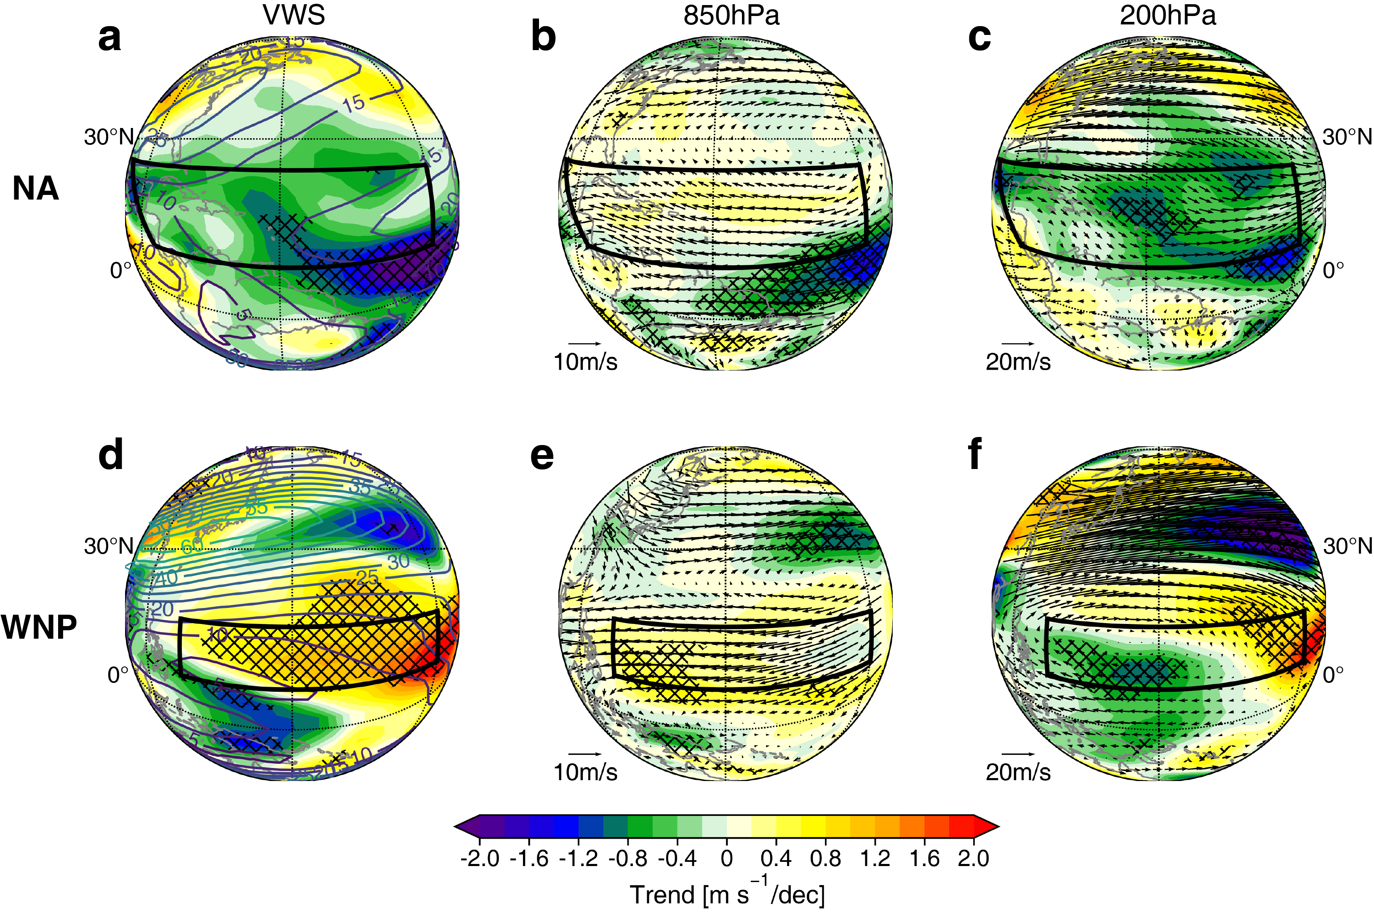
Fig. S5 | Long-term trends in post-season $V_{shear}$ over the NA and WNP. a, Spatial distribution of trends in post-season $V_{shear}$ (unit: m s⁻¹ decade⁻¹) over the NA from 1980–2023. b-c, Same as (a), except for 850-hPa (b) and 200-hPa (c) wind (vector, unit: m s⁻¹ decade⁻¹) and wind speed (shading, unit: m s⁻¹ decade⁻¹). b-c, Same as (a), except for the WNP. Black boxes denote the key areas where the off-season intense TCs formed and intensified.

Text S7. Changes in vertical wind shear, vertical motion, and DGPI over the WNP
In the main text, we show that the decrease in post-season TCG over the WNP domain is mainly contributed by the strengthening background large-scale downdrafts and $V_{shear}$, which respectively explains 49.0% and 42.8% of the decrease in DGPI (Fig. 3b). The enhanced late-season $V_{shear}$ over the WNP have been reported to be affected by the earlier recession of the summer monsoon and the earlier onset of the winter monsoon ³. Some research also attributed it to the SST warming associated with the recent positive phase of AMO ⁴. Meanwhile, the large-scale vertical motion trend is associated with the changes in the Walker circulation. The upward branch of the Walker circulation has shifted westward since 1980, which leads to a significant weakening of updraft over 130–150°E. At the same time, the downdraft over the central Pacific has strengthened (Fig. S6). These together lead to a less favorable atmospheric environment for the formation and development of TCs, thus resulting in the early withdrawal of the WNP intense TC season (Fig. 2k).

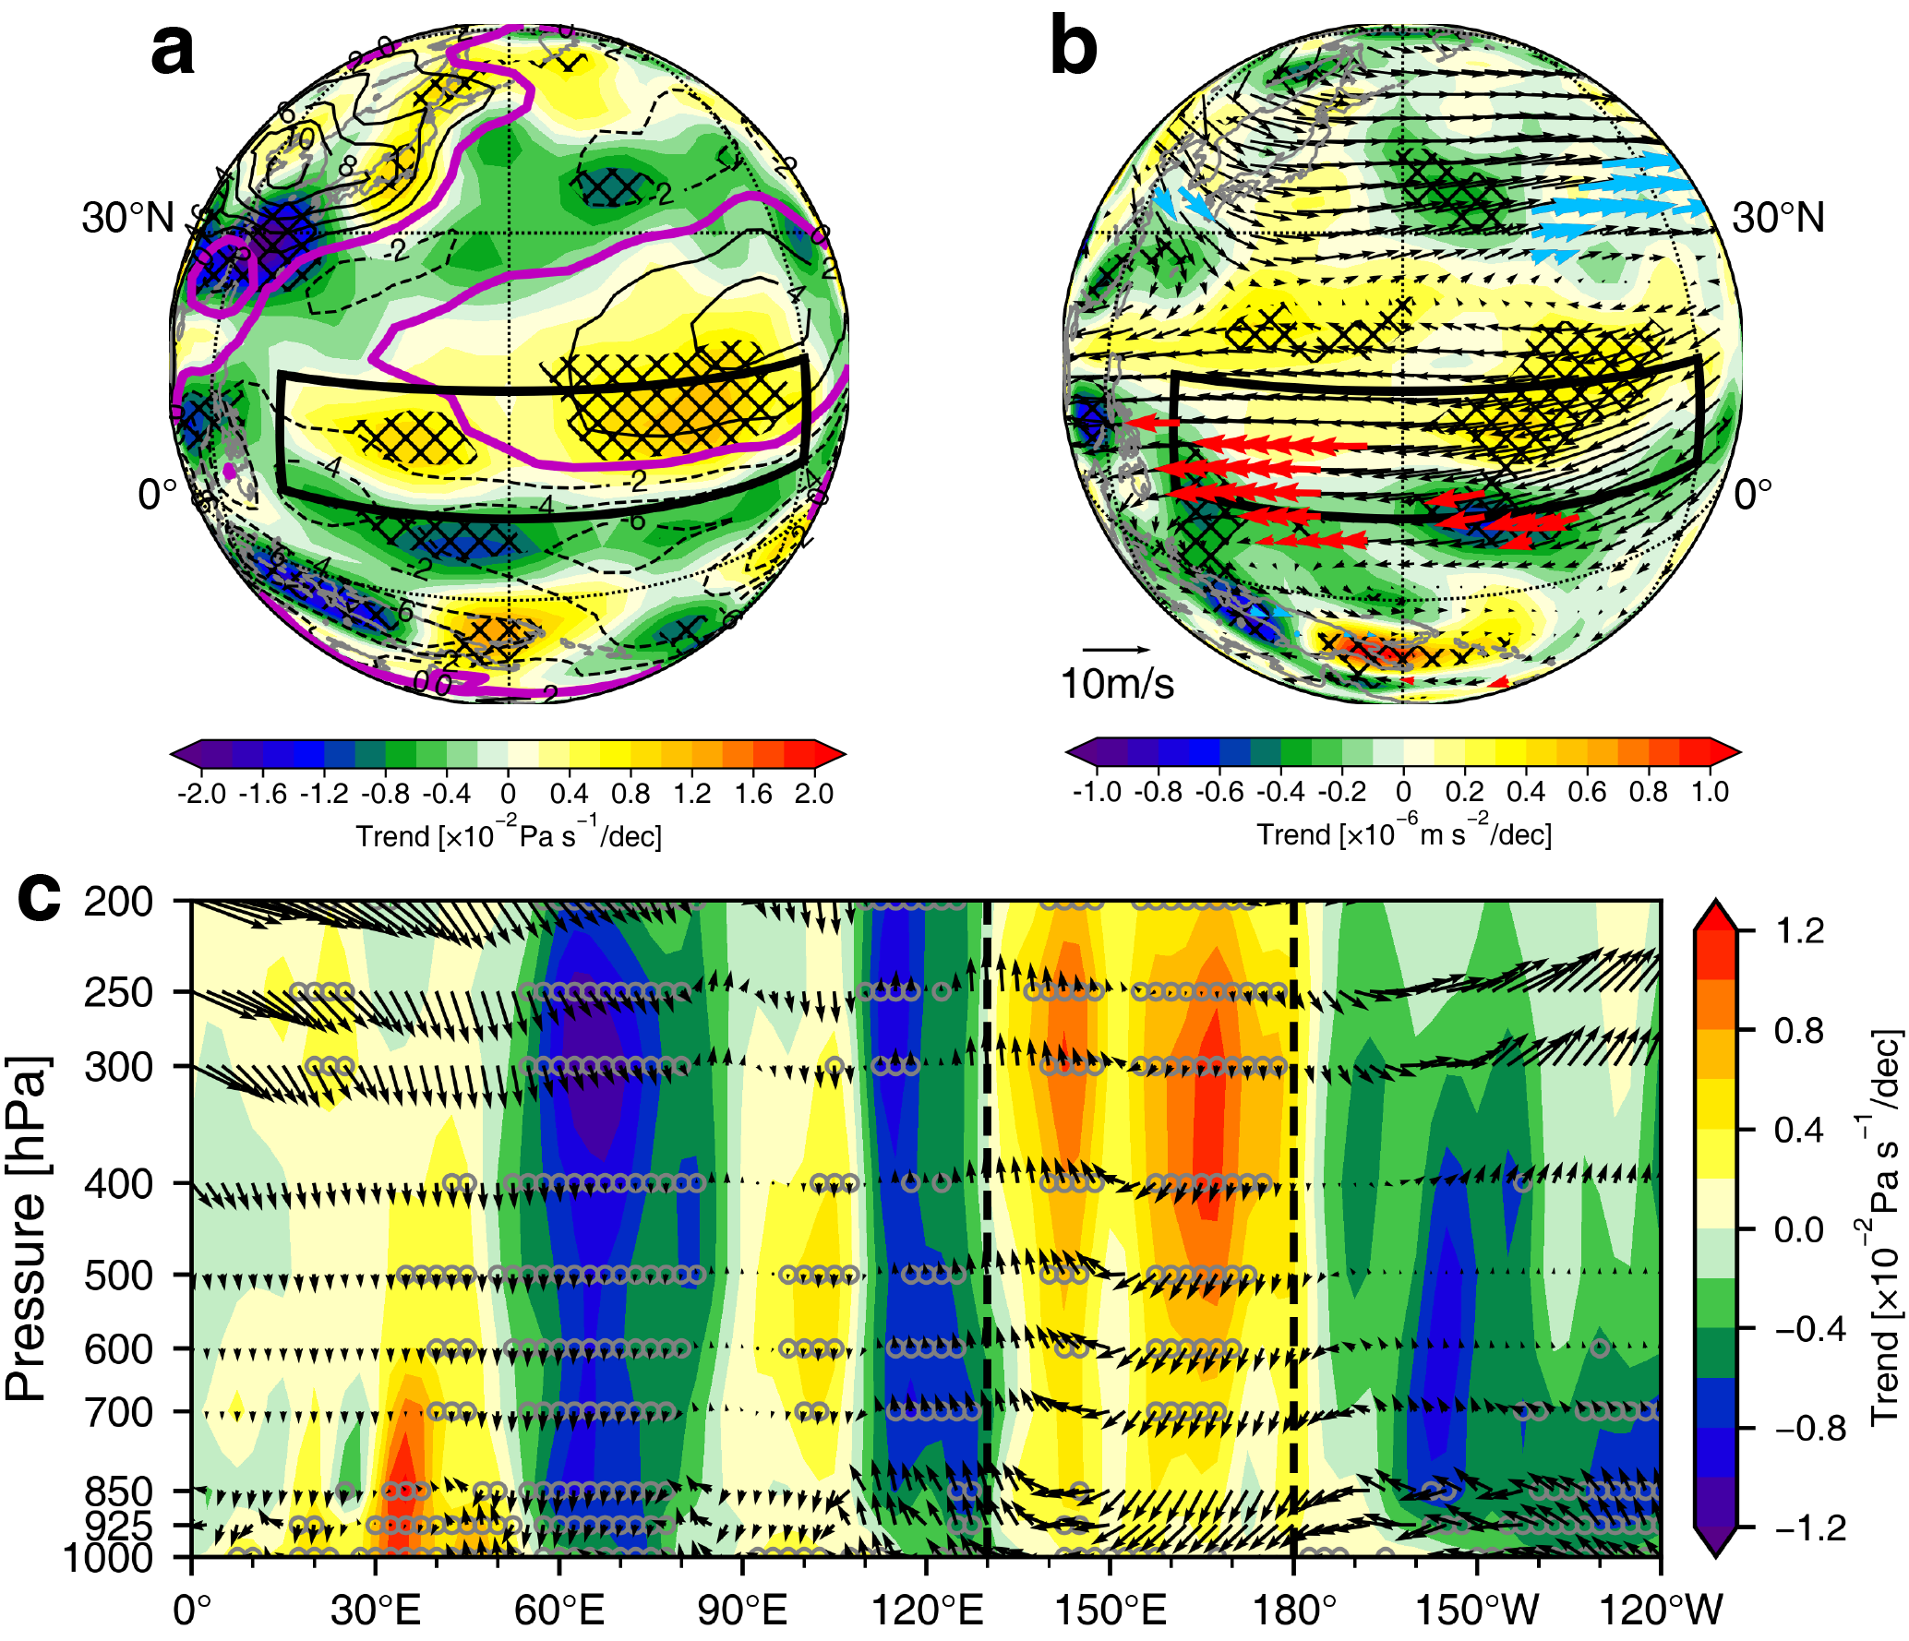
Fig. S6 | Long-term trends in post-season vertical motion over the WNP. a, Spatial distribution of trends in post-season 500-hPa vertical velocity (unit: Pa s⁻¹ decade⁻¹) over the NA from 1980–2023. b, Same as (a), except for 850-hPa wind (vector, unit: m s⁻¹ decade⁻¹) and divergence (shading, unit: m s⁻² decade⁻¹). c, Same as (a), except for a zonal cross-section of trends in vertical velocity (shading, unit: m s⁻¹ decade⁻¹) and the climatological wind (vector, unit: m s⁻¹, with vertical velocity being multiplied by 10 times) over the WNP domain. Black boxes denote the key areas where the off-season intense TCs formed and intensified.

Text S8. Increasing MPI of off-season TCs and its main driver
The maximum potential intensity (MPI) of a TC roughly determines the theoretical upper limit of maximum sustained wind speed that a TC could achieve based on the given environmental atmospheric and oceanic conditions. In Text S5, we show that the lengthening of intense TC seasons is primarily contributed by off-season $\overline{TCG}×\frac{∆α}{∆t}$, which reflects the likelihood that an off-season TC can develop into an intense TC. In this context, examining long-term changes in MPI and their underlying causes can provide insights into the factors driving the lengthening of intense TC seasons.
Results show statistically significant increasing trends in the average pre-season MPI over the ENP (+1.65 m s⁻¹ decade⁻¹), WNP (+2.60 m s⁻¹ decade⁻¹), SI (+1.83 m s⁻¹ decade⁻¹), and SP (+2.66 m s⁻¹ decade⁻¹) from 1980–2023. These trends are consistent with the above findings that pre-season $\overline{TCG}×\frac{∆α}{∆t}$ is responsible for the earlier onset, thereby contributing to the lengthening of intense TC seasons in these basins. Besides, the significantly enhancing average post-season MPI (+1.87 m s⁻¹ decade⁻¹) is also consistent with the increasing trend of post-season $\overline{TCG}×\frac{∆α}{∆t}$ in the NA.
Next, we quantitively estimate the main driver for the enhancing off-season MPI, to investigate the cause of increasing off-season α. As documented in a number of studies ^{5–8}, changes in MPI can be attributed to those in (1) the thermodynamic efficiency term ($∆η/∆t$) and (2) the thermodynamic disequilibrium between the sea surface and troposphere ($∆L/∆t$) of the TC’s surrounding environment. Among the two factors, $∆η/∆t$ is more sensitive to upper tropospheric temperature, while $∆L/∆t$ is generally governed by the SST variability. Based on Eqs. 7–8 in Methods, we quantitatively estimate the contributions of $∆η/∆t$ and $∆L/∆t$ to $∆MPI/∆t$ (see Methods).
First of all, in the basins of TYPE I lengthening (ENP, SI, SP), the pre-season $∆MPI/∆t$ leads to an increase in intense TC season lengths (Fig. 2k). For the ENP, $∆η/∆t$ and $∆L/∆t$ contribute to 25% and 75% of $∆MPI/∆t$, respectively. The MPI trend resulting solely from changes in $∆L/∆t$ (hereafter $MPI_{L}$, Eq. 8) reaches 1.24 m s⁻¹ decade⁻¹. Meanwhile, the MPI trend resulting solely from $∆η/∆t$ (hereafter $MPI_{η}$, Eq. 9) is only 0.41 m s⁻¹ decade⁻¹. (Figs. 4b–d). For the SI basin, $∆η/∆t$ and $∆L/∆t$ contribute to 32% and 68% of $∆MPI/∆t$, respectively, with a significant $MPI_{L}$ trend of 1.25 m s⁻¹ decade⁻¹ (Figs. 4j–4m). For the SP basin, the contribution of $∆L/∆t$ to $∆MPI/∆t$ is as high as 87%, with a $MPI_{L}$ trend of 2.31 m s⁻¹ decade⁻¹. On the other hand, $∆η/∆t$ only contributes to 13% of $∆MPI/∆t$ (Figs. 4j–4m). These results indicate that the changes in the thermodynamic disequilibrium term are the primary drivers for the enhancing pre-season MPI in the ENP, SI, and SP, which leads to the increase in intense TC season lengths in these three basins.
For the WNP (TYPE II lengthening), where the lengthening in intense TC season is primarily attributed to the pre-season $\overline{TCG}×\frac{∆α}{∆t}$ (or $∆MPI/∆t$), our results show that $∆L/∆t$ is also the main contributor to the enhancing pre-season MPI. Specifically, $∆η/∆t$ and $∆L/∆t$ contribute to 13% and 86% of $∆MPI/∆t$, respectively. The MPI trend resulting solely from changes in $∆L/∆t$ ($MPI_{L}$) reaches 2.24 m s⁻¹ decade⁻¹. Meanwhile, the MPI trend resulting solely from $∆η/∆t$ ($MPI_{η}$) is only 0.35 m s⁻¹ decade⁻¹ (Figs. 4f–4i).
Similar results are observed in the NA (TYPE III lengthening), where the lengthening in intense TC season is primarily attributed to the post-season $\overline{TCG}×\frac{∆α}{∆t}$ (or $∆MPI/∆t$). Namely, $∆η/∆t$ and $∆L/∆t$ contribute to 33% and 66% of $∆MPI/∆t$, respectively. The MPI trend resulting solely from changes in $∆L/∆t$ ($MPI_{L}$) reaches 1.24 m s⁻¹ decade⁻¹. Meanwhile, the MPI trend resulting solely from $∆η/∆t$ ($MPI_{η}$) is only 0.62 m s⁻¹ decade⁻¹ (Figs. 4r–4u). This implies that the increasing thermodynamic disequilibrium enhances the post-season MPI in the NA, which lengthens the NA intense TC season.
The above findings suggest that no matter for which lengthening type, the increasing thermodynamic disequilibrium term is the primary driver that enhances the off-season MPI. This increases the likelihood that off-season TCs develop into intense TCs, thereby leading to the lengthening of intense TC seasons globally.

References
1. Huang, H. et al. Recent Unusual Consecutive Spring Tropical Cyclones in North Atlantic and Winter Oceanic Precursor Signals. Journal of Meteorological Research 37, 208–217 (2023).
2. Kossin, J. P. Is the North Atlantic hurricane season getting longer? Geophys Res Lett 35, (2008).
3. Wu, Y., Huang, F. & Xu, S. The earlier end of the tropical cyclone season over the Western North Pacific by environmental cyclogenesis factors. Clim Dyn 61, 1293–1309 (2023).
4. Zhang, W. et al. Dominant Role of Atlantic Multidecadal Oscillation in the Recent Decadal Changes in Western North Pacific Tropical Cyclone Activity. Geophys Res Lett 45, 354–362 (2018).
5. Gilford, D. M., Solomon, S. & Emanuel, K. A. On the Seasonal Cycles of Tropical Cyclone Potential Intensity. J Clim 30, 6085–6096 (2017).
6. Emanuel, K. A. The dependence of hurricane intensity on climate. Nature 326, 483–485 (1987).
7. Wing, A. A., Emanuel, K. & Solomon, S. On the factors affecting trends and variability in tropical cyclone potential intensity. Geophys Res Lett 42, 8669–8677 (2015).
8. Emanuel, K. A. An Air-Sea Interaction Theory for Tropical Cyclones. Part I: Steady-State Maintenance. Journal of Atmospheric Sciences 43, 585–605 (1986).

