Supporting Information

Operando Unraveling Photothermal-Promoted Dynamic Active Sites Generation in Spinel NiFe₂O₄ for Oxygen Evolution

Likun Gao^{1,2,4}, Xun Cui^{1,4}, Zewei Wang¹, Christopher D. Sewell¹, Zili Li¹, Shuang Liang¹, Mingyue Zhang¹, Jian Li², Yingjie Hu³, Zhiqun Lin¹*

¹School of Materials Science and Engineering, Georgia Institute of Technology, Atlanta, GA 30332, USA
²Key Laboratory of Bio‐based Material Science and Technology of Ministry of Education, Northeast Forestry University, Harbin 150040, China
³Nanjing Key Laboratory of Advanced Functional Materials, Nanjing Xiaozhuang University, Nanjing 211171, China
⁴These authors contributed equally: Likun Gao, Xun Cui
* Corresponding Authors: Zhiqun Lin
E-mail: zhiqun.lin@mse.gatech.edu

Supplementary Table 1. Summary of molecular weights (MWs) of amphiphilic multi-arm star-like PAA-b-PSAN diblock copolymers, the corresponding sizes of PSAN-ligated NiFe₂O₄ nanoparticles (NFO NPs), and the length of outer PSAN chains.
Samples | M_{n, PtBA}ª | M_{n, PtBA-b-PSAN}^{b} | M_{n, PAA}^{c} | M_{n, PSAN}^{d} | D_{h} of Star-like PAA-b-PSAN^{e} | NP Designation | NP size
1 | 76K | 162K | 5K | 8K | 8.4 ± 0.3 nm | NFO-3-8K | 3.3 ± 1.7 nm
2 | 110K | 326K | 7K | 15K | 19.0 ± 0.7 nm | NFO-7-15K | 7.0 ± 1.8 nm
3 | 203K | 637K | 15K | 21K | 28.8 ± 0.8 nm | NFO-12-21K | 12.0 ± 2.1 nm
4 | 196K | 343K | 15K | 7K | 23.4 ± 0.5 nm | NFO-12-7K | 12.1 ± 2.5 nm
Notes: ªNumber average molecular weight (M_{n}) of star-like PtBA nanoreactor before hydrolysis determined by GPC in THF. ^{b}M_{n} of star-like PtBA-PSAN nanoreactor before hydrolysis determined by GPC in THF. ^{c}M_{n} of each PAA block calculated from the molecular weight difference between PtBA block (before hydrolysis) and PAA block (after hydrolysis). ^{d}M_{n} of each PSAN block calculated from ¹H NMR data. ^{e}Hydrodynamic diameter D_{h} of star-like PAA-b-PSAN diblock copolymers in DMF measured by dynamic light scattering (DLS).

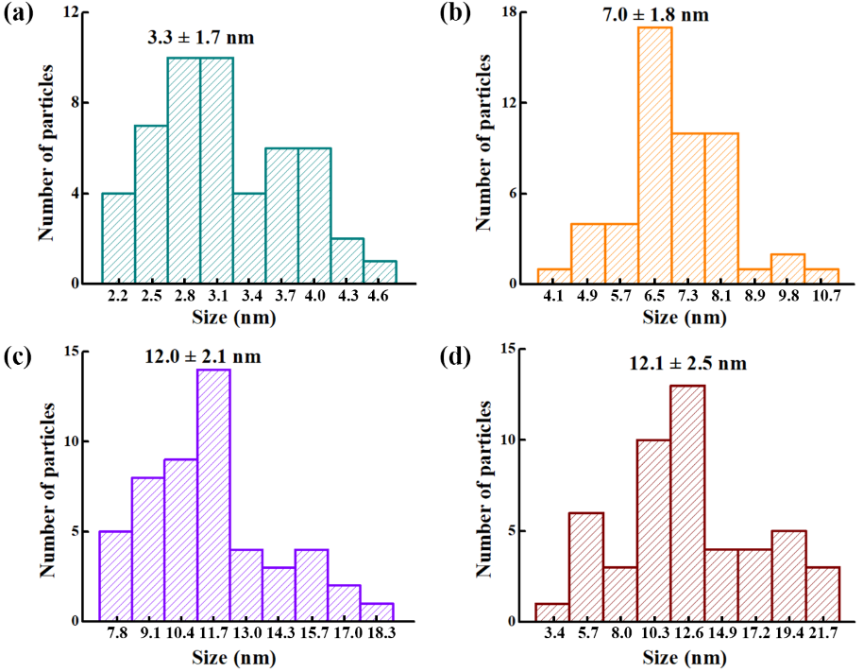
Supplementary Fig. 1 Histograms of the size distributions of randomly selected 50 nanoparticles from TEM images in Fig. 2. PSAN-ligated NFO NPs with diameters of (a) 3.3 ± 1.7 nm ligated by 8K PSAN chains (denoted NFO-3-8K), (b) 7.0 ± 1.8 nm ligated by 15K PSAN chains (denoted NFO-7-15K), (c) 12.0 ± 2.1 nm ligated by 21K PSAN chains (denoted NFO-12-21K), and (d) 12.1 ± 2.5 nm ligated by 7K PSAN chains (denoted NFO-12-7K).

Supplementary Fig. 2 Dynamic light scattering (DLS) measurements on unimolecular micelles of star-like PAA-b-PSAN diblock copolymers in DMF (i.e., samples in Supplementary Table 1). Star-like PAA-b-PSAN diblock copolymers with hydrodynamic diameter D_{h} of (a) 8.4 ± 0.3 nm (denoted Sample 1), (b) 19.0 ± 0.7 nm (denoted Sample 2), (c) 28.8 ± 0.8 nm (denoted Sample 3), and (d) 23.4 ± 0.5 nm (denoted Sample 4).

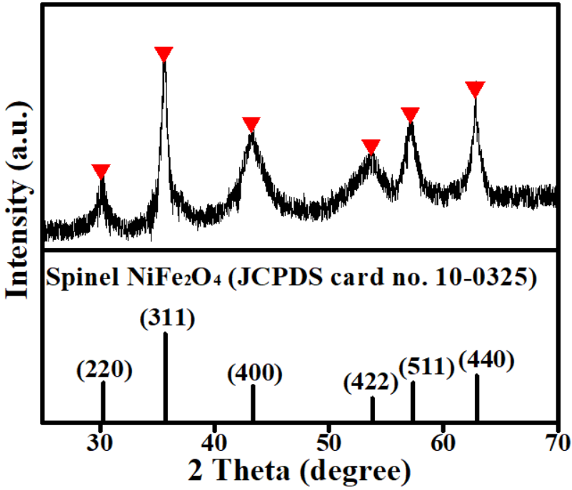
Supplementary Fig. 3 XRD pattern of PSAN-ligated NFO NPs.

Supplementary Fig. 4 HRTEM images of (a) NFO-3-8K, (b) NFO-7-15K, and (c) NFO-12-21K. The white circles are the guides to eyes.

Supplementary Fig. 5 TEM images of (a) carbon black, (b) PSAN-ligated NFO-12-7K NPs (after ethanol washing yet without subsequent drying) on carbon black, and (c) PSAN-ligated NFO-12-7K (after ethanol washing, followed by subsequent drying) on carbon black. The white dashed circle in (c) illustrates that the NPs deposited outside carbon black substrate (i.e., marked as no carbon black).

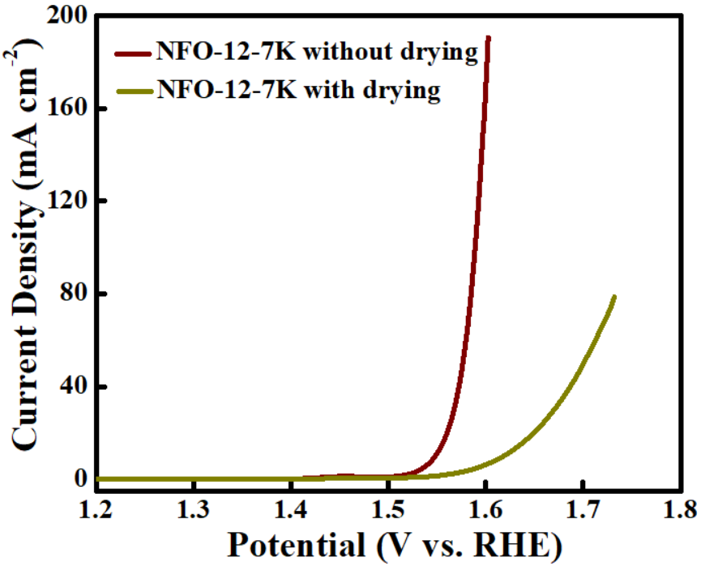
Supplementary Fig. 6 LSV curves of PSAN-ligated NFO-12-7K without drying (η₂₀ = 329 mV) and NFO-12-7K with drying (η₂₀ = 420 mV) for OER in 1.0 M KOH.

Supplementary Fig. 7 Cyclic voltammetry (CV) curves measured at different scan rates from 20 to 60 mV s⁻¹ for (a) NFO-3-8K, (b) NFO-7-15K, (c) NFO-12-21K, and (d) NFO-12-7K.

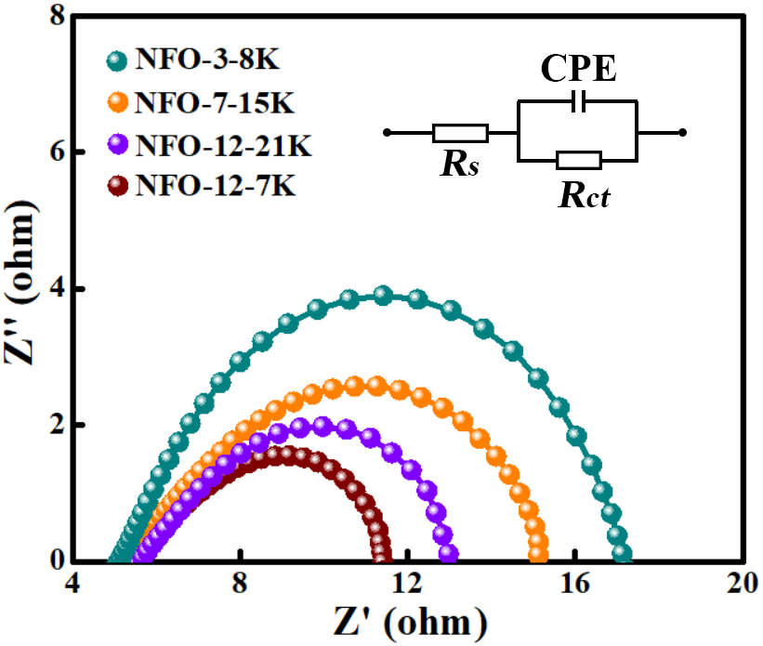
Supplementary Fig. 8 Nyquist plots of PSAN-ligated NFO-3-8K, NFO-7-15K, NFO-12-21K and NFO-12-7K samples. The simple Randles circuit was used, containing a solution resistance (R_{s}), charge transfer resistance (R_{ct}), and a constant-phase element (CPE) related to the double layer capacitance.

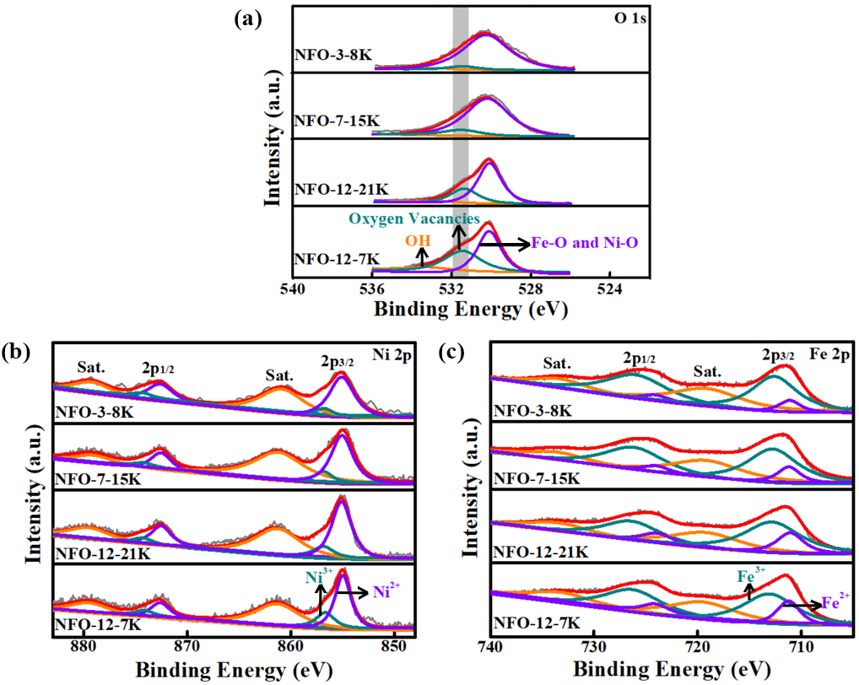
Supplementary Fig. 9 (a) O 1s, (b) Ni 2p and (b) Fe 2p XPS spectra of NFO-3-8K, NFO-7-15K, NFO-12-21K and NFO-12-7K.

Supplementary Fig. 10 Schematic diagrams illustrating the relationship between the PSAN chain length and the exposed active surface area for three representative PSAN-ligated NFO NPs samples (i.e., NFO-3-8K, NFO-12-21K and NFO-12-7K). The white-and-red balls represent OH‒ ions of electrolyte (i.e., KOH solution). A decreasing trend for the OH‒ ions to access the surface of NFO NPs is as follows: NFO-12-7K > NFO-12-21K > NFO-3-8K.

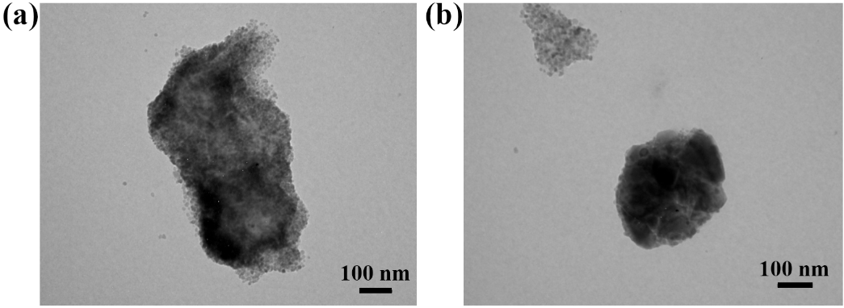
Supplementary Fig. 11 TEM images of (a) NFO NPs templated by star-like PAA only, and (b) NFO NPs formed without the use of any templates.

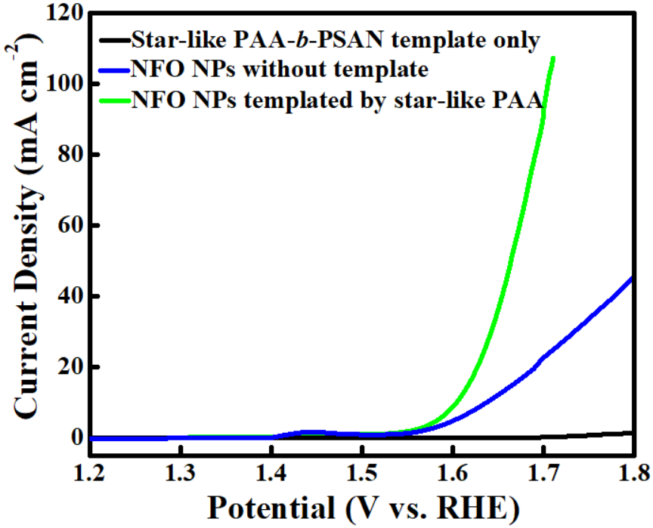
Supplementary Fig. 12 LSV curves of NFO NPs templated by star-like PAA (η₂₀ = 390 mV; blue), NFO NPs synthesized without the use of template (η₂₀ = 440 mV; green) and star-like PAA-b-PSAN template for the OER in 1.0 M KOH.

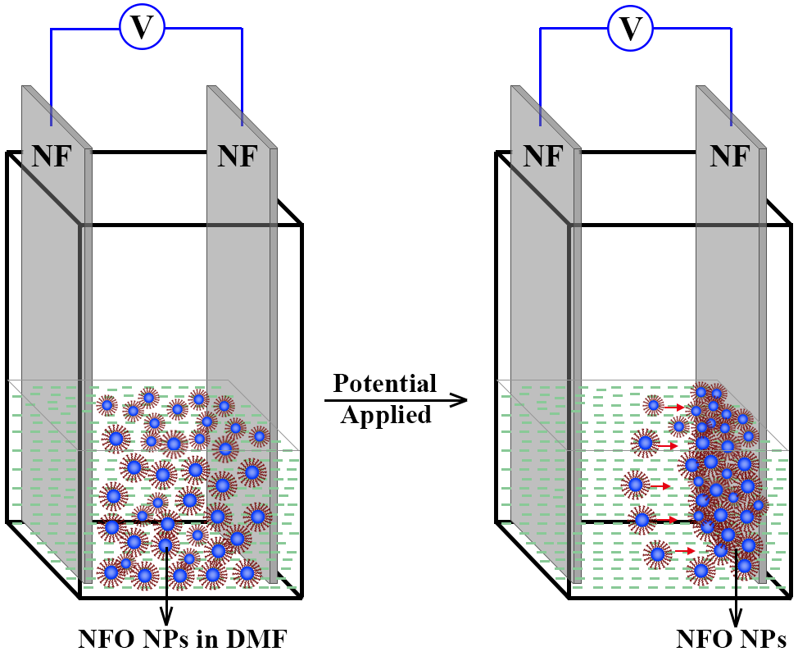
Supplementary Fig. 13 Schematic diagram illustrating the principle of electrophoretic deposition of NFO NPs (NFO-12-7K) from their DMF solution onto a nickel foam (NF). Specifically, 5 mg mL⁻¹ of 5 mL PSAN-ligated NFO NPs DMF solution was transferred into a vial, and two pieces of nickel foams (1.0 cm × 5.0 cm) serving as substrates were inserted in parallel with a fixed gap of ~8 mm and then connected to a DC power supply. With increasing time, the NFO NPs in the solution moved toward the nickel foam and were assembled onto the nickel foam. Then, the as-prepared PSAN-ligated NFO NPs on nickel foam (denoted NFO/NF) were dried at 80 ºC for 2 h.

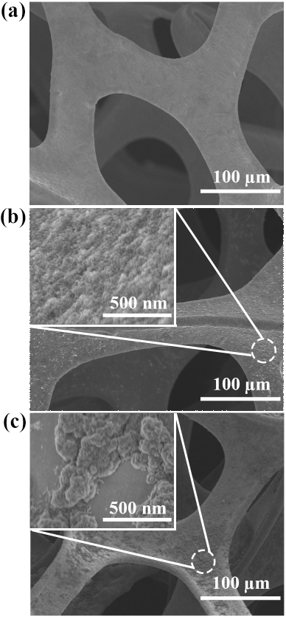
Supplementary Fig. 14 SEM images of (a) bare nickel foam (NF), (b) NFO/NF prepared via electrophoretical deposition, and (c) NFO/NF prepared via direct immersion. The insets are the high-magnification SEM images. For direct immersion method (c), the NF substrate is directly immersed into NFO NPs DMF solution (5 mg mL⁻¹) for 30 min, and then dried at 80 ºC for 2 h.

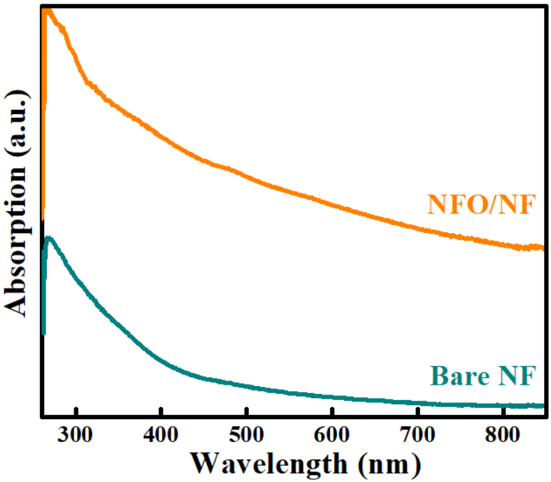
Supplementary Fig. 15 UV–vis absorption spectra of the bare NF and NFO/NF electrodes, respectively.

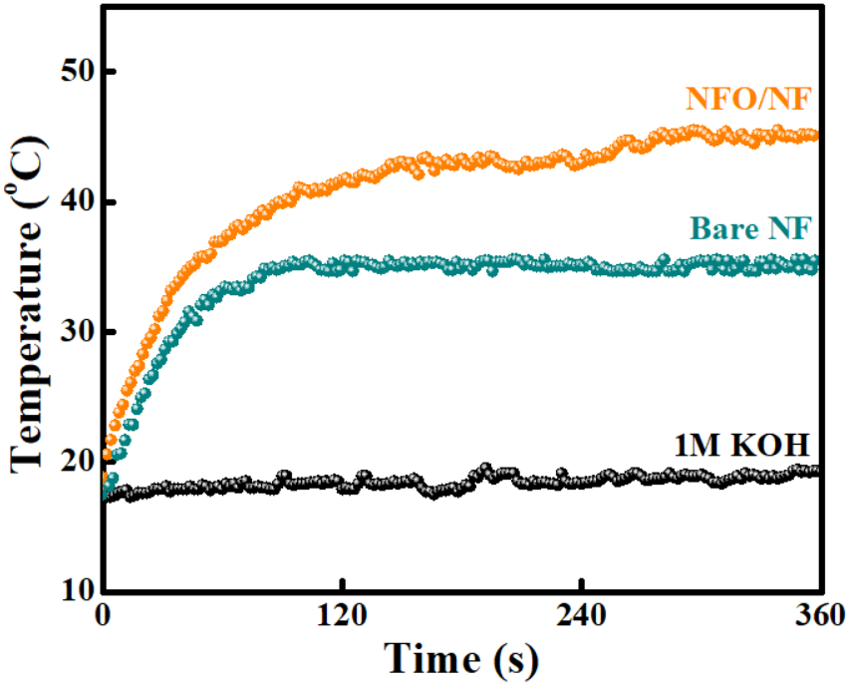
Supplementary Fig. 16 The temperature evolution of 1.0 M KOH electrolyte, bare nickel foam (NF), and NFO/NF over a period of 360 s under exposure to NIR light (808 nm, 2.5 W cm⁻²) measured every 2 s using a digital IR-thermo camera.

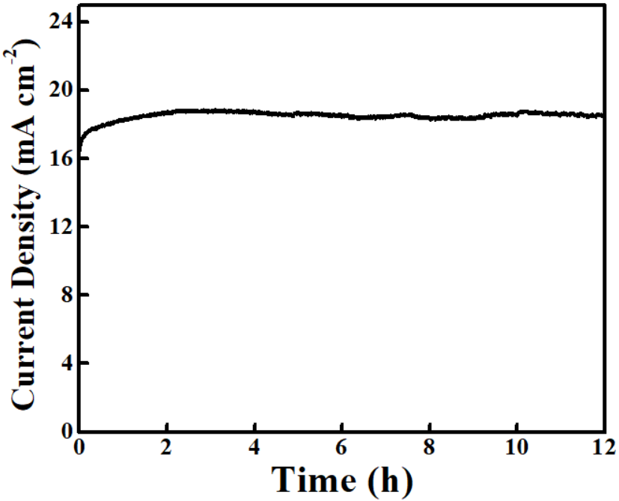
Supplementary Fig. 17 Chronoamperometric responses of NFO/NF at 1.50 V vs. RHE.

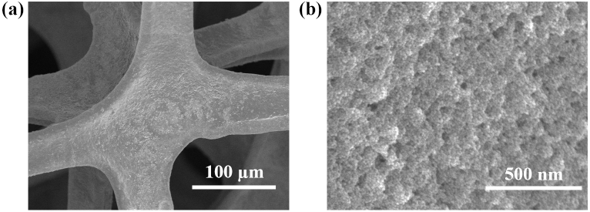
Supplementary Fig. 18 (a-b) SEM images of NFO after a 12-h chronoamperometric stability test.

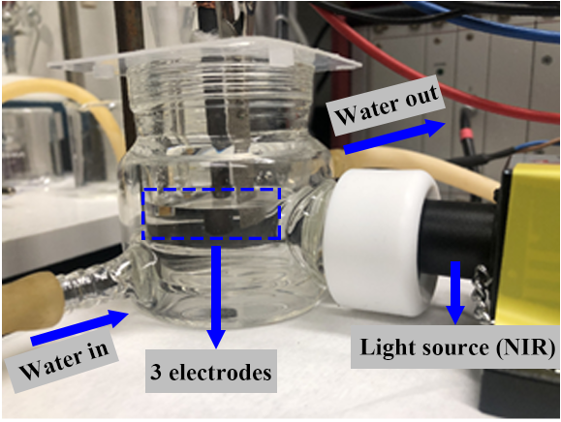
Supplementary Fig. 19 Photograph of the photoelectrochemical cell used for introducing photothermal effect to NFO/NF electrode during the electrocatalytic process. A photoelectrochemical cell with a typical three-electrode system in an O₂-saturated 1.0 M KOH solution is irradiated with an 808 nm NIR light to render investigation into the photothermal-assisted electrocatalysis. The circulating water is used to ensure the temperature of electrolyte to be maintained at room temperature.

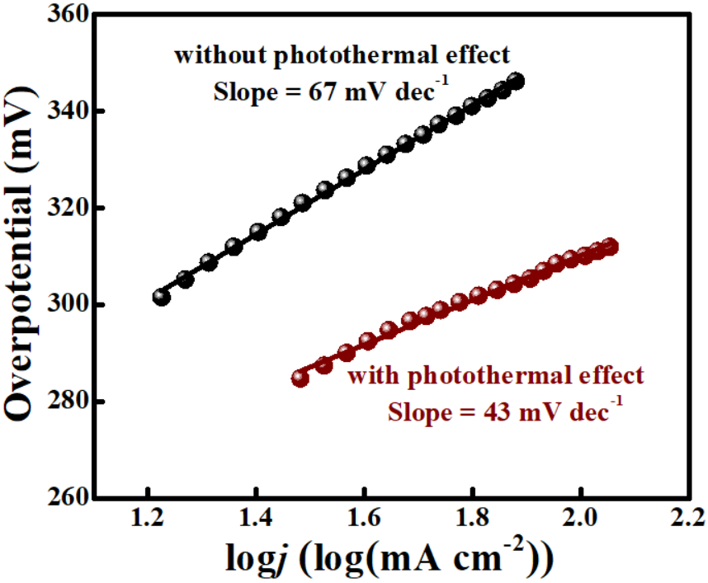
Supplementary Fig. 20 Tafel plots of NFO/NF electrodes in 1.0 M KOH without (at 25 °C; i.e., without NIR light irradiation) and with (at 45 °C; i.e., with NIR light irradiation) photothermal effect.

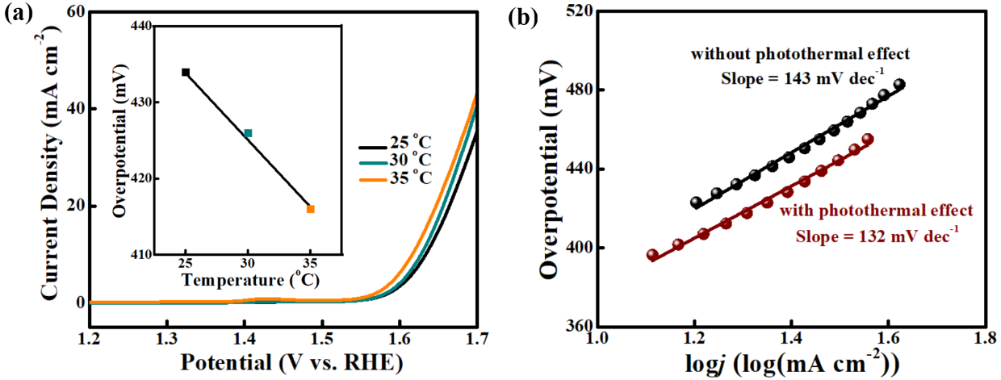
Supplementary Fig. 21 (a) Photothermal electrochemical activities of bare nickel foam (NF) toward OER, measured at different electrode temperatures induced by NIR light. Inset shows the decrease of overpotential at j = 20 mA cm⁻² with the increase of temperature. (b) Tafel plots of NF in 1.0 M KOH without (at 25 °C; i.e., without NIR light irradiation) and with (at 45 °C; i.e., with NIR light irradiation) photothermal effect.

Supplementary Table 2. Summary on the properties of earth-abundant OER catalysts.
Catalyst |  | Electrolyte | Overpotential @20 mA cm⁻² (mV vs.RHE) | Overpotential @50 mA cm⁻² (mV vs.RHE) | Overpotential @100 mA cm⁻² (mV vs.RHE) | Tafel Slope  (mV dec⁻¹) | Ref.
 | NFO/NF without photothermal effect | 1.0 M KOH | 307 | 353 | 370 | 67 | This work
 | NFO/NF with photothermal effect (2.5 W cm⁻² NIR light) | 1.0 M KOH | 272 | 297 | 309 | 43 | This work
 | Ni/Fe₃O₄@N-doped  carbon nanorods/GC | 1.0 M KOH | ≈ 320 | ≈ 345 | ≈ 371 | 61 | [1]
 | Carbon-confined NiCo@NiCoO₂ core@shell nanoparticles | 1.0 M KOH | 366 | ≈ 400 | ≈ 450 | 83.97 | [2]
 | ZnCo₂O₄/N-CNT/GC | 0.1 M KOH | ≈ 480 | -- | -- | 70.6 | [3]
 | Ni_{0.75}V_{0.25}-LDH/GC | 1.0 M KOH | ≈ 340 | ≈ 385 | -- | 50 | [4]
 | CoNi(OH)_{x} nanotubes@Cu foil | 1.0 M KOH | ≈ 290 | ≈ 310 | ≈ 340 | 77 | [5]
 | Co²⁺/NiCoO₂/CP | 1.0 M KOH | ≈ 290 | ≈ 320 | ≈ 360 | 56.9 | [6]
 | Ni(OH)₂-CeO₂@CP | 1.0 M KOH | ≈ 260 | ≈ 320 | ≈ 350 | 81.9 | [7]
 | Ultrathin Co₃O₄ nanomeshes/GC | 1.0 M KOH | ≈ 330 | ≈ 370 | 407 | 76 | [8]
 | Fe-V/NiO@NF | 1.0 M KOH | ≈ 230 | 271.1 | ≈ 340 | 55 | [9]
 | NiCo₂O₄@CP | 1.0 M NaOH | ≈ 400 | ≈ 440 | 463 | 74 | [10]
 | Ni/NiFe₂O₄-CNTs/GC | 1.0 M KOH | ≈ 350 | ≈ 390 | -- | 46.03 | [11]
 | NiFe_{x}/NiFe₂O₄/N-doped graphitic carbon/CP | 1.0 M KOH | ≈ 280 | ≈ 300 | ≈ 340 | 51.4 | [12]
 | V-doped Co₃O₄/GC | 1.0 M KOH | ≈ 320 | ≈ 350 | ≈ 370 | 53.3 | [13]
 | P-Ni_{0.5}Fe@C/GC | 1.0 M KOH | ≈ 270 | ≈ 290 | ≈ 360 | 65 | [14]
 | Ni/NiO@NF without irradiation | 1.0 M KOH | ≈ 340 | ≈ 370 | ≈ 400 | 70 | [15]
 | Ni/NiO@NF with irradiation (300 W Xenon lamp) | 1.0 M KOH | ≈ 290 | ≈ 330 | ≈345 | 41 | [15]
 | Co₃O₄@NF without irradiation | 1.0 M KOH | ≈ 360 | ≈ 430 | ≈ 460 | 111.5 | [16]
 | Co₃O₄@NF with irradiation (5 W cm⁻² NIR laser) | 1.0 M KOH | ≈ 280 | ≈ 325 | ≈ 340 | 74.6 | [16]

Notes: GC is glassy carbon electrode; NF is nickel foam substrate; and CP is carbon paper substrate. The symbol @ refers to the catalyst directly grown on the substrate; the symbol / represents the catalyst dropped on the substrate; and the symbol ≈ means the value estimated from the curve in literature.

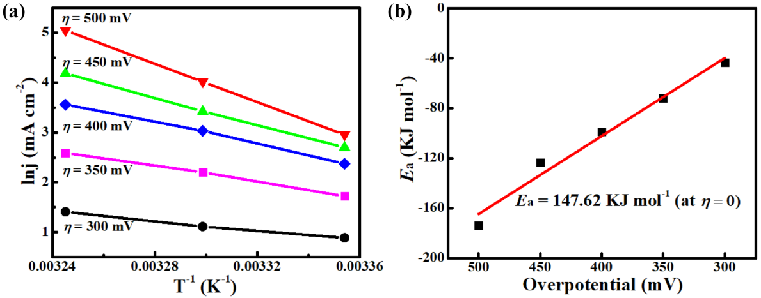
Supplementary Fig. 22 (a) Arrhenius plots for bare NF electrode, depicting semilogarithmic dependence of current densities j on inverse temperatures T at various overpotentials η. Five η are taken from 300 mV to 500 mV at an interval of 50 mV. (b) Activation energy E_{a} at the zero overpotential (η = 0) obtained through extrapolation to η = 0.

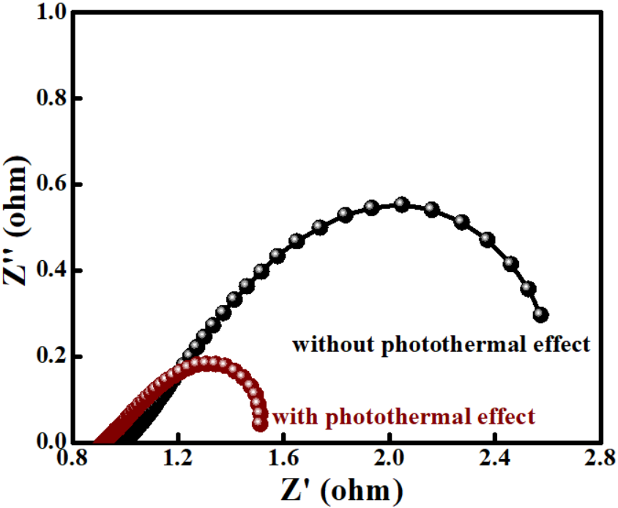
Supplementary Fig. 23 EIS response for the NFO/NF electrodes without (i.e., without NIR light irradiation, thus the temperature remains at 25 ºC) and with (i.e., with NIR light irradiation that raises the temperature to 45 ºC) photothermal effect.

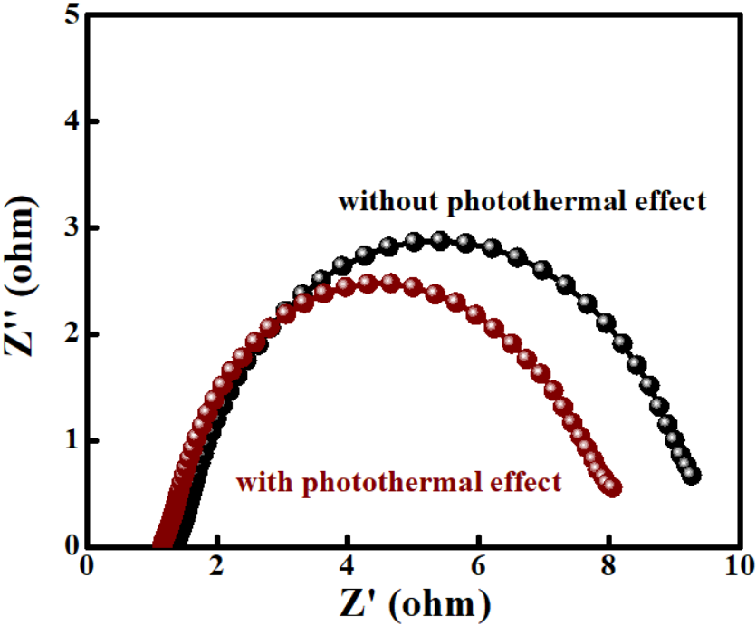
Supplementary Fig. 24 EIS response for bare NF electrodes without (i.e., without NIR light irradiation, thus the temperature remains at 25 ºC) and with (i.e., with NIR light irradiation that raises the temperature to 35 ºC) photothermal effect.

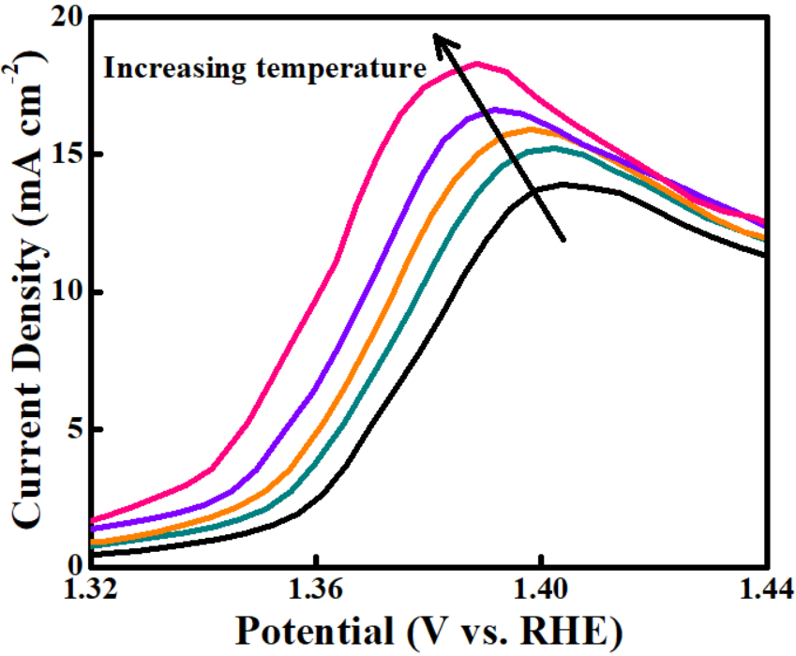
Supplementary Fig. 25 The enlarged Ni oxidation peaks between 1.32 and 1.44 V vs. RHE (from Fig. 4c).

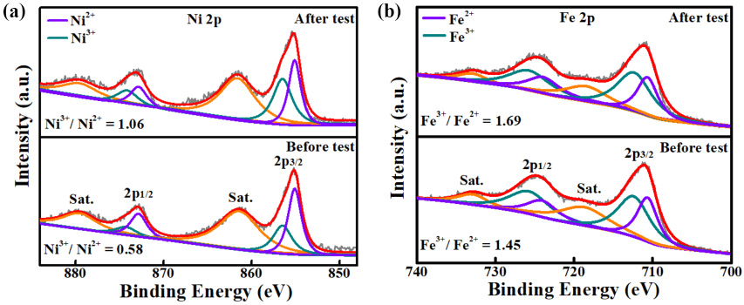
Supplementary Fig. 26 ex-situ XPS spectra for (a) Ni 2p and (b) Fe 2p of NFO/NF before and after photothermal-promoted OER tests.

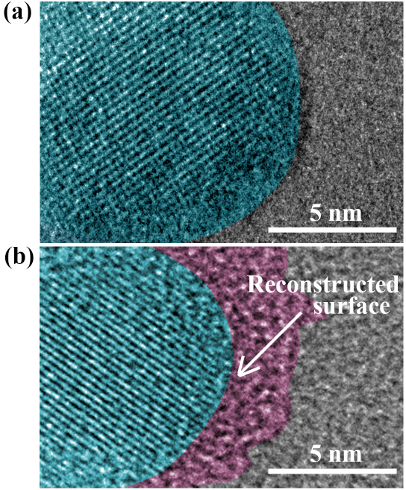
Supplementary Fig. 27 ex-situ HRTEM images showing the surface regions for (a) as-prepared NFO NPs, and (b) NFO NPs after photothermal-promoted OER process and detached from NF for TEM imaging. The green and red regions represent original NFO and reconstructed oxyhydroxides surface (i.e., (Ni,Fe)oxyhydroxides), respectively.

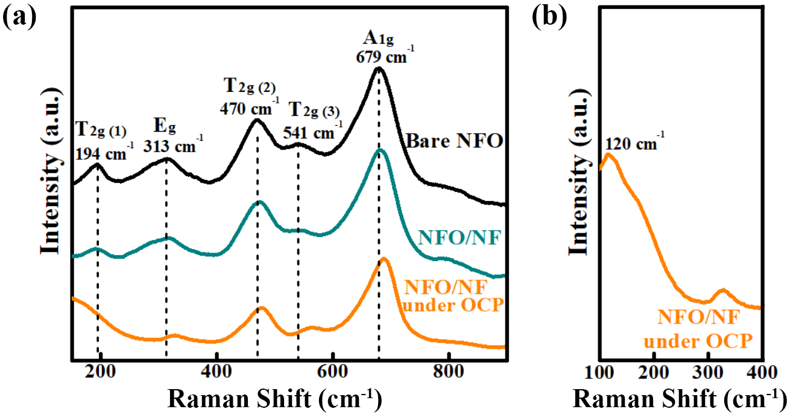
Supplementary Fig. 28 (a) Raman spectra of bare NFO powder, NFO/NF and NFO/NF electrode under open circuit potential (OCP), respectively. (b) Close-up of the Raman shift between 100 and 400 cm⁻¹ for the NFO/NF electrode under OCP.

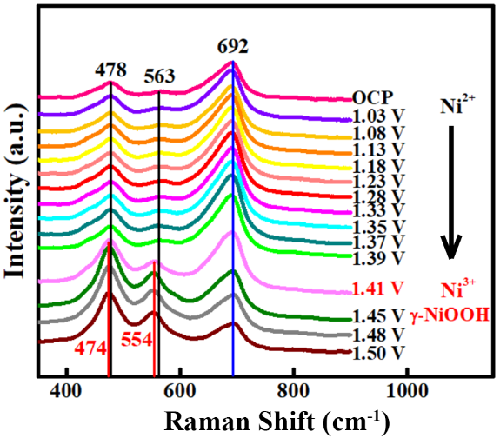
Supplementary Fig. 29 Operando Raman spectra of NFO/NF electrode without invoking photothermal effect (i.e., no exposure to 808-nm NIR light for triggering photothermal heating) from open circuit potential (OCP) to 1.50 V vs. RHE in 1.0 M KOH.

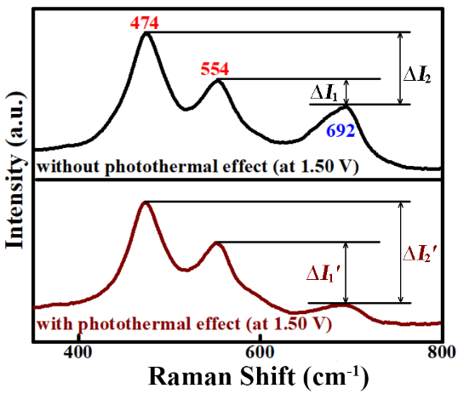
Supplementary Fig. 30 Operando Raman spectra of NFO/NF electrode without (i.e., without 808-nm NIR light irradiation during OER) and with photothermal (i.e., with 808-nm NIR light irradiation during OER) effect at 1.50 V vs. RHE in 1.0 M KOH. ∆I₁ and ∆I₁′ represent the peak intensity difference between 554 cm⁻¹ and 692 cm⁻¹ for the spectra of NFO/NF without and with photothermal effect, respectively. Similarly, ∆I₂ and ∆I₂′ represent the peak intensity difference between 474 cm⁻¹ and 692 cm⁻¹ for the spectra of NFO/NF without and with photothermal effect, respectively. Obviously, much higher ∆I₁′ and ∆I₂′ are seen for NFO/NF with photothermal effect than those without photothermal effect (∆I₁ and ∆I₂).

Supplementary Table 3. Entropies Energy (T = 298.15K) and Zero Point Energy (eV) for gaseous and adsorbed molecules.
 | ZPE (eV) | TS (eV) | ZPEª (eV) | TS^{b} (eV)
H₂(g) | 0.345 | 0.40 | 0.35 | 0.40
O₂(g) | 0.134 | 0.63 | - | 0.63
H₂O(l) | 0.570 | 0.67 | 0.57 | 0.67
O* | 0.061 | - | 0.06 | 0
OH* | 0.369 | - | 0.37 | 0
OOH* | 0.477 | - | 0.44 | 0
Note: ª ZPE values from Ref. [17]. ^{b} TS values from Ref. [18].

Supplementary Table 4. Calculation results of ΔZPE ‒ TΔS (eV) for the corresponding steps.
 | ΔZPE (eV) | TΔS (eV) | ΔZPE ‒ TΔS (eV)
Step Ⅰ | -0.030 | -0.470 | 0.440
Step Ⅱ | -0.135 | 0.215 | -0.350
Step Ⅲ | -0.015 | -0.470 | 0.455
Step Ⅳ | - | - | -
Note: Step Ⅰ to Step Ⅳ represent the proposed 4e OER process in Fig. 5c and Supplementary Fig. 32.

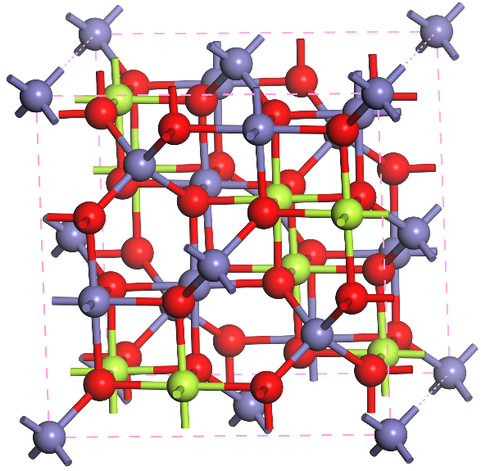
Supplementary Fig. 31 The model crystal structure for inverse spinel NiFe₂O₄, where green ball represents Ni, dark gray ball represents Fe, and red ball represents for O.

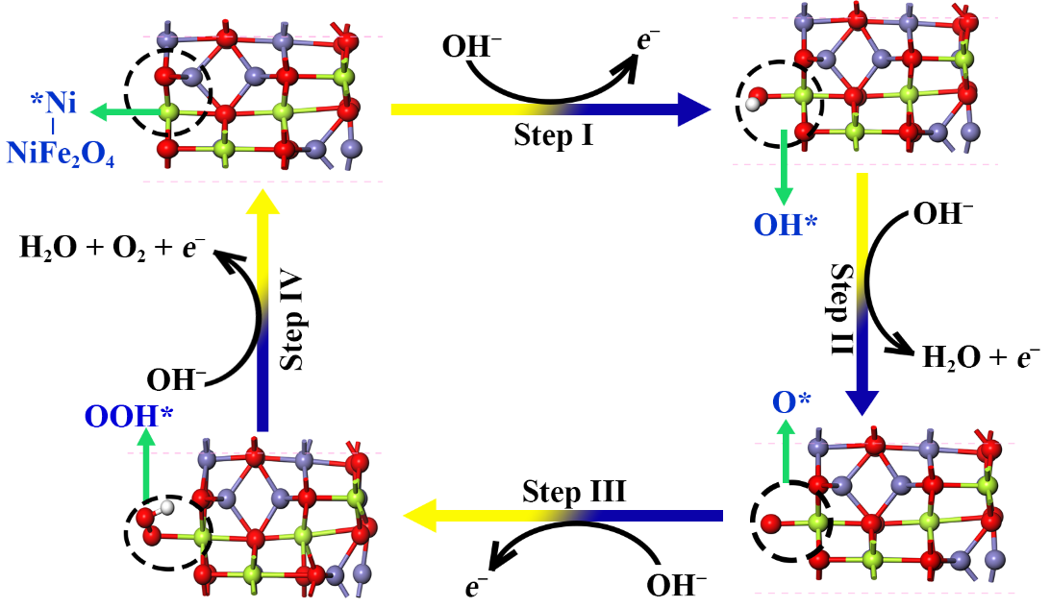
Supplementary Fig. 32 The proposed 4e-mechanism and optimized structures of the intermediates of NiFe₂O₄. The Ni ion (*Ni) in NiFe₂O₄ is active site.

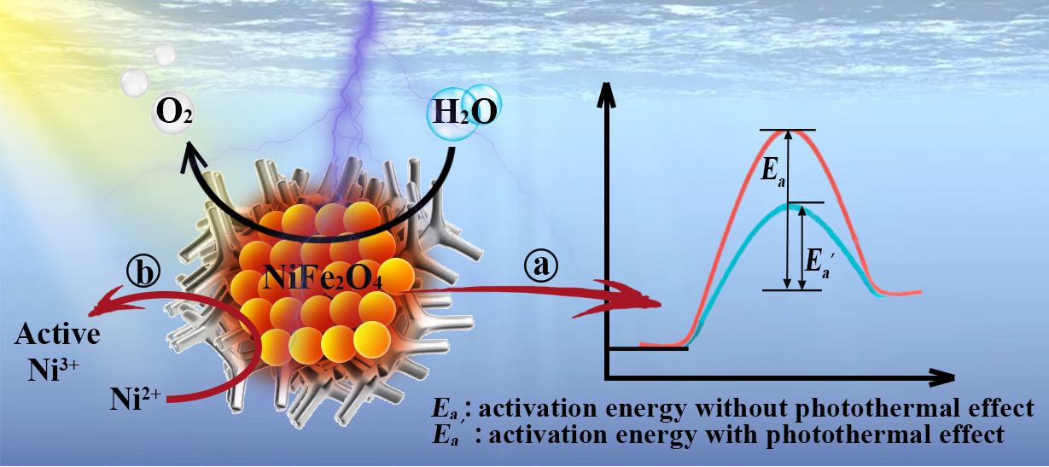
Supplementary Fig. 33 Schematic illustration of proposed photothermal-assisted electrocatalytic OER mechanism of NFO/NF electrode under 808-nm NIR irradiation with (a) reduced activation energy and (b) promoted surface reconstruction. The silver substrate under NFO NPs represents NF. The orange balls correspond to NFO NPs that are capable of conducting photo-to-thermal conversion and thus in-situ generating heat. (a) In the case of photothermal-promoted OER system, localized heat due to NFO NPs under NIR irradiation would lower the activation energy of water splitting. (b) With photothermal effect, it significantly facilitates the surface reconstruction from inactive Ni²⁺ to active Ni³⁺, thus enabling OER reactivity.

Supplementary Note 1: Optimization of the electrocatalyst ink preparation
In contrast to PSAN-ligated NFO-12-7K NPs washed by ethanol yet without subsequent drying for preparing the electrocatalyst ink with carbon black, for PSAN-ligated NFO-12-7K NPs washed by ethanol and then dried, they were redispersed in DMF with sonication for 30 min, then mixed with carbon black to prepare the electrocatalyst ink. More NPs were found to reside outside carbon black substrate (marked with a white dashed circle; Supplementary Fig. 5c). Thus, the contact resistant between NPs electrocatalyst and carbon black is larger, resulting in a decreased OER performance as represented by a larger overpotential η₂₀ of 420 mV at the current density of 20 mA cm⁻² (Supplementary Fig. 6) for NFO-12-7K with the subsequent drying process prior to dissolution in DMF and mixing with carbon black (Supplementary Fig. 5c). Contrastively, a η₂₀ of 329 mV (Supplementary Fig. 6) was found for NFO-12-7K without subsequent drying (Supplementary Fig. 5b).
Supplementary Note 2: X-ray photoelectron spectroscopy (XPS) studies
The chemical compositions and intrinsic deficiencies are studied by X-ray photoelectron spectroscopy (XPS). The presence of intrinsic oxygen vacancies can be introduced by altering the synthesis conditions, particularly at low temperature and oxygen-deficient environment.[19] Therefore, in the present study, the oxygen vacancies were introduced to as-prepared PSAN-ligated NFO NPs due to low temperature (250 ºC) and oxygen-deficient environment (N₂) used for the growth of NFO NPs. Interestingly, the number of oxygen vacancies can be augmented via adjusting the size and shape of nanomaterials, such as nanosheets and nanoparticles.^{[20, 21]} For the O 1s, three peaks can be clearly distinguished (Supplementary Fig. 9a). Specifically, the peak at 530.1 eV is associated with the chemical bonding between oxygen atoms and metal atoms (i.e., Fe-O and Ni-O). The peak with a binding energy of 533.5 eV is due to the surface-adsorbed hydroxyl groups of H₂O molecules. The peak at 531.5 eV can be assigned to the defect sites (i.e., oxygen vacancies),^{[22]} further signifying the existence of oxygen vacancies in as-synthesized PSAN-ligated NFO NPs. Notably, the relative peak intensity of oxygen vacancies (531.5 eV) to that of metal-O (530.1 eV) in the O 1s region exhibited a significant increase from NFO-3-8K to NFO-12-7K, indicating that PSAN-ligated NFO NPs with the largest NP size (12 nm) and the shortest surface PSAN chains (MW = 7K) (i.e., NFO-12-7K) possessed more oxygen vacancies.
The XPS peaks in the Ni 2p, Fe 2p and O 1s regions of NFO-3-8K, NFO-7-15K, NFO-12-21K, and NFO-12-7K (Supplementary Fig. 9a-c) showed identical binding energies, revealing the same chemical composition for these samples, in good agreement with the XRD and HRTEM results. In the Ni 2p spectra (Supplementary Fig. 9a), the peaks at 855.7 eV and 857.4 eV can be assigned to Ni²⁺ and Ni³⁺, respectively.^{[1]} The peaks at 710.3 and 711.8 eV in Fe 2p region are ascribed to Fe²⁺ and Fe³⁺, respectively (Supplementary Fig. 9b).^{[1]} Therefore, the analysis of EIS results (Supplementary Fig. 8) was consistent with the XPS results, that is, NFO-12-7K with the richest oxygen vacancies, achieved the fastest electron transfer (smallest R_{ct}).
Supplementary Note 3: OER performances of the control samples
Importantly, the use of star-like PAA-b-PASN diblock copolymers renders the templated synthesis of NFO NPs of desired sizes without aggregation. By contrast, NFO NPs templated by star-like PAA homopolymers and NFO NPs synthesized without the use of any templates show severe aggregations (Supplementary Fig. 11a and 11b, respectively) and thus poor dispersion in solvent. Accordingly, it is not surprising that these two types of NFO NPs present poor OER activity with overpotential (η₂₀) of 390 mV and 440 mV at a current density of 20 mA cm⁻², respectively (Supplementary Fig. 12) because of the aggregation of NPs. Moreover, the LSV curve of star-like PAA-b-PSAN templates only is also shown in Supplementary Fig. 12, signifying negligible effects of polymers (either PSAN or PAA) on OER performance.
Supplementary Note 4: Optimization of the NFO/NF electrode preparation
Significantly, compared with electrophoretical deposition (Supplementary Fig.14b), there are still partial NF surfaces exposed after NFO NPs deposition by direct immersion method, as clearly evident in the inset (Supplementary Fig. 14c). The electrophoretically-deposited NFO NPs show a uniform NP layer that fully covers the NF surface (inset; Supplementary Fig. 14b).
Supplementary Note 5: Optimized Structures of (Ni,Fe)OOH and NiFe₂O₄
(Ni,Fe)OOH. cif:
_cell_length_a 9.7788
_cell_length_b 5.6303
_cell_length_c 7.3815
_cell_angle_alpha 101.2150
_cell_angle_beta 82.8245
_cell_angle_gamma 90.4536
H1 O17 0.990 . S
H2 O17 0.985 . S
H3 O18 0.984 . S
H4 O18 0.981 . S
H5 O19 0.991 . S
H6 O19 0.985 . S
H7 O20 0.980 . S
H8 O20 0.982 . S
Ni1 O15 2.039 . S
Ni1 O6 1.916 . S
Ni1 O13 1.882 . S
Ni1 O11 1.879 1_655 S
Ni1 O8 2.044 1_655 S
Ni1 O14 1.913 1_655 S
Ni2 O6 1.881 . S
Ni2 O9 1.898 . S
Ni2 O11 1.887 1_655 S
Ni2 O14 1.881 1_665 S
Ni2 O13 1.888 1_565 S
Ni2 O4 1.895 1_665 S
Ni3 O2 1.896 . S
Ni3 O3 1.870 . S
Ni3 O10 1.884 . S
Ni3 O16 1.868 1_565 S
Ni3 O12 1.879 1_565 S
Ni3 O5 1.891 1_565 S
Ni4 O10 1.891 . S
Ni4 O6 1.871 . S
Ni4 O1 1.879 . S
Ni4 O9 1.893 . S
Ni4 O15 1.865 . S
Ni4 O5 1.903 1_565 S
Ni5 O8 1.861 . S
Ni5 O11 1.891 . S
Ni5 O2 1.898 . S
Ni5 O3 1.850 . S
Ni5 O7 1.870 . S
Ni5 O4 1.895 1_565 S
Ni6 O7 1.927 . S
Ni6 O12 1.864 . S
Ni6 O10 1.872 . S
Ni6 O3 2.035 . S
Ni6 O1 1.930 . S
Ni6 O16 2.044 . S
Ni7 O4 1.900 . S
Ni7 O8 1.858 . S
Ni7 O14 1.870 . S
Ni7 O7 1.877 . S
Ni7 O12 1.890 . S
Ni7 O2 1.899 1_545 S
Ni8 O1 1.871 . S
Ni8 O5 1.897 . S
Ni8 O16 1.858 . S
Ni8 O13 1.898 . S
Ni8 O15 1.869 . S
Ni8 O9 1.890 1_545 S
O2 Ni7 1.899 1_565 S
O4 Ni5 1.895 1_545 S
O4 Ni2 1.895 1_445 S
O5 Ni4 1.903 1_545 S
O5 Ni3 1.891 1_545 S
O8 Ni1 2.044 1_455 S
O9 Ni8 1.890 1_565 S
O11 Ni2 1.887 1_455 S
O11 Ni1 1.879 1_455 S
O12 Ni3 1.879 1_545 S
O13 Ni2 1.888 1_545 S
O14 Ni1 1.913 1_455 S
O14 Ni2 1.881 1_445 S
O16 Ni3 1.868 1_545 S
NiFe₂O₄. cif:
_cell_length_a 8.3965
_cell_length_b 8.3965
_cell_length_c 8.3965
_cell_angle_alpha 90.0000
_cell_angle_beta 90.0000
_cell_angle_gamma 90.0000
Fe1 O25 1.889 . S
Fe1 O33 1.889 . S
Fe1 O31 1.889 . S
Fe1 O36 1.889 . S
Fe2 O29 1.889 . S
Fe2 O56 1.889 . S
Fe2 O27 1.889 . S
Fe2 O55 1.889 . S
Fe3 O32 1.889 . S
Fe3 O26 1.889 . S
Fe3 O35 1.889 . S
Fe3 O53 1.889 . S
Fe4 O34 1.889 . S
Fe4 O30 1.889 . S
Fe4 O54 1.889 . S
Fe4 O28 1.889 . S
Fe5 O37 1.889 . S
Fe5 O50 1.889 . S
Fe5 O40 1.889 1_455 S
Fe5 O52 1.889 1_455 S
Fe6 O39 1.889 1_444 S
Fe6 O47 1.889 1_455 S
Fe6 O38 1.889 1_554 S
Fe6 O45 1.889 1_545 S
Fe7 O43 1.889 . S
Fe7 O49 1.889 1_554 S
Fe7 O51 1.889 . S
Fe7 O42 1.889 1_554 S
Fe8 O46 1.889 . S
Fe8 O41 1.889 1_545 S
Fe8 O44 1.889 1_545 S
Fe8 O48 1.889 . S
Fe9 O35 2.059 . S
Fe9 O55 2.059 . S
Fe9 O30 2.059 . S
Fe9 O44 2.059 . S
Fe9 O52 2.059 . S
Fe9 O49 2.059 . S
Ni10 O36 2.059 . S
Ni10 O54 2.059 1_545 S
Ni10 O29 2.059 1_554 S
Ni10 O43 2.059 . S
Ni10 O47 2.059 . S
Ni10 O48 2.059 . S
Ni11 O34 2.059 1_455 S
Ni11 O33 2.059 . S
Ni11 O53 2.059 1_554 S
Ni11 O45 2.059 . S
Ni11 O51 2.059 . S
Ni11 O37 2.059 . S
Ni12 O56 2.059 1_455 S
Ni12 O32 2.059 1_545 S
Ni12 O31 2.059 . S
Ni12 O50 2.059 . S
Ni12 O46 2.059 . S
Ni12 O38 2.059 . S
Ni13 O54 2.059 . S
Ni13 O36 2.059 1_565 S
Ni13 O26 2.059 1_554 S
Ni13 O51 2.059 . S
Ni13 O45 2.059 . S
Ni13 O41 2.059 . S
Ni14 O55 2.059 . S
Ni14 O35 2.059 . S
Ni14 O25 2.059 . S
Ni14 O46 2.059 . S
Ni14 O50 2.059 . S
Ni14 O42 2.059 . S
Fe15 O31 2.059 1_655 S
Fe15 O28 2.059 1_545 S
Fe15 O56 2.059 . S
Fe15 O40 2.059 . S
Fe15 O48 2.059 . S
Fe15 O47 2.059 . S
Fe16 O53 2.059 1_655 S
Fe16 O27 2.059 . S
Fe16 O34 2.059 1_556 S
Fe16 O39 2.059 . S
Fe16 O49 2.059 . S
Fe16 O52 2.059 . S
Fe17 O27 2.059 1_455 S
Fe17 O53 2.059 . S
Fe17 O33 2.059 1_556 S
Fe17 O38 2.059 . S
Fe17 O42 2.059 . S
Fe17 O50 2.059 . S
Ni18 O25 2.059 . S
Ni18 O30 2.059 . S
Ni18 O55 2.059 . S
Ni18 O48 2.059 . S
Ni18 O40 2.059 . S
Ni18 O43 2.059 . S
Fe19 O37 2.059 . S
Fe19 O41 2.059 . S
Fe19 O51 2.059 . S
Fe19 O25 2.059 . S
Fe19 O30 2.059 . S
Fe19 O35 2.059 . S
Fe20 O43 2.059 . S
Fe20 O47 2.059 . S
Fe20 O40 2.059 . S
Fe20 O34 2.059 . S
Fe20 O33 2.059 1_655 S
Fe20 O27 2.059 1_554 S
Ni21 O44 2.059 . S
Ni21 O52 2.059 . S
Ni21 O39 2.059 . S
Ni21 O56 2.059 1_565 S
Ni21 O32 2.059 1_655 S
Ni21 O28 2.059 . S
Fe22 O38 2.059 . S
Fe22 O42 2.059 . S
Fe22 O46 2.059 . S
Fe22 O26 2.059 1_545 S
Fe22 O29 2.059 . S
Fe22 O36 2.059 1_556 S
Fe23 O41 2.059 . S
Fe23 O37 2.059 . S
Fe23 O45 2.059 . S
Fe23 O31 2.059 1_565 S
Fe23 O28 2.059 1_455 S
Fe23 O32 2.059 . S
Ni24 O39 2.059 . S
Ni24 O49 2.059 . S
Ni24 O44 2.059 . S
Ni24 O29 2.059 1_565 S
Ni24 O26 2.059 . S
Ni24 O54 2.059 1_556 S
O26 Fe22 2.059 1_565 S
O26 Ni13 2.059 1_556 S
O27 Fe20 2.059 1_556 S
O27 Fe17 2.059 1_655 S
O28 Fe15 2.059 1_565 S
O28 Fe23 2.059 1_655 S
O29 Ni24 2.059 1_545 S
O29 Ni10 2.059 1_556 S
O31 Fe15 2.059 1_455 S
O31 Fe23 2.059 1_545 S
O32 Ni12 2.059 1_565 S
O32 Ni21 2.059 1_455 S
O33 Fe17 2.059 1_554 S
O33 Fe20 2.059 1_455 S
O34 Fe16 2.059 1_554 S
O34 Ni11 2.059 1_655 S
O36 Fe22 2.059 1_554 S
O36 Ni13 2.059 1_545 S
O38 Fe6 1.889 1_556 S
O39 Fe6 1.889 1_666 S
O40 Fe5 1.889 1_655 S
O41 Fe8 1.889 1_565 S
O42 Fe7 1.889 1_556 S
O44 Fe8 1.889 1_565 S
O45 Fe6 1.889 1_565 S
O47 Fe6 1.889 1_655 S
O49 Fe7 1.889 1_556 S
O52 Fe5 1.889 1_655 S
O53 Fe16 2.059 1_455 S
O53 Ni11 2.059 1_556 S
O54 Ni24 2.059 1_554 S
O54 Ni10 2.059 1_565 S
O56 Ni12 2.059 1_655 S
O56 Ni21 2.059 1_545 S

Supplementary Experimental Section
Materials. β-cyclodextrin (β-CD, Sigma-Aldrich) was dried at 80 °C under vacuum overnight prior to use. 2-Bromoisobutyryl bromide (98%), N,N,Nʹ,Nʹʹ,Nʹʹ-pentamethyldiethylene triamine (PMDETA, 99%), anhydrous 1-methyl-2-pyrrolidinone (NMP, 99.5%), triﬂuoroacetic acid (TFA, 99.9%), nickel acetate tetrahydrate (Ni(CH₃COO)₂·4H₂O, Ni(OAc)₂, 98.0%), iron(III) acetylacetonate (Fe(C₅H₇O₂)₃, Fe(AcAc)₃, ≥ 99.0%), diphenyl ether (DPE, 99%), and butyl acrylate (BA, ≥99.0%) were purchased from Sigma-Aldrich, and used as received. CuBr (98%, Sigma-Aldrich) was stirred in acetic acid overnight, washed with ethanol and diethyl ether, respectively, and dried under vacuum. tBA (Sigma-Aldrich, 98.0%), acrylonitrile (AN, Aldrich, 99.0%), methyl ethyl ketone (MEK, Fisher Scientific, 99.9%) and N, N-dimethylformamide (DMF, Fisher Scientific, 99.9%) were dried over calcium hydride (CaH₂) and distilled under reduced pressure prior to use. Styrene (St, Sigma-Aldrich, ≥99%) was washed with 10% NaOH aqueous solution and water successively, dried over anhydrous MgSO₄ and CaH₂ sequentially, and distilled under reduced pressure. All other reagents were purified by common purification procedures.
Synthesis of Multi-arm Star-Like Poly(tert-Butyl Acrylate) (PtBA) Terminated with Bromine End Groups (i.e., Star-like PtBA-Br). Heptakis[2,3,6-tri-O-(2-bromo-2-methylpropionyl)]-β-cyclodextrin (denoted 21Br-β-CD) was prepared according to previous work.^{[23, 24]} Star-like PtBA was synthesized by atom transfer radical polymerization (ATRP) of tBA monomers (i.e., the first ATRP) in MEK using 21Br-β-CD as the macroinitiator. The polymerization of tBA monomers was carried out in an ampoule. In a typical process, an ampoule was loaded with CuBr, PMDETA, 21Br-β-CD, tBA, and methyl ethyl ketone (as solvent) (the molar ratio of tBA: Br of 21Br-β-CD macroinitiator: copper bromide: PMDETA = 800: 1: 1: 2; the volume ratio of monomer: solvent = 1:1), and was then degassed by three freeze-pump-thaw cycles in liquid nitrogen. The ampoule was sealed and dipped in an oil bath at 60 °C. After a certain desired polymerization time, the reaction was stopped by dipping the ampoule in liquid N₂. The mixture was then diluted with THF, passed through a column of neutral alumina to remove the catalyst, and subsequently purified by fractional precipitation with methanol/water (v/v = 1/1) as the precipitator. The product was dried at 40 °C under vacuum for 2 d.
Synthesis of Multi-arm Star-Like Poly(tert-Butyl Acrylate)-block-Poly(Styrene-co-Acrylonitrile) (PtBA-b-PSAN) Diblock Copolymer. Star-like PtBA-b-PSAN was synthesized via ATRP of styrene-co-acrylonitrile copolymer (i.e., the second ATRP) using star-like PtBA as macroinitiator. In a typical process, star-like PtBA (1.0 g), CuBr (20.0 mg), PMDETA (50.0 µL), St (24.0 mL), and AN (6.0 mL) were mixed in an argon purged ampoule and degassed by three freeze-pump-thaw cycles. The polymerization was performed at 90 °C and quenched by dipping the ampoule in liquid N₂ after a certain desired time. The crude product was diluted with THF and passed through a neutral alumina column to remove the catalyst and purified by fractional precipitation with methanol/water (v/v = 1/1) as the precipitator. The product, multi-arm, star-like PtBA-b-PSAN was dried at 40 °C under vacuum for 2 d.
Synthesis of Multi-arm Star-Like Poly(Acrylic Acid)-block-Poly(Styrene-co-Acrylonitrile) (PAA-b-PSAN) Diblock Copolymers. Star-like PAA-b-PSAN diblock copolymer via the hydrolysis of the tert-butyl ester groups of PtBA blocks in star-like PtBA-b-PSAN. Brieﬂy, star-like PtBA-b-PSAN was dissolved in CH₂Cl₂, followed by the addition of a 10-fold molar excess of TFA with respect to the amount of t-butyl groups in PtBA blocks. The reaction mixture was stirred at room temperature for 24 h. After hydrolysis, the resulting star-like PAA-b-PSAN diblock copolymer was gradually precipitated in CH₂Cl₂. The final product was washed with CH₂Cl₂, and thoroughly dried under vacuum at 40 °C.
Synthesis of PSAN-ligated NiFe₂O₄ Nanoparticles (PSAN-ligated NFO NPs). By capitalizing on star-like PAA-b-PSAN diblock copolymers as nanoreactors, PSAN-ligated NFO NPs were synthesized. In a typical procedure, star-like PAA-b-PSAN (10 mg) was dissolved in 0.2 mL DMF at room temperature, followed by the addition of 9 mL DPE. An appropriate amount of precursors (Ni(OAc)₂ and Fe(AcAc)₃) were added, where the molar ratio of acrylic acid (AA) units in PAA blocks to precursors was set at 1:10 in order to maximize the loading of precursors into the compartment containing PAA blocks. The mixture was stirred under N₂ at 80 ºC for 12 h to ensure that all precursors were well dissolved in DMF and the PAA blocks-containing compartment was fully loaded by precursors. Subsequently, 1 mL BA was added into the reaction system to swell the inner PAA chains as it is a good solvent for PAA yet poor solvent for PSAN. The reaction was then carried out at 250 ºC. After reaction for 4 h, the resulting PSAN-ligated NFO NPs were collected by centrifugation and washed with ethanol several times to remove unreacted precursors and mixed solvent. For comparison, NFO NPs templated by star-like PAA homopolymers as well as NFO NPs without the use of any templates were also synthesized by a similar procedure and used as control samples.
Electrochemical Measurements. The OER activities of catalysts were measured in a three-electrode glass cell filled in 1.0 M KOH electrolyte on a Zennium PP211 electrochemical workstation using an Ag/AgCl electrode as the reference electrode, a carbon rod as the counter electrode, and the glassy carbon (GC, area, 0.19625 cm²) loaded with catalysts as the working electrode. The catalyst ink was prepared by dispersing 1 mL of the 5 mg mL⁻¹ PSAN-ligated NFO NPs in DMF, 2 mg of carbon black and 80 µL Nafion solution (5 wt%) by sonication for 40 min to form a homogenous ink. Next, 20 µL of the ink was loaded onto GC working electrode. The ink was dried slowly in air until a uniform catalyst covered on the working electrode surface was formed.
The polarization curves were recorded at a scan rate of 10 mV s⁻¹. All of the potentials in the LSV polarization curves were 95% iR-corrected with respect to the ohmic resistance of the solution, unless otherwise specified. The electrochemical impedance spectroscopy (EIS) tests were also performed at overpotential with a frequency loop from 100 mHz to 100 kHz by applying a sine wave with an amplitude of 5 mV. The measured impedance data were fitted to a simplified Randles circuit to extract the series and charge transfer resistances. The electrochemical active surface area (ECSA) of the electrocatalysts were estimated from the double-layer capacitance (C_{dl}), and cyclic voltammetry (CV) method was then employed to evaluate C_{dl}. Accordingly, a series of CV measurements were performed at various scan rates (20 mV s⁻¹, 30 mV s⁻¹, 40 mV s⁻¹, 50 mV s⁻¹, and 60 mV s⁻¹) from 1.07 to 1.17 V vs. RHE range. The capacitance of each catalyst was estimated by C_{dl} = dq / dE = dj / dv. All the measured potentials were referred to RHE with the following equation:
E(RHE) = E(Ag/AgCl) + 0.197 V + 0.0592 × pH

Supplementary references
1. Liu, G., et al. Encapsulation of Ni/Fe₃O₄ heterostructures inside onion-like N-doped carbon nanorods enables synergistic electrocatalysis for water oxidation. Nanoscale 10, 3997-4003 (2018).
2. Xu, H., et al. Porous microrod arrays constructed by carbon‐confined NiCo@NiCoO₂ core@shell nanoparticles as efficient electrocatalysts for oxygen evolution. Adv. Mater. 30, 1705442 (2018).
3. Liu, Z. Q., et al. ZnCo₂O₄ quantum dots anchored on nitrogen‐doped carbon nanotubes as reversible oxygen reduction/evolution electrocatalysts. Adv. Mater. 28, 3777-3784 (2016).
4. Fan, K., et al. Nickel–vanadium monolayer double hydroxide for efficient electrochemical water oxidation. Nat. Commun. 7, 1-9 (2016).
5. Li, S., et al. Co–Ni‐based nanotubes/nanosheets as efficient water splitting electrocatalysts. Adv. Energy Mater. 6, 1501661 (2016).
6. Jin, Y. Z., et al. Tuning spin state of rock‐salt‐based oxides by manipulation of crystallinity for efficient oxygen electrocatalysis. Adv. Energy Mater. 8, 1703469 (2018).
7. Zhao, D., et al. Enhancing oxygen evolution electrocatalysis via the intimate hydroxide–oxide interface. ACS Nano 12, 6245-6251 (2018).
8. Li, Y., et al. Ultrathin Co₃O₄ nanomeshes for the oxygen evolution reaction. ACS Catal. 8, 1913-1920 (2018).
9. Zhu, Y. X., et al. An Fe–V@ NiO heterostructure electrocatalyst towards the oxygen evolution reaction. Nanoscale 12, 3803-3811 (2020).
10. Li, J., et al. Boosted oxygen evolution reactivity by igniting double exchange interaction in spinel oxides. J. Am. Chem. Soc. 142, 50-54 (2019).
11. Yu, X., et al. Hierarchical coupling effect in hollow Ni/NiFe₂O₄-CNTs microsphere via spray-drying for enhanced oxygen evolution electrocatalysis. Nano Res. 13, 437-446 (2020).
12. Zhao, J., et al. Metal–organic-framework-derived porous 3D heterogeneous NiFe_{x}/NiFe₂O₄@NC nanoflowers as highly stable and efficient electrocatalysts for the oxygen-evolution reaction. J. Mater. Chem. A 7, 21338-21348 (2019).
13. Wei, R., et al. Engineering surface structure of spinel oxides via high-valent vanadium doping for remarkably enhanced electrocatalytic oxygen evolution reaction. ACS Appl. Mater. Inter. 11, 33012-33021 (2019).
14. Fan, A., et al. Phosphorus-doped FeNi alloys/NiFe₂O₄ imbedded in carbon network hollow bipyramid as efficient electrocatalysts for oxygen evolution reaction. ACS Sustain. Chem. Eng. 7, 2285-2295 (2018).
15. Han, X., et al. Photogenerated carriers boost water splitting activity over transition-metal/semiconducting metal oxide bifunctional electrocatalysts. ACS Catal. 7, 6464-6470 (2017).
16. Jin, B., et al. Promoting oxygen evolution reaction of Co‐based catalysts (Co₃O₄, CoS, CoP, and CoN) through photothermal effect. Small 15, 1903847 (2019).
17. Bajdich, M., et al. Theoretical investigation of the activity of cobalt oxides for the electrochemical oxidation of water. J. Am. Chem. Soc. 135, 13521-13530 (2013).
18. Liao, P., et al. Water oxidation on pure and doped hematite (0001) surfaces: Prediction of Co and Ni as effective dopants for electrocatalysis. J. Am. Chem. Soc. 134, 13296-13309 (2012).
19. Zhao, Q., et al. Spinels: controlled preparation, oxygen reduction/evolution reaction application, and beyond. Chem. Rev. 117, 10121-10211 (2017).
20. Cheng, F., et al. Enhancing electrocatalytic oxygen reduction on MnO₂ with vacancies. Angew. Chem. Int. Edit. 125, 2534-2537 (2013).
21. Yang, H., et al. Lateral-size-mediated efficient oxygen evolution reaction: insights into the atomically thin quantum dot structure of NiFe₂O₄. ACS Catal. 2017. 7(8): p. 5557-5567 (2017).
22. Trotochaud, L., et al. Solution-cast metal oxide thin film electrocatalysts for oxygen evolution. J. Am. Chem. Soc. 134, 17253-17261 (2012).
23. Cui, X., et al., Tailoring carrier dynamics in perovskite solar cells via precise dimension and architecture control and interfacial positioning of plasmonic nanoparticles. Energ. Environ. Sci. 13, 1743-1752 (2020).
24. Pang, X., et al., A general and robust strategy for the synthesis of nearly monodisperse colloidal nanocrystals. Nat. Nanotechnol. 8, 426-431 (2013).

Table of Content

