Additional file 1

A1. Pre-/post-intervention anxiety symptoms: results from FMT mean z-scores and GAD-7

A1.1. Anxiety symptoms – Resting-state EEG frontal midline theta
Table 1. Theta (4.0-8.0 Hz)
Pre/post-intervention FMT mean scores and FMT mean z-scores
 | Pre-MT | Post-MT | Pre-ST | Post-ST
Valid (datapoints) | 9(9) | 9(9) | 4(4) | 4(4)
Missing (datapoints) | 1(1) | 1(1) | 2(2) | 2(2)
Fz μV² (SD)  [z-score] | 8.8 (4.5)  [ -.08] | 8.1 (5.0)  [-.25] | 19.2 (14.6)  [.83] | 20.5 (15.4)  [1.02]
Table 1. FMT mean results. FMT has been calculated within the theta band (4.0-8.0 Hz) at Fz site before and after MT and ST interventions. Population normalized mean z-scores, derived from FMT absolute power, are reported. Additionally, FMT scores are represented as mean absolute power, quantified as mean microvolt squared (μV²), with standard deviations (SD). Bold values with subscripts indicate significant differences identified by non-parametric ANCOVA and Bonferroni post-hoc tests. Matching subscripts (i.e., numbers below the asterisks) indicate a significant comparison, with* = p < .05, or ** = p < .01, or *** = p < .001.

Descriptive statistics
Table 1 displays FMT mean absolute power and corresponding mean z-scores within the theta band (4.0 - 8.0 Hz) at Fz electrode site, assessed evaluated before and after the 6 weeks of MT and ST. The participant pool consisted of 9 participants (9 datapoints) for MT and 4 for ST (4 datapoints). One participant from the MT group and two participants from ST group have been excluded from the analysis for EEG quality reasons.
The results in the MT group showed the following pattern: both groups seem to show stable levels of FMT with slight changes. The MT group displayed a slight decrease in FMT, i.e., from a mean μV² of 8.8 (SD = 4.5, SE=1.5) to 8.1 (SD = 5.0, SE=1.7), reflected in FMT mean z-scores trajectory, i.e., from -.08 to -.25. Regarding the ST group, there was a slight FMT increase, i.e., from a mean μV² of 19.2 (SD = 14.6, SE=7.3) to 20.5 (SD=15.4, SE=7.7), reflected in FMT mean z-scores trajectory, i.e., from .83 to 1.02. Concerning FMT mean z-scores, in relation to a normative population, both pre-intervention and post-intervention values from MT and ST did not significantly deviate from the standard ±1.96 range.
Group statistics. Analysis of mean z-scored absolute power
Within Subjects Effects: FMT (4.0-8.0 Hz) mean z-scores
Cases |  | Sum of Squares |  | df |  | Mean Square |  | F |  | p |  | ω²
Timepoint |  | 4.22 |  | 1 |  | 4.22 |  | .47 |  | .508 |  | .000
Timepoint ✻ Type of intervention |  | 28.54 |  | 1 |  | 28.54 |  | 3.16 |  | .103 |  | .068
Residuals |  | 99.23 |  | 11 |  | 9.02
Table 2. Results from non-parametric ANCOVA depicting within-subject effects regarding FMT mean z-scores (4.0-8.0 Hz) at a frontal ROI before and after MT and ST interventions.
Between Subjects Effects: FMT (4.0-8.0 Hz) mean z-scores

Cases |  | Sum of Squares |  | df |  | Mean Square |  | F |  | p |  | ω²
Type of intervention |  | 33.42 |  | 1 |  | 33.42 |  | 2.52 |  | 0.141 |  | 0.059
Residuals |  | 146.11 |  | 11 |  | 13.28
Table 3. Results from non-parametric ANCOVA depicting between-subject effects regarding FMT mean z-scores (4.0-8.0 Hz) at a frontal ROI before and after MT and ST interventions.

Within-subjects effects. Considering within-subjects changes, the “Timepoint” main effect did not reach significance levels (F(1,11) = .47, p = .508) nor the interaction between “Timepoint” and “Type of intervention” (F(1,11) = 3.16, p = .103).
Between-subjects effect. Concerning between-subjects effects, no significant results have been found for “Type of intervention” factor (F(1,11) = 2.51, p = .141).
No significant changes have been identified by the group-level analysis of FMT mean z-scores indicating that the interventions did not significantly modulate FMT mean z-scored absolute power values. This result suggests similar cognitive and emotional processing underlying anxiety symptoms after MT and ST.
Individual statistics. Analysis of individual z-scores at Fz
In the MT group, scores of all participants did not significantly deviate from the normative population ranges (±1.96). Overall, data showed a stable FMT individual z-score change with a slight decrease, confirming the general group-level modulation in response to MT. Only two (3_MT, 8_MT) participants showed a slight increase in the FMT individual z-score value at post-intervention stage yet configuring as a stable modulation of MT on FMT individual z-scores. This individual-level exploration largely confirmed the group-level findings, indicating a non-significant FMT neurophysiological modulation in response to MT.
In the ST group, scores from one participant (6_ST) significantly diverged from the normative database (range of ±1.96) at both pre-intervention and post-intervention stages. Overall, data showed a stable FMT individual z-score change with a slight increase, confirming the general group-level modulation in response to ST. Only one (4_ST) participants showed a slight decrease in the FMT individual z-score value at post-intervention stage yet configuring as a stable modulation of ST on FMT individual z-scores. This individual-level exploration largely confirmed the group-level findings, indicating a non-significant FMT neurophysiological modulation in response to ST.
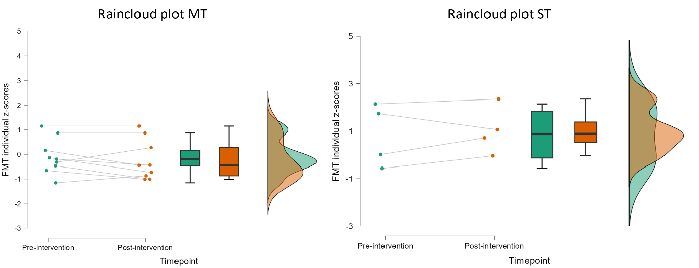
Figure 1. Raincloud plot showing FMT individual z-scored absolute power values in MT and ST pre- and post-intervention. The plot is constituted of three parts: a scatterplot showing beta individual z-scores variation, a box plot showing group-level central tendency and variability and a density plot showing group-level probability density of the data at each value on the y-axis.

A1.2. Anxiety symptoms – Scores at the generalised anxiety disorder assessment – 7
Findings regarding group statistics – i.e., GAD-7 mean total scores – are reported below. Following this, a spotlight on individual statistics– i.e., GAD-7 individual total scores – is presented.
Descriptive: GAD-7 mean total scores
 |  | GAD-7 Pre-intervention |  |  |  | GAD-7 Post-intervention
 |  | MT |  | ST |  | MT |  | ST
Valid |  | 10(10) |  | 6(6) |  | 10(10) |  | 6(6)
Missing |  | 0(0) |  | 0(0) |  | 0(0) |  | 0(0)
Mean |  | 7.8 |  | 12.2 |  | 9.2 |  | 14.8
Std. Error of Mean |  | 2.0 |  | 1.9 |  | 2.0 |  | 1.3
Std. Deviation |  | 6.2 |  | 4.6 |  | 6.3 |  | 3.2
Table 4. Descriptive statistics regarding mean total scores at the GAD-7 questionnaire administered before and after MT and ST.
Descriptive statistics
Table 4 outlines the descriptive statistics GAD-7 mean total scores before and after MT and ST interventions. All participants completed the pre-intervention and post-intervention GAD-7 psychometric measure.
At pre-intervention stage, the MT group exhibited a GAD-7 mean total score of 7.8 (SD = 6.2, SE = 2.0), in contrast to the ST group displaying a higher mean total score of 12.2 (SD = 4.6, SE = 1.9). While the GAD-7 mean total score in the MT group at pre-intervention stage fell in the category “mild anxiety” the mean total score in the ST group fell in the category “moderate anxiety” and exceed the cut-off diagnostic score of 10. Many other studies used different cut-offs higher than 10 with different sensitivity and specificity values. Post-intervention, the mean total score in the MT group slightly increased to 9.2 (SD = 6.3, SE = 2.0), whereas in the ST group, it increased to 14.8 (SD = 3.2, SE = 1.3) falling within the same categories as during pre-intervention measurement (i.e., “mild anxiety” in the MT group and “moderate anxiety” in the ST group).
Group statistics. Analysis of mean total scores
Within-subjects effects: GAD-7 mean total scores
Cases |  | Sum of Squares |  | df |  | Mean Square |  | F |  | p |  | ω²
Timepoint |  | 1.41 |  | 1 |  | 1.41 |  | .09 |  | .768 |  | .000
Timepoint ✻ Type of intervention |  | 22.57 |  | 1 |  | 22.57 |  | 1.45 |  | .249 |  | .015
Residuals |  | 217.91 |  | 14 |  | 15.57
Table 5. Results from non-parametric ANCOVA depicting within-subject effects regarding mean total scores at the GAD-7 before and after MT and ST interventions.
Between-subjects effects: GAD-7 mean total scores
Cases |  | Sum of Squares |  | df |  | Mean Square |  | F |  | p |  | ω²
Type of intervention |  | 5.54 |  | 1 |  | 5.54 |  | .37 |  | .554 |  | .000
Residuals |  | 210.88 |  | 14 |  | 15.06
Table 6. Results from non-parametric ANCOVA depicting between subject effects regarding mean total scores at the GAD-7 before and after MT and ST interventions.
Within-subjects effects: The analysis indicated that the main effect of “Timepoint” on GAD-7 scores did not reach statistical significance (F(1,14) = .09, p = .768). The interaction between “Timepoint” and “Type of intervention” was not significant as well (F(1,14) = 1.45, p = .249).
Between-subjects effects: The effect of the type of intervention did not show significant differences, indicating a similar impact of MT and ST on anxiety levels as measured by the GAD-7 (F(1,14) = .37, p = .554).
The analysis on self-reported rating of anxiety levels – as measured by the GAD-7 – suggested no significant difference in the subjective evaluation of the impact of the respective interventions on anxiety symptoms, with both MT and ST groups showing an increase in self-reported anxiety symptoms. The MT group continued to be classified within the “mild anxiety” category, remaining below the diagnostic cut-off score of 10. The ST group fell within the “moderate” anxiety category at both pre- and post-intervention stages, exceeding at both timepoints the diagnostic cut-off score of 10. Given the small sample size, it is important to acknowledge that the attribution of diagnostic categories and the interpretation of cut-off scores based on averaged values should be approached with caution.
Individual statistics. Analysis of individual total scores
Within the MT group, individual scores generally aligned with the observed group-level tendencies. Most participants stayed within the “mild anxiety” category, albeit with a marginal increase in scores. A high variability can be noted by observing the MT scatterplot (Figure 2, below). This variability is reflected in the fact that two participants reported an increase in GAD-7 individual total score transitioning from “mild” to “severe” anxiety (2_MT) and from “mild” to “moderate” anxiety (5_MT), therefore, exceeding the diagnostic cut-off score of 10. Additionally, one participant (8_MT) reported a decrease in GAD-7 individual total score transitioning from “mild” to “minimal” anxiety category and one participant (10_MT; last observation carried forward principle) falling in the “severe” anxiety diagnostic category at both timepoints. The individual-level analysis confirmed the group-level pattern, with the majority of participants categorized as having 'mild anxiety' post-intervention. However, this more detailed examination revealed greater variability: one participant reported a decrease in their GAD-7 individual total scores, while two others exhibited more pronounced increase in the scores.
In the ST group, changes in GAD-7 individual total scores generally reflected the group-level patterns. At both pre- and post-intervention, most participants fell into the “moderate” anxiety category. Notably, two participants (3_ST and 6_ST) recorded identical scores at baseline and post-intervention, remaining within the “moderate” category. One participant shifted from “mild” to “moderate” anxiety, while another (4_ST) reported an increase from “moderate” to “severe” anxiety. Additionally, one participant showed a minor reduction in symptoms but continued to be classified in the “severe” category. The individual-level analysis underscores the group pattern: all ST participants had pre- and post-intervention GAD-7 scores above the diagnostic threshold of 10, with the exception of participant 1_ST who only exceeded the cut-off score at post-intervention stage.
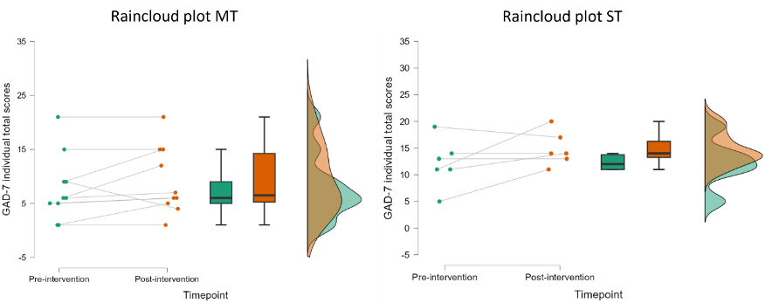
Figure 2. Raincloud plot showing GAD-7 individual total score values in MT and ST pre- and post-intervention. The plot is constituted of three parts: a scatterplot showing beta individual z-scores variation, a box plot showing group-level central tendency and variability and a density plot showing group-level probability density of the data at each value on the y-axis. Diagnostic cut-off score = 10; diagnostic categories: 0-4 – minimal anxiety; 5-9 – mild anxiety; 10-14 – moderate anxiety; 15-21 – severe anxiety.

A1.3. Anxiety symptoms – Relational results
In exploring the correlations between FMT z-scores in the theta band (4.0-8.0 Hz) and GAD-7 total scores for MT and ST type of interventions, for each timepoint (pre-intervention, post-intervention), a reduced sample size was considered. In the MT group, the final sample size was 9. This reduction was due to one participant's EEG data was excluded due to excessive noise. Therefore, the corresponding questionnaire data were excluded as well from the correlational analysis. In the ST group, 4 participants constituted the final correlation sample size. This is because one participant’s EEG data was compromised by hair interference and another's due to falling asleep during the recording process. Consequently, the GAD-7 questionnaires completed by the corresponding participants were not taken into consideration for correlational analyses.
Spearman's Correlations. FMT (4.0-8.0 Hz) at Fz – GAD-7 MT intervention
 |  |  | n | Spearman's rho |  |  | p | Lower 95% CI |  | Upper 95% CI |  | Effect size (Fisher’s z)
FMT_Fz_Pre – GAD-7_Pre |  |  | 9 |  | .00 |  | 1.000 |  | -.66 |  | .66 |  |  | ///
FMT_Fz_Post - GAD-7_Post |  |  | 9 |  | -.27 |  | .484 |  | -.79 |  | .48 |  |  | ///
FMT_Fz_Diff.Score - GAD-7_Diff.Score |  |  | 9 |  | -.87** |  | .002** |  | -.97 |  | -.48 |  |  | -1.32
Table 7. Spearman’s rho correlation between FMT z-scores within the theta band (4.0-8.0 Hz) for electrode’s site Fz and GAD-7 total score. The table depicts correlations pre-MT intervention, post-MT intervention and difference score (Post-minus-Pre scores).

Spearman's Correlations. FMT (4.0-8.0 Hz) at Fz – GAD-7 ST intervention
 |  |  | n | Spearman's rho |  |  | p | Lower 95% CI |  | Upper 95% CI |  | Effect size (Fisher’s z)
FMT_Fz _Pre - GAD-7_Pre |  |  | 4 |  | 1.00 |  | .917 |  | 1.00 |  | 1.00 |  |  | ///
FMT_Fz _Post - GAD-7_Post |  |  | 4 |  | -.20 |  | 1.000 |  | -.97 |  | .94 |  |  | ///
FMT_Fz _Diff.Score - GAD-7_Diff.Score |  |  | 4 |  | .00 |  | .750 |  | -.96 |  | .96 |  |  | ///
Table 8. Spearman’s rho correlation between FMT z-scores within the theta band (4.0-8.0 Hz) for electrode’s site Fz and GAD-7 total score. The table depicts correlations pre-ST intervention, post-ST intervention and difference score (Post-minus-Pre scores).

In the MT group, there was no significant correlation between FMT and GAD-7 scores (rho = .00, p = 1.000) at the pre-intervention stage. Post-intervention, a negative but non-significant relationship was observed (rho = -.27, p = .484). However, a significant negative correlation was found when comparing difference scores (i.e., distribution made by subtracting individual post-intervention scores from individual pre-intervention scores) (rho = -.87, p = .002). This negative significant correlation reflected an increase in average GAD-7 mean scores from 7.80 to 9.20 associated with a decrease in decrease in theta power, i.e., from a mean z-scores of -.08 to -.25.
In the ST group a different picture was found. A positive non-significant correlation at pre-intervention stage (rho= 1.00, p = .917). Contrarily, at post-intervention stage there was a negative non-significant correlation (rho = -.20, p = 1.000). When calculating difference scores, an absence of any monotonic relationship between the two variables has been found (rho = .00, p = 1.00). In the ST group, the increase in GAD-7 mean scores from 12.17 to 14.83 did not significantly correlate with the FMT mean z-score increase from .83 to 1.02.
No significant correlations have been found between FMT mean z-scores and GAD-7 mean scores in the ST group. On the other hand, there was a significant negative correlation between difference scores distribution of the FMT mean z-scores and GAD-7 mean scores in the MT group. A speculation can be drawn from this significant negative correlation: the slight FMT mean z-score decrease and the slight GAD-7 mean total score increase after MT (and increasing also in the ST group), could represent enhanced awareness and the experience of intense emotions.
To provide a visual representation of the relationship between difference scores of FMT (4.0-8.0 Hz) mean z-scores and GAD-7 mean scores, a scatterplot with a linear best fit line is showed below (Figure 3). The best fit line shows the trend between the two variables. The negative slope, as seen in Figure 3, indicates that an increase in one variable is typically accompanied by a decrease in the other. This scatterplot serves as a visual summary of the potential inverse relationship between changes in anxiety symptoms, as measured by GAD-7 scores, and FMT activity in the MT group.
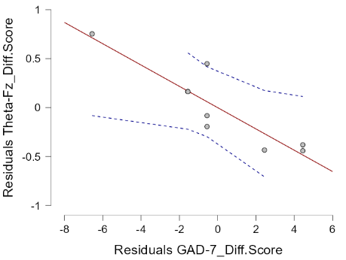
Figure 3: Scatterplot of the residuals from a linear regression model examining the relationship between frontal midline theta (FMT) activity difference scores (Post-minus-Pre MT) and changes in GAD-7 scores (Post-minus-Pre MT). The y-axis displays the residuals of the FMT z-scores, calculated as the observed minus the predicted values from the model. The x-axis presents the residuals for the GAD-7 difference scores, similarly derived. Each data point represents the unique variance for one participant after adjusting for other variables in the regression model. The solid regression line depicts the negative relationship between changes in FMT and GAD-7 scores, with the dashed lines indicating 95% confidence intervals for the regression estimate.

A2. Details of behavioural analysis
In this study, we assessed different behavioural indicators during the Go/NoGo task to support our neurophysiological ERP findings. These indicators were collected during the Go/NoGo task at pre- and post-intervention stages.
Hit and miss rates. The hit rate, which reflects the accuracy in responding to Go stimuli, showed a slight increase post-MT (from .79 to .82) and a similar pattern was observed in the ST group (from .85 to .88). Changes were not statistically significant for both main effects “Timepoint” (F(1,6) = 2.74, p = .149), “Type of intervention” (F(1,6) = .29, p = .602) and “Timepoint”- “Type of intervention” interaction (F(1,6) = .103, p = .758). Conversely, the miss rate, reflecting the rate of omissions in Go trials, decreased slightly post-MT (from .21 to .17) and ST group (from .15 to .11). Changes were not statistically significant for both main effects “Timepoint” (F(1,6) = .03, p = .848), “Type of intervention” (F(1,6) = .301, p = .601) and “Timepoint”- “Type of intervention” interaction (F(1,6) = .19, p = .677).
False alarm and correct rejection rates. The false alarm rate, representing incorrect responses to NoGo stimuli, slightly increased post-MT (from .05 to .07) and more notably after ST (from .03 to .12). However, results from mixed-model ANCOVA are not statistically significant for both main effects “Timepoint” (F(1,6) = 1.08, p = .337), “Type of intervention” (F(1,6) = .14, p = .717) and “Timepoint”- “Type of intervention” interaction (F(1,6) = 2.18, p = .191). The correct rejection rate, indicative of the ability to correctly withhold responses, decreased post-MT (from .96 to .94) and more notably in the ST group (from .97 to .89). Changes were not statistically significant for both main effects “Timepoint” (F(1,6) = .14, p = .716), “Type of intervention” (F(1,6) = .19, p = .672) and “Timepoint”- “Type of intervention” interaction (F(1,6) = .14, p = .197).
Reaction time and d’prime. The reaction time in responding to Go stimuli remained stable with slight reductions after both interventions, i.e., from 299.74 ms to 301.70 ms in the MT group and from 292.12 ms to 286.91 ms in the ST group. These slight changes were not statistically significant for both main effects “Timepoint” (F(1,6) = .05, p = .824), “Type of intervention” (F(1,6) = .42, p = .537) and “Timepoint”- “Type of intervention” interaction (F(1,6) = .26, p = .625). The d'prime, a measure indicating participants’ ability to discriminate between different types of stimuli, showed a slight decrease post-MT (from 2.84 to 2.64) and a similar pattern in the ST group (from 3.42 to 3.07). Changes were not significant for both main effects “Timepoint” (F(1,6) = .07, p = .801), “Type of intervention” (F(1,6) = 1.88, p = .998) and “Timepoint”- “Type of intervention” interaction (F(1,6) = .08, p = .775).

A3. Depressive symptoms/emotional regulation – Resting-state EEG Frontal Alpha Asymmetry

A3.1. FP1/FP2 frontal Alpha Asymmetry
Descriptive statistics
At pre-intervention stage, the MT group showed a mean FAA of -.5 μV2 (SD = 33.8; SE=11.3) and a mean z-score of .22. After the MT intervention, the mean FAA increased to 2.6 μV2 (SD = 31.4; SE=10.4), and the mean z-score increased to .23. This indicated a change in the FAA mean absolute power activity with a reversal hemispheric activation. Concurrently, population normalized mean z-scores calculation revealed a smaller change without a shift of polarity (i.e., from .22 to .23). Considering both FAA mean absolute power at FP1/FP2 and the respective mean z-scored values, descriptive data show a higher alpha power in the left frontal hemisphere relative to the right frontal hemisphere after MT, signifying less brain activity in the left hemisphere as alpha power is inversely related to brain activity. In contrast, the ST group displayed a different pattern, showing a mean FAA of 14.1 μV2 (SD = 20.0; SE=10.0) with a mean z-score of .63 at the pre-intervention stage, while a mean FAA of -26.5 μV2 (SD = 23.3; SE=11.7) and a mean z-score of -.45 after the intervention. Therefore, an opposite trajectory compared to the MT group has been observed in the ST group, with a decreasing FAA power at FP1/FP2 (more negative values) at post-intervention stage.
The observed patterns of hemispheric asymmetry activity within the alpha band at the FP1/FP2 electrode sites aligned with the changes measured at the F7/F8 locations, as well as with the non-significant trajectories observed at the F3/F4 sites. The consistency in FAA patterns across homologous pairs of electrodes in the alpha band showed a coherent neurophysiological picture, suggesting a uniform asymmetry pattern between different homologous channels of the frontal cortex.
Group statistics. Analysis of mean z-scored absolute power at FP1/FP2
Within-subjects effects: FAA mean z-scores – FP1/FP2
Cases |  | Sum of Squares |  | df |  | Mean Square |  | F |  | p |  | ω²
Timepoint |  | 17.94 |  | 1 |  | 17.94 |  | 1.17 |  | .302 |  | .005
Timepoint ✻ Type of intervention |  | 121.28 |  | 1 |  | 121.28 |  | 7.92 |  | .017 |  | .165
Residuals |  | 168.54 |  | 11 |  | 15.32
Table 9. Results from non-parametric ANCOVA depicting within-subject effects regarding FAA mean z-scores within the alpha band (8.0-12.0 Hz) at homologous electrode pair FP1/FP2 before and after MT and ST interventions.
Between-subjects effects: FAA mean z-scores – FP1/FP2
Cases |  | Sum of Squares |  | df |  | Mean Square |  | F |  | p |  | ω²
Type of intervention |  | 128.91 |  | 1 |  | 128.91 |  | 4.38 |  | .060 |  | .123
Residuals |  | 323.78 |  | 11 |  | 29.43
Table 10. Results from non-parametric ANCOVA depicting between-subject effects regarding FAA mean z-scores within the alpha band (8.0-12.0 Hz) at homologous electrode pair FP1/FP2 before and after MT and ST interventions.

Within-subjects effects. Considering within-subjects effects, the main effect of “Timepoint” did not reach significance levels (F(1,11) = 1.17; p = .302). However, a statistically significant interaction, with a large effect size, has been observed between “Timepoint” and “Type of Intervention” on the FAA mean z-scores (F = 7.92, p =.017, ω² =.165).
Between-subjects effects. Regarding between-subject effects, the model indicated a marginally significant main effect, with a medium effect size, of “Type of intervention”, i.e., groups receiving either MT or ST (F = 4.38, p =.060, ω² =.12343).
Post-hoc comparisons. In order to understand which comparison influenced the significant interaction observed, Bonferroni’s pairwise post-hoc comparisons were run. In the post hoc comparisons, one significant result emerged.
A comparison between the MT and ST groups at the post-intervention stage revealed a significant difference, with a large effect size, in FAA mean z-scores at electrode sites FP1/FP2 (t = 3.34; Cohen’s d = 2.0; p = .019). The FAA mean z-score increased in MT from .22 to .23 and decreased in ST from .63 to -.45. The difference between post-MT (.23) and post-ST (-.45) FAA mean z-scores may explain the significant interaction effect between “Timepoint” and “Type of intervention” in the fact that MT maintained a relatively stable FAA mean z-scores while the ST group exhibited a non-significant decrease leading to different FAA mean z-scores at post-intervention stage between the two groups. The negative z-score after ST (decreasing from .63 to -.45; t = 2.34; p = .23) suggested a lower left-sided power (i.e., higher left-sided brain activity) while the positive z-scores after MT (increasing from .22 to .23; t = -1.56; p = .88) indicated a higher left-sided power (i.e., lower left-sided brain activity). In other words, the significant difference in the post-intervention FAA mean z-scores in the alpha band at FP1/FP2 homologous pair, suggested a differential neurophysiological state, in FAA, at post-intervention stage.
The significant difference between MT and ST at post-intervention stage, suggest that MT and ST participants may show different emotional and motivational regulation processes underlying depression, with the MT group associated with a withdrawal affective system while ST with an approach system.
Importantly, results are not driven by baseline differences: in fact, post-hoc tests revealed no significant difference between the MT and ST groups at the pre-intervention stage (t = .05; p = 1.0), confirming that the model appropriately adjusted for initial group imbalances.
Other non-significant post-hoc comparison which are not relevant to the understanding of the results are reported below:
- MT, Pre-intervention vs MT, Post-intervention, t = -1.56; p =.88
- ST, Pre intervention vs MT, Post-intervention, t = -1.06; p = 1.0
- ST, Pre-intervention vs ST, Post-intervention, t = 2.34; p = .23.
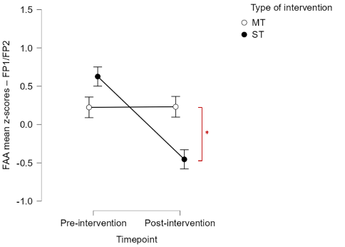
Figure 4. Interactional descriptive plot showing on the y-axis FAA mean z-scores within the alpha band (8.0-12.0 Hz) at homologous electrode pair FP1/FP2 and on the x-axis the factor “Timepoint” (two levels: pre-intervention, post-intervention). Separate lines indicate changes according to the factor “Type of intervention” (two levels, MT, ST) with white dots for MT group and black dots for ST group. Significant differences have been found in the following comparison: MT, post-intervention – ST, post-intervention (p = .019). Asterisks legend: * = p < .05, or ** = p < .01, or *** = p < .001.
Individual statistics. Analysis of individual z-scores at FP1/FP2
In the MT group, FAA individual z-scores demonstrated considerable variability. While the group-level analysis indicated a stable pattern, individual responses varied, with some participants showing increased FAA z-scores and others displaying decreases post-intervention. Importantly, none of the participants deviated significantly from the normal population range at either pre- or post-intervention stages. This individual-level exploration both confirmed the general trend observed in the group-level analysis and highlighted the diverse hemispheric modulations elicited by MT across different participants. In the ST group, there was a general trend of decreasing FAA individual z-scores, largely aligning with the group-level analysis. None of the participants in the ST group significantly diverged from the normative population benchmarks at any stage.
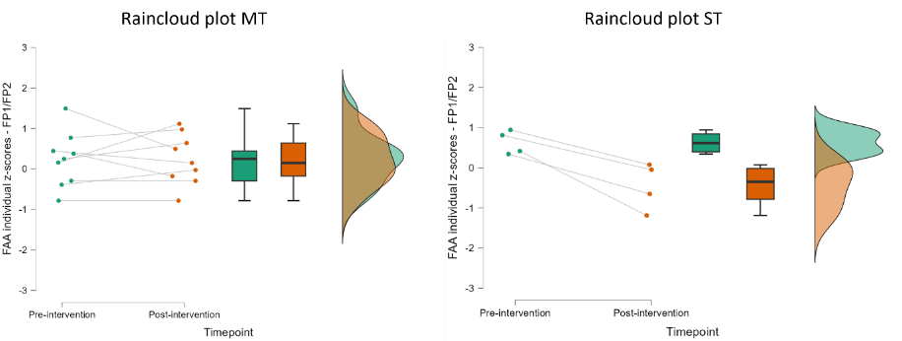
Figure 5. Raincloud plot showing FAA individual z-scored absolute power values in MT and ST pre- and post-intervention at FP1/FP2. The plot is constituted of three parts: a scatterplot showing beta individual z-scores variation, a box plot showing group-level central tendency and variability and a density plot showing group-level probability density of the data at each value on the y-axis.

A3.2. F3/F4 Frontal Alpha Asymmetry
F3/F4 Frontal Alpha Asymmetry z-scores.
The following tables depict within- and between-subjects effects concerning resting-state FAA mean z-scores calculated at F3/F4 homologous pairs and analysed with non-parametric ANCOVA. Bonferroni’s pairwise post-hoc comparisons were conducted were relevant.
Within-subjects effects: FAA mean z-scores – F3/F4
Cases |  | Sum of Squares |  | df |  | Mean Square |  | F |  | p |  | ω²
Timepoint |  | 1.59 |  | 1 |  | 1.59 |  | .069 |  | .796 |  | .0
Timepoint ✻ Type of intervention |  | 10.78 |  | 1 |  | 10.78 |  | .473 |  | .506 |  | .0
Residuals |  | 250.72 |  | 11 |  | 22.79
Table 11. Results from non-parametric ANCOVA depicting within-subject effects regarding FAA mean z-scores within the alpha band (8.0-12.0 Hz) at homologous electrode pair F3/F4 before and after MT and ST interventions.
Between-subjects effects: FAA mean z-scores – F3/F4
Cases |  | Sum of Squares |  | df |  | Mean Square |  | F |  | p |  | ω²
Type of intervention |  | 8.74 |  | 1 |  | 8.74 |  | .47 |  | .508 |  | .0
Residuals |  | 205.62 |  | 11 |  | 18.69
Table 12. Results from non-parametric ANCOVA depicting between-subject effects regarding FAA mean z-scores within the alpha band (8.0-12.0 Hz) at homologous electrode pair F3/F4 before and after MT and ST interventions.

F3/F4 Frontal Alpha Asymmetry absolute power values.
The following tables depict within- and between-subjects effects concerning resting-state FAA mean absolute power calculated at F3/F4 homologous pairs and analysed with non-parametric ANCOVA. Bonferroni’s pairwise post-hoc comparisons were conducted were relevant.
Within-subjects effects: FAA mean absolute power– F3/F4
Cases |  | Sum of Squares |  | df |  | Mean Square |  | F |  | p |  | ω²
Timepoint |  | .87 |  | 1 |  | .87 |  | .03 |  | .855 |  | .0
Timepoint ✻ Type of intervention |  | 5.86 |  | 1 |  | 5.86 |  | .24 |  | .637 |  | .0
Residuals |  | 273.29 |  | 11 |  | 24.84
Table 13. Results from non-parametric ANCOVA depicting within-subject effects regarding FAA mean absolute power within the alpha band (8.0-12.0 Hz) at homologous electrode pair F3/F4 before and after MT and ST interventions.
Between-subjects effects: FAA mean absolute power– F3/F4
Cases |  | Sum of Squares |  | df |  | Mean Square |  | F |  | p |  | ω²
Type of intervention |  | 3.52 |  | 1 |  | 3.52 |  | .14 |  | .717 |  | .0
Residuals |  | 280.22 |  | 11 |  | 25.47
Table 14. Results from non-parametric ANCOVA depicting between-subject effects regarding FAA mean absolute power within the alpha band (8.0-12.0 Hz) at homologous electrode pair F3/F4 before and after MT and ST interventions.

A4. Noise quantification: point-by-point SD at waveforms baseline
Upon visual examination of the ERP parent waveforms during Go and NoGo conditions, which are used to construct the P3d, a higher EEG noise level was observed in the ST waveforms. Given that the pre-processing and processing steps were rigorously verified, a decision was made to perform a noise quantification analysis. This involved calculating the point-by-point SD of the voltage across the ERP baseline period in the averaged Go and NoGo waveforms. Point-by-point SDs were calculated and extracted from all the participants in the first 50 sample points (from -200 to 0 ms, where 0 ms coincides with stimulus onset) at a midline ROI (FCz, Cz, and Pz electrodes). For data comparison, SD values were computed separately for each condition (i.e., Go and NoGo), timepoint (pre- and post-intervention), and for each group (MT and ST). Mean SD values, indicative of noise defined as any source of variability affecting the averaged ERP waveforms, were then analysed using a mixed-model (or factorial) ANOVA. The factors in this analysis were two within-subjects factors: “Timepoint” (with two levels: pre-intervention and post-intervention) and “Condition” (with two levels: Go and NoGo), as well as one between-subjects factor: “Type of Intervention” (with two levels: MT and ST). Where relevant, Bonferroni’s post-hoc comparisons were conducted.
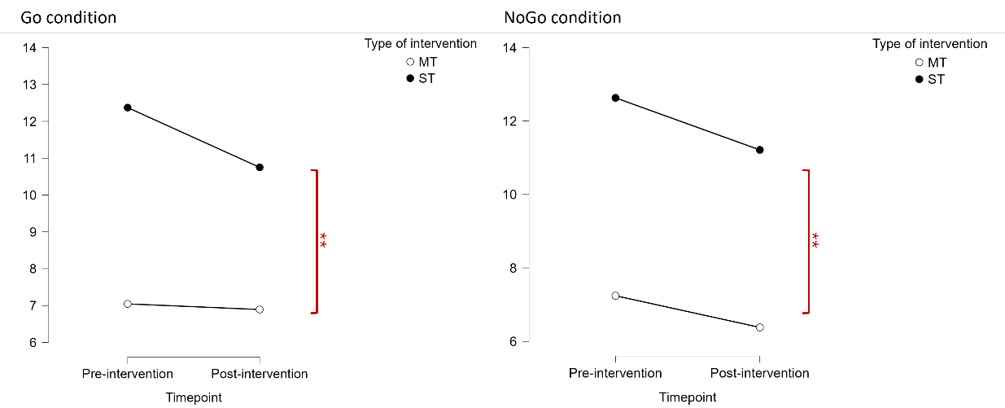
Figure 6. Interactional plots from mixed-model repeated-measures parametric ANOVA depicting point-by-point SD ERP baseline noise in parent ERP Go (a) and ERP NoGo (b) waveforms. SD values were calculated at pre- and post-intervention stages in the MT and ST groups.

Descriptive statistics
As depicted in the interactional plot (Figure 6,a), the Go waveforms in the ST group exhibited higher mean SD values at the ERP baseline, both at pre-intervention (M = 12.4; SE = 1.8) and post-intervention stages (M = 10.8; SE = .5), when compared to the Go waveforms in the MT group, which demonstrated lower noise levels at both pre-intervention (M = 7.04; SE = .5) and post-intervention stages (M = 6.89; SE = ..4). A similar pattern was noted for the NoGo waveforms (Figure 6,b), with the NoGo waveforms in the ST group demonstrating higher mean SD values at the ERP baseline both at pre-intervention (M = 12.6; SE = 2.6) and post-intervention stages (M = 11.2; SE = .83), in contrast to the NoGo waveforms in the MT group which showed lower noise levels at pre-intervention (M = 7.2; SE = .6) and post-intervention stages (M = 6.4; SE = .3).
Inferential statistics
Results from the mixed-model ANOVA revealed a significant main effect of the factor “Timepoint” with a small effect size (F(1, 5) = 22.3, p =.0005, ω² = .6), indicating variations in mean SD noise values across different timepoints. Because the main effect of “Condition” was not significant (F(1,5) = .099, p = .781), Go and NoGo conditions did not differ in noise levels.
A significant between-subjects effect, with a large effect size, was observed for “Type of Intervention” (F(1, 5) = 968.26, p = .0002, ω² =.265), indicating a strong difference between MT and ST in noise levels.
Regarding interaction effects, the “Timepoint × Type of Intervention” interaction did not reach significance (F(1,5) = .67, p = .778). The “Timepoint × Condition × Type of Intervention” interaction was also not significant (F(1,5) = 1.11, p = .112). However, significant interactions with a small effect size were found for “Condition × Type of Intervention” (F(1, 5) = 31.30, p = .003, ω² = .004) and “Timepoint × Condition” (F(1, 5) = 4.55, p = .021, ω² = .04).
To understand which comparisons explained the general effects observed, Bonferroni’s pairwise post-hoc comparisons were conducted. Significant differences with large effect sizes in the SD noise values were noted between the following cases:
- “MT, Pre-intervention, Go” - “ST, Pre-intervention, Go” (t = -3.26, Cohen’s d = -3.32, p = .134).
- “MT, Post-intervention, Go” - “ST, Post-intervention, Go” (t = -6.59, Cohen’s d = -2.403, p = .007**).
- “MT, Pre-intervention, NoGo” - “ST, Pre-intervention, NoGo” (t = -2.38, Cohen’s d = -2.44 , p =.37 )
- “MT, Post-intervention, NoGo” - “ST, Post-intervention, NoGo” (t = -6-212 , Cohen’s d = -2.186 , p = .009**).
Conclusion
The analysis revealed a significant difference in noise levels between the MT and ST groups. This variance is thought to stem from the disparity in sample sizes; the MT group provided 6 viable ERP datasets both pre- and post-intervention, while the ST group only 3. The outcome from noise quantification led to the decision of including in the statistical analysis only ERP from the MT group. The smaller sample size in the ST group posed challenges for conducting reliable group comparisons. For instance, this is evident in discrepancies on the P3d polarity (see Supplementary materials S6). This approach was chosen to ensure that interpretations were not based on ERP waveforms compromised by excessive noise.

A5. Analysis of CT individual scores
In the scatterplot below (Figure 7) the data points across consistently show negative difference scores (Post-minus-Pre CT individual scores), indicating that all participants experienced a decrease in their instantaneous craving levels following each MT session. Furthermore, no single evaluation at the CT exceeded the suggested cut-off score for craving prediction. While thresholds in one-item scale can lead to erroneous information and be more easily misinterpreted, it is notable how no positive difference scores are observed; this means that there were no instances where pre-intervention craving levels were lower than post-intervention levels.
This pattern across the scatterplot suggested a uniform effect of MT both in group (GMT) and individual (IMT) settings, in consistently reducing self-reported instantaneous craving symptoms.
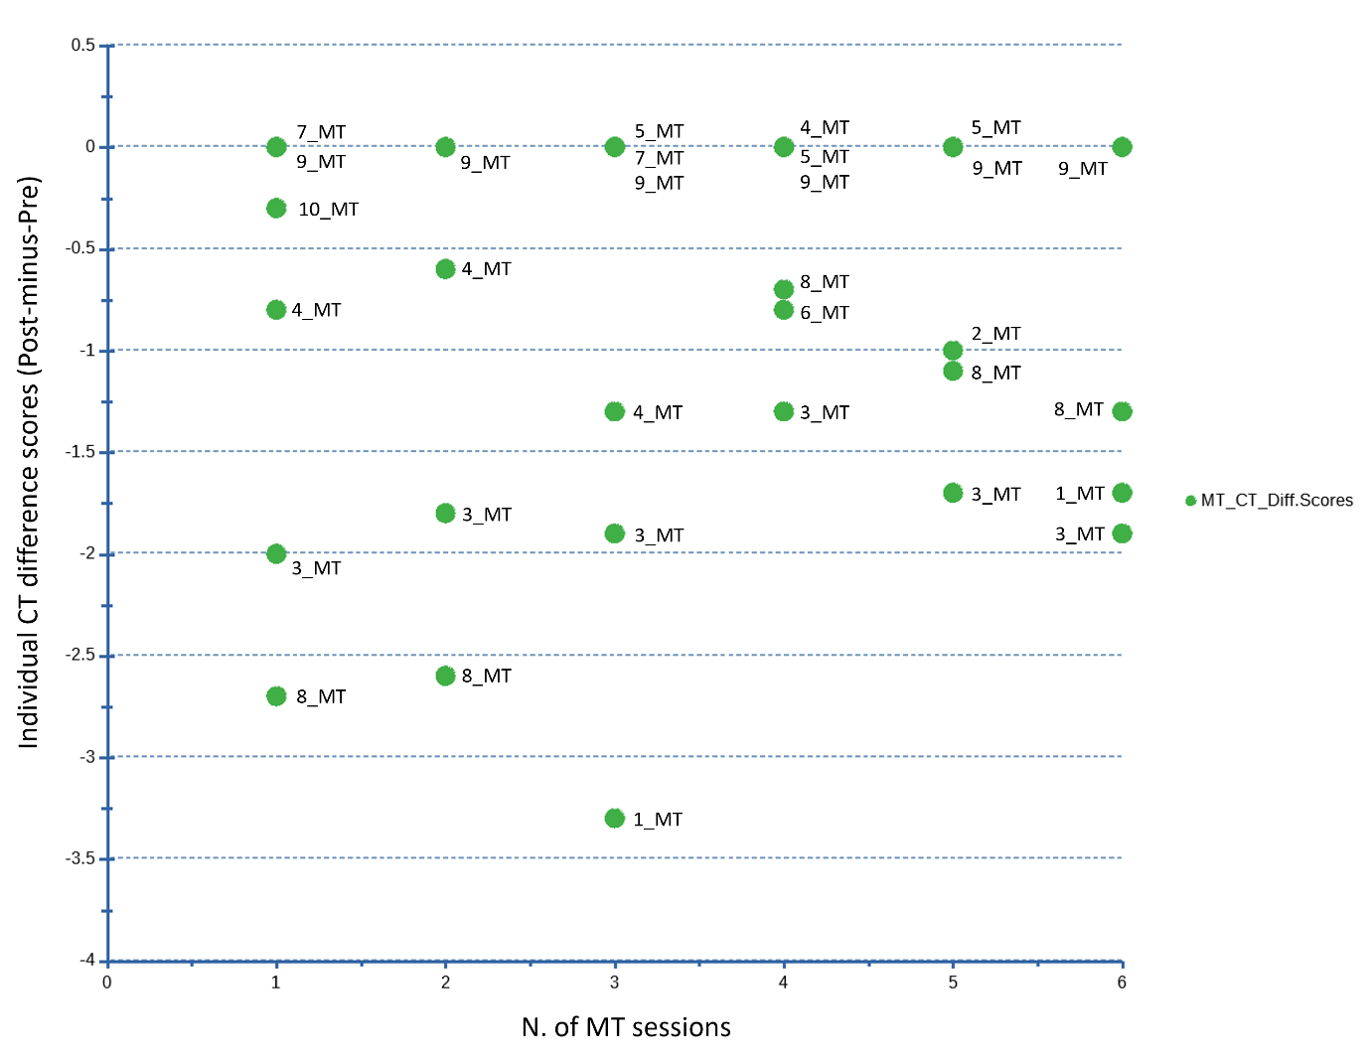
Figure 7. The scatterplot visualizes the change in craving symptoms experienced by participants undergoing music therapy (MT). On the y-axis, individual craving difference scores are plotted. These scores are calculated by subtracting the craving levels reported before each MT session (Pre-MT) from those reported after the session (Post-MT). A negative value here indicates a reduction in craving levels post-MT session. On the x-axis, the number of MT sessions completed by each participant over a 6-week period is displayed.

A6. Evoked Go-P3 and NoGo-P3
Descriptive statistics
Table 15 displays mean amplitude (μV) values of P3 “parent waveforms” during Go and NoGo conditions, i.e., Go-P3 and NoGo P3. These waveforms were computed for the MT group at FCz, Cz, and Pz midline electrodes’ sites (midline ROI) in 350-500 ms time-window at pre- and post-intervention stages. After conducting a noise quantification analysis, the data from the ST group were excluded.
The participant pool consisted of 6 individuals (18 datapoints: i.e., midline electrodes’ sites corresponding to FCz, Cz, and Pz * 6 participants) receiving MT. Four participants’ ERP recordings were excluded from the analysis. One of them was excluded because of high level of motion during EEG recording which resulted in compromised signal quality and three participants’ datasets because of an insufficient number of artifact-free Go/NoGo trials.
Descriptive statistics, presented in Table 15, indicated a decreased Go-P3 mean amplitude after MT: from 12.11 μV (SD = 6.72, SE = 1.58) to 10.62 μV (SD = 6.85, SE = 1.61) Similarly, NoGo-P3 mean amplitude values decreased after MT from 11.39 μV (SD = 5.74, SE = 1.35) to 10.70 (SD = 5.90, SE = 1.39).
Descriptive statistics: Evoked Go-P3 and NoGo-P3 amplitude Pre- and Post-MT (midline ROI)
 |  | Go_Pre |  | Go_Post |  | NoGo_Pre |  | NoGo_Post
Valid (datapoints) |  | 6(18) |  | 6(18) |  | 6(18) |  | 6(18)
Missing (datapoints) |  | 0(0) |  | 0(0) |  | 0(0) |  | 0(0)
Mean Amplitude (μV) |  | 12.11 |  | 10.62 |  | 11.39 |  | 10.70
Std. Deviation |  | 6.72 |  | 6.85 |  | 5.74 |  | 5.90
Std. Error of Mean |  | 1.58 |  | 1.61 |  | 1.35 |  | 1.39
Table 15. Descriptive statistics regarding mean amplitude (μV) and standard deviation (SD) values of evoked Go-P3 and NoGo-P3 measured at a midline ROI (i.e., FCz, Cz and Pz electrodes’ sites) in 350-500 ms time-window. According to the noise quantification analysis, those data only depict MT participants at pre- and post-intervention stages.

Group statistics
A two-way repeated-measures ANOVA was utilized to analyse the data, with “Timepoint” (pre- and post-MT intervention) and “Condition” (Go and NoGo) as within-subjects factors. The results, presented in Table 16, indicated: no significant main effect for “Timepoint” (F(1, 17) = 2.90, p = .107) or for “Condition” (Go vs. NoGo) (F(1, 17) = .10, p = .757). Furthermore, a marginally significant interaction between “Timepoint” and “Condition” (F(1, 17) = 3.43, p = .082), suggesting a slight difference in amplitude changes between Go and NoGo conditions over time, potentially reflecting the impact of MT on reducing P3 values (350-500ms).
Observing the tendencies in Go- and NoGo-P3 amplitudes, it could be speculated that a reduction in the cognitive resources and efforts necessary for the detection of visual stimuli may be required following MT.
Descriptive statistics, temporal distributions, and topographic plots in Figure 8 indicate that the Go condition showed a more pronounced reduction than the NoGo condition following MT, possibly contributing to the observed trend in the “Timepoint” and “Condition” interaction.
Figures 8 and 9 (see below) display the averaged EEG waveforms from key cortical sites (Fz, FCz, Cz, Pz) during Go and NoGo conditions for both MT (Figure 8) and ST (Figure 9) at pre- and post-intervention stages. Highlighted within these waveforms is the 350-500 ms time window, marking the peak of the neural response. The topographical maps beneath the EEG traces show the spatial distribution of neural activity across the scalp, with red areas denoting positive mean μV potentials and blue areas negative mean μV potentials, captured during the 350-500 ms post-stimulus onset window.
Two-way repeated measures ANOVA: Evoked Go-P3 and NoGo-P3 amplitude in the MT group
Cases |  | Sum of Squares |  | df |  | Mean Square |  | F |  | p |  | ω²
Timepoint |  | 21.22 |  | 1 |  | 21.22 |  | 2.90 |  | .107 |  | .005
Residuals |  | 124.37 |  | 17 |  | 7.32
Condition |  | 1.82 |  | 1 |  | 1.82 |  | .10 |  | .757 |  | .000
Residuals |  | 312.81 |  | 17 |  | 18.40
Timepoint ✻ Condition |  | 2.92 |  | 1 |  | 2.92 |  | 3.43 |  | .082 |  | .001
Residuals |  | 14.46 |  | 17 |  | 0.85
Table 16. Two-way repeated measures parametric ANOVA results depicting within-subjects effects regarding evoked Go-P3 and NoGo-P3 mean amplitude (μV) measured at FCz, Cz and Pz midline electrodes’ sites in 350-500ms time-window pre- and post-MT.

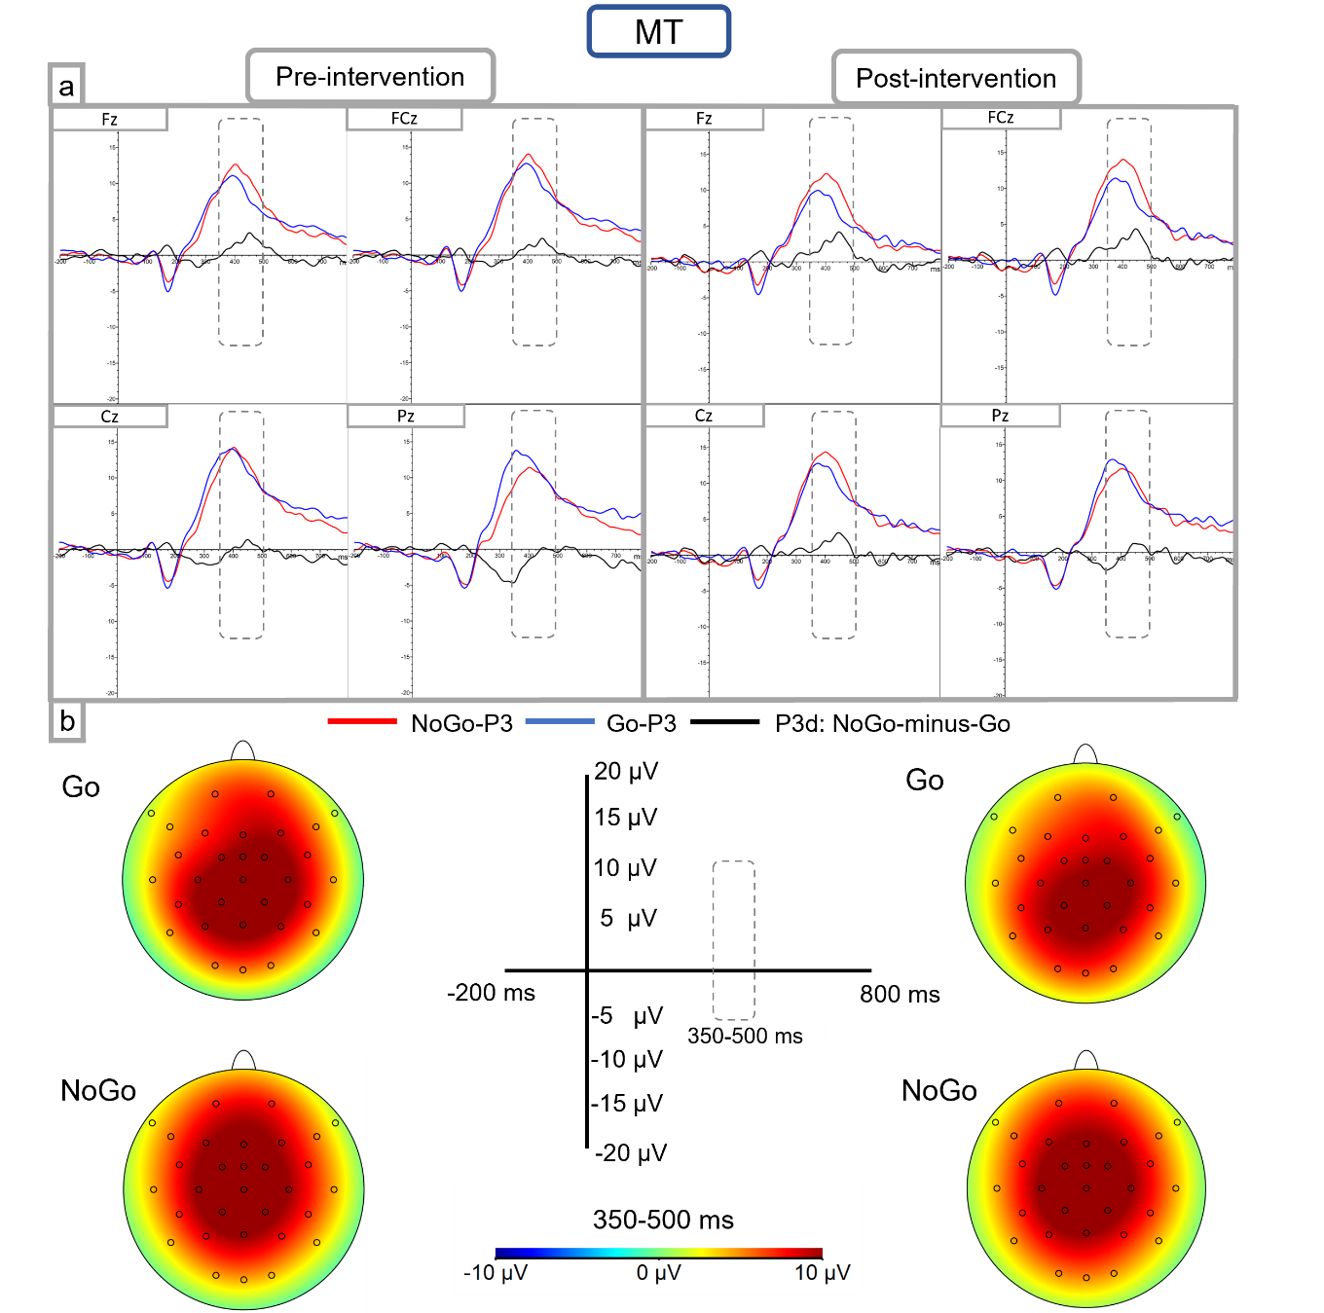
Figure 8. Temporal distribution and scalp topography of evoked Go-P3 (blue lines) and NoGo-P3 (red lines) in the MT group. The figure displays the temporal distribution of P3d (NoGo-minus-Go) in black lines. All evoked potentials are represented as mean μV amplitude in MT pre-intervention and post-intervention stages.
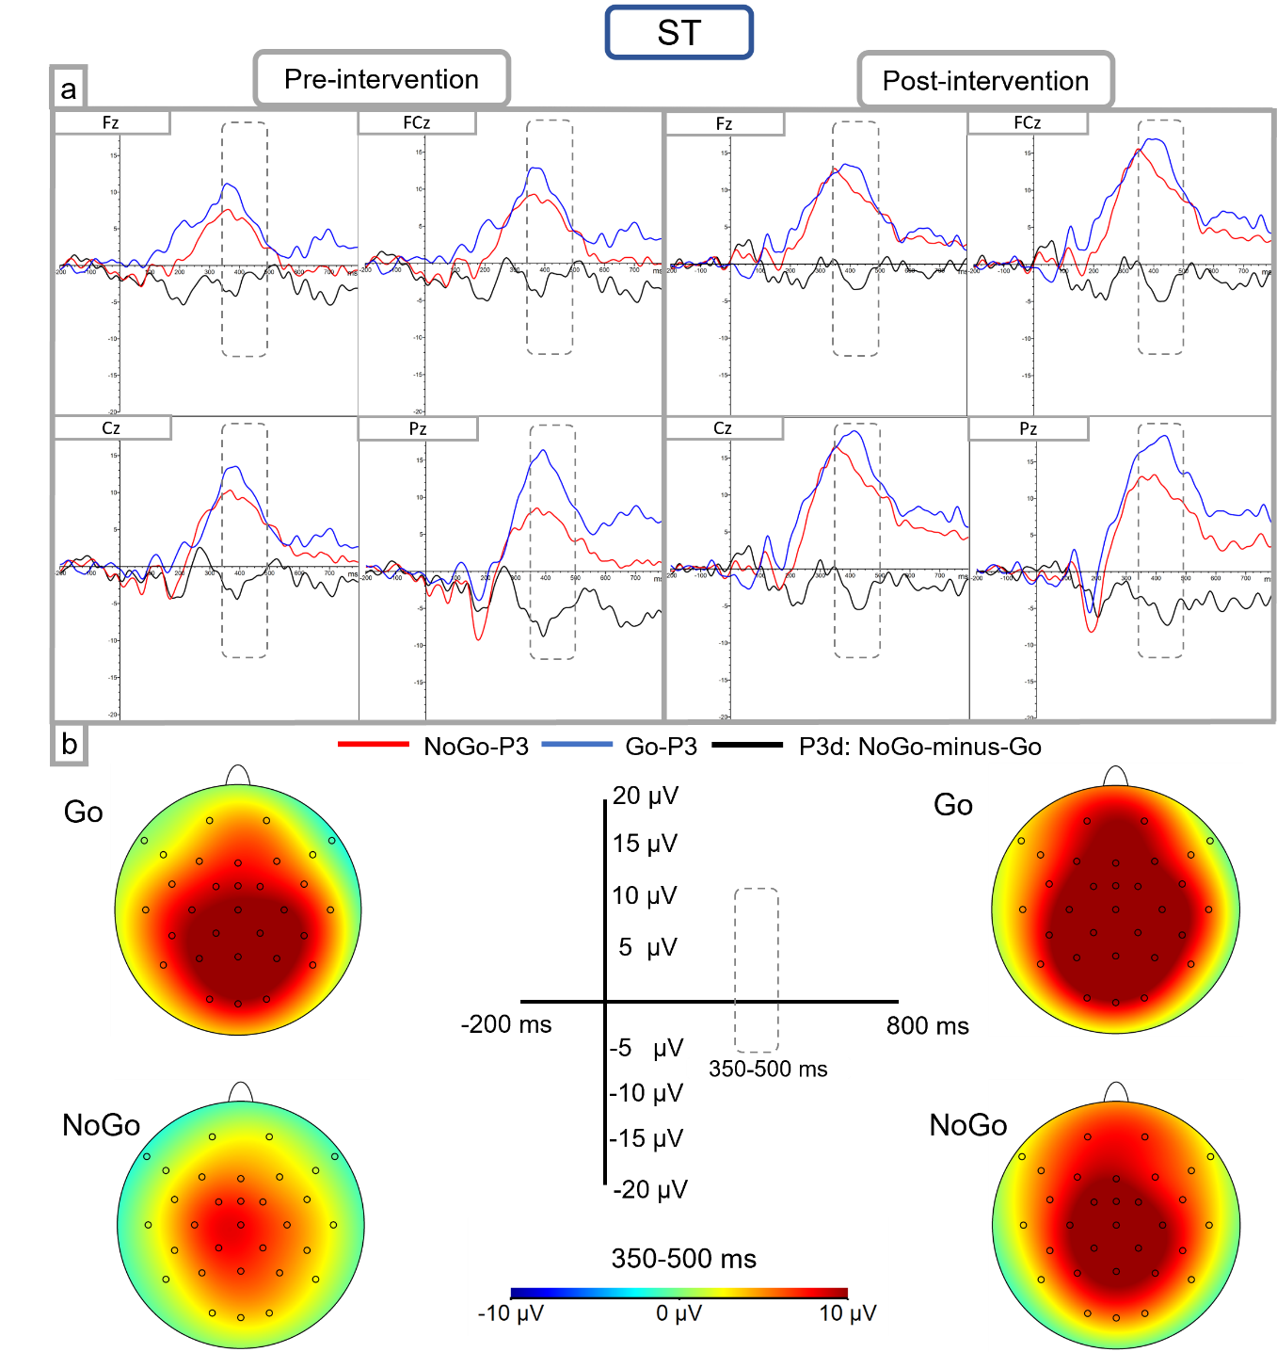
Figure 9. Temporal distribution and scalp topography of evoked Go-P3 (blue lines) and NoGo-P3 (red lines) in the ST group. The figure displays the temporal distribution of P3d (NoGo-minus-Go) in black lines. All evoked potentials are represented as mean μV amplitude in ST pre-intervention and post-intervention stages.

A7. Demographic information
Participants in this study were engaged in either tier 3 structured treatment or tier 2 recovery support. It is widely recognized that methodological rigor is crucial when attributing outcomes to experimental treatments alongside standard care. Considering the variability of participant stages in the current study, specific information about the sample involved in this pilot study (and generally, in the CRAVEMT feasibility clinical trial) will be described below.
Participant_Type of intervention | Date of birth | Sex | 1st  substance | 2nd  substance | 3rd  substance | Treatment Status | N. of ST sessions. | N. of MT sessions.
1_MT (GMT) | Nov-71 | M | Cannabis | MDMA | N/A | Structured treatment | 13 | 5
2_MT (GMT) | May-74 | M | Alcohol | N/A | N/A | Recovery support | 36 | 3
3_MT (IMT) | Sep-79 | M | Cannabis | Alcohol | Cocaine | Recovery support | 28 | 6
4_MT (IMT) | Sep-69 | M | Alcohol | N/A | N/A | Recovery support | 16 | 5
5_MT (GMT) | Sep-76 | M | Alcohol | N/A | N/A | Recovery support | 11 | 5
6_MT (GMT) | Sep-02 | F | Cocaine | Alcohol | N/A | Recovery support | 6 | 1
7_MT (IMT) | Jul-61 | M | Alcohol | N/A | N/A | Recovery support | 0 | 2
8_MT (IMT) | Jul-74 | M | Cannabis | N/A | N/A | Structured treatment | 4 | 6
9_MT (IMT) | Nov-66 | M | Alcohol | N/A | N/A | Structured treatment | 17 | 6
10_MT (IMT) | May-82 | F | Heroin | N/A | N/A | Structured treatment | 0 | 2
1_ST | Jun-83 | F | Alcohol | N/A | N/A | Recovery support | 20 | N/A
2_ST | May-89 | F | Cannabis | Alcohol | N/A | Recovery support | 12 | N/A
3_ST | Nov-85 | M | Heroin | Crack Cocaine | N/A | Structured treatment | 3 | N/A
4_ST | Sep-88 | F | Heroin | Cannabis | N/A | Structured treatment | 4 | N/A
5_ST | Mar-71 | M | Alcohol | N/A | N/A | Recovery support | 11 | N/A
6_ST | Oct-75 | M | Heroin | Cocaine | N/A | Structured treatment | 15 | N/A
Table 17. Demographic information regarding the final cohort of 16 SUD participants involved in the study.

Table 17 details information regarding participant demographics and interventions characteristics. The study cohort consists of 16 participants, divided into two intervention groups: those receiving MT (i.e., 4 participants involved in GMT and 6 participants in IMT) and those undergoing ST (6 participants). The participants predominantly identified as male (11/16), with a smaller female representation (5/16). Age distribution among the participants ranged widely from young adults born in 2002 to older adults born in 1961, indicating a diverse participant pool.
Substance use varied across individuals, with alcohol being the most commonly reported primary substance of misuse, followed by cannabis, heroin, and cocaine. A notable portion of the participants reported using more than one substance, although the use of a third substance was less common.
Regarding treatment status, the majority of participants were engaged in recovery support programs, with a smaller number undergoing structured treatment. The number of ST sessions attended by participants varied, with some individuals attending as many as 36 sessions and others attending none. Similarly, the number of MT sessions attended was not always complete: 6 GMT and IMT sessions were offered and, as stated in the protocol article, participants with fewer sessions were not excluded from data analysis as their incomplete datasets still represented an important source of information in a pilot study embedded within a feasibility clinical trial. Furthermore, two participants (i.e., 4_MT and 10_MT) dropped out before post-intervention measurement stage due to a relapse episode.
From the pre-EEG screening questionnaire, no participant declared to have ever suffered from a Stroke, Epilepsy, a brain injury, or any other condition that could have made wearing the EEG cap difficult or uncomfortable. Furthermore, all participants declared to be right-handed except for 3_ST who was left-handed. This was an exclusion criterion because one EEG outcome measure utilized (i.e., the FAA) is modulated by handedness direction (i.e., left-handed, right-handed). However, 3_ST EEG data turned out to be unusable due to excessive noise. Therefore, all the data from this participant, except for EEG datasets, were included in the analysis. Considering treatment statuses, participants were expected to be abstinent during assessments at all timepoints. However, but because of the study’s design which involved the inclusion on outpatients – engaging with the community service but continuing their lives also outside of it – this factor could not be entirely controlled.
Participants’ medications
1_MT (GMT) | Tetracyclic antidepressant | Asthma medication | Gastrointestinal medication | Vitamin  supplement
2_MT (GMT) | Alcohol maintenance non-substitution | Vitamin  supplement
3_MT (IMT) | N/A
4_MT (IMT) | SSRI antidepressant | Gastrointestinal medication | Vitamin  supplement
5_MT (GMT) | Second-generation antipsychotic | Mood stabilizer | SNRI antidepressant | Several non-strictly-mental-health medications: cardiovascular, gastrointestinal, cholesterol-lowering medications.
6_MT (GMT) | N/A
7_MT (IMT) | N/A
8_MT (IMT) | N/A
9_MT (IMT) | Alcohol maintenance non-substitution | Tetracyclic antidepressant | Laxative
10_MT (IMT) | Opioid maintenance substitution | Benzodiazepine  antianxiety
1_ST | N/A
2_ST | N/A
3_ST | Opioid maintenance substitution | SSRI antidepressant | Second-generation antipsychotic | ADHD stimulant
4_ST | Cardiovascular medication | Gastrointestinal medication | Asthma medication
5_ST | N/A
6_ST | Tricyclic antidepressant | Gabapentinoid antianxiety and neuropathic pain. | Several non-strictly-mental-health medications: cholesterol-lowering, cardiovascular, gastrointestinal, asthma medication
Table 18. Participants mental-health-related and non-strictly-mental-health-related medications. N/A: no medications declared by the GP.

Table 18 shows the medication regimens of participants engaged in the study. Medications range widely, including psychiatric treatments such as tetracyclic and selective serotonin reuptake inhibitors (SSRI) antidepressants, second-generation antipsychotics, mood stabilizers, serotonin, and norepinephrine reuptake inhibitors (SNRI) antidepressants, benzodiazepine antianxiety drugs, and Attention-Deficit/Hyperactivity disorder ADHD stimulants. Additionally, some participants are on maintenance medications for substance dependency, including alcohol maintenance non-substitution (i.e., Acamprosate) and opioid maintenance substitution treatments (i.e., Methadone and Buprenorphine).
Beyond psychiatric medications, participants are also prescribed a variety of medications addressing conditions that are not strictly related to mental health, such as asthma medications, gastrointestinal treatments, cardiovascular and cholesterol-lowering medications, laxatives, and vitamin supplements, indicating a complex a varied healthcare management.
Some participants in the MT group (4/10) and the ST group (2/6) did not use medications, suggesting a variation in the medical and psychiatric needs within this group.
This medication profile summary provides insight into the heterogenic healthcare needs of the participants involved, underpinning the importance of considering these factors when evaluating the preliminary outcomes of the study.

