Extended data

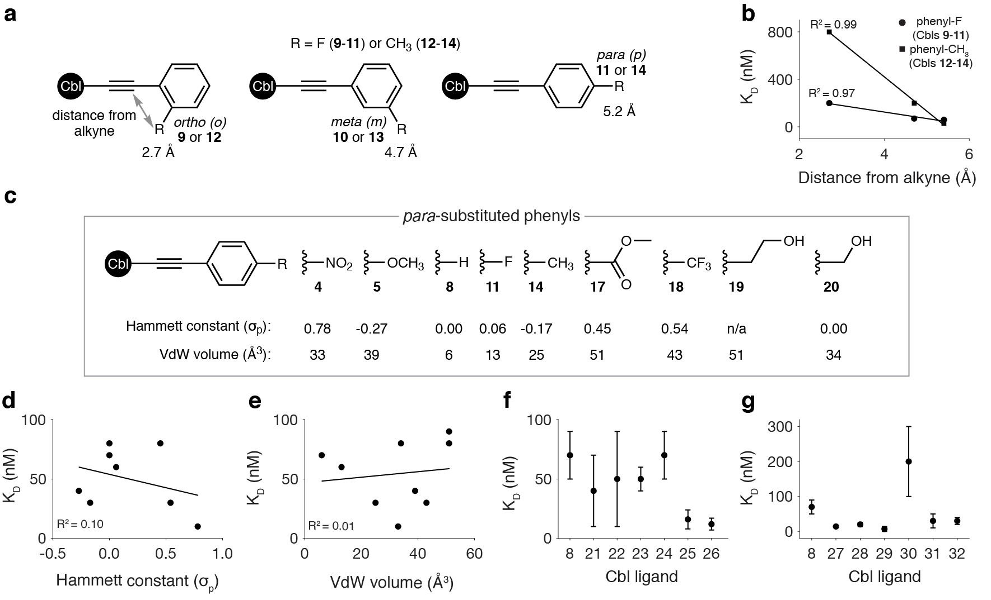

Extended Data Fig. 1. Quantitative structure-activity relationship (QSAR) analysis of RNA binding data. a, Schematic representation of the “distance from alkyne”. b, Plot of K_{D} values and “distance from alkyne” for the phenyl-F (9-11) and -CH₃ (12-14) series. c, Chemical structures of the para-substituted phenyls (4, 5, 8, 11, 14, and 17-20) with their respective Hammett constant (σ_{p}) and Van der Waals (VdW) volume values listed. d, Plot of K_{D} values and the σ_{p} of the chemical group in the para-substituted phenyls. e, Same as in d but using the VdW volume of the same chemical groups. f, Plot of K_{D} values for the heterocyclic derivatives (21-26) and 8 for comparison. g, Same as in f but for the multi-ring derivatives (27-32). In f and g, mean and s.d. from independent experiments (n = 3-5) are shown.

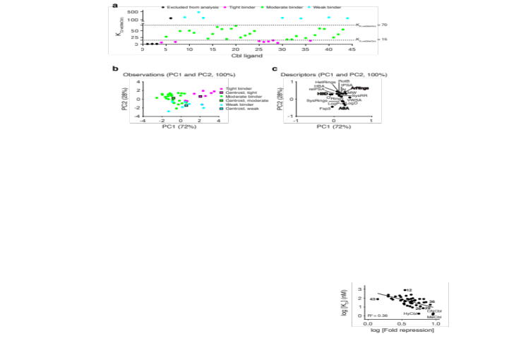

Extended Data Fig. 2. Linear discriminant analysis (LDA) of RNA binding data. a, Plot of the K_{D} values for Cbls 1-44, where the data have been normalized to the value for MeCbl. On this basis, we clustered our derivatives into three groups: tight (K_{D,rel(MeCbl)} <15), moderate (K_{D,rel(MeCbl)} = 15-70), and weak (K_{D,rel(MeCbl)} >70) binders. Given that standard Cbls 1-3 do not have a chemically diverse β-axial group, they were excluded from the LDA (and downstream QSAR modeling). Cbl 6 was also excluded due to its a sp³ carbon adjacent to the alkyne, a chemical space that was unique within the library and one that we did not wish to pursue. b, LDA plot for principal components 1 and 2 (PC1 and PC2) depicting the clustering of the three binding groups and their centroids using chemoinformatic parameters (Supplementary Table 1). c, LDA loading plot of the contributions of each chemoinformatic parameter on PC1 and PC2, with the most obvious descriptor colored by the binding cluster that they best explain (e.g., number of aromatic rings, ArRings; number of hydrogen bond donors, HBD; and accessible solvent area, ASA).

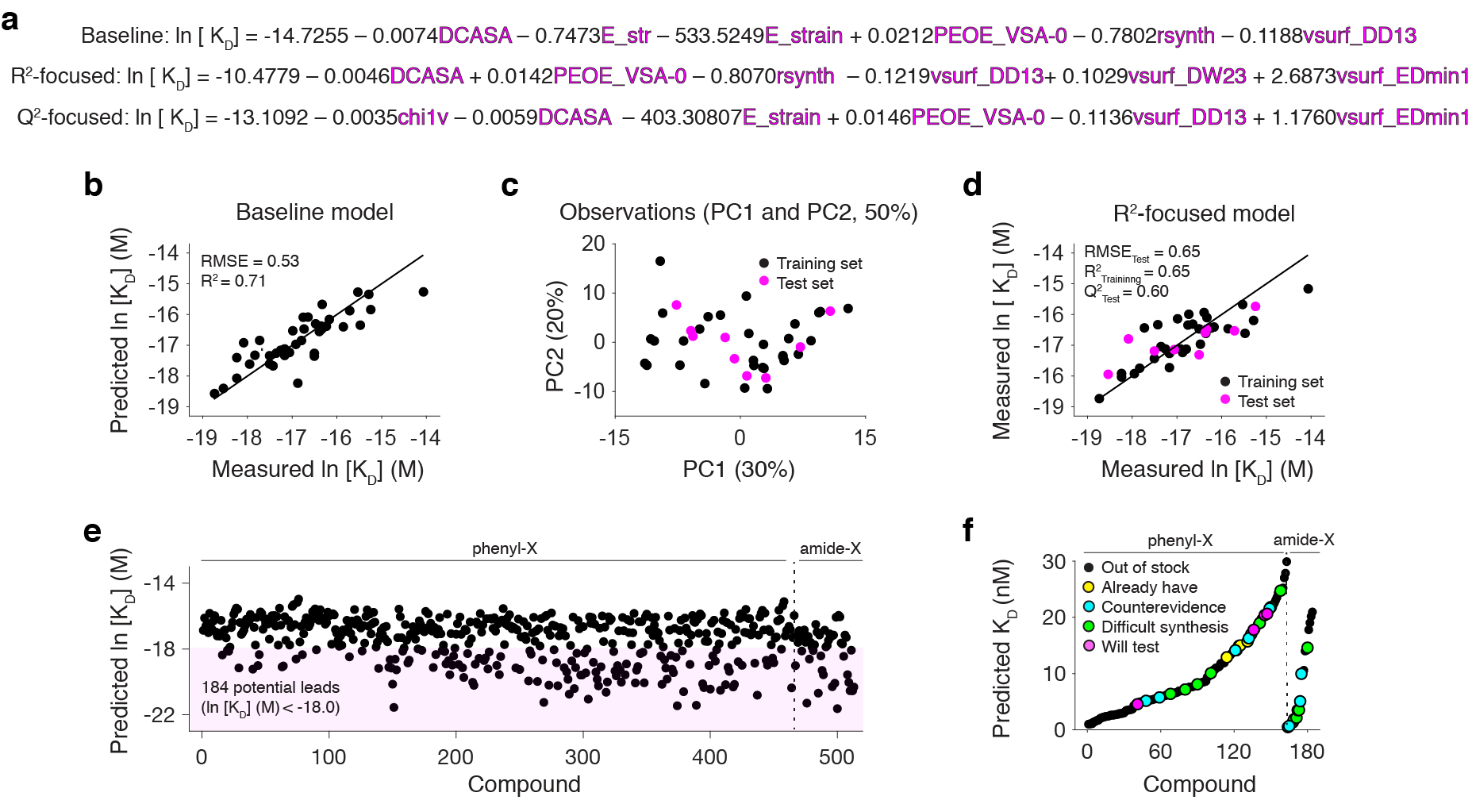

Extended Data Fig. 3. QSAR modeling framework to predict binding lead compounds. a, Written out multiple linear regression (MLR) baseline, R²-focused, and Q²-focused models. The physical meaning of each physiochemical descriptor is listed in Supplementary Table 2. b, Measured ln [K_{D}] values plotted with the value predicted by the baseline model that did not include a data split. c, Locations of the training and test set from the R²-focused modeling in two-dimensional chemical space constructed from PC1 and PC2 of the whole data set. d, Same as in b but for the R²-focused model. e, Average ln [K_{D}] values predicted by our three models for each compound in the alkyne library. The magenta shaded box represents the 184 compounds that have a predicted affinity tighter than that of our current binding lead 29 (ln [K_{D}] < -18.0). f, Rank-ordered plot the average K_{D} values predicted by our binding models for the 184 potential lead compounds that were identified from the alkyne library, separated by type (phenyl-X and amide-X). These compounds are classified as either “out of stock”, “already have”, “counterevidence”, “difficult synthesis”, and “will test”. Here, “out of stock” refers to alkynes that were not purchasable from Enamine. “Counterevidence” refers to compounds that are chemically similar to derivatives in our library that are known to have weak affinity. “Difficult synthesis” refers to compounds that contain amino groups or protonated nitrogen atoms, which were not compatible with the reduction-free synthesis^{26,27} (Supplementary Fig. 2). The vast majority of “out of stock” compounds also contained amino groups or protonated nitrogen atoms. Thus, even if they become purchasable from Enamine, they are still synthetically inaccessible. Finally, “will test” refers to the four purchasable alkynes that were predicted to yield binding lead Cbls 45-48.

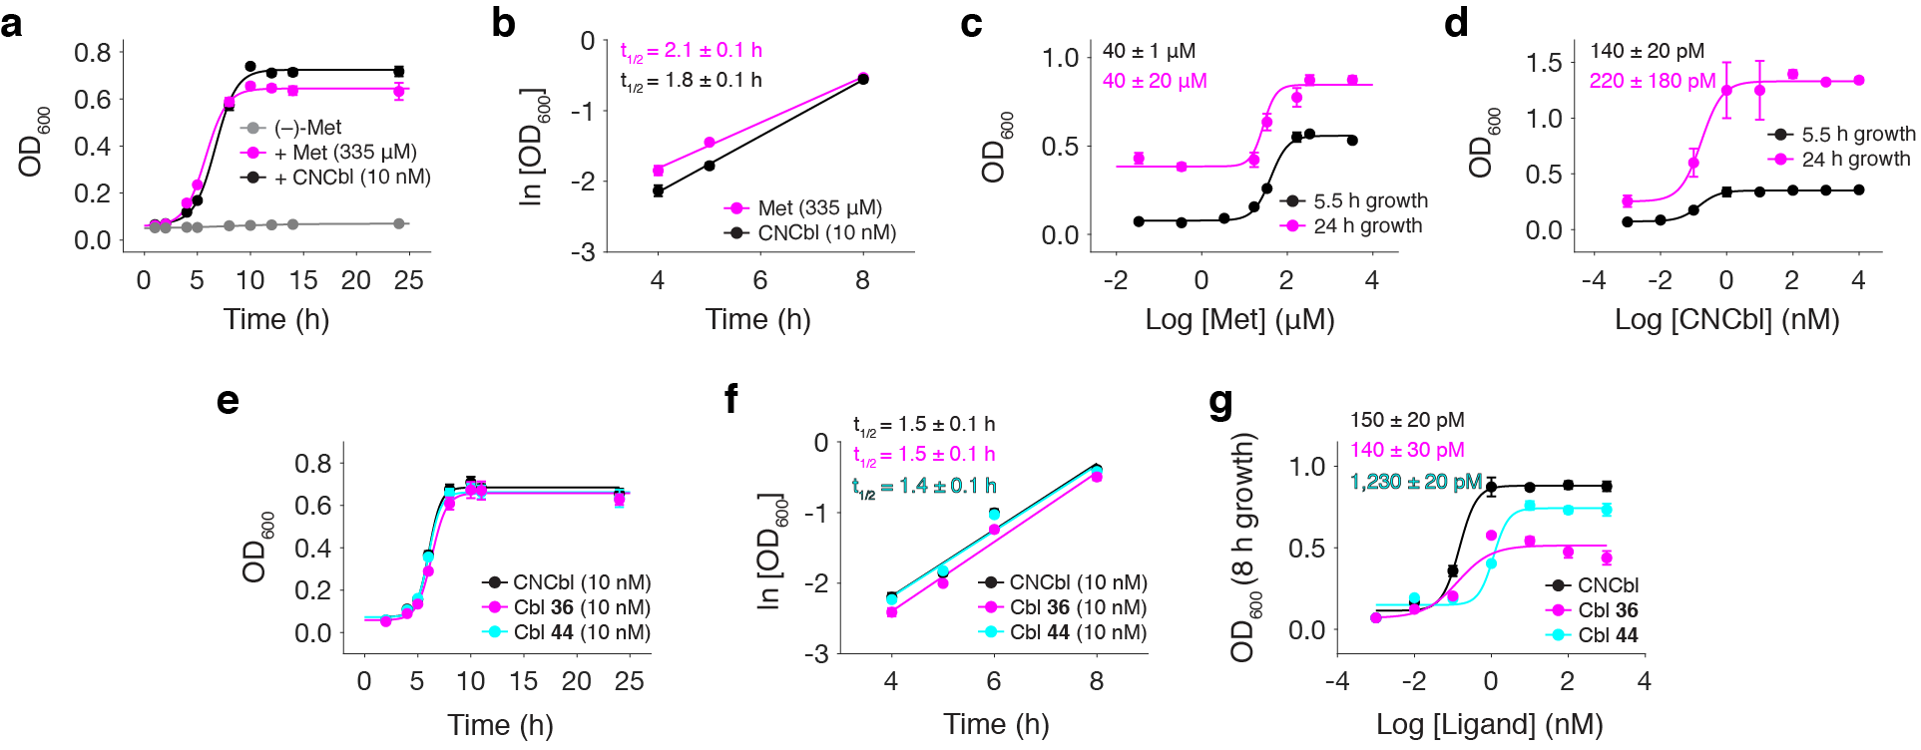

Extended Data Fig. 4. Growth experiments in ΔMetE cells. a, Growth (as measured by OD₆₀₀) curve of ΔMetE cells (which lack the Cbl-independent methionine synthase MetE) that were grown in methionine (Met)-dropout CSB media and supplemented with either Met or CNCbl. b, Plot of ln [OD₆₀₀] against time from the data in a where cell growth is exponential. The doubling time (t_{1/2}) is obtained from the slope. c, Titration of ΔMetE cells grown for a variable duration in increasing amounts Met. d, Same as in c but for titration of CNCbl. e, Same as in a but for CNCbl and Cbls 36 (strong repressor) and 44 (weak repressor). f, Same as in b but for the data in e. g, Same as in d but for cells grown for 8 hours in increasing amounts of CNCbl, 36, or 44. All t_{1/2}values and concentrations at which growth is at its half maximum are reported as mean and s.d. from biological replicates (n = 3).

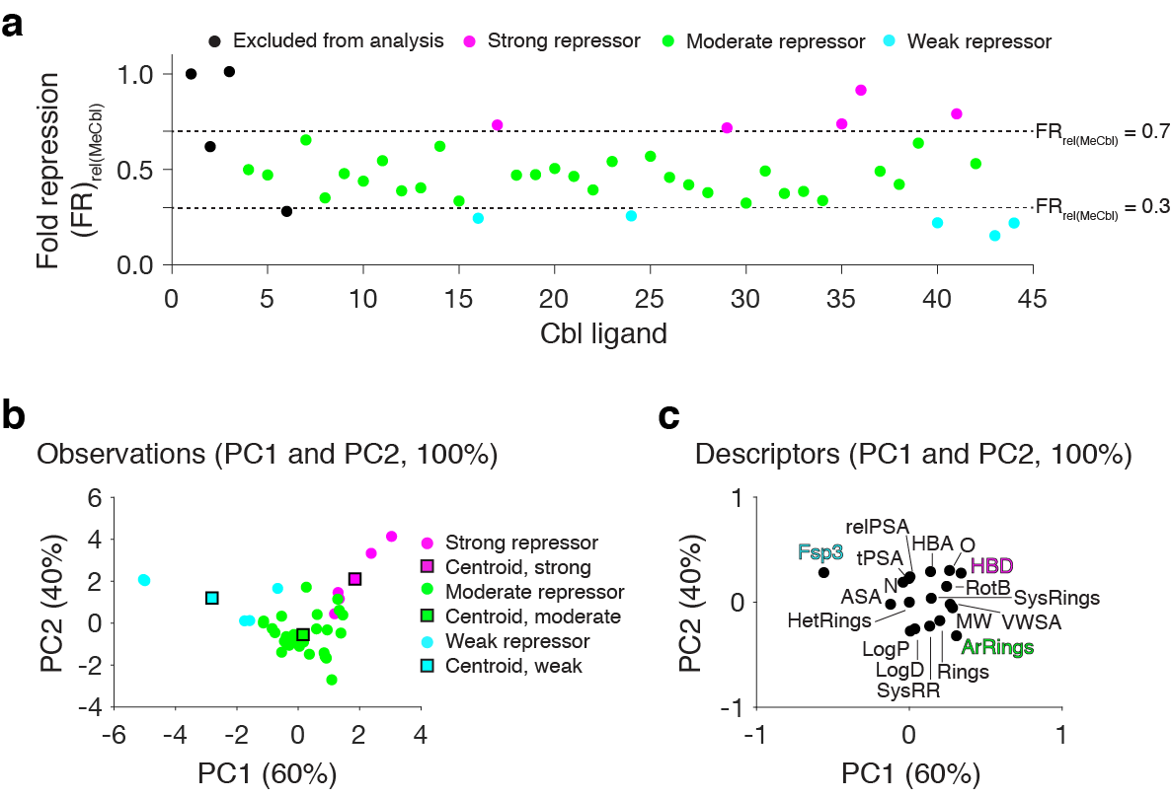

Extended Data Fig. 5. LDA of RNA functional data. a, Plot of the fold repression (FR) values for Cbls 1-44, where the data have been normalized to the value for MeCbl. On this basis, we clustered our derivatives into three groups: strong (FR_{rel(MeCbl)} <0.3), moderate (FR_{rel(MeCbl)} = 0.3-0.7), and weak (K_{D,rel(MeCbl)} >0.7) repressors. b, LDA plot for PC1 and PC2 depicting the clustering of the three functional groups and their centroids using chemoinformatic parameters (Supplementary Table 1). c, LDA loading plot of the contributions of each chemoinformatic parameter on PC1 and PC2, with the most obvious descriptor colored by the functional cluster that they best explain (e.g., number of aromatic rings, ArRings; number of hydrogen bond donors, HBD; and fraction of sp³ centers, Fsp³).

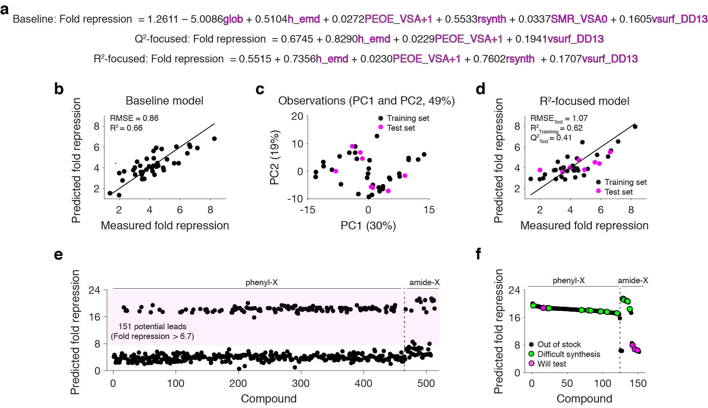

Extended Data Fig. 6. QSAR modeling framework to predict functional lead compounds. a, Written out MLR baseline, Q²-focused, and R²-focused models. The physical meaning of each physiochemical descriptor is listed in Supplementary Table 3. b, Measured fold repression values plotted with the value predicted by the baseline model that did not include a data split. c, Locations of the training and test set from the R²-focused modeling in two-dimensional chemical space constructed from PC1 and PC2 of the whole data set. d, Same as in b but for the R²-focused model. e, Average fold repression values predicted by our three models for each compound in the alkyne library. The magenta shaded box represents the 151 compounds that have a predicted fold repression greater than that of our current functional lead 36 (fold repression > 6.7). f, Rank-ordered plot the average fold repression values predicted by functional models for the 151 potential lead compounds that were identified from the alkyne library, separated by type (phenyl-X and amide-X). These compounds are classified as either “out of stock”, “difficult synthesis”, and “will test” as described in the legend of Extended Data Fig. 3.

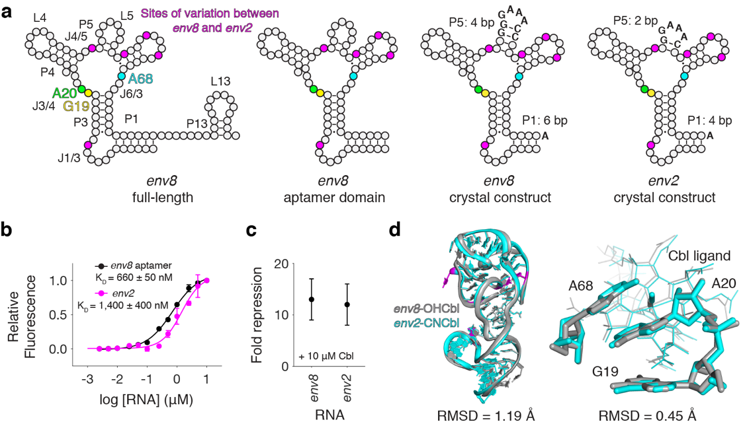

Extended Data Fig. 7. Validation of the env2 crystal construct. a, Schematic representation of the secondary structures of full-length env8, env8 aptamer domain, and the env8 and env2 RNA crystallography constructs. The binding pocket nucleotides G19 (yellow), A20 (green), and A68 (cyan) are colored and the sites of variation between the env8 and env2 RNA sequences are indicated in magenta. Other changes to the env8 wild-type RNA sequence are the insertion of a gGAAAc tetraloop at L5, the variable lengths of helices P1 and P5 (either four or six base pairs, bp), and a 3′-end adenosine, which were all incorporated to aid crystallization. b, Binding curve of the fluorescence induction of CNCbl-5×PEG-ATTO590 binding to env8 aptamer domain and env2 crystal construct. The K_{D} values are reported as mean and s.d. from independent experiments (n = 3). c, Fold repression values for our env8 and env2 reporter systems in the presence of 10 µM CNCbl, reported as mean and s.d. from biological replicates (n = 4). d, Co-crystal structure of env2-CNCbl aligned to the env8-OHCbl complex (PDB 4FRG²⁰). Global RNA architecture (left) is displayed as cartoon, with sites of variation between the env8 and env2 shown in magenta. The ligand binding pocket (right) is shown in sticks and shows very strong agreement between the two RNA-ligand complexes (RMSD = 0.45 Å). Given that env2 shows near-identical ligand binding, regulatory activity, and local and global RNA architecture, all structural information from env2 can be translated to env8.

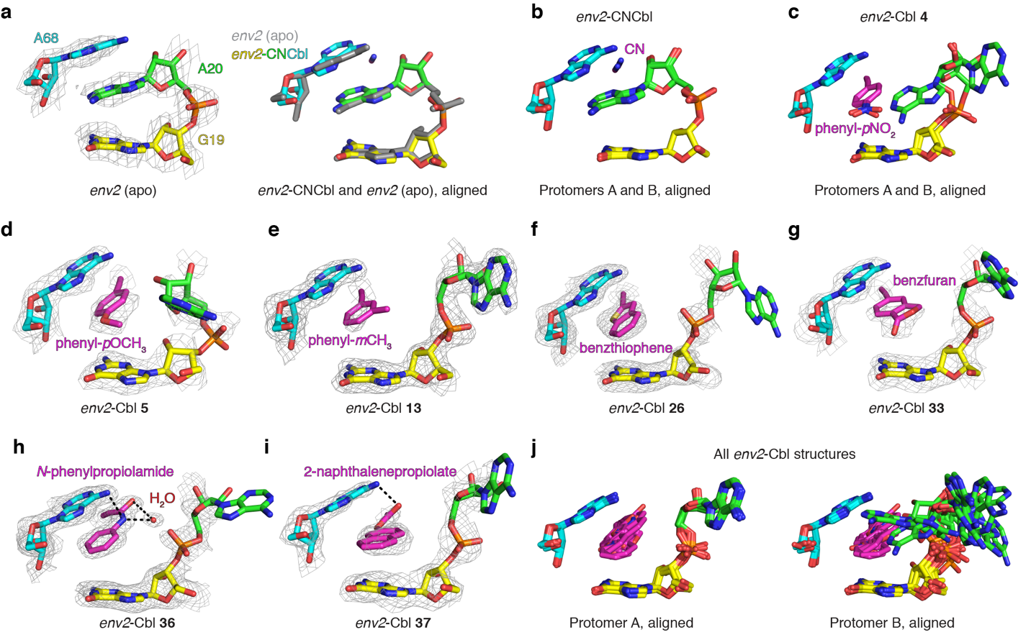

Extended Data Fig. 8. Additional env2-Cbl co-crystal structures. a, Crystal structure of env2 in the apo state showing only the binding pocket nucleotides (left). Alignment of the binding pockets of env2-CNCbl (protomer A) and the apo state (right). In all structural representations, the binding pocket nucleotides G19 (yellow), A20 (green), and A68 (cyan) are colored and the β-axial is shown in magenta. All mesh representations correspond to a simulated annealing 2F_{o}-F_{c} map where A20 and the ligand (if present) were omitted from the model and are shown at 1 σ contour. b, Our env2-CNCbl co-crystal structure has two molecules in the asymmetric unit (ASU). Protomer A is already shown in Fig. 4c. Here, we are showing an alignment of the binding pockets of both protomers, which are nearly identical. c, Our env2-Cbl 4 co-crystal structure also has two molecules in the ASU. Protomer B is already shown in Fig. 4d. Here, we are showing an alignment of the binding pockets of both protomers, which reveals a different orientation of A20. This was a common feature of all but one of our co-crystal structures. In each protomer A, A20 is locked in a crystal lattice contact. In each protomer B, we get a variable conformation of protomer B, suggesting that A20 is dynamic. This also explains why the electron density of A20 is well defined in protomer A but less so in protomer B. We will therefore focus on the more solution-representative protomer B in all analyses. d, Co-crystal structure of env2-Cbl 5 showing only the binding pocket nucleotides and the β-axial group. e, Same as in d but for env2-Cbl 13. This structure had four molecules in the ASU. In all four protomers, there is well defined density for A20 and minimal conformational variety (data not shown). f, Same as in d but for env2-Cbl 26. g, Same as in d but for env2-Cbl 33. h, Same as in d but for env2-Cbl 36. i, Same as in d but for env2-Cbl 37. j, Alignment of the binding pockets of protomers A (left) and B (right) for all the co-crystal structures shown here and in Fig. 4.

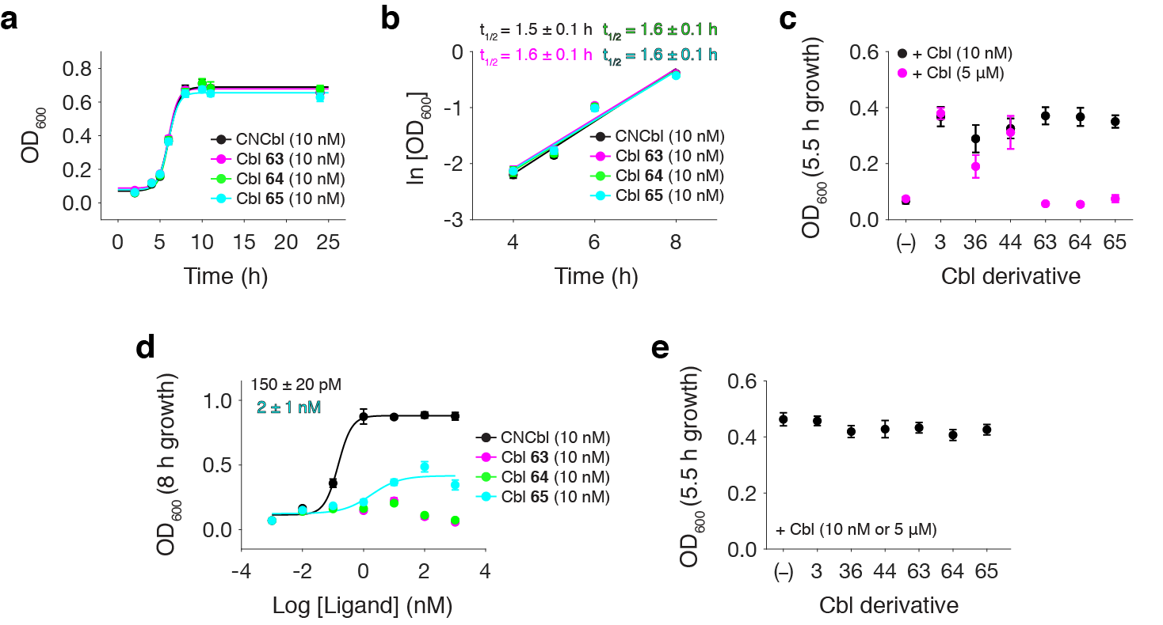

Extended Data Fig. 9. High concentrations of click Cbls inhibit ΔMetE cell growth. a, Growth (as measured by OD₆₀₀) curve of ΔMetE cells grown in Met-dropout CSB media and supplemented with either CNCbl or Cbls 63-65. b, Plot of ln [OD₆₀₀] against time from the data in a where cell growth is exponential. The t_{1/2} is obtained from the slope and is reported as mean and s.d. from biological replicates (n = 3). c, Growth of ΔMetE cells grown for 5.5 hours and supplemented with different Cbls. Here, (–) refers to cells without Met or Cbl supplemented to the media. d, Titration of ΔMetE cells grown for 8 hours in increasing amounts of CNCbl or Cbls 63-65. The concentration at which the growth is at its half maximum value is reported as mean and s.d. from biological replicates (n = 3). e, Growth of keio E. coli cells from the fold repression experiment shown in Fig. 5g. In this experiment, 10 nM CNCbl was added to all cells and excess amount of Cbls 36, 44, or 63-65 (5 µM) were also added to the growth media. Here, (–) refers to cells without any ligand added and 3 refers to cells with just 10 nM CNCbl added. Data are reported as mean and s.d. from biological replicates (n = 4). In contrast to ΔMetE cells, the growth of Keio cells is unaffected by high concentrations of Cbls.

