Supplementary Materials

Eliminating or decreasing matrix effect in skin moisturizers employing a magnetic adsorbent in the analysis of primary aliphatic amines
Mir Ali Farajzadeh ^{a, b*}, Sina Mohammad Mehri ª, Mohammad Reza Afshar Mogaddam ^{c, d, e}

ª Department of Analytical Chemistry, Faculty of Chemistry, University of Tabriz, Tabriz, Iran.
^{b} Engineering Faculty, Near East University, 99138 Nicosia, North Cyprus, Mersin 10, Turkey.
^{c} Food and Drug Safety Research Center, Tabriz University of Medical Sciences, Tabriz, Iran.
^{d} Chemistry and Chemical Engineering Department, Khazar University, 41 Mehseti Street, Baku AZ1096, Azerbaijan
^{e} Pharmaceutical Analysis Research Center, Tabriz University of Medical Sciences, Tabriz, Iran
*Corresponding author: M.A. Farajzadeh
Tel.: +98 41 33393084
Fax: +98 41 33340191
Email address: mafarajzadeh@yahoo.com; mafarajzadeh@tabrizu.ac.ir

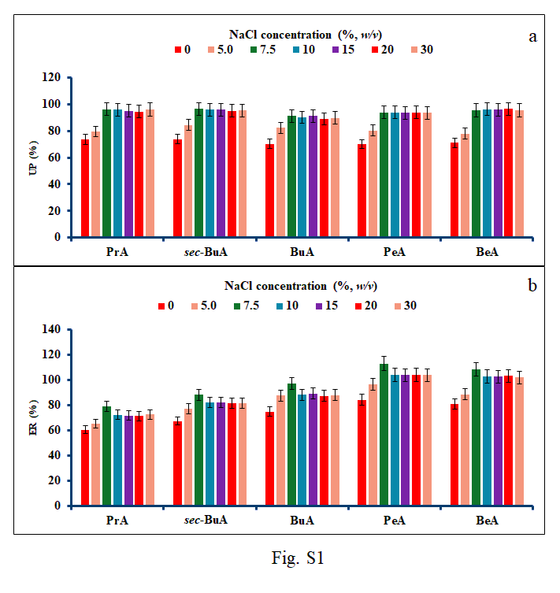
Fig. S1. Optimization of NaCl concentration used in DµSPE (a) and VALLME (b) steps.
Conditions correspond to those shown in Fig. 5, except NaCl was used to adjust ionic strength of solution.

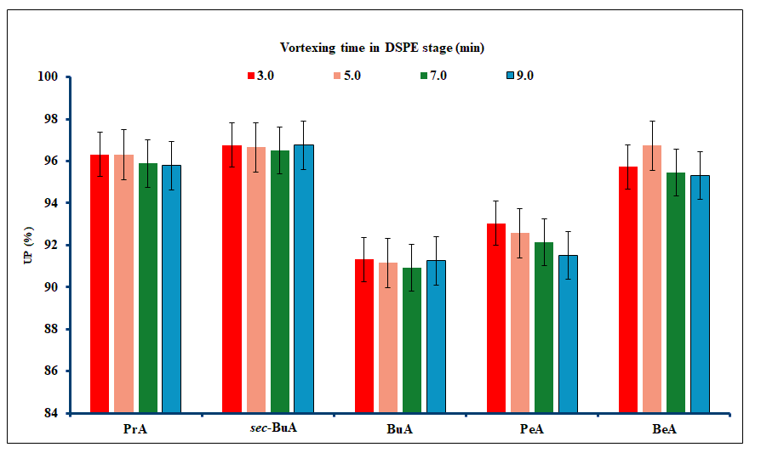
Fig. S2. Optimization of vortexing time in DµSPE step.
Experimental conditions were the same as those applied in Fig. S1, except NaCl at the concentration of 7.5 % (w/v) was used.

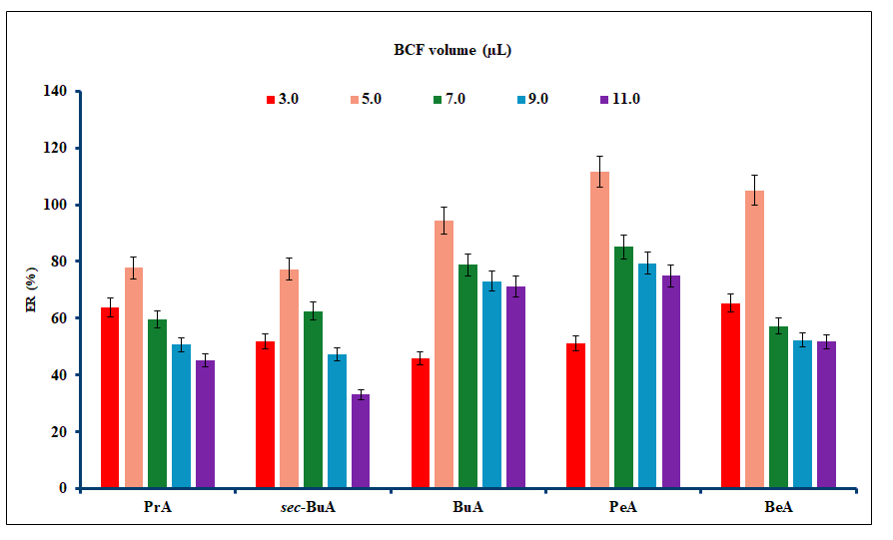
Fig. S3. Selection of volume of derivatization agent.
Experimental conditions were the same as those used in Fig. S2, except that the vortexing time was set at 3 min.

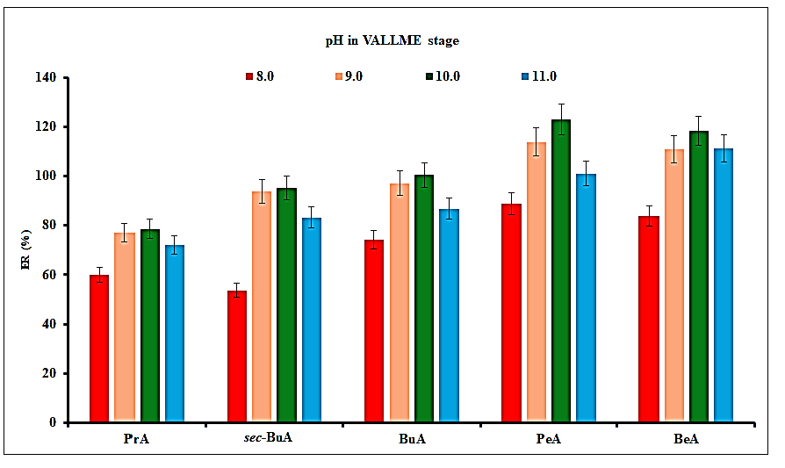
Fig. S4. Optimization of pH in VALLME stage.
Experimental conditions align with those illustrated in Fig. S3, except 5 µL BCF was used.

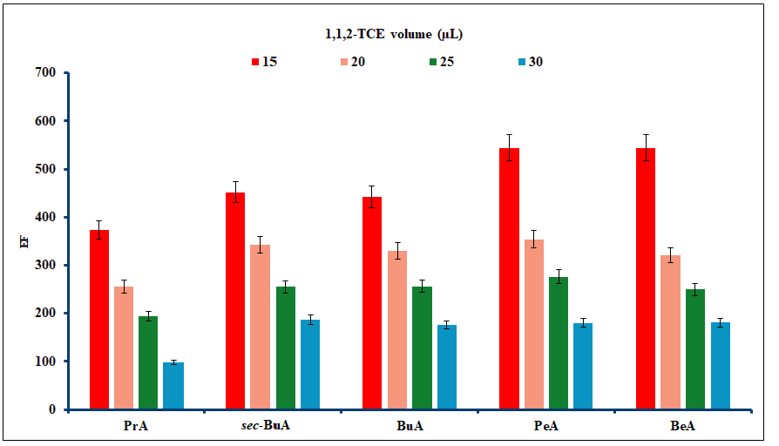
Fig. S5. Selection of the optimal volume of 1,1,2-TCE.
Experimental conditions were the same as those shown in Fig. 6, except 1,1,2-TCE was utilized as the extraction solvent.

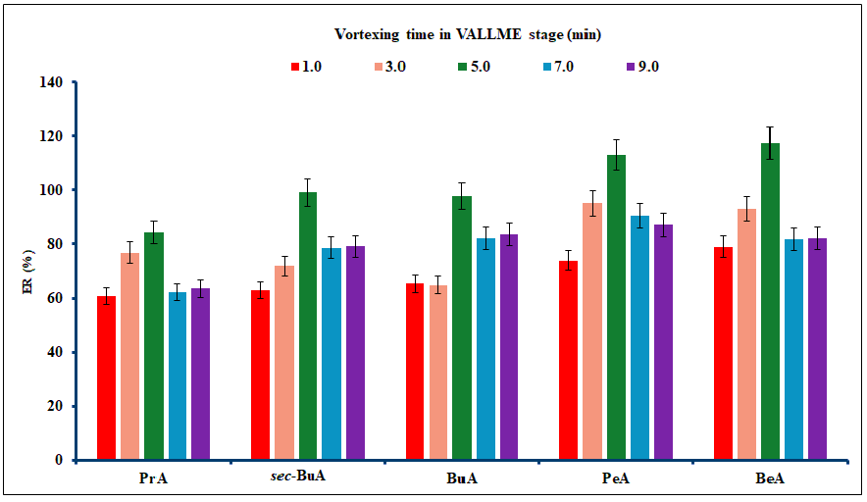
Fig. S6. Optimization of vortexing time in VALLME step.
Experimental conditions were the same as those shown in Fig. S5, except 15 µL of 1,1,2-TCE was used as the extractant.

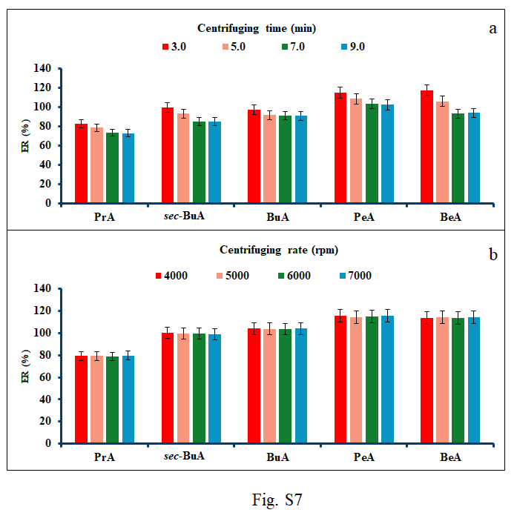
Fig. S7. Investigating the influence of centrifugation time (a) and rate (b).
Experimental conditions are congruent with those depicted in Fig S6, except that the vortexing time was set at 5 min.

