SUPPLEMENTARY MATERIALS

Supplementary Figure 1. Directed acyclic graph for outcome of a single lactate measurement on day 1 of hospital admission
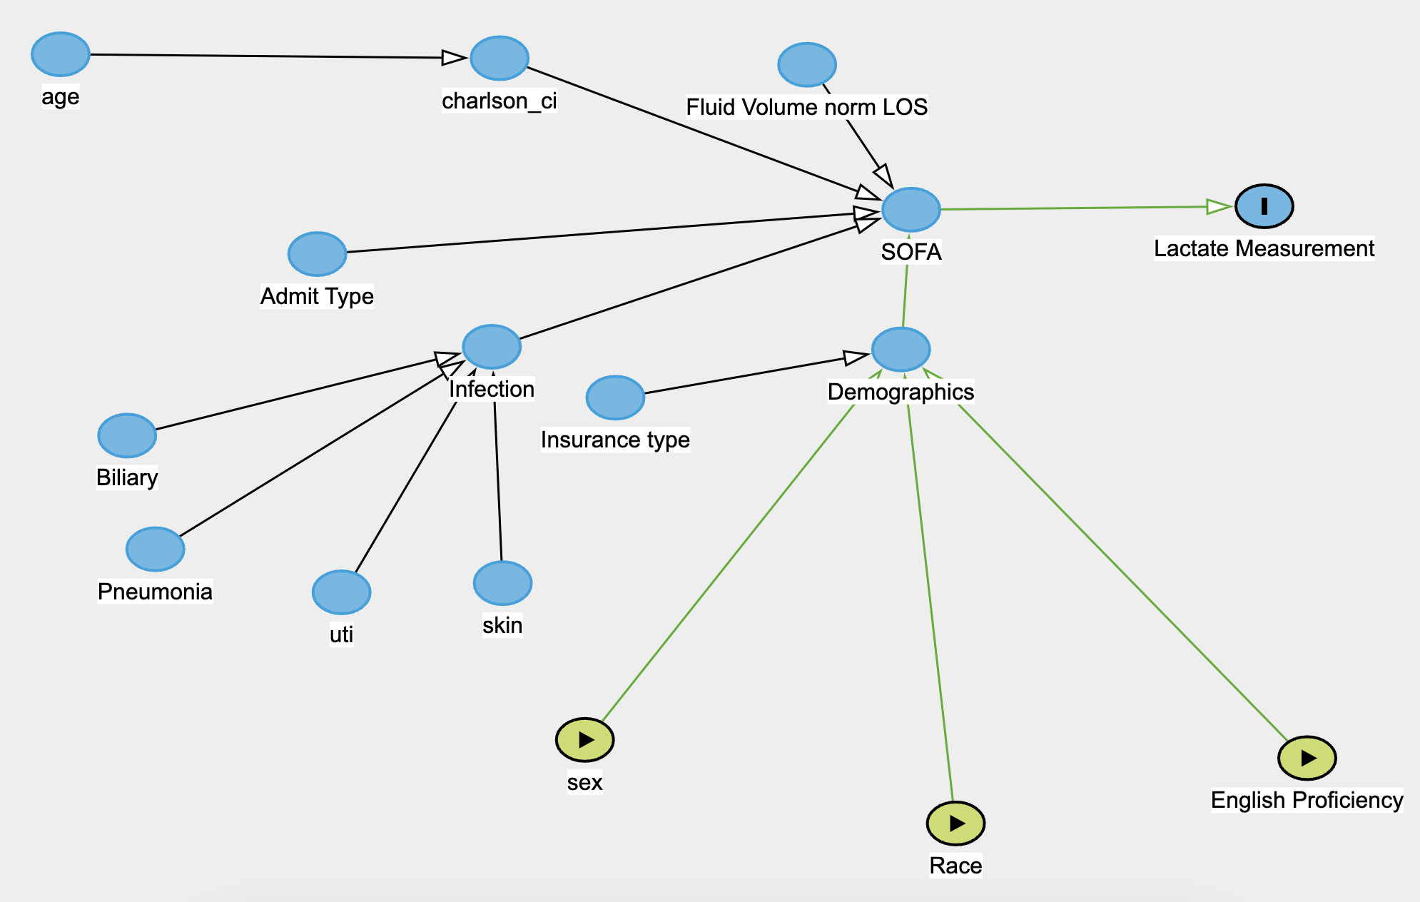
Legend: Race ethnic group includes Whites, Blacks, Hispanics, and Asians.
Abbreviations: charlson_ci, Charlson comorbidity score; SOFA, sequential organ failure assessment; uti, urinary tract infection; LOS, length of stay; REF, reference

Supplementary Table 1. Definition of considered covariates
Covariates | Description | Handling of missing values
Sex | As provided by dataset | N/A
Age | At admission | N/A
Race Ethnicity | Grouped into Asian, Black, White, Hispanic, and Other | Exclusion of group “Other”
Insurance | As provided by dataset, Medicare/Medicaid or other | N/A
English Proficiency | As provided by dataset, English or limited | N/A
Year Group | As provided by dataset, bi-yearly bins | N/A
Elective Admission | As provided by dataset, true or false if admission is elective | N/A
Charlson comorbidity Index | As provided by dataset | N/A
Fluid Volume Normalized by Length of Stay | As provided by dataset | Mean Imputation
SOFA | SOFA score with each of its  subcomponents: on admission and for the selected 24 hours, aggregated by the maximum value | Assumption of best possible value in case of missing
Source of infection | ICD-10 codes J09.X, J1.X, J85.X, J86.X, N300.X, N390.X, K81.X, K830.X, K851.X, L0.X | Zero Imputation
Lactate | MIMIC-IV Item IDs 50813, 52442, 53154 | Assume no lactate measurement if no entries.
Legend: X denotes a wild card character
Abbreviations: SOFA, sequential organ failure assessment

Supplementary Table 2. Likelihood of receiving a lactate measurement on day 1 fitted by a Logistic regression model

Demographic | OR | 2.50% CI | 97.5% CI
White | Reference
Black | 1.11 | 1.09 | 1.13
Asian | 0.95 | 0.89 | 0.99
Hispanic | 0.9 | 0.84 | 0.97
Male Sex | Reference
Female Sex | 0.99 | 0.97 | 0.99
English proficient | Reference
English non-proficient | 1.00 | 1.00 | 1.00
Abbreviations: OR, odds ratio; CI, confidence interval

