Cascading effects of soil salinization to soil biodiversity-multifunctionality relationship

Supplementary Information
Supplementary Text 1. Methods of soil physical and biochemical analysis
Soil EC and pH values are determined in a 1:5 soil-to-water suspension using a soil conductivity meter and pH meter, respectively¹. Soil texture, including the percentage content of sand, silt, and clay, is measured with a MasterSizer 2000 laser particle size analyzer². Soil aggregation is assessed using the dry sieving method with sieve sizes of 2 mm, 1 mm, 0.5 mm, 0.25 mm, and 0.053 mm, followed by calculations of average mass diameter (MWD) and geometric mean diameter (GMD), aggregates larger than 0.25 mm are defined as water-stable aggregates (R0.25)³. The bulk density (BD) of undisturbed soil and soil porosity are determined using the ring knife method⁴. Total soil organic carbon (SOC) is measured in all composite samples after oxidation with a mixture of potassium dichromate and sulfuric acid, followed by colorimetric determination⁵. Total soil nitrogen (TN) is assessed using an elemental analyzer (C/N Flash EA 112 Series Leco TruSpec)⁶. Total phosphorus (TP) in all composite samples is determined after nitric acid-perchloric acid digestion using an inductively coupled plasma optical emission spectrometer (ICAP 6500 DUO; Thermo Scientific)⁷. Carbon-to-nitrogen, carbon-to-phosphorus, and nitrogen-to-phosphorus ratios are calculated based on the elemental proportions. Total potassium (TK) is extracted using hydrofluoric acid digestion, and available soil potassium (AK) is extracted with neutral ammonium acetate, followed by flame photometry for quantification⁸. Alkali-hydrolyzable nitrogen (AN) is determined after alkaline hydrolysis, with borate absorption and subsequent standard acid titration⁹. Available phosphorus (AP) in the soil is measured after sodium fluoride-hydrochloric acid extraction, using the colorimetric method¹⁰. Microbial biomass carbon (MBC), microbial biomass nitrogen (MBN), and microbial biomass phosphorus (MBP) are determined using the chloroform fumigation method¹¹. The activity of soil β-glucosidase (BG) is measured colorimetrically¹². The activity of phosphatase enzymes in the soil is determined spectrophotometrically¹³. Dehydrogenase enzyme activity is assessed based on iodonitrotetrazolium chloride method¹⁴. Urease enzyme activity is measured using the indigo method by monitoring the production of ammonia¹³. Sucrase enzyme activity in the soil is determined with the generation of reducing sugars measured. N-acetyl-β-glucosaminidase (NAG) activity is assessed with the production of p-nitrophenol measured¹⁵. Leucine aminopeptidase (LAP) activity is determined using the p-nitrophenyl substrate method, with the generation of p-nitroaniline measured¹⁶. Cellobiosidase enzyme activity in the soil is measured colorimetrically by monitoring the production of p-nitrophenyl cellobioside¹⁷. Catalase enzyme activity is determined, with the change in absorbance due to the decomposition of hydrogen peroxide measured¹⁸.

Supplementary Text 2. Detailed steps of a bioinformatics pipeline
Following sequencing, the raw data were meticulously processed to eliminate low-quality sequences and contaminants, specifically adaptor and host sequences, utilizing the Fast QC (version 0.11.8) and BWA (version 0.7.12) software packages¹⁹. Subsequently, the refined reads underwent assembly via MEGAHIT (version 1.1.1), with a minimum contig length threshold set at 500 bp. Contigs exhibiting less than 60% coverage were excluded using Salmon²⁰. Gene prediction was then performed on the assembled contigs using Prodigal (version 2.6.3), and the resultant open reading frames (ORFs) were clustered into a non-redundant set by applying CD-HIT (version 4.6.7) with a 95% sequence identity cutoff²¹. Subsequently, a pan-metagenome was constructed to assess alterations in metagenome functionality subsequent to the introduction of a starter culture. Clean reads were utilized to generate contigs for each sample using MegaHit, with a minimum contig length parameter of 500 bp²². ORFs were predicted from these assembled contigs via Prodigal, and clustering with CD-HIT yielded a unique set of genes²¹. The longest sequence within each cluster was designated as the representative gene for the unique gene set²³. Salmon was employed to quantify gene abundance across samples by tallying the reads per gene²⁰.

Supplementary Text 3. Differences in abundance of different biological communities in non-salinized and salinized soils.
By comparing the changes of the top ten genera in the five microbial communities (bacteria, fungus, archaea, protist, and metazoans) under non-saline and saline soil, we found that Anaerolinea, Pseudarthrobacter, Polaromonas, Mrakia, Mortierella, and Chlamydomonas decreased significantly in the saline soil (P < 0.05) (Fig. S3A, B, D). These microbial groups are extensively involved in the decomposition of soil organic matter and the cycling of nutrients, and their significant reduction in abundance leads to a weakened association with soil-related functions compared to non-salinized soils (Fig. S7A, B). However, the abundance of Fusarium increased significantly in high salinity environments (P < 0.05) (Fig. S3B), and it is significantly correlated with soil pathogen control functions in salinized soils (Fig. S7B). The abundance of certain microbial species highly adapted to saline environments increased significantly (such as Archaeorhizomyces and Halalkalicoccus) (P < 0.05) (Fig. S3B, C), which may enhance functions related to salt conversion and cycle. In protist communities, Deviata and Pseudochilodonopsis showed decreased abundance in salinized soils (P < 0.05) (Fig. S3D), and they are significantly correlated with soil water regulation capabilities and plant productivity functions in salinized soils (Fig. S7B). In metazoans communities, the abundance of Ilyocypris decreased, while the abundance of Flamella and Acrobeloides groups increased in salinized soils (P < 0.05) (Fig. S3E). These groups of organisms may play an important role in maintaining soil symbiotic relationships, pathogen control, and ARG control in salinized soils (Fig. S7B).

Supplementary Text 4. Logic behind model construction and references for structural equation model
Fig. S10 Briefly described the logic behind model construction for structural equation model to dissect the influences of soil salinization on various biological communities.
① Soil salinization may directly influence the diversity and community composition of soil fungi²⁴.
② Soil salinization directly affects the diversity and community composition of archaea²⁵.
③ Soil salinization directly impacts the community composition of metazoans and soil fauna²⁴.
④ Fungi and bacteria jointly participate in organic matter decomposition in soil, but they exhibit different efficiencies in decomposing organic matter of varying complexity. Bacteria are more efficient in utilizing simple organic compounds, whereas fungi have an advantage in decomposing complex organic compounds such as lignin and cellulose²⁶. This difference leads to competition between them in the decomposition process, with fungi decomposing complex organic matter and releasing simple organic compounds that are subsequently utilized by bacteria²⁶. Therefore, the richness and diversity of soil fungi have a significant impact on the assembly of bacterial communities. Studies have shown that an increase in fungal richness alters the β-diversity of bacterial communities, i.e., the degree of change in community composition²⁷. Fungi decompose refractory organic matter through the secretion of extracellular enzymes, providing substrates for bacteria and thereby influencing the structure and function of bacterial communities²⁶. In the context of soil salinization, competition between fungi and bacteria intensifies, which affects the stability and function of soil bacterial communities, subsequently exerting profound impacts on soil health and ecosystems²⁸.
⑤ The activities of soil fungi can alter the community structure of soil archaea. This change may result from fungi altering the soil's chemical environment through their metabolic activities, thereby influencing the survival conditions of archaea²⁹.
⑥ Protozoa are one of the primary predators of bacteria, obtaining nutrition by preying on them³⁰. This predation behavior significantly affects the structure and function of bacterial communities, for example, by reducing the abundance and diversity of certain bacteria³¹. Some bacteria can survive within protozoan cells, forming endosymbiotic relationships³². This symbiosis not only protects bacteria from predation but also provides them with a relatively stable living environment conducive to their growth and reproduction. For instance, Legionella pneumophila can survive within Acanthamoeba cells and use them as a transmission vector.
⑦ Archaea serve as a food source for animals. For example, in deep-sea methane seep ecosystems, symbiotic aggregates formed by archaea and bacteria are the primary food source for certain annelid worms³³.
⑧ Protozoa are one of the main predators of numerous small multicellular organisms, such as nematodes and rotifers³⁴. They obtain nutrition by preying on these multicellular organisms, thereby influencing the population density and distribution of metazoans. Protozoa and metazoans compete for resources³⁴. For example, in soil ecosystems, protozoa and metazoans (such as nematodes) both prey on bacteria, and their competition affects their respective positions and functions within the ecosystem.

Fig. S11 Briefly described the logic behind model construction for structural equation model to dissect the interconnections between soil multitrophic biodiversity and soil function.
①Soil salinization directly influences soil microbial communities²⁸.
②Soil salinization reduces soil porosity, diminishing the soil's water regulation capacity³⁵, as well as affecting the activity of soil pathogens²⁴.
③Soil salinization changed soil structure significantly³⁶.
④Soil salinization leads to salt stress in crops, affecting crop productivity^{37, 38}. Besides, soil salinization directly affects fungal communities, impacting the activity of arbuscular mycorrhizal fungi, and consequently, soil symbiotic relationships²⁸.
⑤Soil salinization directly affects the availability of nitrogen, phosphorus, and potassium, thereby impacting soil fertility^{39, 40, 41}. The soil's carbon sequestration function is highly correlated with soil nutrient availability⁴².
⑥⑦Soil salinization directly influences microbial communities, which further impact the expression of antibiotic resistance genes⁴³.
⑧Microbial communities alter soil nitrogen and phosphorus mineralization, the absorption and maintenance of available potassium and magnesium, thereby affecting the effectiveness of soil fertility^{5, 39, 44}. Besides, soil microbial communities affect the decomposition process of soil organic matter⁴⁵. Further, soil microbial communities impact the soil's carbon sequestration function through the microbial carbon pump^{45, 46}.
⑨The expression of antibiotic resistance genes affects crop productivity⁴⁷.
⑩The decomposition process of soil organic matter affects crop productivity⁴⁸. The soil's carbon sequestration function is highly correlated with crop productivity⁴⁹.
⑪Soil carbon sequestration capacity, nutrient availability, and soil structure are usually highly correlated³⁶.
⑫Soil structure affects crop growth, thereby influencing crop productivity⁵⁰.
⑬The soil structure significantly affects the hydraulic characteristics of the soil and may have an impact on the control function of pathogenic bacteria³⁵.

Supplementary Text 5. Details of performing K-means clustering analysis
To determine the optimal number of clusters, we calculated the within groups sum of squares for varying numbers of clusters. Specifically, we computed the within groups sum of squares (WSS) values for 1 to 15 cluster centers and plotted the elbow chart (Fig. S10). The elbow chart, by graphing the relationship between WSS and the number of clusters, helps us visually identify the "elbow point" of the cluster number, where the rate of decrease in WSS significantly slows down, which is generally considered the optimal number of clusters⁵¹. The results indicate that when the number of clusters is 5, the rate of decrease in the within-cluster sum of squares significantly slows down, suggesting that 5 cluster centers can adequately describe the structure of the data. Finally, the k-means algorithm was used for cluster analysis of the data⁵².

Supplementary Text 6. Details of constructing generalized linear model
In our analysis, we initially transformed the variables to satisfy the assumptions of Generalized Linear Models (GLMs), including proper scaling or normalization of the response variable⁵³. For model specification, we formulated a GLM for each soil factor in conjunction with EC, incorporating both the main effects and their interaction. The model was articulated as:
Response ∼ Soil Factor + EC + Soil Factor × EC
where an appropriate link function was selected based on the response variable's distribution; a Poisson link for count data or a logistic link for binary data. Utilizing the glm function from the "stats" package in R, we fitted the models, meticulously verifying the assumptions, including residual distribution and the exclusion of multicollinearity among predictors⁵⁴. Subsequently, we appraised the models' fit through diagnostic plots and statistics such as residual analysis, deviance, and the AIC. Hypothesis tests were conducted on the model coefficients to assess the significance of the main effects and the interaction term. The coefficients of the GLMs were interpreted to elucidate the separate and joint impacts of soil factors and EC on the response variable, with confidence intervals used to evaluate the accuracy of these estimates and to report the significance levels of the coefficients⁵⁴. Finally, to ascertain the most fitting model, we compared models both with and without interaction terms, using AIC as the criterion to select the model with the lowest value, indicating a better balance between model fit and complexity.

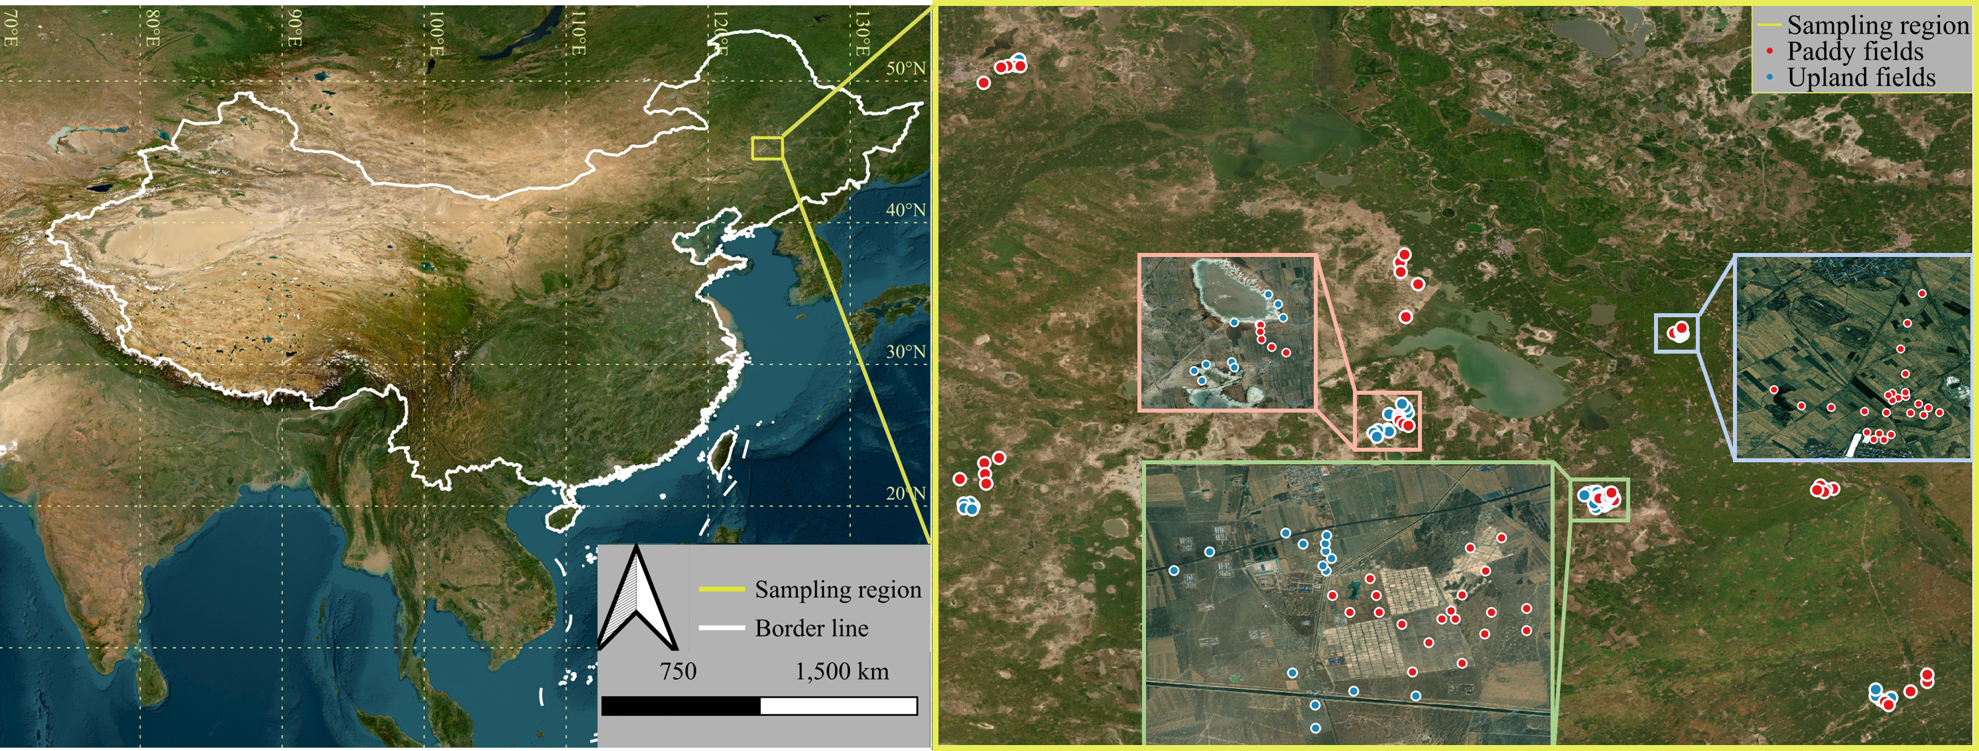
Fig. S1 Sampling region and specific distribution of 115 plots

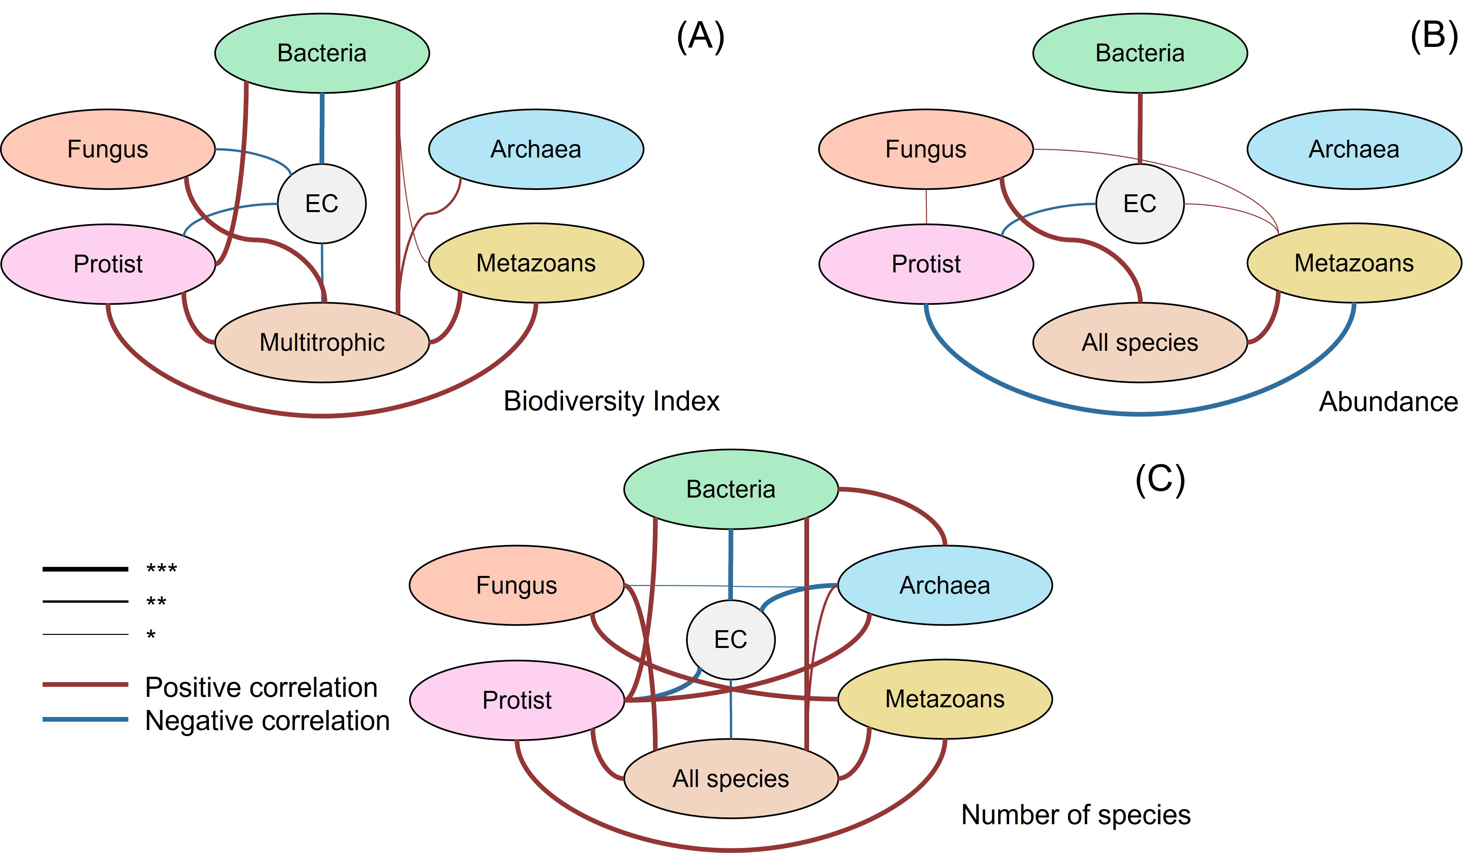
Fig. S2 Spearman correlation coefficients for soil EC, soil multidiversity (A), abundance of different soil biota groups (B), and number of soil biota species (C).

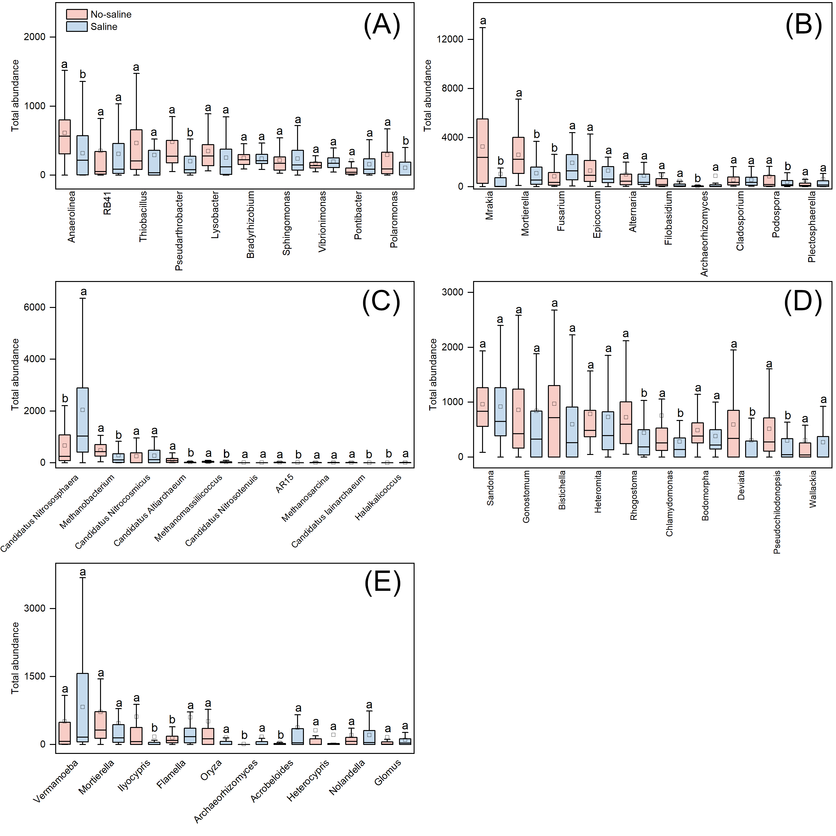
Fig. S3 Total abundance of top 10 genera in Bacteria (A), Fungus (B), Archaea (C), Protist (D) and Metazoans (E) community. Different lowercase letters indicate significant differences in total abundance between non-saline and saline soils.

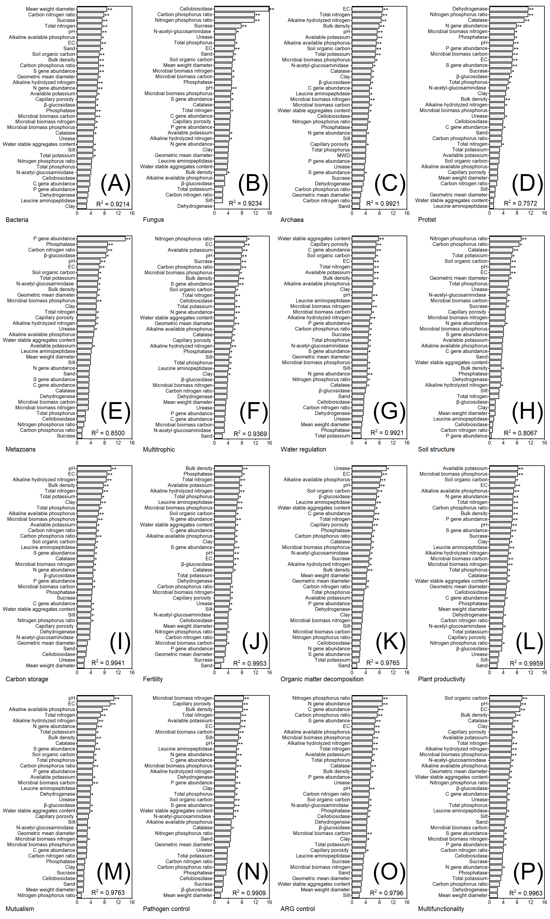
Fig. S4 Importance of soil properties in driving the distribution of soil multidiversity, individual soil function, and multifunctionality. We used a random forest algorithm to estimate the importance of environmental factors and presented their importance value as an increase in mean squared error (IncMSE, %). The numbers in the boxes represent the variation explained by the model, and asterisk above bars denotes a significant influential factor at the significance level. * represents P value < 0.05, ** represents P value < 0.01, *** represents P value < 0.001. Same below.
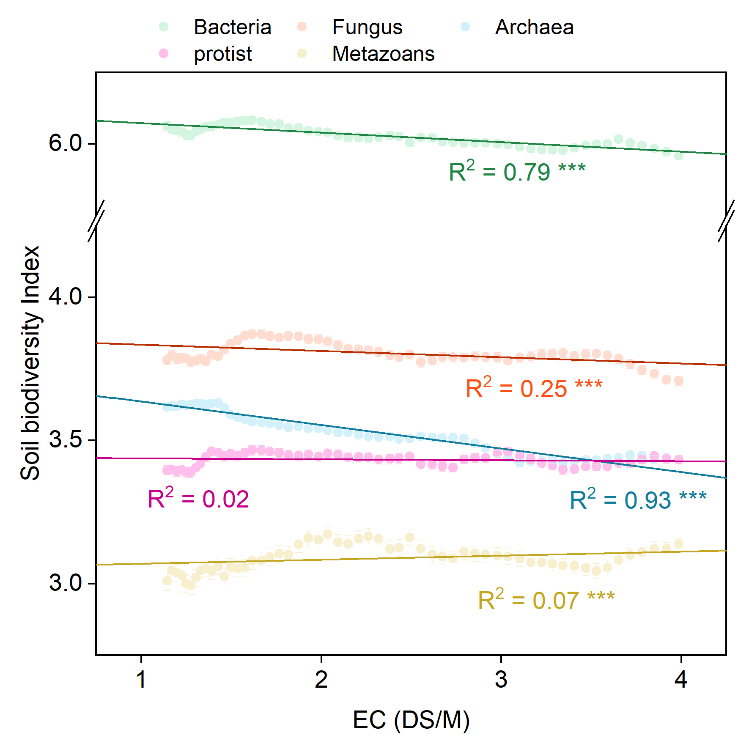
Fig. S5 Linear regression relationship between individual soil diversity index and soil EC.

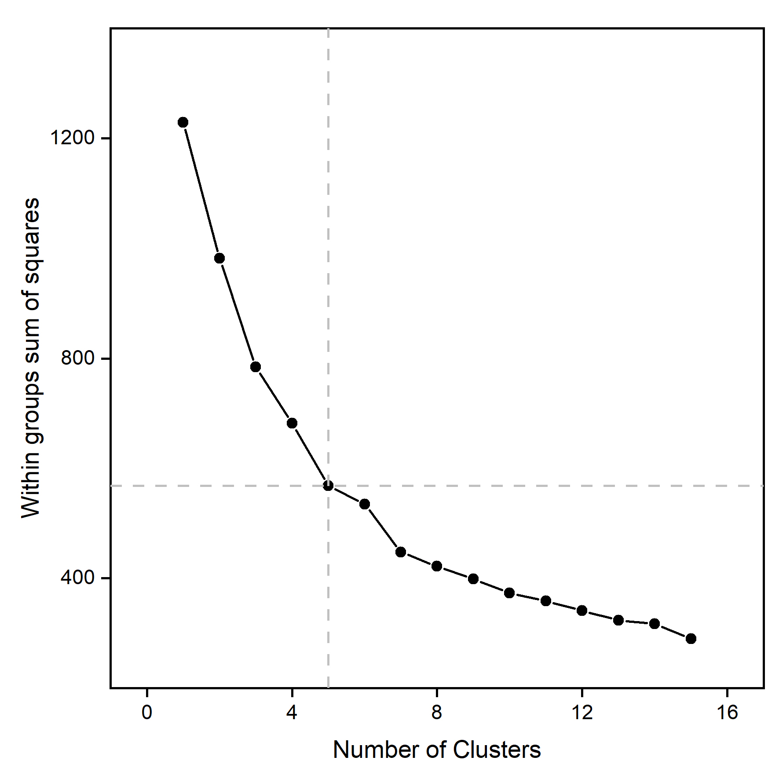
Fig. S6 The relationship between Number of Clusters and Within groups sum of squares

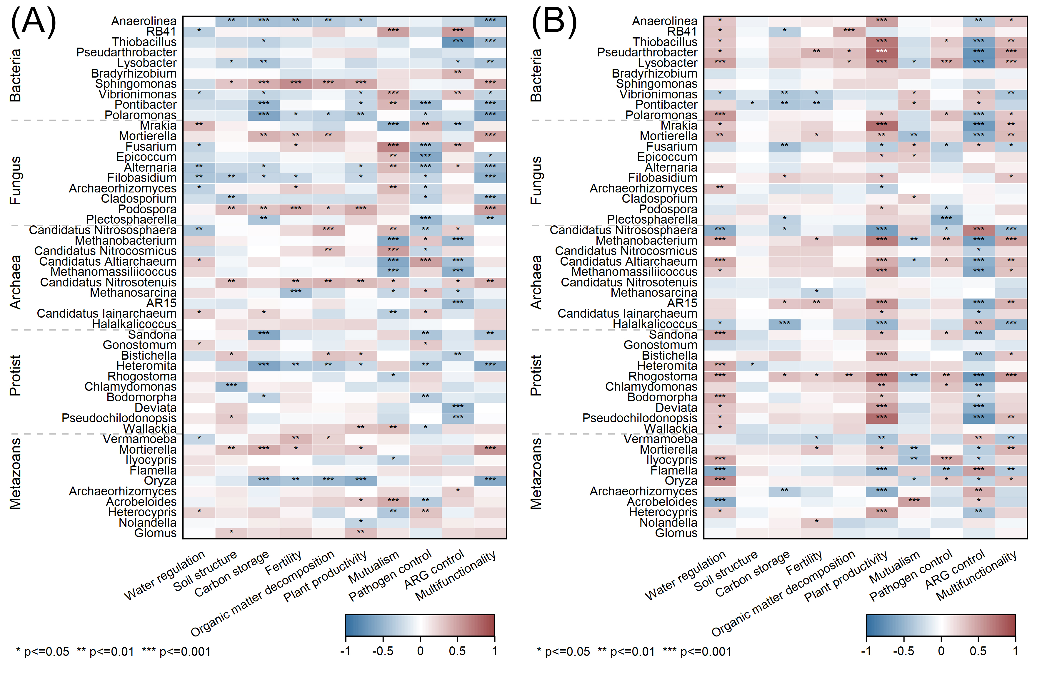
Fig. S7 The Spearman correlation coefficient between the abundance of the top 10 dominant genus groups in the main soil communities and soil function, in both non-saline (A) and saline soils (B).

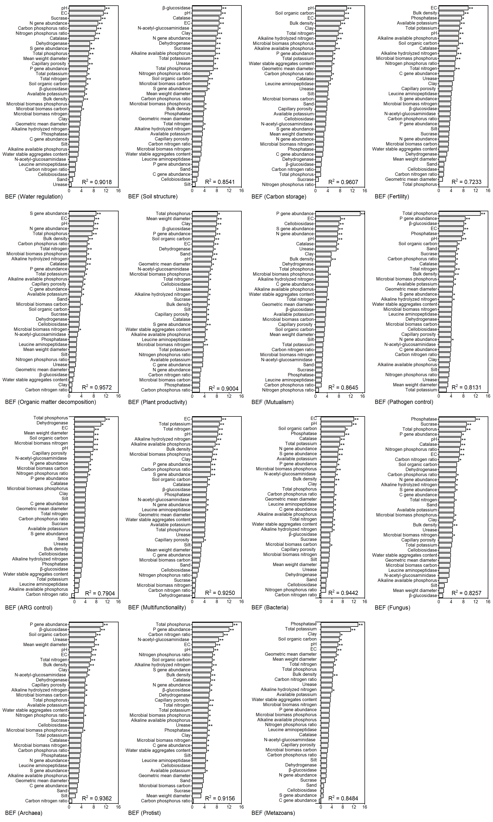
Fig. S8 Importance of soil properties in driving the distribution of the local relationship between soil multidiversity and ecosystem function (BEF).

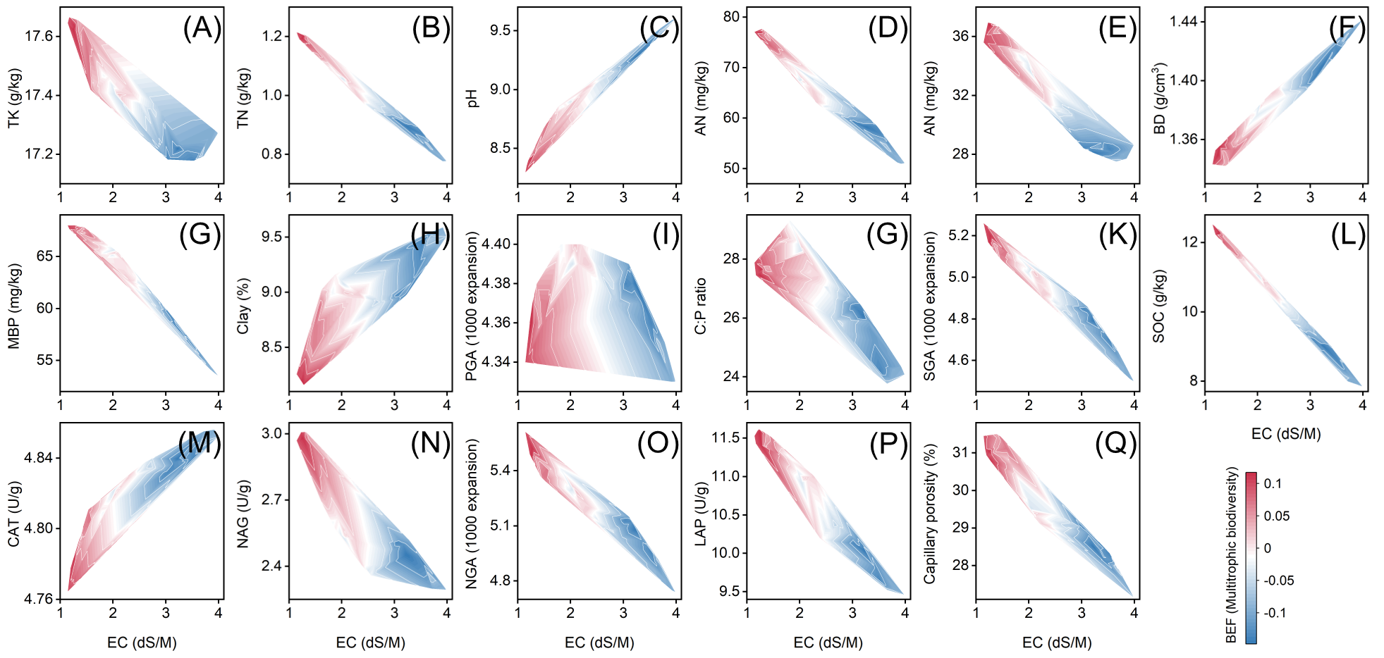
Fig. S9 Heatmap of the BEF relationship (soil multitrophic diversity and multifunctionality) with soil salinization and other soil factors. The red, white, and blue colors represent key information about the BEF relationship as soil salinization and environmental factors. TK, Total potassium; TN, Total nitrogen; AN, Alkaline hydrolyzed nitrogen; BD, Bulk density; MBP, Microbial biomass phosphorus; PGA, P gene abundance; C:P ratio, Carbon phosphorus ratio; SGA, S gene abundance; SOC, Soil organic carbon; CAT, Catalase; NAG, N-acetyl-glucosaminidase; NGA, N gene abundance; LAP, Leucine-aminopeptidase.

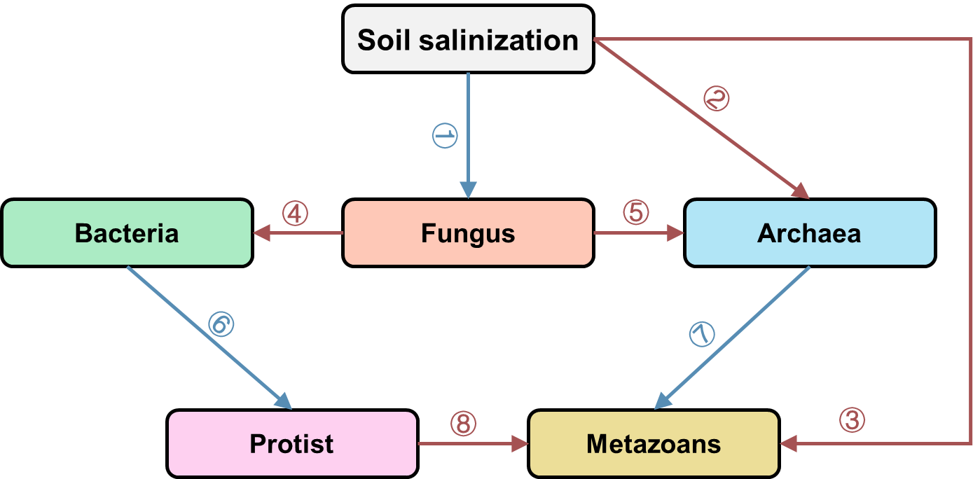
Fig. S10 The logic behind model construction for structural equation model to dissect the influences of soil salinization on various biological communities.

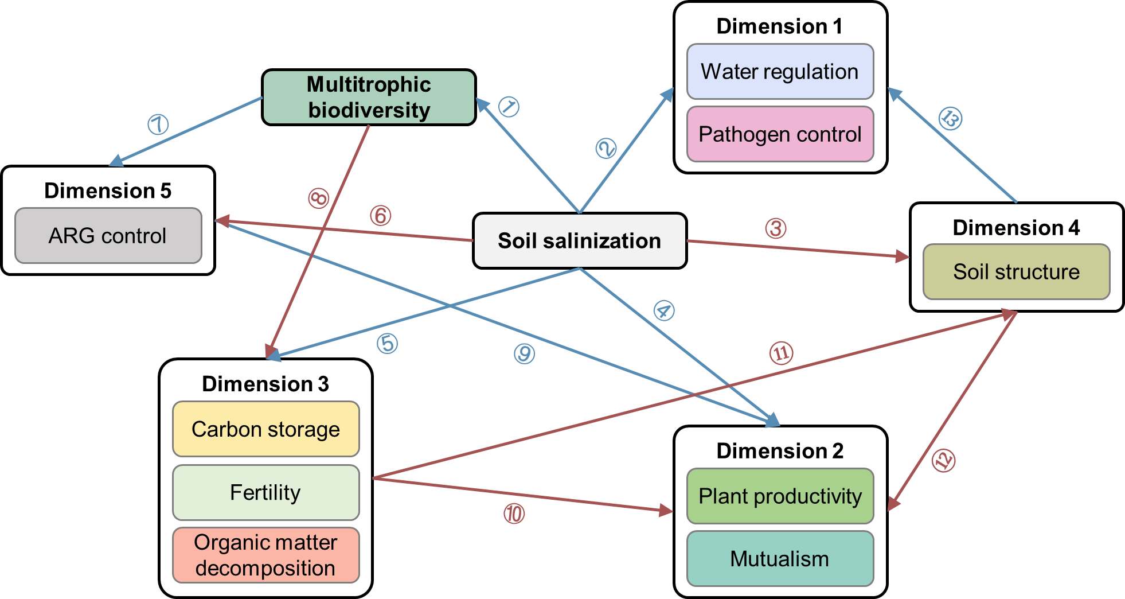
Fig. S11 The logic behind model construction for structural equation model to dissect the interconnections between soil multitrophic biodiversity and soil function.

Table S1 Basic information of 115 plots
Sampling location num | Cultivation period (year) | EC (dS/M) | Types of cultivated crops | 5-YEAR average yield (t/ha)
1 | 1 | 4.19 | Paddy fields (rice) | 1.5
2 | 1 | 4.64 | Paddy fields (rice) | 1.84
3 | 1 | 4.74 | Paddy fields (rice) | 1.72
4 | 1 | 2.55 | Paddy fields (rice) | 1.69
5 | 1 | 4.52 | Paddy fields (rice) | 1.75
6 | 3 | 1.93 | Paddy fields (rice) | 4.72
7 | 3 | 1.5 | Paddy fields (rice) | 4.56
8 | 3 | 1.99 | Paddy fields (rice) | 5.03
9 | 3 | 2.25 | Paddy fields (rice) | 5.06
10 | 3 | 1.82 | Paddy fields (rice) | 5.22
11 | 5 | 3.1 | Paddy fields (rice) | 8.6
12 | 5 | 1.72 | Paddy fields (rice) | 8.68
13 | 5 | 2.3 | Paddy fields (rice) | 9.14
14 | 5 | 1.96 | Paddy fields (rice) | 8.56
15 | 5 | 2.13 | Paddy fields (rice) | 8.98
16 | 10 | 0.63 | Paddy fields (rice) | 9
17 | 10 | 0.85 | Paddy fields (rice) | 8.41
18 | 10 | 0.66 | Paddy fields (rice) | 8.09
19 | 10 | 0.68 | Paddy fields (rice) | 8.54
20 | 10 | 0.6 | Paddy fields (rice) | 8.84
21 | 15 | 0.91 | Paddy fields (rice) | 8.58
22 | 15 | 1.43 | Paddy fields (rice) | 8.34
23 | 15 | 1.45 | Paddy fields (rice) | 9.05
24 | 15 | 1.51 | Paddy fields (rice) | 8.9
25 | 15 | 0.83 | Paddy fields (rice) | 8.97
26 | 20 | 1.09 | Paddy fields (rice) | 8.55
27 | 20 | 1.37 | Paddy fields (rice) | 8.93
28 | 20 | 1.55 | Paddy fields (rice) | 9.17
29 | 20 | 1.2 | Paddy fields (rice) | 8.12
30 | 20 | 1.14 | Paddy fields (rice) | 8.63
31 | 30 | 0.88 | Paddy fields (rice) | 8.96
32 | 30 | 0.75 | Paddy fields (rice) | 8.45
33 | 30 | 0.61 | Paddy fields (rice) | 8.1
34 | 30 | 0.81 | Paddy fields (rice) | 8.08
35 | 30 | 1.67 | Paddy fields (rice) | 8.24
36 | 80 | 0.64 | Paddy fields (rice) | 8.91
37 | 80 | 0.71 | Paddy fields (rice) | 8.54
38 | 80 | 0.42 | Paddy fields (rice) | 8.54
39 | 80 | 0.73 | Paddy fields (rice) | 8.38
40 | 80 | 0.37 | Paddy fields (rice) | 8.77
41 | 3 | 4.92 | Paddy fields (rice) | 5.1
42 | 3 | 5.02 | Paddy fields (rice) | 5.12
43 | 3 | 4.76 | Paddy fields (rice) | 5.17
44 | 3 | 4.93 | Paddy fields (rice) | 5.13
45 | 3 | 5.07 | Paddy fields (rice) | 5.22
46 | 7 | 3.05 | Paddy fields (rice) | 8.5
47 | 7 | 2.81 | Paddy fields (rice) | 8.9
48 | 7 | 1.68 | Paddy fields (rice) | 8.67
49 | 7 | 2.29 | Paddy fields (rice) | 8.14
50 | 7 | 1.87 | Paddy fields (rice) | 8.59
51 | 10 | 1.29 | Paddy fields (rice) | 8.5
52 | 10 | 1.28 | Paddy fields (rice) | 8.41
53 | 10 | 0.99 | Paddy fields (rice) | 8.5
54 | 10 | 1.04 | Paddy fields (rice) | 8.87
55 | 10 | 1.07 | Paddy fields (rice) | 8.58
56 | 1 | 2.77 | Paddy fields (rice) | 1.5
57 | 1 | 1.28 | Paddy fields (rice) | 1.65
58 | 1 | 1.35 | Paddy fields (rice) | 1.72
59 | 1 | 1.88 | Paddy fields (rice) | 1.5
60 | 1 | 1.04 | Paddy fields (rice) | 1.65
61 | 9 | 1.11 | Paddy fields (rice) | 8.34
62 | 9 | 0.95 | Paddy fields (rice) | 8.58
63 | 9 | 0.79 | Paddy fields (rice) | 8.57
64 | 9 | 0.63 | Paddy fields (rice) | 8.45
65 | 9 | 0.48 | Paddy fields (rice) | 8.44
66 | 5 | 2.2 | Paddy fields (rice) | 8.37
67 | 5 | 3.7 | Paddy fields (rice) | 8.52
68 | 5 | 4.57 | Paddy fields (rice) | 9.09
69 | 5 | 5.01 | Paddy fields (rice) | 8.64
70 | 5 | 4.22 | Paddy fields (rice) | 8.42
71 | 15 | 1.53 | Paddy fields (rice) | 8.75
72 | 15 | 1.7 | Paddy fields (rice) | 8.42
73 | 15 | 1.33 | Paddy fields (rice) | 8.99
74 | 15 | 1.57 | Paddy fields (rice) | 8.42
75 | 15 | 1.29 | Paddy fields (rice) | 8.52
76 | 10 | 1.43 | Upland fields (corn) | 9.79
77 | 10 | 1.11 | Upland fields (corn) | 9.84
78 | 10 | 4.28 | Upland fields (corn) | 9.59
79 | 10 | 4.14 | Upland fields (corn) | 10.36
80 | 10 | 4.59 | Upland fields (corn) | 9.44
81 | 10 | 4.99 | Upland fields (corn) | 10.09
82 | 10 | 3.94 | Upland fields (corn) | 10.47
83 | 10 | 2.12 | Upland fields (corn) | 10.82
84 | 10 | 2.1 | Upland fields (corn) | 9.64
85 | 10 | 1.28 | Upland fields (corn) | 10.95
86 | 20 | 0.83 | Upland fields (corn) | 11.92
87 | 20 | 0.83 | Upland fields (corn) | 11.26
88 | 20 | 0.79 | Upland fields (corn) | 12.96
89 | 20 | 0.77 | Upland fields (corn) | 12.06
90 | 20 | 1.04 | Upland fields (corn) | 13.17
91 | 20 | 2.94 | Upland fields (corn) | 1.87
92 | 20 | 4.76 | Upland fields (corn) | 1.88
93 | 20 | 6.03 | Upland fields (corn) | 1.86
94 | 20 | 3.39 | Upland fields (corn) | 1.82
95 | 20 | 5.31 | Upland fields (corn) | 1.75
96 | 20 | 4.76 | Upland fields (corn) | 2.94
97 | 20 | 4.34 | Upland fields (corn) | 3.13
98 | 20 | 2.02 | Upland fields (corn) | 2.67
99 | 20 | 4.41 | Upland fields (corn) | 3.24
100 | 20 | 3.88 | Upland fields (corn) | 2.99
101 | 10 | 4.41 | Upland fields (corn) | 1.2
102 | 10 | 5.07 | Upland fields (corn) | 1.76
103 | 10 | 3.72 | Upland fields (corn) | 1.38
104 | 10 | 5.07 | Upland fields (corn) | 1
105 | 10 | 5.04 | Upland fields (corn) | 0.62
106 | 5 | 5.18 | Upland fields (corn) | 3.16
107 | 5 | 5.69 | Upland fields (corn) | 2.96
108 | 5 | 5.72 | Upland fields (corn) | 2.58
109 | 5 | 5.82 | Upland fields (corn) | 2.4
110 | 5 | 5.54 | Upland fields (corn) | 2.16
111 | 1 | 5.12 | Upland fields (corn) | 0
112 | 1 | 5.18 | Upland fields (corn) | 0
113 | 1 | 5.15 | Upland fields (corn) | 0
114 | 1 | 5.15 | Upland fields (corn) | 0
115 | 1 | 4.11 | Upland fields (corn) | 0

Table S2 The network parameter of total network and sub networks of various biological communities
Number | Soil Salinization | Network | Nodes number | Edges number | Positive correlation number | Negative correlation number | Average path length (10¹² expanded) | Network diameter (10¹² expanded) | Network density | Clustering coefficient
1 | No-saline | Archaea | 2 | 1 | 0 | 0 | 0.0004 | 0.0004 | 1 | 0
2 | Saline | Archaea | 4 | 2 | 0 | 0 | 2.1764 | 2.4984 | 0.3333 | 0
3 | No-saline | Bacteria | 82 | 87 | 0 | 0 | 3.3556 | 21.7777 | 0.0262 | 0.4247
4 | Saline | Bacteria | 118 | 193 | 0 | 0 | 30.3245 | 215.6537 | 0.028 | 0.3943
5 | No-saline | Fungus | 49 | 73 | 72 | 1 | 1.0062 | 10.7117 | 0.0621 | 0.6446
6 | Saline | Fungus | 47 | 83 | 83 | 0 | 3.1791 | 78.568 | 0.0768 | 0.5789
7 | No-saline | Metazoans | 9 | 6 | 0 | 0 | 13.5109 | 26.8279 | 0.1667 | 0
8 | Saline | Metazoans | 22 | 96 | 0 | 0 | 6.7583 | 61.5226 | 0.4156 | 0.7522
9 | No-saline | Protist | 5 | 3 | 0 | 0 | 25.1217 | 50.2431 | 0.3 | 0
10 | Saline | Protist | 8 | 9 | 0 | 0 | 46.1333 | 122.2831 | 0.3214 | 0.4737
11 | No-saline | Archaea-Bacteria | 85 | 92 | 87 | 5 | 4.9577 | 26.2004 | 0.0258 | 0.425
12 | Saline | Archaea-Bacteria | 123 | 210 | 205 | 5 | 30.783 | 208.5629 | 0.028 | 0.3947
13 | No-saline | Archaea-Fungus | 52 | 75 | 73 | 2 | 1.0602 | 11.3181 | 0.0566 | 0.642
14 | Saline | Archaea-Fungus | 51 | 85 | 85 | 0 | 3.667 | 83.9426 | 0.0667 | 0.5789
15 | No-saline | Bacteria-Fungus | 136 | 213 | 209 | 4 | 2.9163 | 26.2226 | 0.0232 | 0.593
16 | Saline | Bacteria-Fungus | 169 | 349 | 344 | 5 | 34.483 | 291.4144 | 0.0246 | 0.4899
17 | No-saline | Archaea-Metazoans | 11 | 7 | 7 | 0 | 11.7108 | 25.6346 | 0.1273 | 0
18 | Saline | Archaea-Metazoans | 26 | 98 | 98 | 0 | 7.4857 | 67.5953 | 0.3015 | 0.7522
19 | No-saline | Bacteria-Metazoans | 98 | 106 | 104 | 2 | 12.2172 | 67.3901 | 0.0223 | 0.3938
20 | Saline | Bacteria-Metazoans | 148 | 394 | 389 | 5 | 25.4948 | 220.757 | 0.0362 | 0.5914
21 | No-saline | Fungus-Metazoans | 65 | 93 | 92 | 1 | 2.6564 | 23.846 | 0.0447 | 0.5863
22 | Saline | Fungus-Metazoans | 77 | 336 | 336 | 0 | 4.6567 | 83.89 | 0.1148 | 0.6838
23 | No-saline | Archaea-Protist | 7 | 4 | 4 | 0 | 16.734 | 41.797 | 0.1905 | 0
24 | Saline | Archaea-Protist | 13 | 12 | 12 | 0 | 58.739 | 181.8643 | 0.1538 | 0.45
25 | No-saline | Bacteria-Protist | 95 | 99 | 97 | 2 | 8.0344 | 44.6976 | 0.0222 | 0.3967
26 | Saline | Bacteria-Protist | 132 | 242 | 234 | 8 | 44.1716 | 341.4222 | 0.028 | 0.4175
27 | No-saline | Fungus-Protist | 56 | 81 | 80 | 1 | 2.8872 | 29.6294 | 0.0526 | 0.6395
28 | Saline | Fungus-Protist | 60 | 150 | 150 | 0 | 11.893 | 128.9324 | 0.0847 | 0.5937
29 | No-saline | Metazoans-Protist | 20 | 14 | 14 | 0 | 29.8761 | 70.9277 | 0.0737 | 0
30 | Saline | Metazoans-Protist | 33 | 161 | 161 | 0 | 14.4758 | 134.0958 | 0.3049 | 0.7192
31 | No-saline | Multitrophic | 177 | 274 | 266 | 8 | 10.9948 | 73.6753 | 0.0176 | 0.5423
32 | Saline | Multitrophic | 233 | 888 | 880 | 8 | 26.4569 | 279.5117 | 0.0329 | 0.6116

Table S3 The generalized linear model of soil EC and soil properties that reflecting their independent and interactive effects respectively. The soil properties were selected from random forests model, which significantly affect the BEF relationship between soil EMF and multidiversity.
Soil properties | The estimate of soil properties | Interaction effect | The estimate of EC | Intercept
Total potassium | 0.1 ± 0.18 | 0.53 ± 0.11 *** | -0.32 ± 0.11 ** | 0.37 ± 0.1 ***
Total nitrogen | -1 ± 0.17 *** | -0.89 ± 0.3 ** | -1.63 ± 0.3 *** | 1.83 ± 0.3 ***
pH | 1.01 ± 0.22 *** | 0.22 ± 0.26 | -1.98 ± 0.37 *** | 0.92 ± 0.04 ***
Alkaline hydrolyzed nitrogen | -0.97 ± 0.17 *** | -0.51 ± 0.23 * | -1.27 ± 0.23 *** | 1.46 ± 0.23 ***
Alkaline available phosphorus | -0.33 ± 0.2 | 0.55 ± 0.18 ** | -0.24 ± 0.21 | 0.35 ± 0.18
Bulk density | 0.69 ± 0.15 *** | 0.39 ± 0.21 | -1.83 ± 0.21 *** | 0.92 ± 0.03 ***
Microbial biomass phosphorus | -0.64 ± 0.23 ** | 0.21 ± 0.56 | -0.58 ± 0.59 | 0.72 ± 0.57
Clay | 0.78 ± 0.15 *** | -0.25 ± 0.09 * | -1.34 ± 0.13 *** | 0.97 ± 0.04 ***
P gene abundance | -0.39 ± 0.19 * | -0.05 ± 0.11 | -0.72 ± 0.09 *** | 0.93 ± 0.06 ***
Carbon phosphorus ratio | -0.42 ± 0.22 | -0.15 ± 0.17 | -0.92 ± 0.15 *** | 1.04 ± 0.13 ***
S gene abundance | -0.59 ± 0.16 *** | -0.85 ± 0.29 ** | -1.48 ± 0.26 *** | 1.71 ± 0.26 ***
Soil organic carbon | -0.67 ± 0.17 *** | -0.51 ± 0.57 | -1.32 ± 0.57 * | 1.44 ± 0.56 *
Catalase | 1.9 ± 0.29 *** | 0.3 ± 0.14 * | -2.89 ± 0.35 *** | 0.92 ± 0.04 ***
N-acetyl-glucosaminidase | -1.3 ± 0.2 *** | 0.1 ± 0.07 | -0.68 ± 0.08 *** | 0.87 ± 0.06 ***
N gene abundance | 0.35 ± 0.23 | -0.2 ± 0.11 | -1.03 ± 0.15 *** | 0.96 ± 0.06 ***
Leucine-aminopeptidase | -0.67 ± 0.16 *** | -0.22 ± 0.2 | -1.06 ± 0.22 *** | 1.17 ± 0.2 ***
Capillary porosity | -0.93 ± 0.16 *** | -0.32 ± 0.16 | -1.02 ± 0.15 *** | 1.25 ± 0.15 ***

References
1. Delgado-Baquerizo M, et al. Multiple elements of soil biodiversity drive ecosystem functions across biomes. Nat Ecol Evol 4, 210-220 (2020).
2. Ryżak M, Bieganowski A. Methodological aspects of determining soil particle-size distribution using the laser diffraction method. Journal of Plant Nutrition and Soil Science 174, 624-633 (2011).
3. Abid M, Lal R. Tillage and drainage impact on soil quality: I. Aggregate stability, carbon and nitrogen pools. Soil Tillage Res 100, 89-98 (2008).
4. Jabro JD, Mikha MM. Determination of Infiltration Rate and Bulk Density in Soils. In: Soil Health Series) (2021).
5. Fan K, et al. Soil biodiversity supports the delivery of multiple ecosystem functions in urban greenspaces. Nat Ecol Evol 7, 113-126 (2023).
6. Bremner JM, Mulvaney CS. Nitrogen-total. In: Page, A.L. (Ed.), Methods of Soil Analysis. Part 3 - chemical methods. American Society of Agronomy, Madison, pp. 595–624 (1982).
7. Sommers LE, Nelson DW. Determination of Total Phosphorus in Soils: A Rapid Perchloric Acid Digestion Procedure. Soil Sci Soc Am J 36, 902-904 (1972).
8. Pratt PF. Digestion with hydrofluoric and perchloric acids for total potassium and sodium. In: Methods of Soil Analysis) (1965).
9. Drescher GL, et al. Alkaline hydrolyzable nitrogen and properties that dictate its distribution in paddy soil profiles. Pedosphere 30, 326-335 (2020).
10. Dalal RC. Estimation of available phosphorus in soils by extraction with sodium hydroxide sodium carbonate solution. Journal of the Australian Institute of Agricultural Science 39, 142-143 (1973).
11. Cleveland CC, Liptzin D. C:N:P stoichiometry in soil: is there a “Redfield ratio” for the microbial biomass? Biogeochemistry 85, 235-252 (2007).
12. Stott DE, Andrews SS, Liebig MA, Wienhold BJ, Karlen DL. Evaluation of β-Glucosidase Activity as a Soil Quality Indicator for the Soil Management Assessment Framework. Soil Sci Soc Am J 74, 107-119 (2010).
13. Nannipieri P, Ceccanti B, Cervelli S, Matarese E. Extraction of Phosphatase, Urease, Proteases, Organic Carbon, and Nitrogen from Soil. Soil Sci Soc Am J 45, (1981).
14. von Mersi W, Schinner F. An improved and accurate method for determining the dehydrogenase activity of soils with iodonitrotetrazolium chloride. Biology and Fertility of Soils 11, 216-220 (1991).
15. Mbuthia LW, et al. Long term tillage, cover crop, and fertilization effects on microbial community structure, activity: Implications for soil quality. Soil Biol Biochem 89, 24-34 (2015).
16. Saiya-Cork KR, Sinsabaugh RL, Zak DR. The effects of long term nitrogen deposition on extracellular enzyme activity in an Acer saccharum forest soil. Soil Biol Biochem 34, 1309-1315 (2002).
17. Wittmann C, Kähkönen MA, Ilvesniemi H, Kurola J, Salkinoja-Salonen MS. Areal activities and stratification of hydrolytic enzymes involved in the biochemical cycles of carbon, nitrogen, sulphur and phosphorus in podsolized boreal forest soils. Soil Biol Biochem 36, 425-433 (2004).
18. Cakmak I, Strbac D, Marschner H. Activities of Hydrogen Peroxide-Scavenging Enzymes in Germinating Wheat Seeds. J Exp Bot 44, 127-132 (1993).
19. Bolger AM, Lohse M, Usadel B. Trimmomatic: a flexible trimmer for Illumina sequence data. Bioinformatics 30, 2114-2120 (2014).
20. Patro R, Duggal G, Love MI, Irizarry RA, Kingsford C. Salmon provides fast and bias-aware quantification of transcript expression. Nat Methods 14, 417-419 (2017).
21. Hyatt D, Chen G-L, LoCascio PF, Land ML, Larimer FW, Hauser LJ. Prodigal: prokaryotic gene recognition and translation initiation site identification. BMC Bioinf 11, 119 (2010).
22. Li D, Liu CM, Luo R, Sadakane K, Lam TW. MEGAHIT: an ultra-fast single-node solution for large and complex metagenomics assembly via succinct de Bruijn graph. Bioinformatics 31, 1674-1676 (2015).
23. Fu L, Niu B, Zhu Z, Wu S, Li W. CD-HIT: accelerated for clustering the next-generation sequencing data. Bioinformatics 28, 3150-3152 (2012).
24. He M, et al. The influence of soil salinization, induced by the backwater effect of the Yellow River, on microbial community dynamics and ecosystem functioning in arid regions. Environmental Research 262, 119854 (2024).
25. Zhang L, Yang J, Ge A-H, Xie W, Yao R, Wang X. Salinity drives niche differentiation of soil bacteria and archaea in Hetao Plain, China. J Environ Manage 370, 122977 (2024).
26. Wang C, Kuzyakov Y. Mechanisms and implications of bacterial–fungal competition for soil resources. ISME J 18, wrae073 (2024).
27. Jiao S, Chu H, Zhang B, Wei X, Chen W, Wei G. Linking soil fungi to bacterial community assembly in arid ecosystems. iMeta 1, e2 (2022).
28. Zhang G, et al. Microbial diversity and functions in saline soils: A review from a biogeochemical perspective. J Adv Res 59, 129-140 (2024).
29. Cheung MK, Wong CK, Chu KH, Kwan HS. Community Structure, Dynamics and Interactions of Bacteria, Archaea and Fungi in Subtropical Coastal Wetland Sediments. Sci Rep 8, 14397 (2018).
30. Saleem M, Fetzer I, Harms H, Chatzinotas A. Diversity of protists and bacteria determines predation performance and stability. ISME J 7, 1912-1921 (2013).
31. Triplett LR, Taerum SJ, Patel RR. Protists at the plant-bacterial interface: Impacts and prospective applications. Physiol Mol Plant Pathol 125, 102011 (2023).
32. Henriquez FL, et al. Paradigms of Protist/Bacteria Symbioses Affecting Human Health: Acanthamoeba species and Trichomonas vaginalis. Front Microbiol 11, (2021).
33. Thurber AR, Levin LA, Orphan VJ, Marlow JJ. Archaea in metazoan diets: implications for food webs and biogeochemical cycling. ISME J 6, 1602-1612 (2012).
34. Thompson AR, Roth-Monzón AJ, Aanderud ZT, Adams BJ. Phagotrophic Protists and Their Associates: Evidence for Preferential Grazing in an Abiotically Driven Soil Ecosystem. Microorganisms 9, (2021).
35. Tang S, She D, Wang H. Effect of salinity on soil structure and soil hydraulic characteristics. Can J Soil Sci 101, 62-73 (2020).
36. Robinson DA, et al. Analytical modelling of soil porosity and bulk density across the soil organic matter and land-use continuum. Sci Rep 12, 7085 (2022).
37. Mukhopadhyay R, Sarkar B, Jat HS, Sharma PC, Bolan NS. Soil salinity under climate change: Challenges for sustainable agriculture and food security. J Environ Manage 280, 111736 (2021).
38. Shrivastava P, Kumar R. Soil salinity: A serious environmental issue and plant growth promoting bacteria as one of the tools for its alleviation. Saudi J Biol Sci 22, 123-131 (2015).
39. Zhou T, et al. Sulfur dynamics in saline sodic soils: The role of paddy cultivation and organic amendments. Ecol Indic 162, 112014 (2024).
40. Yu J, Wang Z, Meixner FX, Yang F, Wu H, Chen X. Biogeochemical Characterizations and Reclamation Strategies of Saline Sodic Soil in Northeastern China. CLEAN – Soil, Air, Water 38, 1010-1016 (2010).
41. Singh A. Soil salinity: A global threat to sustainable development. Soil Use Manage 38, 39-67 (2022).
42. Follett RF. Soil management concepts and carbon sequestration in cropland soils. Soil Tillage Res 61, 77-92 (2001).
43. Jechalke S, Heuer H, Siemens J, Amelung W, Smalla K. Fate and effects of veterinary antibiotics in soil. Trends Microbiol 22, 536-545 (2014).
44. Zhou T, et al. Converted paddy to upland in saline-sodic land could improve soil ecosystem multifunctionality by enhancing soil quality and alleviating microbial metabolism limitation. Sci Total Environ 924, 171707 (2024).
45. Philippot L, Chenu C, Kappler A, Rillig MC, Fierer N. The interplay between microbial communities and soil properties. Nat Rev Microbiol 22, 226-239 (2024).
46. Zhu XF, Jackson RD, DeLucia EH, Tiedje JM, Liang C. The soil microbial carbon pump: From conceptual insights to empirical assessments. Glob Change Biol 26, 6032-6039 (2020).
47. Williams-Nguyen J, et al. Antibiotics and Antibiotic Resistance in Agroecosystems: State of the Science. Journal of Environmental Quality 45, 394-406 (2016).
48. Lal R. Soil Carbon Sequestration Impacts on Global Climate Change and Food Security. Science 304, 1623-1627 (2004).
49. Ma Y, Woolf D, Fan M, Qiao L, Li R, Lehmann J. Global crop production increase by soil organic carbon. Nat Geosci 16, 1159-1165 (2023).
50. Hartmann M, Six J. Soil structure and microbiome functions in agroecosystems. Nat Rev Earth Environ 4, 4-18 (2023).
51. Kumar DA, Kannathasan N. A study and characterization of chemical properties of soil surface data using K-means algorithm. In: 2013 International Conference on Pattern Recognition, Informatics and Mobile Engineering) (2013).
52. Hot E, Popović-Bugarin V. Soil data clustering by using K-means and fuzzy K-means algorithm. In: 2015 23rd Telecommunications Forum Telfor (TELFOR)) (2015).
53. Li Z, et al. Climatic humidity mediates the strength of the species richness–biomass relationship on the Mongolian Plateau steppe. Sci Total Environ 718, 137252 (2020).
54. Zeileis A, Kleiber C, Jackman S. Regression Models for Count Data in R. J Stat Softw 27, 1 - 25 (2008).

