Supplementary Information

Table S1. Parameters (mean ± SD ) of the fixations in the behavioral task: number of fixations, duration of fixations, dispersion of fixations (distance to the screen center).
 | Face |  | House
 | mean | SD | mean | SD
Number of Fixations | 3.8 | 0.9 | 3.7 | 0.9
Duration of Fixations (ms) | 268 | 53 | 273 | 53
Dispersion of Fixations (°) | 3.0 | 3.2 | 3.1 | 3.3

Behavioral results
In the behavioral task, an N-back task was introduced to engage the picture viewing, which showed a 85.2 ± 11.1% (mean ± SD ) hit rate, and a 4.7 ± 5.0% false alarm rate. In the Gaze Session, participants were informed to detect a subtle change in 20% of the trials (e.g., a flash of a black dot inside the moving dot), which showed a 90.0 ± 1.4% hit rate and a 0.2 ± 0.3% false alarm rate. In the Image Session, a 1-back task was introduced and all participants showed a hit rate above 95% with no false alarms.

Cross-experiment classification of gaze patterns
To investigate if the distinct gaze patterns recorded in the MEG were related to the distinction between face and house categories, we performed cross-experiment classification where the classifier was trained with the gaze patterns from the behavioral experiment and was used to predict the gaze patterns in the Gaze Session of the MEG experiment (SF vs. SH, OF vs. OH). Moreover, to evaluate the sensitivity of self-generated gaze tracks, the classification analysis was performed by varying the number of fixations included. The cross-experiment classifications showed above-chance accuracies regardless of the included number of fixations, all p < 10⁵ except p = 0.011 for OF vs. OH when only the first fixation was included (Bonferroni-corrected, Fig. 1e in the main text). Importantly, the accuracies increased when the included number of fixations increased from one to two, but did not further increase when there were more than two fixations, all p < 0.001 for Fix 1 vs. Fix 1-2, Fix 1 vs. Fix 1-3, and Fix 1 vs. Fix 1-4, p = 0.1 for Fix 1-2 vs. Fix 1-3, p = 0.004 for Fix 1-2 vs. Fix 1-4, p > 0.999 for Fix 1-3 vs. Fix 1-4 (Bonferroni-corrected, Fig. 1e in the main text). Moreover, the accuracy for SF vs. SH was higher than the accuracy for OF vs. OH, but the difference held only when the first two fixations (Fix 1: p = 0.008, Fix 1-2: p = 0.032), not when more fixations were included (Fix 1-3, p = 0.088, Fix 1-4: p = 0.34, Bonferroni-corrected, Fig. 1e in the main text).

The structural pattern of face-related gaze tracks
We have assumed that face-related gaze tracks had a structural pattern than house-related gaze tracks, hence treating the house-related gaze tracks as a control in the analysis of MEG signals. As an assumption check, we quantified the structural patterns of the gaze tracks by calculating the representational distance among the gaze tracks in different trials, assuming that a lower representational distance indicates a higher representational similarity¹, hence a higher structured pattern². The Euclidean distance was calculated based on the fixation parameters within the face category, within the house category, and between the two categories in the Gaze Session. The representational distance for face-related gaze tacks was lower than the representational distance for house-related gaze tracks, all p < 0.001 (Bonferroni-corrected), and also lower than the between-category representational distance, all p < 0.01, regardless of whether the gaze tracks were from the current observer (self-gaze, Fig. S1 left) or from another observer (other-gaze, Fig. S1 right). However, the representational distance for house-related gaze tracks was not significantly different from the between-category representational distance, all p > 0.38. This pattern still held even when more fixations were considered (Fig. S1). Consistent with Wang et al², these results showed that the face-related gaze tracks had a highly structured pattern, whereas the house-related gaze tracks did not have such a consistent structure.

References
1. Kriegeskorte, N. Mur, M., & Bandettini, P. Representational similarity analysis – connecting the branches of systems neuroscience. Front. Sys. Neurosci. 2(4), 1-28 (2008).
2. Wang, Z., Meghanathan, R. N., Pollmann, S. & Wang, L. Common structure of saccades and microsaccades in visual perception. J. Vis. 24, 1–13 (2024).

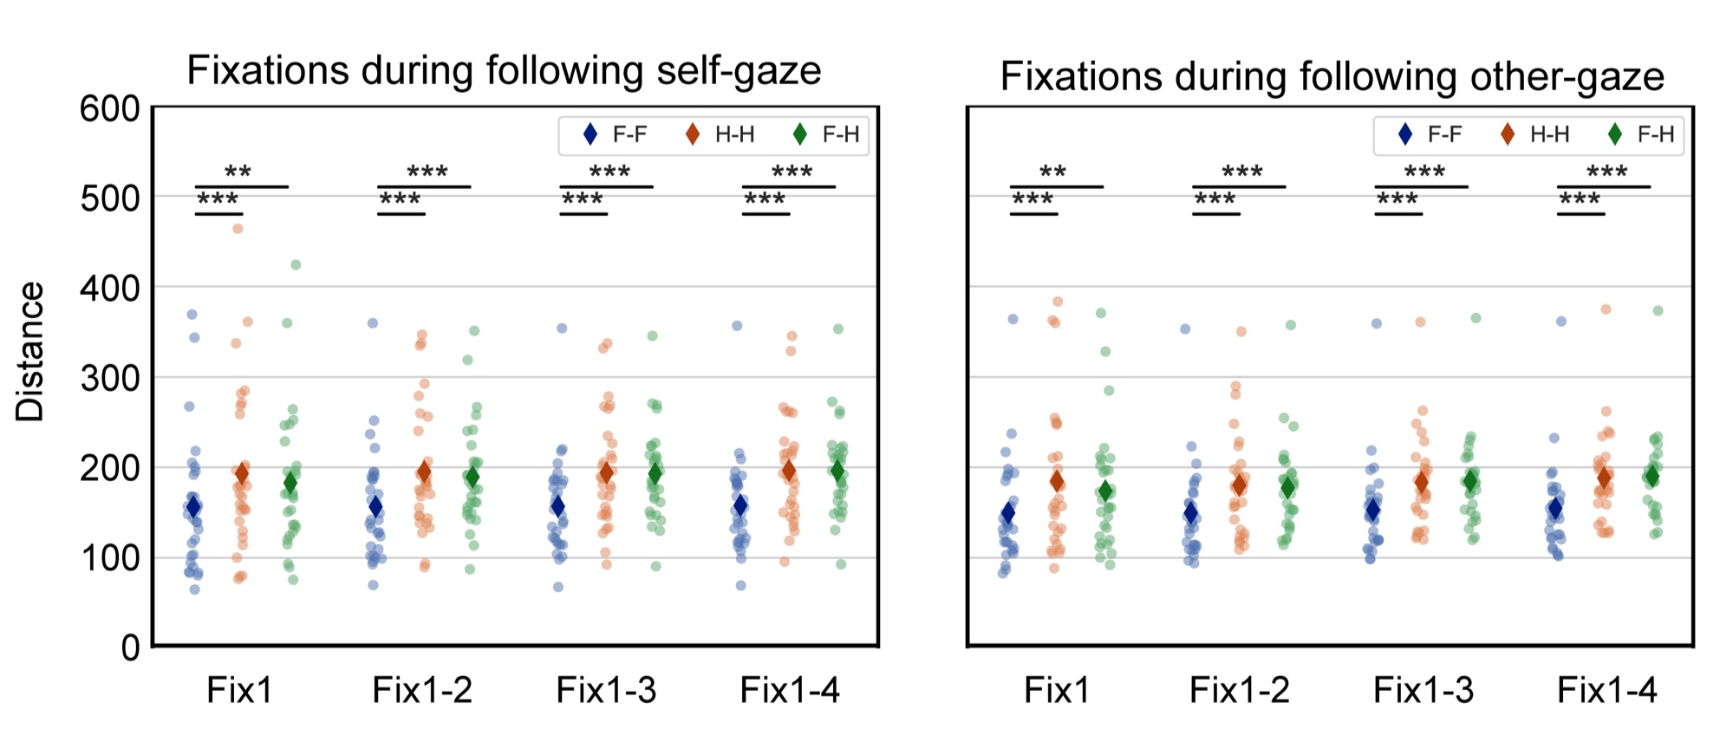

Figure S1. Structural pattern of face-related gaze tracks. The representational distance between fixations during the following of self-gaze tracks (left) and other-gaze tracks (right). F-F: the representational distance of fixations within the face category. H-H: the representational distance of fixations within the house category. F-H: the representational distance of fixations between face and house. The number of fixations was also included to show a consistent pattern. *** p < 0.001, ** p < 0.01.

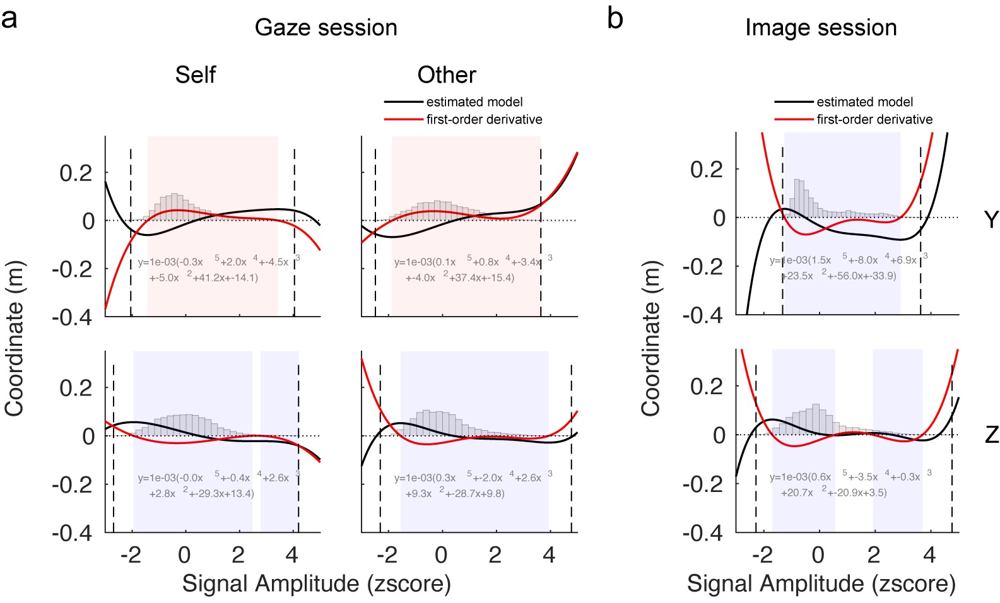
Figure S2. The estimated models (y dimension in upper row, z dimension in lower row) and their first-order derivatives of the MEG spatial gradients in the gaze session (a, left: SF vs. SH, right: OF vs. OH) and the Image Session (b, Face vs. House). The dashed vertical lines denote the minimum and maximum MEG signals, and the shaded areas denote the range that the derivatives > 0 (pink) or < 0 (violet). The gray histograms illustrate the distribution of the signal amplitudes.

