Identification of cytosolic RC3H1 as antiviral host factor binding to the non-structural protein 1 of Influenza A virus via a 3-stage computational pipeline
Swee Teng TEO¹, Shamima RASHID², Kong Yen LIEW¹, Kah Man LAI¹, Teng Ann NG², Jifeng JIAO³, Chee Keong KWOH², Yee-Joo TAN^{1*}
Supplementary Material:
Supplementary Table 1: Full list of C3H-ZF proteins predicted to bind to NS1 of PR8 virus with HVPPI probability score of at least 0.143.
Gene | UniProtID  (Mouse) | UniProtID (human) | Subcellular Location¹ | HVPPI Score² | Known Functions
CPSF30 | Q8BQZ5 | O95639 | Nucleus | 0.747 | - Regulates the polyadenylation step of cellular pre-mRNA 3’ end processing [1, 2]
ZC3H15 | Q3TIV5 | Q8WU90 | Cytoplasm, Nucleus | 0.639 | - Involved in cell proliferation, apoptosis, cell adhesion, and transcription [3]
PPP1R10 | Q80W00 | Q96QC0 | Nucleus | 0.475 | - Acts as a regulator of protein phosphatase 1 (PP1) that is involved in transcriptional regulation, cell cycle progression, apoptosis, telomere maintenance, and DNA damage response [4]
ZC3H8 | Q9JJ48 | Q8N5P1 | Nucleus | 0.353 | - One of the compenents of the human little elongation complex (LEC), which regulates the gene transcription of nuclear RNA by RNA polymerase II and III [5]  - Interferes with DNA damage repair and response pathway [6]
MKRN1 | Q9QXP6 | Q9UHC7 | Cytosol | 0.332 | - An E3 ubiquitin ligase that regulates protein stability, transcriptional control, and RNA metabolism [7]  - Regulates RNA polymerase II-dependent transcription [8]
ZC3H18 | Q0P678 | Q86VM9 | Nucleus | 0.307 | - Promotes RNA decay by binding to the cap-binding complex (CBC) on capped RNAs and associating with the nuclear exosome targeting (NEXT) complex [9]
RC3H1 | Q4VGL6 | Q5TC82 | Cytoplasm, P-body,  Cytoplasmic granule | 0.294 | - An E3 ubiquitin ligase that targets mRNAs for decay, particularly short-lived and DNA damage-induced mRNAs [10]  - Controls T-cell activation, regulates B cell homeostasis and proliferation, and maintains immune homeostasis by regulating mRNA decay of key immune genes [11, 12]
TRMT1 | Q3TX08 | Q9NXH9 | Nucleoplasm, Nucleus | 0.281 | - A tRNA methyltransferase 1 enzyme that modifies tRNAs by adding dimethylguanosine (m2,2G) to the guanine residue at position 26, which is required for proper cellular proliferation and oxidative stress survival [13]
RC3H2 | P0C090 | Q9HBD1 | Cytoplasm, P-body | 0.277 | - An E3 ubiquitin ligase that is involved in the ubiquitination of MAP3K5 [14]  - Regulates gene expression by binding to the constitutive decay element (CDE) at the 3′ untranslated regions (UTRs) of mRNAs, causing mRNA deadenylation and degradation [15]
RBM22 | Q8BHS3 | Q9NW64 | Cytoplasm, Nucleus | 0.257 | - Involved in pre-mRNA splicing and acts as a transcription factor by binding to DNA [16]  - Regulates RNA polymerase II activity [17].
DHX57 | Q6P5D3 | Q6P158 | Not Available | 0.255 | - Probable ATP-binding RNA helicase [18, 19]
ZC3H13 | E9Q784 | Q5T200 | Nucleus speckle, Nucleus, Nucleoplasm | 0.227 | - An essential component of the m6A methyltransferase complex that regulates RNA stability and translation [20]
PRR3 | Q811B5 | P79522 | Not Available | 0.221 | - Stabilizes TOC1 (Timing of Cab Expression 1) in plants with potential parallels in mammalian circadian rhythm control [21]
MKRN3 | Q60764 | Q13064 | Ribonucleoprotein complex | 0.216 | - An E3 ligase that ubiquitinates substrates for degradation and modulates developmental pathways [22]
ZC3H6 | Q8BYK8 | P61129 | Chromatin, Nucleus | 0.214 | - Acts as an RNA-binding protein that potentially regulates RNA processing [23]
PAN3 | Q640Q5 | Q58A45 | Cytoplasm, P-body | 0.211 | - Works as a part of the PAN deadenylation complex, which helps to degrade mRNA by removing its protective poly(A) tail [24]
ZGPAT | Q8VDM1 | Q8N5A5 | Nucleus | 0.203 | - Acts as a transcriptional repressor by binding to specific DNA sequence and recruiting a nucleosome remodeling and deacetylase (NuRD) complex to inhibit transcription [25]
ZC3H4 | Q6ZPZ3 | Q9UPT8 | Chromosome | 0.19 | - Promotes the termination of long non-coding RNAs (lncRNAs) and their degradation by the exosome [26]  - Involved in RNA biogenesis [26]
MKRN2 | Q9ERV1 | Q9H000 | Cytoplasm, Nucleus | 0.184 | - An E3 ubiquitin ligase that targets transcription factors for degradation, thereby regulating inflammatory responses and inhibiting cancer-related pathways [27, 28]  - Interacts with GLE1, a DEAD-box helicase activator, to regulate mRNA export [29]
HELZ | Q6DFV5 | P42694 | Nucleus | 0.177 | - Acts as an RNA helicase by unwinding RNA structures to facilitate various RNA metabolic processes [30]  - Promotes cell proliferation, translation initiation and ribosomal protein S6 phosphorylation [30]  - Promotes R loop resolution to facilitate DNA double strand break repair [31]
UNK | Q8BL48 | Q9C0B0 | Cytoplasm | 0.167 | - Acts as an RNA-binding protein that regulates mRNA translation [32]
¹ Subcellular localization of C3H ZF proteins retrieved from Uniprot and QuickGO
² Human-virus PPI probability score calculated using HVPPI web server.

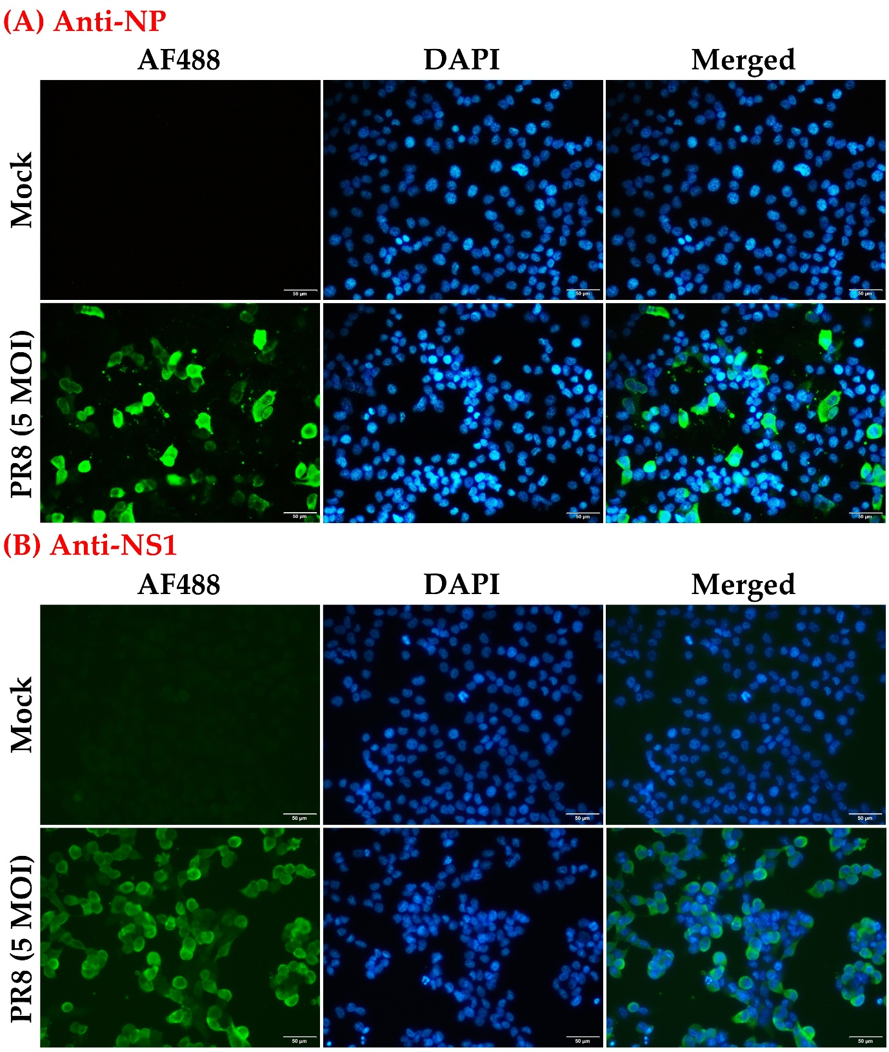

Supplementary Figure 1: Estimation of infection rate of H1299 cells as determined by immunofluorescence asssay. H1299 cells were either mock or infected with PR8 at MOI of 5. At 48 h post infection, the cells were stained with (A) mouse anti-influenza A nucleoprotein (NP) antibody or (B) rabbit anti-NS1 antibody, followed by AF488 anti-mouse or anti-rabbit IgG (H+L) secondary antibody. DAPI was used for nuclei staining. To estimate the infection rate, the number of infected cells (green) and cell nuclei (blue) in 3 random fields was counted. A representative image (out of 3 fields used for counting) is shown. Magnification = 20X. Scale bar = 50 μm.

Supplementary Figure 2: Performance of rabbit anti-RC3H1 antibody in Western blot (WB) analysis. This is the uncut blot for figure 4B in the main text which was showing the expression of RC3H1 (predicted molecular weight (MW) of 126kDa) in RC3H1 siRNA-treated and negative control siRNA-treated H1299 cells. The commercially available anti-RC3H1 antibody binds to several host proteins as shown in WB probably because it is a rabbit polyclonal antibody. The protein corresponding to the predicted MW of RC3H1 showed reduced expression in knockdown cells whereas the other proteins of lower MW were not affected by the knockdown of RC3H1 mRNA. Thus, the anti-RC3H1 antibody is binding non-specifically to other host proteins and so it is not suitable for fluorescent microscopy.

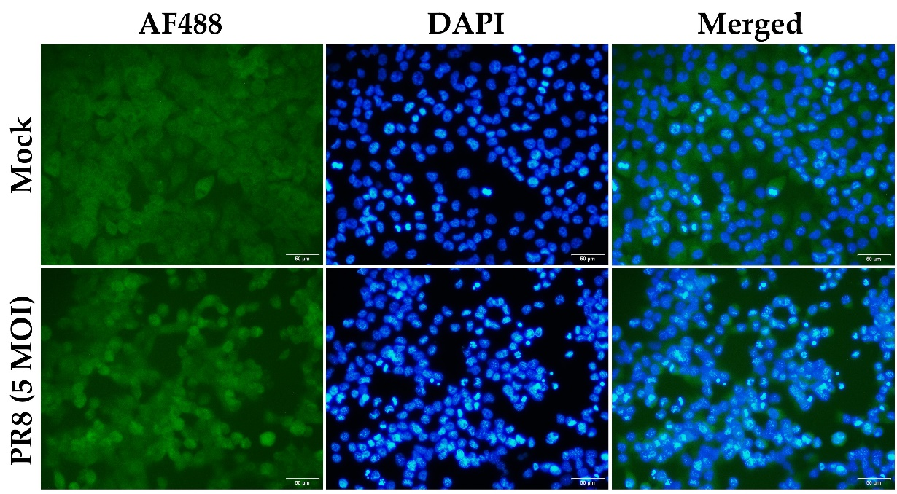

Supplementary Figure 3: Performance of rabbit anti-RC3H1 antibody in immunofluorescence asssay. H1299 cells were either mock or infected with PR8 at MOI of 5. At 48 h post infection, the cells were stained with rabbit anti-RC3H1 antibody, followed by AF488 anti-rabbit IgG (H+L) secondary antibody. DAPI was used for nuclei staining. Consistent with the result of WB, the commercially available anti-RC3H1 antibody shows a high background due to its non-specific binding to other host proteins. As such, it is not possible to conclude if there is an increase in RC3H1 in the nucleus of infected. Thus fractionation and WB to further verify the localization RC3H1 in the nucleus of infected cells (see main text). Magnification = 20X. Scale bar = 50 μm.

Additional Material and Methods:

Immunofluorescence asssay
H1299 cells were seeded on cover slips that were coated with Poly-D-Lysine (Sigma) in 24-well plates. After overnight seeding, the cells were either mock or infected with PR8 at MOI of 5. At 48 h post infection (hpi), the cells were washed with PBS and fixed with 4% paraformaldehyde at room temperature for 10 min. After that, the cells were permeabilized with 0.2% Triton-X 100 in PBS for 5 min and blocked with 10% FBS in PBS for 30 min. The cells were then stained with mouse anti-influenza A nucleoprotein (NP) antibody (clone A3) (Merck) (1:1000), rabbit anti-NS1 (polyclonal) (1:500) or rabbit anti-RC3H1 antibody (Invitrogen) (1:500) in blocking solution for 1.5 h. After washing 3 times with PBS, incubation with goat anti-mouse or anti-rabbit IgG (H+L) secondary antibody, Alexa Fluor™ 488 (Invitrogen) diluted 1:500 in blocking solution was performed for 1 h. The cell nuclei were stained with DAPI (Invitrogen) for 5 min. After washing 3 times with PBS, the cover slips were mounted with ProLong™ Gold Antifade Mountant (Invitrogen). To estimate the PR8 infection rate in H1299 cells, immunofluorescence images of 3 random fields under the magnification of 20X were taken using Olympus CKX53 microscope. The number of NP- or NS1-positive (green) cells and nuclei (blue) in each field were then counted using ImageJ (National Institues of Health) to obtain the percentage of infected cells.

Detailed information for each stage of the computational protocol

A three-stage protocol comprising of (i) domain assignment, (ii) domain-domain interaction prediction (DDI) and (iii) refinement with a protein-protein interaction (PPI) prediction tool was used to generate a list candidate host proteins as targets for experimental verification. In our earlier publication [33], stages (i) and (ii) were developed and we summarized it here for clarity. As IAV virulence is often studied via lethal dosage values in mouse model literature, mouse host proteins were first considered for the domain level interactions, followed by homology mapping to human host proteins during refinement with PPI prediction. Details of the protocol are as follows.

i. Domain Assignment with SUPERFAMILY
This stage of the protocol was developed in an earlier work [33]. Fasta sequence records of 17,120 Swiss-Prot [34] gold star reviewed mouse proteins were first retrieved from UniProt protein knowledgebase (UniProtKB) [35] , with the reference proteome ID (UP000000589). SUPERFAMILY 2.0 [36] was then used to assign at least one Structural Classification of Proteins (SCOP) [37] domain to IAV and mouse amino acid sequences.

ii. Domain-Domain Interaction Prediction with DISPOT
This stage of the protocol was developed in an earlier work [33]. The Domain Interaction Statistical Potential (DISPOT) (http://dispot.korkinlab.org/home/pairs) [38] web tool was utilized to determine occurrence of DDIs between IAV-mouse SCOP superfamily domain pairs. For a query domain pair, DISPOT returns a statistical potential based on the observed frequencies of domain pairs in the DOMMINO [39] database . DOMMINO is an exhaustive database of structurally resolved macromolecular interactions, where data about DDIs is copious. The statistical potential (P_{ij}) is calculated according to the equation below, from [38]:
$$P_{ij}=\frac{1}{Z_{2}}ln\frac{M_{Pij}}{M_{mean}},whereZ_{2}=\sum{\sum{ln\frac{M_{Pkl}}{M_{mean}}}}$$
M_{mean} is the average number of interactions for a pair of domain families, calculated from the non-redundant DOMMINO dataset. M_{pij} denotes the number of interactions of all domains that also belong to the same SCOP family as the viral (i) and host domains (j). In Z₂, M_{pkl} represents the number of interactions over all possible domain pairs.
A negative value in DISPOT can be understood as having more than the average number of observed DDIs in the DOMMINO [39] database. Similar to statistical potentials in thermodynamic systems, it can be interpreted as “more negative scores indicate higher or better chances of occurring”.
The results of the DDI query of IAV-mouse host domains indicated that the C3H zinc finger domain in mouse proteins was predicted to be interacting significantly, with the NS1 effector domain-like in IAV proteins, with a strong DISPOT statistical potential score of -2.916 (rounded to 3 d.p.).
Hence, the C3H zinc finger domain was selected for further refinement stage. Among the 17, 120 mouse proteins, 35 were found to contain the C3H zinc finger domain. As C3H zinc finger proteins have different length and motifs, HVPPI described below was applied to distinguish between them, to identify highly likely pairs.

iii. Refinement with HVPPI Server
Based on the stages (i) and (ii) described above, we were able to deduce that C3H1 mouse zinc finger proteins are interactors of IAV NS1. In this study, we developed stage (iii) which yielded new results for this manuscript. The detailed method for stage (iii) computational work is described here. We used the human-virus PPI (HVPPI) web server (http://zzdlab.com/hvppi/predict.php) [40] as developed by X.Yang et al. This implements an unsupervised sequence embedding approach, doc2vec to represent protein sequences as rich feature vectors of low dimensionality. Then, these vectors were used as inputs to train a random forest (RF) classifier to predict human-virus PPIs.

The human homologues of 35 C3H1 mouse zinc finger proteins were first obtained through mouse-human homology mapping using UniProt. Then, these 35 human proteins were paired with the NS1 segment of the H1N1 IAV strain of interest (A/PR8/34), forming the input to HVPPI. Lastly, HVPPI automatically calculates and outputs the interaction probability of a query protein pair. In this experiment, to identify if two proteins interact, the 0.90 specificity threshold was referenced, corresponding to a probability score of at least 0.143. Therefore, protein pairs which obtained a score of at least 0.143 were deemed interacting.

This procedure refined a total of 21 human proteins (Supplementary Table 1) as interacting from the initial list of 35, as interacting with IAV (A/PR8/34) with HVPPI score $≥0.143$). Of these, the top 7 high scoring proteins were examined in co-immunoprecipitation experiments as described in the main text.

Additional References

1. Shimberg, G.D., et al., Cleavage and polyadenylation specificity factor 30: An RNA-binding zinc-finger protein with an unexpected 2Fe-2S cluster. Proc Natl Acad Sci U S A, 2016. 113(17): p. 4700-5.
2. Chan, S.L., et al., CPSF30 and Wdr33 directly bind to AAUAAA in mammalian mRNA 3' processing. Genes Dev, 2014. 28(21): p. 2370-80.
3. Hou, J., et al., ZC3H15 promotes gastric cancer progression by targeting the FBXW7/c-Myc pathway. Cell Death Discov, 2022. 8(1): p. 32.
4. Kim, Y.-M., et al., PNUTS, a protein phosphatase 1 (PP1) nuclear targeting subunit: characterization of its PP1-and RNA-binding domains and regulation by phosphorylation. Journal of Biological Chemistry, 2003. 278(16): p. 13819-13828.
5. Schmidt, J.A., et al., Regulation of the oncogenic phenotype by the nuclear body protein ZC3H8. BMC Cancer, 2018. 18(1): p. 759.
6. Schmidt, J.A. and R. Sato, Differential Expression of Nuclear Body Component, Zc3h8, Disrupts DNA Double Strand Break Repair. The FASEB Journal, 2022. 36.
7. Wang, T., et al., MRKNs: gene, functions, and role in disease and infection. Frontiers in Oncology, 2022. 12: p. 862206.
8. Omwancha, J., et al., Makorin RING finger protein 1 (MKRN1) has negative and positive effects on RNA polymerase II-dependent transcription. Endocrine, 2006. 29(2): p. 363-73.
9. Winczura, K., et al., Characterizing ZC3H18, a Multi-domain Protein at the Interface of RNA Production and Destruction Decisions. Cell Rep, 2018. 22(1): p. 44-58.
10. Murakawa, Y., et al., RC3H1 post-transcriptionally regulates A20 mRNA and modulates the activity of the IKK/NF-kappaB pathway. Nat Commun, 2015. 6: p. 7367.
11. Schaefer, J.S. and J.R. Klein, Roquin--a multifunctional regulator of immune homeostasis. Genes Immun, 2016. 17(2): p. 79-84.
12. Athanasopoulos, V., R.R. Ramiscal, and C.G. Vinuesa, ROQUIN signalling pathways in innate and adaptive immunity. Eur J Immunol, 2016. 46(5): p. 1082-90.
13. Dewe, J.M., et al., TRMT1-Catalyzed tRNA Modifications Are Required for Redox Homeostasis To Ensure Proper Cellular Proliferation and Oxidative Stress Survival. Mol Cell Biol, 2017. 37(21).
14. Maruyama, T., et al., Roquin-2 promotes ubiquitin-mediated degradation of ASK1 to regulate stress responses. Sci Signal, 2014. 7(309): p. ra8.
15. Raj, T., A. Negraschus, and V. Heissmeyer, Roquin-dependent gene regulation in immune-mediated diseases and future therapies. Int Immunol, 2023. 35(4): p. 159-170.
16. Soubise, B., et al., RBM22, a Key Player of Pre-mRNA Splicing and Gene Expression Regulation, Is Altered in Cancer. Cancers (Basel), 2022. 14(3).
17. Du, X., et al., RBM22 regulates RNA polymerase II 5' pausing, elongation rate, and termination by coordinating 7SK-P-TEFb complex and SPT5. Genome Biol, 2024. 25(1): p. 102.
18. Abdelhaleem, M., L. Maltais, and H. Wain, The human DDX and DHX gene families of putative RNA helicases. Genomics, 2003. 81(6): p. 618-22.
19. Fuller-Pace, F.V., DExD/H box RNA helicases: multifunctional proteins with important roles in transcriptional regulation. Nucleic acids research, 2006. 34(15): p. 4206-4215.
20. Yue, Y., et al., VIRMA mediates preferential m(6)A mRNA methylation in 3'UTR and near stop codon and associates with alternative polyadenylation. Cell Discov, 2018. 4: p. 10.
21. Para, A., et al., PRR3 Is a vascular regulator of TOC1 stability in the Arabidopsis circadian clock. Plant Cell, 2007. 19(11): p. 3462-73.
22. Palumbo, S., et al., MKRN3 role in regulating pubertal onset: the state of art of functional studies. Front Endocrinol (Lausanne), 2022. 13: p. 991322.
23. Information, N.C.f.B. ZC3H6 zinc finger CCCH-type containing 6 [Homo sapiens (human)] - Gene - NCBI. 2024; Available from: https://www.ncbi.nlm.nih.gov/gene/376940.
24. Christie, M., et al., Structure of the PAN3 pseudokinase reveals the basis for interactions with the PAN2 deadenylase and the GW182 proteins. Mol Cell, 2013. 51(3): p. 360-73.
25. Gui, B., et al., Dimerization of ZIP promotes its transcriptional repressive function and biological activity. Int J Biochem Cell Biol, 2012. 44(6): p. 886-95.
26. Estell, C., et al., ZC3H4 restricts non-coding transcription in human cells. Elife, 2021. 10.
27. Shin, C., et al., MKRN2 is a novel ubiquitin E3 ligase for the p65 subunit of NF-kappaB and negatively regulates inflammatory responses. Sci Rep, 2017. 7: p. 46097.
28. Jiang, J., et al., MKRN2 inhibits migration and invasion of non-small-cell lung cancer by negatively regulating the PI3K/Akt pathway. J Exp Clin Cancer Res, 2018. 37(1): p. 189.
29. Wolf, E.J., et al., MKRN2 Physically Interacts with GLE1 to Regulate mRNA Export and Zebrafish Retinal Development. Cell Rep, 2020. 31(8): p. 107693.
30. Hasgall, P.A., et al., The putative RNA helicase HELZ promotes cell proliferation, translation initiation and ribosomal protein S6 phosphorylation. PLoS One, 2011. 6(7): p. e22107.
31. Haji-Seyed-Javadi, R., et al., HELZ promotes R loop resolution to facilitate DNA double-strand break repair by homologous recombination. bioRxiv, 2023.
32. Bajak, K., et al., A potential role for a novel ZC3H5 complex in regulating mRNA translation in Trypanosoma brucei. J Biol Chem, 2020. 295(42): p. 14291-14304.
33. Ng, T.A., S. Rashid, and C.K. Kwoh, Virulence network of interacting domains of influenza a and mouse proteins. Front Bioinform, 2023. 3: p. 1123993.
34. Bairoch, A. and R. Apweiler, The SWISS-PROT protein sequence data bank and its supplement TrEMBL. Nucleic Acids Res, 1997. 25(1): p. 31-6.
35. Bairoch, A., et al., The Universal Protein Resource (UniProt). Nucleic Acids Res, 2005. 33(Database issue): p. D154-9.
36. Pandurangan, A.P., et al., The SUPERFAMILY 2.0 database: a significant proteome update and a new webserver. Nucleic Acids Res, 2019. 47(D1): p. D490-D494.
37. Andreeva, A., et al., SCOP database in 2004: refinements integrate structure and sequence family data. Nucleic Acids Res, 2004. 32(Database issue): p. D226-9.
38. Narykov, O., D. Bogatov, and D. Korkin, DISPOT: a simple knowledge-based protein domain interaction statistical potential. Bioinformatics, 2019. 35(24): p. 5374-5378.
39. Kuang, X., et al., DOMMINO: a database of macromolecular interactions. Nucleic Acids Res, 2012. 40(Database issue): p. D501-6.
40. Yang, X., et al., Prediction of human-virus protein-protein interactions through a sequence embedding-based machine learning method. Computational and structural biotechnology journal, 2020. 18: p. 153-161.

