SUPPLEMENTARY FIG.1 Flowchart of research methodology of study

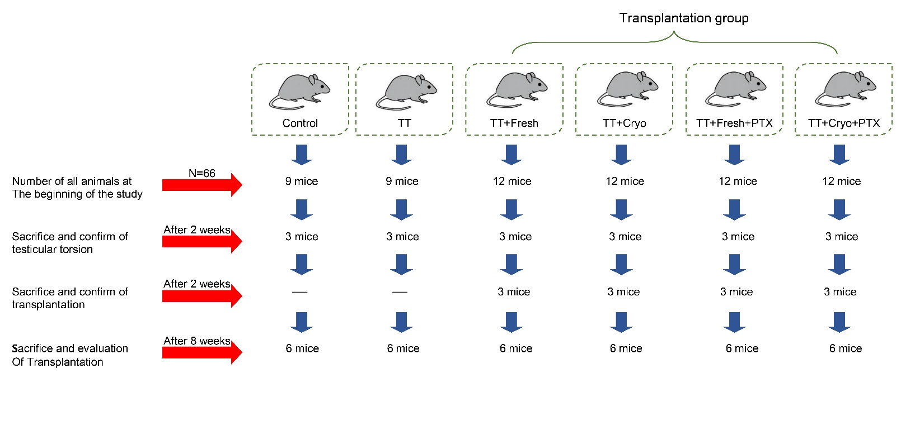
SUPPLEMENTARY FIG.2 Number of mice were used in each group at different steps of study

