Greater vulnerability of lowland communities to extreme heat events across seasons

Supplementary Information
Table of contents
Table S1 | Description of the field sites
Table S2 | Description of soil physicochemical parameters
Table S3 | Description of the experimental temperature regimes
Table S4 | Collembola species abundances and vertical stratification
Table S5 | List of controls used in the amplicon sequencing
Table S6 | Scale reduction factors of the joint species distribution models
Table S7 | Comparison between experimental and field-recorded temperatures
Table S8 | Output of GLMMs of total Collembola abundance
Table S9 | Output of GLMMs of saprotrophic fungi reads
Table S10 | Output of GLMMs of pathogenic fungi reads
Table S11 | Output of Collembola-fungal association network analysis
Fig. S1 | Map of the study area
Fig. S2 | Pictures of the field sites
Fig. S3 | Gravimetric soil water content at field sampling
Fig. S4 | Daily soil temperatures in the field sites during the study period
Fig. S5 | Visualization of Collembola and fungal communities
Fig. S6 | Diversity profiles of Collembola communities
Fig. S7 | Estimates of the Beta parameters of Collembola jSDMs: Baseline
Fig. S8 | Estimates of the Gamma parameters of jSDMs: Collembola vertical stratification
Fig. S9 | Diversity profiles of fungal communities
Fig. S10 | Estimates of the Beta parameters of fungal jSDMs: Baseline
Fig. S11 | Estimates of the Beta parameters of fungal jSDMs: Resistance
Fig. S12 | Estimates of the Beta parameters of fungal jSDMs: Recovery
Fig. S13 | Estimates of the Gamma parameters of jSDMs: Fungal trophic groups (presence-absence model)
Fig. S14 | Abundance responses of unassigned and symbiotic fungi
Fig. S15 | Association networks between Collembola and fungi

Table S1. Description of the field sites. All plots were located in extensively managed dry meadows (i.e. one hay cut per year occurring not before July 1st and/or low-intensity grazing, no inputs of fertilizer or irrigation), with no recent soil disturbances.
Location | Chasseral | Le Landeron | Chasseron | Onnens
Block | North | North | South | South
Elevation | High (1558 m) | Low (481 m) | High (1565 m) | Low (540 m)
Coordinates | 47°07’43” N 7°02’52” E | 47°03’39” N  7°03’49” E | 46°50’58” N 6°32’18? E | 46°50’49” N 6°41’07” E
Aspect | 170° (S) | 210° (SSW) | 190° (S) | 140° (SE)
Slope | 6% | 21% | 10% | 5%
Mowing (frequency, period) | Annually; August-September | Biannually; July-August | No mowing | Annually; July-August
Grazing (type, period) | Not grazed | Not grazed | Cow grazing in the past years, currently not grazed | Sheep grazing, October-November
Dominant plant species | Carex nigra, Agrostis capillaris, Dactylis glomerata | Securigera varia, Bromus erectus, Carex sp. | Carex montana, Sanguisorba officinalis, Agrostis capillaris | Bromus erectus, Trisetum flavescens,  Salvia pratensis

Site  (block and elevation) | Season | Soil pH | Bulk density (g cm⁻³) | Gravimetric water content (%)
Chasseral (north high) | Spring | 5.54 ± 0.67 | 0.60 ± 0.15 | 44.91 ± 3.94
Chasseral (north high) | Summer | 5.54 ± 0.67 | 0.69 ± 0.11 | 36.10 ± 2.37
Chasseral (north high) | Autumn | 5.54 ± 0.67 | 0.80 ± 0.20 | 36.70 ± 2.60
Le Landeron (north low) | Spring | 7.91 ± 0.05 | 0.84 ± 0.13 | 24.47 ± 3.90
Le Landeron (north low) | Summer | 7.91 ± 0.05 | 0.95 ± 0.21 | 24.51 ± 1.93
Le Landeron (north low) | Autumn | 7.91 ± 0.05 | 0.89 ± 0.14 | 22.44 ± 1.07
Chasseron (south high) | Spring | 5.10 ± 0.21 | 0.72 ± 0.12 | 44.00 ± 3.09
Chasseron (south high) | Summer | 5.10 ± 0.21 | 0.68 ± 0.13 | 30.35 ± 2.86
Chasseron (south high) | Autumn | 5.10 ± 0.21 | 0.61 ± 0.13 | 28.90 ± 4.55
Onnens (south low) | Spring | 5.98 ± 0.25 | 1.19 ± 0.15 | 25.56 ± 1.30
Onnens (south low) | Summer | 5.98 ± 0.25 | 1.27 ± 0.05 | 15.29 ± 1.10
Onnens (south low) | Autumn | 5.98 ± 0.25 | 1.29 ± 0.16 | 20.35 ± 1.38
Table S2. Description of soil physicochemical parameters at the time of field sampling (i.e., not exposed to subsequent incubation in the laboratory) across the three studied seasons (spring, summer, autumn). For soil pH, we measured N = 3 per site and across seasons. For bulk density and gravimetric water content, we measured N = 5 per site and season combination.

Table S3. Description of the experimental temperature regimes. Climatic data representative of high elevations was obtained from the weather station in Chasseral (47°07′54″N 7°03′16″E; 1596 m.a.s.l.), whereas for low elevation, we acquired data from the weather station in Neuchâtel (47°00′00″N 6°57′12″E; 485 m.a.s.l.). We retrieved air temperatures recorded at 2 m aboveground from the period 2015-2020 (source: Meteoswiss). Control temperatures were set as the average daily temperature over the reference period for every combination of elevation and season. To recreate extreme heat events for each elevation and season, we adopted the 99th percentile of daily temperatures across the reference period for spring (May-June), summer (July-August) and autumn (Spring-October). For both control and extreme heat temperature regimes, we included a diel light and temperature cycle (8h night/ 16h day), with a 6 °C-amplitude between night and day. C: Control temperature, EH: Extreme heat. The identity of the incubators (#1 to #4) containing each treatment combination is provided.
Elevation | Season | Temperature treatment | Average daily temperature (°C) | Daytime temperature (°C) | Nighttime temperature (°C) | Incubator ID
High | Spring | C | 8.8 | 10.8 | 4.8 | #3
High | Spring | EH | 20.5 | 22.5 | 16.5 | #1
High | Summer | C | 13.5 | 15.5 | 9.5 | #1
High | Summer | EH | 21.7 | 23.7 | 17.7 | #4
High | Autumn | C | 7.3 | 9.3 | 3.3 | #2
High | Autumn | EH | 16.2 | 18.2 | 12.2 | #4
Low | Spring | C | 16.5 | 18.5 | 12.5 | #2
Low | Spring | EH | 26.6 | 28.6 | 22.6 | #4
Low | Summer | C | 21.2 | 23.2 | 17.2 | #2
Low | Summer | EH | 28.0 | 30.0 | 24.0 | #3
Low | Autumn | C | 13.6 | 15.6 | 9.6 | #3
Low | Autumn | EH | 21.7 | 23.7 | 17.7 | #1

Table S4. Total Collembola species abundances (N = 360) and vertical stratification of the species across the soil profile: epedaphic (surface-living), hemiedaphic (living in litter and upper soil layers) and euedaphic (permanently living in the soil). The sources for the identification of Collembola species were Dunger & Schlitt (2011); Fjellberg (1998, 2007); Gisin (1960); Hopkin (2007); Thibaud et al. (2004). The vertical stratification of each Collembola species was extracted mainly from Gisin (1943), as well as Chauvat et al. (2014); Ferlian et al. (2015); Leinaas & Bleken (1983); Urbášek & Rusek (1994). The abundances of immature individuals that could not be assigned to a particular species are displayed at the bottom of the table.
Collembola species | Family | Vertical stratification | Total abundance
Folsomia quadrioculata | Isotomidae | Hemiedaphic | 3502
Parisotoma notabilis | Isotomidae | Hemiedaphic | 2867
Isotoma viridis | Isotomidae | Hemiedaphic | 918
Isotomiella minor | Isotomidae | Euedaphic | 890
Protaphorura pseudovanderdrifti | Onychiuridae | Euedaphic | 863
Lepidocyrtus cyaneus | Entomobryidae | Hemiedaphic | 820
Pseudosinella alba | Entomobryidae | Euedaphic | 750
Lepidocyrtus lignorum | Entomobryidae | Epedaphic | 461
Ceratophysella denticulata | Hypogastruridae | Epedaphic | 351
Stenaphorura denisi | Tullbergiidae | Euedaphic | 288
Sminthurinus signatus | Katiannidae | Hemiedaphic | 251
Choreutinula inermis | Hypogastruridae | - | 116
Sminthurinus aureus | Katiannidae | Epedaphic | 48
Sphaeridia pumilis | Sminthurididae | Hemiedaphic | 41
Neanura muscorum | Neanuridae | Hemiedaphic | 20
Sminthurus viridis | Sminthurididae | Epedaphic | 15
Orchesella flavescens | Orchesellidae | Epedaphic | 5
Entomobrya multifasciata | Entomobryidae | Epedaphic | 4
Pogonognathellus flavescens | Tomoceridae | Hemiedaphic | 2
Heteromurus nitidus | Orchesellidae | Euedaphic | 1
Immature individuals
Isotomidae |  |  | 397
Hypogastruridae |  |  | 191
Entomobryidae |  |  | 132
Symphypleona |  |  | 7

Table S5. List of the controls incorporated in the amplicon sequencing pipeline.

Type of control | Description | Reference
Blank | Buffers from the extraction kit; added at the extraction phase | https://www.qiagen.com/us/products/discovery-and-translational-research/dna-rna-purification/dna-purification/microbial-dna/dneasy-powersoil-pro-kit
Negative | Elution buffer: buffer used to dilute samples, primers and in MasterMix | https://www.pacb.com/wp-content/uploads/Procedure-Checklist-%E2%80%93-Amplification-of-Full-Length-16S-Gene-with-Barcoded-Primers-for-Multiplexed-SMRTbell-Library-Preparation-and-Sequencing.pdf
Negative | MasterMix | https://www.pacb.com/wp-content/uploads/Procedure-Checklist-%E2%80%93-Amplification-of-Full-Length-16S-Gene-with-Barcoded-Primers-for-Multiplexed-SMRTbell-Library-Preparation-and-Sequencing.pdf
Positive | ATCC MSA-1010 | https://www.atcc.org/products/msa-1010
Positive | ZymoBIOMICS Microbial Community Standard | https://zymoresearch.eu/products/zymobiomics-microbial-community-dna-standard-ii-log-distribution

Table S6. Potential scale reduction factors for the parameters estimated in the joint species distribution models.
Model | Collembola
Harvest | Baseline |  |  | Resistance |  |  |  | Recovery
Parameter | Beta | Gamma |  | Beta |  | Gamma |  | Beta |  | Gamma
Min. | 1.00 | 1.00 |  | 1.00 |  | 1.00 |  | 1.00 |  | 1.00
1st Qu. | 1.00 | 1.00 |  | 1.00 |  | 1.00 |  | 1.00 |  | 1.00
Median | 1.00 | 1.00 |  | 1.00 |  | 1.00 |  | 1.00 |  | 1.00
Mean | 1.00 | 1.00 |  | 1.00 |  | 1.00 |  | 1.00 |  | 1.00
3rd Qu. | 1.00 | 1.01 |  | 1.00 |  | 1.00 |  | 1.00 |  | 1.00
Max. | 1.01 | 1.01 |  | 1.01 |  | 1.01 |  | 1.01 |  | 1.01
Model | Fungi (presence-absence)
Harvest | Baseline |  |  | Resistance |  |  |  | Recovery
Parameter | Beta | Gamma |  | Beta |  | Gamma |  | Beta |  | Gamma
Min. | 1.00 | 1.00 |  | 1.00 |  | 1.00 |  | 1.00 |  | 1.00
1st Qu. | 1.00 | 1.00 |  | 1.00 |  | 1.00 |  | 1.00 |  | 1.00
Median | 1.00 | 1.00 |  | 1.00 |  | 1.00 |  | 1.00 |  | 1.00
Mean | 1.00 | 1.00 |  | 1.00 |  | 1.00 |  | 1.00 |  | 1.00
3rd Qu. | 1.00 | 1.00 |  | 1.00 |  | 1.00 |  | 1.00 |  | 1.00
Max. | 1.01 | 1.01 |  | 1.02 |  | 1.01 |  | 1.01 |  | 1.01
Model | Fungi (abundance conditional on presence)
Harvest | Baseline |  |  | Resistance |  |  |  | Recovery
Parameter | Beta | Gamma |  | Beta |  | Gamma |  | Beta |  | Gamma
Min. | 1.00 | 1.00 |  | 1.00 |  | 1.00 |  | 1.00 |  | 1.00
1st Qu. | 1.00 | 1.00 |  | 1.00 |  | 1.00 |  | 1.00 |  | 1.00
Median | 1.00 | 1.00 |  | 1.00 |  | 1.00 |  | 1.00 |  | 1.00
Mean | 1.00 | 1.00 |  | 1.00 |  | 1.00 |  | 1.00 |  | 1.00
3rd Qu. | 1.00 | 1.00 |  | 1.00 |  | 1.00 |  | 1.00 |  | 1.00
Max. | 1.01 | 1.01 |  | 1.02 |  | 1.01 |  | 1.02 |  | 1.01
Model | Collembola-fungal models (only recovery)
Parameter | Beta
Treatment | Low spring |  | High spring |  | High summer |  | Low autumn |  | High autumn
Min. | 1.00 |  | 1.00 |  | 1.00 |  | 1.00 |  | 1.00
1st Qu. | 1.00 |  | 1.00 |  | 1.00 |  | 1.00 |  | 1.00
Median | 1.00 |  | 1.00 |  | 1.00 |  | 1.00 |  | 1.00
Mean | 1.00 |  | 1.00 |  | 1.00 |  | 1.00 |  | 1.00
3rd Qu. | 1.00 |  | 1.00 |  | 1.00 |  | 1.00 |  | 1.00
Max. | 1.02 |  | 1.02 |  | 1.02 |  | 1.08 |  | 1.04

Table S7. Output of model used to compare the average daily soil temperature (measured at 3-5 cm depth) in the extreme heat events simulated in the lab, against the hottest days recorded in the field sites during the study period (N = 6 days, per each elevation and season combination). This analysis was conducted to evaluate the severity of our experimental treatments compared to the natural variability of heat extremes in the field sites. We fitted a linear mixed effect model with the R package nlme v.3.1-163 (Pinheiro et al., 2023), accounting for heterogeneity of residuals by taking the origin of the data (field or lab) as an offset term, due to the greater variance of the data collected from the field compared to the temperature data from the lab experiments. We note that the year in which the study took place (2022) was one of the warmest on record in the area, exceeding the norm of monthly mean temperature of May-October by 2.3-2.5 °C on average (relative to the 1990-2010 reference period; source Meteoswiss).
Average daily soil temperature (°C)
Elevation | Season | Origin of data | Estimate | SE | P | Marginal/  Conditional R²
High | Spring | Lab | 19.60 | 0.33 | 0.060 | 0.993 / 0.998
High | Spring | Field | 18.02 | 0.24 | 0.060 | 0.993 / 0.998
High | Summer | Lab | 20.75 | 0.33 | 0.087 | 0.993 / 0.998
High | Summer | Field | 19.44 | 0.26 | 0.087 | 0.993 / 0.998
High | Autumn | Lab | 15.72 | 0.33 | 0.011 | 0.993 / 0.998
High | Autumn | Field | 11.87 | 0.26 | 0.011 | 0.993 / 0.998
Low | Spring | Lab | 25.47 | 0.33 | 0.962 | 0.993 / 0.998
Low | Spring | Field | 25.49 | 0.24 | 0.962 | 0.993 / 0.998
Low | Summer | Lab | 27.23 | 0.33 | 0.322 | 0.993 / 0.998
Low | Summer | Field | 26.69 | 0.26 | 0.322 | 0.993 / 0.998
Low | Autumn | Lab | 21.03 | 0.33 | 0.010 | 0.993 / 0.998
Low | Autumn | Field | 16.82 | 0.26 | 0.010 | 0.993 / 0.998
Table S8. Output of the generalized linear mixed-effects model with negative binomial distribution used to evaluate the effect of the temperature treatments, modulated by elevation and season, on total Collembola abundances. Separate models were fit for each experimental harvest: baseline (harvest 1, before extreme heat), resistance (harvest 2, at the end of extreme heat) and recovery (harvest 3, five weeks after the end of extreme heat). Estimates, standard errors (SE), p-values (P) of the contrasts between temperature treatments, marginal and conditional R² (trigamma estimate) are provided. Significant p-values (P < 0.05) are highlighted in bold. Abbreviations of temperature treatment levels: C: Control temperature, EH: Extreme heat.
Total Collembola abundances (log-scale)
 | Elevation | Season | Temperature treatment | Estimate | SE | P | Marginal/  Conditional R²
Baseline (harvest 1) | High | Spring | C | 3.86 | 0.21 | 0.651 | 0.263/0.305
Baseline (harvest 1) | High | Spring | EH | 3.76 | 0.21 | 0.651 | 0.263/0.305
Baseline (harvest 1) | High | Summer | C | 3.71 | 0.22 | 0.356 | 0.263/0.305
Baseline (harvest 1) | High | Summer | EH | 3.93 | 0.20 | 0.356 | 0.263/0.305
Baseline (harvest 1) | High | Autumn | C | 3.18 | 0.25 | 0.218 | 0.263/0.305
Baseline (harvest 1) | High | Autumn | EH | 3.53 | 0.23 | 0.218 | 0.263/0.305
Baseline (harvest 1) | Low | Spring | C | 3.28 | 0.25 | 0.949 | 0.263/0.305
Baseline (harvest 1) | Low | Spring | EH | 3.26 | 0.25 | 0.949 | 0.263/0.305
Baseline (harvest 1) | Low | Summer | C | 2.60 | 0.30 | 0.827 | 0.263/0.305
Baseline (harvest 1) | Low | Summer | EH | 2.68 | 0.29 | 0.827 | 0.263/0.305
Baseline (harvest 1) | Low | Autumn | C | 3.70 | 0.22 | 0.356 | 0.263/0.305
Baseline (harvest 1) | Low | Autumn | EH | 3.92 | 0.20 | 0.356 | 0.263/0.305
Resistance (harvest 2) | High | Spring | C | 3.88 | 0.24 | 0.969 | 0.512/0.566
Resistance (harvest 2) | High | Spring | EH | 3.89 | 0.24 | 0.969 | 0.512/0.566
Resistance (harvest 2) | High | Summer | C | 3.79 | 0.24 | 0.965 | 0.512/0.566
Resistance (harvest 2) | High | Summer | EH | 3.80 | 0.24 | 0.965 | 0.512/0.566
Resistance (harvest 2) | High | Autumn | C | 3.22 | 0.27 | 0.208 | 0.512/0.566
Resistance (harvest 2) | High | Autumn | EH | 3.56 | 0.25 | 0.208 | 0.512/0.566
Resistance (harvest 2) | Low | Spring | C | 3.47 | 0.26 | <0.001 | 0.512/0.566
Resistance (harvest 2) | Low | Spring | EH | 2.29 | 0.35 | <0.001 | 0.512/0.566
Resistance (harvest 2) | Low | Summer | C | 2.68 | 0.32 | 0.007 | 0.512/0.566
Resistance (harvest 2) | Low | Summer | EH | 1.19 | 0.52 | 0.007 | 0.512/0.566
Resistance (harvest 2) | Low | Autumn | C | 3.68 | 0.25 | 0.277 | 0.512/0.566
Resistance (harvest 2) | Low | Autumn | EH | 3.40 | 0.27 | 0.277 | 0.512/0.566
Recovery (harvest 3) | High | Spring | C | 3.88 | 0.24 | 0.787 | 0.356/0.387
Recovery (harvest 3) | High | Spring | EH | 3.80 | 0.24 | 0.787 | 0.356/0.387
Recovery (harvest 3) | High | Summer | C | 3.76 | 0.25 | 0.503 | 0.356/0.387
Recovery (harvest 3) | High | Summer | EH | 3.55 | 0.26 | 0.503 | 0.356/0.387
Recovery (harvest 3) | High | Autumn | C | 4.01 | 0.23 | 0.378 | 0.356/0.387
Recovery (harvest 3) | High | Autumn | EH | 3.77 | 0.24 | 0.378 | 0.356/0.387
Recovery (harvest 3) | Low | Spring | C | 4.00 | 0.23 | 0.747 | 0.356/0.387
Recovery (harvest 3) | Low | Spring | EH | 3.91 | 0.24 | 0.747 | 0.356/0.387
Recovery (harvest 3) | Low | Summer | C | 3.09 | 0.29 | 0.005 | 0.356/0.387
Recovery (harvest 3) | Low | Summer | EH | 1.65 | 0.47 | 0.005 | 0.356/0.387
Recovery (harvest 3) | Low | Autumn | C | 4.14 | 0.22 | 0.323 | 0.356/0.387
Recovery (harvest 3) | Low | Autumn | EH | 3.88 | 0.24 | 0.323 | 0.356/0.387
Table S9. Output of the generalized linear mixed-effects model with negative binomial distribution used to evaluate the effect of the temperature treatments, modulated by elevation and season, on the total number of metabarcoding reads of saprotrophic fungi. Separate models were fit for each experimental harvest: baseline (harvest 1, before extreme heat), resistance (harvest 2, at the end of extreme heat) and recovery (harvest 3, five weeks after the end of extreme heat). Estimates, standard errors (SE), p-values (P) of the contrasts between temperature treatments, marginal and conditional R² (trigamma estimate) are provided. Significant p-values (P < 0.05) are highlighted in bold. Abbreviations of temperature treatment levels: C: Control temperature, EH: Extreme heat.
Number of reads of saprotrophic fungi (log-scale)
 | Elevation | Season | Temperature treatment | Estimate | SE | P | Marginal/  Conditional R²
Baseline (harvest 1) | High | Spring | C | 7.503 | 0.226 | 0.167 | 0.804/0.818
Baseline (harvest 1) | High | Spring | EH | 7.870 | 0.225 | 0.167 | 0.804/0.818
Baseline (harvest 1) | High | Summer | C | 7.586 | 0.226 | 0.319 | 0.804/0.818
Baseline (harvest 1) | High | Summer | EH | 7.322 | 0.225 | 0.319 | 0.804/0.818
Baseline (harvest 1) | High | Autumn | C | 8.120 | 0.232 | 0.471 | 0.804/0.818
Baseline (harvest 1) | High | Autumn | EH | 7.925 | 0.226 | 0.471 | 0.804/0.818
Baseline (harvest 1) | Low | Spring | C | 6.525 | 0.231 | 0.068 | 0.804/0.818
Baseline (harvest 1) | Low | Spring | EH | 7.013 | 0.239 | 0.068 | 0.804/0.818
Baseline (harvest 1) | Low | Summer | C | 6.974 | 0.225 | 0.730 | 0.804/0.818
Baseline (harvest 1) | Low | Summer | EH | 7.066 | 0.225 | 0.730 | 0.804/0.818
Baseline (harvest 1) | Low | Autumn | C | 7.401 | 0.225 | 0.562 | 0.804/0.818
Baseline (harvest 1) | Low | Autumn | EH | 7.555 | 0.225 | 0.562 | 0.804/0.818
Resistance (harvest 2) | High | Spring | C | 7.223 | 0.322 | 0.581 | 0.720/0.820
Resistance (harvest 2) | High | Spring | EH | 7.347 | 0.322 | 0.581 | 0.720/0.820
Resistance (harvest 2) | High | Summer | C | 7.148 | 0.322 | 0.503 | 0.720/0.820
Resistance (harvest 2) | High | Summer | EH | 7.297 | 0.322 | 0.503 | 0.720/0.820
Resistance (harvest 2) | High | Autumn | C | 7.712 | 0.322 | 0.843 | 0.720/0.820
Resistance (harvest 2) | High | Autumn | EH | 7.667 | 0.323 | 0.843 | 0.720/0.820
Resistance (harvest 2) | Low | Spring | C | 6.680 | 0.327 | 0.680 | 0.720/0.820
Resistance (harvest 2) | Low | Spring | EH | 6.775 | 0.322 | 0.680 | 0.720/0.820
Resistance (harvest 2) | Low | Summer | C | 6.710 | 0.322 | 0.351 | 0.720/0.820
Resistance (harvest 2) | Low | Summer | EH | 6.502 | 0.322 | 0.351 | 0.720/0.820
Resistance (harvest 2) | Low | Autumn | C | 6.953 | 0.325 | 0.195 | 0.720/0.820
Resistance (harvest 2) | Low | Autumn | EH | 6.652 | 0.322 | 0.195 | 0.720/0.820
Recovery (harvest 3) | High | Spring | C | 7.465 | 0.250 | 0.616 | 0.742/0.817
Recovery (harvest 3) | High | Spring | EH | 7.564 | 0.249 | 0.616 | 0.742/0.817
Recovery (harvest 3) | High | Summer | C | 7.524 | 0.250 | 0.735 | 0.742/0.817
Recovery (harvest 3) | High | Summer | EH | 7.591 | 0.249 | 0.735 | 0.742/0.817
Recovery (harvest 3) | High | Autumn | C | 7.917 | 0.248 | 0.490 | 0.742/0.817
Recovery (harvest 3) | High | Autumn | EH | 8.054 | 0.252 | 0.490 | 0.742/0.817
Recovery (harvest 3) | Low | Spring | C | 7.112 | 0.250 | 0.092 | 0.742/0.817
Recovery (harvest 3) | Low | Spring | EH | 6.775 | 0.249 | 0.092 | 0.742/0.817
Recovery (harvest 3) | Low | Summer | C | 7.320 | 0.249 | 0.089 | 0.742/0.817
Recovery (harvest 3) | Low | Summer | EH | 6.986 | 0.249 | 0.089 | 0.742/0.817
Recovery (harvest 3) | Low | Autumn | C | 7.511 | 0.253 | 0.038 | 0.742/0.817
Recovery (harvest 3) | Low | Autumn | EH | 7.094 | 0.249 | 0.038 | 0.742/0.817
Table S10. Output of the generalized linear mixed-effects model with negative binomial distribution used to evaluate the effect of the temperature treatments, modulated by elevation and season, on the total number of metabarcoding reads of pathogenic fungi. Separate models were fit for each experimental harvest: baseline (harvest 1, before extreme heat), resistance (harvest 2, at the end of extreme heat) and recovery (harvest 3, five weeks after the end of extreme heat). Estimates, standard errors (SE), p-values (P) of the contrasts between temperature treatments, marginal and conditional R² (trigamma estimate) are provided. Significant p-values (P < 0.05) are highlighted in bold. Abbreviations of temperature treatment levels: C: Control temperature, EH: Extreme heat.
Number of reads of pathogenic fungi (log-scale)
 | Elevation | Season | Temperature treatment | Estimate | SE | P | Marginal/  Conditional R²
Baseline (harvest 1) | High | Spring | C | 5.845 | 0.277 | 0.606 | 0.649/0.689
Baseline (harvest 1) | High | Spring | EH | 5.997 | 0.278 | 0.606 | 0.649/0.689
Baseline (harvest 1) | High | Summer | C | 6.211 | 0.277 | 0.544 | 0.649/0.689
Baseline (harvest 1) | High | Summer | EH | 6.034 | 0.276 | 0.544 | 0.649/0.689
Baseline (harvest 1) | High | Autumn | C | 6.327 | 0.280 | 0.136 | 0.649/0.689
Baseline (harvest 1) | High | Autumn | EH | 5.892 | 0.279 | 0.136 | 0.649/0.689
Baseline (harvest 1) | Low | Spring | C | 6.417 | 0.280 | 0.945 | 0.649/0.689
Baseline (harvest 1) | Low | Spring | EH | 6.396 | 0.287 | 0.945 | 0.649/0.689
Baseline (harvest 1) | Low | Summer | C | 6.887 | 0.277 | 0.906 | 0.649/0.689
Baseline (harvest 1) | Low | Summer | EH | 6.922 | 0.276 | 0.906 | 0.649/0.689
Baseline (harvest 1) | Low | Autumn | C | 6.602 | 0.277 | 0.449 | 0.649/0.689
Baseline (harvest 1) | Low | Autumn | EH | 6.377 | 0.280 | 0.449 | 0.649/0.689
Resistance (harvest 2) | High | Spring | C | 5.497 | 0.235 | 0.272 | 0.643/0.671
Resistance (harvest 2) | High | Spring | EH | 5.795 | 0.235 | 0.272 | 0.643/0.671
Resistance (harvest 2) | High | Summer | C | 5.983 | 0.234 | 0.837 | 0.643/0.671
Resistance (harvest 2) | High | Summer | EH | 5.928 | 0.234 | 0.837 | 0.643/0.671
Resistance (harvest 2) | High | Autumn | C | 6.241 | 0.233 | 0.571 | 0.643/0.671
Resistance (harvest 2) | High | Autumn | EH | 6.394 | 0.236 | 0.571 | 0.643/0.671
Resistance (harvest 2) | Low | Spring | C | 6.326 | 0.239 | 0.952 | 0.643/0.671
Resistance (harvest 2) | Low | Spring | EH | 6.342 | 0.235 | 0.952 | 0.643/0.671
Resistance (harvest 2) | Low | Summer | C | 6.781 | 0.235 | 0.560 | 0.643/0.671
Resistance (harvest 2) | Low | Summer | EH | 6.625 | 0.240 | 0.560 | 0.643/0.671
Resistance (harvest 2) | Low | Autumn | C | 6.301 | 0.234 | 0.774 | 0.643/0.671
Resistance (harvest 2) | Low | Autumn | EH | 6.224 | 0.233 | 0.774 | 0.643/0.671
Recovery (harvest 3) | High | Spring | C | 6.557 | 0.199 | 0.151 | 0.656/0.659
Recovery (harvest 3) | High | Spring | EH | 6.172 | 0.193 | 0.151 | 0.656/0.659
Recovery (harvest 3) | High | Summer | C | 6.195 | 0.198 | 0.541 | 0.656/0.659
Recovery (harvest 3) | High | Summer | EH | 6.365 | 0.204 | 0.541 | 0.656/0.659
Recovery (harvest 3) | High | Autumn | C | 6.782 | 0.193 | 0.114 | 0.656/0.659
Recovery (harvest 3) | High | Autumn | EH | 6.353 | 0.197 | 0.114 | 0.656/0.659
Recovery (harvest 3) | Low | Spring | C | 6.383 | 0.194 | 0.241 | 0.656/0.659
Recovery (harvest 3) | Low | Spring | EH | 6.703 | 0.198 | 0.241 | 0.656/0.659
Recovery (harvest 3) | Low | Summer | C | 6.642 | 0.196 | 0.002 | 0.656/0.659
Recovery (harvest 3) | Low | Summer | EH | 7.471 | 0.196 | 0.002 | 0.656/0.659
Recovery (harvest 3) | Low | Autumn | C | 6.704 | 0.193 | 0.126 | 0.656/0.659
Recovery (harvest 3) | Low | Autumn | EH | 7.110 | 0.193 | 0.126 | 0.656/0.659

Elevation | Season | Sign of associations | Connectance extreme heat | Connectance control | Connectance difference | z-score | P | Connectance differences within fungal groups | WN | OS | ST | % OS | % ST
High | Spring | Positive | 0.082 | 0.099 | -0.017 | -0.475 | 0.635 | None | 0.719 | 0.234 | 0.484 | 32.6 | 67.4
High | Spring | Negative | 0.124 | 0.085 | 0.040 | 1.201 | 0.230 | None | 0.676 | 0.203 | 0.473 | 30.0 | 70.0
High | Summer | Positive | 0.076 | 0.044 | 0.032 | 0.233 | 0.815 | None | 0.967 | 0.283 | 0.683 | 29.3 | 70.7
High | Summer | Negative | 0.097 | 0.058 | 0.038 | 0.504 | 0.614 | None | 0.896 | 0.156 | 0.740 | 17.4 | 82.6
High | Autumn | Positive | 0.123 | 0.055 | 0.069 | 1.095 | 0.274 | None | 0.912 | 0.298 | 0.614 | 32.7 | 67.3
High | Autumn | Negative | 0.075 | 0.055 | 0.020 | 0.299 | 0.765 | None | 0.880 | 0.361 | 0.518 | 41.1 | 58.9
Low | Spring | Positive | 0.059 | 0.063 | -0.005 | -0.037 | 0.970 | None | 0.815 | 0.241 | 0.574 | 29.5 | 70.5
Low | Spring | Negative | 0.136 | 0.061 | 0.075 | 2.958 | 0.003 | Saprotroph** | 0.770 | 0.287 | 0.483 | 37.3 | 62.7
Low | Autumn | Positive | 0.078 | 0.032 | 0.046 | 1.383 | 0.167 | None | 0.891 | 0.145 | 0.745 | 16.3 | 83.7
Low | Autumn | Negative | 0.087 | 0.054 | 0.032 | 0.486 | 0.627 | None | 0.886 | 0.257 | 0.629 | 29.0 | 71.0
Table S11. Output of the network analysis evaluating differences between the Collembola-fungal association networks from extreme heat and control treatments. Z-scores and p-values were computed to establish whether the observed connectance differences were significantly greater or smaller compared to those from random networks generated with null models (1000 permutations for each network). Significant p-values (P < 0.05) are highlighted in bold. The connectance analysis was repeated separately for each fungal trophic group, on subsets of networks only made of either pathogens or saprotrophs. Connectance differences within the subsets of specific fungal groups are indicated; asterisks indicate the level of statistical significance (**P < 0.01). Whole network dissimilarity (WN) and its additive components are provided, based on Poisot et al. (2012) and Dormann et al. (2009): dissimilarity explained by the rewiring of associations among shared species (OS) and dissimilarity explained by differences in species composition between networks (ST). The percentages (%) of whole network dissimilarity explained by OS and ST components are shown. The observed association networks are displayed in Fig. S12.

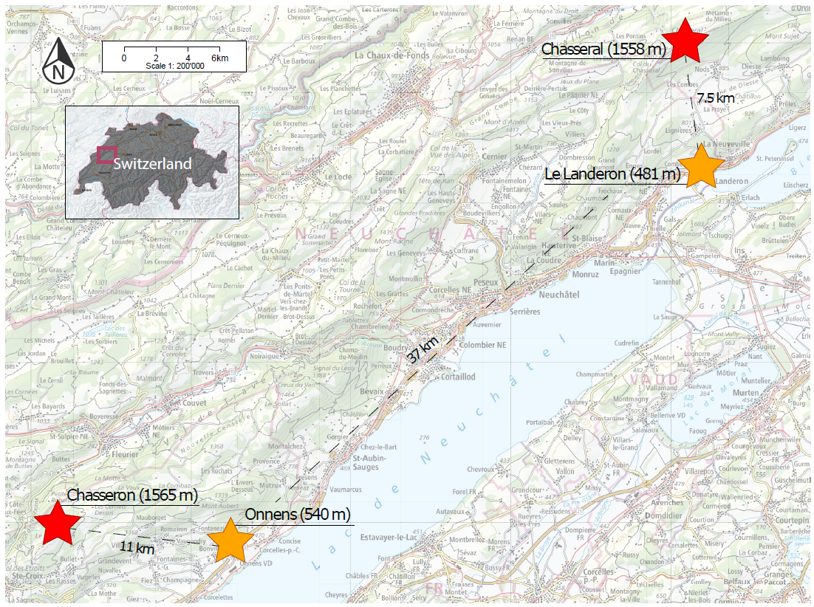
Fig. S1. Map of the study area showing the geographic position and elevation of the sampling sites, indicated with star signs. The shortest distance between sites of different blocks (north block: Chasseral and Le Landeron; south block: Chasseron and Onnens), as well as the distance between sites of the same block, are provided. Stars’ colors indicate sites at different elevations: red: high elevation; orange: low elevation. Map adapted from https://map.geo.admin.ch.

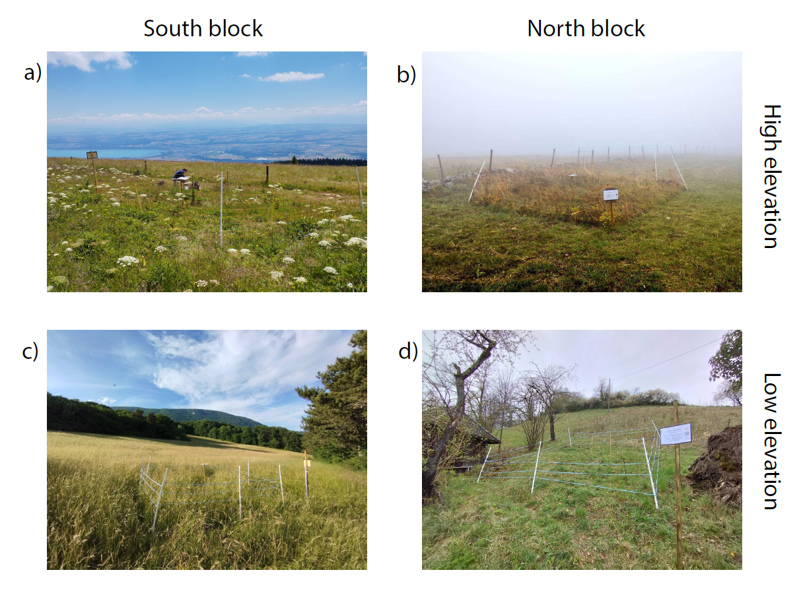
Fig. S2. Pictures of the field sites taken at various seasons: a) Chasseron (summer), b) Chasseral (autumn), c) Onnens (summer), d) Le Landeron (early spring, before the start of the experiments). The pictures are arranged in a grid, so that the rows indicate the elevation (high and low), and the columns show the block (south and north).
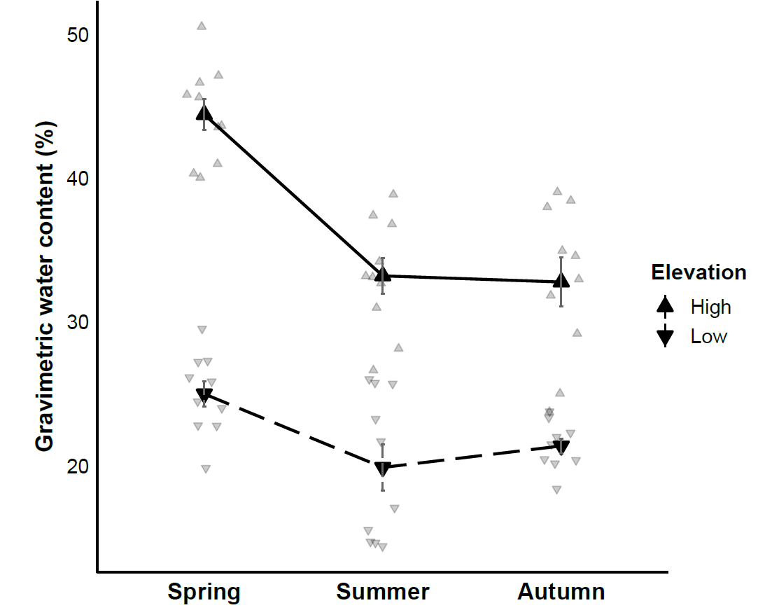
Fig. S3. Gravimetric soil water content, measured immediately after field sampling. Solid black points represent means, grey bars represent standard errors, and faded points are raw data (N = 10 per each elevation and season combination).

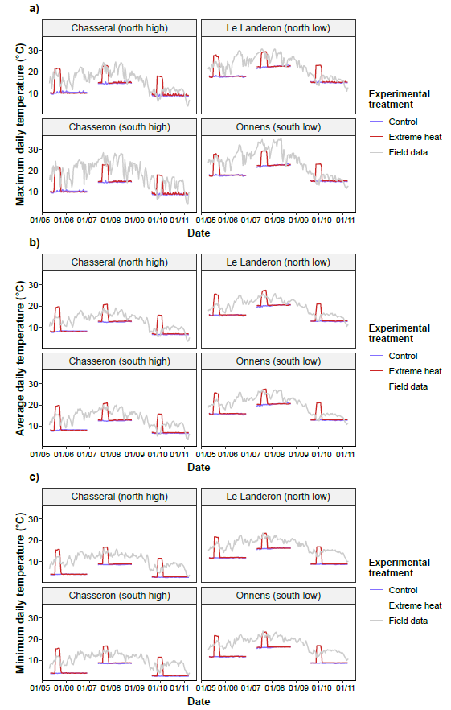
Fig. S4. Site-specific maximum (a), average (b) and minimum (c) daily soil temperatures at 5 cm depth, together with the daytime (a), average (b), and nighttime temperatures (c) recorded during the lab experiment, for both control (blue lines) and extreme heat treatments (red lines).
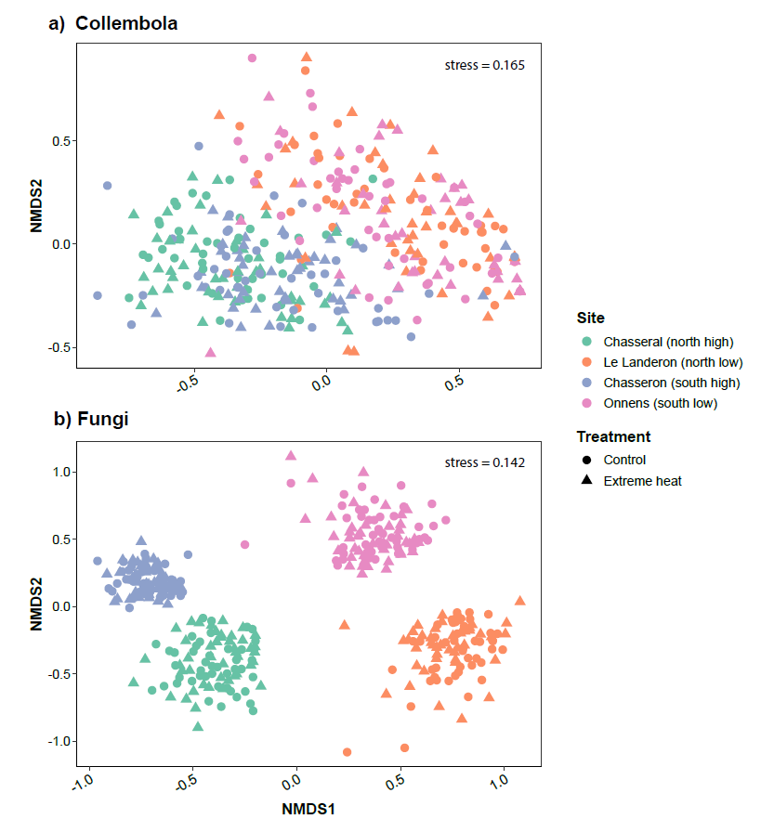
Fig. S5. Visualization of Collembola (a) and fungal communities (b) using non-metric multidimensional scaling (NDMS), implemented in the package vegan (version 2.6-4; Oksanen et al. 2022). Different colors indicate the sites: green: Chasseral; orange: Le Landeron; blue: Chasseron; pink: Onnens. The experimental treatments are shown with different shapes: round: control; triangle: extreme heat. We note that the first axis (NMDS1) mainly represents compositional differences between elevations (high/low), while the second axis (NMDS2) captures differences between the blocks (north/south). k=3 in both NDMS.

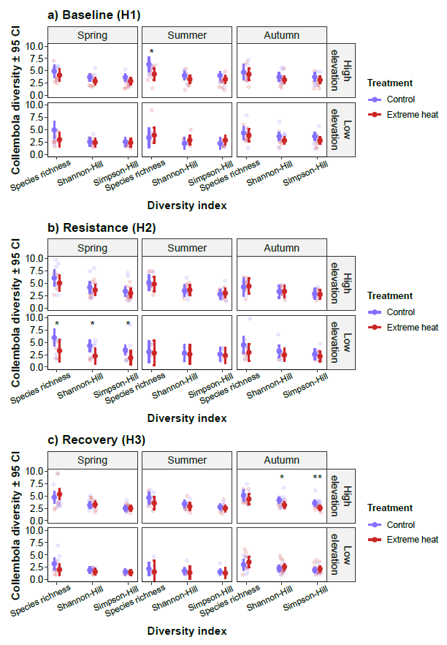
Fig. S6. Estimated marginal means (± 95 confidence intervals) of diversity profiles of Collembola communities, showing three indices calculated from various values of Hill number exponents (q): q = 0 (species richness), q = 1 (Shannon-Hill), q = 2 (Simpson-Hill). Lower values of the q exponent provide diversity estimates that give more leverage to rare species (e.g., species richness), while higher values give more leverage to dominant species (Roswell et al., 2021). Diversity profiles are shown for each experimental harvest separately: a) baseline or harvest 1 (H1; N = 97), b) resistance or harvest 2 (H2; N = 91), and c) recovery or harvest 3 (H3; N = 103). Colours indicate different experimental temperature treatments: blue: control; red: extreme heat. Stars show significant differences between treatments at each harvest: *P < 0.05, **P < 0.01.
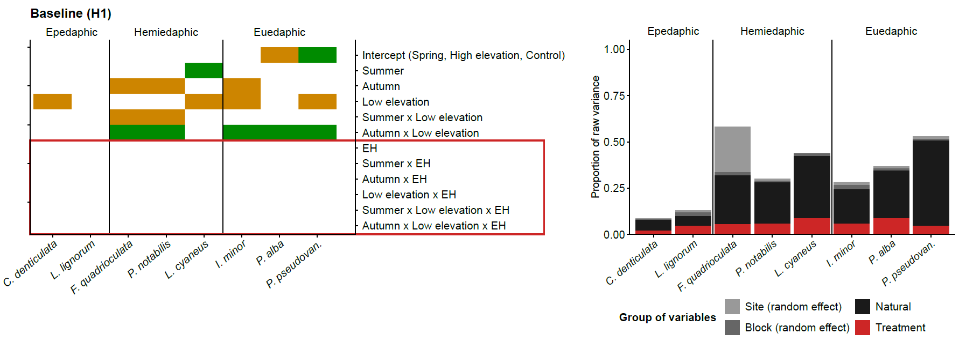
Fig. S7. Output of the joint species distribution models (jSDMs) fitted to investigate the responses of Collembola species abundances to season, elevation, treatment, and their three-way interactions, in the baseline response (i.e., harvest 1: H1; before the onset of the extreme heat events). Estimates from the beta parameters (left panels) show the responses of species abundances (x-axis) to each of the model parameters (y-axis). Green and orange colors indicate positive and responses with 95% posterior probability, respectively, while blank spaces denote responses that lacked statistical support. Species abundances at the intercept (spring, high elevation, control treatment) denote more abundant species in green, less abundant species in orange, and blank spaces indicating intermediate abundances. Parameters enclosed within the red area represent species responses to the experimental treatment (extreme heat: EH; see Table 1 for an ecological interpretation of the model parameters). The proportion of raw explained variance (right panels) is provided for different groups of variables: random effects (site and block), natural variables (season and elevation), and treatment (containing the variance explained by all parameters influenced by extreme heat, shown within the red area of the right panels). Collembola species are ordered according to their vertical stratification across the soil profile: epedaphic (surface-living), hemi-edaphic (living in litter and shallow soil layers), and euedaphic (permanently living in the soil).

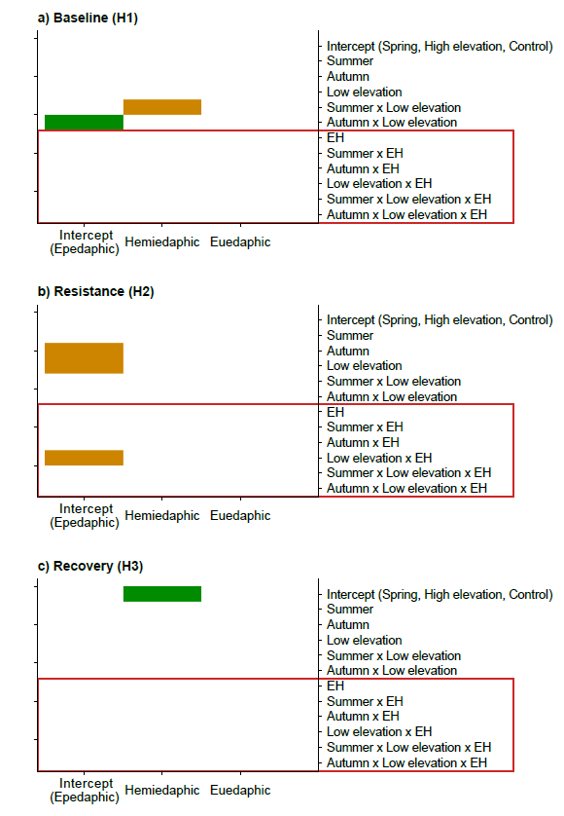
Fig. S8. Output of the joint species distribution models (jSDMs) fitted to investigate the responses of Collembola species abundances to season, elevation, treatment, and their three-way interactions, in the baseline (H1), resistance (H2) and recovery responses (H3). Estimates from the gamma parameters show whether species traits (i.e., vertical stratification; x-axis) mediate species abundance responses to each of the model parameters (y-axis). Three types of the vertical stratification of Collembola across the soil profile were investigated: epedaphic (surface-living), hemi-edaphic (living in litter and shallow soil layers), and euedaphic (permanently living in the soil). Green and orange colors indicate positive and responses with 95% posterior probability, respectively, while blank spaces denote responses that lacked statistical support. Parameter estimates at the intercepts (x-axis: epedaphic Collembola; y-axis: spring, high elevation, control treatment) denote higher overall abundances in green, lower overall abundances in orange, and blank spaces indicating intermediate abundances. The variation in species abundances explained by their vertical stratification ($R_{T}^{2}$; Ovaskainen et al. 2017) amounts to: 0.15 (baseline), 0.35 (resistance), 0.43 (recovery). Parameters enclosed within the red area represent species responses to the experimental treatment (extreme heat: EH; see Table 1 for an ecological interpretation of the model parameters).
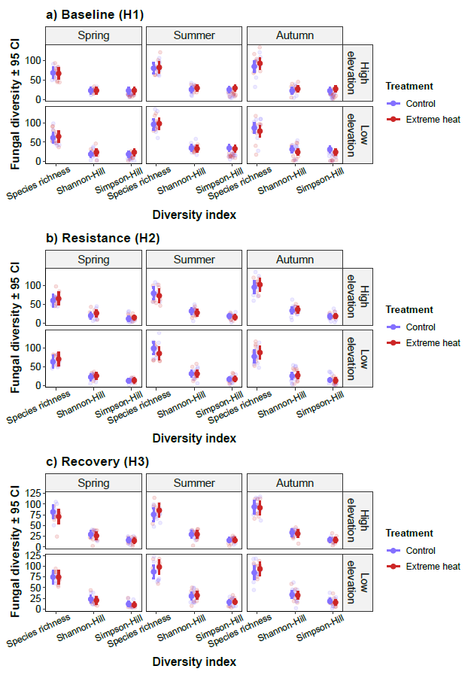
Fig. S9. Estimated marginal means (± 95 confidence intervals) of diversity profiles of fungal communities, showing three indices calculated from various values of Hill number exponents (q): q = 0 (species richness), q = 1 (Shannon-Hill), q = 2 (Simpson-Hill). Lower values of the q exponent provide diversity estimates that give more leverage to rare species (e.g., species richness), while higher values give more leverage to dominant species (Roswell et al., 2021). Diversity profiles are shown for each experimental harvest separately: a) baseline or harvest 1 (H1; N = 120), b) resistance or harvest 2 (H2; N = 120), and c) recovery or harvest 3 (H3; N = 120). Colours indicate different experimental temperature treatments: blue: control; red: extreme heat. The extreme heat treatment did not have significant effects on fungal diversity in any case.

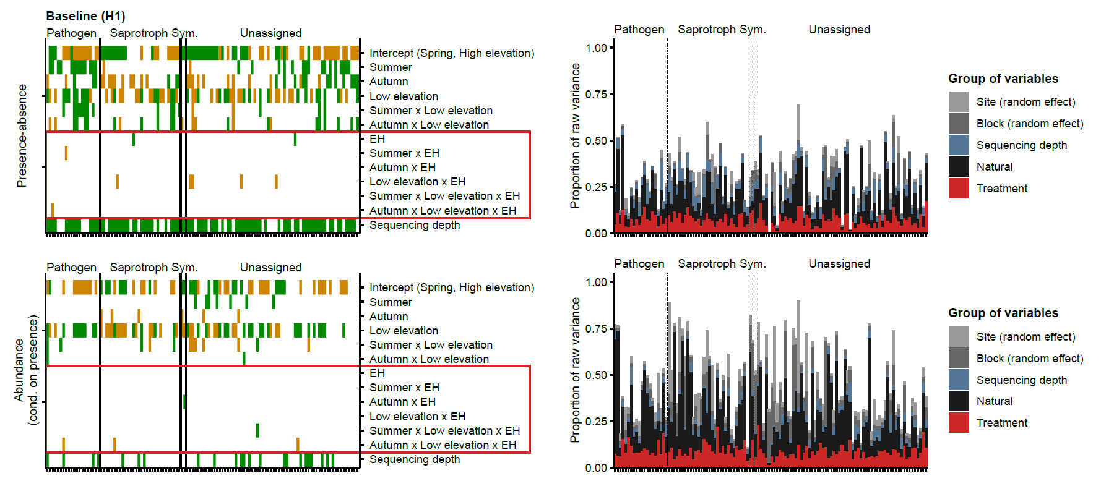
Fig. S10. Output of the joint species distribution models (jSDMs) fitted to investigate the responses of fungal species occurrences (panels above) and abundances (panels below) to season, elevation, treatment, and their three-way interactions, in the baseline response (i.e., harvest 1: H1; before the onset of the extreme heat events). Estimates from the beta parameters (left panels) show the responses of species abundances (x-axis) to each of the model parameters (y-axis). Green and orange colors indicate positive and responses with 95% posterior probability, respectively, while blank spaces denote responses that lacked statistical support. Species abundances at the intercept (spring, high elevation, control treatment) denote more abundant species in green, less abundant species in orange, and blank spaces indicating intermediate abundances. Parameters enclosed within the red area represent species responses to the experimental treatment (extreme heat: EH; see Table 1 for an ecological interpretation of the model parameters). The proportion of raw explained variance (right panels) is provided for different groups of variables: random effects (site and block), natural variables (season and elevation), and treatment (containing the variance explained by all parameters influenced by extreme heat, shown within the red area of the right panels). Fungal species are ordered according to their main trophic modes: pathogens, saprotrophs, symbionts, and unassigned fungi.

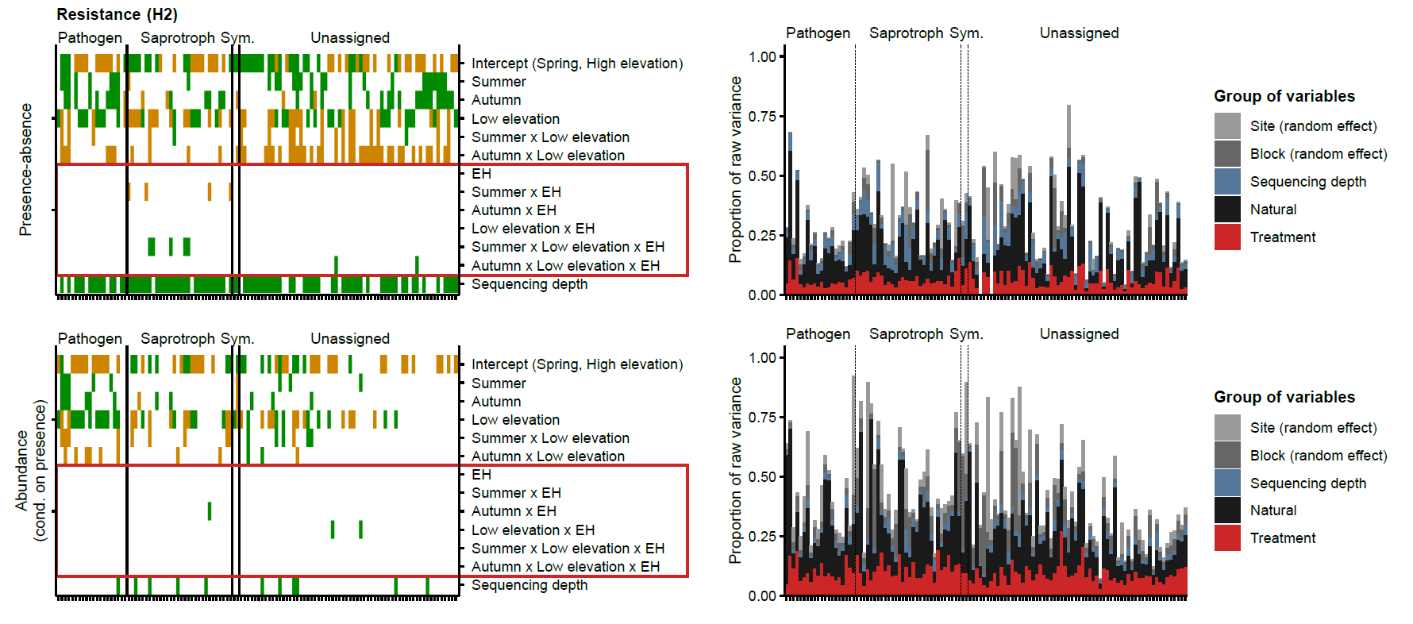
Fig. S11. Output of the joint species distribution models (jSDMs) fitted to investigate the responses of fungal species occurrences (panels above) and abundances (panels below) to season, elevation, treatment, and their three-way interactions, in the resistance response (i.e., harvest 2: H2; after the extreme heat events). Estimates from the beta parameters (left panels) show the responses of species abundances (x-axis) to each of the model parameters (y-axis). Green and orange colors indicate positive and responses with 95% posterior probability, respectively, while blank spaces denote responses that lacked statistical support. Species abundances at the intercept (spring, high elevation, control treatment) denote more abundant species in green, less abundant species in orange, and blank spaces indicating intermediate abundances. Parameters enclosed within the red area represent species responses to the experimental treatment (extreme heat: EH; see Table 1 for an ecological interpretation of the model parameters). The proportion of raw explained variance (right panels) is provided for different groups of variables: random effects (site and block), natural variables (season and elevation), and treatment (containing the variance explained by all parameters influenced by extreme heat, shown within the red area of the right panels). Fungal species are ordered according to their main trophic modes: pathogens, saprotrophs, symbionts, and unassigned fungi.

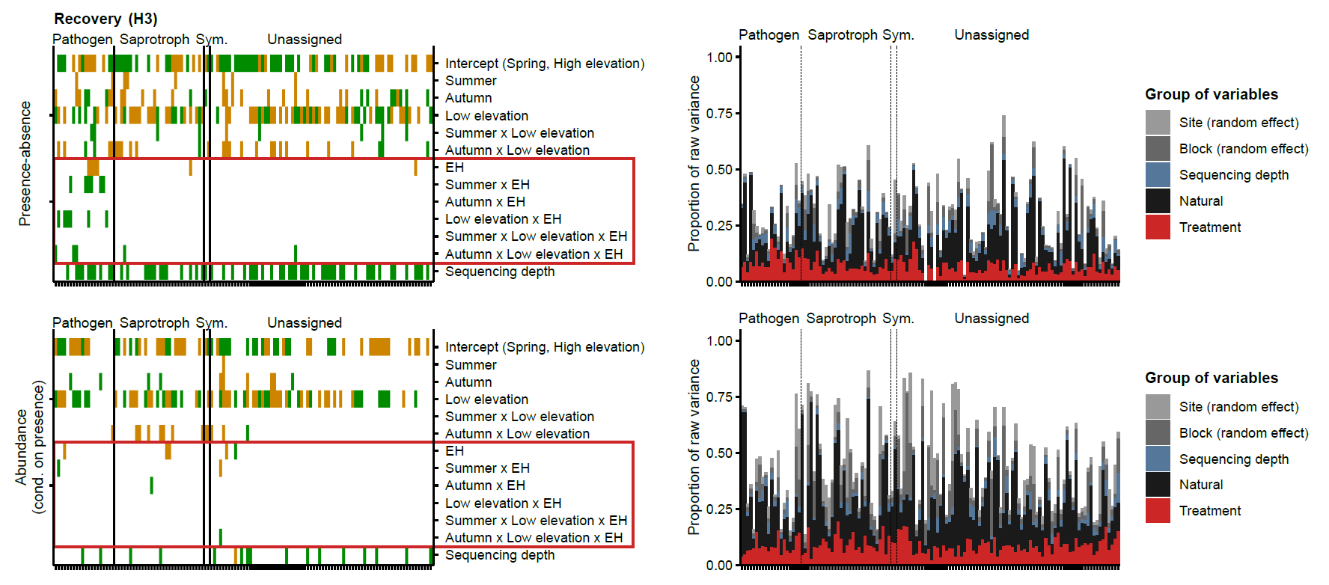
Fig. S12. Output of the joint species distribution models (jSDMs) fitted to investigate the responses of fungal species occurrences (panels above) and abundances (panels below) to season, elevation, treatment, and their three-way interactions, in the recovery response (i.e., harvest 3: H3; five weeks after the end of the extreme heat events). Estimates from the beta parameters (left panels) show the responses of species abundances (x-axis) to each of the model parameters (y-axis). Green and orange colors indicate positive and responses with 95% posterior probability, respectively, while blank spaces denote responses that lacked statistical support. Species abundances at the intercept (spring, high elevation, control treatment) denote more abundant species in green, less abundant species in orange, and blank spaces indicating intermediate abundances. Parameters enclosed within the red area represent species responses to the experimental treatment (extreme heat: EH; see Table 1 for an ecological interpretation of the model parameters). The proportion of raw explained variance (right panels) is provided for different groups of variables: random effects (site and block), natural variables (season and elevation), and treatment (containing the variance explained by all parameters influenced by extreme heat, shown within the red area of the right panels). Fungal species are ordered according to their main trophic modes: pathogens, saprotrophs, symbionts, and unassigned fungi.

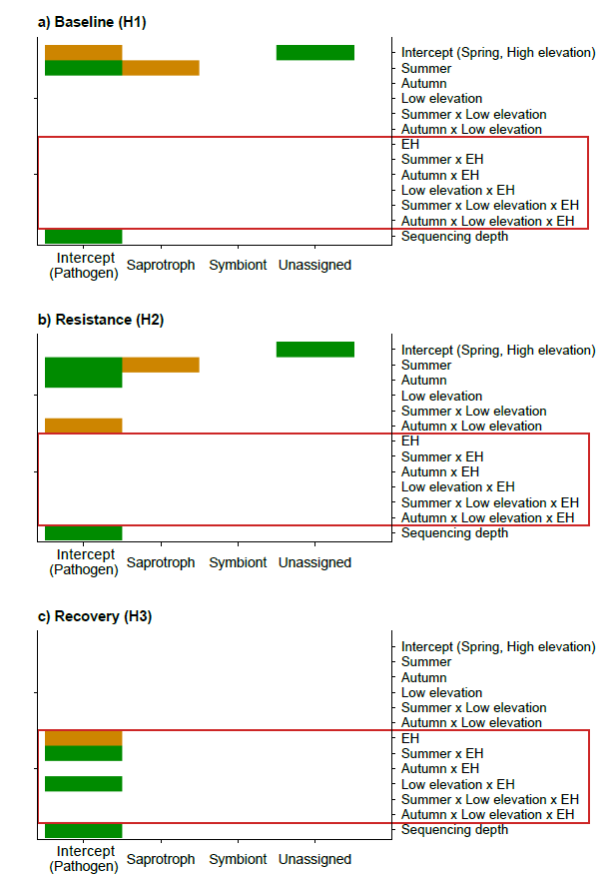
Fig. S13. Output of the joint species distribution models (jSDMs) fitted to investigate the responses of fungal species occurrences (i.e., presence-absence) to season, elevation, treatment, and their three-way interactions, in the baseline (H1), resistance (H2) and recovery responses (H3). Estimates from the gamma parameters show whether species traits (i.e., fungal trophic modes; x-axis) mediate species occurrence responses to each of the model parameters (y-axis). Three types of the fungal trophic modes were investigated: pathogens, saprotrophs and symbionts. Unassigned fungi represent the species for which a trophic mode could not be reliably determined. Green and orange colors indicate positive and responses with 95% posterior probability, respectively, while blank spaces denote responses that lacked statistical support. Parameter estimates at the intercepts (x-axis: pathogenic fungi; y-axis: spring, high elevation, control treatment) denote higher overall occurrences in green, lower overall occurrences in orange, and blank spaces indicating intermediate occurrences. The variation in species occurrences explained by their trophic modes ($R_{T}^{2}$; Ovaskainen et al. 2017) amounts to: 0.04 (baseline), 0.03 (resistance), 0.02 (recovery). Parameters enclosed within the red area represent species responses to the experimental treatment (extreme heat: EH; see Table 1 for an ecological interpretation of the model parameters).
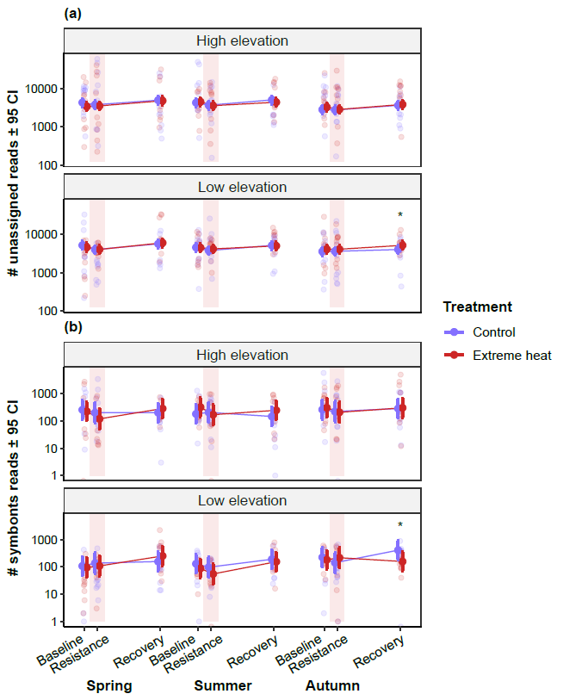
Fig. S14. Estimated marginal means (± 95 confidence intervals) of the number of reads (log-transformed) of unassigned (a; upper panel) and symbiotic fungi (b; lower panel) over the course of the experiments in spring, summer and autumn. The labels on the x-axis specify the different time points in which fungal metabarcoding reads were assessed during the experiment (i.e., harvests): baseline (harvest 1); resistance (harvest 2); recovery (harvest 3). The faded red areas represent the one-week extreme heat events. Colours indicate different experimental temperature treatments: blue: control; red: extreme heat. Stars show significant differences between treatments at each harvest: *P < 0.05.

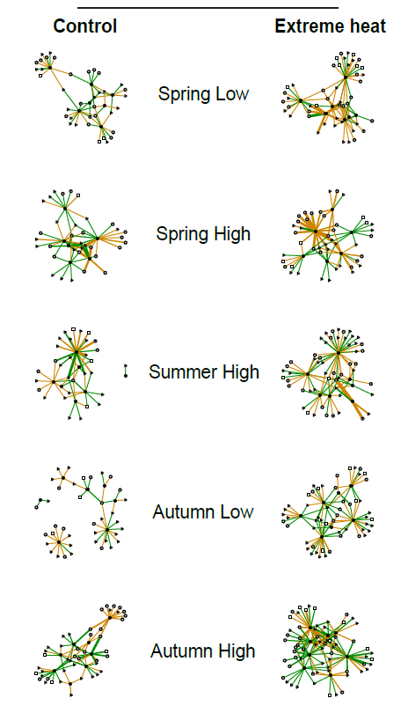
Fig. S15. Association networks of Collembola and fungi in the different spatiotemporal contexts (i.e., season and elevation) at the recovery response, separately for control (left column) and extreme heat treatments (right column). Positive associations are displayed with green colors and negative associations are shown with orange colors. The width of the links is proportional to the strength of the associations (i.e., parameter estimates of the Collembola-fungal jSDM). Black and white nodes denote Collembola and fungal species, respectively. Different node shapes represent various fungal trophic groups: saprotrophs (circle), pathogens (square), symbionts (pie), and unassigned fungi (triangle). Nodes without associations (i.e., degree = 0) are not displayed. A high-resolution version of the figure is available at the data repository (Data from: Belowground Communities in Lowlands Are Less Stable to Climate Extremes across Seasons, 2025).
References
Chauvat, M., Perez, G., & Ponge, J. F. (2014). Foraging patterns of soil springtails are impacted by food resources. Applied Soil Ecology, 82, 72–77. https://doi.org/10.1016/j.apsoil.2014.05.012
Data from: Belowground communities in lowlands are less stable to climate extremes across seasons. (2025). [Dataset]. Figshare Repository. https://doi.org/10.6084/m9.figshare.26142490
Dormann, C. F., Frund, J., Bluthgen, N., & Gruber, B. (2009). Indices, Graphs and Null Models: Analyzing Bipartite Ecological Networks. The Open Ecology Journal, 2(1), 7–24. https://doi.org/10.2174/1874213000902010007
Dunger, W., & Schlitt, B. (2011). Synopses on Palaearctic Collembola – Tullbergiidae. Soil Organisms, 83(1), Article 1.
Ferlian, O., Klarner, B., Langeneckert, A. E., & Scheu, S. (2015). Trophic niche differentiation and utilisation of food resources in collembolans based on complementary analyses of fatty acids and stable isotopes. Soil Biology and Biochemistry, 82, 28–35. https://doi.org/10.1016/j.soilbio.2014.12.012
Fjellberg, A. (1998). The Collembola of Fennoscandia and Denmark, Part I: Poduromorpha (Vol. 35, p. 184). Brill. https://brill.com/display/title/6555
Fjellberg, A. (2007). The Collembola of Fennoscandia and Denmark, Part II: Entomobryomorpha and Symphypleona (Vol. 42). Brill. https://brill.com/display/title/14147
Gisin, H. (1960). Collembolenfauna Europas. Museum D’Histoire Naturelle Genève.
Gisin, H. F. (1943). Oekologie und Lebensgemeinschaften der Collembolen im schweizerischen Exkursionsgebiet Basels. Kundig. https://books.google.ch/books?id=m5HFzQEACAAJ
Hopkin, S. P. (2007). A Key to the Collembola (springtails) of Britain and Ireland. FSC.
Leinaas, H. P., & Bleken, E. (1983). Egg diapause and demographic strategy in Lepidocyrtus lignorum Fabricius (Collembola; Entomobryidae). Oecologia, 58(2), 194–199.
Oksanen, J., Simpson, G., Blanchet, F., Kindt, R., Legendre, P., Minchin, P., O’Hara, R., Solymos, P., Stevens, M., Szoecs, E., Wagner, H., Barbour, M., Bedward, M., Bolker, B., Borcard, D., Carvalho, G., Chirico, M., De Caceres, M., Durand, S., … Weedon, J. (2022). vegan: Community Ecology Package [Computer software]. https://cran.r-project.org/package=vegan
Ovaskainen, O., Tikhonov, G., Norberg, A., Guillaume Blanchet, F., Duan, L., Dunson, D., Roslin, T., & Abrego, N. (2017). How to make more out of community data? A conceptual framework and its implementation as models and software. Ecology Letters, 20(5), 561–576. https://doi.org/10.1111/ele.12757
Pinheiro, J., Bates, B., & R Core Team. (2023). nlme: Linear and Nonlinear Mixed Effects Models [Computer software]. https://cran.r-project.org/package=nlme
Poisot, T., Canard, E., Mouillot, D., Mouquet, N., & Gravel, D. (2012). The dissimilarity of species interaction networks. Ecology Letters, 15(12), 1353–1361. https://doi.org/10.1111/ele.12002
Roswell, M., Dushoff, J., & Winfree, R. (2021). A conceptual guide to measuring species diversity. Oikos, 130(3), 321–338. https://doi.org/10.1111/oik.07202
Thibaud, J.-M., Schulz, H.-J., & da Gama, M. M. (2004). Synopses on Palaearctic Collembola, Volume IV: Hypogastruridae (Vol. 75). https://www.nhbs.com/en/synopses-on-palaearctic-collembola-volume-4-hypogastruridae-book
Urbášek, F., & Rusek, J. (1994). Activity of digestive enzymes in seven species of Collembola (Insecta: Entognatha). Pedobiologia, 38(5), 400–406. https://doi.org/10.1016/s0031-4056(24)00143-4

