Table 1. Ecological interpretation of the parameters from the joint species distribution models (jSDMs) used in our study. We test the effects of season, elevation, treatment, and their three-way interactions, on Collembola and fungal species abundances. In the schematic visualization, green and orange lines represent positive and negative parameter estimates, respectively, while grey lines represent estimates that lack statistical support (i.e., blank fields in Fig. 3).
Parameter | Ecological interpretation | Schematic visualization
Intercept | Species abundances in the treatment combination set as the intercept: spring, at high elevation, in the control treatment. | 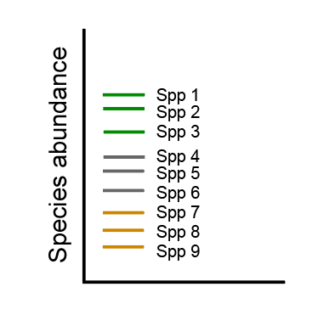
Summer | Shifts in abundance from spring to summer (relative to the intercept). | 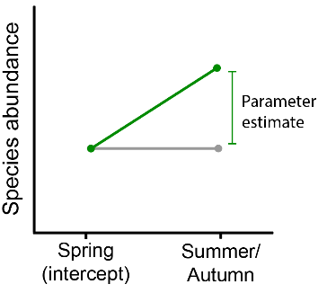
Autumn | Shifts in abundance from spring to autumn (relative to the intercept).
Low elevation | Shifts in abundance from high to low elevation (relative to the intercept). | 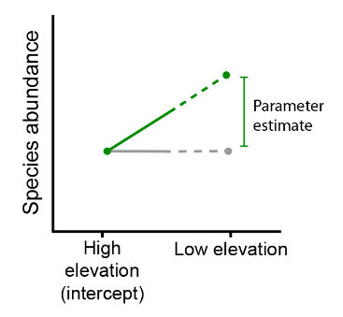
Summer x Low elevation | Given the seasonal abundance shifts as described above, it shows whether this effect is modulated by elevation (in control treatment). | 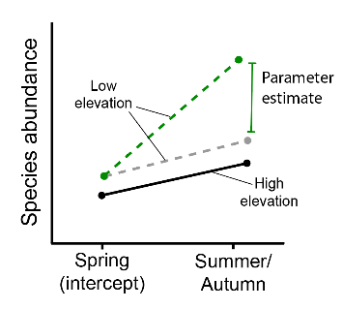
Autumn x Low elevation
EH (extreme heat; including all the interactions involved) | Effect of the extreme heat event, compared to their corresponding reference level in the control treatment. | 