Supplementary figures
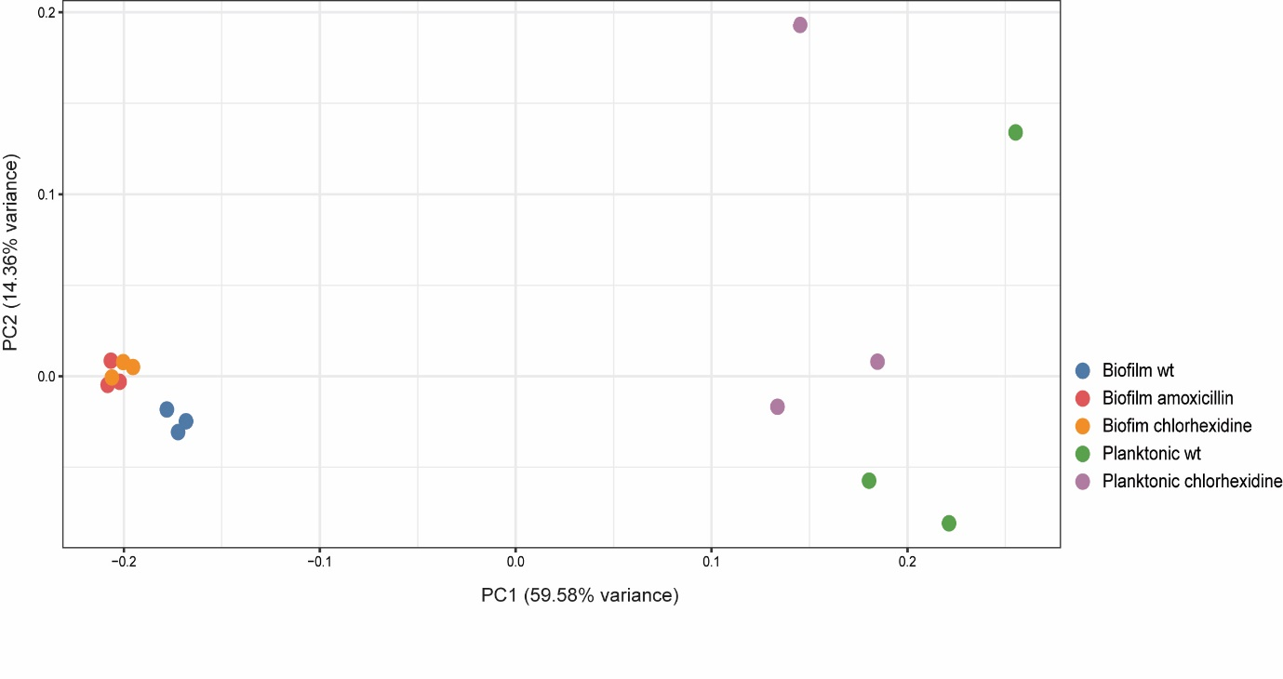

Figure S1. Principal component analysis (PCoA) based on Bray-Curtis dissimilarity. The plot illustrates the distances between the analysed conditions in all biological replicates. The number following B or P indicates the biological replicate. Abbreviations: wt, wild-type S. mutans UA159.

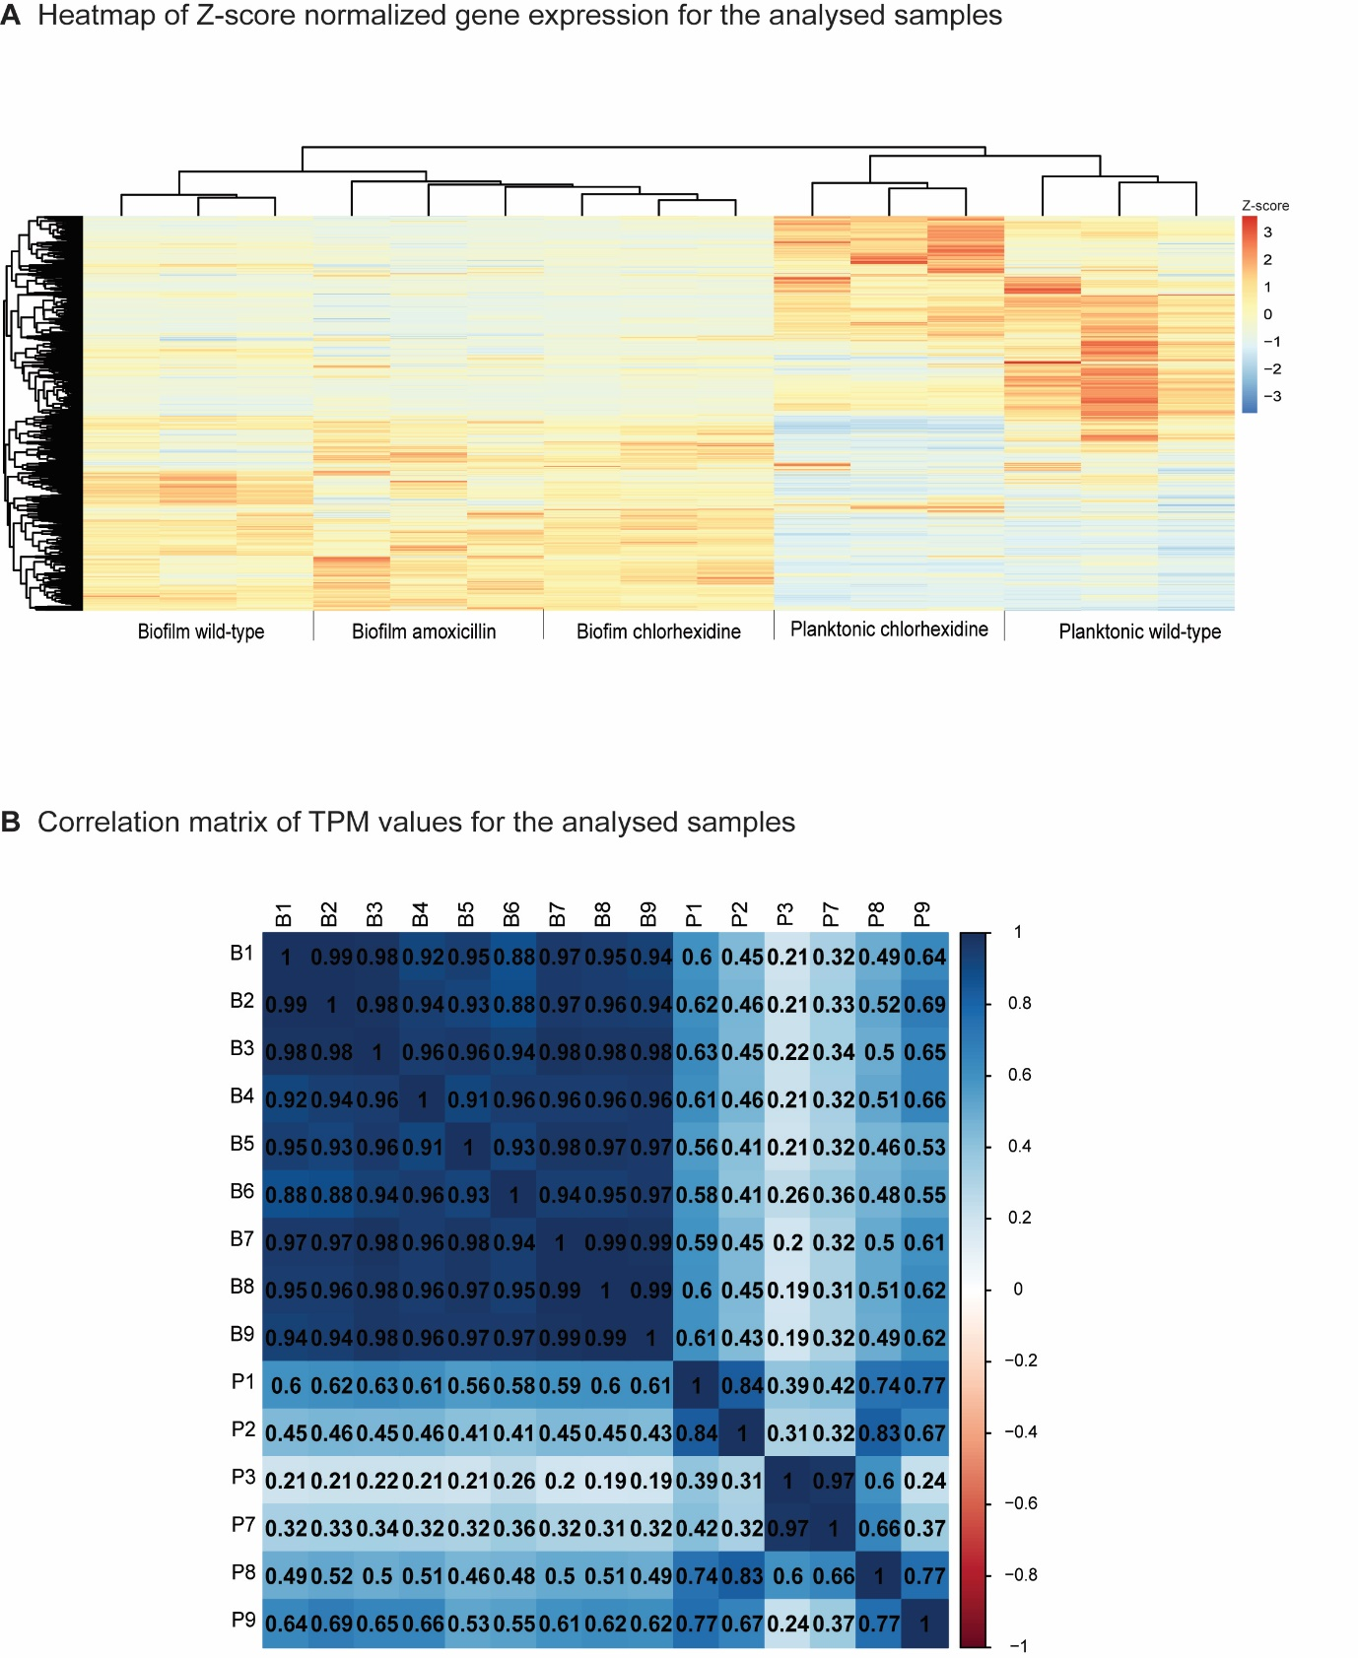

Fig S2. Quality assessment of the analysed samples based on TPM values. (A). Heatmap showing clustering of all genes and analysed samples. (B) Correlation plot showing the correlation coefficients between the analysed samples. Biofilm wild-type (B1-B3), biofilm amoxicillin (B4-B6), biofilm chlorhexidine (B7-B9), planktonic wild-type (P1-P3), planktonic chlorhexidine (P7-P9).

Table S6. Summary of significantly regulated ABC transporter and PTS system- related genes
Compared conditions | ABC transporters
planktonic vs. biofilm | 38 up  25 down
planktonic vs. CHXª planktonic | 22 up  28 down
biofilm vs. CHX biofilm | 1 up  9 down
biofilm vs. AMOX^{b} biofilm | 6 up  8 up
AMOX biofilm vs. CHX biofilm | 26 up  9 down
ªCHX: chlorhexidine, ^{b}AMOX: amoxicillin

