SUPPLEMENTARY INFORMATION
Identification of Hub Genes Involved in Early-onset Schizophrenia: From Genetic Susceptibility to Predicted Regulated Gene Expression

Yawen Jen, Sung-Liang Yu, Po-Chang Hsiao, Po-Hsiu Kuo, Chih-Min Liu, Chen-Chung Liu, Tzung-Jeng Hwang, Ming H. Hsieh, Yi-Ling Chien, Yi-Ting Lin, Hailiang Huang, Yen-Chen Anne Feng, Chuhsing K. Hsiao, Yen-Feng Lin, Stephen V. Faraone, Benjamin Neale, Stephen J. Glatt, Ming T. Tsuang, Hai-Gwo Hwu, and Wei J. Chen

This file provides details of the samples, measurements, and statistical methods, along with results from additional analyses, presented under the following sub-headings: Supplementary Methods and Materials, Supplementary Note, Supplementary Tables, and Supplementary Figures.

Supplementary Methods and Materials

Taiwan Schizophrenia Linkage Study (TSLS)
TSLS recruited a total of 2,242 individuals from 557 multiplex families who underwent interviews using the Diagnostic Interview for Genetic Studies (DIGS) and the Family Diagnostic Interview for Genetic Studies (FIGS), both of which are designed for family genetic studies of schizophrenia and bipolar disorder and have demonstrated good interrater reliability (1). Research assistants who had received standardized psychiatric interview training conducted the Chinese version of the DIGS. The diagnosis of SZ was independently made by at least two psychiatrists based on integrated clinical information from DIGS, FIGS interview data, and summary notes of clinical course, symptom manifestations, and social functioning derived from medical records based on the fourth edition of the Diagnostic and Statistical Manual (DSM-IV). Among the 557 recruited multiplex families in TSLS (2), 1,275 individuals were genotyped using the Illumina PsychChip array, and 1,224 individuals passed quality control.

Ethics statement
The participant recruitment was approved by the internal review board (IRB) of National Taiwan University Hospital (assurance number 87001 for the TSLS and 200810016R for the S-TOGET), where the research headquarters were located for both projects, and the IRBs of other participating hospitals nationwide. All participants provided written informed consent after receiving a complete description of the study. The multi-omics analysis of this study was approved by the Research Ethics Committee of National Taiwan University Hospital (202006021RINC).

Neurocognitive measurements
To evaluate the profile of impairments in cognition function, two neurocognitive measurements were included in this study. One is the continuous performance test (CPT), which is used for measuring sustained attention deficit, with the procedure and reliability of the data obtained from the CPT in this study described in more detail elsewhere (3). The sensitivity index (d′) for CPT performance was determined by calculating the difference between the standard deviation of the hit rate (probability of responding to target trials) and false alarms. The Wisconsin Card Sorting Test (WCST) was used to assess patients’ executive function (4), and two performance indices, perseverative errors and categories achieved, were used for subsequent analyses.

Quality control (QC) of genotypes
For multiplex samples, we first conducted QC separately for each batch, including removing variants and samples with a high missing data rate. Specifically, we sequentially excluded variants with a missing rate > 5%, subjects with a missing rate > 5%, and variants with a missing rate > 2% to mitigate batch effects in this study. After batch-specific QC, we carried out the final QC after merging batches, following these steps and parameters: 1) excluding monomorphic variants; 2) excluding subjects with mismatches between reported sex and chromosome X computed sex; 3) excluding subjects with deviant autosomal heterozygosity (± 6SD); 4) excluding variants with a missing rate > 2%; 5) excluding variants violating Hardy‒Weinberg equilibrium (P < 10-6 for unaffected relatives or P < 10-10 for cases); and 6) subsequent to step 5, retaining autosomal variants.

Polygenic risk score (PRS) calculation
To remove variants in linkage disequilibrium, the SNPs were clumped based on a pairwise r2 threshold of 0.1 and a window size of 250 kb, and these approximately independent loci were used to construct a PRS for schizophrenia (SZ-PRS). First, we utilized the latest version of GWAS summary statistics from the PGC SZ cohort (5), which included 69,369 cases and 236,642 controls, as the discovery dataset. Each individual’s SZ-PRS was subsequently calculated as the weighted sum of SNPs, with each SNP’s weight using the logarithm of the corresponding odds ratio (OR) for the effect allele derived from the discovery dataset. We estimated various PRSs based on SNPs selected at a series of p-value thresholds (including 0.001, 0.01, 0.1, 0.2, 0.5, or 1) in the multiplex sample dataset. All PRSs were subsequently normalized to z scores for easier interpretation.

Deriving the effect sizes of predicted gene expression on SZ from the TWAS for SZ
We performed a tissue-specific TWAS for SZ using S-PrediXcan to derive the effect sizes of predicted gene expression on SZ. This method initially trained a SNP-expression prediction model using a relatively small sample that had both SNP genotype and tissue-specific gene expression data to derive SNP expression weights. These weights were subsequently applied to predict the effects on gene expression inferred from GWAS summary data of patients with SZ, incorporating SNPs from a linkage disequilibrium reference panel. The GWAS summary data of patients with SZ were downloaded from PGC SZ cohort, and the existing SNP-expression prediction model was obtained from CMC(6), derived from DLPFC brain tissue samples.

Assessment of reproducibility of early-onset-related module and hub genes
When the research group conducting the WGCNA later narrowed their samples of postmortem brain tissue to three common psychiatric disorders and healthy controls, focusing on the frontal and temporal cortices, they obtained 34 coexpression modules (7). To assess the reproducibility of the early-onset-related module and hub genes identified in these procedures, we recalculated the module-based GeRS using gene lists from the 34 newly derived coexpression modules. Briefly, after recalculating individual module-based GeRS results, we evaluated their associations with early-onset SZ to identify which one explained the most variance. We subsequently compared the genes and hub genes listed in this module to those in the originally identified early-onset-related module in this study.

Supplementary Note

Reproducibility of early-onset-related module and hub genes
When we used the 34 modules derived from 3-diagnosis groups (7) to reconstruct individual module-based GeRS based on PsychChip GWAS genotypes of schizophrenia patients in the multiplex sample, we found that the SZ-GeRS based on the module 9 (M9-GeRS) explained the most variance for the early-onset SZ, with a Pseudo-R² of 1.5% (p = 0.01; more detail in Supplementary Figure S6). Notably, within the 262 genes included in module 9, 119 genes had a SNP-expression weight in the brain region of DLPFC and 19 of them were listed in the originally identified early-onset-related module, i.e., module-10 derived from the gene expression of cerebral cortex tissue (Supplementary Table S2) (8). Following the same process mentioned in the precedent section to identify hub genes in the module 9, 8 genes were defined as hub genes in the top-ranking network, which had an IPA score of 46 (Supplementary Data 4, Data 5, and Figure S7). Intriguing, we found that 2 of these hub genes were also defined as hub genes in the originally identified early-onset-related module (i.e., module-10).
Additionally, we used these hub genes to construct the module-based GeRS, dubbed as M9_{hub}-GeRS, and compared their utility in distinguishing early-onset SZ from late-onset SZ among SZ-PRS, M9-GeRS, and M9_{hub}-GeRS (Supplementary Figure S8). Similar to the findings based on the cerebral cortex modules, M9-GeRS led to a significant aOR of 1.27 and explained more variance (1.5%) than that of SZ-PRS (1.1%), while M9_{hub}-GeRS had an aOR with borderline significance (1.11, 95% CI = 0.97-1.26) that explains 0.5% of the variance. As expected, after adding M9-GeRS (model 3) or M9_{hub}-GeRS (model 4) to the model containing SZ-PRS (model 0), both of them accounted for additional variance, i.e., M9-GeRS accounting for additional 1.3% of the variance and M9_{hub}-GeRS for additional 0.6% of the variance.

Supplementary Tables

Table S1. Distributions of sociodemographic characteristics in patients with schizophrenia grouped by TSLS sample, S-TOGET sample and matching sample.

Table S2. Genes as listed in the Module-10 derived from a previous WGCNAa predicted to have genetically regulated expression in DLPFC on the basis of PsychChip GWAS genotypes of schizophrenia patients in the discovery sample (N = 595) and the replication sample (N = 595), respectively.

Table S3. Genes listed in Module 9, derived from a previous WGCNA based on gene expression of frontal cortex and temporal cortex brain tissue, are predicted to have genetically regulated expression in the DLPFC based on PsychChip GWAS genotypes of schizophrenia patients in the discovery sample.
Table S1. Distributions of sociodemographic characteristics in patients with schizophrenia grouped by multiplex sample, S-TOGET sample, and simplex sample.
Variables | Multiplex sample  (N = 595) |  | S-TOGET sample  (N = 1635) |  |  |  |  |  | Simplex sample  (N = 595)
Variables | Mean | S.D. |  | Mean | S.D. | pª |  |  |  | Mean | S.D. | p^{b}
Male gender, n % | 355 | 59.7% |  | 1003 | 61.3% | 0.50 |  |  |  | 355 | 59.7% | 1.00
Age, years | 33.17 | 7.34 |  | 35.04 | 7.96 | <0.01** |  |  |  | 33.98 | 7.93 | 0.05
Age at onset, years | 21.10 | 5.80 |  | 21.40 | 5.79 | 0.28 |  |  |  | 21.05 | 5.61 | 0.87
*p value < .05; **<0.01
ª The group comparisons were conducted using t-test between discovery sample and S-TOGET sample.
^{b} The group comparisons were conducted using paired t-test between discovery sample and replication samples.

Table S2. Genes as listed in the Module-10 derived from a previous WGCNAª predicted to have genetically regulated expression in DLPFC on the basis of
161 gene with active expression, with 94 having SNP-expression weights in DLPFC | 57 for multiplex sample  61 for simplex sample | No. of genes = 56; by alphabetic order  ACOT8; ATP6V1H; B4GAT1; BLVRA;  CLTA; COA1; COPS6; COPS7A; COX6B1; CSTPP1; CUEDC2; DHPS; DHRS7B; EIPR1; ERCC3; FEN1; FIBP; GARS1; GOT2; GPX4; IDH3B; IMMT; LCMT1; LRPAP1; LRPPRC; LYRM4; MCAT; ME3; MRPS7; NANS; NAPA; NDN; PARP2; PEF1; PITPNB; PNMA8A; PSMB5; PSMD2; PTPRR; RNF8; RUVBL2;  SAE1; SAMM50; SARS1; SERPINF1; SNRNP25; SNRPN; SNX17; STOML2;  THOC5; TMEM177; TOR1A; TSPAN5; TUBA4A; TXNL4A; VPS33B | No. of gene = 1  CCKBR | No. of genes = 5  ASH2L; FAM134A; HMOX2; POLR3K;  PSMB6;
ª Gandal, M. J., Haney, J. R., Parikshak, N. N., Leppa, V., Ramaswami, G., Hartl, C., et al. (2018). Shared molecular neuropathology across major psychiatric disorders parallels polygenic overlap. Science, 359(6376), 693-697. doi:10.1126/science.aad6469

PsychChip GWAS genotypes of schizophrenia patients in the multiplex sample (N = 595) and the simplex sample (N = 595), respectively
Table S3. Genes listed in Module 9, derived from a previous WGCNAª based on the gene expression of frontal cortex and temporal cortex brain tissue, are predicted to have genetically regulated expression in the DLPFC based on PsychChip GWAS genotypes of schizophrenia patients in the multiplex sample (N = 595)
 | Individual genes predicted to have genetically regulated expression based on sample’s GWAS
Total no. of genes in the Module 9 | No. of genes predicted to have genetically regulated expression | Overlapped with module 10 derived from WGCNA^{b} based on cerebral cortex
262 gene with active expression, with 162 having SNP-expression weights in DLPFC | No. of genes = 119; by alphabetic order  AAGAB; ABCF3; ACAD8; ANXA6; AP1S1; APBA2; APLP2; APMAP; ARFGEF2; ATAD1; ATP5PD; ATP6V1H; ATXN7L3B; B4GAT1; BLOC1S2; BMS1; CDC37; CDS2; CHGB; CHMP4B; CHMP7; CMTR1; COA7; COPS3; COPS7A; CTPS1; DDX24; DDX41; DEPDC5; DHPS; DHRS7B; DNAJC5; DYNLL2; EBNA1BP2; ECPAS; EIF2B3; ELAC2; ELP3; ENTPD6; ERCC3; EXOC3; FOXRED1; GARS1; GLOD4; GNL3; HAGH; HK1; IARS1; IDH3B; KAT14; KIAA0319L; KLC1; LETMD1; LRPPRC; MDN1; METTL3; MFN2; MICU1; MRPS9; MSH2; MTCH1; NDRG4; NDUFA10; NDUFS2; NIPSNAP1; NME1; NRDC; NUDCD3; PDAP1; PDHB; PEBP1; PGAM1; PICK1; PKM; PLCL2; PMS2; PNMA8A; PNMA8B; POLR3E; PRKAR1A; PSEN2; PSMA1; PSMB5; PSMD13; PSMD2; PSMD3; PSMD4; PSMD7; RAB11A; RAN; RBM5; RNF187; RNF8; SAE1; SARS1; SDHA; SDHB; SERINC1; SF3A3; SLC25A3; SLC27A4; SLC35B4; SLC4A1AP; SLU7; SNX17; SPRYD3; SRPRA; STRIP1; SUCLA2; THYN1; TRIM3; USF1; VDAC1; VDAC3; VPS11; VPS16; VPS4A; ZFYVE27; ZNF875; | No. of gene = 16; by alphabetic order  ATP6V1H; B4GAT1; COPS7A; DHPS; DHRS7B; ERCC3; GARS1; IDH3B; LRPPRC; PNMA8A; PSMB5; PSMD2; RNF8; SAE1; SARS1; SNX17

ª Gandal, M. J., Zhang, P., Hadjimichael, E., Walker, R. L., Chen, C., Liu, S., et al. (2018). Transcriptome-wide isoform-level dysregulation in ASD,
schizophrenia, and bipolar disorder. Science, 362(6420). doi:10.1126/science.aat8127
^{b} Gandal, M. J., Haney, J. R., Parikshak, N. N., Leppa, V., Ramaswami, G., Hartl, C., et al. (2018). Shared molecular neuropathology across major psychiatric disorders parallels polygenic overlap. Science, 359(6376), 693-697. doi:10.1126/science.aad6469

Supplementary Figures

Figure. S1. Flow diagram of data preparation, analysis, and validation. DLPFC, dorsolateral prefrontal cortex; BIP, bipolar; MDD, major depression disorder; ASD, autism; ADD, alcohol abuse; PGC-SZ3, schizophrenia GWAS 3 of the Psychiatric Genomics Consortium; WGCNA, weighted gene co-expression network analysis; TWAS, transcriptome-wide association study; SZ-GeRS, predicted gene expression risk score for SZ; *Michael J. Gandal et al., 2018; orange represents our dataset; green represents external downloaded datasets.

Figure. S2. Quantile-quantile (QQ) plot of genotyped SNPs after quality control depicting observed (y-axis) versus expected P-values (x-axis).

Figure. S3. Association of predicted SZ-GeRS and early-onset SZ in the discovery sample. Results from mixed-effect logistic regression model with family index as random effect. Each point represents a gene, with physical genomic position (chromosome, basepair) plotted on the X-axis and the Z score of the association between SZ-GeRS and early-onset SZ plotted on the Y-axis. The sign of Z score value indicate predicted direction of effect. The horizontal grey line shows the significance threshold at p-value < 0.05, blue line shows the significance threshold at p-value < 0.005, and red line shows the significance threshold at p-value < 0.001.

Figure. S4. Association of predicted GeRS and early-onset SZ in the replication sample.

Figure. S5. Predictive utility of each module-based GeRS, derived from WGCNA based on gene expression of frontal cortex and temporal cortex brain tissue, for early-onset SZ in discovery sample.

Figure. S6. The 119 genes of M9-GeRS, derived from WGCNA based on gene expression of frontal cortex and temporal cortex brain tissue, listed in module 9 forming the top gene network, as identified by ingenuity pathway analysis (IPA).

Figure. S7. Utility of M9-GeRS, derived from WGCNA based on gene expression of frontal cortex and temporal cortex brain tissue, and standardize SZ-PRS for distinguishing early-onset from late-onset SZ in discovery sample.

Figure. S8.Comparison between the M10-GeRS_{hub} and onset status of SZ in (A) the discovery sample and (B) the replication sample.

Figure. S9. Expression levels of hub genes across cell types in brain single-cell data from samples in psychENCODE.

Genotypes of discovery sample (595 SZ patients from TSLS)
p-value thresholding SZ-PRS
3. Hub gene-based SZ-GeRS
Replicated in 595 SZ patients from S-TOGET
- Identifying the module most related to early-onset
- Identifying hub genes from IPA Network analysis in the module most related to early-onset
Assessing the associations with early-onset SZ

2. Module-based SZ-GeRS
- p-value thresholding-based SZ-GeRS
Gene-summing GeRS (summing over genes)
SZ-GeRS for individual genes
WGCNA results based on 5-psychiatric disorders*
(159 SZ, 94 BIP, 87 MDD, 50 ASD, 17 ADD and 293 controls from cerebral cortical samples)
PGC-SZ3 summary statistics
(76,755 SZ and 243,649 controls)
Extracted gene list of 13 co-expression modules
Weighting the predicted expression by gene expression effect on SZ from TWAS
Applying PrediXcan
Applying S-PrediXcan
DLPFC SNP-expression prediction model from CommonMind
(254 SZ, 52 BIP, and 279 controls)
Predicted expression per gene
Extracted effect of gene expressions on SZ from TWAS

Figure S1. Flow diagram of data preparation, analysis, and validation. DLPFC, dorsolateral prefrontal cortex; BIP, bipolar; MDD, major depression disorder; ASD, autism; ADD, alcohol abuse; PGC-SZ3, schizophrenia GWAS 3 of the Psychiatric Genomics Consortium; WGCNA, weighted gene co-expression network analysis; TWAS, transcriptome-wide association study; SZ-GeRS, predicted gene expression risk score for SZ; *Michael J. Gandal et al., 2018; orange represents our dataset; green represents external downloaded datasets.

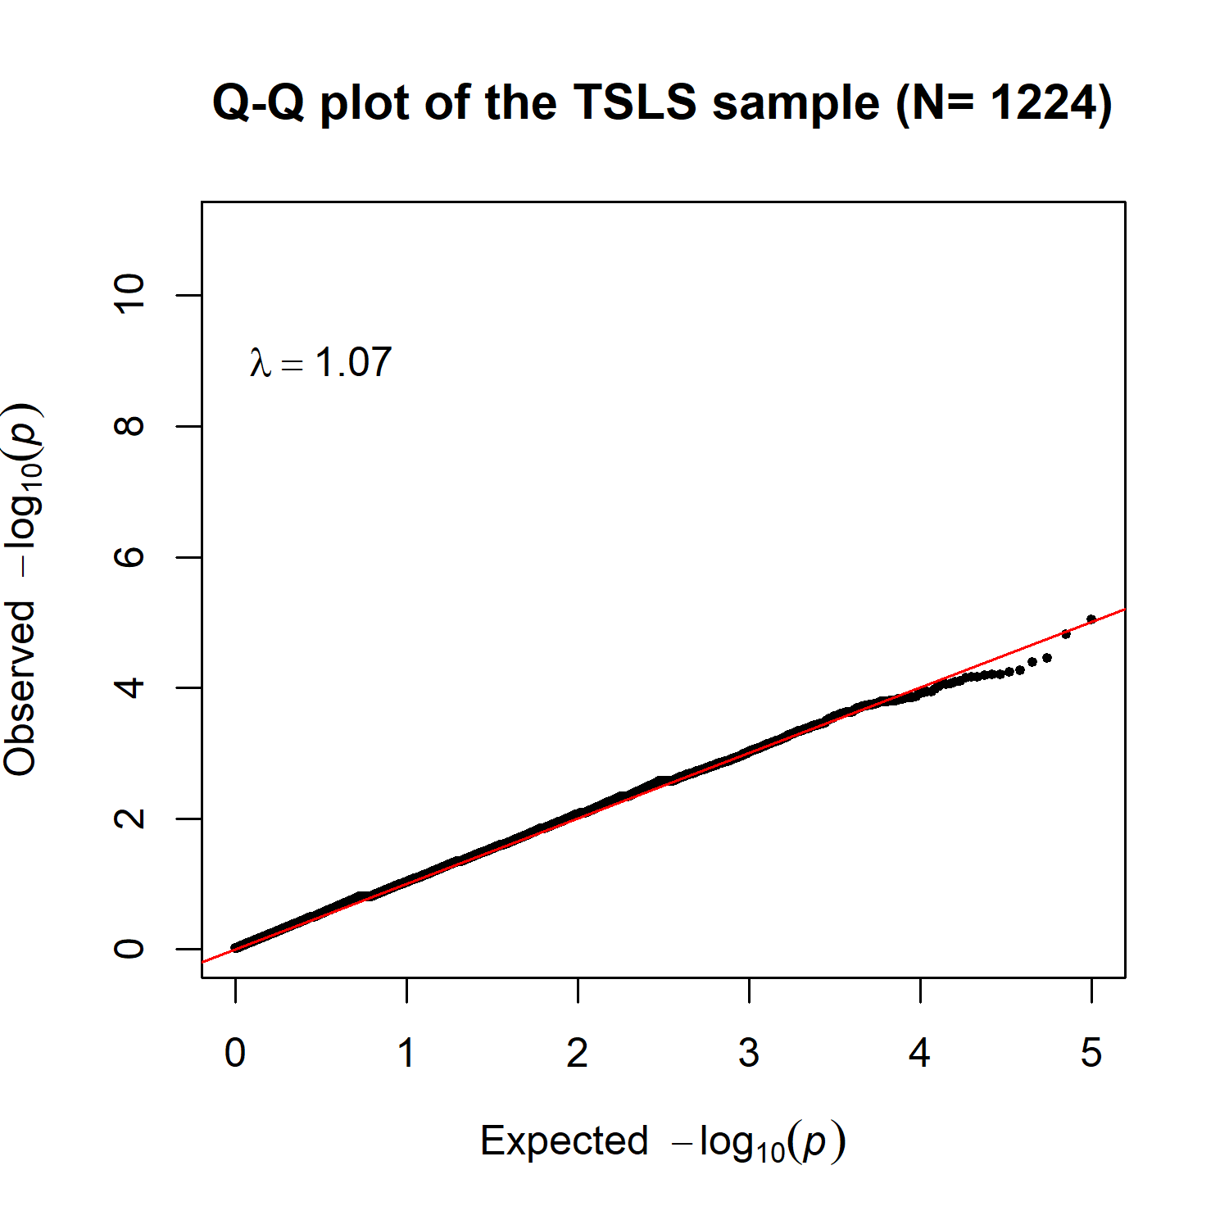

Figure S2. Quantile-quantile (QQ) plot of genotyped SNPs after quality control depicting observed (y-axis) versus expected P-values (x-axis). The lambda of 1.07 indicates a small genomic inflation corroborated by the near perfect correlation between the observed and expected p value.
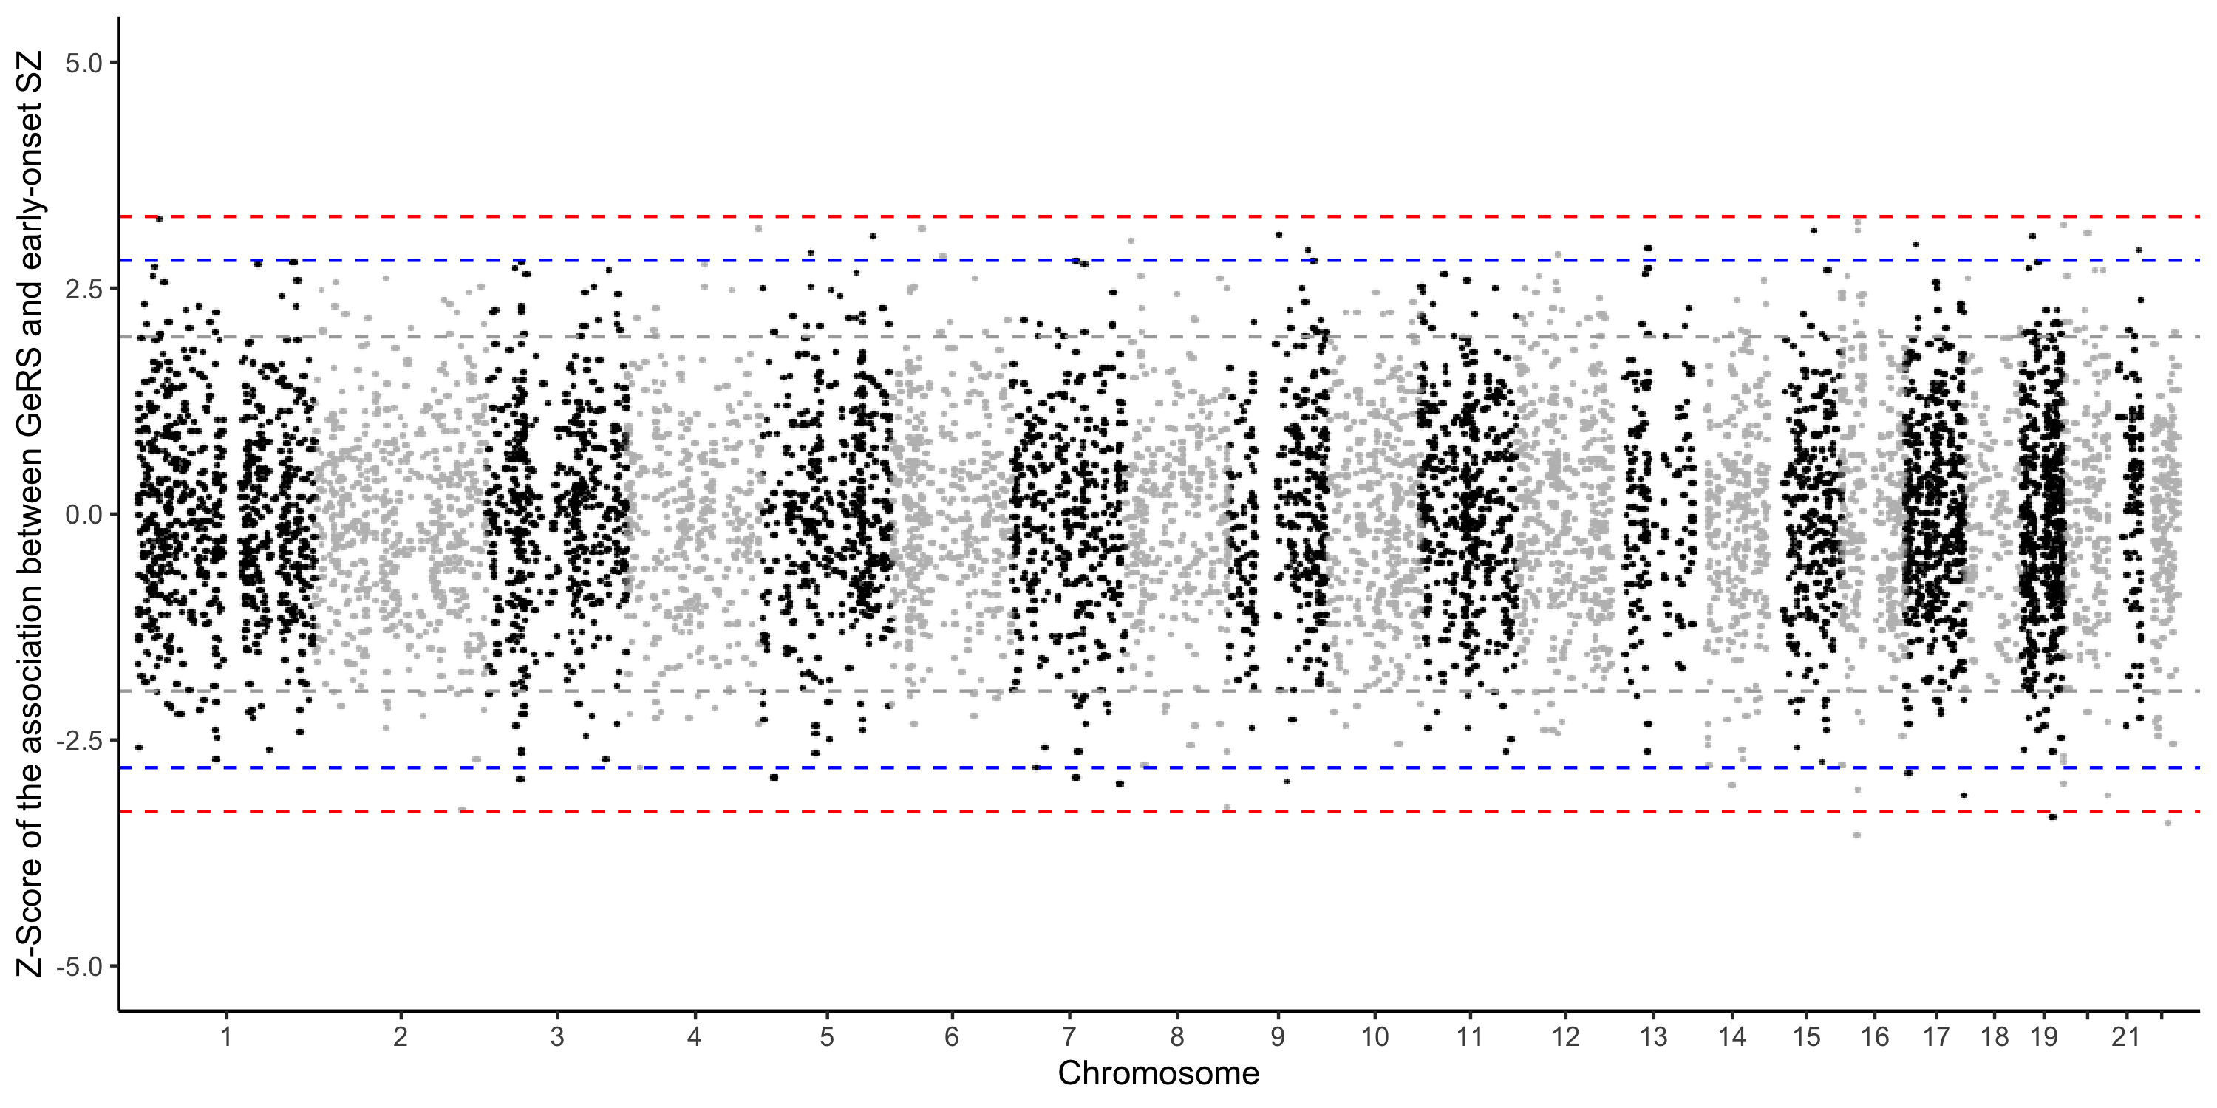

Figure S3. Association of predicted SZ-GeRS and early-onset SZ in the discovery sample. Results from mixed-effect logistic regression model with family index as random effect. Each point represents a gene, with physical genomic position (chromosome, basepair) plotted on the X-axis and the Z score of the association between SZ-GeRS and early-onset SZ plotted on the Y-axis. The sign of Z score value indicate predicted direction of effect. The horizontal grey line shows the significance threshold at p-value < 0.05, blue line shows the significance threshold at p-value < 0.005, and red line shows the significance threshold at p-value < 0.001.

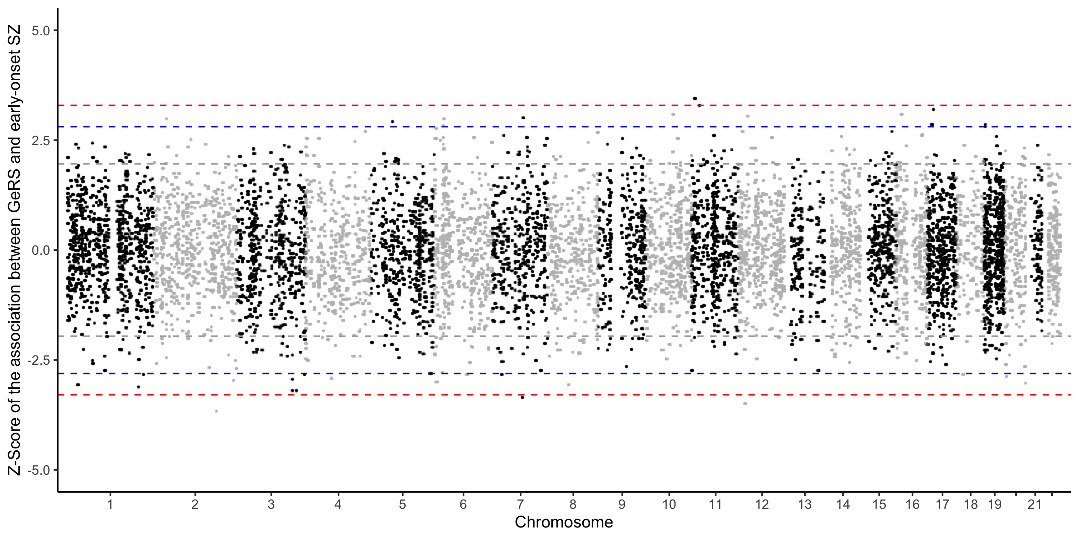

Figure S4. Association of predicted GeRS and early-onset SZ in the replication sample. Results from mixed-effect logistic regression model with family index as random effect. Each point represents a gene, with physical genomic position (chromosome, basepair) plotted on the X-axis and the Z score of the association between GeRS and early-onset SZ plotted on the Y-axis. The sign of Z score value indicate predicted direction of effect. The horizontal grey line shows the significance threshold at p-value < 0.05, blue line shows the significance threshold at p-value < 0.005, and red line shows the significance threshold at p-value < 0.001.

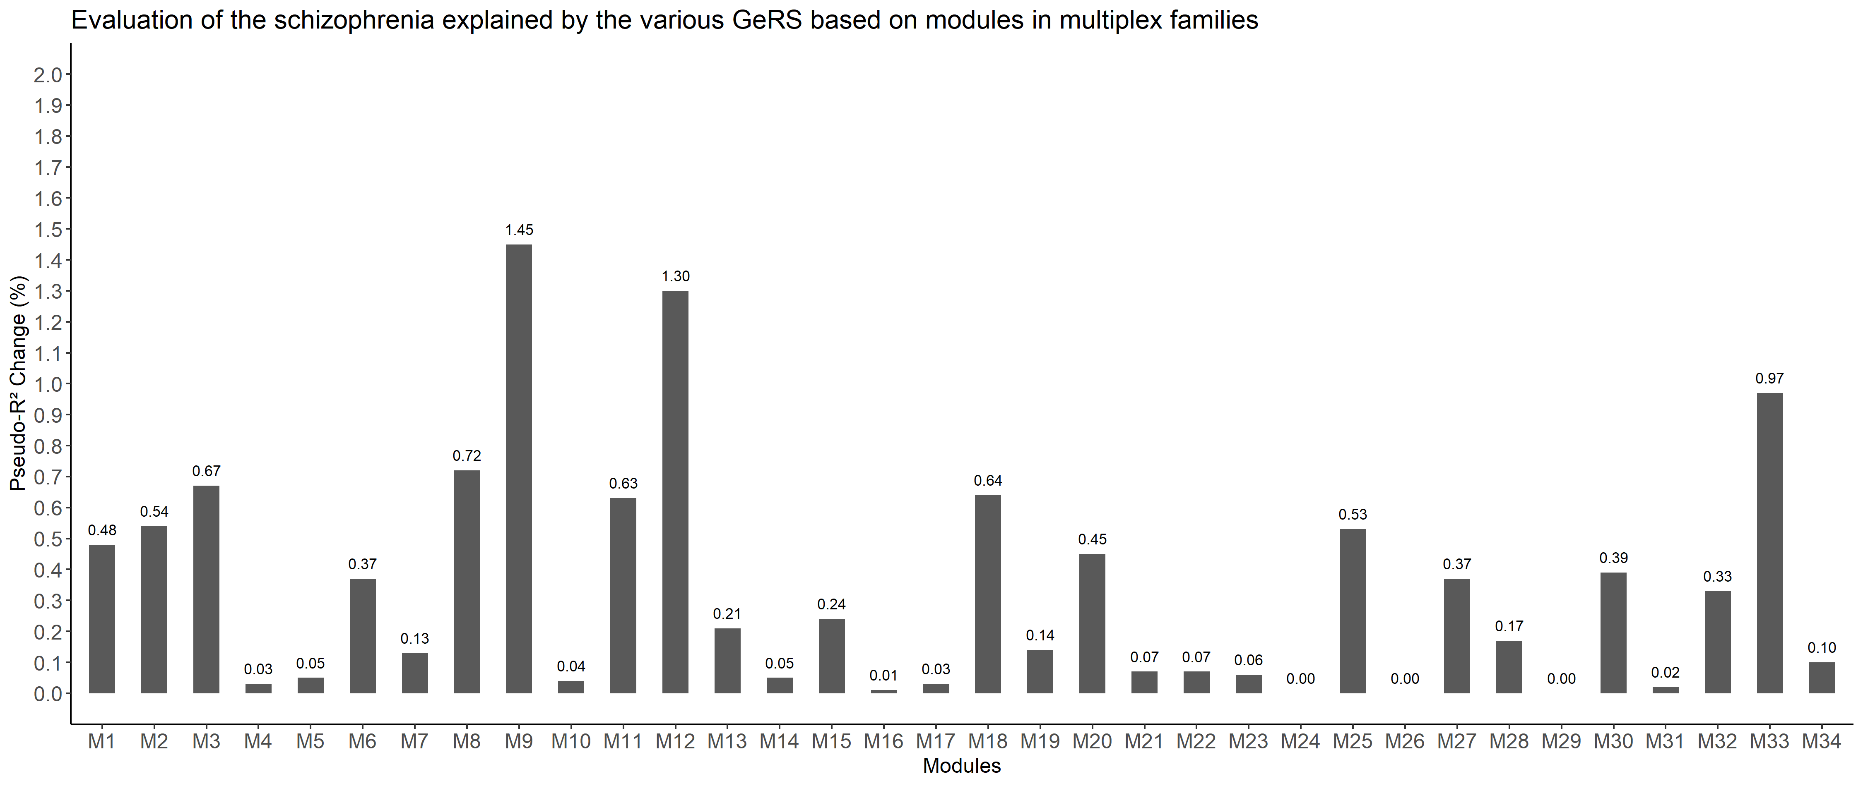
Pseudo-R² = 1.45% (p = 0.01)

Pseudo-R² = 1.30% (p = 0.02)

Pseudo-R² = 0.97% (p = 0.05)

Figure S5. Predictive utility of each module-based GeRS, derived from WGCNA based on gene expression of frontal cortex and temporal cortex brain tissue, for early-onset SZ in discovery sample. Y-axis indicated the increase in Nagelkerke pseudo-R² while adding module-based GeRS into the model only with covariates (sex and education levels and 4 PCs). The Nagelkerke pseudo-R² derived from the mixed-effect logistic regression analysis with family index as a random effect. X-axis indicated module 1 (M1) to module 34 (M34).

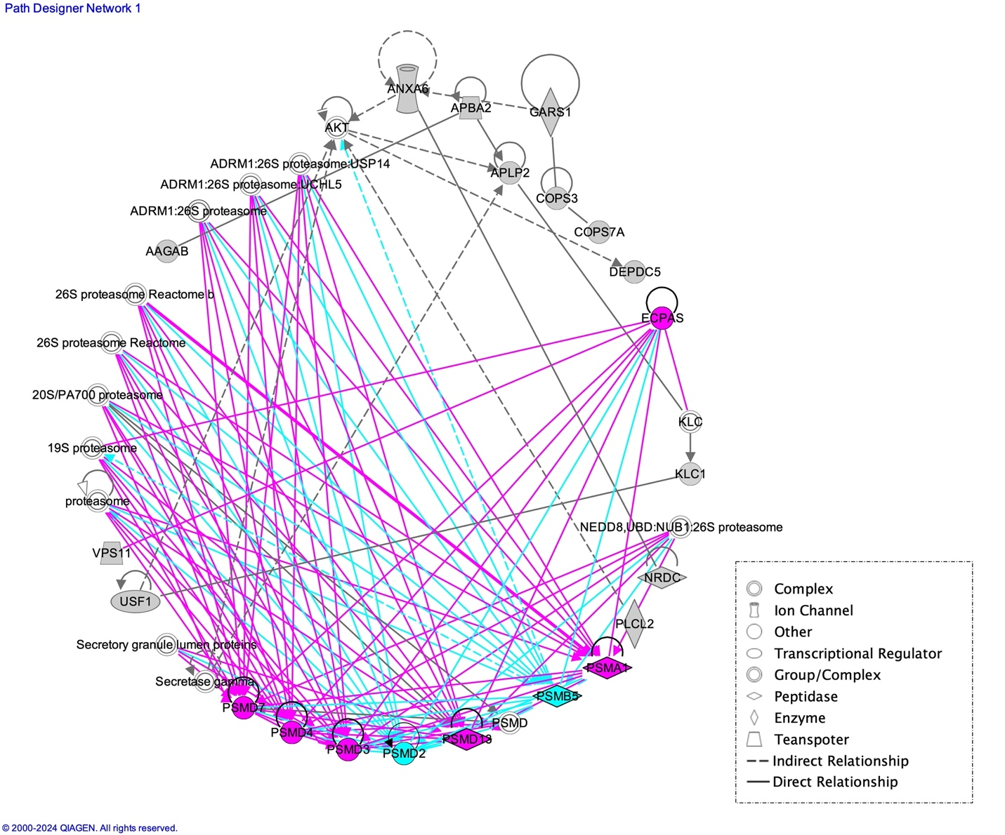

Figure S6. The 119 genes of M9-GeRS, derived from WGCNA based on gene expression of frontal cortex and temporal cortex brain tissue, listed in module 9 forming the top gene network, as identified by ingenuity pathway analysis (IPA). Gray shading: genes listing in module 9 subjected to the network analysis. Straight lines represent direct relationships between genes, whereas broken lines signify indirect relationships. Hub genes are colored in red (those regulating at least 4 other genes) and blue (these genes are also identified as hub genes in module 10, derived from WGCNA based on the cerebral cortex).

Figure S7. Utility of M9-GeRS, derived from WGCNA based on gene expression of the frontal cortex and temporal cortex brain tissue, and standardized SZ-PRS for distinguishing early-onset from late-onset SZ in discovery sample. Each model contains covariates (including sex, education level, and 4 PCs) and additional risk scores. Risk scores underwent initial individual testing within a model to examine their association with the early-onset SZ, respectively (i.e., model 0 to model 3). Model 0 assessed the utility of SZ-PRS at the best performance p-value threshold. Model 1 assessed the utility of M9-GeRS, derived from module 9, 119 genes, predicted to have genetically regulated expression in DLPFC using GWAS genotypes. Model 2 assessed the utility of M9_{hub}-GeRS based on 8 hub genes identified by the IPA top gene network (including ECPAS, PSMA1, PSMB5, PSMD2, PSMD3, PSMD4, PSMD7, and PSMD13). The advanced models containing M9-GeRS/M9_{hub}-GeRS and SZ-PRS simultaneously were then tested in Model 3 and Model 4, respectively. OR: Odds ratios derived from the mixed-effect logistic regression analysis with family index as a random effect in the discovery sample whereas those derived from the logistic regression analysis in the replication sample; 95% CI: 95% confidence intervals. Pseudo R²: Increase in Nagelkerke pseudo-R² while adding additional variables into the model only contains the covariates.
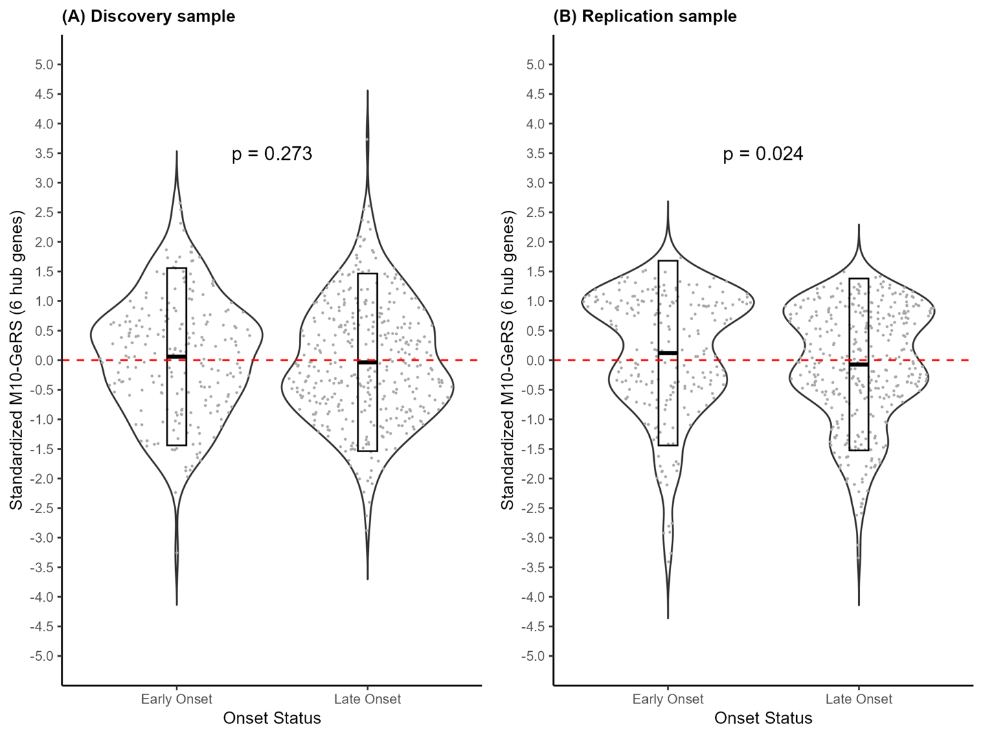

Figure S8. Comparison between the M10_{hub}-GeRS and onset status of SZ in (A) the discovery sample and (B) the replication sample. The M10_{hub}-GeRS were based on 6 hub genes identifying from the top network of IPA. The M10_{hub}-GeRS is distributed normally according to scaled M10-GeRS_{hub} score (mean 0, standard deviation 1). The mean of standardized M10-GeRS_{hub} was 0.06 for the early-onset group and -0.04 for the late-onset group in the discovery sample, and 0.12 for the early-onset group and -0.07 for the late-onset group in the replication sample. Violin plot with median and interquartile range.

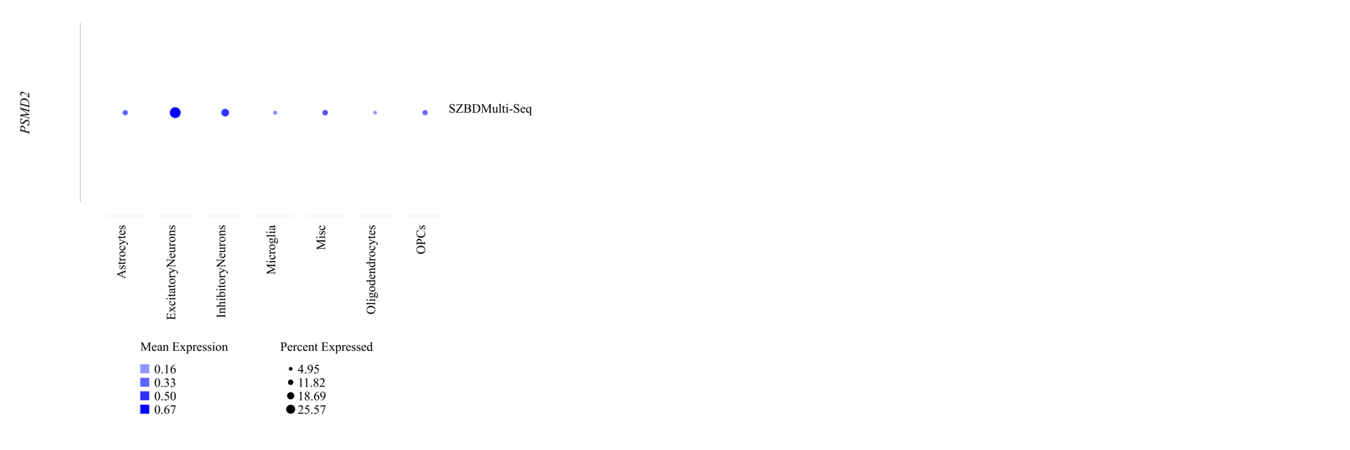
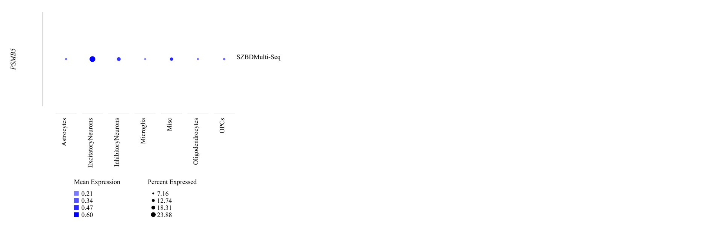
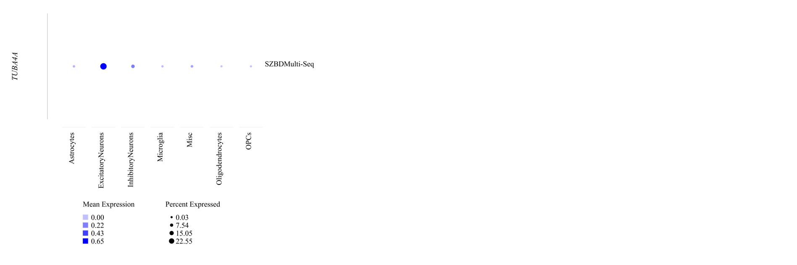
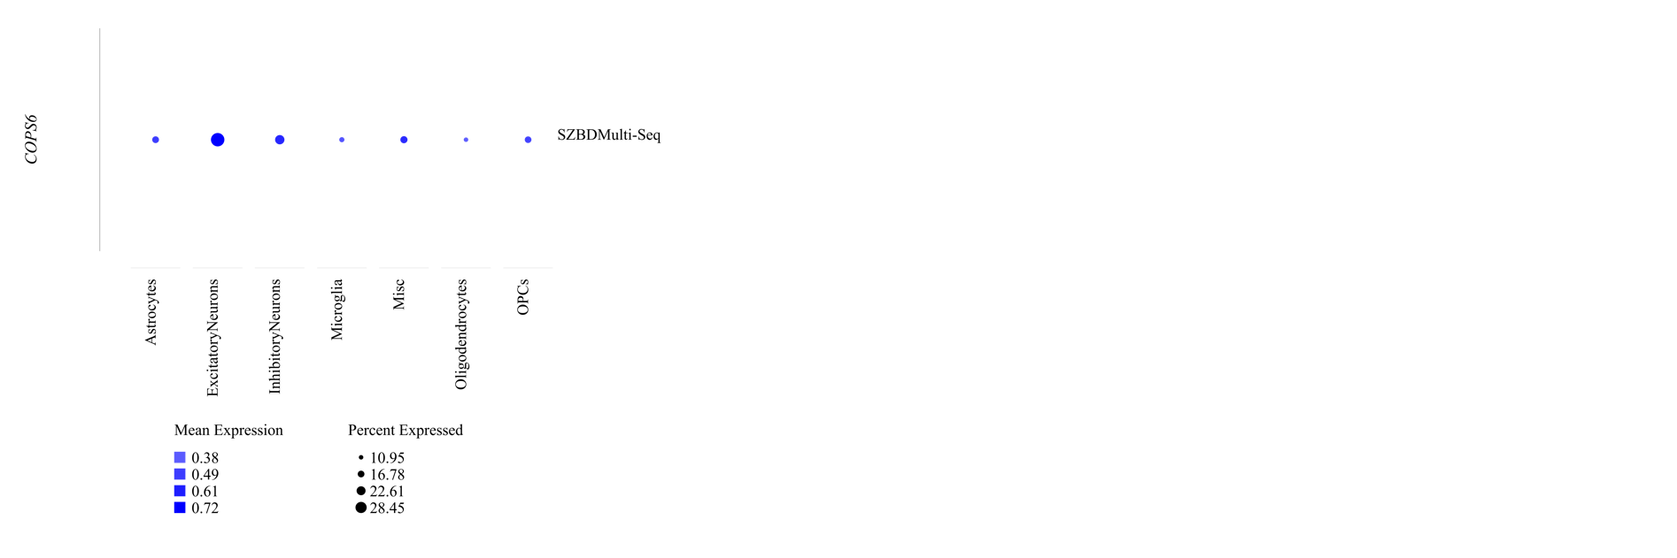
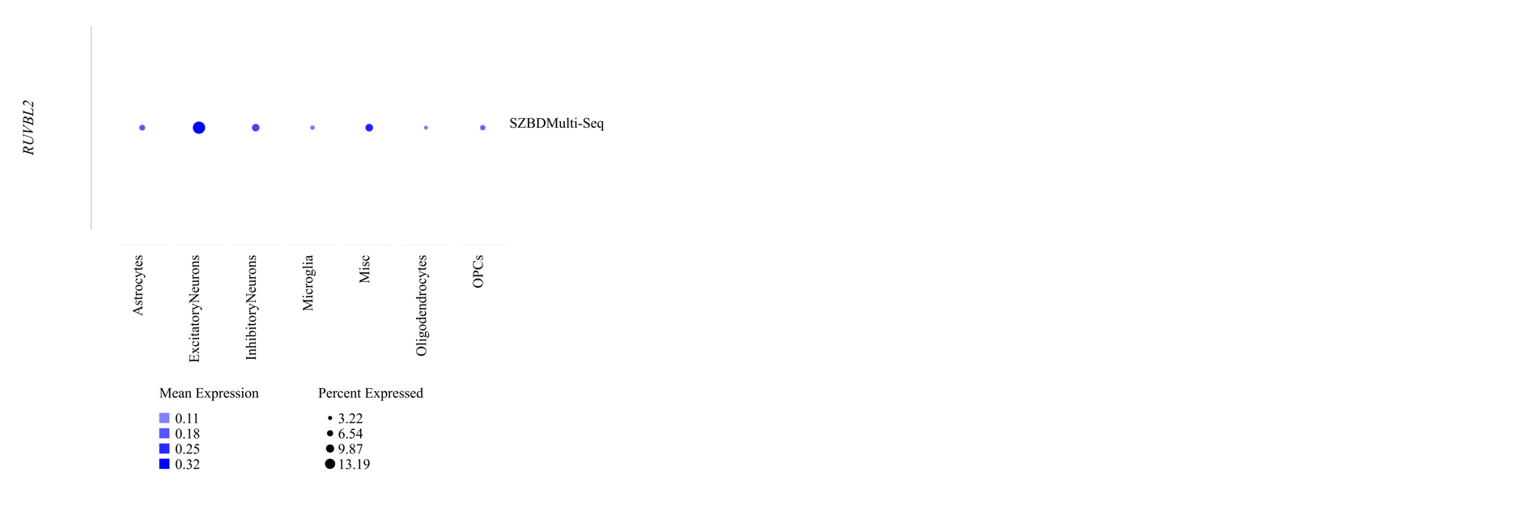

Figure S9. Expression levels of hub genes across cell types in brain single-cell data from samples in psychENCODE.

References
1. Nurnberger JI, Jr., Blehar MC, Kaufmann CA, York-Cooler C, Simpson SG, Harkavy-Friedman J, et al. (1994): Diagnostic Interview for Genetic Studies: Rationale, unique features, and training. Arch Gen Psychiatry. 51:849-859.
2. Faraone SV, Hwu H-G, Liu C-M, Chen WJ, Tsuang M-M, Liu S-K, et al. (2006): Genome scan of Han Chinese schizophrenia families from Taiwan: confirmation of linkage to 10q22.3. Am J Psychiatry. 163:1760-1766.
3. Chen WJ, Hsiao CK, Hsiao LL, Hwu HG (1998): Performance of the Continuous Performance Test among community samples. Schizophr Bull. 24:163-174.
4. Lin S-H, Liu C-M, Hwang T-J, Hsieh MH, Hsiao P-C, Faraone SV, et al. (2013): Performance on the Wisconsin Card Sorting Test in families of schizophrenia patients with different familial loadings. Schizophr Bull. 39:537-546.
5. Trubetskoy V, Pardiñas AF, Qi T, Panagiotaropoulou G, Awasthi S, Bigdeli TB, et al. (2022): Mapping genomic loci implicates genes and synaptic biology in schizophrenia. Nature. 604:502-508.
6. Huckins LM, Dobbyn A, Ruderfer DM, Hoffman G, Wang W, Pardiñas AF, et al. (2019): Gene expression imputation across multiple brain regions provides insights into schizophrenia risk. Nat Genet. 51:659-674.
7. Gandal MJ, Zhang P, Hadjimichael E, Walker RL, Chen C, Liu S, et al. (2018): Transcriptome-wide isoform-level dysregulation in ASD, schizophrenia, and bipolar disorder. Science. 362:eaat8127.
8. Gandal MJ, Haney JR, Parikshak NN, Leppa V, Ramaswami G, Hartl C, et al. (2018): Shared molecular neuropathology across major psychiatric disorders parallels polygenic overlap. Science. 359:693-697.

