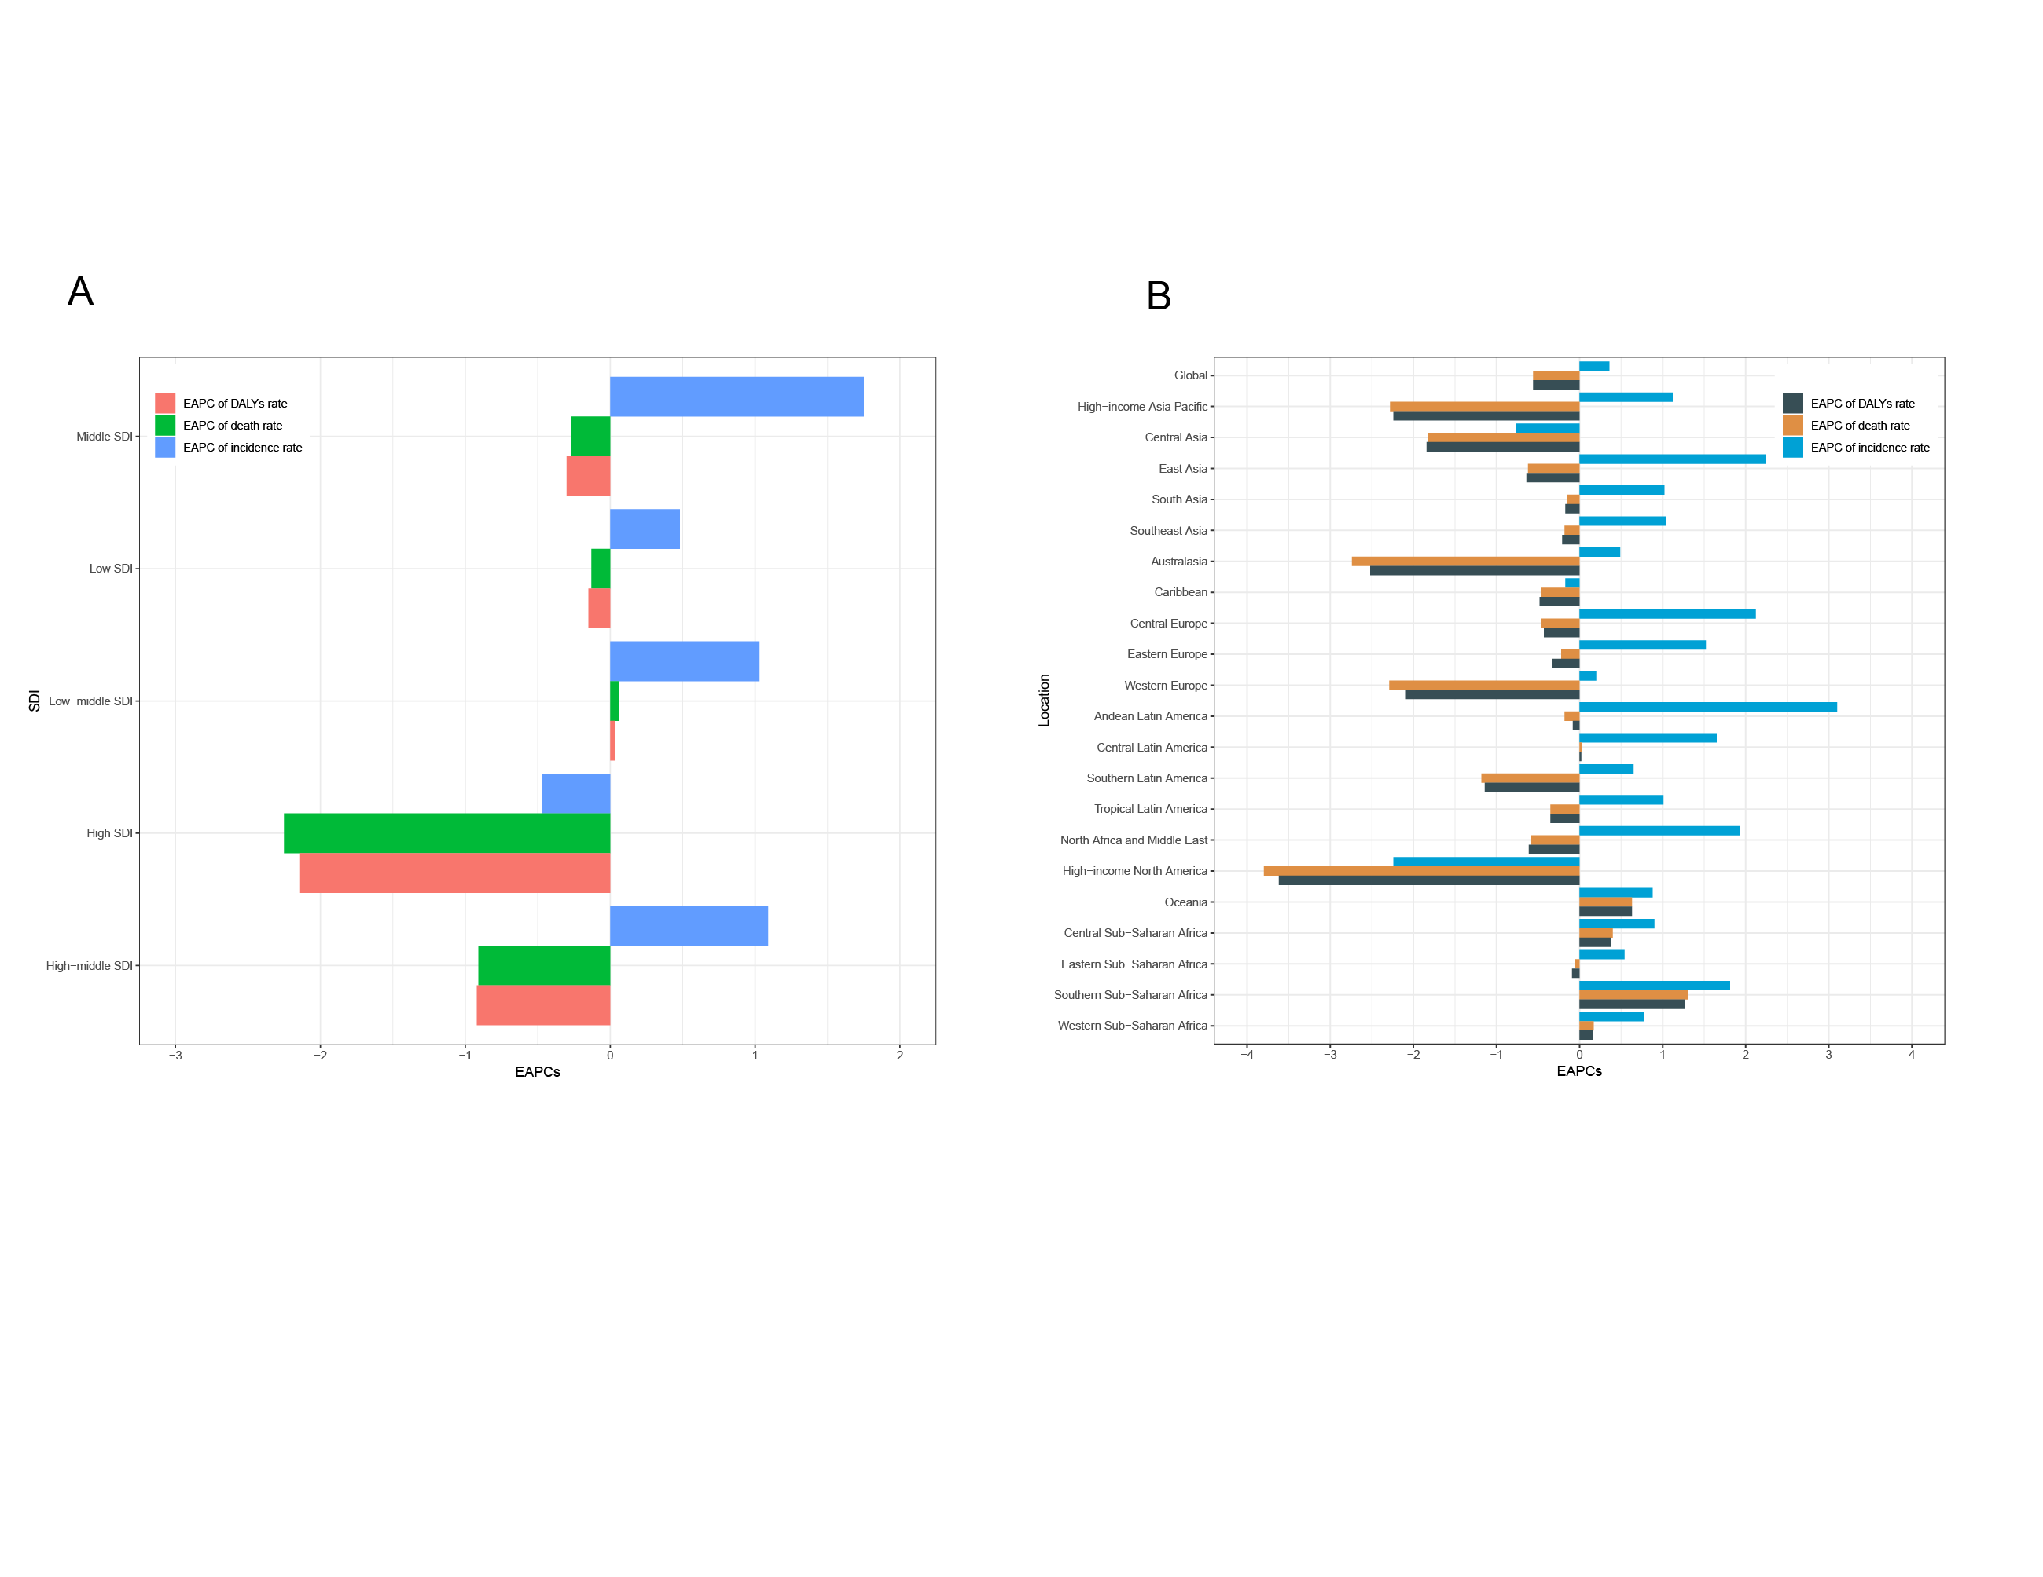
Supplementary Figure 1. EAPC of incidence, mortality, and DALYs rates in five SDI regions and 21 geographical regions. (A). EAPC of incidence, mortality, and DALYs rates in five SDI regions. (B). EAPC of incidence, mortality, and DALYs rates in 21 geographical regions.

