The Role of Atherogenic Index of Plasma and Inflammation in Stroke Risk Among Non-Diabetic Individuals: A National Cohort Study
Supplemental Figures
Figure 1 : Flowchart of the study population.
Figure 2: Nonlinear association between AIP and Stroke.
Figure 3: K-M plot of stroke by AIP and hsCRP level
Figure 4:Stroke risks in different groups according to the AIP and hsCRP levels.
Figure 5. Subgroup and interaction analyses among the quartile 1−4 and stroke across various subgroups(hsCRP was divided into two groups at 1 mg/L).
Figure 6. Subgroup and interaction analyses among the quartile 1−4 and stroke across various subgroups(hsCRP was divided into two groups at 2 mg/L).
Figure 7: Mutual mediation effects of AIP index and hsCRP on stroke
Figure 8: Predictive capacity of AIP and hsCRP on the cardiovascular risk

Supplemental Tables
Table S1: Baseline characteristics of the study population across AIP quartiles.
Table S2: Cox Proportional Hazards Model Analysis of AIP and hsCRP Levels with Stroke Event Risk
Table S3: Risk of stroke upon coexposure stratified by the AIP and hsCRP
Table S4:Sensitivity analysis of AIP and hsCRP with new-onset stroke.
Table S5: Incremental predictive value of hsCRP and AIP beyond traditional risk factors.
Table S6: Cox Proportional Hazards Model Analysis of CumAIP and CumhsCRP Levels with Stroke Event Risk
Table S7: Risk of stroke upon coexposure stratified by the CumAIP and CumhsCRP

Figure 1 : Flowchart of the study population.

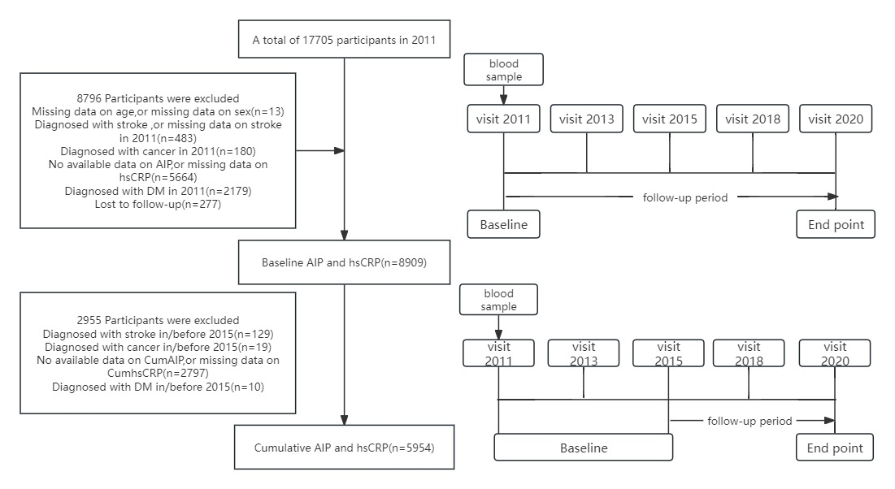

Table S1: Baseline characteristics of the study population across AIP quartiles.
Characteristics | Overall | Quartile |  |  |  | p
 |  | Q1 | Q2 | Q3 | Q4
Participants,No. | 8909 | 2228 | 2227 | 2227 | 2227
Age,years | 58.56(9.60) | 59.26(9.86) | 58.71 (9.92) | 58.42(9.35) | 57.85(9.20) | <0.001
Gender
female | 4784(53.7) | 1097(49.2) | 1213 (54.5) | 1226 (55.1) | 1248 (56.0) | <0.001
male | 4125(46.3) | 1131(50.8) | 1014 (45.5) | 1001(44.9) | 979(44.0)
Education level
high | 139 ( 1.6) | 29 ( 1.3) | 30 ( 1.3) | 35 ( 1.6) | 45 ( 2.0) | <0.001
middle | 2643 (29.7) | 591 (26.5) | 643 (28.9) | 685 (30.8) | 724 (32.5)
primary | 6127(68.8) | 1608(72.2) | 1554 (69.8) | 1507 (67.7) | 1458 (65.5)
Residence
Rural | 7365(82.7) | 1927(86.5) | 1873 (84.1) | 1829 (82.1) | 1736 (78.0) | <0.001
Urban | 1544(17.3) | 301(13.5) | 354 (15.9) | 398 (17.9) | 491 (22.0)
Marital status
married | 7914(88.8) | 1963(88.1) | 1974 (88.6) | 1980 (88.9) | 1997 (89.7) | 0.413
others | 995 (11.2) | 265(11.9) | 253 (11.4) | 247 (11.1) | 230 (10.3)
Smoking
no | 5620(63.1) | 1353(60.7) | 1403 (63.0) | 1438 (64.6) | 1426 (64.0) | 0.040
yes | 3289(36.9) | 875(39.3) | 824 (37.0) | 789 (35.4) | 801 (36.0)
Drinking
no | 5937 (66.6) | 1316 (59.1) | 1524 (68.4) | 1555 (69.8) | 1542 (69.2) | <0.001
yes | 2972 (33.4) | 912 (40.9) | 703 (31.6) | 672 (30.2) | 685 (30.8)
BMI
Continuous | 21.80 (4.97) | 20.71 (4.17) | 21.45 (4.79) | 22.10 (5.10) | 22.93 (5.46) | <0.001
<23.9 | 4652 (52.2) | 1521 (68.3) | 1282 (57.6) | 1047 (47.0) | 802 (36.0) | <0.001
24-27.9 | 2131 (23.9) | 342 (15.4) | 494 (22.2) | 598 (26.9) | 697 (31.3)
≥28 | 2126 (23.9) | 365 (16.4) | 451 (20.3) | 582 (26.1) | 728 (32.7)
SBP | 123.64 (24.77) | 121.94 (23.55) | 122.70 (24.05) | 124.60 (25.59) | 125.31 (25.67) | <0.001
DBP | 73.90 (16.68) | 72.59 (16.19) | 73.21 (16.36) | 74.38 (16.91) | 75.42 (17.14) | <0.001
BUN | 15.69 (4.55) | 16.50 (4.76) | 15.89 (4.68) | 15.28 (4.36) | 15.11 (4.27) | <0.001
UA | 4.42 (1.23) | 4.23 (1.14) | 4.29 (1.19) | 4.41 (1.24) | 4.75 (1.29) | <0.001
TG | 121.82(75.49) | 61.50 (14.42) | 88.55 (17.76) | 121.74 (24.94) | 215.51 (90.18) | <0.001
TC | 191.79(37.37) | 187.41(34.01) | 189.15 (36.82) | 192.54 (36.87) | 198.05 (40.61) | <0.001
HDLC | 52.02 (14.97) | 67.49 (13.81) | 54.80 (10.15) | 47.55 (8.69) | 38.21 (8.34) | <0.001
LDLC | 116.58(33.78) | 110.23(29.06) | 119.04 (32.97) | 122.39 (33.46) | 114.68 (37.85) | <0.001
HbA1c | 5.10 (0.40) | 5.07 (0.39) | 5.09 (0.39) | 5.10 (0.41) | 5.13 (0.42) | <0.001
hsCRP | 2.06 (3.35) | 1.89 (3.45) | 1.99 (3.42) | 2.11 (3.34) | 2.25 (3.16) | 0.002
FBG | 99.92(12.05) | 97.77(12.69) | 98.54 (11.63) | 99.95 (11.28) | 103.44 (11.78) | <0.001
Cr | 0.78 (0.23) | 0.77 (0.29) | 0.77 (0.23) | 0.78 (0.18) | 0.79 (0.19) | <0.001
Comorbidities
Dyslipidemia | 654 ( 7.3) | 101 ( 4.5) | 129 ( 5.8) | 163 ( 7.3) | 261 (11.7) | <0.001
Hypertension | 1954 (21.9) | 353 (15.8) | 410 (18.4) | 552 (24.8) | 639 (28.7) | <0.001
Heart disease | 1321 (14.8) | 310 (13.9) | 302 (13.6) | 372 (16.7) | 337 (15.1) | 0.014
Stroke | 696 ( 7.8) | 123 ( 5.5) | 171 ( 7.7) | 197 ( 8.8) | 205 ( 9.2) | <0.001
History of medication use
Dyslipidemia medications | 348 ( 3.9) | 43 ( 1.9) | 70 ( 3.1) | 85 ( 3.8) | 150 ( 6.7) | <0.001
Hypertension medications | 1411 (15.8) | 235 (10.5) | 286 (12.8) | 401 (18.0) | 489 (22.0) | <0.001

P value was based on χ2 or analysis of variance or Kruskal-Wallis rank sum test where appropriate.
AIP: Q1 < 0.105 , Q2 0.105–0.302 , Q3 0.302-0.522, Q4 >0.522 .
BMI body mass index, BUN blood urea nitrogen, DBP diastolic blood pressure, DM diabetes mellitus, FBG fasting blood glucose, HbA1c glycosylated hemoglobin A1c, HDLC high density lipoprotein cholesterol, hsCRP high-sensitivity C-reactive protein, LDLC low density lipoprotein cholesterol, SBP systolic blood pressure, TC total cholesterol, TG triglycerides, UA uric acid,AIP atherogenic index of plasma.

Figure 2: Nonlinear association between AIP , CumAIP and Stroke.

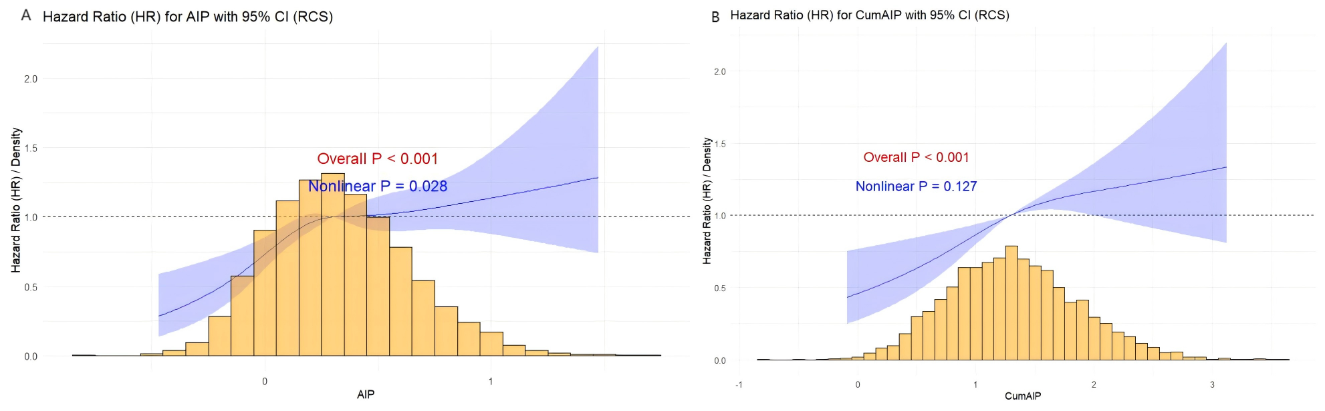

Graphs show β for triglyceride-glucose adjusted for age, gender, marital status, education level, residence,smok, and drink, hypertension, heart disease, dyslipidaemia. Data were fitted by a restricted cubic spline (RCS) linear regression model. Solid lines indicate β, and shadow shapes indicate 95% CIs.

Table S2: Cox Proportional Hazards Model Analysis of AIP and hsCRP Levels with Stroke Event Risk
Variable |  | No. of events (Incident ratea) | Model1 |  | Model2 |  | Model3
 |  |  | HR (95% CI) | P value | HR (95% CI) | P value | HR (95% CI) | P value
AIP | Quartiles
 | Q1 | 123 | Ref. |  | Ref. |  | Ref.
 | Q2 | 171 | 1.44(1.14-1.82) | 0.002 | 1.43(1.13-1.80) | 0.003 | 1.39(1.10-1.76) | 0.005
 | Q3 | 197 | 1.69(1.35-2.12) | <0.001 | 1.67(1.33-2.10) | <0.001 | 1.48(1.18-1.86) | <0.001
 | Q4 | 205 | 1.79(1.43-2.25) | <0.001 | 1.75(1.40-2.20) | <0.001 | 1.49(1.18-1.88) | <0.001
P for trend |  |  |  | <0.001 |  | <0.001 |  | 0.002
sensitivity
 | AIP < median | 294 | Ref. |  | Ref. |  | Ref.
 | AIP≥median | 402 | 1.43(1.23-1.66) | <0.001 | 1.41(1.34-1.82) | <0.001 | 1.26(1.08-1.47) | 0.004
hsCRP
 | hsCRP <1 | 275 | Ref. |  | Ref. |  | Ref.
 | hsCRP≥1 | 421 | 1.58(1.36-1.84) | <0.001 | 1.56(1.11-1.57) | 0.002 | 1.43(1.23-1.68) | <0.001
sensitivity
 | hsCRP <2 | 480 | Ref. |  | Ref. |  | Ref.
 | hsCRP≥2 | 216 | 1.30(1.10-1.52) | 0.002 | 1.28(1.08-1.50) | 0.003 | 1.18(1.01-1.39) | 0.042
Abbreviations: CI, confidence interval HR, hazard ratio.
Mode1: Adjusted for age, gender.
Mode2: Adjusted for age, gender, bmi level, smoking status, and drinking status.
Mode3: Adjusted for age, gender, bmi level, marital status,education level, smoking status, drinking status, hypertension, heart disease, dyslipidaemia, and history of medication use for dyslipidaemia、hypertension.

Figure 3: K-M plot of stroke by AIP and hsCRP level
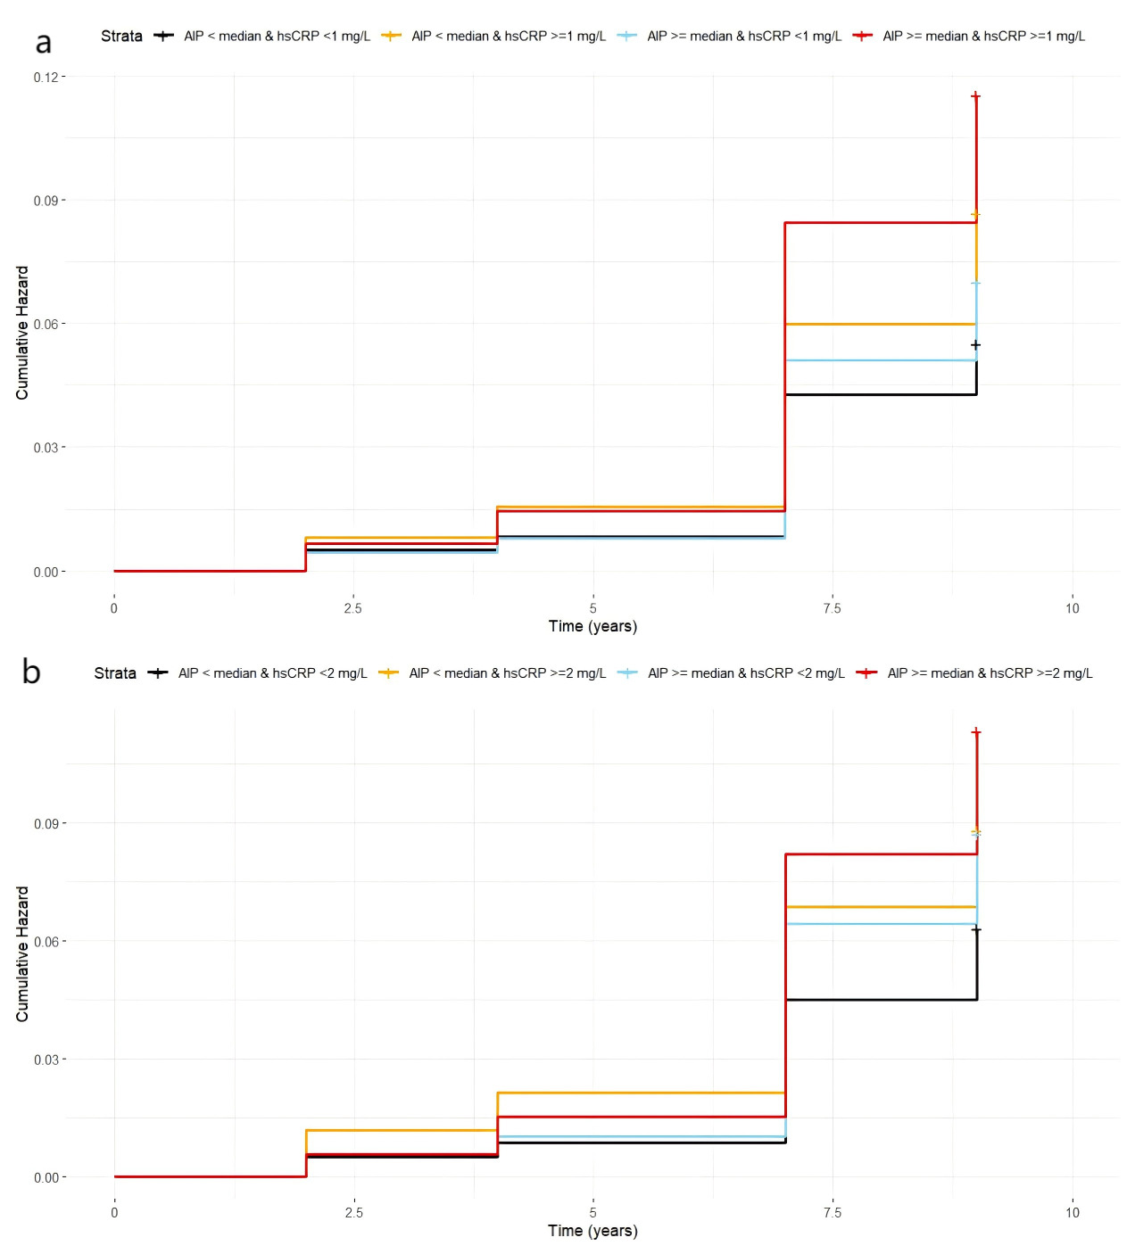

Fig3. K‒M plot of cardiovascular diseases by AIP and hsCRP level. TyG triglyceride-glucose index, hsCRP high-sensitivity C-reactive protein; median of AIP: 0.302. a hsCRP was divided into two
groups at 1 mg/L; b hsCRP was divided into three groups at 2 mg/L.

Figure 4:Stroke risks in different groups according to the AIP and hsCRP levels.
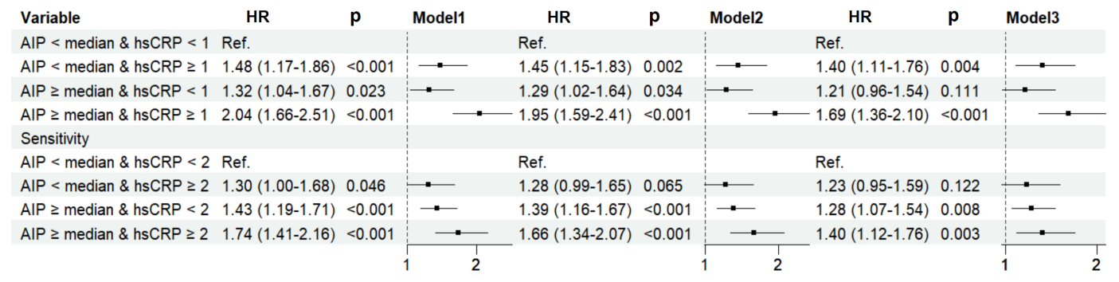
Model1: Adjusted for age, gender.
Model2: Adjusted for age, gender, bmi level, smoking status, and drinking status.
Model3:Adjusted for age, gender, marital status,residence, education level, smoking status, drinking status, hypertension, diabetes, heart disease, dyslipidaemia, and history of medication use for hypertension, and dyslipidaemia.

 |  | Model1 | p | Model 2 | p | Model 3 | p
 | AIP < median & hsCRP < 1 | Ref. |  | Ref |  | Ref
 | AIP < median & hsCRP ≥ 1 | 1.48 (1.17-1.86) | <0.001 | 1.45 (1.15-1.83) | 0.001 | 1.40(1.11-1.76) | 0.004
 | AIP ≥ median & hsCRP < 1 | 1.32 (1.04-1.67) | 0.023 | 1.29 (1.02-1.64) | 0.034 | 1.21 (0.96-1.54) | 0.111
 | AIP ≥ median & hsCRP ≥ 1 | 2.04 (1.66-2.51) | <0.001 | 1.95 (1.59-2.41) | <0.001 | 1.69 (1.36-2.10) | <0.001
P for trend |  |  | <0.001 |  | <0.001 |  | <0.001
Table S3: Risk of stroke upon coexposure stratified by the AIP and hsCRP

Table S4:Sensitivity analysis of AIP and hsCRP with new-onset stroke.
 |  | Model1 | p | Model 2 | p | Model 3 | p
 | AIP < median & hsCRP < 2 | Ref. |  | Ref |  | Ref
 | AIP < median & hsCRP ≥ 2 | 1.30 (1.00-1.68) | 0.046 | 1.28 (0.99-1.65) | 0.065 | 1.23(0.95-1.59) | 0.122
 | AIP ≥ median & hsCRP < 2 | 1.43 (1.19-1.71) | <0.001 | 1.39 (1.16-1.67) | <0.001 | 1.28(1.07-1.54) | 0.008
 | AIP ≥ median & hsCRP ≥ 2 | 1.74 (1.41-2.16) | <0.001 | 1.66 (1.34-2.07) | <0.001 | 1.40(1.12-1.76) | 0.003
P for trend |  |  | <0.001 |  | <0.001 |  | 0.001

Figure 5. Subgroup and interaction analyses among the quartile 1−4 and stroke across various subgroups(hsCRP was divided into two groups at 1 mg/L).

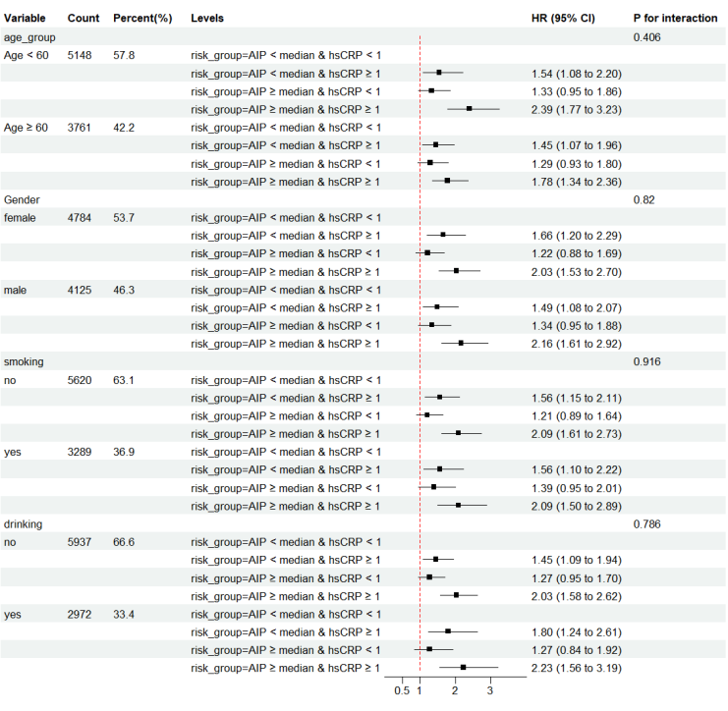

Figure 6. Subgroup and interaction analyses among the quartile 1−4 and stroke across various subgroups(hsCRP was divided into two groups at 2 mg/L).

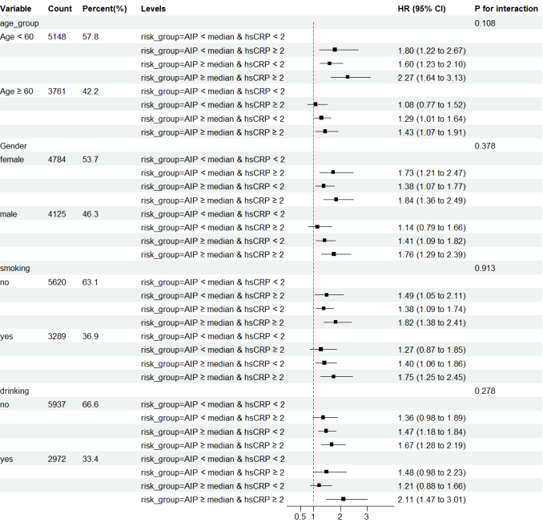

Figure 7: Mutual mediation effects of AIP index and hsCRP on stroke

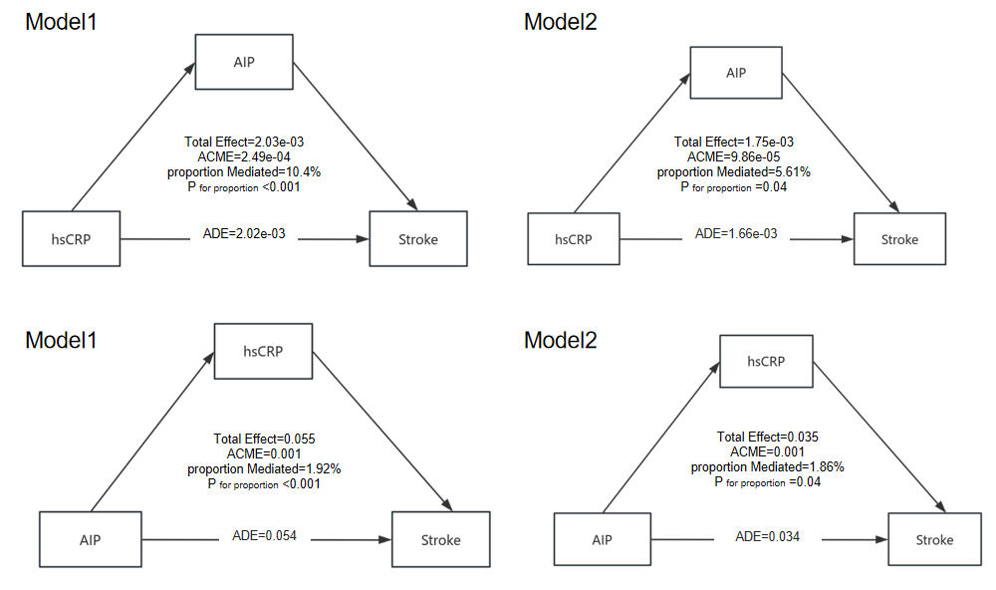
Abbreviations:ACEM:Average Causal Mediation Effect;ADE:Average Direct Effect
Model 1: age and gender adjusted; Model 2: age, gender, marital status,residence, education level, smoking status, drinking status, hypertension, heart disease, dyslipidaemia, and history of medication use for hypertension, and dyslipidaemia were adjusted.

Figure 8: Predictive capacity of AIP and hsCRP on the cardiovascular risk

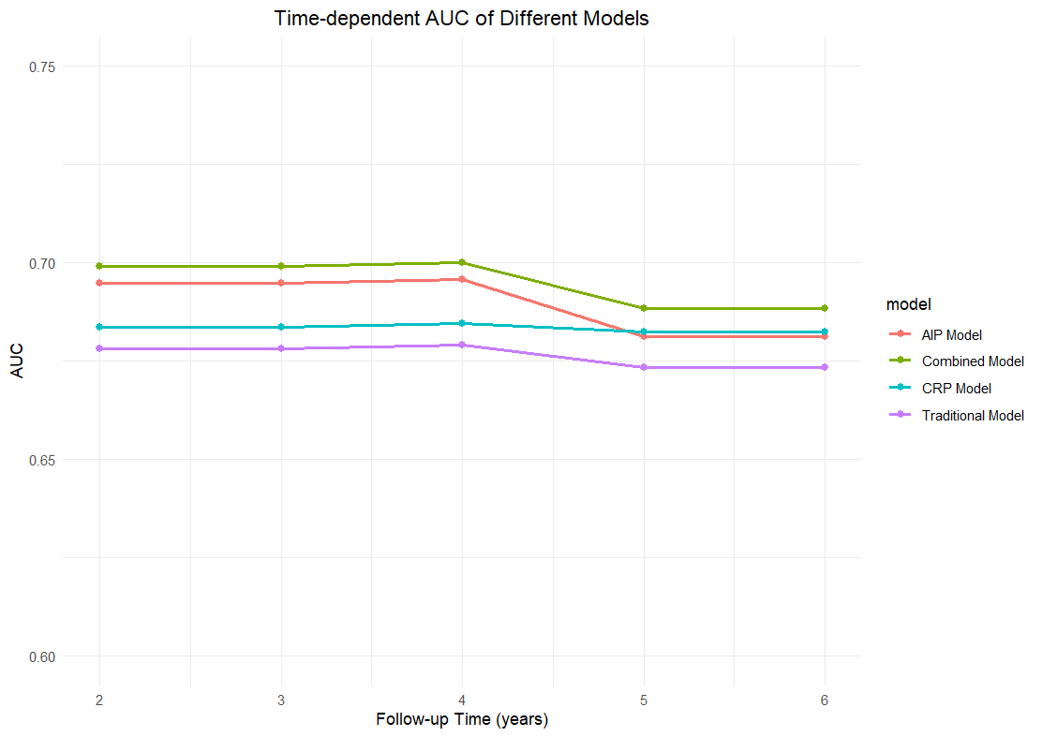

Table S5: Incremental predictive value of hsCRP and AIP beyond traditional risk factors.
Models | AUC(95% CI) | P_{AUC} | NRI (95% CI) | P_{NRI} | IDI (95% CI) | P_{IDI}
Traditional model ª | 0.673(0.652-0.693) |  | Ref. |  | Ref.
Traditional model +hs CRP + AIP | 0.680(0.659-0.700) | 0.028 | 0.106(0.028-0.183) | 0.007 | 0.002(0.001-0.003) | 0.003
Abbreviations: AUC, area under curve; BMI, body mass index; CI, confidence interval; NRI,net reclassification index;IDI,integrated discrimination.
ª Traditional model based on gender, sex, marital status, residence, education level, smoking status, drinking status,hypertension, heart disease, dyslipidaemia, and history of medication use for hypertension, dyslipidaemia.

Table S6: Cox Proportional Hazards Model Analysis of CumAIP and CumhsCRP Levels with Stroke Event Risk
Variable |  | No. of events (Incident ratea) | Model1 |  | Model2 |  | Model3
 |  |  | HR (95% CI) | P value | HR (95% CI) | P value | HR (95% CI) | P value
CumAIP | Tertiles
 | Q1 | 124 | Ref. |  | Ref. |  | Ref.
 | Q2 | 171 | 1.44(1.14-1.81) | 0.002 | 1.37(1.09-1.73) | 0.008 | 1.35(1.07-1.71) | 0.012
 | Q3 | 202 | 1.75(1.40-2.19) | <0.001 | 1.57(1.25-1.98) | <0.001 | 1.49(1.18-1.89) | <0.001
P for trend |  |  |  | <0.001 |  | <0.001 |  | 0.002
sensitivity
 | CumAIP < median | 217 | Ref. |  | Ref. |  | Ref.
 | CumAIP≥median | 280 | 1.38(1.15-1.65) | <0.001 | 1.27(1.06-1.52) | 0.011 | 1.21(1.01-1.46) | 0.044
CumhsCRP | Continuous | 497 | 1.02(1.01-1.03) | 0.001 | 1.01(1.01-1.02) | 0.002 | 1.01(1.00-1.02) | 0.08
 | CumhsCRP <median | 204 | Ref. |  | Ref. |  | Ref.
 | CumhsCRP≥median | 293 | 1.38(1.16-1.66) | <0.001 | 1.29(1.08-1.55) | 0.006 | 1.20(1.01-1.45) | 0.049
Abbreviations: CI, confidence interval HR, hazard ratio.
Mode1: Adjusted for age, gender.
Mode2: Adjusted for age, gender, bmi level, smoking status, and drinking status.
Mode3: Adjusted for age, gender, bmi level, marital status,education level, smoking status, drinking status, hypertension, heart disease, dyslipidaemia, and history of medication use for dyslipidaemia、hypertension.

Table S7: Risk of stroke upon coexposure stratified by the CumAIP and CumhsCRP

 |  | Model1 | p | Model 2 | p | Model 3 | p
 | Low Risk | Ref. |  | Ref |  | Ref
 | Moderate Risk | 1.30(1.03-1.65) | 0.026 | 1.27(01.01-1.61) | 0.043 | 1.18(0.931-1.49) | 0.172
 | High Risk | 1.76 (1.38-2.23) | <0.001 | 1.63(1.27-2.08) | <0.001 | 1.41(1.10-1.82) | 0.007
P for trend |  |  | <0.001 |  | <0.001 |  | 0.032
Low Risk:CumAIP < median & CumhsCRP < median; Moderate Risk:CumAIP ≥ median & CumhsCRP < median , CumAIP < median & CumhsCRP ≥ median;,High Risk:CumAIP ≥ median & CumhsCRP ≥ median
Model1: Adjusted for age, gender.
Model2: Adjusted for age, gender, bmi level, smoking status, and drinking status.
Model3:Adjusted for age, gender, marital status,residence, education level, smoking status, drinking status, hypertension, diabetes, heart disease, dyslipidaemia, and history of medication use for hypertension, and dyslipidaemia.

