Supplementary Tables and Figures

Table S1. Previous and Current Pregnancy Complications
 | COVID -19 Negative |  | COVID -19 Positive
 | Yes | No | Yes | No | p
Previous Pregnancy Complication | 39 (18.6) | 171 (81.4) | 6 (8.6) | 64 (91.4) | 0.05
Gestational Hypertension | 0 (0) | 210 (100) | 0 (0) | 70 (0) | --
Preecalmpsia | 14 (6.7) | 196 (93.3) | 1 (1.4) | 69 (98.6) | 0.13
Gestational Diabetes | 2 (1.0) | 208 (99.0) | 2 (2.9) | 68 (97.10 | 0.25
IUGR | 1 (0.5) | 209 (99.5) | 0 (0) | 70 (100) | --
Preterm Delivery | 6 (2.9) | 204 (97.1) | 1 (1.4) | 98.6) | 0.51
PROM | 3 (1.4) | 207 (98.6) | 0 (0) | 70 (100) | --
PPROM | 1 (0.5) | 209 (99.5) | 0 (0) | 70 (100) | --
Preterm Labor | 2 (1.0) | 208 (99.0) | 1 (1.4) | 69 (98.6) | 0.74
Short Cervix | 4 (1.9) | 206 (98.1) | 1 (1.4) | 69 (98.6) | 0.80
Placental Abruption | 1 (0.5) | 209 (99.5) | 1 (1.4) | 69 (98.6) | 0.41
Current Pregnancy Complications
Gestational Hypertension | 6 (2.9) | 204 (97.1) | 7 (10.0) | 63 (90.0) | 0.014
Preecalmpsia | 20 (9.5) | 190 (90.5) | 15(21.4) | 55 (78.6) | 0.009
Gestational Diabetes | 21 (10.0) | 189 (90.0) | 6 (8.6) | 64 (91.4) | 0.73
IUGR | 8 (3.8) | 202 (96.2) | 4 (5.7) | 66 (94.3) | 0.50
Preterm Delivery | 7 (3.3) | 203 (96.3) | 4 (5.7) | 66 (94.3) | 0.38
PPROM | 2 (1.0) | 208 (99.0) | 0 (0) | 70 (100) | --
Preterm Labor | 3 (1.4) | 207 (98.6) | 1 (1.4) | 69 (98.6) | 1.0
Short Cervix | 4 (1.9) | 206 (98.1) | 0 (0) | 70 (100) | --
IUGR = Intrauterine Growth Restriction; PROM = Prelabor Rupture of the Membranes; PPROM = Preterm Prelabor Rupture of the Membranes
*For currently pregnancy complications 1 patient had HELLP syndrome and 1 Patient had eclampsia. Both were COVID-19 negative. Both are included under hypertensive disorders of pregnancy in Tables 3 and 4
**There were no PROMs or Placental Abruptions recorded for either cohort in current pregnancy complications

Table S2. Rates of Gestational Hypertension and Preeclampsia with and without Severe Features in COVID-19 positive and COVID-19 negative Pregnancies
 | COVID-19
HDP | Negative (n = 210) | Positive (n = 70) | p
Gestational HTN | 8 (3.8) | 4 (5.7) | 0.500
PreE without severe features | 5 (2.4) | 5 (7.1) | 0.061
PreE with Severe Features | 15 (7.1) | 13 (18.6) | 0.006
Data reported in n (%)

Table S3. Univariable Analysis of Factors Associated with Hypertensive Disorders of Pregnancy

Characteristic | No Hypertensive Disorder Diagnosis  (n = 230) | Hypertensive Disorder Diagnosis  (n = 50) | p
COVID-19 infection | 48 (20.9) | 22 (44.0) | 0.01
Previous Pregnancy Complications
Preeclampsia | 8 (3.5) | 7 (14.0) | 0.01
Gestational Diabetes | 3 (1.3) | 1 (2.0) | 0.55
Prior Cesarean Section
Medical Comorbidities
Chronic Hypertension | 6 (2.6) | 10 (20.0) | <0.0001
Diabetes Mellitus | 5 (2.2) | 3 (6.0) | 0.14
Asthma | 24 (10.5) | 10 (20.0) | 0.06
CVD | 2 (0.9) | 1 (2.0) | 0.44
COPD | 1 (0.4) | 1 (2.0) | 0.32
Social Habits
Tobacco Use | 4 (1.7) | 1 (2.0) | 1.0
Marijuana Use | 9 (3.9) | 3 (6.0) | 0.45
Current Pregnancy Complications
HELLP syndrome | 0 (0) | 1 (2.0) | 0.18
Gestational Diabetes | 21 (9.1) | 6 (22.2) | 0.53
IUGR | 9 (3.9) | 3(6.0) | 0.45
Preterm Birth | 8 (3.5) | 3 (6.0) | 0.42
PROM | 2 (0.9) | 0 (0) | 1.0
Preterm Labor | 2 (0.9) | 2 (4.0) | 0.15
Short Cervix | 3 (1.3) | 1 (2.0) | 0.55
Race
White | 100 (43.3) | 15 (30) | 0.19
Black | 91 (39.6) | 26 (52.0) | 0.19
All other | 39 (17) | 9 (18.0) | 0.19
Maternal Characteristics
Age | 29.5±5.7 | 29.6±6.1 | 0.89
BMI | 32.4±6.4ª | 36.17±6.6^{b} | <0.001
Gravidity | 2.81±1.9 | 2.64±2.0 | 0.56
Gestational Age at Delivery | 38.8±1.7 | 37.2±2.6 | <0.001
All values reported in n(%) and Mean ± SD unless otherwise specified . Two-tailed p-value based on 𝛘². For data with less than 5, two-tailed p-value based on Fisher’s exact test.

CVD = cardiovascular disease; COPD = chronic obstructive pulmonary disease; HELLP = hemolysis, elevated liver enzymes, low platelet syndrome; IUGR = intrauterine growth restriction; PPROM = preterm prelabor rupture of membranes; BMI = body mass index
ªN=225; ^{b}N=46

Table S4. COVID-19 Disease Severity: Clinical Signs and Self-Reported Symptoms
Clinical Signs | n = 70
Low Grade Fever () | 4 (5.7)
Fever (>100.4ºF) | 16 (22.9)
Self-Reported Symptoms
Rhinorrhea | 4 (5.7)
Congestion | 3 (4.3)
Cough | 11 (15.7)
Dizziness | 1 (1.4)
Dyspnea/Difficulty in Breathing | 12 (17.1)
Chest Pain | 2 (2.9)
Myalgias | 7 (10)
Arthralgias | 1 (1.4)
Fatigue | 4 (5.7)
Sore Throat | 2 (2.9)
Headache | 4 (5.7)
Nausea/Vomiting | 11 (15.7)
Diarrhea | 2 (2.9)
Anosmia | 3 (4.3)
Ageusia | 3 (4.3)
Severity of Illness
Outpatient (mild) | 48 (68.6)
Inpatient (moderate) | 18 (25.7)
ICU or Intubation (Critical/Severe) | 4 (5.7)
Reported as n (%)
No reported cases of conjunctivitis, hemoptysis or rash

Table S5. Pregnancy Outcomes

COVID-19 | SVD | OVD | Primary CS | Repeat CS | Total
COVID-19 | n (%) | n (%) | n (%) | n (%) | n (%) | p
Negative | 124 (59.6) | 6 (2.9) | 49 (23.6) | 29 (13.9) | 208(100.0) | 0.36
Positive | 43 (61.4) | 0 (0) | 20 (28.6) | 7 (10.0) | 70 (100.0) | 0.36
SVD = Spontaneous Vaginal Delivery
OVD = Operative Vaginal Delivery
pCS = Primary Cesarean Section

Table S6. Fetal Outcomes
 | Room In | NICU | SCN | Demise | p
COVID-19 Status | n (%) | n (%) | n (%) | n (%)
Negative | 185 (88.9) | 19 (9.1) | 3 (1.4) | 1 (0.5) | 0.27
Positive | 57 (81.4) | 10 (14.3) | 3 (1.4) | 0 (0)
NICU = Neonatal Intensive Care Unit
SCN = Special Care Nursery

Table S7. Laboratory Values

Characteristic | COVID -19 Negative |  | COVID -19 Positive
Characteristic | n | Statistic | n | Statistic | p
Leukocyte Count | 210 | 10.9 ± 4.0 | 69 | 10.0 ± 3.4 | 0.11
Lymphocyte Count | 139 | 1.97 ± 0.7 | 57 | 1.5 ± 0.7 | <0.001
Thrombocyte Count | 206 | 223.8 ± 63.4 | 69 | 230.5 ± 70.7 | 0.46
Procalcitonin | 2 | 0.10 ± 0 | 18 | 0.16 ± 0.02 | 0.02
C-reactive Protein | 7 | 12.2 (6.2, 19.3) | 25 | 25.3 (11.3, 64.3) | 0.04
Ferritin | 11 | 30 (9, 65) | 27 | 68 (17, 141) | 0.12
Creatinine | 59 | 0.63 ± 0.14 | 48 | 0.72 ± 0.26 | 0.02
Protein:Creatinine | 30 | 0.1 (0.1,0.23) | 18 | 0.1 (0.1, 0.23) | 0.66
AST | 57 | 26.0 ± 19.8 | 48 | 28.3 ± 15.3 | 0.51
ALT | 57 | 19.7 ± 19.1 | 48 | 20.0 ± 12.8 | 0.93
LDH | 39 | 205.5 ± 58.8 | 32 | 228.9 ± 67.8 | 0.12
Uric Acid | 32 | 4.6 ± 1.2 | 13 | 5.9 ± 1.4 | 0.03
Vitamin D | 65 | 26.9 ± 11.7 | 24 | 23.5 ± 14.6 | 0.26
Normally Distributed Data are reported as Mean ± SD; Nonnormal Data are reported as Median (Interquartile Range)
AST = Aspartate aminotransferase
ALT = Alanine aminotransferase
LDH = Lactate dehydrogenase

Figure S1: Study Cohorts

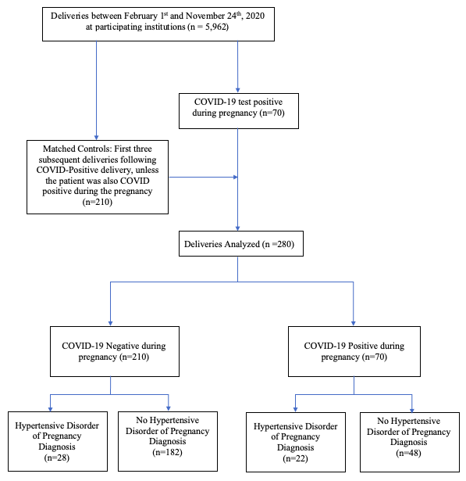

Figure S2: Rates of Hypertensive Disorders of Pregnancy by COVID-19 diagnosis and COVID-19 severity

Figure S3: Percent of Patients with Hypertensive Disorders of Pregnancy with Early vs Late COVID-19 Diagnosis.

