Supplementary Information for

Synergy of a Complimentary Ionic Biogel Network for Through-Hair Neurohaptics

Ankan Dutta^{1,2,3}, Md Abu Sayeed Biswas^{2,§}, Long Meng^{1,§}, Ethan Gerhard^{4,§}, Arantza Moreno Calva^{2,5}, Wanqing Zhang², Abu Musa Abdullah², Lana Joharji^{6,7}, Yuju Che^{2,8}, Jian Yang^{3,9}, Xiaogang Hu^{1,3,10}, Huanyu Cheng^{1,2,3*}

¹Department of Mechanical Engineering, The Pennsylvania State University, University Park, 16802, USA
²Department of Engineering Science and Mechanics, The Pennsylvania State University, University Park, 16802, USA
³Center for Neural Engineering, The Pennsylvania State University, University Park, 16802, USA
⁴Department of Biomedical Engineering, The Pennsylvania State University, University Park, 16802, USA
⁵Department of Biomedical Engineering, Universidad Iberoamericana, CDMX, 01219, Mexico
⁶Department of Electrical Engineering, The Pennsylvania State University, University Park, 16802, USA
⁷Department of Electrical Engineering, King Fahd University of Petroleum and Minerals, Dhahran 31261, Saudi Arabia
⁸Marine College, Shandong University (Weihai), Weihai, 264209, China
⁹Department of Materials Science and Engineering, Westlake University, Hangzhou, Zhejiang, 310030, P.R. China
¹⁰Department of Kinesiology, The Pennsylvania State University, University Park, 16802, USA
§These authors contributed equally
*To whom correspondence should be addressed: E-mail: huanyu.cheng@psu.edu

Supplementary Note 1
Two Material System of Ionic Biogel: Ionic and Biogel system
In the PEDOT:PSS/EMIM-TFSI system, the ionic liquid (EMIM-TFSI) functions as a strong plasticizer, profoundly influencing the electrostatic interactions between the PEDOT and PSS chains¹. The EMIM⁺ cations and TFSI– anions intercalate between the PEDOT and PSS chains, effectively screening the Coulombic attractions and reducing the electrostatic binding energy. This screening reduces the electrostatic enthalpy and increases the entropy to facilitate increased chain mobility and segmental motion, leading to a softer material with enhanced ionic conductivity and improved p-type semiconducting behaviour. The screening also promotes a more disordered morphology, which contributes to faster sol-gel transitions. Concurrently, the gelatin-glycerol-salt hydrogel matrix is stabilized through an extensive hydrogen-bonding network^{2,3}. Gelatin forms triple-helical structures connected via hydrogen bonds between peptide backbone amide groups. The addition of glycerol introduces multiple hydroxyl groups capable of forming hydrogen bonds with both gelatin and water molecules, enhancing the stretchability and reversibility of the gel-sol transition of the hydrogel. The presence of salts, such as NaCl, can further modulate the hydrogen-bonding network by influencing the hydration shell and ionic strength, which not only affects the ionic conductivity but also the gelation kinetics and thermal responsiveness. These hydrogen bonds are highly dynamic in response to temperature yet robust, conferring self-healing properties and biocompatibility to the hydrogel matrix.

Supplementary Note 2
Metastability and Phase Separation in Ionic Biogels Inspired by Membraneless Organelles
Membraneless organelles (MLOs), such as the nucleolus, stress granules, and P-bodies, exploit liquid-liquid phase separation (LLPS) to dynamically organize biomolecules into dense and dilute phases^{4–6}. This partitioning facilitates the synergy of the dense phase to enhance molecular concentration and reaction rates with the dilute phase to maintain fluidity and exchange. In MLOs, LLPS enables an interplay of complementary properties. For example, the nucleolus exhibits improved biochemical efficiency from a dense ribosome assembly hub and the dynamic exchange capabilities from a dilute surrounding phase, ensuring sustained throughput of ribosomal RNA and proteins⁷. Similarly, stress granules demonstrate adaptive resilience by sequestering untranslated mRNAs in their dense core during cellular stress, while maintaining interaction with signaling networks through the dilute phase. Such phase-reversible behavior ensures that the organelles adapt to environmental and functional demands, transitioning seamlessly between liquid-like states and more solid-like assemblies as needed. MLOs demonstrate that phase-separated states are not static but instead exhibit a metastable nature, capable of transitioning between coexisting phases to optimize functionality⁶. This behavior is governed by a complex balance of weak multivalent interactions, including electrostatic, π–π, cation-π, and hydrogen bonding, which allow dynamic molecular rearrangements without compromising structural integrity⁸. The phase-separated environment also ensures that individual phases retain their intrinsic properties while participating in interphase interactions that generate emergent, unified functionalities.
Supplementary Note 3
Metastable Phase-Separated Network Due to Dissimilar Bonding Mechanism
At room temperature, mixing all the components of the ionic biogel (as detailed in the Methods section) and allowing the mixture to stand for two hours initially results in a kinetically restricted amorphous gel^{2,3}. This gel comprises two distinct polymer networks: the PEDOT:PSS/ionic liquid network (Network A) stabilized by electrostatic interactions, and the gelatin/glycerol/salt network (Network B) stabilized by hydrogen bonding. Although the Gibbs free energy of mixing $ΔG_{mix}>0$ is positive (indicating thermodynamic instability and a tendency toward phase separation), the high activation energy barriers and limited molecular mobility at room temperature prevent phase separation, trapping the system in an amorphous state. As the temperature increases, the Flory-Huggins interaction parameter $χ$ decreases (as explained in the following), leading to a negative $ΔG_{mix}$ and making the system thermodynamically favourable for mixing. As a result, the polymers become partially miscible, forming a homogeneous mixture. Cooling back to room temperature—from high temperature for the first time and onwards—results in ionic biogel with a metastable phase-separated state rather than the initial amorphous gel. This is because the cooling process reduces the activation energy barriers compared to the initial state, kinetically facilitating the formation of the phase-separated structure⁹.
The change in the total Gibbs free energy upon mixing ($ΔG_{mix}$) of the two networks can be expressed as:
$ΔG_{mix}=ΔH_{mix}-TΔS_{mix}$, (S1)
where $ΔH_{mix}$ is the enthalpy change of mixing, $ΔS_{mix}$ is the entropy change of mixing, and $T$ is the absolute temperature. For the initial polymer blends at room temperature, the enthalpy of mixing is influenced by the interaction parameter $χ$ according to the Flory-Huggins theory^{10,11}, which quantifies the energetic interactions between the polymers:
$ΔH_{mix}=RTχϕ_{A}ϕ_{B}$, (S2)
where $R$ is the gas constant, $ϕ_{A}$ and $ϕ_{B}$ are the volume fractions of networks A and B, respectively. The interaction parameter $χ$ can be related to the interaction energies between like and unlike components:
$χ=\frac{z}{kT}\left(ϵ_{AB}-\frac{ϵ_{AA}+ϵ_{BB}}{2}\right)$, (S3)
where $z$ is the coordination number, $k$ is the Boltzmann constant, and $ϵ_{AB}$ is the interaction energy between components A and B. Alternatively, the Flory-Huggins interaction parameter can be expressed as a function of the solubility parameters ($δ_{A}$ and $δ_{B}$ of Networks A and B), with $V_{ref}$ being a reference molar volume:
$χ=\frac{V_{ref}}{RT}{(δ_{A}-δ_{B})}^{2}$. (S4)
In this system, the significant differences in bonding schemes—electrostatic interactions in the PEDOT:PSS/ionic liquid network (network A) and hydrogen bonding in the gelatin/glycerol/salt network (network B)—result in a large positive $χ$ at room temperature, which decreases with the increasing temperature. This trend can be attributed to the following reasons.
Nature of Hydrogen Bonding
Hydrogen bonding is a specific type of dipole-dipole interaction that occurs between a hydrogen atom covalently bonded to a highly electronegative atom (e.g., oxygen, nitrogen, or fluorine) and another electronegative atom with a lone pair of electrons. The key characteristics of hydrogen bonds are:
- Directional Nature: Hydrogen bonds have specific geometries, typically linear or nearly linear, due to the directional overlap of orbitals.
- Moderate Strength: They are stronger than van der Waals forces but weaker than covalent or ionic bonds, with bond energies ranging from 10 to 30 kJ/mol.
- Specificity: Hydrogen bonding requires specific functional groups (donors and acceptors), making these interactions highly selective.
In the gelatin/glycerol/salt network, extensive hydrogen bonding occurs due to the abundance of hydroxyl and amino groups, leading to a well-organized, cohesive network stabilized by numerous hydrogen bonds.
Nature of Electrostatic Interactions
Electrostatic interactions, also known as ionic or Coulombic interactions, occur between particles bearing full positive and negative charges. The main features of electrostatic interactions are:
- Non-Directional Nature: Unlike hydrogen bonds, electrostatic interactions are non-directional and depend solely on the distance between charges.
- Long-Range and Strong Interactions: They can operate over longer distances compared to other intermolecular forces, with energies that can exceed 250 kJ/mol.
- Charge Magnitude: These interactions involve full ionic charges rather than partial charges.
In the PEDOT:PSS/ionic liquid network, electrostatic interactions arise from the presence of charged species. PEDOT is positively charged, while PSS is negatively charged, with the ionic liquid contributing additional mobile ions.
The interaction between the PEDOT:PSS/ionic liquid network and the gelatin/glycerol/salt network is weak due to the fundamental incompatibility of their bonding mechanisms:
- Lack of Favourable Interactions: The electrostatic network lacks the functional groups necessary to engage in hydrogen bonding with the gelatin network. Similarly, hydrogen-bonding groups from the gelatin network do not effectively interact with the charged species in the electrostatic network.
- Energetic Disparity: The intra-network interactions ($ϵ_{AA}$ for the electrostatic network and $ϵ_{BB}$ for the hydrogen-bonding network) are strong and energetically favourable. Therefore, $ϵ_{AA}$ and $ϵ_{BB}$ are large negative values. On the other side, the inter-network interactions ($ϵ_{AB}$) are weaker because there is no efficient mechanism for the networks to stabilize each other through bonding, making $ϵ_{AB}$ a small negative number⁵. Therefore, the intra- and inter-network interactions are related as:
$\left(ϵ_{AB}-\frac{ϵ_{AA}+ϵ_{BB}}{2}\right)≫kT$. (S5)
Substituting these values in Equation S3 shows that $χ$ is large and positive: $χ≫1$. This large positive $χ$ reflects the significant energetic penalty for mixing the two networks, due to the unfavourable interactions between their dissimilar bonding schemes at room temperature.
- Differences in Solubility Parameters: The solubility parameter is a measure of the cohesive energy density of a material, reflecting the energy required to separate molecules from each other. Due to the different types of interactions (electrostatic vs. hydrogen bonding), Networks A and B have significantly different solubility parameters. The square of their difference is large:
${(δ_{A}-δ_{B})}^{2}≫0$. (S6)
This leads to a large positive $χ$, indicating immiscibility due to unfavorable energetic interactions.
Mixing the two networks would disrupt the favourable intra-network interactions without providing equally favourable inter-network interactions. The entropy of mixing ($ΔS_{mix}$) for polymers is generally small due to their high molecular weights, which limits the configurational entropy gain upon mixing. The entropy of mixing is given by:
$ΔS_{mix}=-k\left(\frac{ϕ_{A}}{N_{A}}\ln{ϕ_{A}}+\frac{ϕ_{B}}{N_{B}}\ln{ϕ_{B}}\right)$, (S7)
where $N_{A}$ and $N_{B}$ are the degrees of polymerization of networks A and B. Large $N_{A}$ and $N_{B}$ give mall $ΔS_{mix}$, rendering the entropic contribution to $ΔG_{mix}$ insufficient to overcome the unfavourable enthalpic contribution. Consequently, the total Gibbs free energy change upon mixing becomes positive at room temperature:
$ΔG_{mix}=RT\left(\frac{ϕ_{A}}{N_{A}}\ln{ϕ_{A}}+\frac{ϕ_{B}}{N_{B}}\ln{ϕ_{B}}+χϕ_{A}ϕ_{B}\right)$. (S8)
These observations indicate that there are unfavourable interactions between Networks A and B at room temperature, resulting in an amorphous mixture before heating. The incompatibility between the electrostatic interactions in Network A and the hydrogen bonding in Network B leads to thermodynamically unfavorable mixing, characterized by a positive Gibbs free energy of mixing. This positive Gibbs free energy and slow kinetics indicate that the system minimizes its free energy by remaining amorphous at room temperature. However, upon increasing the temperature, the system becomes partially miscible because the Flory-Huggins interaction parameter $χ$ decreases with temperature. A lower $χ$ value reduces the enthalpic penalty associated with the mixing of the two networks, leading to a negative Gibbs free energy of mixing. This temperature-induced decrease in $χ$ facilitates mixing between the networks, making the system thermodynamically favourable for partial miscibility.
The interaction parameter $χ$ is known to be temperature-dependent and can be expressed as:
$χ=\frac{A}{T}-B$, (S9)
where $A$ and $B$ are empirical constants reflecting the enthalpic and entropic contributions, respectively. As temperature increases, the $\frac{A}{T}$ term decreases, leading to a reduction in $χ$. This reduction can reach a critical point, where $χ$ becomes sufficiently small or even negative, favouring miscibility. Higher temperatures provide sufficient thermal energy to overcome kinetic barriers such as chain entanglement and viscosity. Enhanced diffusion allows the polymers to mix more thoroughly, leading to a homogeneous partial miscible state. The effectiveness of mixing at elevated temperatures is demonstrated by the altered characterization of PEDOT:PSS upon cooling back to room temperature. In the presence of gelatin, the system exhibits phase separation, indicating that the gelatin network significantly influences the morphology of PEDOT:PSS after thermal cycling. This observation highlights how high-temperature mixing followed by cooling leads to a phase-separated structure due to the interplay between the polymer networks.
However, cooling back to room temperature increases $χ$ and leads to a positive enthalpy of mixing; therefore, the Gibbs free energy of mixing becomes positive, indicating that the mixed state is thermodynamically unstable. The system lowers its free energy by separating into two phases, each rich in one of the networks. During heating, the polymers rearranged into a more thermodynamically favorable configuration, overcoming initial kinetic barriers. The cooling process follows a different path on the Gibbs free energy landscape compared to initial mixing. The initial amorphous state results from kinetic trapping during mixing, not a thermodynamic equilibrium. Upon cooling (from high temperature), the system has already surpassed these kinetic barriers and cannot revert to the original amorphous configuration.
This outcome is reinforced by examining the metastable condition for phase separation, which occurs when the second derivative of the Gibbs free energy with respect to composition is positive or zero (spinodal condition):
${\left(\frac{∂^{2}ΔG_{mix}}{∂{ϕ_{A}}^{2}}\right)}_{T,P}=RT\left(\frac{1}{ϕ_{A}N_{A}}+\frac{1}{ϕ_{B}N_{B}}-2χ\right)≥0$, (S10)
while
$\frac{∂ΔG_{mix}}{∂ϕ_{A}}=RT\left[\frac{1}{N_{A}}\ln{ϕ_{A}}-\frac{1}{N_{B}}\ln{ϕ_{B}}+χ(1-2ϕ_{A})\right]≠0$. (S11)
As a result, small fluctuations in composition increase the free energy, providing kinetic stability against phase separation, even though the mixed state is thermodynamically unfavourable. However, because the first derivative is non-zero (with zero for the binodal condition), there is a thermodynamic driving force for phase separation through nucleation and growth if an energy barrier is overcome.
The metastable condition exhibits thermoreversible behaviour, which would not be possible in a stable gel that has reached thermodynamic equilibrium. In a stable gel, the system resides at the global minimum of the Gibbs free energy landscape, and significant energy input would be required to alter its state. Metastability allows the system to reversibly transition between states upon thermal cycling because it is only separated from other states by modest energy barriers.
The thermoreversible behavuior of the gelatin network facilitates reversible transitions between miscible and partially miscible states. Upon heating, the hydrogen bonds within the gelatin network are disrupted. Heating provides sufficient thermal energy to overcome the energy of hydrogen bonds, causing them to break, which increases the enthalpy associated with hydrogen bonding and enhances chain mobility. The increase in chain mobility further leads to a rise in entropy due to a greater number of accessible conformations.
Each phase (ionic and biogel system) exhibits a stable set of thermodynamic conditions (e.g., stable water content in the gelatin/glycerol/salt matrix and stable doping/ion-exchange equilibrium in ionic-liquid/PEDOT:PSS). As a result, the overall system settles into a metastable configuration with a relatively stable open electrochemical potential difference of ~40 mV for >7 hours.
Supplementary Note 4
Coherence of Characteristics of Distinct Phases
From a statistical and thermodynamic standpoint, the presence of phase separation and metastability can be conceptualized through free-energy landscapes and energetic barriers that emerge when a mixed system spontaneously decomposes into two coexisting phases. Each separated phase represents a region—characterized by distinct molecular densities, interaction strengths, or order parameters—where the system can locally minimize its free energy. In each phase, the collective excitations, such as electrons, holes, or phonons, adopt specific local equilibrium distributions and dispersion relations that are consistent across their phase boundaries. Metastable interfaces then form natural energy barriers, restricting certain excitations from freely crossing between phases. At the interface between these domains, there is an energy cost associated with gradients, governed by a surface tension term. This surface tension imposes a potential barrier that excitations must overcome to transform from one phase to another.
Using Kramers’ escape model¹², if we treat electrons, holes, or phonons as quasiparticles with given energy distributions, their probability of occupying states in a given region is controlled by Boltzmann or Fermi-Dirac statistics. Within one phase, the density of states, effective masses, or vibrational spectra differ from those in the other phase due to variations in underlying molecular arrangements. The interface thus acts as an energy barrier to cross from one domain into the other, a quasiparticle must have sufficient energy to overcome differences in chemical potential, band alignment, or phonon dispersion relations. Mathematically, if the energy difference or barrier at the interface is $ΔE$, the probability of a quasiparticle in phase A entering phase B is suppressed by a Boltzmann factor $e^{-ΔE/kT}$ or a related statistical weight. Hence, low-energy excitations may remain confined to their original phase, ensuring that each domain preserves its characteristic properties. The result is that charge carriers (electrons, holes) or vibrational modes (phonons) that might dominate transport or scattering in one phase do not simply diffuse into the other and dilute or disrupt its properties.
This confinement and barrier-limited exchange help restore and preserve each phase’s intrinsic characteristics. A dense, low-entropy phase may support efficient energy transfer and rapid reaction kinetics among localized molecular components, while the adjacent dilute phase allows for diffusion-based exchange. From a statistical perspective, these distinct distributions and transport properties become metastable states because attempts to randomize or homogenize the system must overcome interfacial free-energy costs. Thus, the interplay of energy minima, surface tension, and excitation statistics leads to stable coexistence, where each phase can maintain its unique set of properties despite adjacency. In other words, phase separation and metastability enable a scenario where the system’s global free energy is lowered by permitting the local free-energy minima associated with each phase to coexist. Meanwhile, the energy barriers at the boundaries ensure the coherent restoration and maintenance of each phase’s distinct statistical and dynamic characteristics.

Supplementary Note 5
Material Characterization of Ionic Biogel
X-ray photoelectron spectroscopy
X-ray photoelectron spectroscopy (XPS) analysis of the ionic biogel reveals the presence of key carbon, nitrogen, and sulfur species, including CH_{x} (25.6%), C–(O, N) (27.4%), and SO₃ (6.2%) (Figure S3). The detection of sulfonate (SO₃) groups and thiols confirms the functionality of PEDOT:PSS, while fluorocarbon and siloxane signals suggest interactions with the ionic liquid EMIM-TFSI. Additionally, the presence of protonated amines (N–C⁺, 2.9%) and carbonyl groups (C=O, 5.1%) underscores the role of the gelatin-glycerol matrix in stabilizing the ionic and electronic interfaces.
Raman spectroscopy
Raman spectroscopy at different temperatures analyses the synergistic aspect of the ionic biogel (Extended Figure 2a). The Raman spectra reveal that the C_{α}=C_{β} symmetric stretching vibration peaks of PEDOT exhibit a red shift from 1423 cm⁻¹ at 25°C and 30°C to 1417 cm⁻¹ at 40°C and 50°C, with an accompanying increase in intensity up to 40°C, followed by a decrease at 50°C post-phase transition. This shift indicates that a higher proportion of benzoid moieties in PEDOT are converted to the quinoid structure due to oxidative charge transfer doping at elevated temperatures, resulting in a more planar polymer backbone¹. The enhanced planarity facilitates greater π-electron delocalization and a higher degree of molecular packing, which may contribute to the observed rapid sol transition. Concurrently, the Amide I band associated with the C=O stretching vibrations in gelatin increases in intensity from 25°C to 40°C and then diminishes at 50°C, suggesting the formation and subsequent disruption of intermolecular hydrogen bonding interactions between gelatin and glycerol molecules. These findings indicate that elevated temperatures promote both the unwrapping of gelatin's helical structure and the planarization of PEDOT chains, leading to synergistic enhancements in the electrical and mechanical properties of the ionic biogel.
Fourier-transform infrared spectroscopy
The Fourier-transform infrared spectroscopy (FTIR) spectra reveal strong characteristic infrared absorption peaks of thiophene functional groups at 1,640 cm⁻¹, with a markedly higher absorption intensity observed at 45°C compared to 25°C (Extended Figure 2b). This increase in absorption intensity at elevated temperatures suggests enhanced vibrational activity of the thiophene rings within the PEDOT chains, potentially due to increased conjugation length arising from thermal effects. Such changes may facilitate greater π-electron delocalization and contribute to the improved charge mobility or conductivity of the ionic biogel at higher temperatures. The Amide A band—corresponding to the N–H and O–H stretching vibrations—exhibits a blue shift from 3,287 cm⁻¹ at 25°C to 3,317 cm⁻¹ at 45°C, along with notable peak broadening. This shift to higher wavenumbers indicates a decrease in hydrogen bonding interactions within the gelatin-glycerol-salt hydrogel matrix as temperature increases. The disruption of hydrogen bonds by thermal agitation strengthens the N–H bonds, causing them to absorb at higher frequencies (blue shift). The observed peak broadening suggests increased molecular disorder and a wider distribution of hydrogen-bonding environments resulting from the enhanced thermal motion of gelatin chains³.

Atomic Force Microscopy
The atomic force microscopy (AFM) images reveal a hierarchical porous architecture to feature interconnected pores ranging from nanometers to micrometers in size (Extended Figure 2c). This hierarchical porosity arises from the thermodynamically driven phase separation between the hydrophilic gelatin-glycerol network and the more hydrophobic PEDOT:PSS/EMIM-TFSI domains during the gelation process (Figure S4).

UV–Vis
The UV–Vis–NIR spectra exhibit a significant redshift, with the characteristic absorption peak of PEDOT appearing around 978 nm instead of the typical ~800 nm observed in pristine PEDOT films (Figure S5). This pronounced shift to longer wavelengths indicates an increase in the effective conjugation length and enhanced delocalization of π-electrons along the PEDOT backbone within the ionic biogel matrix¹.

Grazing-Incidence Wide-Angle X-ray Scattering
The grazing-incidence wide-angle X-ray scattering (GIWAXS) patterns reveal notable temperature-dependent changes in the crystalline ordering of the PEDOT:PSS domains within the biogel matrix (Extended Figure 2d,e). Specifically, the (200) d-spacing, corresponding to the scattering vector q_{z} ~0.4 Å⁻¹, exhibits an increase from 0.011 (a.u.) to 0.014 (a.u.) as the temperature is elevated from 25°C to 40°C (Figure S6). This observation suggests an expansion of the lattice spacing within the PEDOT:PSS crystallites, potentially due to reduced intercalation of gelatin and glycerol molecules, when the temperature nears transition. The decrease in d-spacing at 50°C can be attributed to the collapse or aggregation of PEDOT:PSS domains as the gelatin-glycerol matrix transitions into a sol state, reducing the steric hindrance and allowing the polymer chains to pack more closely. The peak at q_{z}≈0.87 Å⁻¹ in GIWAXS patterns, previously assigned to the stacking of PEDOT chains along the π–π direction, remains consistent in intensity and position at 25°C and 40°C, indicating stable π–π stacking interactions within the PEDOT domains across this temperature range. The unchanged ordering suggests that the planarization and increased conjugation of the PEDOT chains at elevated temperatures up to 40°C do not disrupt the overall stacking arrangement but may enhance charge transport by improving orbital overlap. At 50°C, the reduction implies a loss of π–π stacking order within the PEDOT domains, likely due to thermal agitation that overcomes the weak van der Waals forces responsible for π–π interactions.

Biocompatibility
Despite the known cytotoxicity of EMIM-TFSI, the inherent biocompatibility of the gelatin-glycerol matrix effectively encapsulates and screens the PEDOT:PSS/EMIM-TFSI components, ensuring that the composite can be safely integrated with the scalp or skin. The gelatin-glycerol hydrogel acts as a biocompatible barrier, preventing direct contact between the ionic liquid and biological tissues while maintaining the composite's functional properties. Applying the ionic biogel to the forearm skin of human subjects for one week evaluates the biocompatibility. Throughout the application period, no signs of skin irritation, inflammation, or adverse reactions are observed (Figure S7). The biocompatibility of the ionic biogel is also confirmed with the MTT assay (Figure S8). The cell viability of 89% and 110% in 24 h and 48 h is comparable to that of 100% and 127% from the control, supporting the proliferative effects of hydrogels on MCF-10A cells (Extended Figure 2f). The demonstrated biocompatibility is critical to prevent adverse immune responses and ensure the longevity of the device.

Supplementary Note 6
Rheological Characterization of Ionic Biogel
Temperature and time are critical factors in modulating and restoring the mechanical properties of thermoresponsive viscoelastic materials. The loss modulus decreases from 490 Pa at room temperature to 210 Pa at 40°C, which marks the transition temperature of the ionic biogel as the loss modulus equals the storage modulus. In comparison, the gelatin-glycerol-salt composite biogel without PEDOT:PSS and ionic liquid exhibits a higher transition temperature of around 45°C. The higher storage modulus of 19 kPa (and loss modulus of 2.1 kPa) at room temperature reduces but still to a relatively higher storage (and loss) modulus of 800 Pa at 45°C. The change of loss tangent with temperature is greater and earlier for ionic biogel with 0.25 1/K at ~39°C than biogel with 0.1 1/K at ~43°C (Figure S9). The dynamic viscosity of 1 kPa-s at ~34°C for both the ionic biogel and normal biogel decreases rapidly to 10 Pa-s for ionic biogel and 150 Pa-s for biogel at ~45°C, respectively (Extended Figure 3a). All the measurements are taken at 1 Hz and 0.05% shear strain. The material exhibits a shear-thinning property having a solid-liquid transition ($\tan{δ}=1$) at 190% shear strain with a dynamic viscosity of 400 Pa-s, sharply decreased from 1.3 kPa-s at 10% shear strain (Figure S10). With the increase in frequency, the loss tangent $\tan{(δ)}$ increases from 0.06 at 1 Hz to 2.4 at 100 Hz, and the viscosity decreases linearly from 7.7 kPa-s at 0.1 Hz to 11 Pa-s at 100 Hz (Extended Figure 3b).

Supplementary Note 7
Computational Modelling of Rheological Parameters for Ionic Biogel
The adapted Ellis equation¹³ that incorporates temperature dependence is used to model the temperature sweep rheology for capturing the nonlinear transition in viscosity and modulus near the critical temperature, $T_{c}$. The temperature-dependent viscosity, $η(T)$, with a sigmoidal expression provides a gradual viscosity transition across the Upper Critical Solution Temperature (UCST):
$η(T)=η_{∞}\left[1+{\left(\frac{T}{T_{2}}\right)}^{s}\right]+\frac{\frac{η_{0}}{1+{\left(\frac{T}{T_{1}}\right)}^{p}}-η_{∞}\left[1+{\left(\frac{T}{T_{2}}\right)}^{s}\right]}{1+{\left(\frac{T}{T_{c}}\right)}^{m}}$, (S12)
where $η_{0}$ and $η_{∞}$ represent low- and high-temperature viscosities, respectively, and empirical parameters $T_{1}$, $T_{2}$, $p$, $s$, and $m$ control the transition profile and accommodate temperature sensitivity near $T_{c}$. This sigmoidal expression captures the dramatic viscosity reduction of gelatin with the increasing temperature that reflects the collapse of the gel network at the UCST. Similar to viscosity, the temperature-dependent storage modulus $G'(T)$ can also be expressed as a sigmoidal function:
$G'={G'}_{∞}\left[1+{\left(\frac{T}{T_{2}}\right)}^{s}\right]+\frac{\frac{{G'}_{0}}{1+{\left(\frac{T}{T_{1}}\right)}^{p}}-{G'}_{∞}\left[1+{\left(\frac{T}{T_{2}}\right)}^{s}\right]}{1+{\left(\frac{T}{T_{c}}\right)}^{m}}$, (S13)
where ${G'}_{0}$ and ${G'}_{∞}$ denote the low- and high-temperature asymptotic values of the storage modulus, respectively.
Supplementary Note 8
Repeated Rheological Characterization of Ionic Biogel showing Metastability
In this experiment, the temperature is ramped up from room temperature to 60°C at a rate of 5°C/min and back to room temperature, along with holding for a 15-minute equilibrium period before repeating the cycle (Figure S11). The loss tangent $\tan{(δ)}$ increases from 0.1 at room temperature to 2.2 at 60°C, and then to 0.9 back at room temperature (Figure S12). Keeping the material at room temperature for 15 minutes decreases the loss tangent from 0.9 to 0.2. In the second temperature cycle, the loss tangent increases to 1.7 at 60°C and recovers to 0.9 back at room temperature again. Similarly, the dynamic viscosity decreases rapidly from 1.7 kPa-s at room temperature to 10 Pa-s at 60°C and then increases to 200 Pa-s back at the room temperature, followed by a further increase to 950 Pa-s after keeping it isothermal for 15 mins (Figure S13). During the second cycle, the viscosity decreases to 30 Pa-s at 60°C and increases back to 210 Pa-s at room temperature. The storage modulus reduces from 6 kPa at room temperature to 110 Pa at 60°C for the second ramp-up, whereas the loss modulus reduces from 1.1 kPa at room temperature to 190 Pa at 60°C (Figure S14). A similar pattern is observed during the temperature ramp-down, where both loss and storage moduli increase with the decreasing temperature. For example, in the second ramp, storage (or loss) modulus increases from 60 (or 110) Pa at 60°C to 1 kPa at room temperature, probably due to metastability and a high efficiency of recovery for the gelatin chains to re-establish hydrogen bonds (Figure S15). After the first cycle to remove excess water, the viscosity normalized by the viscosity at the end of the 2nd isothermal process remains almost unchanged (with only $±3\%$ variation) at the end of the isothermal process after additional cycles (N=1, 2, and 3), showcasing a thermoreversible material (with minimal thermal fatigue) with metastable characteristics (Figure 2b). However, there is a 10% increase in the normalized viscosity at the end of each ramp-down process (or starting of the isothermal process), possibly due to the slower recovery time of the formation of hydrogen bonds (but with high efficiency) or altering alignment of distinct phases. This result indicates that the recovery or recombination of hydrogen bonding (larger time constant) during the ramp-down exhibits a larger thermal hysteresis than the breaking of the hydrogen bonding (smaller time constant) of the gelatin chains during the ramp-up (Figure S16). A very similar trend is also observed in the ~3-month-old sample kept at room temperature with only $±4\%$ variation at the end of the isothermal process for N= 1, 2, and 3 (Extended Figure 3c).

Supplementary Note 9
Computational Model of Temperature-dependent Rheology using Spring-Damper
Viscoelastic materials exhibit both elastic (storage) and viscous (loss) characteristics, which are traditionally modeled using fundamental spring-damper systems, as in the Maxwell and Kelvin-Voigt models¹³. The Maxwell Model, arranged in series, is well-suited for describing time-dependent stress relaxation, capturing the loss modulus under constant strain as the material dissipates energy over time. In contrast, the Kelvin-Voigt Model, arranged in parallel, effectively represents the creep recovery of the material, where the elastic response under constant stress can be quantified by the storage modulus, especially in cyclic loading scenarios. While these classic models provide foundational insights into viscoelastic behaviors, they require adaptation to accurately represent thermoresponsive materials, where changes in the modulus are temperature-dependent, and shear-thinning behaviour induces nonlinear dependencies on both temperature and shear rate.
The Kelvin-Voigt model combines a spring and damper in parallel, describing a material that behaves elastically when subjected to a constant strain:
$σ(t)=Eε(t)+η\frac{∂ε(t)}{∂t}$, (S14)
where $σ(t)$ is the stress, $ε(t)$ is the strain, $E$ is the elastic modulus of the individual spring, and $η$ is the viscosity of the individual damper. For materials that exhibit complex, multi-stage recovery of storage and loss moduli, we can generalize the Kelvin-Voigt model by introducing several spring-damper units in parallel, each with distinct moduli ($E_{i}$) and viscosities ($η_{i}$):
$σ(t)=\sum_{i=1}^{N}{E_{i}ε(t)+η_{i}\frac{∂ε(t)}{∂t}}$. (S15)
Each spring-damper unit contributes to a unique time constant $τ_{i}={η_{i}}/{E_{i}}$, allowing the model to simulate various rates of recovery. The storage modulus ($G'$) and loss modulus ($G''$) can then be expressed as:
$G'(t,T)=\sum_{i=1}^{N}{\left[E_{i}e^{-t/τ_{i}}\right]}$, (S16)
$G^{''}\left(t,T\right)=\sum_{i=1}^{N}{\left[\frac{η_{i}}{τ_{i}}e^{-\frac{t}{τ_{i}}}\right]}$. (S17)
For the ionic biogel, viscosity $η_{i}(T)$ typically decreases with temperature $T$ as indicated in Eq. (S12). However, the rheological parameters such as viscosity and modulus are not symmetrical probably due to the difference in time scales of breaking and formation of hydrogen bonds; therefore, the time constants for temperature ramp up ($τ_{breaking}$) and down ($τ_{recovery}$) are different. At a constant shear rate (1 Hz), shear strain (0.05%), and temperature rate ($±5℃/min$), (positive or negative for increase or decrease in temperature with zero for the isothermal condition), the dynamics of rheological properties under cyclic heating can be modeled with two distinct time constants:
- Time Constant for breaking hydrogen bonds ($τ_{breaking}$), which describes a rapid reduction in viscosity and modulus upon heating;
- Time Constant for recovering hydrogen bonds ($τ_{recovery}$), which governs the increased viscosity and modulus upon cooling, describing the reformation or "healing" of the structure.
To capture these behaviours, the generalized Kelvin-Voigt model in Eqns. (S15-17) with parallel spring-damper elements can be extended, with temperature-dependent moduli ($E_{i}(T)$) and viscosities ($η_{i}(T)$) that integrate decay/recovery time constants into the storage and loss modulus equations for each element. The moduli $G'(t,T)$ and $G''(t,T)$ can be extended as follows:
$$G'(t,T)=\sum_{i=1}^{N}{\left[E_{i}(T)e^{-t/τ_{breaking}}H(t_{breaking}-t)+E_{i}(T){(1 - e}^{-t/τ_{recovery}})H({t-t}_{recovery})\right]}$$
(S18)
$$G''(t,T)=\sum_{i=1}^{N}{\left[\frac{η_{i}(T)}{τ_{breaking}}e^{-t/τ_{breaking}}H(t_{breaking}-t)+\frac{η_{i}(T)}{τ_{recovery}}{(1 - e}^{-t/τ_{recovery}})H({t-t}_{recovery})\right]}$$
(S19)
where $H$ is the Heaviside step function, dividing temperature ramp up ($t<t_{breaking}$) and down (${t>t}_{recovery}$) phases.

Supplementary Note 10
Compression and Adhesion Test of Ionic Biogel
The ionic biogel has a very low shear modulus of 6.75 kPa (Figure S17). However, the material exhibits a strain-stiffening effect¹⁴ for larger strain (>20%) in the compression test with a plateau modulus of ~50 kPa (Figure S18). Compared with the strong adhesion in the normal direction (Figure S19), the lap-shear adhesion strength in the shear direction is significantly smaller (Extended Figure 3d).

Supplementary Note 11
Water Retention, Water Vapor Transmission Rate Test for Ionic Biogel
Thermogravimetric analysis (TGA) is carried out by ramping the temperature at a rate of 5°C/min to 150°C followed by holding for 5 mins. The ionic biogel shows a much better water-retention property (~97% at 70°C) compared to the normal biogel (~88%) (Figure 2c). The ionic biogel also retains about 91% of its weight in the first week and saturates around 89% till 3 weeks, whereas the biogel counterpart loses about 20% of its weight in the first week (Figure S20). The hierarchically porous structure of the ionic biogel from phase separation also exhibits a high water vapour transmission rate (WVTR) of ~1417 g/m²/day, which is reasonably close to that of 1725 g/m²/day from the open bottle and more than the maximum transdermal water loss of 1050 g/m²/day (typically from axilla)¹⁵ (Extended Figure 3e) as measured according to the ASTM E96-95 standard. As a result, the ionic biogel with high air and moisture permeabilities makes it particularly suitable for comfortable, long-term use on the skin surface in varying complex scenarios.

Supplementary Note 12
Synergistic Thermodiffusion and Thermogalvanic Effect on Ionic Biogel
The observed thermoelectric behaviour in the ionic biogel composite arises from the synergy of thermodiffusion and thermogalvanic effects, each of which has been studied separately in previous works¹⁶. Thermogalvanic cells rely on temperature-dependent redox reactions, whereas thermodiffusion-based ionic thermoelectric devices leverage ion transport under thermal gradients. While both effects hold promise for low-grade heat harvesting, attempts to combine these effects within a single ionic thermoelectric (i-TE) system remain relatively limited. In ionic biogel, the Seebeck coefficient reaches approximately 21 mV/K under a temperature difference of 0–3 K (dominated by the synergy of thermogalvanic and thermodiffusion) and decreases to about 4.6 mV/K for gradients between 3–8 K (probably dominated by either of the mechanism). This response exceeds the typical value of ~100 to 200 µV/K from conventional electronic thermoelectric materials based on narrow-bandgap semiconductors¹⁷. The observed behaviour is attributed to a non-linear coupling of ion migration with redox-driven electrochemical potentials.
The thermodiffusion mechanism, guided by the Soret effect, drives ions along the temperature gradient. In our composite, the gelatin–ionic liquid matrix provides a porous, quasi-solid environment that enhances ionic mobility while maintaining mechanical stability. Simultaneously, the thermogalvanic mechanism leverages the temperature-dependent redox potential of the PEDOT:PSS component. In ionic biogel, the PEDOT:PSS domains undergo entropy-driven changes that, when aligned with ionic thermodiffusion, produce an additional voltage contribution.
At lower temperature gradients (0–3 K), both the ionic and redox contributions combine effectively to generate higher thermoelectric voltages. This synergy decreases at larger temperature differences, possibly due to the saturation of ion migration pathways and a diminished redox response, leading to lower effective Seebeck coefficients. The resulting thermopower profile suggests that the composite’s performance can be fine-tuned by the interplay between thermodiffusion and thermogalvanic effects, as well as by optimizing composition and nanostructure to enhance ionic selectivity and redox activity.

Supplementary Note 13
Tensile Properties and Self-Healing Property of Ionic Biogel
The ionic biogel shows smaller Young’s Modulus of 33 ± 0.5 kPa compared to 71 kPa for the biogel (Figure S21). The ionic biogel could be stretched to 380% with a tensile strength of 84 ± 0.1 kPa. The self-healing property of the material allows the recovery of Young’s modulus to 33 kPa as in pristine condition after cutting and healing at room temperature for 12 hours, but with lowered tensile strength (26 ± 0.2 kPa) and stretchability (120%). However, if the temperature is raised above the transition temperature, the material exhibits a 100% self-healing capability for both tensile strength and stretchability (as in the repeated temperature cycles), so self-healing at higher temperatures is not shown explicitly. The material also shows instantaneous self-healing property accelerated by its inherent adhesive property (Figure S22).

Supplementary Note 14
Electrode Performance of Ionic Biogel
The ionic biogel with a thickness of 5 mm has a low electrical impedance of 190 Ω at 4 kHz in the thickness direction (Figure S24), which decreases to 16 Ω as the thickness is reduced to 0.5 mm (Figure S25). These impedance values are reduced by more than 50% compared to the normal biogel. The normalized skin contact impedance of 6.4 kΩ.cm² at 4 kHz from the ionic biogel at 40°C is 70% lower than that of 20.7 kΩ.cm² for the normal biogel (Extended Figure 4a). The normalized impedance decreases from 12.6 kΩ.cm² at 30°C (4 kHz) to 6.4 kΩ.cm² at 40°C and remains almost the same at 50°C (Extended Figure 4b). The normalized skin contact impedance for the ionic biogel with a diameter of 2.2 cm is 12.5 kΩ.cm² at 30°C, which is 27% lower than the commercial Ag/AgCl (17.1 kΩ.cm²) (Figure S26). The normalized skin contact impedance decreases to 3.6 kΩ.cm² (from 7.2 kΩ.cm²) as the electrode diameter decreases to 5 mm (from 15 mm) probably due to the increased normalized capacitance governed by the electric double layer (Figure S27). Both the ionic and normal biogel have a low contact resistance of 28 Ω at the high frequency of 0.1 MHz according to the electrochemical impedance spectra (EIS) (Extended Figure 4c). However, the ionic biogel has a lower charge transfer resistance of 160 Ω than that of 267 Ω from the normal biogel owing to the high electric double layer formation at the boundary. The electric double layer capacitance for ionic biogel increases from 62.5 µF (at a peak frequency of 100 Hz) to 2 mF (at a peak frequency of 1 Hz) after complete swelling to reach a steady state in the PBS electrolyte. This substantial increase suggests enhanced capacitive behaviour due to an increased effective interfacial area and greater ion accessibility. The swelling process likely leads to the expansion of the biogel matrix and the exposure of additional active sites, facilitating the formation of electric double layers at multiple interfaces within the porous structure. The contact resistance and charge transfer resistance also increase from 160 Ω to 730 Ω with swelling in the EIS electrolyte (Figure S28). This increase in resistance can be attributed to the excessive swelling or partial dissolution of the gelatin component in the electrolyte. The gelatin-glycerol matrix, upon swelling, may disrupt the percolation network of the conductive PEDOT:PSS/EMIM-TFSI domains by increasing the distance between conductive pathways or introducing insulating barriers. At lower frequencies (typically below 100 Hz), the swelling of the ionic biogel from sweat or the environment can hinder ion mobility over time (from several hours to days) by increasing the disorderness of the ionic pathways. However, at higher frequencies (typically above 1 kHz), the impedance of the skin-biogel interface is predominantly governed by capacitive reactance, which decreases over time due to both increased contact area and enhanced ion accumulation. The impedance of the ionic biogel at higher frequencies such as 40 kHz is slightly decreased by 16% over 11 hours, whereas the impedance at low frequencies such as 4 Hz is markedly increased by 130% (Figure S29). A similar trend follows over a span of 8 days, where the impedance at the high frequency of 1 kHz is decreased by 32.5% (Extended Figure 4d).

Supplementary Note 15

Electromyography (EMG) Characteristics using Ionic Biogel
Owing to the high ionic conductivity and low skin contact impedance of the ionic biogel, a high signal-to-noise ratio (SNR) of 26 dB is obtained from the measured electromyography (EMG) signal at room temperature (Figure S30), which increases to 36 dB at 40°C (Figure S31). Both the EMG voltage (Figure S32) and frequency amplitude (Figure S33) increase with the increasing force applied during grasping, which captures the varied muscle action potentials with two electrodes placed over different muscle groups (flexor digitorum superficialis and flexor carpi ulnaris) in the arm. It is also possible to decipher different materials (e.g., cotton and Ecoflex) from the measured EMG amplitude as they provide different contact forces on the arm during grasping (Figure S34).

Supplementary Note 16
Charge Injection Capacity of Ionic Biogel
The charge injection capacity (CIC) is a critical parameter that ensures the safety of electrodes during stimulation. It is defined as the maximum charge density that an electrode can inject without exceeding the water electrolysis threshold. Exceeding these thresholds can result in electrode damage, generation of toxic byproducts, or tissue damage. Safe stimulation relies on maintaining the maximum cathodal voltage (E_{mc}) within the electrochemical water window, typically between -0.6 V and 0.8 V¹⁸.
Voltage-Transient Analysis: The CIC is derived from voltage transients during a biphasic current pulse. The cathodal and anodal pulse widths ($t_{c}$, $t_{a}$) and respective currents ($i_{c}$, $i_{a}$) determine the injected charge:
$Q_{inj}=\int_{0}^{t_{c}}{i_{c}(t)dt}+\int_{0}^{t_{a}}{i_{a}(t)dt}$. (S20)
The maximum cathodal excursion potential (E_{mc}) is measured immediately after the pulse and corrected for access voltage (V_{a}) due to series resistance:
$E_{mc}=V_{transient}-V_{a}$. (S21)
Charge Injection Limits: The Charge Injection Capacity (CIC) is the maximum charge density that can be injected without the onset of water reduction (cathodal limit) or oxidation (anodal limit):
$CIC=\frac{Q_{inj}}{A_{eff}}$, (S22)
where A_{eff} is the geometric surface area of the electrode.
Electrochemical Window Constraints: To ensure safety: E_{mc}>−0.6 V and E_{ma}<0.8 V
The frequency ($f$) of stimulation is inversely related to the total period ($T$) of the waveform, which includes both the cathodal (t_{c}) and anodal (t_{a}) pulse widths, as well as the inter-phase delay (t_{ip}):
$f=\frac{1}{T}$, (S23)
where $T=t_{c}+t_{a}+t_{ip}$. Here, cathodal and anodal pulse widths are the same $t_{c}=t_{a}=t$, and inter-phase delay $t_{ip}=10 ms$ is kept constant. Therefore, a shorter pulse width signifies higher frequency with
$f=\frac{1}{2t+10 ms}$. (S24)

The CIC of ionic biogel is assessed by applying programmed current stimulation waveforms with an amplitude of 5 mA at 0.5 Hz using the galvanostatic mode of Autolab (Figure S35). Transient voltages are recorded at increasing current amplitudes (from 5 mA to 400 mA) until the interface polarization marked by maximum cathodal voltage (E_{mc}) approaches the water electrolysis (-0.7 V) threshold (Figure S36). The measured maximum cathodic capacity of -0.6 V and base voltage of 0.6 V from the voltage-transient results in a CIC of 500 mC/cm² at 0.05 Hz (Extended Figure 4e). As the current amplitude increases from 5 mA to 10 mA at 0.5 Hz, the amplitude of the voltage-transient increases from ~0.9V to ~1.6 V (Extended Figure 4f). The CIC of the ionic biogel is 10 mC/cm² at 33 Hz (Figure S37) and 5 mC/cm² at 67 Hz (Figure S38). This high CIC indicates that the ionic biogel can inject higher amounts of charge without exceeding safe voltage limits or causing electrode polarization, thereby maintaining signal fidelity and reducing the risk of tissue damage¹⁸. As the frequency increases from 0.05 Hz to 67 Hz, the CIC of the ionic biogel decreases from 500 to 5 mC/cm² (Figure 2f), which is much higher than normal biogel (Figure S39). The ionic biogel also has a modest charge storage capacity of 1 mC/cm² at high scan rates from 25 to 100 mV/s) (Figure S40). Besides the remarkable electrochemical stability, the ionic biogel also maintains a stable CIC value over prolonged charging and discharging cycles during cyclic CIC measurements as shown in Figure S35, ensuring reliable performance during extended use. This stability is primarily attributed to the robust formation of the electric double layer (EDL) at the biogel-electrode interface, facilitated by the high density of mobile ions provided by the EMIM-TFSI ionic liquid within the PEDOT:PSS chains.

Supplementary Note 17
EEG Characterization during rest and mechanical or natural sensation
Notably, the scalp contact impedance for the ionic biogel at the C3 electrode position (grounded behind the left ear, following the international 10-20 system) with dense, curly hair of approximately 6.5 cm in length is measured as 2.6 kΩ at 4 kHz (Extended Figure 5a). The power amplitude of the alpha wave (8–13 Hz), particularly the “mu rhythm” (9–11 Hz) originating from the motor cortex, exhibits a 300% increase when transitioning from open to closed eyes at ~10 Hz (Extended Figure 5b). Further analysis reveals that the dynamics of the alpha-wave power spectrum during open and closed eyes are not much influenced by the presence of sweat (generated from running exercise) on the scalp. An increase in EEG power amplitude during closed eyes state is observed with (Figure 3b) and without sweat (Figure S41) compared to open eyes state, correlating with changes in the skin contact impedance spectra (Figure S42). The EEG power spectra during the eye-closing state show coupling between alpha-beta and alpha-gamma bands (Figure S43), indicating functional connectivity and neural synchronization relevant to attentional and sensory processing. During motor tasks involving weight repetitions, the time-averaged power amplitude of the EEG response in the beta range (13–30 Hz) is increased by 160% (or 300%) when the weight is increased from 0.5 kg to 1 kg (or 2 kg) (Extended Figure 5c). This enhancement corresponds to the changes in the EMG amplitude during muscle flexing, suggesting that higher motor effort elicits stronger cortical activation detectable by the ionic biogel electrode. Examining the power amplitude dynamics in the beta range reveals that lower frequencies are initially activated at 0.5 kg, whereas higher frequencies in the gamma band become more dominant at 2 kg (Figure S44). This shift may be attributed to the recruitment of additional muscle groups and increased neural synchronization within the motor cortex during heavier lifting¹⁹. Interestingly, the EEG power spectrum in the beta and gamma ranges at C3 and Cz during weight repetitions shows a reduction in power amplitude, indicative of ERD, around 20 Hz during flexing for both 1 kg (Extended Figure 5d) and 2 kg (Extended Figure 5e) weights. ERD is a well-established marker for cortical activation during motor tasks, reflecting the desynchronization of neuronal populations involved in movement execution^{20,21}. The time-averaged power spectrum increases from 1 kg to 2 kg for both C3 and Cz (Figure S45). However, Cz and C3 exhibit different trends during repeated weight repetitions: Cz power amplitude strongly correlates with the increased weight, while C3 initially increases with weight but then decreases with further increased weight, potentially signifying cortical adaptation or saturation due to redundant muscle activation²² (Figure S46).

Supplementary Note 18
Wearable Stimulation Array
The large, stretchable patch designed on an adhesive, hydrophobic VHB tape exploits the ionic biogel as the skin-interfaced conductive medium for electrical stimulation. By systematically varying the electrode pairs within the array, optimal configurations are identified for targeting the ulnar nerve to elicit haptic sensations localized near the pinky finger region. While TENS of varied current amplitude in the range from 2 to 3.9 mA (depending on the pain threshold) at 150 Hz (duration of 3 s, pulse duration of 0.2 ms, and 450 number of pulses) is applied to the right arm, the corresponding force sensation is quantitatively measured on the left arm using a force sensor (Figure S47), allowing us to assess bilateral cortical processing of somatosensory inputs.
Supplementary Note 19
Signal Processing Methods for EEG Analysis during Electrical Stimulation
To process the EEG signals effectively and mitigate potential artifacts, we employed a rigorous multi-step approach that included filtering, downsampling, and time-frequency analysis. Each step was designed to preserve the integrity of the neural signals while eliminating confounding noise from stimulation and environmental sources. The following sections provide a detailed account of the methods and underlying principles.

1. Data Acquisition and Initial Processing
The EEG signals were acquired at a sampling frequency of f_{s} = 4,000 Hz, a sufficiently high rate to capture the rapid dynamics of neural activities and avoid aliasing. High sampling rates are critical in the initial stages to ensure that all frequency components, including those influenced by external noise, are accurately recorded.
To mitigate external electrical interference and improve signal quality, the grounding electrode was positioned at the neck, along the electrical pathway between the ulnar stimulation site and the EEG recording electrodes. This strategic placement minimized the effect of stray currents and muscle activity from regions unrelated to the stimulation, ensuring a stable reference for the recorded signals. Such grounding configuration is crucial for suppressing electrical noise introduced by stimulation artifacts, as well as reducing variability from physiological sources near the head.

2. Noise Reduction Using Empirical Mode Decomposition (EMD)
To address stimulation-induced noise, we employed Empirical Mode Decomposition (EMD) as an initial filtering technique²³. EMD is a data-driven method that decomposes signals into a series of intrinsic mode functions (IMFs), each representing simple oscillatory modes within the data. This approach does not rely on predefined basis functions, making it well-suited for non-stationary and nonlinear signals such as EEG. Due to the limited number of channels (only two in this study), traditional techniques such as Independent Component Analysis (ICA) commonly used for multi-channel artifact removal, were not feasible. In contrast, EMD allowed us to effectively isolate and remove noise components without relying on the statistical assumptions required for ICA.
The decomposition of the EEG signal $x(t)$ into $N$ IMFs is expressed mathematically as:
$x(t)=\sum_{k=1}^{N}{{IMF}_{k}(t)}+r(t)$, (S25)
where ${IMF}_{k}(t)$ represents the k-th intrinsic mode function, characterized by a symmetric waveform with a zero mean and the same number of extrema and zero crossings, $r(t)$ is the residual signal, representing the slowly varying trend or baseline.
Each IMF is extracted iteratively using the sifting process, which identifies local maxima and minima, interpolates them to form an upper and lower envelope, and subtracts their mean from the signal. The process repeats until the resulting IMF satisfies the criteria of zero mean and symmetric oscillations. For artifact removal, IMFs dominated by stimulation noise and high-amplitude artifacts (e.g., frequencies around the stimulation frequency) were identified and excluded. The residual signal and the remaining IMFs, containing neural activities, were retained for further analysis. This method effectively isolated stimulation noise from the underlying neural signals, preserving the spectral and temporal fidelity of the EEG data.

3. Bandpass and Notch Filtering
To further refine the signal, we applied a bandpass filter with a passband tailored to the frequency range of neural activities of interest. The bandpass filter was implemented using a zero-phase finite impulse response (FIR) design to avoid phase distortion, ensuring that the temporal structure of the EEG signals was preserved. Additionally, notch filters were employed to suppress specific interference frequencies: 60 Hz to remove power-line noise, and 150 Hz (or stimulation frequency) to eliminate noise from electrical stimulation. The notch filters were designed as second-order infinite impulse response (IIR) filters with a quality factor Q=30, ensuring effective attenuation of the target frequencies without excessively broad attenuation bands.

4. Downsampling
After filtering, the data were downsampled from 4000 Hz to 500 Hz. Downsampling reduces computational complexity while retaining the frequency components of interest, as neural signals of relevance typically fall below 250 Hz. Prior to downsampling, an anti-aliasing low-pass filter was applied to prevent spectral distortion. This filter was designed with a cutoff frequency of 200 Hz, well below the Nyquist limit of the reduced sampling rate.

5. Time-Frequency Analysis Using Gabor Spectrogram
To investigate the time-frequency dynamics of the EEG signals, we employed the Gabor spectrogram, a method that provides high-resolution spectrotemporal representations by convolving the signal with Gaussian-windowed sinusoidal functions²⁴. The spectrogram $S(f,t)$ was computed as:
$S(f,t)= \int_{-∞}^{∞}{z(τ)g(t-τ)e^{-i2πft}dτ}$, (S26)
where $g(t)$ is the Gaussian window defined as:
$g(t)=e^{-t^{2}/(2σ^{2})}$. (S27)
The window width $σ$ was optimized to balance time and frequency resolution, considering the trade-off imposed by the uncertainty principle. The resulting spectrogram provided insights into the evolution of neural activities across multiple frequency bands, revealing the temporal modulation of oscillatory patterns.

Supplementary Note 20
Effect on mechanoreceptors during electrical stimulation
As these mechanoreceptors convert mechanical vibrations into temporally patterned afferents, the somatosensory cortex receives a frequency-tuned neural response that engages corresponding cortical circuits with precise temporal specificity. Such alignment between peripheral mechanoreceptors response and cortical desynchronization states underscores a hierarchical coding mechanism, where optimally matched frequencies enhance the fidelity of sensory processing and increase modulation of the cortical network activity. The reduction of alpha power i.e. ERD during haptic sensation suggests that active cortical engagement in processing the sensory input may modulate neural responses to minimize interference from artificial sensation. The observed ERD during electrical stimulation is consistent with known mechanisms of sensory processing and sensorimotor integration, where cortical neurons desynchronize their firing rates during active engagement, leading to a reduction in EEG power in specific frequency bands²⁵. Moreover, the progressive decrease in pain threshold and increased force perception over repeated sessions imply neuroplastic adaptations within the somatosensory pathways²⁶. These adaptations could involve synaptic potentiation, alterations in receptor sensitivity, or changes in neural network connectivity²⁷, reflecting the nervous system's ability to adapt to repeated stimuli. Such plasticity is fundamental for learning and memory and has significant implications for rehabilitation and neuroprosthetics applications.

Supplementary Note 21
Current Methods of Analyzing Response of Mechanoreceptors during Mechanical Stimulation
The response of mechanoreceptors to different frequencies of tactile stimulation can be currently measured through the following methods.
Microneurography: Microneurography is a precise technique used to directly measure the activity of individual mechanoreceptor afferents²⁸. This method involves inserting a fine needle electrode into a peripheral nerve to record the electrical activity of single nerve fibers. While highly accurate, this technique is invasive and can only record from a limited number of nerve fibers at a time.
Psychophysical Methods: Researchers often use psychophysical experiments to indirectly measure mechanoreceptor responses²⁹. These studies involve presenting various tactile stimuli and asking participants to make judgments about the sensations they experience. For example, participants might be asked to discriminate between different frequencies of vibration or to rate the perceived intensity of stimuli.
Intracranial EEG: Intracranial EEG, where electrodes are placed directly on or in the brain, provides high spatial and temporal resolution for measuring neural responses to tactile stimuli³⁰. This method has revealed that neural responses to tactile stimulation can be recorded mainly in insular and opercular regions, as well as in the amygdala and fronto-temporal cortex.

Frequency-Dependent Mechanosensation in Mechanoreceptors
The human somatosensory system is finely tuned to detect mechanical stimuli across a wide range of frequencies, enabling precise discrimination of textures, vibrations, and pressure. This capability arises from the specialized roles of mechanoreceptors in the skin, each of which exhibits unique frequency response characteristics. These receptors, classified broadly into rapidly adapting (RA) and slowly adapting (SA) types, demonstrate resonant frequency behaviours that dictate their contributions to sensory perception.
Resonant Frequencies of Mechanoreceptors: Mechanoreceptors such as Meissner’s corpuscles, Pacinian corpuscles, Merkel cells, and Ruffini endings are distributed throughout the dermis and epidermis. Each receptor type is optimized for specific frequency ranges. Meissner’s corpuscles, located just beneath the epidermis, respond to low-frequency vibrations (2–50 Hz) and are highly sensitive to fluttering or light touch. This frequency range is particularly significant in detecting fine textures and dynamic skin deformations during object manipulation. Pacinian corpuscles, in contrast, are situated deeper in the dermis and are exquisitely sensitive to high-frequency vibrations (50–1,000 Hz). These corpuscles act as high-pass filters, allowing them to detect rapid oscillatory stimuli, such as those generated during the use of tools or interaction with surfaces that produce fine vibrations. Their peak sensitivity at around 250 Hz corresponds to the resonant frequency of the receptor's lamellar structure, which amplifies these signals.
Correlation Between Resonant Frequency and Sensation: The frequency-dependent sensitivity of mechanoreceptors enables the encoding of distinct tactile sensations. The low-frequency sensitivity of Meissner’s corpuscles contributes to the perception of softness and slippage, providing critical feedback during grip adjustments. Pacinian corpuscles, by contrast, are essential for detecting surface texture and vibratory cues, such as the fine-grained properties of sandpaper or the vibration of a smartphone. Slowly adapting receptors, including Merkel cells and Ruffini endings, exhibit different resonant behaviours. Merkel cells, which are tuned to static pressure and low-frequency vibrations, are critical for high-acuity spatial discrimination, such as reading Braille or identifying object shapes. Ruffini endings respond to sustained stretch and skin deformation, contributing to proprioception and the perception of skin tension during movements.
Interaction of Mechanoreceptors Across Frequencies: The overlap in frequency sensitivity among these receptors ensures a rich, multimodal sensory experience. For instance, during interactions with textured surfaces, low-frequency signals may activate Meissner’s corpuscles, while high-frequency components simultaneously stimulate Pacinian corpuscles. This interplay allows the brain to integrate diverse tactile inputs, creating a comprehensive representation of the stimulus.

Supplementary Note 22

Optimization of Channel Length for self-balancing tip-based OECT
The on-site amplification of the vertical OECT hinges on its transconductance $g_{m}$, defined as $g_{m}​=φC^{*}dW(V_{TH}-V_{G})/L$, where $φ$ is the charge-carrier mobility, $C^{*}$ is the volumetric capacitance, $W$ is the channel height, $d$ is the channel depth, and $V_{TH}$ and $V_{G}$ are the threshold and gate voltages, respectively^{31–33}. As the channel length $L$ decreases, $g_{m}$ increases to enhance amplification. Similar to combing, pressing the tip-shaped OECT down against the head gives high pressure (that exceeds the critical buckling load for hair) to induce instability at the tip-hair interface and remove the hair from the trajectory of the tip. Therefore, a small tip diameter or channel length is also preferred to enable through-hair as needed for high OECT amplification. However, the tip with a significantly small channel length is susceptible to buckling itself under compressive loads. The critical buckling load $P_{cr}$ is described by Euler's formula $P_{cr}={π^{2}EI}/{{{(KL}_{eff})}^{2}}$, where $E$ is the modulus of elasticity of the tip material, $I=πL^{4}/64$ is the area moment of inertia for an annulus cross-section, $K=2$ is the effective length factor (considering adhesive ionic biogel at the bottom tip and free at the top end), and $L_{eff}$ is the effective length of the tip. As $L$ decreases, $I$ decreases significantly to reduce $P_{cr}$ and making the tip prone to buckling under its own weight $\left(0.25ρπL^{2}L_{eff}\right)$ or applied forces. To enhance mechanical stability, materials with higher $E$, such as polyimide or PET, are employed for encapsulation, and critical load $P_{cr}$ should be less than its own weight:
$\frac{π^{2}EI}{{{(KL}_{eff})}^{2}}>\frac{ρπL^{2}L_{eff}}{4}$ (S28)
However, utilizing stiffer materials and sharper tips exacerbates the contact pressure issue to potentially cause discomfort upon scalp contact, which can be compensated by the overflown of soft ionic biogel at the interface that acts as a spring with a very low spring constant. Additionally, this overflown ionic biogel is critical for increasing the contact area and reducing skin contact impedance. The volumetric flow rate $Q$ of the ionic biogel through the tip is governed by the Hagen-Poiseuille equation³⁴:
$Q(L)=\frac{πΔPL^{4}}{128μW}$ (S29)
where $μ$ is the dynamic viscosity as a function of temperature $T$, $W$ is the channel width or the length of the flow path, and $ΔP=ρgW-{2ζ\cos{θ}}/L$ is the pressure drop due to height (or width) and surface tension between the vertical OECT substrate and the ionic biogel, in which $ζ$ and $θ$ are the surface tension and contact angle, respectively (Figure S49). Enhancing $Q$ requires increased $L$ or decreased $μ$ by controlling $T$ via the Peltier module. However, the need for increased $L$ here is in conflict with the goal of maximizing $g_{m}$ from minimized $L$. Moreover, the flow rate $Q(L)$ needs to be higher than $Q_{min}$ that is the minimum required flow rate for sufficient overflow of the ionic biogel to reduce the skin contact impedance and adhere to the scalp surface. Here, the minimum overflow rate is related to the overflown length and time $ω$ as
$Q_{min}=\frac{πL_{overflow}^{2}W}{4ω}$ (S30)
where $L_{overflow}$ is the overflown length of the ionic biogel (as a function of tip diameter $L$). Therefore, the transconductance $g_{m}$ can be maximized by minimizing the channel length $L$ according to the constraints as shown in equation (2)
$L=\min_{T} \left[\max\left(L_{m},\sqrt{\frac{64ρg{L_{eff}}^{3}}{π^{2}E}}\right)\right]$ (S31)
$L_{overflow}^{3}(L, T)≥\frac{ρgL^{2}L_{eff}}{4J(T)}$ (S32)
where the adhesive strength of the ionic biogel is $J$ as a function of temperature $T$. The second inequality arises to ensure the stability of self-balancing of the tips due to its own weight $G$, which is balanced by the adhesive force $F_{adh}$ between the scalp and the ionic biogel ($F_{adh}L≥GL_{eff}$). Also, $L_{m}$ is the solution by solving equations (3) and (4) for maximum channel length. The channel length becomes $L_{m}$ only when the channel length optimization is only governed by the ionic biogel overflow, and is solved from
$πρgWL_{m}^{4}-2πζL_{m}^{3}\cos{θ}=\frac{32μ(T)πW^{2}L_{overflow}^{2}}{ω}$. (S33)
With an active control of temperature $T$ and passive control of time $ω$, the channel length $L$ is determined by $L_{m}$, i.e. optimization governed by ionic biogel overflow, therefore,
$L=L_{m}>\sqrt{\frac{64ρgL_{eff}^{3}}{π^{2}E}}$. (S34)
Assuming $L_{eff}$ of 1 cm and equivalent modulus $E$ of 100 kPa gives a diameter of 2.6 mm. Therefore, maximizing transconductance leads to the choice of $2.6 mm$ as the optimized channel length.

To ensure the overflow of the ionic biogel and stability, the temperature to be controlled is given by the inequality:
${\left[\frac{ω\left(πρgWL_{m}^{4}-2πζL_{m}^{3}\cos{θ}\right)}{32μ(T,ω)πW^{2}L_{m}^{4/3}}\right]}^{3/2}≥\frac{ρL_{eff}}{J(T,ω)}$ (S35)
The condition can be simplified (considering the above design and material parameters) as
${\left[\frac{ω}{μ(T,ω)}\right]}^{3/2}J(T,ω)≥\frac{1}{Υ}\sim 900$ (S36)
where $Υ$ is a constant given by the geometry and material properties, considering no surface tension effects ($ζ=0$). For the ionic biogel with a viscosity of 10 Pa-s (at 45°C) and effective adhesive strength of 1 kPa at a high temperature, the minimum time to hold before the tips stabilize or self-balance themselves is about 9 seconds. Therefore, pre-heating the tips at 45°C and holding them for some time (~9 seconds) will ensure the stability of the tips.
Supplementary Note 23
Multiphysics Modeling of Temperature-Driven Flow and Electrochemical Transistor in a Tip-Shaped Ionic Biogel System
The ion transport within the ionic biogel—and consequently the on-site amplification of the electrode signal—is directly influenced by the ionic biogel's flow dynamics, which are governed by its viscosity, a parameter intrinsically linked to the local temperature distribution. These complex interdependencies are elucidated by the phase-field dynamics model of the ionic biogel and air at the interface between the electrode tip and the scalp, along with non-isothermal flow and transport of dilute species in COMSOL Multiphysics. The temperature at the electrode tip actively maintained at 320 K using a Peltier module and the scalp temperature remained at approximately 300 K generate a thermal gradient. Coupled with the different thermal conductivities of the involved materials, a spatially and dynamically varying temperature field is created within the ionic biogel, which in turn modulates its viscosity according to a temperature-dependent relationship (Extended Figure 7a). The use of the tip-shaped OECT starts with the contact of the ionic biogel with the scalp surface. The viscosity of the ionic biogel decreases with increasing temperature near the heated tip, which enhances the flow velocity $v$ of the ionic biogel to flow more readily, displacing the air at the interface (Extended Figure 7b). Furthermore, the ion transport within the ionic biogel is directly affected by these flow characteristics. The convection of ions due to the flow of ionic biogel, combined with diffusion and possible electrostatic interactions, leads to spatiotemporal variations in ion concentration $C(r,t)$, which is described by the convection-diffusion equation:
$\frac{∂C(r,t)}{∂t}+v.∇C(r,t)=D∇^{2}C(r,t)+\frac{ze}{k_{B}T}DC∇φ$ (S37)
where $D$ is the diffusion coefficient, $z$ is the ionic valence, $e$ is the elementary charge, $k_{B}$ is the Boltzmann constant, and $φ$ is the electric potential (Extended Figure 7c).
Equations Involved
Heat Transfer in Fluids and Solids (Domain: Ionic Biogel, Air, and Tips)
The governing equation for heat transfer in a fluid and solid domain is given by:
$ρC_{p}\frac{∂T}{∂t}+ρC_{p}u⋅∇T=∇⋅(k∇T)+Q$, (S38)
where ρ is density, $C_{p}$ is the specific heat capacity at constant pressure, T is temperature, $u$ is the velocity vector, k is thermal conductivity, and Q is the heat source term.

Non-Isothermal Laminar Flow (Domain: Ionic Biogel)
For incompressible laminar flow coupled with heat transfer, the Navier-Stokes equations are expressed as:
$ρ(\frac{∂u}{∂t}+(u⋅∇)u)=-∇p+∇⋅μ(∇u+{∇u}^{T})+F$ (S39)
$∇⋅u=0$ (S40)
where p is pressure, $μ$ is the temperature-dependent dynamic viscosity, and F is the external force (e.g., gravity or capillary force).

Phase Field Model (Domain: Ionic Biogel and Air)
The Cahn-Hilliard formulation used in the Phase Field module describes the evolution of the phase field variable $ϕ$, which distinguishes between fluid ($ϕ=1$) and air ($ϕ=-1$). The governing equations are:
$\frac{∂ϕ}{∂t}+u⋅∇ϕ=∇⋅(M_{ϕ}∇μ_{ϕ})$ (S41)
$μ_{ϕ}=\frac{δF}{δϕ}=λ∇^{2}ϕ+\frac{∂f(ϕ)}{∂ϕ}$ (S42)
where $M_{ϕ}$ is the mobility, $F=\frac{λ}{2}{|∇ϕ|}^{2}+f(ϕ)$ is the free energy, $f(ϕ)=\frac{γ}{4}{(ϕ^{2}-1)}^{2}$ is the double-well potential, and $γ$ is the surface tension parameter.

Electrostatics (Domain: Ionic Biogel and Tissue)
The Electrostatics module solves for the electric potential V using Poisson’s equation:
$∇⋅(ϵ∇V)=Ψ$, (S43)
where $ϵ$ is the permittivity of the medium and $Ψ$ is the charge density.

Transport of Diluted Species (Domain: Ionic Biogel and Tissue)
The transport of ionic species in the ionic biogel can be modeled by the Nernst-Planck equation:
$\frac{∂C}{∂t}+∇⋅N=R$ (S44)
$N=-D∇C-\frac{zFD}{RT}C∇V+Cu$ (S45)
where C is the concentration of species, D is the diffusion coefficient, z is the valence of the species, F is the Faraday constant, and R is the universal gas constant.

Supplementary Note 24

Electrical Impedance of Tip-shaped OECT
As the temperature increases to 50°C, the impedance is decreased to approximately 70 Ω, while the capacitance is increased to 70 µF (Figure S50). This significant change in electrical properties with temperature is attributed to the enhanced ionic mobility and increased conductivity of the PEDOT:PSS/EMIM-TFSI system, as well as the thermoresponsive behaviour of the gelatin-glycerol matrix. The gelatin-glycerol hydrogel becomes more flexible at elevated temperatures, facilitating ion diffusion and improving the coupling between the ionic and electronic charge carriers within the ionic biogel. The tip-shaped OECT operates in depletion mode, leveraging the synergistic properties of the gelatin-glycerol hydrogel matrix and the PEDOT:PSS/EMIM-TFSI network. After applying a positive gate voltage, mobile cations from the salt ions and ionic liquid EMIM-TFSI ions, homogeneously distributed within the porous, three-dimensional gelatin-glycerol matrix, migrate into the PEDOT-rich regions of the film^{33,35}. The gelatin-glycerol hydrogel, saturated with the ionic liquid, acts as an intrinsic electrolyte, facilitating efficient ion transport throughout its volume. This architecture forms multiple EDLs within the interconnected porous network, significantly enhancing the volumetric capacitance of the device. These infiltrating cations penetrate the PEDOT:PSS domains and compensate the negatively charged sulfonate groups on the PSS chains. This electrostatic compensation effectively dedopes the PEDOT by reducing the hole density within its conjugated backbone, which is characteristic of its p-type semiconducting nature. The reduction in hole carriers leads to a decrease in the channel current due to the diminished availability of charge carriers for conduction. The PEDOT chains, with fewer positive charges (holes), thus give reduced current; the converse is also true for the negative gate voltage. The reversible electrochemical doping and dedoping process underscores the semiconducting nature of the PEDOT:PSS/EMIM-TFSI network and its critical role in modulating the OECT's performance.

Supplementary Note 25
Improved Signal-to-Noise ratio (SNR) in Organic Electrochemical Transistors from reduced Skin-contact Impedance
The performance of the OECT device critically depends on the efficiency of signal transfer between the biological tissue (e.g., scalp) and the gate electrode. Low skin-contact impedance ($Z_{skin}$) plays a pivotal role in improving the coupling of the weak bioelectric signal to the OECT, enhancing overall device performance. In OECTs, the coupling efficiency of the bio-signal (EEG) to the gate voltage $V_{g}$ depends on the impedance ratio between the skin-contact interface ($Z_{skin}$) and the transistor's channel impedance ($Z_{OECT}$). The effective gate voltage is given by:
$V_{g}=V_{EEG}\frac{Z_{skin}}{Z_{skin}+Z_{OECT}}$, (S36)
where $V_{EEG}$ is the bio-signal voltage originating from the scalp.

Supplementary Figure 1
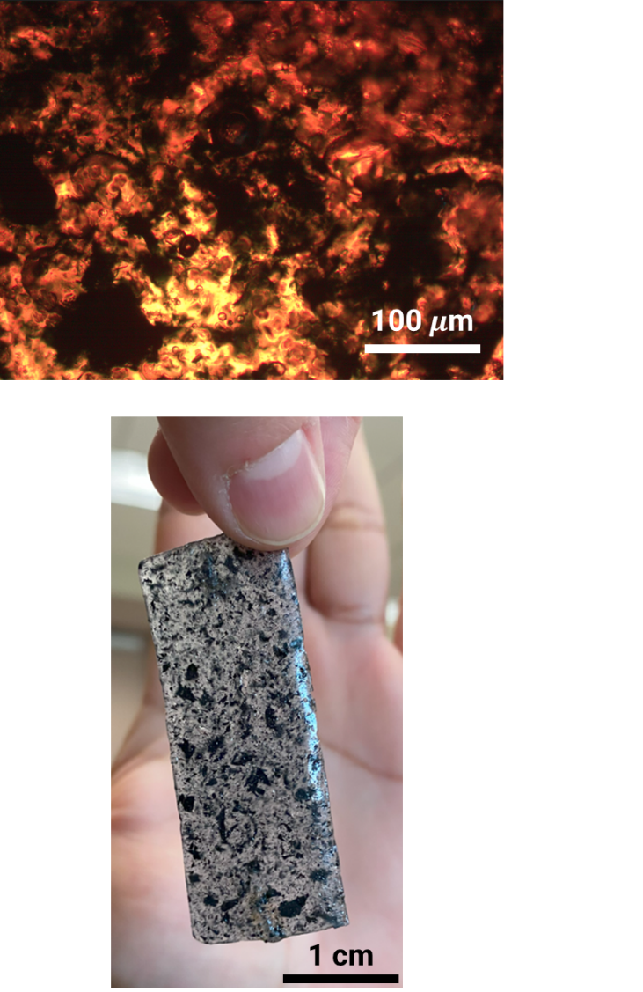
Figure S1: Optical microscope images of ionic biogel showing phase-separation between two phases: PEDOT:PSS/ionic liquid (ionic system - dark blue) and gelatin/glycerol/salt (biogel system - transparent).

Supplementary Figure 2
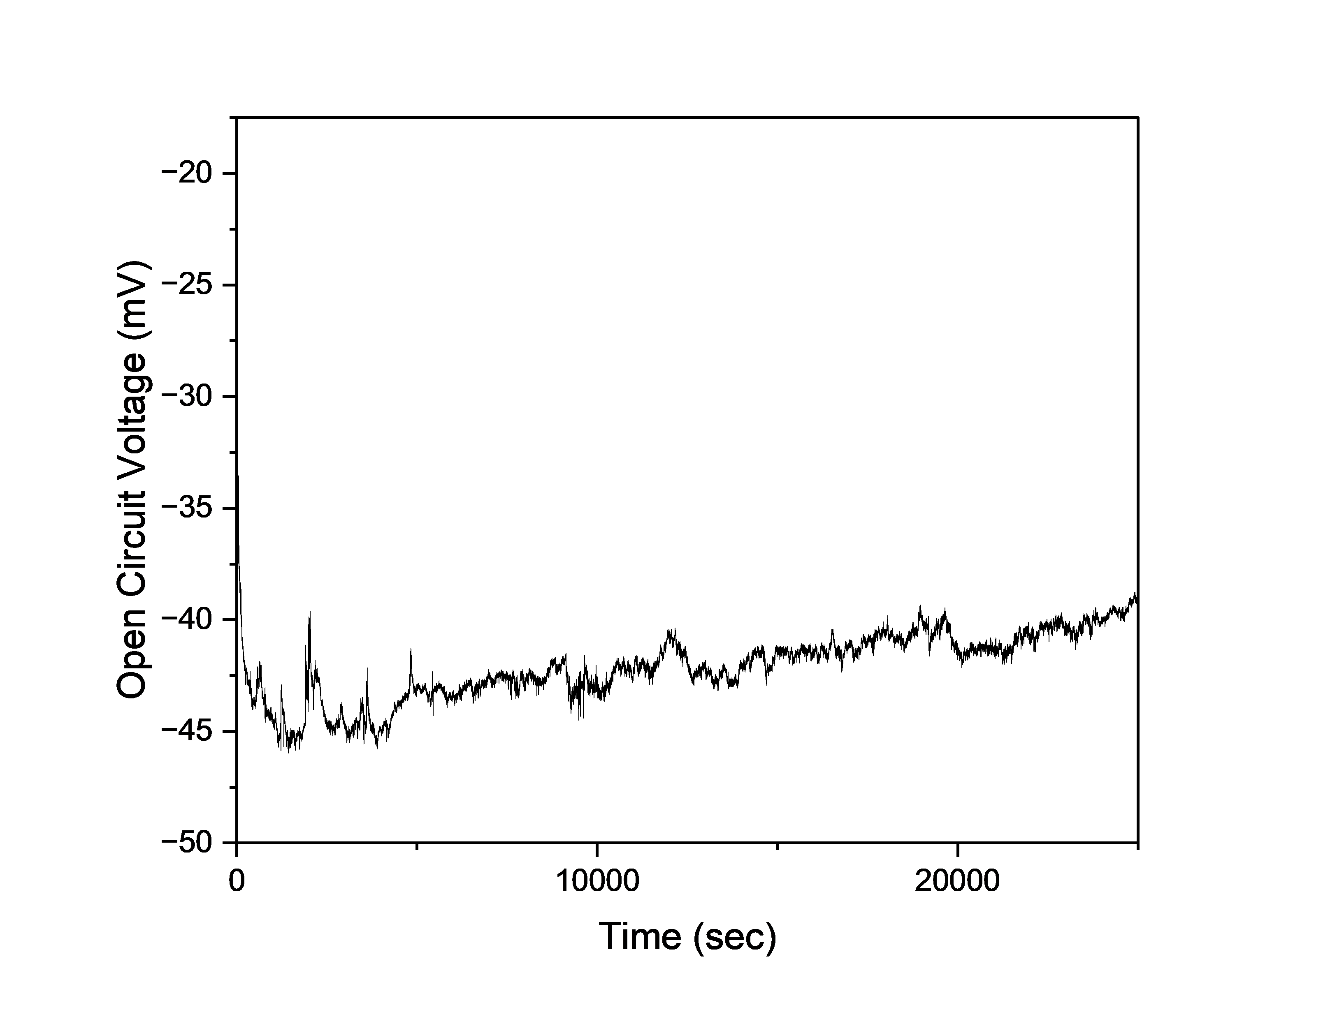
Figure S2: Open Circuit Voltage of ~40 mV across the ionic biogel over 7 hours.
Supplementary Figure 3
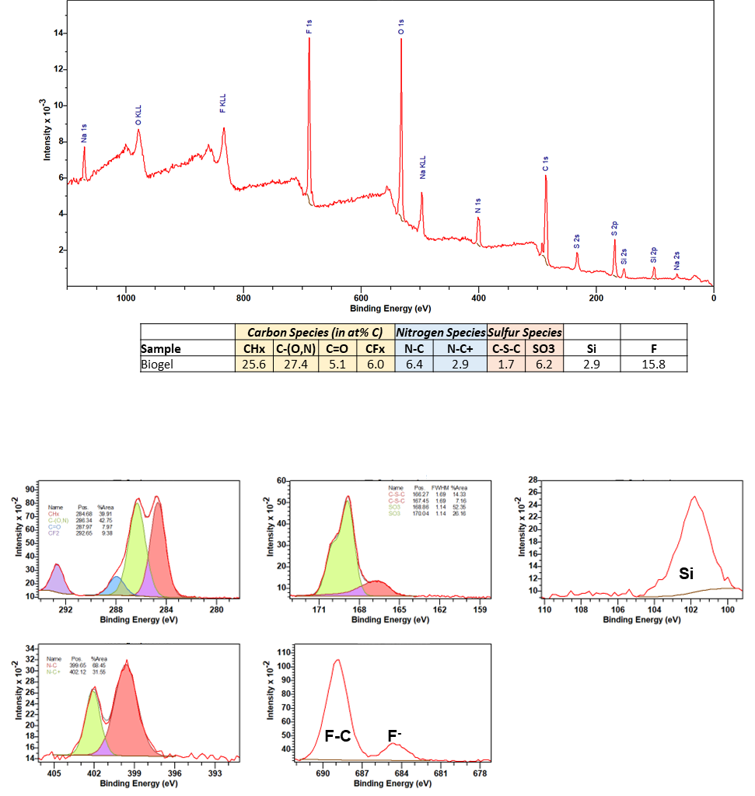
Figure S3: XPS analysis of the ionic biogel to show different components.

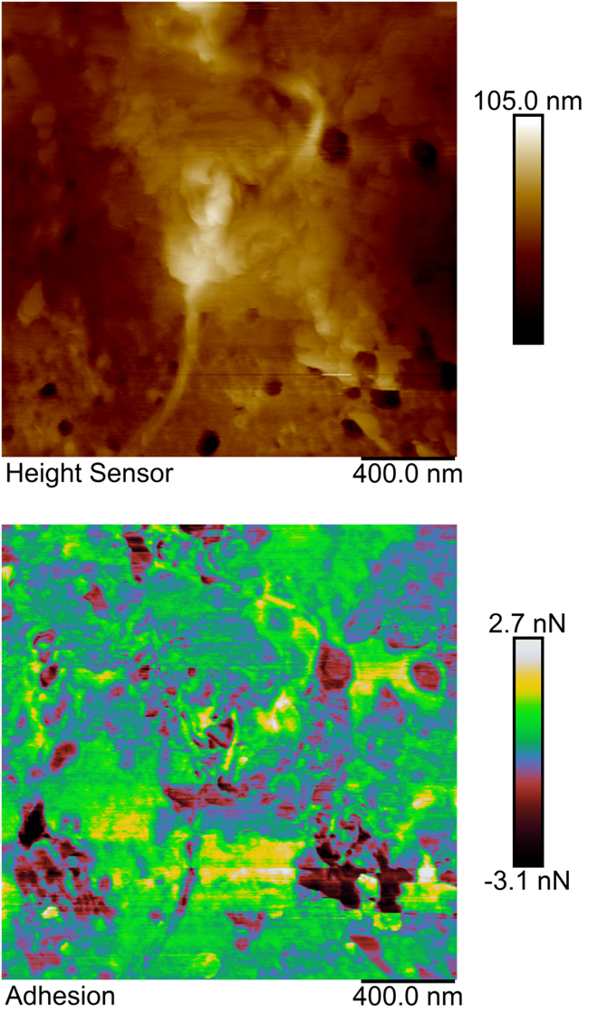
Supplementary Figure 4
Figure S4: AFM image of the ionic biogel with hierarchical pores to show the variation in (a) height and (b) adhesion.

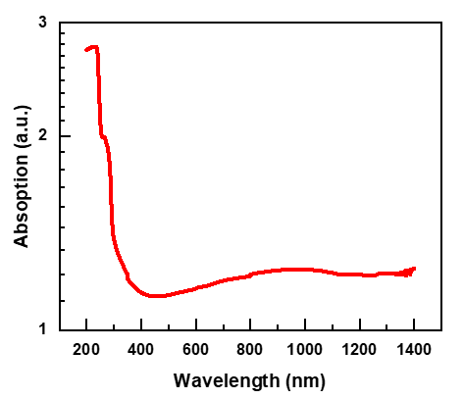
Supplementary Figure 5
Figure S5: UV-Vis spectrum of the ionic biogel.

Supplementary Figure 6
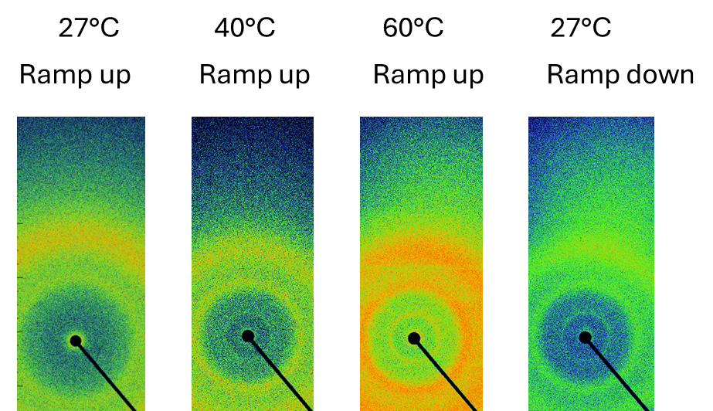
Figure S6: GIWAXS spectrum at different temperatures: 27, 40, 60, and back to 27°C.

Supplementary Figure 7
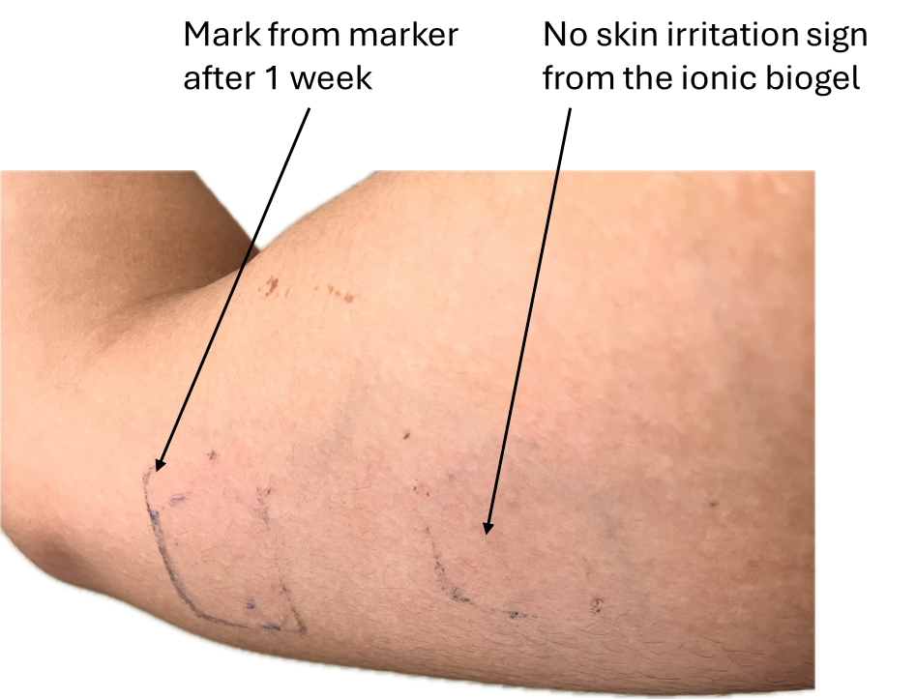
Figure S7: Image showing no skin irritation from the ionic biogel after continuous wearing for 7 days.

Supplementary Figure 8
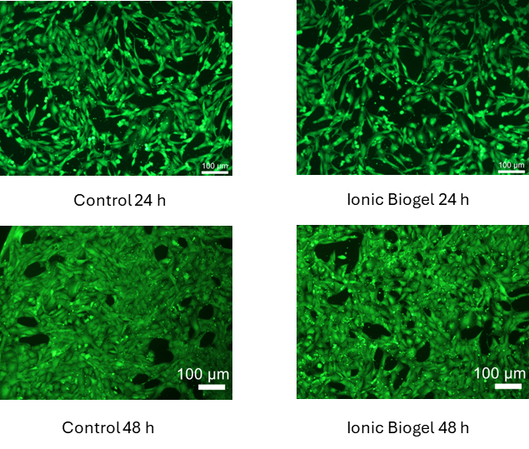
Figure S8: Comparison in the biocompatibility test between the ionic biogel and control after culturing for 24 h and 48 h.
Supplementary Figure 9
Figure S9: Comparison in the change of tan($δ$) with respect to temperature between biogel and ionic biogel.

Supplementary Figure 10
Figure S10: Shear-thinning property of the ionic biogel, with tan($δ$) and viscosity shown on the left and right, respectively.
Supplementary Figure 11
Figure S11: Change of tan($δ$) (left) and viscosity (right) as a function of frequency.
Supplementary Figure 12
Figure S12: Temperature profile used for the repeated rheology test.

Supplementary Figure 13
Figure S13: Dynamic changes in the viscosity during temperature ramp up, down, and isothermal.
Supplementary Figure 14
Figure S14: Comparison of storage and loss moduli during temperature ramp-up for the first two cycles.
Supplementary Figure 15
Figure S15: Comparison of storage and loss moduli during temperature ramp down for the first two cycles.

Supplementary Figure 16

Figure S16: Comparison of loss modulus during temperature ramp-ups and ramp-downs for four cycles.

Supplementary Figure 17
Figure S17: Shear stress-strain response of the ionic biogel.

Supplementary Figure 18
Figure S18: Comparison in the compressive stress and strain between the biogel and ionic biogel.

Supplementary Figure 19
Figure S19: Adhesive force of the ionic biogel normally peeled away from porcine skin in a T-pull test.

Supplementary Figure 20
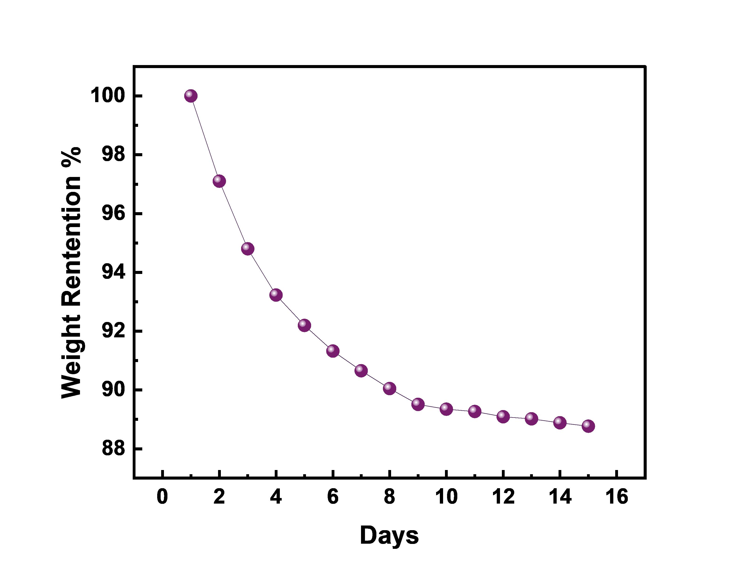

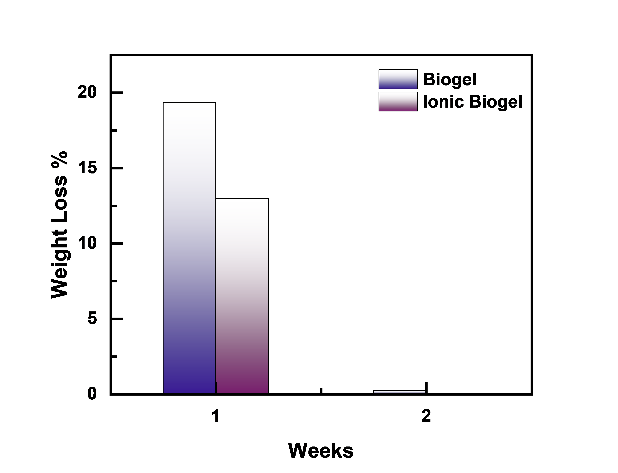

Figure S20: (a) Weight retention of the ionic biogel over the time of two weeks and (b) comparison in the incremental weight loss between biogel and ionic biogel over two weeks.

Supplementary Figure 21
Figure S21: Comparison of the stress-strain curve between the pristine and self-healed ionic biogel (after cutting and heating for 12 h at room temperature).

Supplementary Figure 22
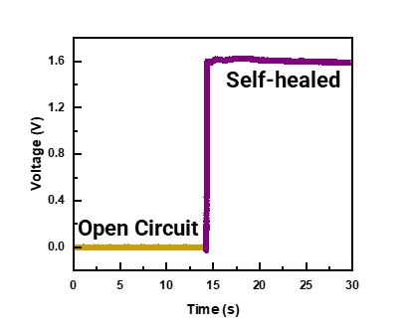
Figure S22: The instantaneous restoration of current due to self-healing and adhesive properties of the ionic biogel

Supplementary Figure 23
Figure S23: The normalized relative resistance change as a function of strain to show the significantly reduced strain-sensitivity of the ionic biogel upon stretching up to 380%.

Supplementary Figure 24
Figure S24: Comparison in the electrical impedance (left) and phase (right) for a parallel plate capacitor based on the dielectric ionic biogel (dots) and biogel (squares) with a thickness of 5 mm.

Supplementary Figure 25
Figure S25: Changes in the electrical impedance magnitude (left) and phase (right) for a parallel plate capacitor with 0.5 mm-thick ionic biogel dielectric.

Supplementary Figure 26
Figure S26: Comparison in the skin contact impedance between the ionic biogel and commercial Ag/AgCl gel electrode.

Supplementary Figure 27
Figure S27: Comparison in the electrical Impedance between ionic biogels with different diameters: 5, 10, and 15 mm.

Supplementary Figure 28
Figure S28: Changes in the electrochemical impedance spectrograph of the ionic biogel with time or swelling: <10 sec (dark purple), 5 mins (purple), 30 mins (light purple).

Supplementary Figure 29
Figure S29: Variation of impedance at low (4 Hz, left) and high (40 kHz, right) frequencies over time.

Supplementary Figure 30
Figure S30: EMG signal measured with ionic biogel kept at 25°C during flexing.
Supplementary Figure 31
Figure S31: EMG signal measured with the ionic biogel kept at 40°C during flexing.
Supplementary Figure 32
Figure S32: Comparison in the EMG signals measured from two ionic biogel electrodes at body temperature during repeated flexing.
Supplementary Figure 33
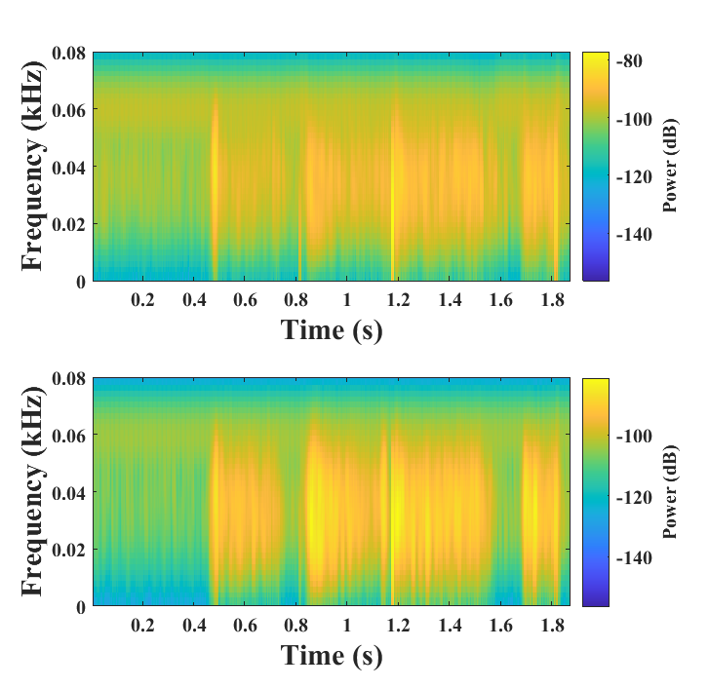
Figure S33: Comparison in the EMG power spectrum between the two ionic biogel electrodes during repeated flexing.
Supplementary Figure 34
Figure S34: Comparison in the amplitude of measured EMG signals from grasping two different materials: cotton vs. Ecoflex.

Supplementary Figure 35
Figure S35: Transient voltage response to an electrical current pulse train of 5 mA at 0.05 Hz.

Supplementary Figure 36
|E_{mc}|<0.6

Figure S36: Transient voltage changes to varying current pulses with different amplitudes: 400 mA (gold), 200 mA (purple), 100 mA (green), 50 mA (blue), 10 mA (red), and 5 mA (black).

Supplementary Figure 37
Figure S37: Transient voltage in response to 100 mA with a pulse width of 33 Hz.

Supplementary Figure 38
Figure S38: Transient voltage in response to 100 mA with a pulse width of 67 Hz.
Supplementary Figure 39
Figure S39: Comparison in the charge injection capacity at different frequencies between ionic biogel (purple) and biogel (yellow).
Supplementary Figure 40
Figure S40: Changes in the charge storage capacity of the ionic biogel with varied scan rates.

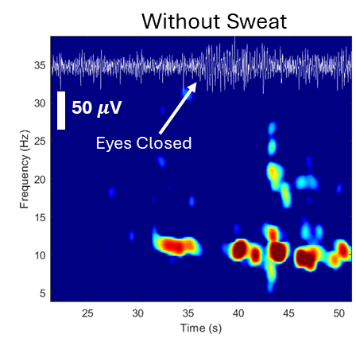
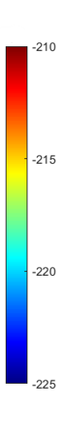
Supplementary Figure 41

Figure S41: EEG amplitude (top inset) and power spectrum during eye opening and closing.

Supplementary Figure 42
Figure S42: Comparison in the skin contact impedance of the ionic biogel before and after sweating from running.

Supplementary Figure 43
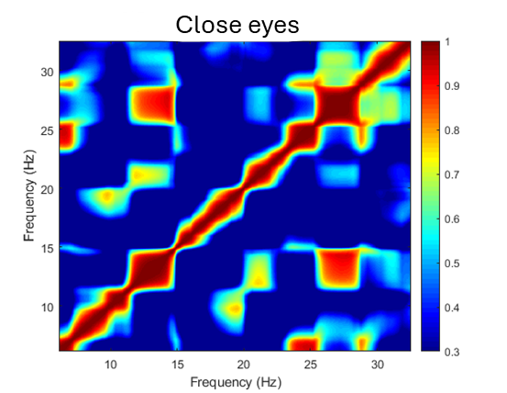
Figure S43: Coupling of different waves (alpha – 8 to 13 Hz, beta – 13 to 30 Hz) in the EEG power spectrum during eye closing.

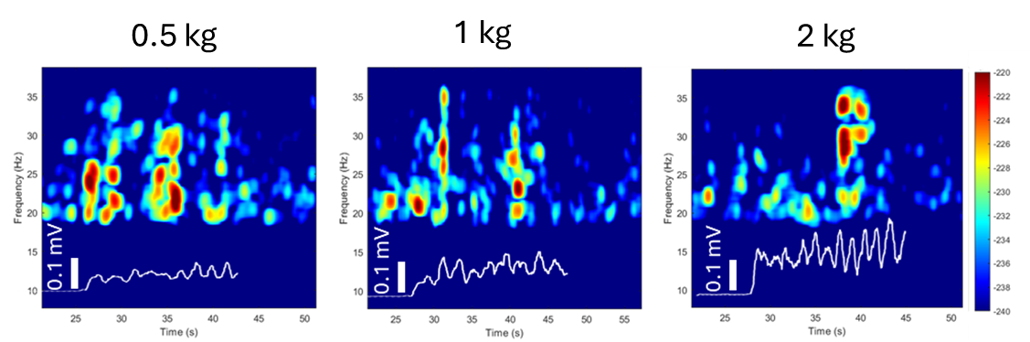
Supplementary Figure 44
Figure S44: Comparison in the EEG signal and power spectrum from lifting different weights: 0.5, 1, and 2 kg.

Supplementary Figure 45
Figure S45: Increased EEG power amplitude as the lifting weight is increased from 1 to 2 kg.

Supplementary Figure 46
Figure S46: Variation of power amplitude with repeated weight reps.

Supplementary Figure 47
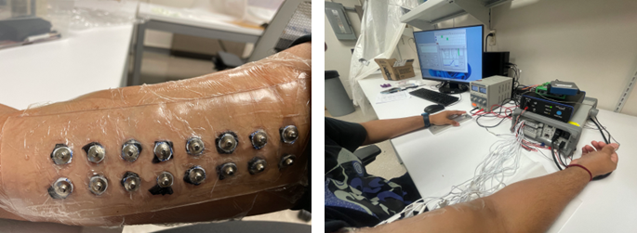
Figure S47: Photograph of the wearable electrical stimulator array placed on the arm.
Supplementary Figure 48
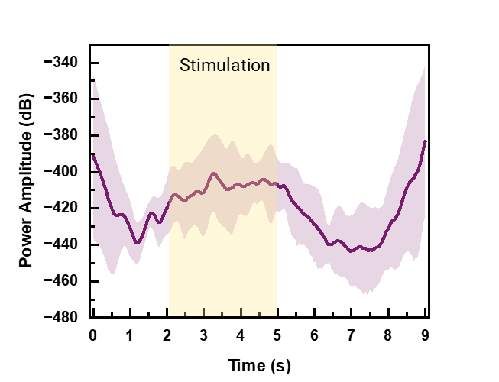
Figure S48: Event Related Desynchronization (ERD) during electrical stimulation or haptic sensation on Day 7.

Supplementary Figure 49
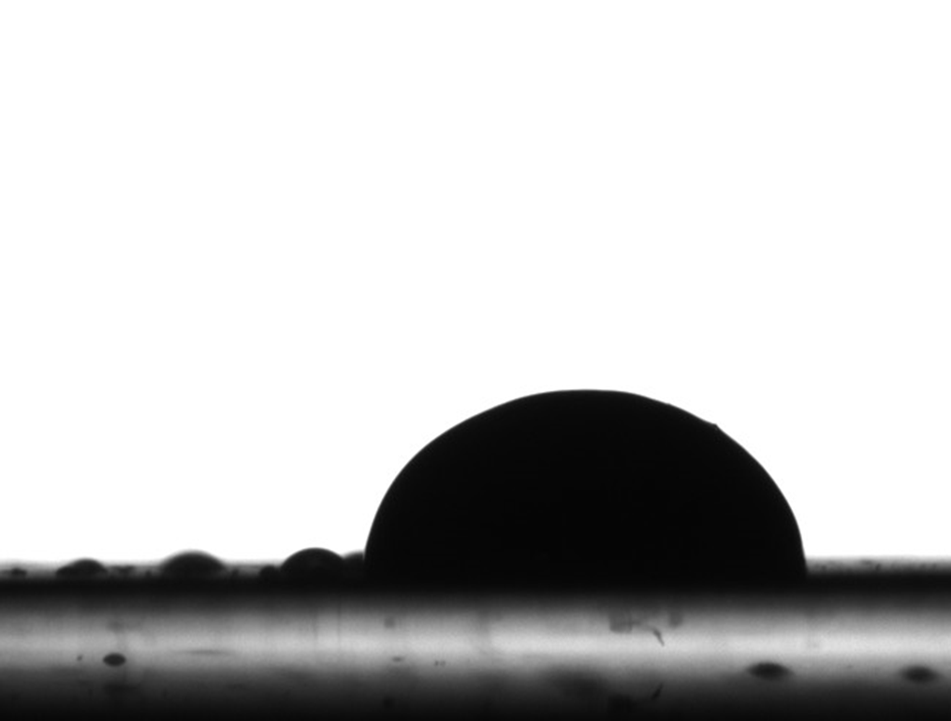
Figure S49: Contact angle (82°) between Paraffin Film and Ionic Biogel, which is larger than that of 60° for Ionic Biogel on Polyimide Film.

Supplementary Figure 50
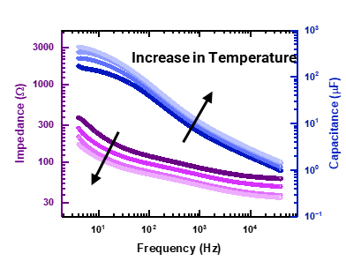
Figure S50: Impedance spectra of tip-shaped neural interface with temperature.

Supplementary Figure 51
Figure S51: Difference in the transconductance while ramping up and down the temperature at 20° C. The slight difference in transconductance during ramping up and ramping down at the same temperature can be attributed to hysteresis arising from the slow ion migration and redistribution within the biogel matrix and PEDOT:PSS domains. This time-dependent ionic motion causes a lag in electrochemical doping/dedoping, leading to minor asymmetry in the channel current response.

References
1. Wang, Y. et al. A highly stretchable, transparent, and conductive polymer. Sci. Adv. 3, e1602076 (2017).
2. Wang, C. et al. On-skin paintable biogel for long-term high-fidelity electroencephalogram recording. Sci. Adv. 8, eabo1396 (2022).
3. Lan, L. et al. Skin‐Inspired All‐Natural Biogel for Bioadhesive Interface. Adv. Mater. 36, 2401151 (2024).
4. Brangwynne, C. P. et al. Germline P Granules Are Liquid Droplets That Localize by Controlled Dissolution/Condensation. Science 324, 1729–1732 (2009).
5. Duan, C. & Wang, R. A Unified Description of Salt Effects on the Liquid–Liquid Phase Separation of Proteins. ACS Cent. Sci. 10, 460–468 (2024).
6. Liu, J. et al. Metastable biological matter in liquid phase separation. Appl. Res. 3, e202300071 (2024).
7. Hirose, T., Ninomiya, K., Nakagawa, S. & Yamazaki, T. A guide to membraneless organelles and their various roles in gene regulation. Nat. Rev. Mol. Cell Biol. 24, 288–304 (2023).
8. Fritsch, A. W. et al. Local thermodynamics govern formation and dissolution of Caenorhabditis elegans P granule condensates. Proc. Natl. Acad. Sci. 118, e2102772118 (2021).
9. Zhou, T. et al. 3D printable high-performance conducting polymer hydrogel for all-hydrogel bioelectronic interfaces. Nat. Mater. 22, 895–902 (2023).
10. Qian, D., Michaels, T. C. T. & Knowles, T. P. J. Analytical Solution to the Flory–Huggins Model. J. Phys. Chem. Lett. 13, 7853–7860 (2022).
11. van Leuken, S. H. M., van Benthem, R. A. T. M., Tuinier, R. & Vis, M. Predicting Multi-Component Phase Equilibria of Polymers using Approximations to Flory–Huggins Theory. Macromol. Theory Simul. 32, 2300001 (2023).
12. Berera, A., Mabillard, J., Mintz, B. W. & Ramos, R. O. Formulating the Kramers problem in field theory. Phys. Rev. D 100, 076005 (2019).
13. Kopač, T. Mathematical model for characterization of temperature-responsive polymers: A study on the rheological behavior of gelatin and poly(N-isopropylacrylamide). Polym. Test. 133, 108402 (2024).
14. Jaspers, M. et al. Ultra-responsive soft matter from strain-stiffening hydrogels. Nat. Commun. 5, 5808 (2014).
15. Kottner, J., Lichterfeld, A. & Blume-Peytavi, U. Transepidermal water loss in young and aged healthy humans: a systematic review and meta-analysis. Arch. Dermatol. Res. 305, 315–323 (2013).
16. Han, C.-G. et al. Giant thermopower of ionic gelatin near room temperature. Science 368, 1091–1098 (2020).
17. Xu, S. et al. High-Performance PEDOT:PSS Flexible Thermoelectric Materials and Their Devices by Triple Post-Treatments. Chem. Mater. 31, 5238–5244 (2019).
18. Ganji, M., Tanaka, A., Gilja, V., Halgren, E. & Dayeh, S. A. Scaling Effects on the Electrochemical Stimulation Performance of Au, Pt, and PEDOT:PSS Electrocorticography Arrays. Adv. Funct. Mater. 27, 1703019 (2017).
19. Engchuan, P., Wongsuphasawat, K. & Sittiprapaporn, P. Brain electrical activity during bench press weight training exercise. Asian J. Med. Sci. 10, 80–85 (2019).
20. Peter, J. et al. Movement-related beta ERD and ERS abnormalities in neuropsychiatric disorders. Front. Neurosci. 16, 1045715 (2022).
21. Meirovitch, Y., Harris, H., Dayan, E., Arieli, A. & Flash, T. Alpha and Beta Band Event-Related Desynchronization Reflects Kinematic Regularities. J. Neurosci. 35, 1627–1637 (2015).
22. Hortobágyi, T. et al. Functional relevance of resistance training-induced neuroplasticity in health and disease. Neurosci. Biobehav. Rev. 122, 79–91 (2021).
23. Zhuang, N. et al. Emotion Recognition from EEG Signals Using Multidimensional Information in EMD Domain. BioMed Res. Int. 2017, 8317357 (2017).
24. Spyropoulos, G. D., Gelinas, J. N. & Khodagholy, D. Internal ion-gated organic electrochemical transistor: A building block for integrated bioelectronics. Sci. Adv. 5, eaau7378 (2019).
25. Yakovlev, L., Syrov, N., Miroshnikov, A., Lebedev, M. & Kaplan, A. Event-Related Desynchronization Induced by Tactile Imagery: an EEG Study. eneuro 10, ENEURO.0455-22.2023 (2023).
26. Meesen, R. L. J., Cuypers, K., Rothwell, J. C., Swinnen, S. P. & Levin, O. The effect of long‐term TENS on persistent neuroplastic changes in the human cerebral cortex. Hum. Brain Mapp. 32, 872–882 (2011).
27. Beijora, A. C., Back, A. P., Fréz, A. R., Azevedo, M. R. B. & Bertolini, G. R. F. Peripheral electrical stimulation on neuroplasticity and motor function in stroke patients: a systematic review and meta-analysis. Neurol. Res. 45, 1111–1126 (2023).
28. Ackerley, R. & Watkins, R. H. Microneurography as a tool to study the function of individual C-fiber afferents in humans: responses from nociceptors, thermoreceptors, and mechanoreceptors. J. Neurophysiol. 120, 2834–2846 (2018).
29. Blau, R. et al. Conductive block copolymer elastomers and psychophysical thresholding for accurate haptic effects. Sci. Robot. 9, eadk3925 (2024).
30. Alsuradi, H., Park, W. & Eid, M. EEG-Based Neurohaptics Research: A Literature Review. IEEE Access 8, 49313–49328 (2020).
31. Khodagholy, D. et al. High transconductance organic electrochemical transistors. Nat. Commun. 4, 2133 (2013).
32. Rivnay, J. et al. Organic electrochemical transistors. Nat. Rev. Mater. 3, 17086 (2018).
33. Rivnay, J. et al. Structural control of mixed ionic and electronic transport in conducting polymers. Nat. Commun. 7, 11287 (2016).
34. Nauenberg, M. A paradox with the Hagen-Poiseuille relation for viscous fluid flow. Am. J. Phys. 82, 82–85 (2014).
35. Rivnay, J. et al. High-performance transistors for bioelectronics through tuning of channel thickness. Sci. Adv. 1, e1400251 (2015).

