Supplementary figures

Multi-ancestry analysis of plasma protein levels influencing and responding to major depression liability

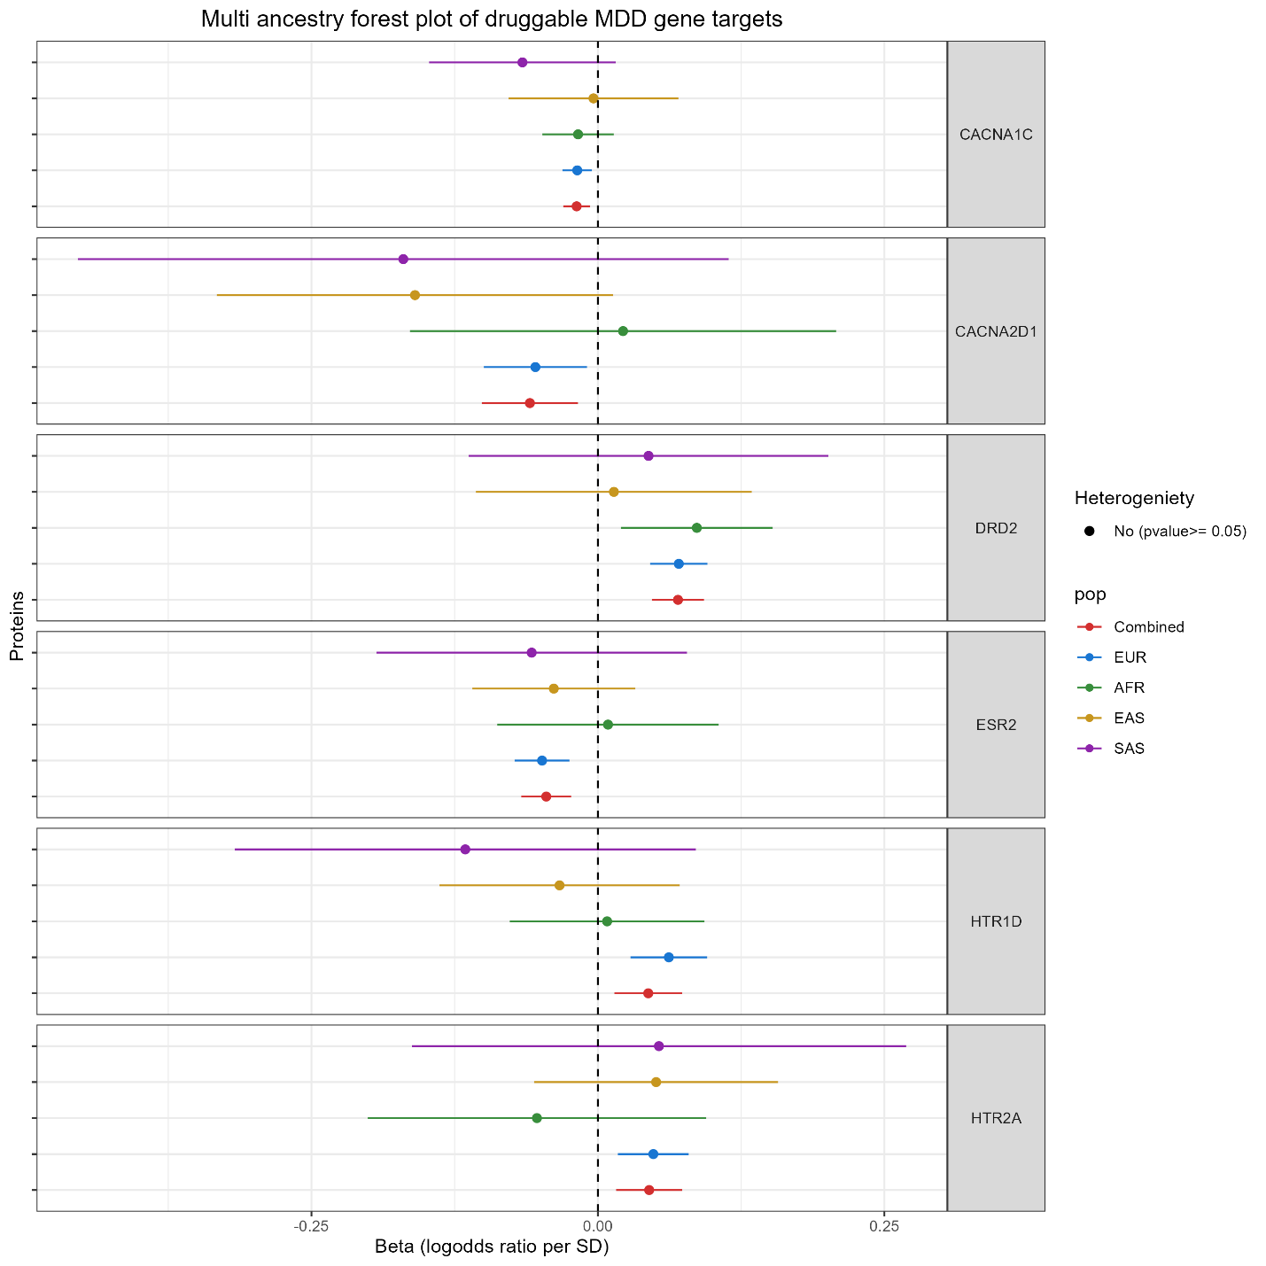
Supplementary figure 1: A forest plot of multi-ancestry Mendelian randomization effect estimates of druggable genes on MDD liability. A forest plot showing the Beta coefficients (log odds ratio per standard deviation) for the causal effects of druggable genes on MDD liability across different ancestries (European [EUR], African [AFR], East Asian [EAS], and South Asian [SAS] ancestries). Each point represents the estimated effect size for a specific protein, with horizontal bars indicating 95% confidence intervals.

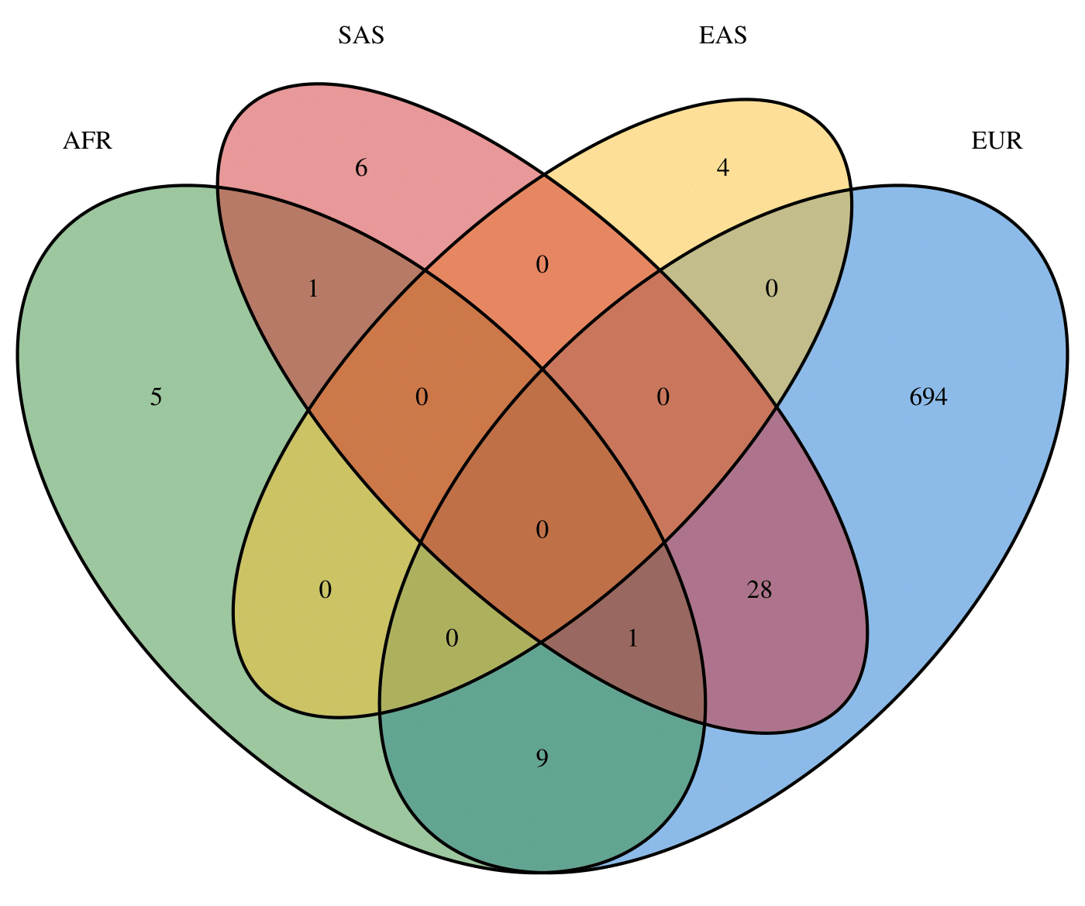
Supplementary figure 2: Venn diagram of the per-ancestry number of significant protein associations with genetic liability to MDD. There is relatively low overlap in significantly discovered protein associations with major depressive disorder (MDD) polygenic risk scores (PRS) across the four ancestry groups: African (AFR), East Asian (EAS), South Asian (SAS), and European (EUR) (FDR < 0.05). Though effect estimates are relatively consistent across ancestries, there is a large disparity in statistical power which may give the illusion of widespread ancestry-specific effects if not interpreted with care.

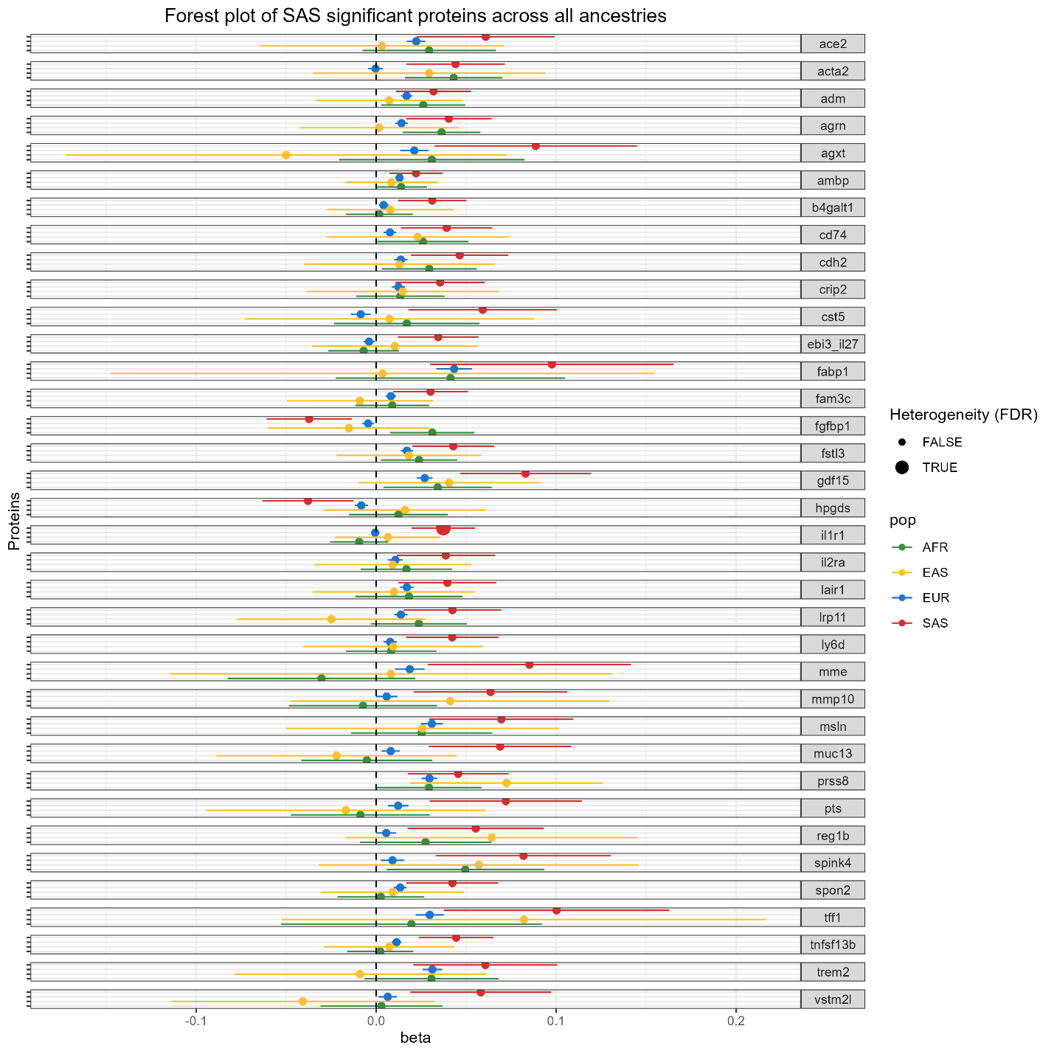
Supplementary figure 3: A forest plot of multi-ancestry Mendelian randomization effect estimates of SAS ancestry significant proteins on MDD liability. A forest plot showing beta coefficients and 95% confidence intervals for only proteins that are significantly associated with MDD polygenic risk scores (PRS) in SAS ancestry individuals across different ancestries (European [EUR], African [AFR], East Asian [EAS], South Asian [SAS]. Cochran's Q-statistic (False Discovery Rate -adjusted p-value < 0.05) was used to assess proteins with heterogeneity. There are some instances of heterogeneity of effect sizes, for example IL1R1 only associating in SAS, but in most instances the null hypothesis that effects are consistent across ancestral groups of MDD on protein levels cannot be rejected.

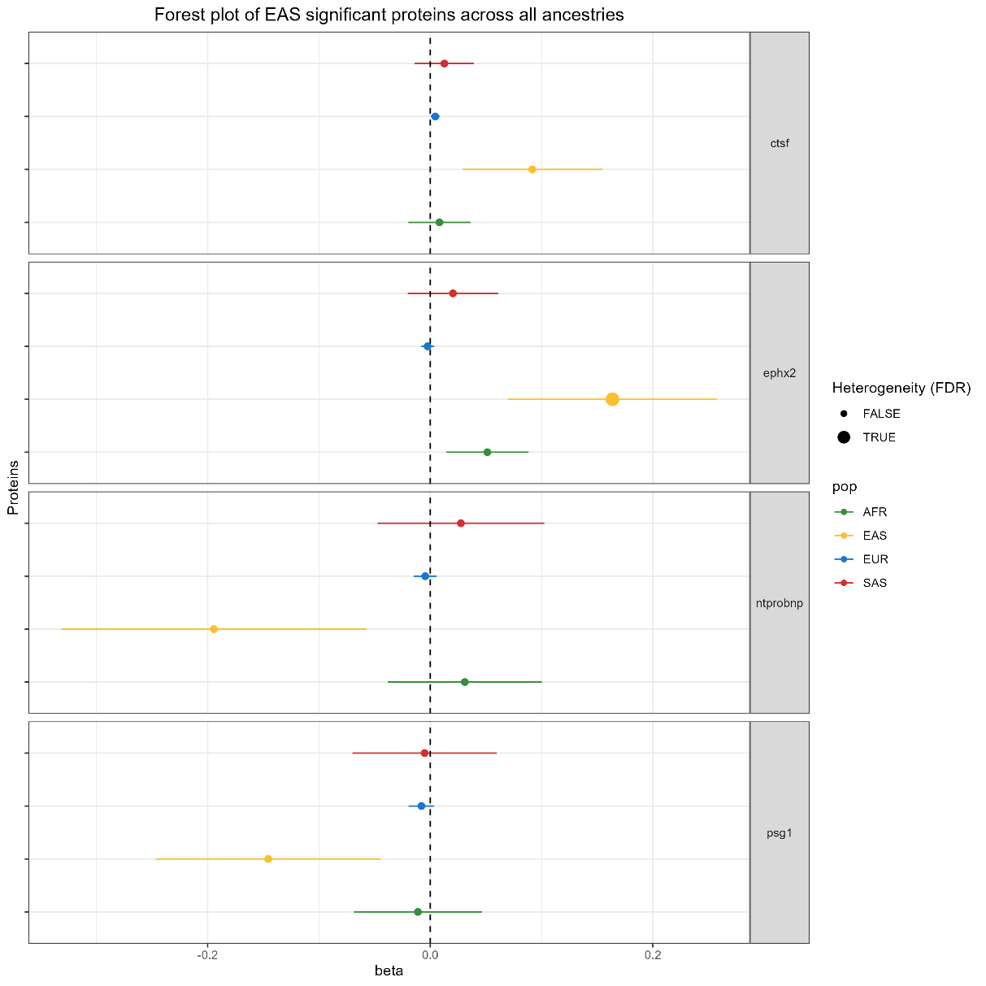
Supplementary figure 4: A forest plot of multi-ancestry Mendelian randomization effect estimates of EAS ancestry significant proteins on MDD liability. A forest plot showing beta coefficients and 95% confidence intervals for only proteins that are significantly associated with MDD polygenic risk scores (PRS) in EAS ancestry individuals across different ancestries (European [EUR], African [AFR], East Asian [EAS], South Asian [SAS]. Cochran's Q-statistic (False Discovery Rate -adjusted p-value < 0.05) was used to assess proteins with heterogeneity.
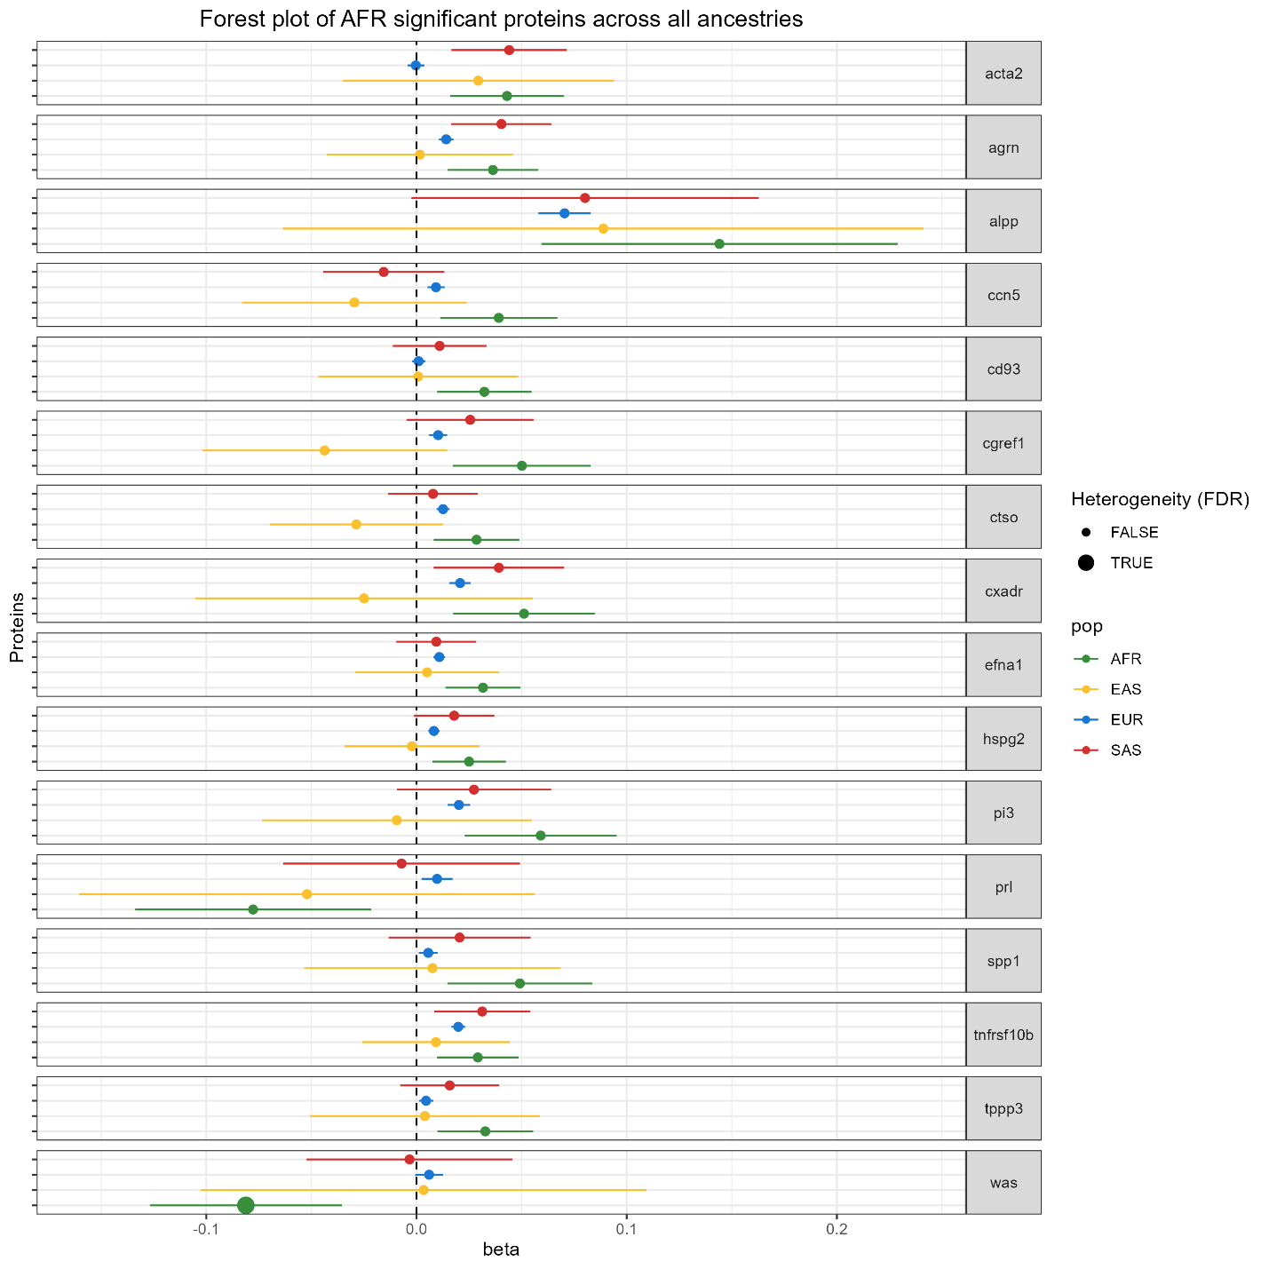
Supplementary figure 5: A forest plot of multi-ancestry Mendelian randomization effect estimates of AFR ancestry significant proteins on MDD liability. A forest plot showing beta coefficients and 95% confidence intervals for only proteins that are significantly associated with MDD polygenic risk scores (PRS) in AFR ancestry individuals across different ancestries (European [EUR], African [AFR], East Asian [EAS], South Asian [SAS]. Cochran's Q-statistic (False Discovery Rate -adjusted p-value < 0.05) was used to assess proteins with heterogeneity.

