Supplementary Information
Distinct families of small RNAs are associated with different stages of parasitism by the Strongyloides venezuelensis nematodes
Key words:
Contents Page:
- Supplementary Figure 1 - MDS Plots from Edge R analysis
- Supplementary Figure 2 - Differential Expression of sRNA in four life cycle stages (monophosphate library and phosphate independent library)
- Supplementary Figure 3 - Dicer-processing signature of sRNA families
- Supplementary Figure 4 - Base distribution of 18-30 nt in free-living and parasitic 5’pN-enriched library
- Supplementary Figure 5 - The proportion of TEs in S. venezuelensis
- Supplementary Figure 6 - differential expression of miRNAs in five life cycle stages
- Supplementary Table 1 – sRNA classes identified in parasitic nematodes and C. elegans

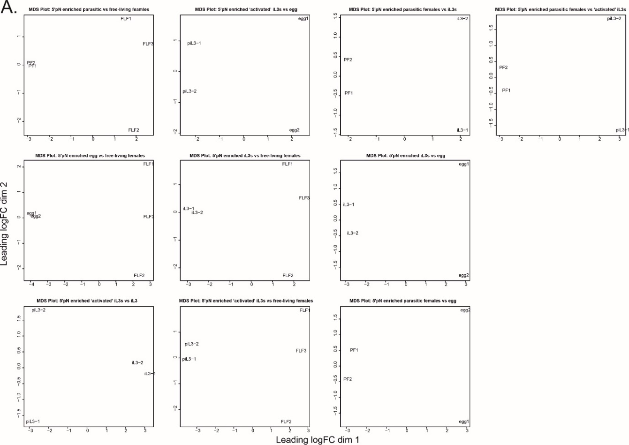
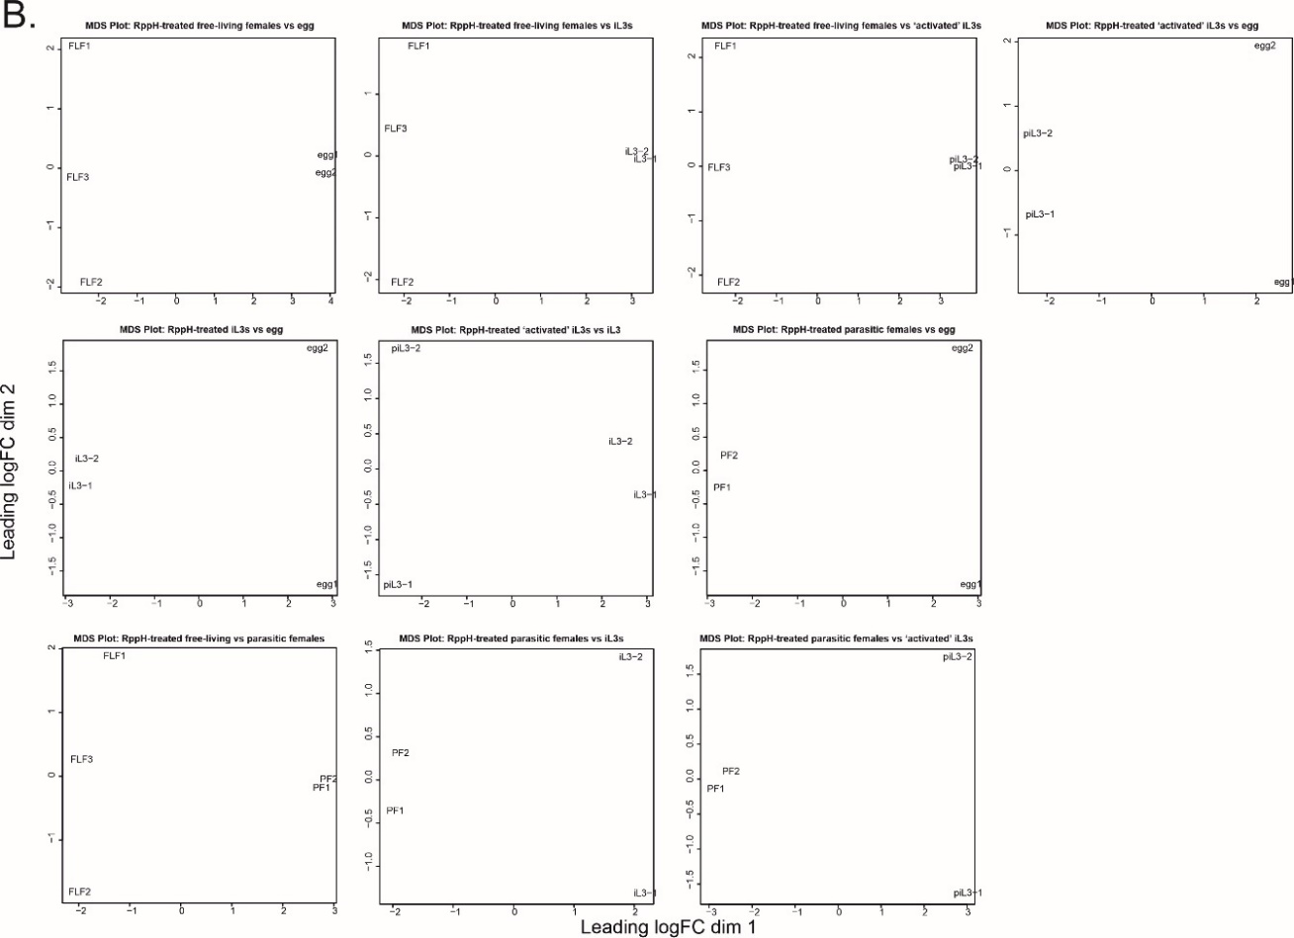
SI Figure 1 - MDS Plots from Edge R analysis
The multidimensional scaling (MDS) plots from Edge R analysis for A) 5’pN enriched and B) RppH-treated libraries used to explore differences in samples for comparisons of parasitic and free-living females, iL3s, ‘activated’ iL3s and eggs.
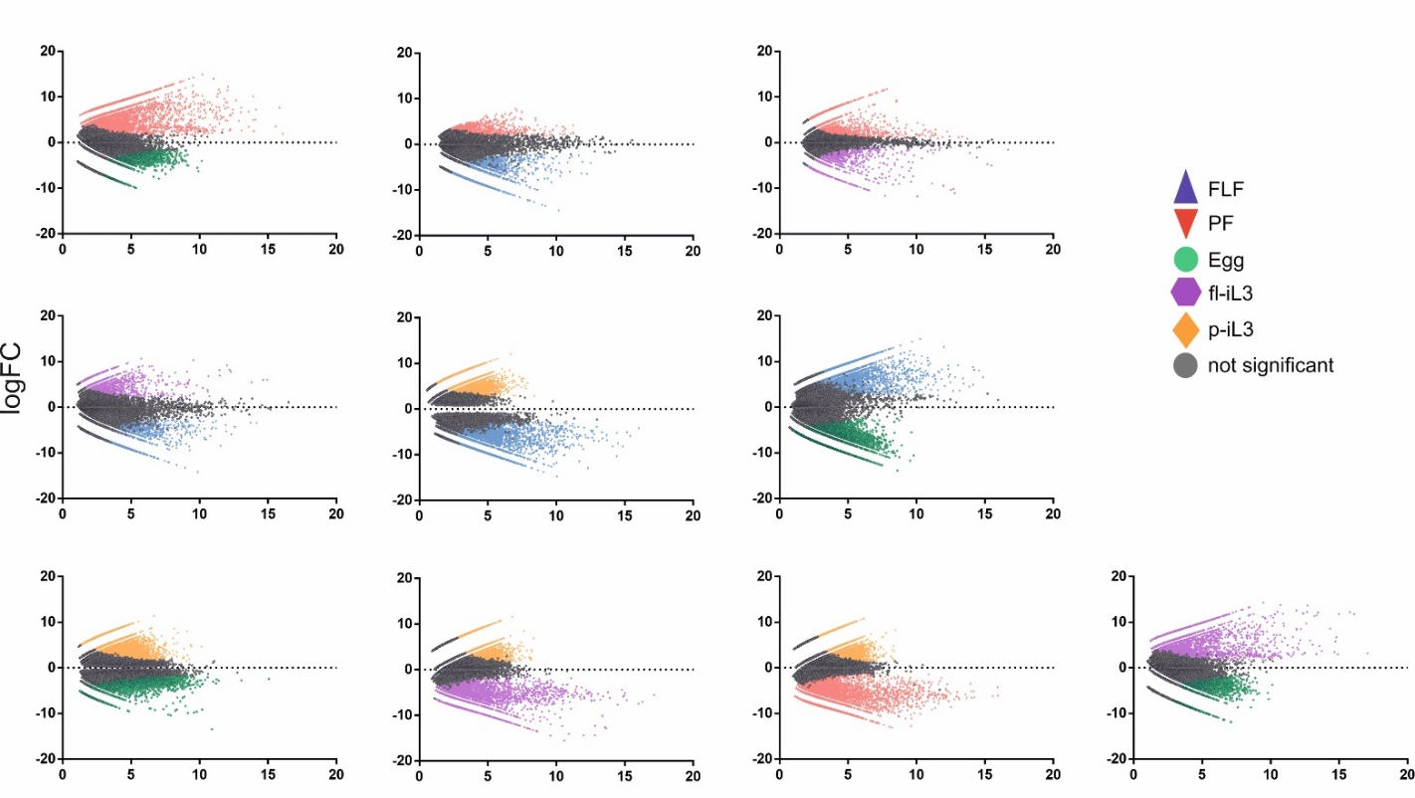
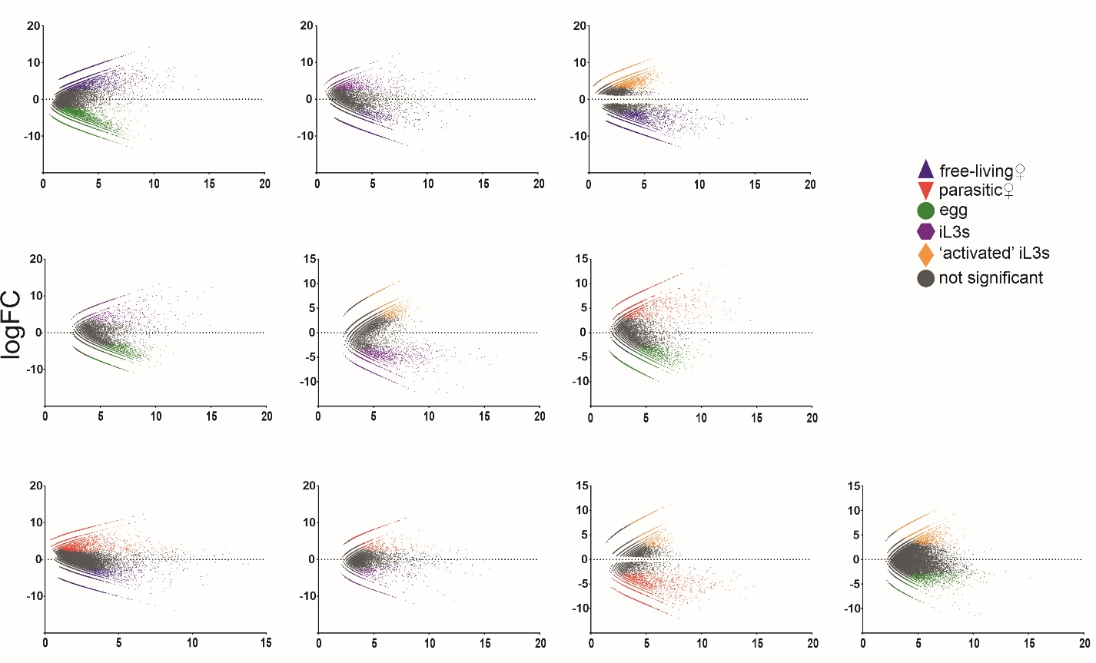
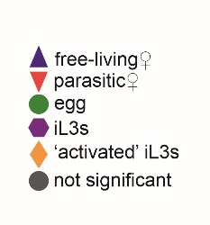
SI Figure 2 - Differential Expression of sRNA in four life cycle stages
A.
B.
sRNAs upregulated in each life cycle stage in pairwise comparisons in A) 5’pN enriched libraries and B) RppH-treated libraries. The free-living adult female (blue triangle), parasitic adult females (red triangle), eggs (green circles), free-living iL3s (purple pentagons), ‘activated’ iL3s (orange diamonds) on axis showing the fold change (FC) in expression vs counts per million (CPM). Reads considered significantly upregulated were coloured if the FDR adjusted p value ≤ 0.001. Each data point is a unique sRNA sequence.
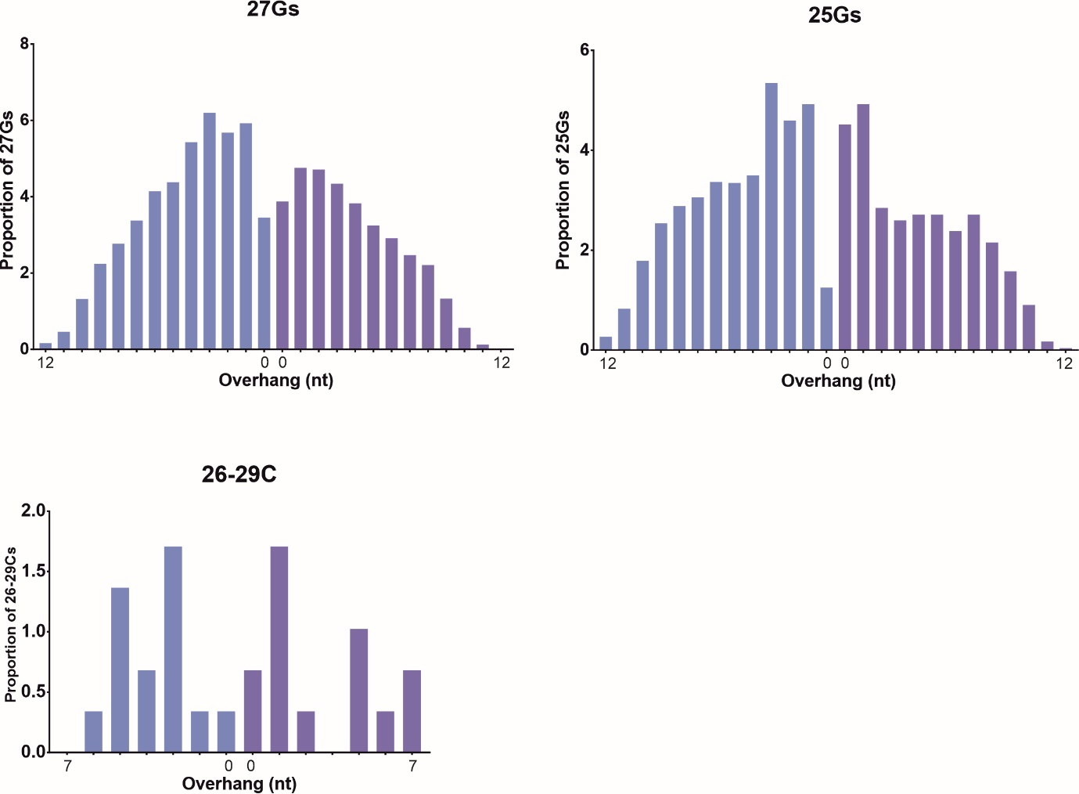
B.
A.

C.

SI Figure 3 - Analysing sRNA families for Dicer-processing signature using stepRNA.
A) Unique 27Gs in parasitic and free-living females, B) 25Gs in parasitic and free-living females and C) 26-29Cs in parasitic females were used as a reference for passenger strand analysis from total trimmed, mapped sRNA reads expressed in either parasitic or parasitic and free-living females. Bar charts represent the percentage of reads with an overhang. The 5’ overhangs are coloured in blue and the 3’ overhangs in purple.

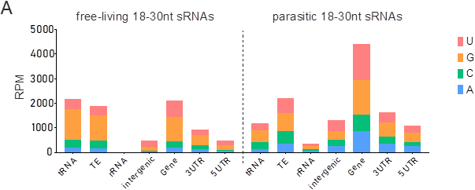

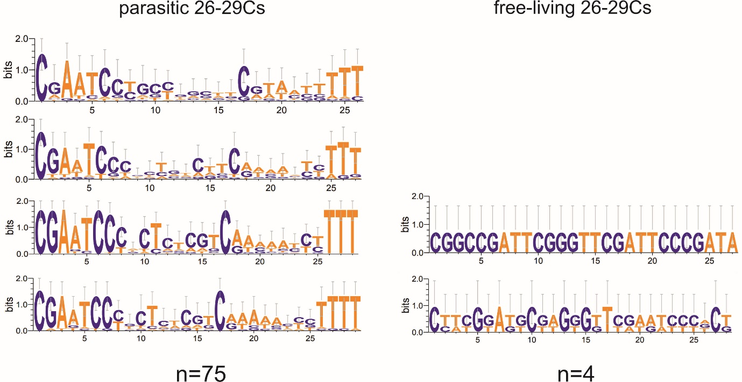
B

SI Figure 4 - Base distribution of 18-30 nt in free-living and parasitic 5’pN-enriched library
A) small RNAs derived from tRNAs, rRNAs, intergenic regions, genes, TE, 3’UTR and 5’UTR and their starting base in colour. B) nucleotide composition of parasitic and free-living 26-29Cs

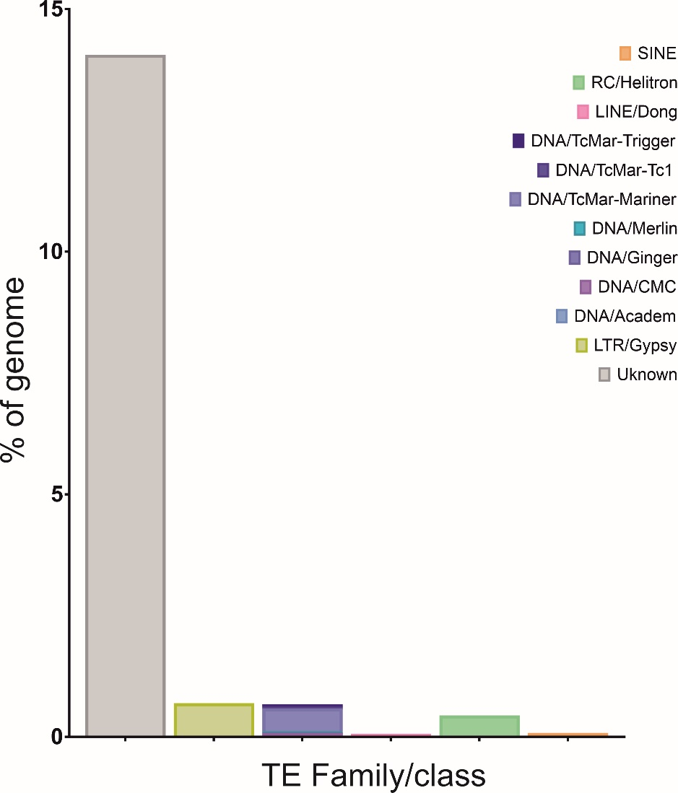

SI Figure 5. The proportion of TEs in S. venezuelensis
Proportion of TE families and sub-families predicted in S. venezuelensis genome
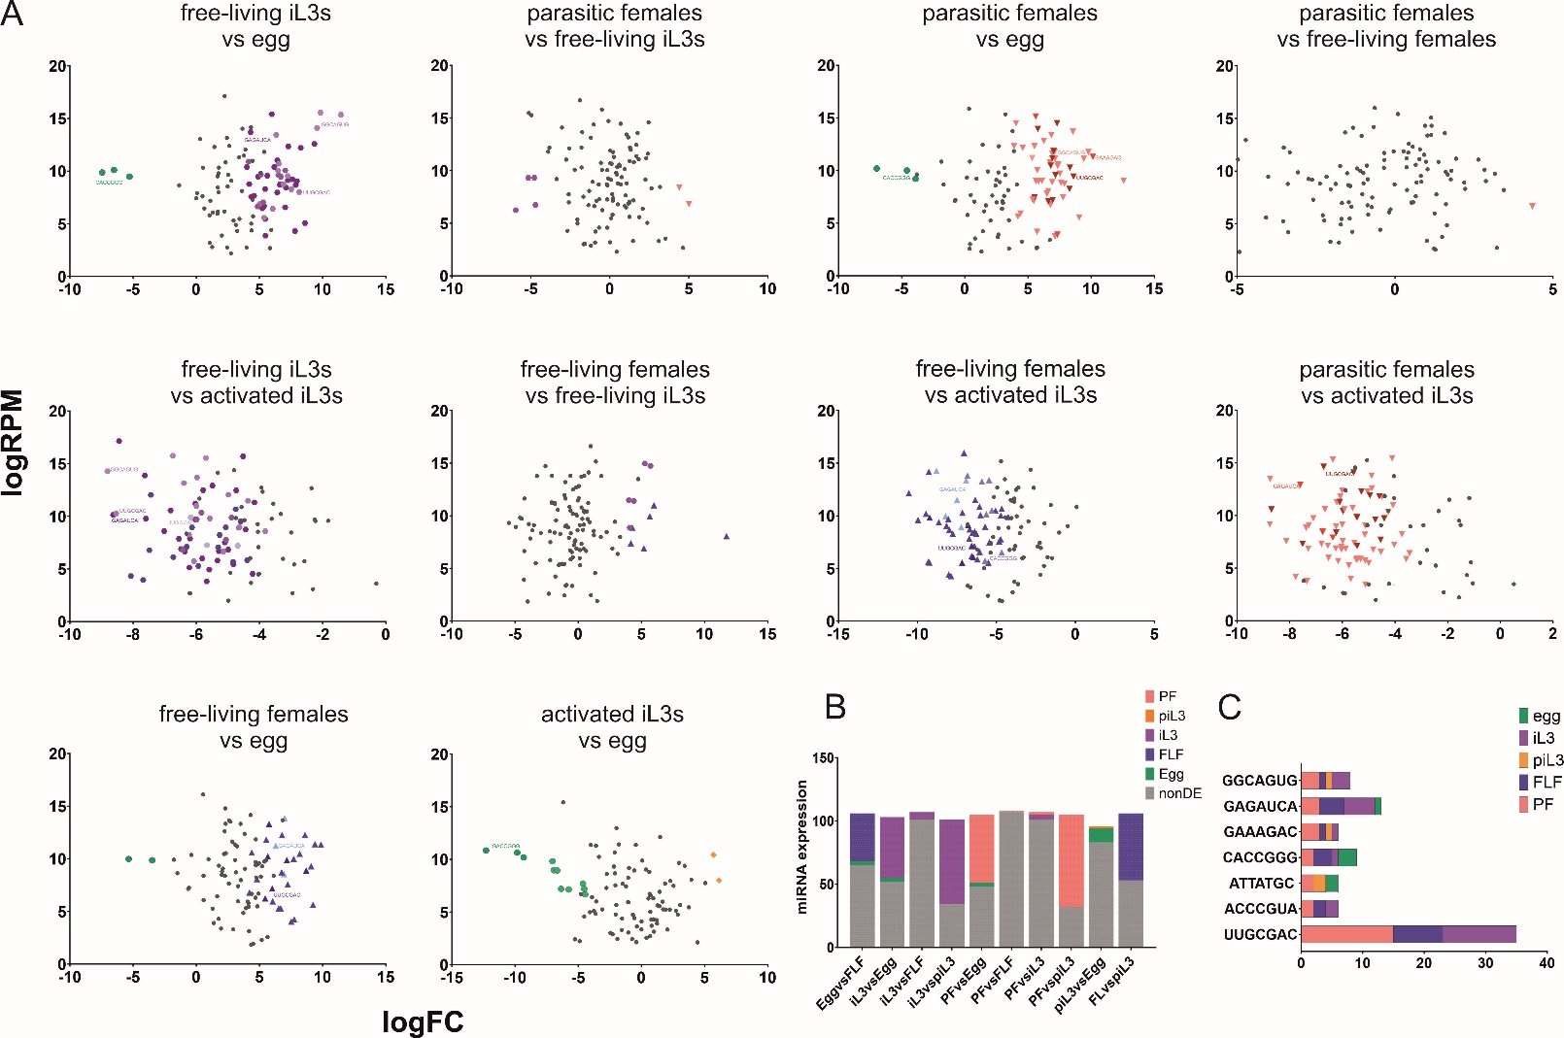

SI Figure 6 - differential expression of miRNAs in five life cycle stages
A) miRNAs upregulated at each life cycle stage in a pairwise comparison free-living females (blue triangle), parasitic females (red triangle), eggs (green circles), iL3s (purple pentagons) and ‘activated’ iL3s (orange diamonds) on axis showing the log fold change (FC) in expression vs counts per million (CPM). Common seed regions (expressed 3 times or more) highlighted. sRNAs identified using the edgeR package in R. Reads considered significantly upregulated if the FDR adjusted p value ≤ 0.001. Each point is a single miRNA. B) miRNA differential expression in each life cycle stage comparison. Non differentially expressed miRNAs are shown in grey. C) The top 7 seed sequences found in S. venezuelensis showing the number times the seed sequence is present and the life cycle stage they are expressed in.

SI Table 1 – sRNA classes excluding miRNAs identified in parasitic nematodes and C. elegans
References:
Ambros V, Lee RC, Lavanway A, Williams PT, Jewell D. MicroRNAs and other tiny endogenous RNAs in C. elegans. Curr Biol. 2003 May 13;13(10):807-18. doi: 10.1016/s0960-9822(03)00287-2. PMID: 12747828.
Chow, F.W.-N., Koutsovoulos, G., Ovando-Vázquez, C., Neophytou, K., Bermúdez-Barrientos, J.R., Laetsch, D.R., Robertson, E., Kumar, S., Claycomb, J.M., Blaxter, M., Abreu-Goodger, C. and Buck, A.H. (2019). Secretion of an Argonaute protein by a parasitic nematode and the evolution of its siRNA guides. Nucleic Acids Research, 47(7), pp.3594–3606. doi:https://doi.org/10.1093/nar/gkz142
Holz, A. and Streit, A. (2017). Gain and Loss of Small RNA Classes—Characterization of Small RNAs in the Parasitic Nematode Family Strongyloididae. Genome Biology and Evolution, 9(10), pp.2826–2843. doi:https://doi.org/10.1093/gbe/evx197
Ruby JG, Jan C, Player C, Axtell MJ, Lee W, Nusbaum C, Ge H, Bartel DP. Large-scale sequencing reveals 21U-RNAs and additional microRNAs and endogenous siRNAs in C. elegans. Cell. 2006 Dec 15;127(6):1193-207. doi: 10.1016/j.cell.2006.10.040. PMID: 17174894.
Sarkies, P., Selkirk, M.E., Jones, J.T., Blok, V., Boothby, T., Goldstein, B., Hanelt, B., Ardila-Garcia, A., Fast, N.M., Schiffer, P.M., Kraus, C., Taylor, M.J., Koutsovoulos, G., Blaxter, M.L. and Miska, E.A. (2015). Ancient and Novel Small RNA Pathways Compensate for the Loss of piRNAs in Multiple Independent Nematode Lineages. PLOS Biology, 13(2), p.e1002061. doi:https://doi.org/10.1371/journal.pbio.1002061
Suleiman, M., Kounosu, A., Murcott, B., Dayi, M., Pawluk, R., Yoshida, A., Viney, M., Kikuchi, T. and Hunt, V.L. (2022). piRNA-like small RNAs target transposable elements in a Clade IV parasitic nematode. Scientific Reports, [online] 12(1), p.10156. doi:https://doi.org/10.1038/s41598-022-14247-1
Wang, J., Czech, B., Crunk, A., Wallace, A., Mitreva, M., Hannon, G.J. and Davis, R.E. (2011). Deep small RNA sequencing from the nematode Ascaris reveals conservation, functional diversification, and novel developmental profiles. Genome Research, 21(9), pp.1462–1477. doi:https://doi.org/10.1101/gr.121426.111
Winter, A.D., Weir, W., Hunt, M., Berriman, M., Gilleard, J.S., Devaney, E. and Britton, C. (2012). Diversity in parasitic nematode genomes: the microRNAs of Brugia pahangi and Haemonchus contortus are largely novel. BMC Genomics, 13(1), p.4. doi:https://doi.org/10.1186/1471-2164-13-4

