Supplementary information

Shared structural mechanisms of alternating access between the secondary peptide transporter SbmA and ABC transporters

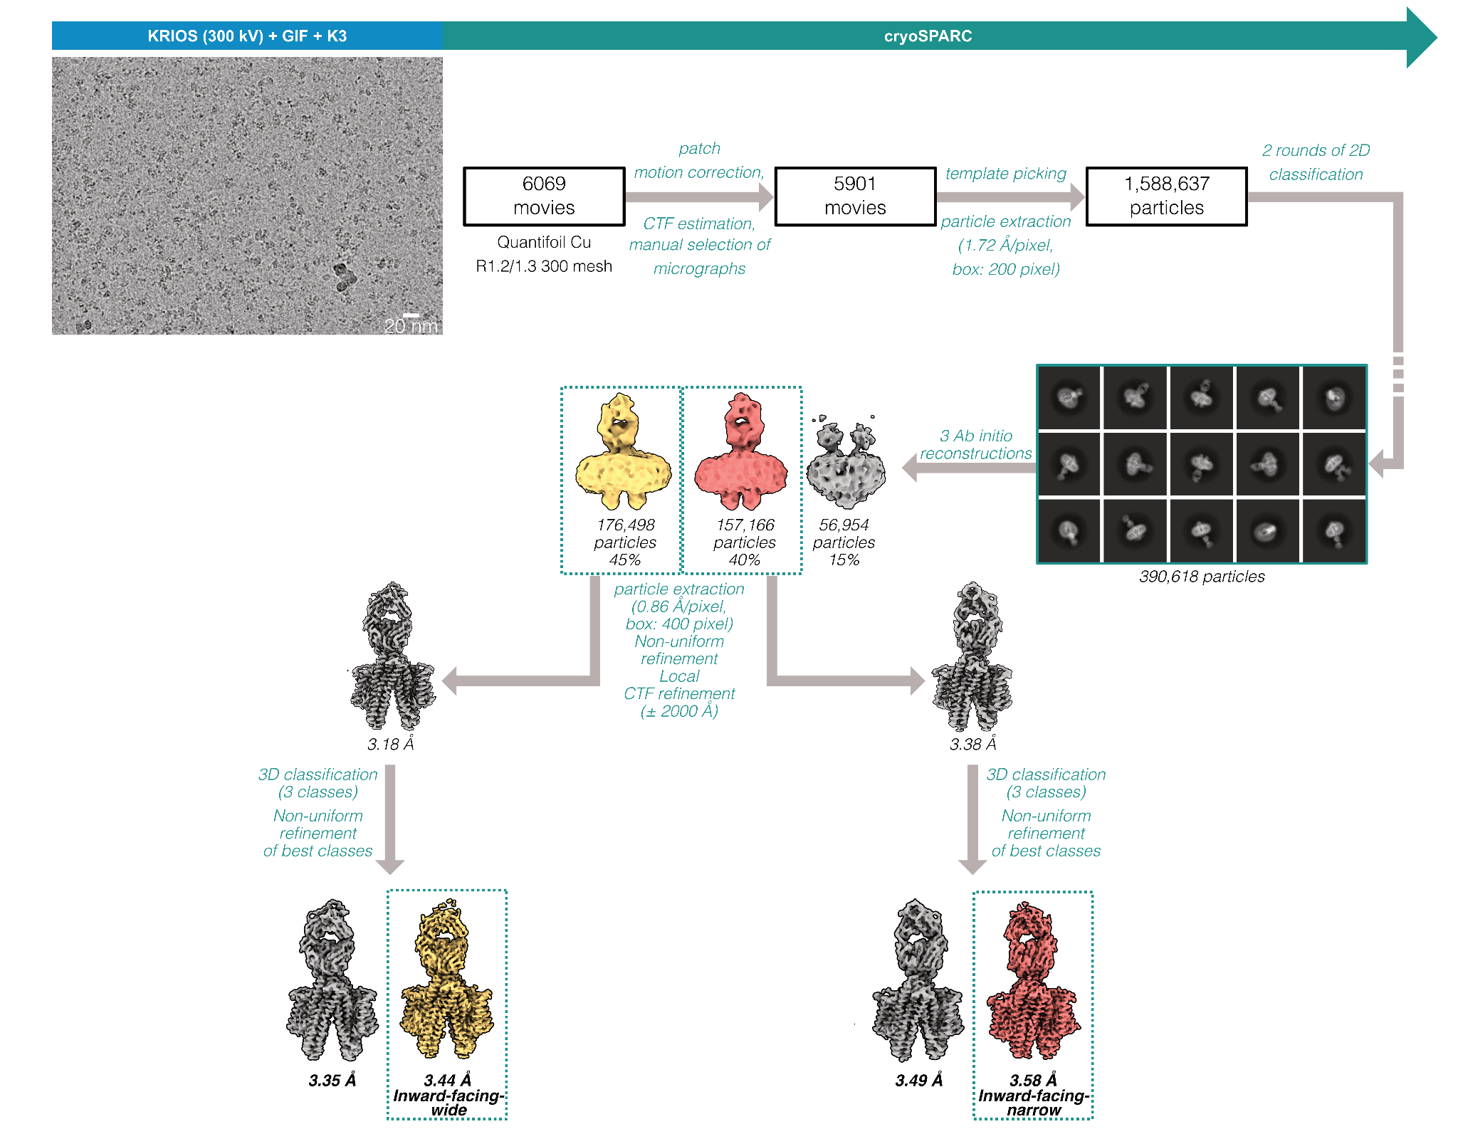

Supplementary Fig. 1 - Cryo-EM reconstructions of SbmA in the inward-facing-narrow and -wide conformations bound to FabS11-1. Detailed image processing workflow including a representative micrograph showing the particle distribution on a Quantifoil Cu R1.2/1.3 300 mesh grid.

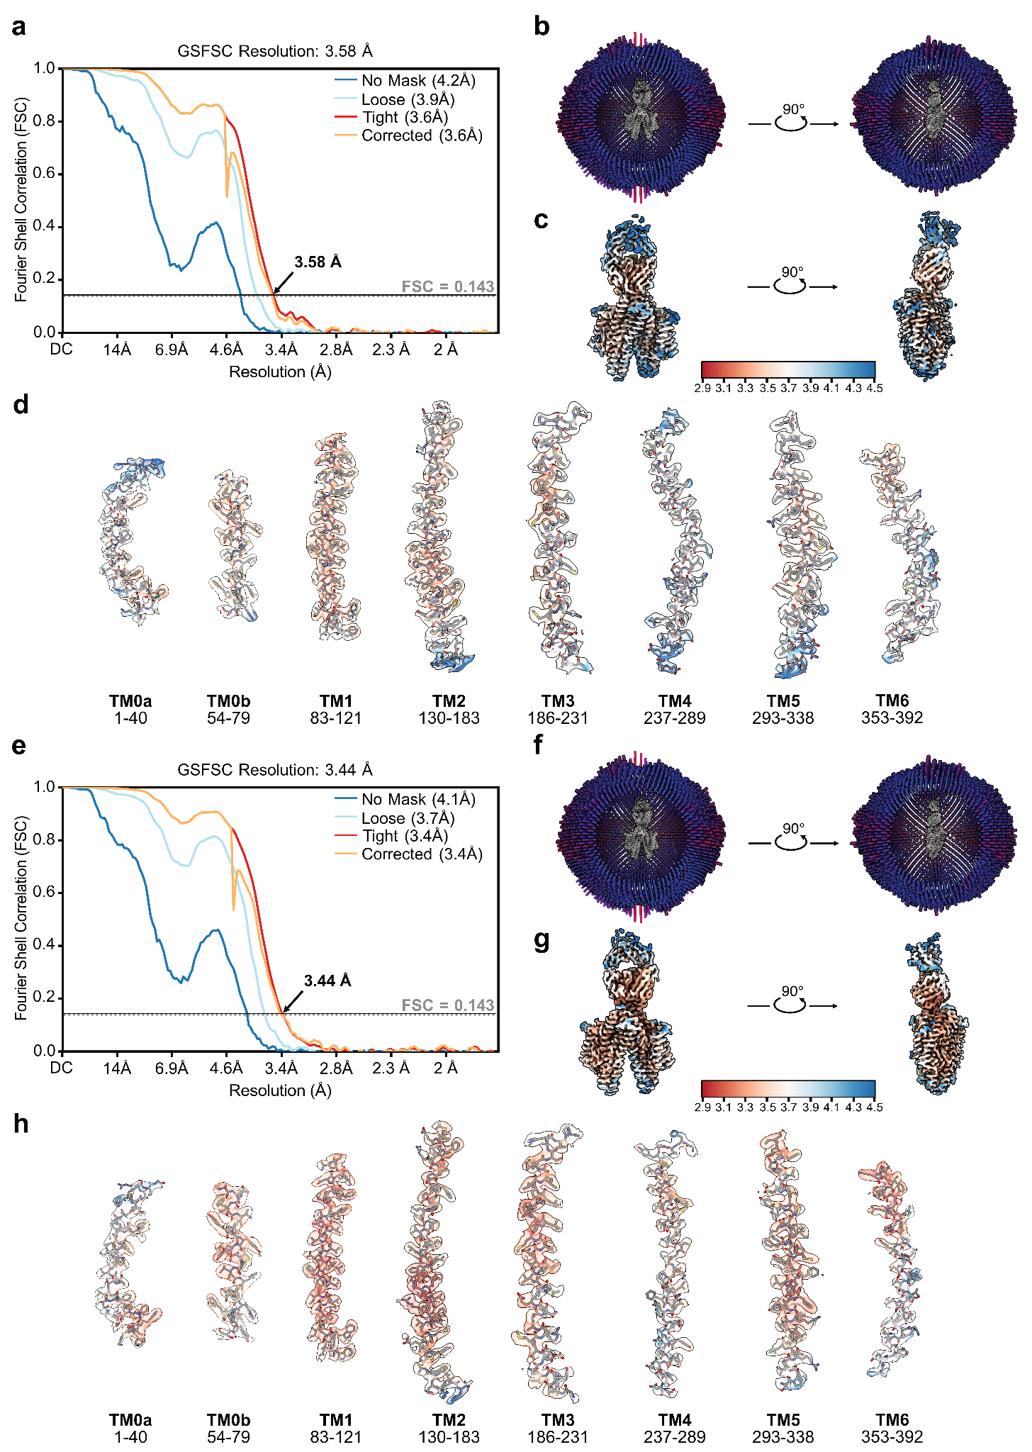

Supplementary Fig. 2 - Validation of SbmA in the inward-facing-narrow and -wide conformations bound to FabS11-1. a,e, FSC plot of the final reconstruction with the arrow indicating the global resolution based on the threshold of FSC = 0.143 for SbmA in the (a) inward-facing-narrow and (e) -wide conformations. b,f, Angular distribution plot of particles included in the asymmetric 3D reconstruction. The number of particles with their respective orientation is represented by the length and color of the cylinders. c,g, Final reconstructed map colored according to the local resolution estimated in cryoSPARC. d,h, Densities (semi-transparent surface renderings) for indicated residue ranges are shown in relation to the fitted atomic model (shown in stick representation). The surface renderings of the selected regions are colored according to the estimated local resolution.

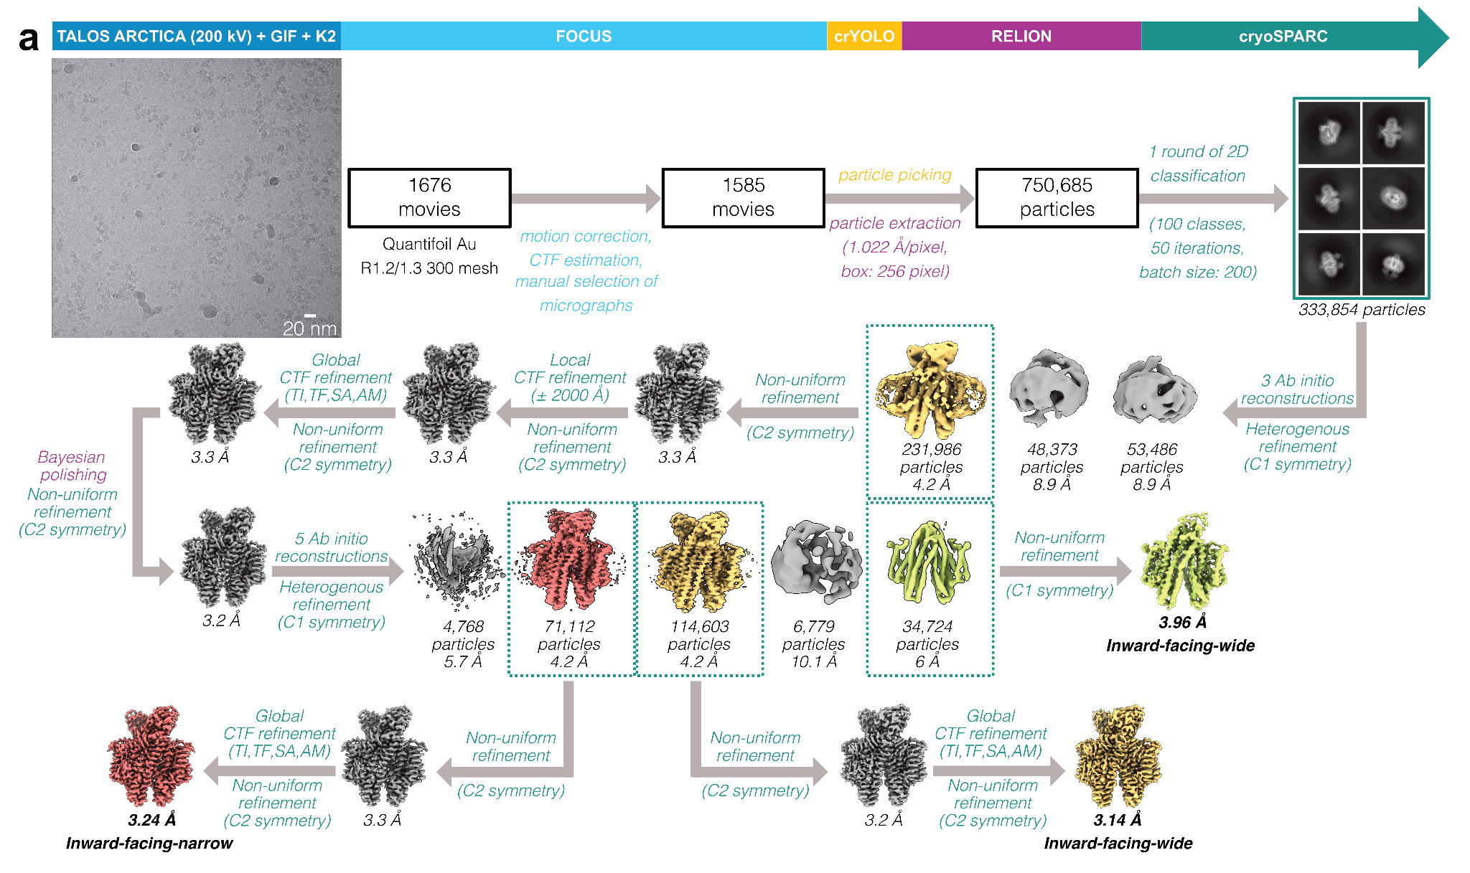

Supplementary Fig. 3 - Cryo-EM reconstructions of SbmA in the inward-facing-narrow and -wide conformations bound to Sy2. Detailed image processing workflow including a representative micrograph at a defocus of volume of -1.4 μm showing the particle distribution on a Quantifoil Au R1.2/1.3 300 mesh grid. Abbreviations correspond to the following: TI = Tilt, TF = Trefoil, SA = Spherical Aberration, AM = Anisotropic magnification.

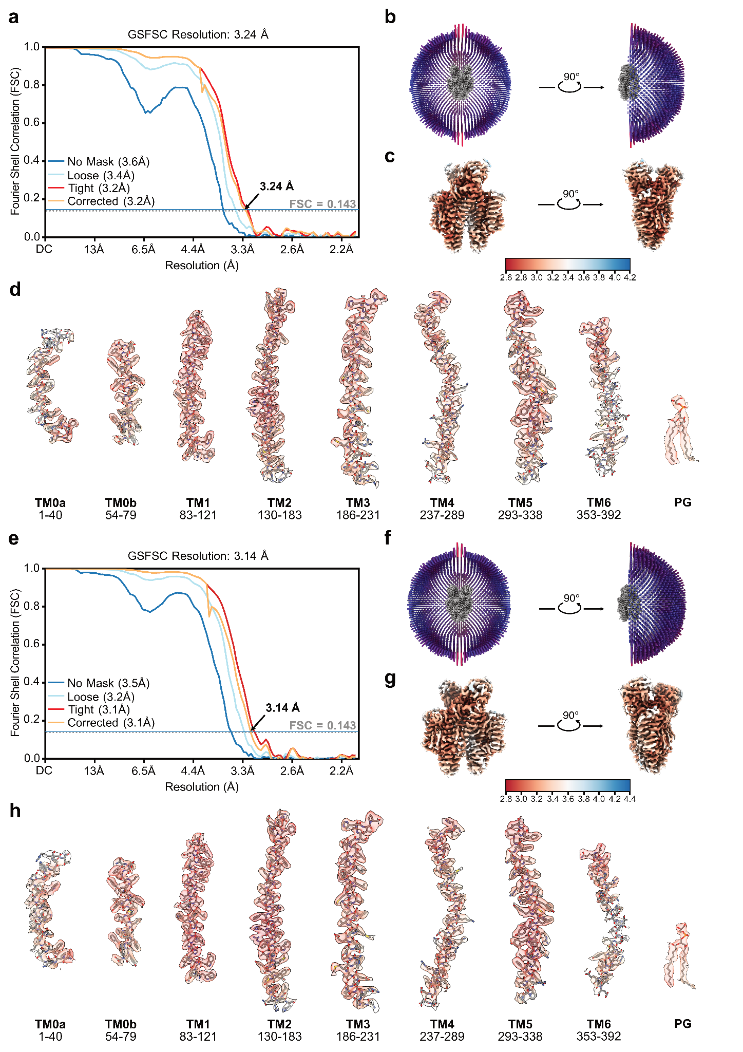

Supplementary Fig. 4 - Validation of SbmA in the inward-facing-narrow and -wide conformations bound to two Sy2. a,e, FSC plot of the final reconstruction with the arrow indicating the global resolution based on the threshold of FSC = 0.143 for SbmA in the (a) inward-facing-narrow and (e) -wide conformations. b,f, Angular distribution plot of particles included in the symmetric 3D reconstruction. The number of particles with their respective orientation is represented by the length and color of the cylinders. c,g, Final reconstructed map colored according to the local resolution estimated in cryoSPARC. d,h, Densities (semi-transparent surface renderings) for indicated residue ranges are shown in relation to the fitted atomic model (shown in stick representation). The surface renderings of the selected regions are colored according to the estimated local resolution.

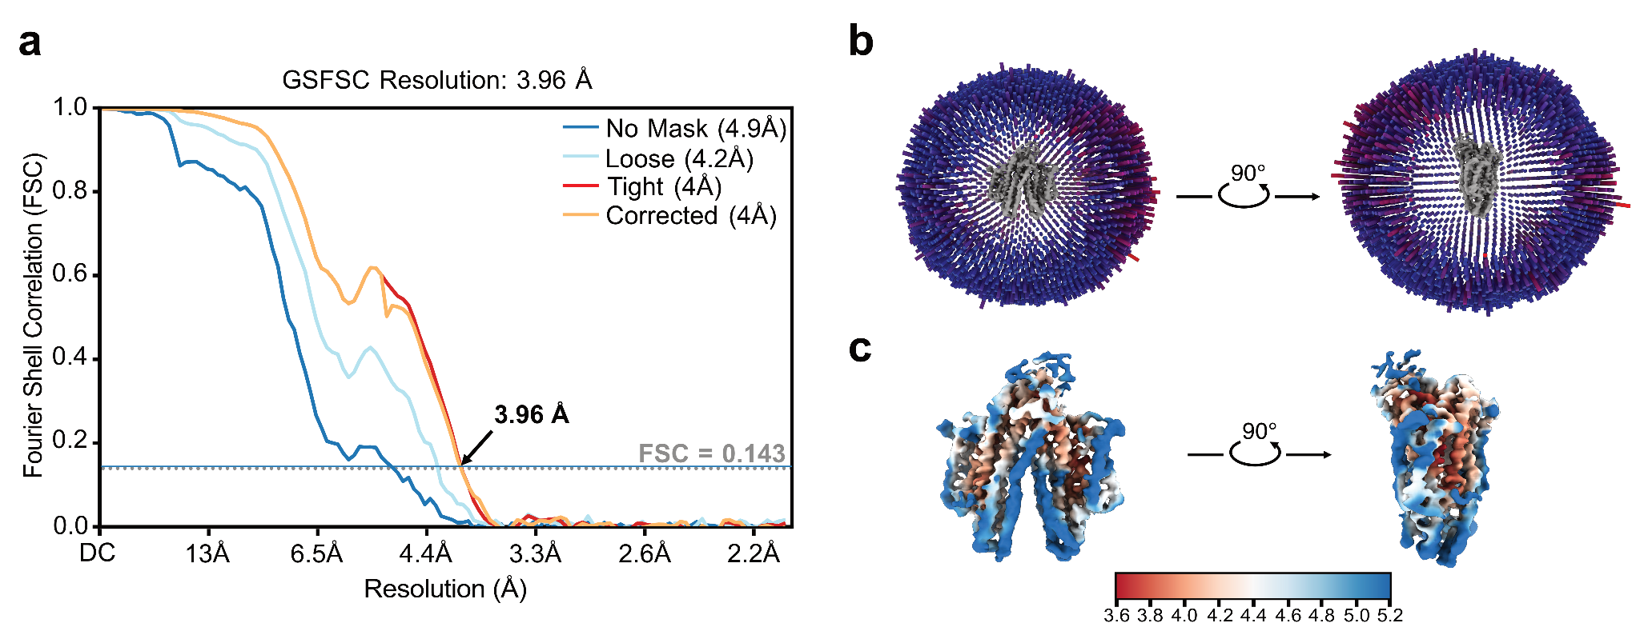

Supplementary Fig. 5 - Validation of SbmA in the inward-facing-narrow and -wide conformations bound to a single Sy2. a, FSC plot of the final reconstruction with the arrow indicating the global resolution based on the threshold of FSC = 0.143. b, Angular distribution plot of particles included in the asymmetric 3D reconstruction. The number of particles with their respective orientation is represented by the length and color of the cylinders. c, Final reconstructed map colored according to the local resolution estimated in cryoSPARC.

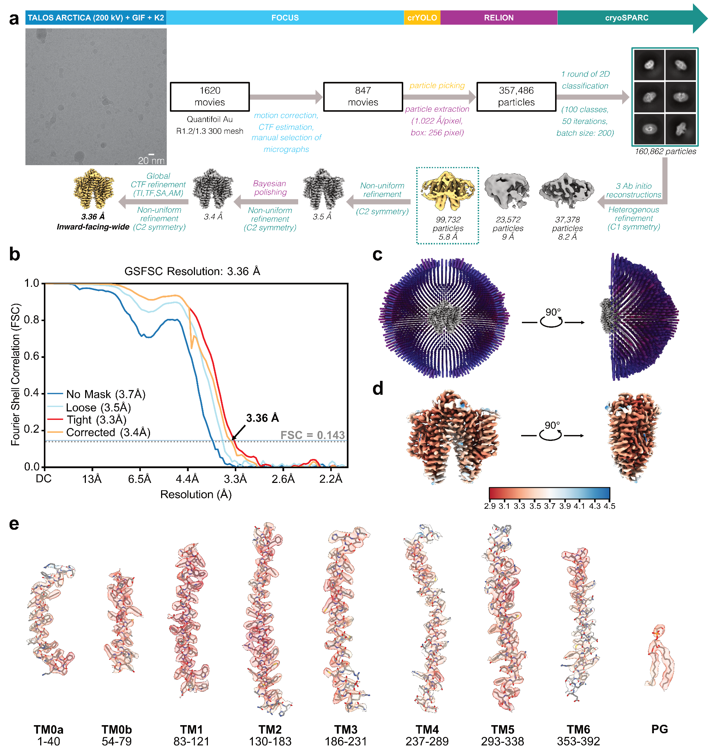

Supplementary Fig. 6 - Cryo-EM reconstruction and validation of SbmA in the inward-facing-wide conformation in detergent solution at high pH. a, Detailed image processing workflow including a representative micrograph at a defocus of volume of -1.4 μm showing the particle distribution on a Quantifoil Au R1.2/1.3 300 mesh grid. Abbreviations correspond to the following: TI = Tilt, TF = Trefoil, SA = Spherical Aberration, AM = Anisotropic magnification. b, FSC plot of the final reconstruction with the arrow indicating the global resolution based on the threshold of FSC = 0.143. b, Angular distribution plot of particles included in the symmetric 3D reconstruction. The number of particles with their respective orientation is represented by the length and color of the cylinders. d, Final reconstructed map colored according to the local resolution estimated in cryoSPARC. e, Densities (semi-transparent surface renderings) for indicated residue ranges are shown in relation to the fitted atomic model (shown in stick representation). The surface renderings of the selected regions are colored according to the estimated local resolution.

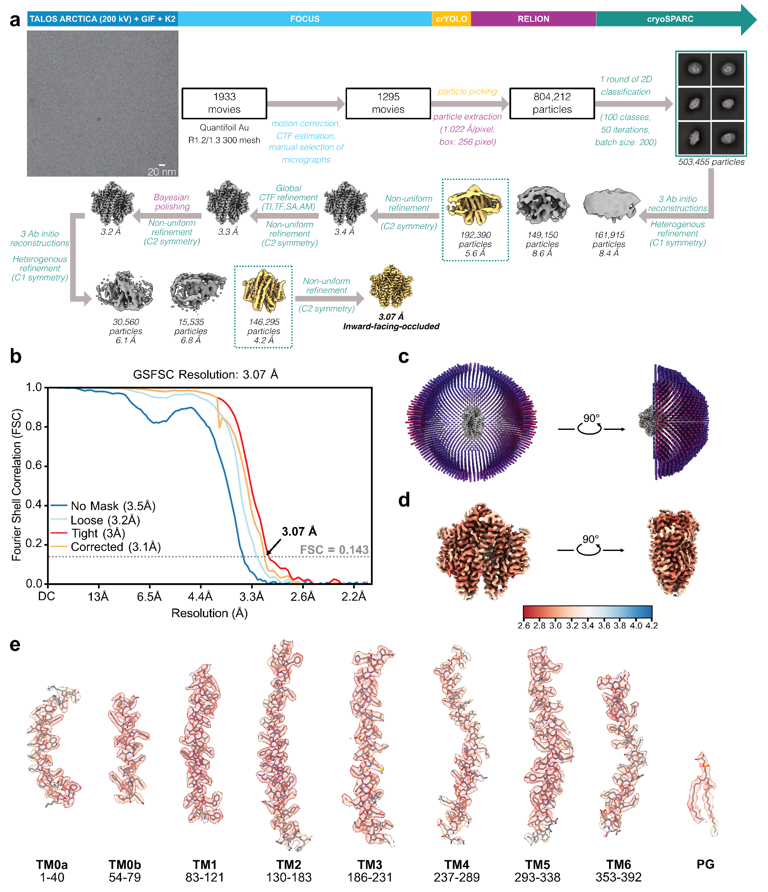

Supplementary Fig. 7 - Cryo-EM reconstruction and validation of SbmA in the inward-facing-occluded conformation in lipid nanodiscs at low pH. a, Detailed image processing workflow including a representative micrograph at a defocus of volume of -1.4 μm showing the particle distribution on a Quantifoil Au R1.2/1.3 300 mesh grid. b, FSC plot of the final reconstruction with the arrow indicating the global resolution based on the threshold of FSC = 0.143. b, Angular distribution plot of particles included in the symmetric 3D reconstruction. The number of particles with their respective orientation is represented by the length and color of the cylinders. d, Final reconstructed map colored according to the local resolution estimated in cryoSPARC. e, Densities (semi-transparent surface renderings) for indicated residue ranges are shown in relation to the fitted atomic model (shown in stick representation). The surface renderings of the selected regions are colored according to the estimated local resolution.
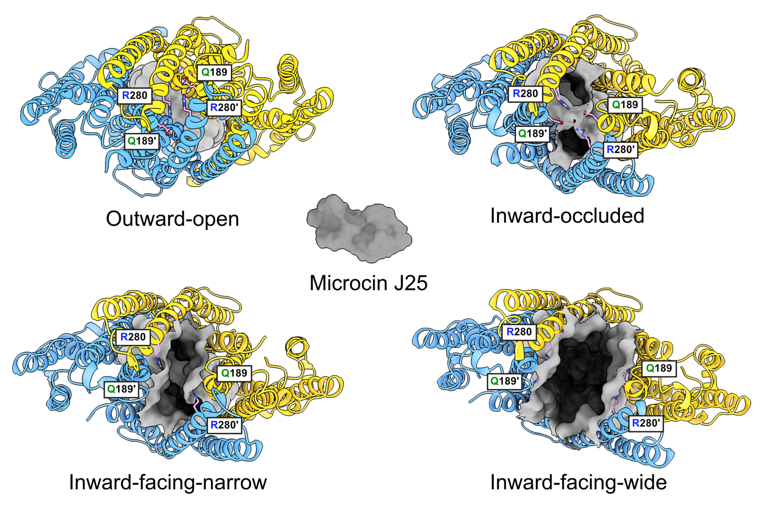

Supplementary Fig. 8 - Comparison of the opening of the internal cavity viewed from the cytoplasm between the outward-open, inward-occluded, inward-facing-narrow and inward-facing-wide (Table 1, identifiers A, B, C and G). Models are shown in cartoon representation and colored by chain, internal cavity is shown as gray surface. To compare the size of the opening to the size of a substrate of SbmA, a surface model of Microcin J25 (PDB 1pp5) has been included. The side chains of Q189, Q189’, R385 and R385’ are colored by atom with carbons highlighted in pink to show the initial point of contact for closure of the second internal cytoplasmic gate, which can be observed in the outward-occluded conformation.

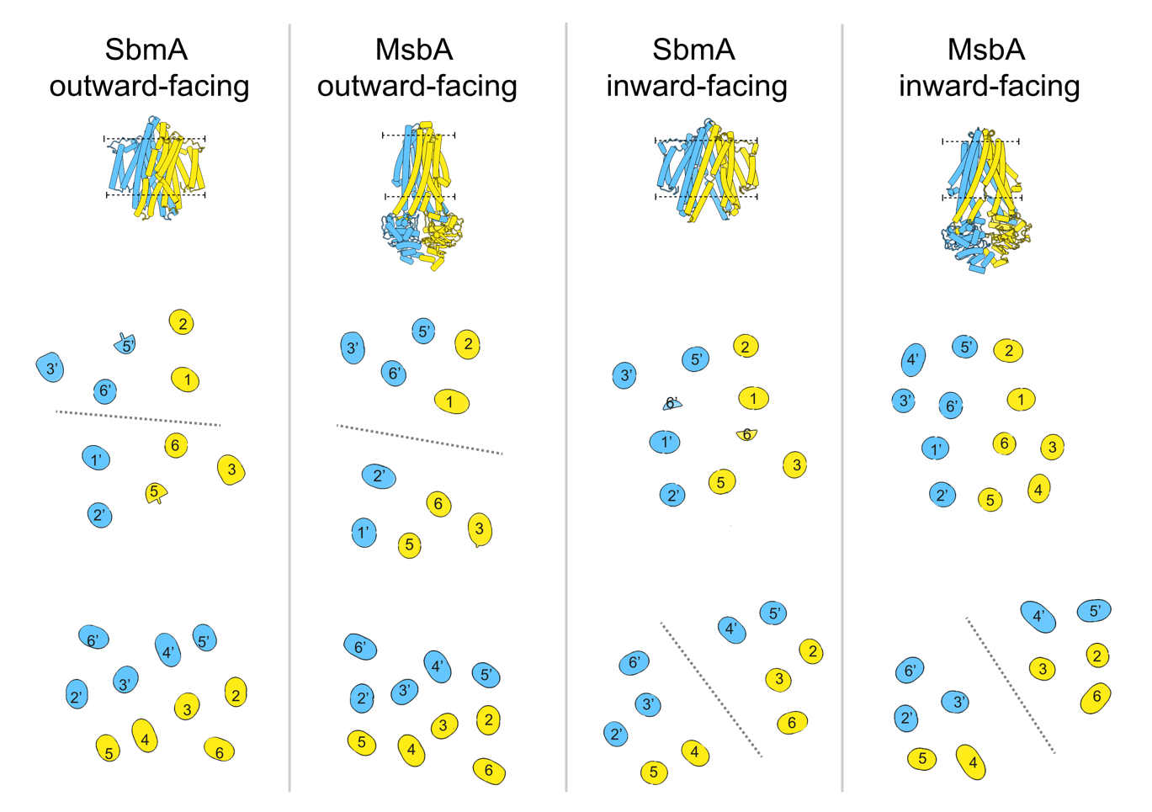
Supplementary Fig. 9 - TM movement between the outward-facing and inward-facing conformations of SbmA compared to the full-length ABC transporter MsbA (outward-facing SbmA – Table 1 identifier A, outward-facing MsbA - PDB 8tso, inward-facing SbmA - Table 1 identifier G, inward-facing MsbA – PDB 7mew). The top tube models, colored by chain, provide a side view from the membrane plane and the black dotted lines indicate the position of the slice-through images shown below. The gray dotted lines are included to illustrate the separation into two distinct domains that create the opening of the cavity.

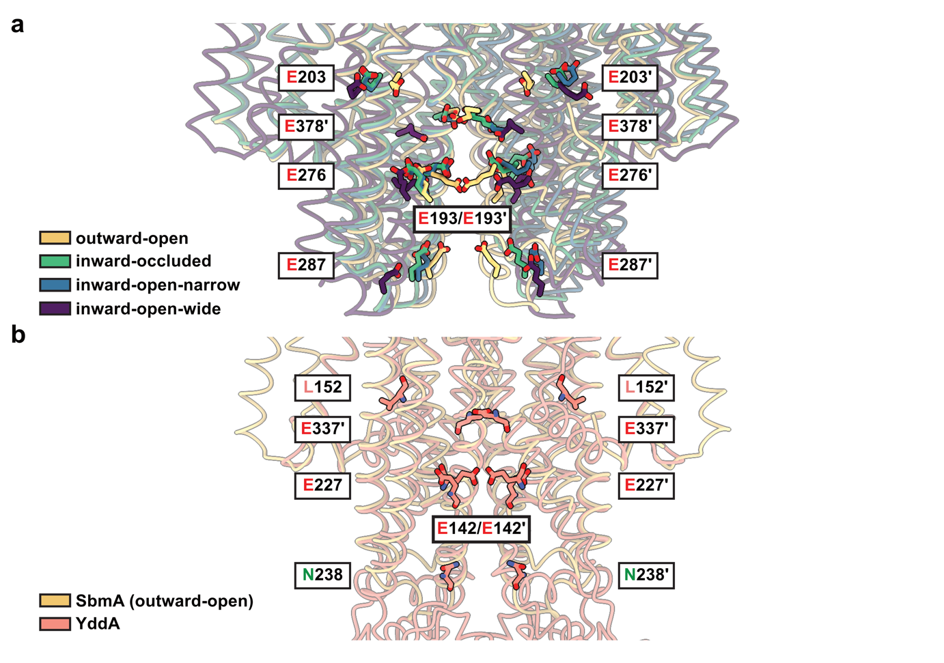
Supplementary Fig. 10 - Movement and conservation of the glutamate ladder. a, Movement of the glutamate ladder from the outward-open to the inward-open conformation. An overlay of SbmA in the different conformations (outward-open in gold, inward-occluded in green, inward-open-narrow in blue, inward-open-wide in purple) is shown in cartoon representation with the residues forming the glutamate ladder shown as sticks. b, Presence of the SbmA glutamate ladder in the E. coli type IV ABC transporter YddA. An overlay of SbmA in the outward-open (gold) and YddA (salmon) is shown with the equivalent residues of the SbmA glutamate ladder in YddA shown as sticks.

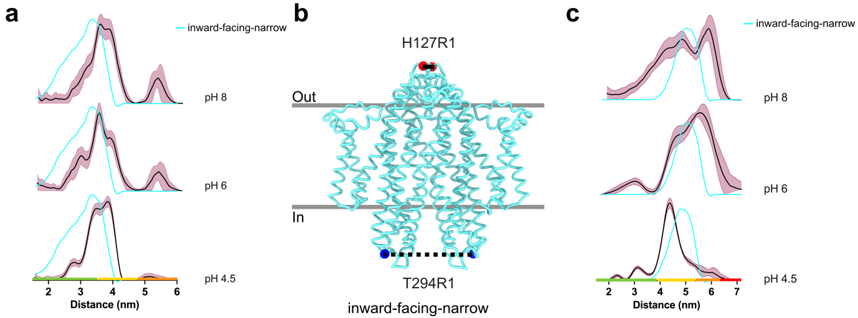
Supplementary Fig. 11 - Monitoring the entire conformational ensemble of SbmA in solution by EPR spectroscopy. a, Overlay between the predicted distance distributions of H127R1 from the cryo-EM structure of SbmA in the inward facing-narrow state (cyan line) and the DEER distance distributions (black line) for pH 8 (top), pH 6 (middle) and pH 4.5 (bottom). The maroon-shaded regions represent 2σ confidence intervals in the distribution and the colored bar above the x-axis represents the DeerAnalysis ¹ ‘traffic light’ system for assessing the reliability of the distribution presented. For the time window of this dataset, the distances within the regions highlighted in green and yellow indicate the reliability of the mean distance, peak shape, and width. In silico distance predictions were performed using MMM ². The data were processed in DeerAnalysis, with validation in the same way as described in the methods. b, Structure of the SbmA dimer in the inward-facing-narrow (cyan cartoon) conformation. The sites mutated to Cys and labelled with MTSSL to enable the DEER distance measurements are shown by blue spheres for T294R1 (cytoplasmic, bottom) and red spheres for H127R1 (periplasmic, bottom) side of the membrane. c, Overlay between the predicted distance distributions for T294R1 from the cryo-EM structure in the inward facing-narrow (cyan line) and the DEER distance distributions (black line), for pH 8 (top), pH 6 (middle) and pH 4.5 (bottom).

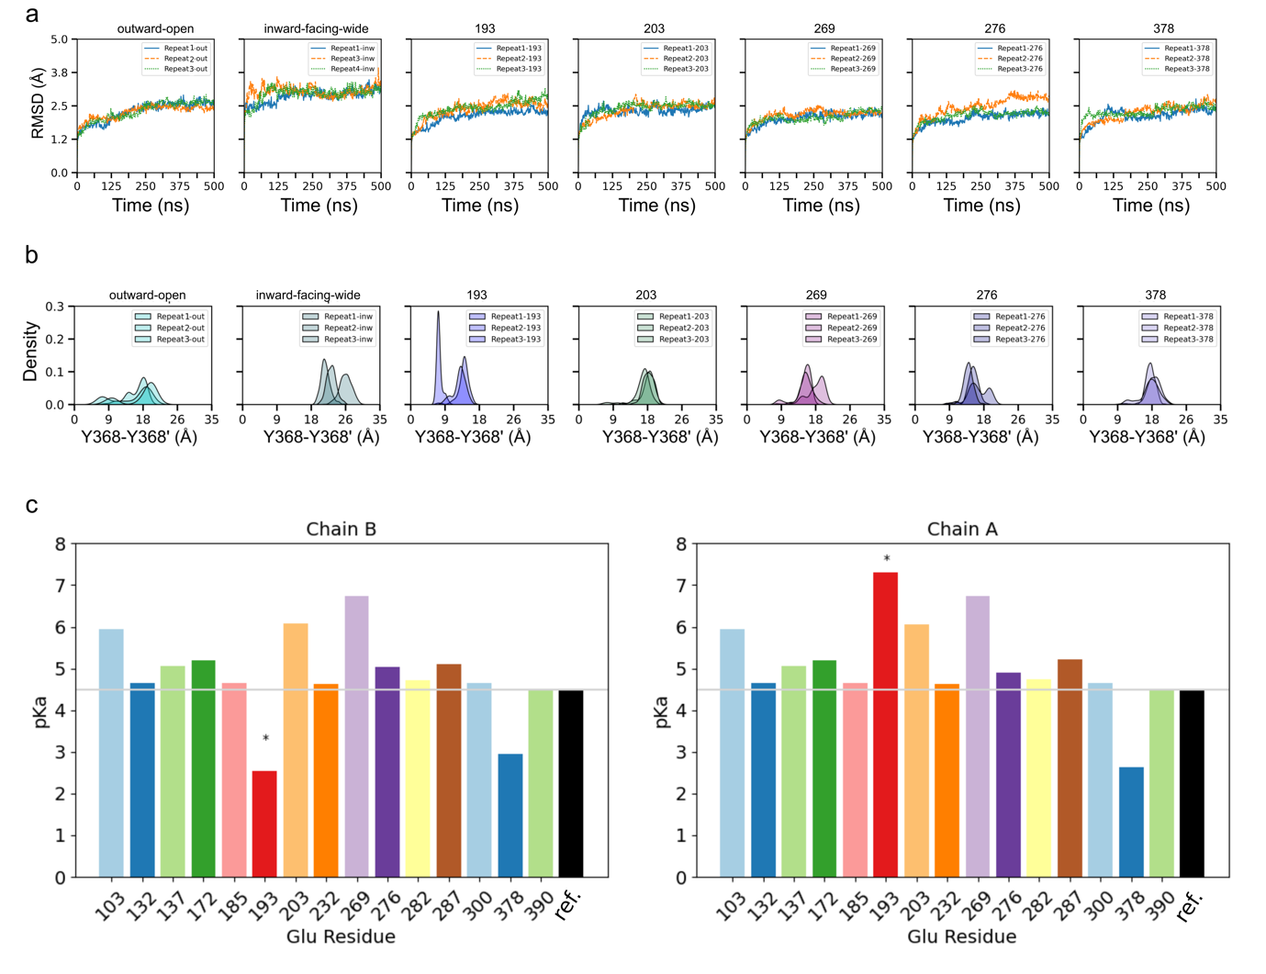

Supplementary Fig. 12 - Root mean square deviation (RMSD), central gate distance distribution, and pKa glutamate prediction. a, Root mean square deviation (RMSD) of the Cα atoms of SbmA fitted to Cα atoms of each repeat (Repeat1, Repeat2, and Repeat3) of all systems simulated: outward-open, inward-open, and outward-open in different protonation states (193, 203, 269, 276, 378). b, Distance distribution of the central gate of SbmA of the Cα atoms of the residue pair (Y368-Y368’) for different protonation states. c, pKa values of the glutamate residues of each individual chain of SbmA (Chain A and Chain B) predicted using PROPKA version 3.4.0 ^{3,4}. The asterisk indicates that the glutamate residue at position 193 is coupled i.e. the protonation of one of them will affect the protonation state of the other.

Supplementary Table 1 – Data collection, processing and refinement statistics of the 300 kV cryo-EM structures

 | SbmA-Fab (1x) inward-facing-wide  in lipid nanodiscs  (EMD-51036, PDB 9g4e, EMPIAR 12192) | SbmA-Fab (1x) inward-facing-narrow  in lipid nanodiscs  (EMD-51037, PDB 9g4f, EMPIAR 12192)
Data collection and processing
Microscope | Thermo Fisher Krios G3i
Energy filter | Gatan GIF BioQuantum K3
Detector | Gatan K3
Camera mode | counting mode
Voltage (kV) | 300
Nominal magnification | 105,000x
Pixel size (Å) | 0.86
Exposure navigation | Beam-image shift (AFIS)
Number of frames | 40
Total electron exposure (e⁻/Å²) | 42.39
Defocus range (µm) | -0.9 to -2.7
Data collection software | EPU 2.10.0.5REL
Micrographs collected | 6069 | 6069
Micrographs used | 5901 | 5901
Total number of extracted particles | 1,294,264 | 1,294,264
Final number of particles | 56,582 | 50,775
Symmetry imposed | C1 | C1
Global map resolution (Å) | 3.44 | 3.58
Map resolution range (Å) | ~3.0 – ~5.0 | ~3.2 – ~5.5
FSC threshold | 0.143 | 0.143
Refinement
Initial model used | Ab-initio | Ab-initio
Model resolution | 3.66 | 3.79
FSC threshold | 0.5 | 0.5
Map sharpening B-factor (Å²) | - | -
Model composition
Chains | 4 | 4
Non-hydrogen atoms | 9660 | 9660
Protein residues | 1215 | 1215
Water | - | -
Ligands | - | -
B factors (Å²)
Protein (min/max/mean)  Ligand (min/max/mean) | 2.71/103.36/41.58  - | 20.15/159.51/72.29  -
R.m.s. deviation
Bond lengths (Å) | 0.007 | 0.012
Bond angles (°) | 0.761 | 0.945
Validation
Molprobity score | 1.72 | 1.93
Clashscore | 5.77 | 7.75
Ramachandran plot
Favoured (%) | 94.03 | 91.30
Allowed (%) | 5.97 | 8.70
Outliers (%) | 0 | 0
Rotamer outliers (%)  Rama-Z | 0 | 0
Whole | -0.27 (0.24) (N = 1207) | -1.02 (0.24) (N = 1207)
Helix | 0.89 (0.20) (N = 658) | 0.23 (0.20) (N = 635)
Sheet | -0.12 (0.36) (N = 221) | -0.36 (0.39) (N = 187)
Loop | -2.39 (0.30) (N = 328) | -2.31 (0.30) (N = 385)

Supplementary Table 2 – Data collection, processing and refinement statistics of the 200 kV cryo-EM structures

 | SbmA-Sb2 (2x) inward-facing-narrow  in detergent micelles  (EMD-50994, PDB 9g3d, EMPIAR XXXXX) | SbmA-Sb2 (2x) inward-facing-wide  in detergent micelles  (EMD-50996, PDB 9g3e, EMPIAR XXXXX) |  | SbmA-Sb2 (1x) inward-facing-wide  in detergent micelles  (EMD-50995, EMPIAR XXXXX) |  | SbmA inward-facing-wide  in detergent micelles  (EMD-50997, PDB 9g3f, EMPIAR XXXXX) |  | SbmA inward-facing-occluded  in lipid nanodiscs  (EMD-50998, PDB 9g3g, EMPIAR XXXXX)
Data collection and processing
Microscope | Thermo Fisher Talos Arctica
Energy filter | Gatan GIF BioQuantum K2
Detector | Gatan K2 Summit
Camera mode | counting mode
Voltage (kV) | 200
Nominal magnification | 130,000x
Pixel size (Å) | 1.022
Exposure navigation | Beam-image shift with a 3 x 3 pattern (Serial EM)
Number of frames | 60
Total electron exposure (e⁻/Å²) | 50.1
Defocus range (µm) | -0.5 to -2.0
Data collection software | Serial EM v3.9.0 beta
Micrographs collected | 1676 |  | 1676 |  | 1676 |  | 1620 | 1933
Micrographs used | 1585 |  | 1585 |  | 1585 |  | 874 | 1295
Total number of extracted particles | 750,685 |  | 750,685 |  | 750,685 |  | 357,486 | 804,212
Final number of particles | 71,122 |  | 114,603 |  | 34,724 |  | 99,732 | 146,295
Symmetry imposed | C2 |  | C2 |  | C1 |  | C2 | C2
Global map resolution (Å)* | 3.24 |  | 3.14 |  | 3.96 |  | 3.36 | 3.07
Map resolution range (Å) | ~2.6 – ~4.2 |  | ~2.8 – ~4.4 |  | ~3.6 – ~5.2 |  | ~2.9 to ~3.5 | ~2.6 to ~4.2
FSC threshold | 0.143 |  | 0.143 |  | 0.143 |  | 0.143 | 0.143
Refinement
Initial model used | Ab-initio (Model Angelo) |  | Ab-initio (Model Angelo) |  | - |  | Ab-initio (Model Angelo) | Ab-initio (Model Angelo)
Model resolution | 3.4 |  | 3.4 |  | - |  | 3.5 | 3.1
FSC threshold | 0.5 |  | 0.5 |  | - |  | 0.5 | 0.5
Map sharpening B-factor (Å²) | -104.6 |  | -107.4 |  | - |  | -117.4 | -117.4
Model composition |  |  |  |  | -
Chains | 4 |  | 4 |  | - |  | 2 | 2
Non-hydrogen atoms | 8210 |  | 8255 |  | - |  | 6419 | 6482
Protein residues | 1010 |  | 1015 |  | - |  | 778 | 784
Water | - |  | - |  | - |  | - | -
Ligands
PGT | 2 |  | 2 |  | - |  | 2 | 2
B factors (Å²)
Protein (min/max/mean)  Ligand (min/max/mean) | 2.79/132.31/54.04  44.48/72.00/52.13 |  | 0.00/120.12/40.93  23.76/76.60/39.52 |  | -  - |  | 1.32/117.55/50.97  42.97/79.05/53.18 | 0.00/73.49/25.74  8.63/37.59/24.13
R.m.s. deviation
Bond lengths (Å) | 0.003 |  | 0.003 |  | - |  | 0.003 | 0.002
Bond angles (°) | 0.490 |  | 0.529 |  | - |  | 0.541 | 0.405
Validation
Molprobity score | 1.78 |  | 1.55 |  | - |  | 1.46 | 1.19
Clashscore | 7.57 |  | 5.59 |  | - |  | 5.12 | 3.92
Ramachandran plot
Favoured (%) | 94.61 |  | 96.33 |  | - |  | 96.90 | 97.95
Allowed (%) | 5.39 |  | 3.67 |  | - |  | 3.10 | 2.05
Outliers (%) | 0 |  | 0 |  | - |  | 0 | 0
Rotamer outliers (%)  Rama-Z | 0 |  | 0 |  | - |  | 0 | 0
Whole | 0.87 (0.27) (N = 1002) |  | 1.19 (0.26) (N = 1007) |  | - |  | -1.83 (0.28) (N= 774) | 1.58 (0.28) (N= 780)
Helix | 1.50 (0.20 (N = 653) |  | 1.80 (0.19) (N = 666) |  | - |  | -0.92 (0.19) (N = 626) | 1.49 (0.19) (N = 651)
Sheet | -0.44 (0.52) (N = 98) |  | -0.53 (0.50) (N = 15) |  | - |  | - | -
Loop | -1.40 (0.39) (N = 251) |  | -1.51 (0.38) (N = 236) |  | - |  | -1.71 (0.48) (N = 148) | -1.07 (0.49) (N = 129)

Supplementary references

1. Jeschke, G. et al. DeerAnalysis2006—a comprehensive software package for analyzing pulsed ELDOR data. Appl. Magn. Reson. 30, 473–498 (2006).
2. Jeschke, G. MMM: A toolbox for integrative structure modeling. Protein Sci. 27, 76–85 (2018).
3. Olsson, M. H. M., Søndergaard, C. R., Rostkowski, M. & Jensen, J. H. PROPKA3: Consistent Treatment of Internal and Surface Residues in Empirical p K _{a} Predictions. J. Chem. Theory Comput. 7, 525–537 (2011).
4. Søndergaard, C. R., Olsson, M. H. M., Rostkowski, M. & Jensen, J. H. Improved Treatment of Ligands and Coupling Effects in Empirical Calculation and Rationalization of p K _{a} Values. J. Chem. Theory Comput. 7, 2284–2295 (2011).

