Supplementary information

Combined immune-peptide nanofiber with HSP70/AKT/mTOR axis blockade enhances near-infrared photoimmunotherapy, inhibiting tumor growth and recurrence

Xinyu Zhang^{a, b, #}, Zhenqi Jiang^{c, #,} *, Wenjia Zhang^{d, #}, Juncheng Wu^{a, b}, Haozhuo Guo^{e, b}, Changlei Li^{b}, Mingwei Sun^{b}, Xiaoying Tang^{c}, Wei Huang^{f,} *, Huadan Xue^{a,} *, Yang Du^{b, g,} *

- Department of Radiology, State Key Laboratory of Complex Severe and Rare Diseases, Peking Union Medical College Hospital, Peking Union Medical College and Chinese Academy of Medical Sciences, No. 1 Shuaifuyuan, Dongcheng District, Beijing, 100730, China
- CAS Key Laboratory of Molecular Imaging, Beijing Key Laboratory of Molecular Imaging, Institute of Automation, Chinese Academy of Sciences, Beijing, 100190, China
- School of Medical Technology, Beijing Institute of Technology Zhengzhou Academy of Intelligent Technology, Beijing Institute of Technology, No. 5 South Zhongguancun Street, Haidian District, Beijing, 100081, China
- Department of Radiology, Peking University People's Hospital, No. 11 Xizhimen Nandajie, Xicheng District, Beijing, 100044, China
- Department of Interventional Radiology, Shengjing Hospital of China Medical University, Shenyang, Liaoning, 110004, China
- Department of Radiation Oncology, Shandong Cancer Hospital and Institute, Shandong First Medical University, Shandong Academy of Medical Sciences, Jinan, China.
- University of Chinese Academy of Sciences, Beijing, 100080, China

# These authors contributed equally: Xinyu Zhang, Zhenqi Jiang, Wenjia Zhang
* Correspondence and reprint request:
Zhenqi Jiang, Ph.D., No. 5 South Zhongguancun Street, Haidian District, Beijing, 100081, China. Email: jiangzhenqi@bit.edu.cn
Wei Huang, M.D., No. 440 Jiyan Road, Jinan City, Shandong Province, 250117, China, Email: alvinbird@163.com
Huadan Xue, M.D., No. 1 Shuaifuyuan, Dong Cheng District, Beijing, 100730, China. Email: bjdanna95@163.com
Yang Du, Ph.D., No.95 Zhongguancun East Road, Haidian District, Beijing, 100190, China. Email: yang.du@ia.ac.cn

Supplementary Methods

Synthesis of IR-CF₃
IR-CF₃ was synthesized through a two-step reaction. Specifically, the 1,1,2-Trimethyl-1H-benzo[e]indole (9.8 g) and 4-(Trifluoromethyl) Benzyl Bromide (12.3 g) were dissolved in 40 ml o-dichlorobenzene and stirred under 120 °C for 30 min. The solid crude product was then filtered and recrystallized in methanol. The purified product 1 (10.06 g, 62%) was dried under vacuum. 80 mL DMF/dichloromethane mixture (1/1, v/v) was added dropwise into a solution of phosphoryl chloride (37 mL) and anhydrous dichloromethane (35 ml) under stirring at 0 °C. Afterwards, 10 g cyclohexanone was added dropwise, and the solution was then heated and refluxed for 3 h. The mixture was poured onto ice, yielding a solid product which was collected by filtration and washed with iced diethyl ether. The resulting yellow product (2-chloro-3-(hydroxymethylidene) cyclohexene-1-carbaldehyde, product 1) was used directly. After that, product 1 (1.32 g), 2-chloro-3-(hydroxymethylidene) cyclohexene-1-carbaldehyde (0.34 g) and sodium acetate (1.65 g, 19.8 mmol) were mixed in 260 ml methanol, and stirred for 1 h at 60 °C under N₂. The solvent was removed by rotary evaporation, and the crude product (product 2) was purified by dissolving in DMF and precipitating in diethyl ether. After filtration, the end-product, IR-CF₃ (0.984 g, 64%), was dried under vacuum. 1H NMR (600 MHz, Methanol-d4) δ 8.52 (d, J = 14.1 Hz, 1H), 8.32 (d, J = 8.5 Hz, 2H), 8.00 (d, J = 8.8 Hz, 3H), 7.69 (dt, J = 23.6, 8.3 Hz, 6H), 7.57 (t, J = 9.8 Hz, 3H), 7.54–7.49 (m, 5H), 7.44 (d, J = 8.1 Hz, 1H), 6.30 (d, J = 14.1 Hz, 1H), 5.67 (s, 3H), 4.10 (q, J = 7.1 Hz, 1H), 2.56 (t, J = 6.1 Hz, 3H), 2.09 (s, 9H), 1.99 (d, J = 17.9 Hz, 3H), 1.89–1.80 (m, 2H), 1.69 (s, 2H), 1.24 (t, J = 7.1 Hz, 2H)

Western blotting (WB)
The cells were lysed using lysis buffer containing a protease inhibitor cocktail. The extracts from cells or tissues were denatured and analyzed using sodium dodecyl sulfate polyacrylamide gel electrophoresis (SDS-PAGE). Then the protein was separated on SDS-PAGE gels and transferred to poly (vinylidene difluoride) (PVDF) membranes. The blots were blocked with 5% nonfat dry milk in tris buffered saline with Tween 20 (TBST). Next, they were exposed to primary antibodies. Signals were detected using horseradish peroxidase (HRP)-conjugated secondary antibodies and the enhanced chemiluminescence (ECL) detection method.

Characterization of PSP@IR-CF₃ NFs
TEM and high-resolution TEM (HR-TEM) images were taken on a FEI Talos F200X G2 (Thermo Fisher, U.S.). Ultraviolet-visible (UV-Vis) absorption spectra were acquired using a UV-vis spectrophotometer (Lambda 950, Perkin Elmer, U.S.). AFM images were taken on a Dimension XR Fast Scan (Bruker, Germany). The DLS and zeta potential were measured at room temperature using a particle size analyzer (Nano-ZS, Malvern, England). Circular dichroism was measured by Chirascan VX (Applied Photophysics, England).

Molecular dynamics experimental procedure
According to the molar ratios, we used Packmol software to construct the box containing four peptide molecules and two ligand molecules. The system was placed in a cubic box using the gmx editconf command. All MD simulations were executed using GROMACS 2018.4 software, with the Amber99SB force field and SPCE water model.
First, the system was positioned at the center of a cubic box with a side length of 7 nm and randomly filled with water molecules. Appropriate ions replaced some water molecules to ensure the electroneutrality of the system. Energy minimization was then performed using the steepest descent method to optimize the system to its lowest energy state. Subsequently, constrained MD simulations were conducted with ensembles having a constant number of particles, volume, and temperature (NVT) and a constant number of particles, pressure, and temperature (NPT) to equilibrate the system. These steps primarily aim to optimize the interactions between the molecules, solvents, and ions, thereby achieving an optimal simulation system.
The Verlet leapfrog algorithm was used to solve Newton’s equations of motion, with a time step of 2 fs. The Lennard–Jones function was used to calculate the van der Waals forces with a non-bonded cutoff distance of 1.2 nm. The LINCS algorithm constrained all atomic bond lengths, whereas the long-range electrostatic interactions were computed using the particle mesh Ewald method with a grid spacing of 0.16 nm. Periodic boundary conditions were applied in the simulations.
All MD simulations were conducted in an NPT ensemble at 300 K and 1 atm, controlled using the V-rescale and Parrinello–Rahman methods, respectively. The temperature and pressure coupling constants were set to 0.1 and 0.5 ps, respectively. The molecular dynamics simulation lasted for 100 ns.

Photothermal properties of PSP@IR-CF₃ NFs
To investigate the photothermal properties of IR-CF₃, PSP@IR-CF₃ was dissolved in ddH₂O at 50 μg/mL and irradiated with 1.0 W/cm² 808 nm laser power for 10 min. To investigate the relationship between the photothermal effects and the NFs concentration, 0, 10, 25, 50, and 100 μg/mL IR-CF₃ and PSP@IR-CF₃ were irradiated with 1.0 W/cm² for 10 min. To investigate the relationship between the photothermal effects and laser power, 50 μg/mL IR-CF₃ and PSP@IR-CF₃ were irradiated with 0.5, 1.0, 1.5, and 2.0 W/cm² for 10 min. Three individual measurements were performed for each sample, and the mean was calculated.

Evaluation of in vitro targeting specificity
CT26 cells were seeded (approximately 1 × 10⁵ cells/well) in 20 mm glass-bottom dishes for 24 h. Afterwards, aPD-L1 was added to the medium of the blocking groups to a final concentration of 0.3 mg/mL, then the medium of all groups was replaced with 2 mL fresh medium containing 100 μg/mL PSP@IR-CF₃/IR-808 or IR-808. After 4 h, the cells were washed with cold PBS, fixed with 4% paraformaldehyde, and stained with DAPI (Solarbio, Beijing, China). The samples were protected from light throughout this process. Images were obtained using a confocal laser-scanning microscope (LSM780; Carl Zeiss, Jena, Germany).

In vitro cell viability of different groups
CT26 cells were seeded (approximately 2,000 cells/well) in 96-well plates, and
incubated with various concentrations of PSP@IR-CF₃ NFs or IR-CF₃ NFs for 24 h. Then, the cells were subjected with or without laser irradiation for 10 min and subsequently treated with 20 μL of CCK-8 solution per well for 2 h. Optical density values were analyzed at 450 nm. Then the quantitative values were measured by a microplate reader (Synergy HT Multi-Mode Microplate Reader, Biotek, Winooski, VT, USA).

Safety assessment
Serum and tissue samples were collected after treatment and observation. ALT, AST, and BUN levels were measured with the Automated Chemistry Analyzer (Rayto, Shenzhen, China) following the provided instructions. Histopathological analysis was performed on the heart, liver, spleen, lungs, kidneys, and skin, which were gathered and stained with hematoxylin and eosin.

Supplementary Figures and Tables

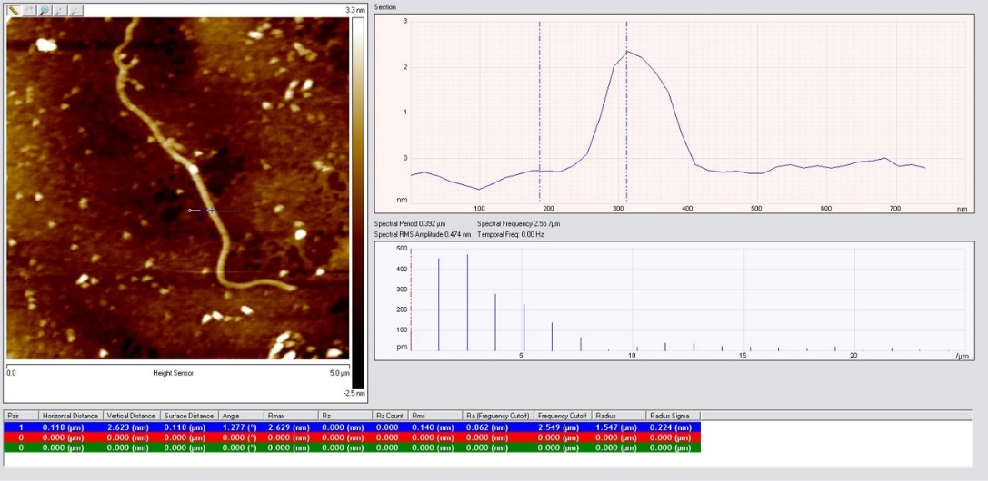
Supplementary Fig. 1 AFM of PSP@IR-CF_{3.}

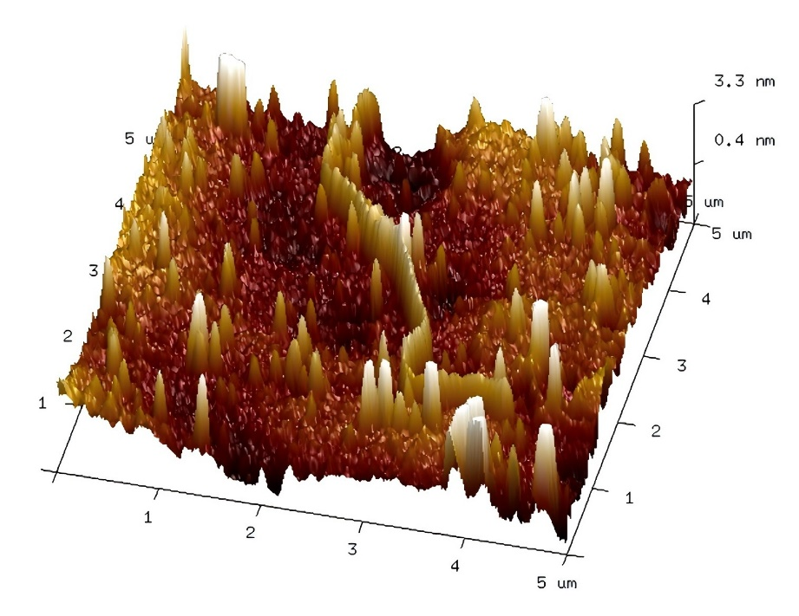
Supplementary Fig. 2 3D AFM of PSP@IR-CF_{3.}

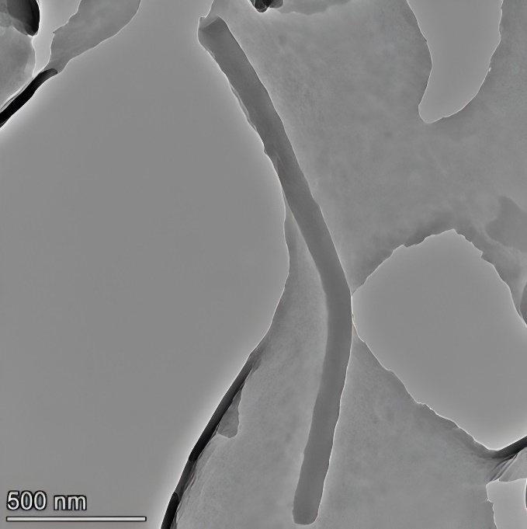
Supplementary Fig. 3 TEM of PSP@IR-CF_{3.}

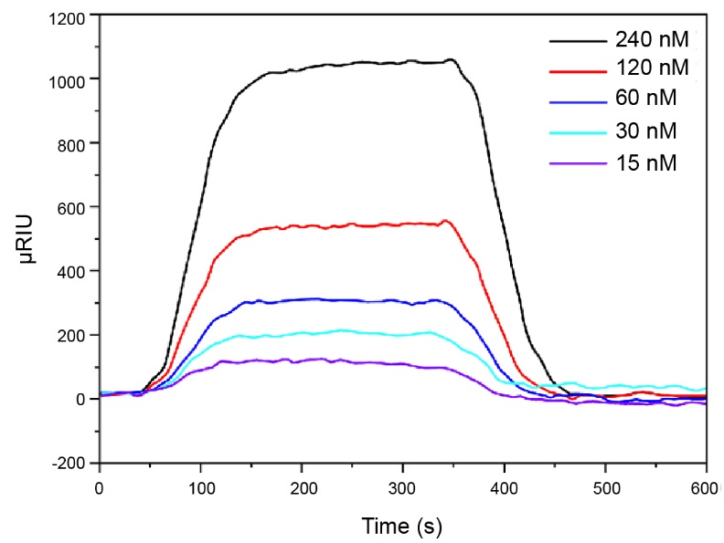
Supplementary Fig. 4 The interaction between the nanofibers and PD-L1 protein.

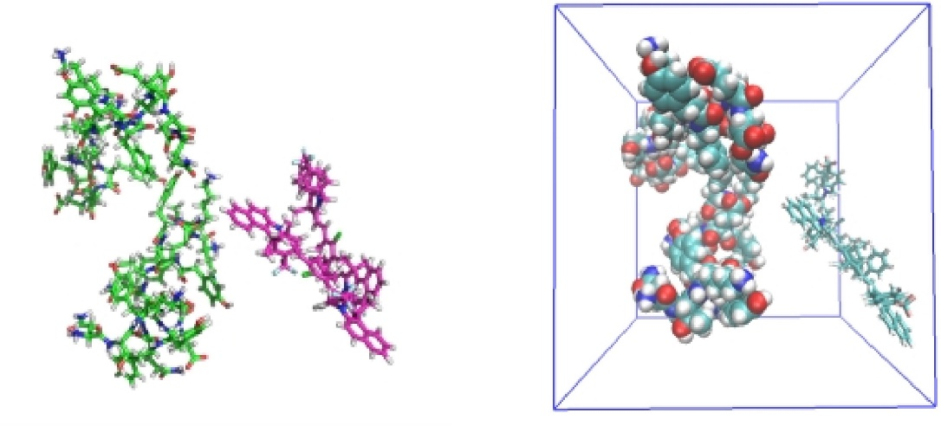
Supplementary Fig. 5 Construction of PSP@IR-CF₃ systems.

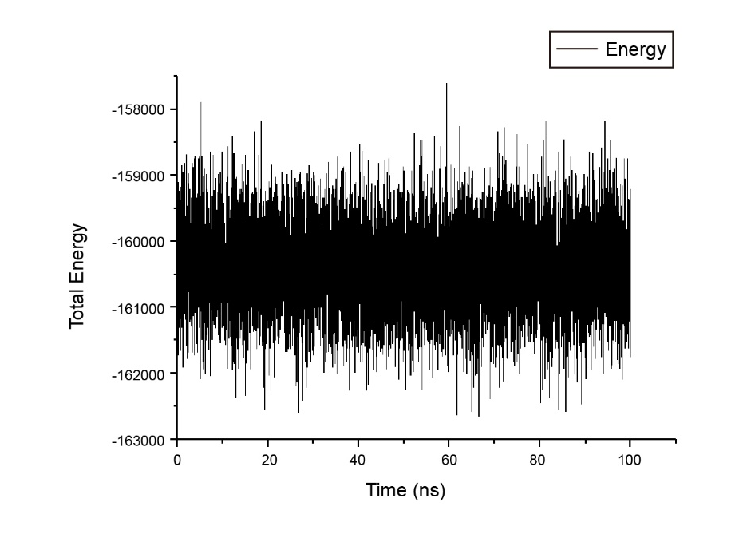
Supplementary Fig. 6 Energy analysis of dynamic processes.

Supplementary Table 1 Overview of interaction forces, including van der Waals energy, electrostatic energy, polar solvation energy, SASA energy, and binding energy.

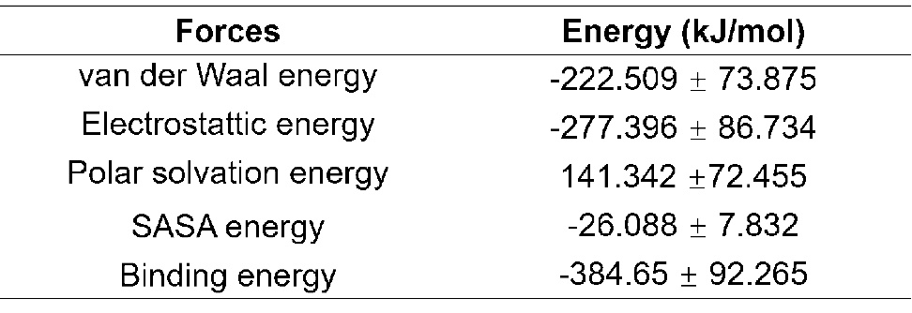

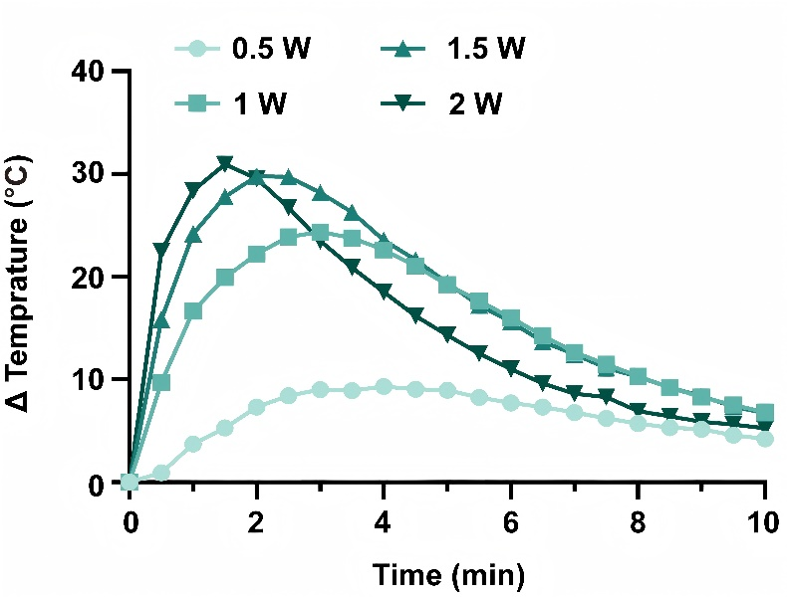
Supplementary Fig. 7 Monitoring temperature changes of PSP@IR-CF₃ under varying laser power irradiation.

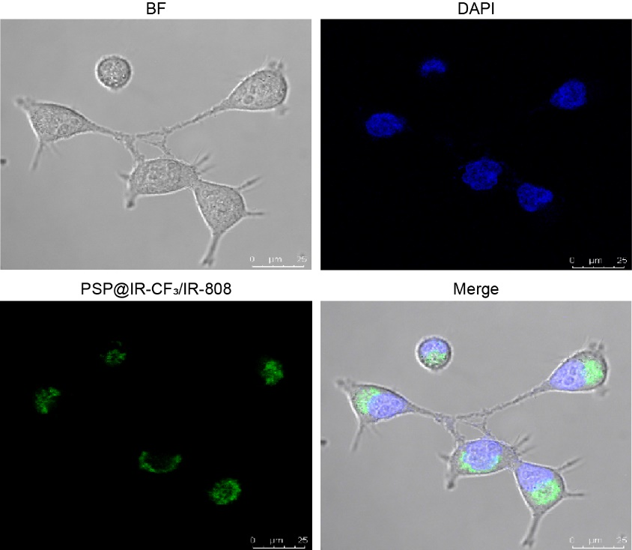
Supplementary Fig. 8 Colocalization of PSP@IR-CF₃ with CT26 cells by immunofluorescence staining. BF: Bright field microscopy.

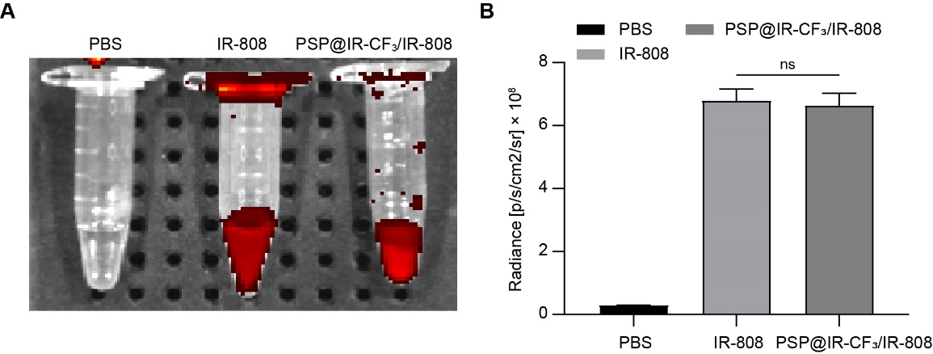
Supplementary Fig. 9 Fluorescence imaging and fluorescence intensity of PBS, IR-808, and PSP@IR-CF₃/IR-808. (a) Fluorescence imaging of PBS, IR-808, and PSP@IR-CF₃/IR-808. (b) Statistical analysis of fluorescence intensity.

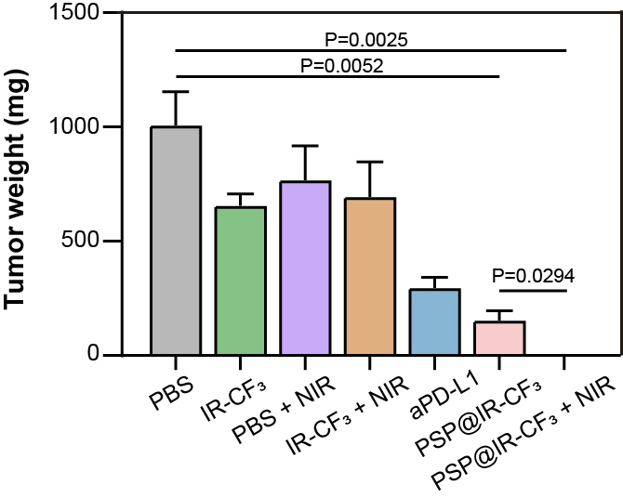
Supplementary Fig. 10 Tumor weights of mice in each group after different treatments (n=5).

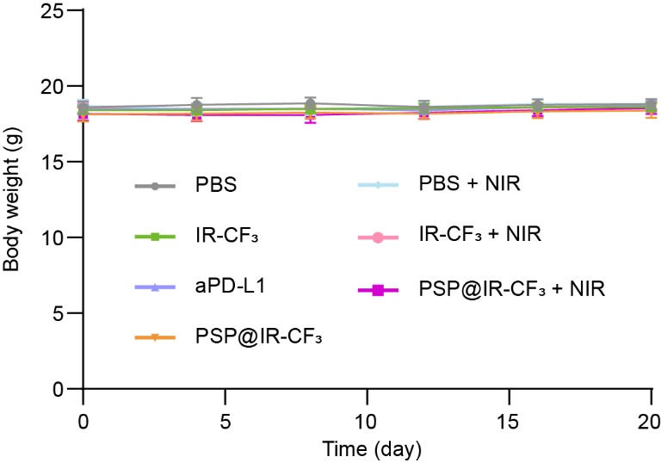
Supplementary Fig. 11 Body weights of mice in each group after different treatments (n=5).

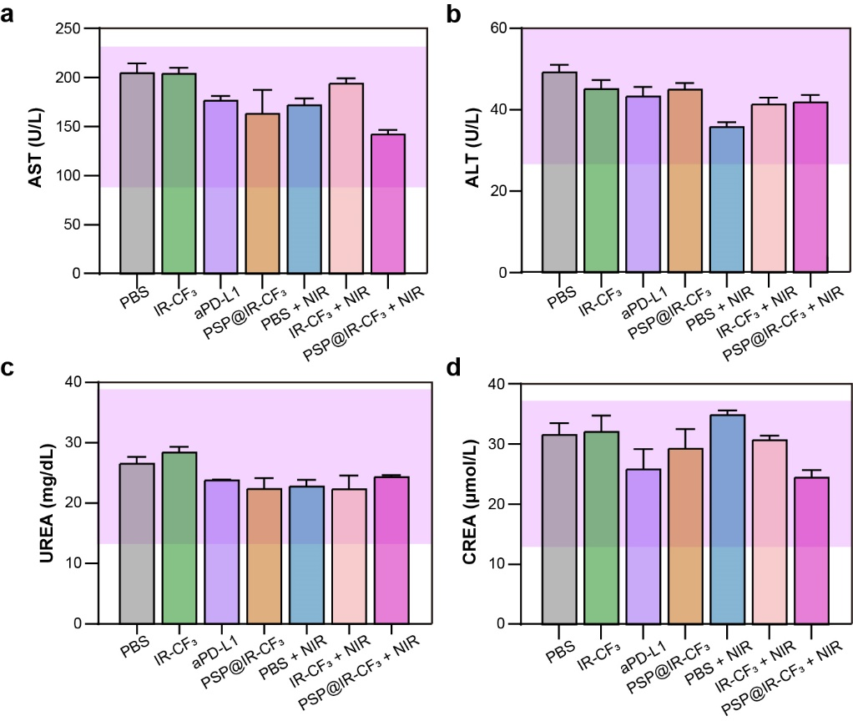
Supplementary Fig. 12 Assessment of liver (a, b) and renal (c, d) functions in mice treated with PBS, IR-CF₃, aPD-L1, PSP@IR-CF₃, PBS + NIR, IR-CF₃ + NIR, or PSP@IR-CF₃ + NIR (n=3).

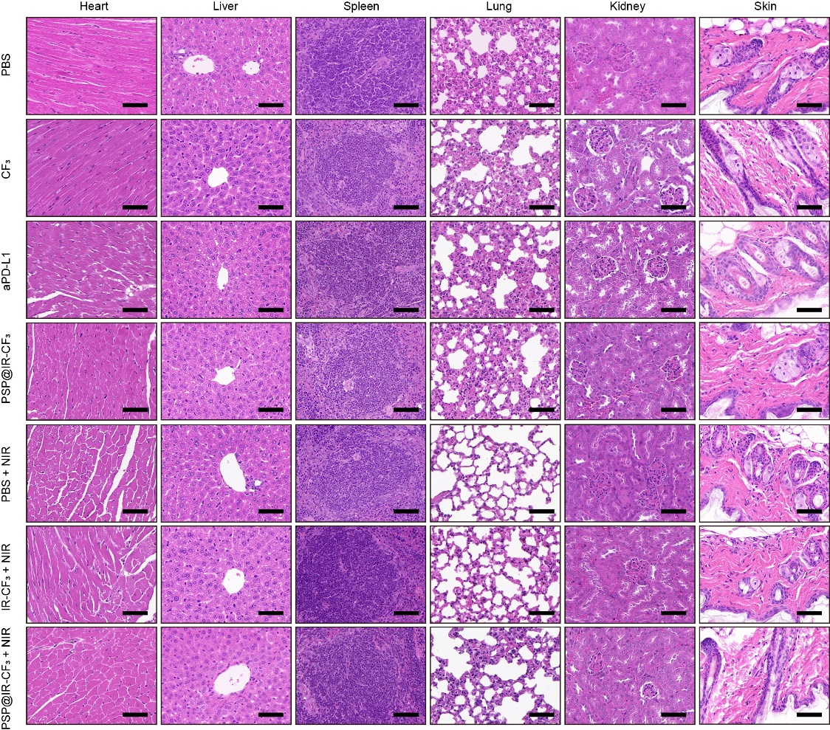
Supplementary Fig. 13 H&E staining of major organs after treatment with PBS, IR-CF₃, aPD-L1, PSP@IR-CF₃, PBS + NIR, IR-CF₃ + NIR, or PSP@IR-CF₃ + NIR. Scale bars: 20 μm.

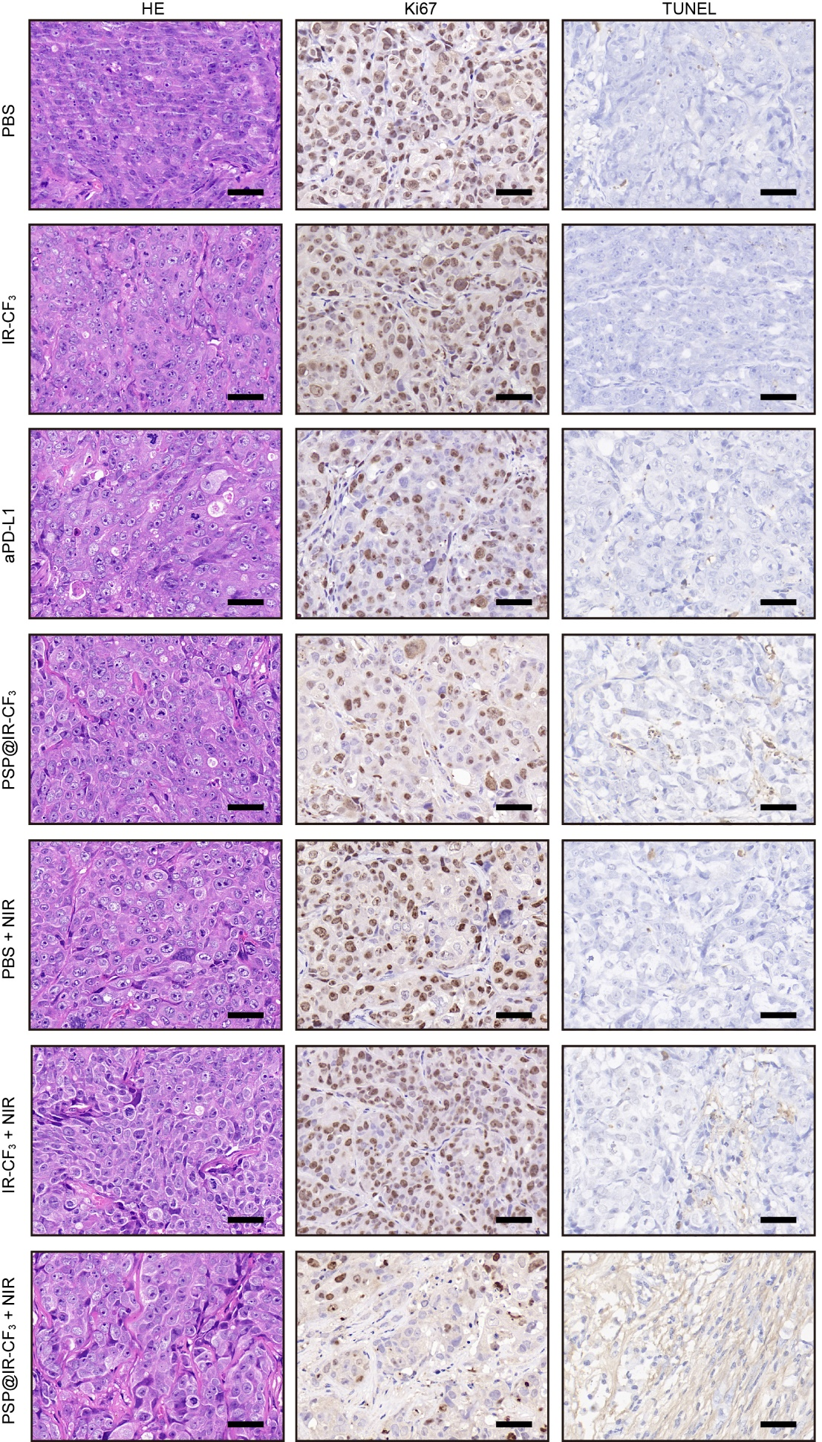
Supplementary Fig. 14 H&E, Ki67, and TUNEL staining of tumors in each group. Scale bars: 20 μm.

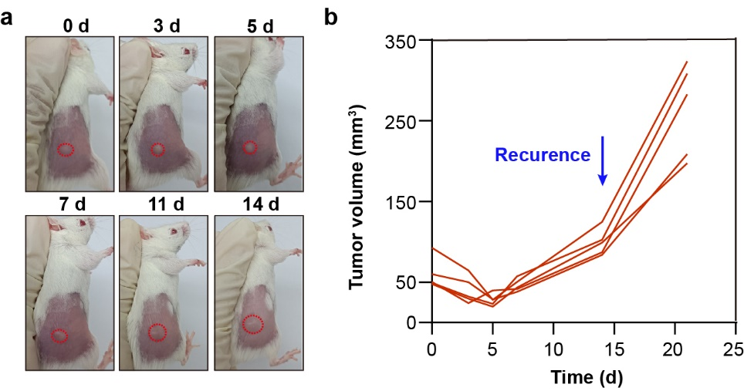
Supplementary Fig. 15 Representative tumor recurrence images and tumor volume measurements.

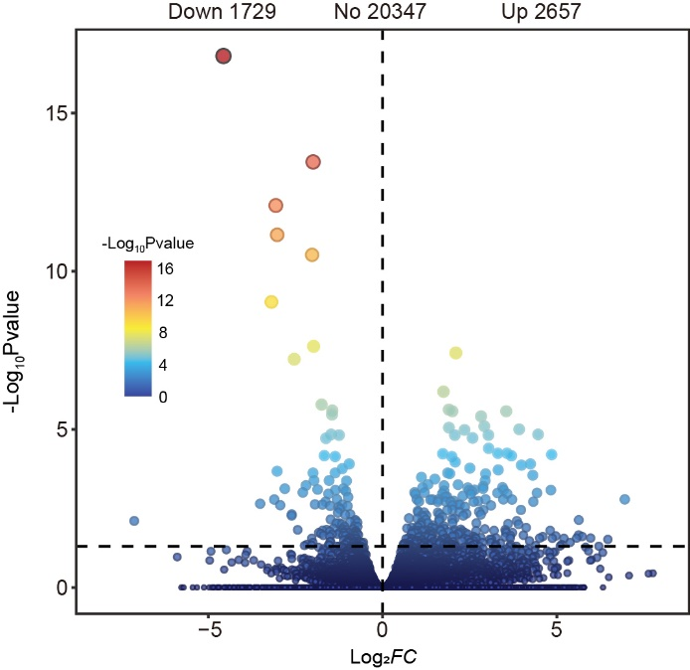
Supplementary Fig. 16 The volcano plot of differentially expressed genes between PSP@IR-CF₃ + NIR and PBS group.

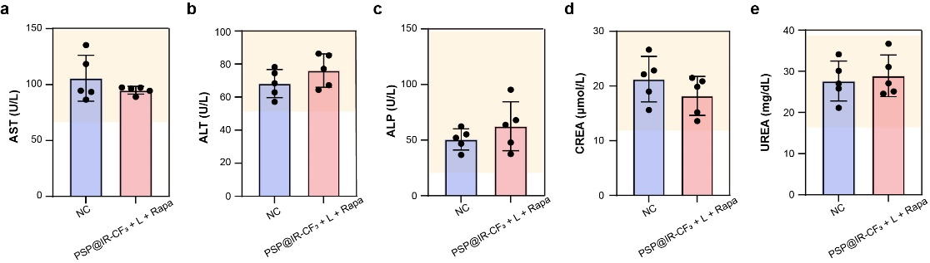
Supplementary Fig. 17 Assessment of liver (a–c) and renal (d, e) functions in mice treated with PBS or PSP@IR-CF₃ + NIR + Rapa. Rapa, rapamycin (n=5).

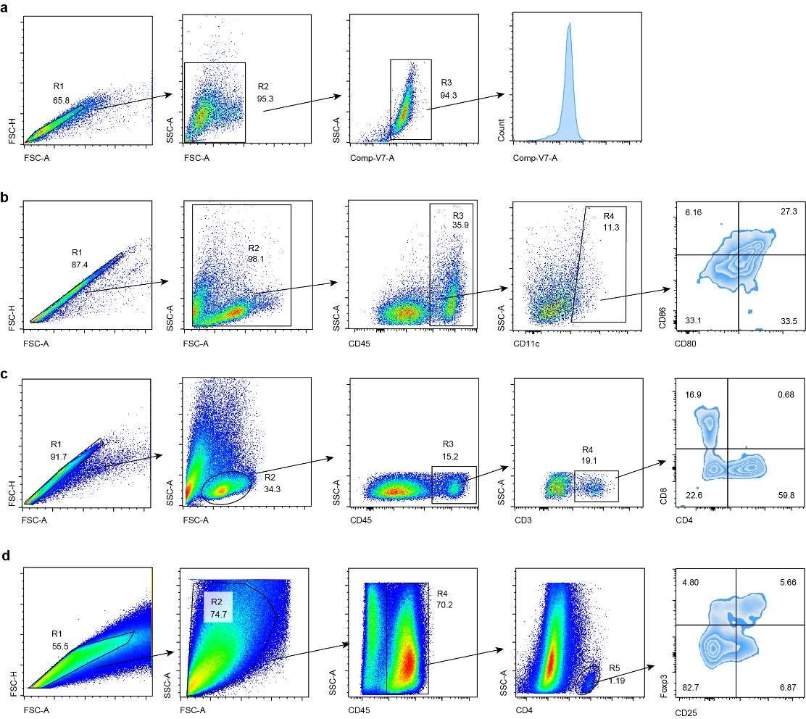
Supplementary Fig. 18 Gating strategies used for flow cytometry cell sorting. (a) Gating strategy to sort cells binding to PSP@IR-CF₃/IR-808. (b) Gating strategy to sort matured DCs (CD11c⁺CD80⁺CD86⁺). (c) Gating strategy to sort CD8⁺ (CD45⁺CD3⁺CD8⁺) T cells and CD4⁺ (CD45⁺CD3⁺CD4⁺) T cells. (d) Gating strategy to sort Tregs (CD4⁺CD25⁺Foxp3⁺).

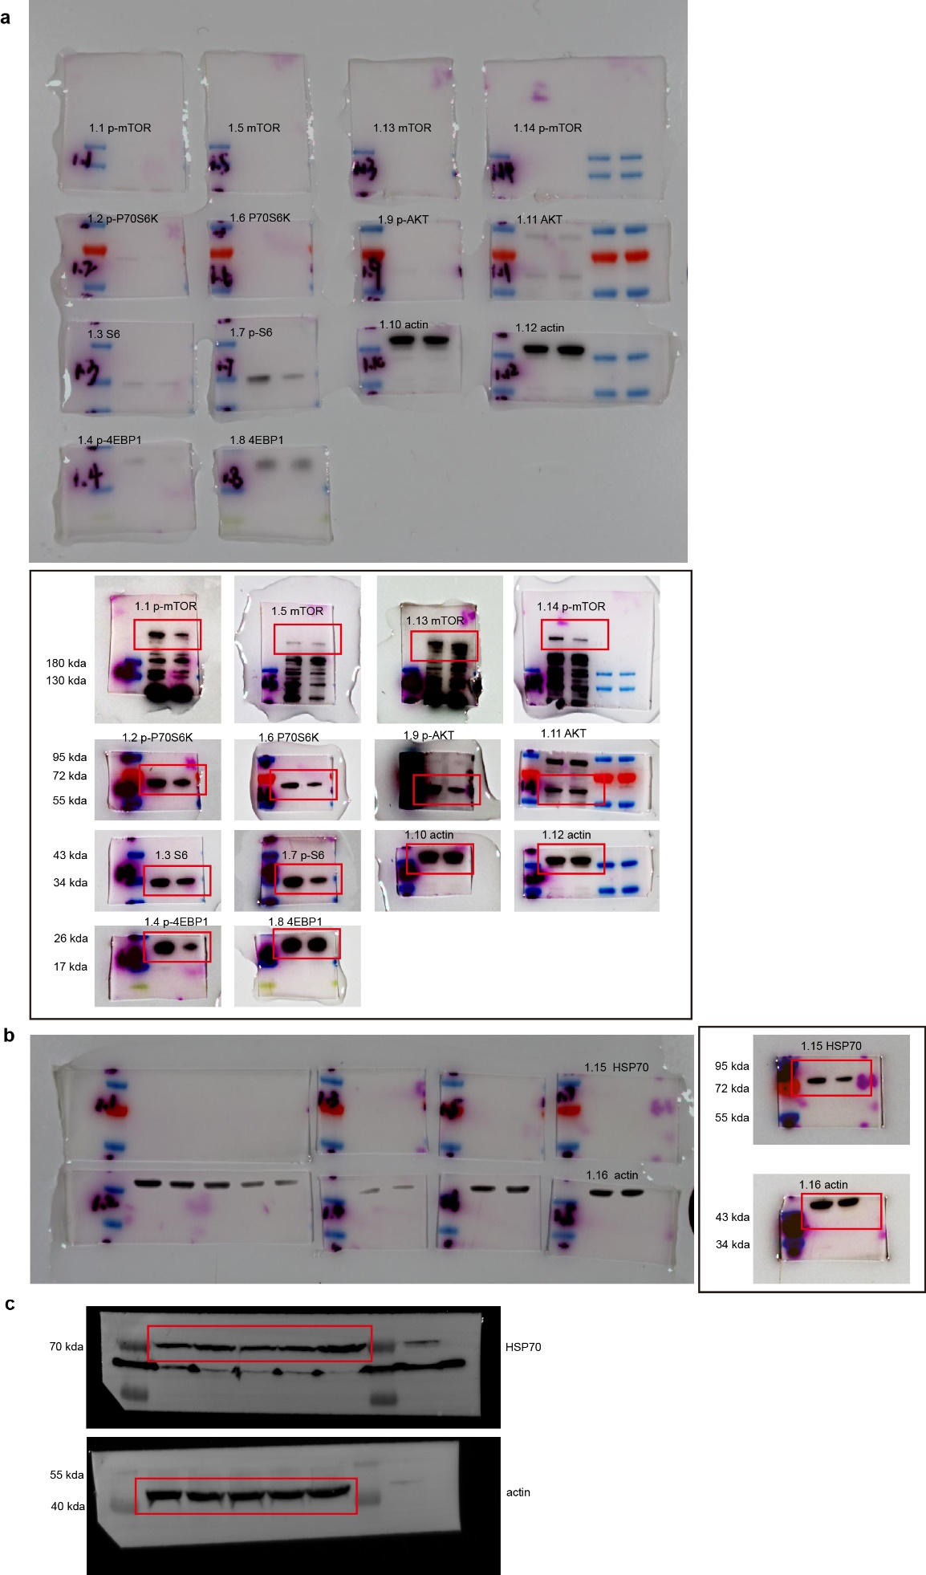
Supplementary Fig. 19 Raw data for Western blotting. (a, b) Raw data for Fig. 8g and the results after appropriate exposure time. (c) Raw data for Fig. 8f.

