ADDITIONAL FILES
Additional File 1
Reflexivity Statement
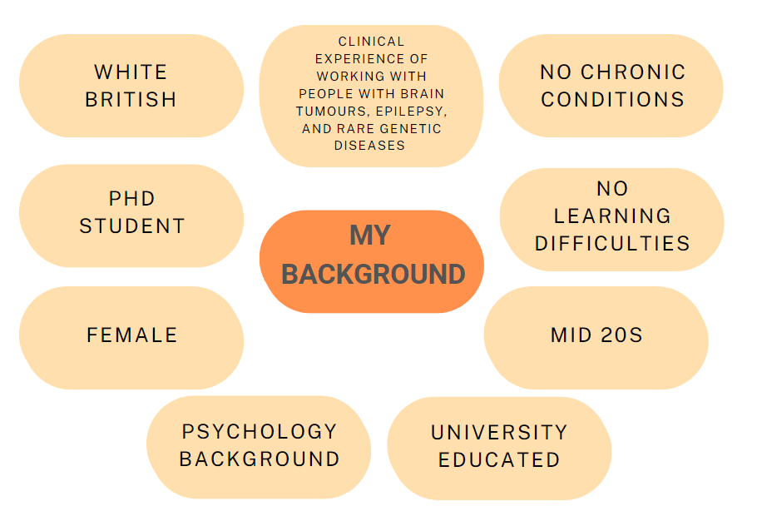
When designing the study, I was most aware of my position as a university-educated individual with a psychology background and without personal experience of a chronic condition or intellectual difficulties. I was also concerned about my knowledge of the methodology of ‘EMA’ (Ecological Momentary Assessment) as I had decided to simplify the information given to the participants and only explain it as an ‘app’ rather than explain in detail ‘EMA’ methodology. Although I provided some background information on the ‘app’ and the focus group and interview schedule was designed to be answered with the information provided, I was wary that my knowledge of EMA may influence any of my spontaneous follow-up prompts and, therefore, be difficult to answer.
From the start of data collection, I quickly began to learn about the wide spectrum of abilities of young people with TSC. The parents participating reported many different ability levels of their young adults which was useful for the generalisability of my findings. However, because of these differences, I was worried about the nature of the focus group and whether what I was presenting or prompting would not be at all relevant to some of the participants and their young adults. This was the case for some participants; however, I was surprised at how they still engaged in the focus groups and provided constructive feedback rather than outright dismissing the methodology. This was probably due to my bias that parents often primarily focus on what’s best for their children, not for the whole population.
In the first focus group, on reflection, I felt my questioning could have been a bit more inclusive to accommodate all the different levels of the young adults being represented. This led to me realising that because there were two aims to this study, I sometimes felt that they conflicted. It was easier to follow up with the participants on how the EMA could be useful for their young adults rather than to the participants why it would not be useful for their young adults as this provided more information on how to guide the follow-up EMA study. However, I made an active effort in the second group to explore these differences further as they did reveal useful information that I would have otherwise missed.
One thing I found with the focus group was that it was hard not to go into ‘therapy mode” with the parents. My background experience of working clinically with similar young adult individuals and their parents or caregivers (rare disease, epilepsy, intellectual disability, brain tumours, etc) hindered my ability to stay as a neutral researcher. I often found myself trying to repeat back their answers to show my understanding and acknowledge their difficulties in a therapeutic way rather than as a researcher. I did adapt my presentation to the focus groups as I went on as I learnt to navigate those conversations without feeling the need to provide ‘supportive feedback’ and instead prioritise prompting further description of their experiences and feelings. On reflection, my clinical skills may have helped with rapport building which in turn could have allowed the participants to share more. As such, I believe there are unique benefits to being a clinical researcher.
In summary, at first, I identified myself as an “outside researcher” (Hellawell, 2007) as I had no personal experience with living with a rare disease or having intellectual difficulties. However, as the focus groups went on, I realised my background experience of working with children and young adults with very similar conditions had changed both the way I ran the focus groups and my assumptions and biases about the participants. I acknowledged that this would influence my interpretation of their experiences.

Hellawell, D. (2007). Teaching in Higher Education Inside-out: analysis of the insider-outsider concept as a heuristic device to develop reflexivity in students doing qualitative research. https://doi.org/10.1080/13562510600874292

Additional File 2
COREQ (COnsolidated criteria for REporting Qualitative research) Checklist
A checklist of items that should be included in reports of qualitative research. You must report the page number in your manuscript where you consider each of the items listed in this checklist. If you have not included this information, either revise your manuscript accordingly before submitting or note N/A.
Topic | Item No. | Guide Questions/Description | Reported on Page No.
Domain 1: Research team and reflexivity
Personal characteristics
Interviewer/facilitator | 1 | Which author/s conducted the interview or focus group? | 7-8
Credentials | 2 | What were the researcher’s credentials? E.g. PhD, MD | 7
Occupation | 3 | What was their occupation at the time of the study? | 7
Gender | 4 | Was the researcher male or female? | 7
Experience and training | 5 | What experience or training did the researcher have? | 7-8
Relationship with participants
Relationship established | 6 | Was a relationship established prior to study commencement? | 3
Participant knowledge of the interviewer | 7 | What did the participants know about the researcher? e.g. personal goals, reasons for doing the research | 3
Interviewer characteristics | 8 | What characteristics were reported about the inter viewer/facilitator? e.g. Bias, assumptions, reasons and interests in the research topic | Additional file
Domain 2: Study design
Theoretical framework
Methodological orientation and Theory | 9 | What methodological orientation was stated to underpin the study? e.g. grounded theory, discourse analysis, ethnography, phenomenology, content analysis | 9
Participant selection
Sampling | 10 | How were participants selected? e.g. purposive, convenience, consecutive, snowball | 6
Method of approach | 11 | How were participants approached? e.g. face-to-face, telephone, mail, email | 6
Sample size | 12 | How many participants were in the study? | 6
Non-participation | 13 | How many people refused to participate or dropped out? Reasons? | 7 (Fig 1)
Setting
Setting of data collection | 14 | Where was the data collected? e.g. home, clinic, workplace | 8
Presence of nonparticipants | 15 | Was anyone else present besides the participants and researchers? | 8
Description of sample | 16 | What are the important characteristics of the sample? e.g. demographic data, date | 7
Data collection
Interview guide | 17 | Were questions, prompts, guides provided by the authors? Was it pilot-tested? | 8
Repeat interviews | 18 | Were repeat interviews carried out? If yes, how many? | NA
Audio/visual recording | 19 | Did the research use audio or visual recording to collect the data? | 8
Field notes | 20 | Were field notes made during and/or after the interview or focus group? | 8
Duration | 21 | What was the duration of the inter views or focus group? | 6
Data saturation | 22 | Was data saturation discussed? | 27
Transcripts returned | 23 | Were transcripts returned to participants for comment and/or correction | NA

Topic | Item No. | Guide Questions/Description | Reported on Page No.
Domain 3: analysis and findings
Data analysis
Number of data coders | 24 | How many data coders coded the data? | 9
Description of the coding tree | 25 | Did authors provide a description of the coding tree? | 11 (Fig 4)
Derivation of themes | 26 | Were themes identified in advance or derived from the data? | 9
Software | 27 | What software, if applicable, was used to manage the data? | 9
Participant checking | 28 | Did participants provide feedback on the findings? | 9
Reporting
Quotations presented | 29 | Were participant quotations presented to illustrate the themes/findings? Was each quotation identified? participant number | 11-22
Data and findings consistent | 30 | Was there consistency between the data presented and the findings? | 22
Clarity of major themes | 31 | Were major themes clearly presented in the findings? | 11-22
Clarity of minor themes | 32 | Is there a description of diverse cases or discussion of minor themes? | 11-22

Developed from: Tong A, Sainsbury P, Craig J. Consolidated criteria for reporting qualitative research (COREQ): a 32-item checklist for interviews and focus groups. International Journal for Quality in Health Care. 2007. Volume 19, Number 6: pp. 349 – 357
Once you have completed this checklist, please save a copy and upload it as part of your submission. DO NOT include this checklist as part of the main manuscript document. It must be uploaded as a separate file.

