Supplementary Materials for

Targeted delivery of BACE1 siRNA for synergistic treatment of Alzheimer's disease

Zhaohan Li#, Jun Yang#, Jianan Li, Shuxuan Zhao, Shaoping Jiang, Weimin Liu, Xinjian Li, Simeng Zhang, Haiyan Du, Junjun Ni, Yuanyu Huang*, Hong Qing*, Shaobo Ruan*
*Corresponding authors: Email: ruanshaobo@bit.edu.cn; hqing@bit.edu.cn; yyhuang@bit.edu.cn;

This PDF file includes:

Scheme S1
Figs. S1 to S16
Table. S1

Scheme S1. Synthesis protocol of PPR

Synthesis of PPR. Dissolve COOH-PEG2000-MAL (30 mg, 15 μmol), 1-(3-dimethylaminopropyl)-3-ethylcarbodiimide hydrochloride (EDC) (11.5 mg, 60 μmol), and N-hydroxysuccinimide (NHS) in Phosphate Buffered Saline (PBS) (6.903 mg, 60 μmol). Stir the solution at room temperature for 24 hours in a round-bottom flask. Subsequently, transfer an appropriate volume of polyamide-amine (PAMAM) methanol solution to a round-bottom flask and evaporate it to dryness using a rotary evaporator. Dissolve 43.2 mg (1.5 μmol) of PAMAM in PBS at a ratio of 1:10 (mol/mol) PAMAM to PEG. Mix with NHS-PEG-MAL and stir at room temperature for 8 hours. The NHS groups on NHS-PEG-MAL react specifically with the amino groups on the surface of PAMAM to synthesize PAMAM-PEG. Dialyze the reaction product against pure water using a dialysis bag with a molecular weight cutoff of 5000 Da for 24 hours, changing the water every 4 hours. Place the dialyzed product in a sample vial, remove the cap, wrap with parafilm, and then freeze-dry using a freeze-drying machine. Store the dried PAMAM-PEG in the refrigerator at -20℃.The synthetic targeted peptide RVG29 contains cysteine, whose sulfhydryl group (-SH) can specifically react with Maleimide (-MAL) to form a covalent linkage. Dissolve RVG29 (49 mg, 15 μmol) in PBS and mix it with a molar ratio of PAMAM:RVG29 = 1:10. Stir the mixture at room temperature for 24 hours to synthesize PAMAM-PEG-RVG29. The resulting product was then dialyzed against pure water using a dialysis bag with a molecular weight cutoff of 12000 Da for 24 hours, with the water changed every 4 hours. The dried PAMAM-PEG-RVG29 was stored in a refrigerator at -20°C.The solvent peak of CDCl₃ is at 7.26 ppm and the characteristic absorption peak of methylene in the PEG structure is around 3.64 ppm. The backbone peak of PAMAM overlaps with RVG29 between 0.88-3.39 ppm. The multi-peak absorption peaks around 6.99 and 7.52 ppm are characteristic absorption peaks of the benzene ring in RVG29.
UV-vis absorbance spectra. The interaction of siRNA between PPR was investigated by UV-vis absorption spectra. The UV-vis absorption spectrum was taken from 400 to 700 nm.

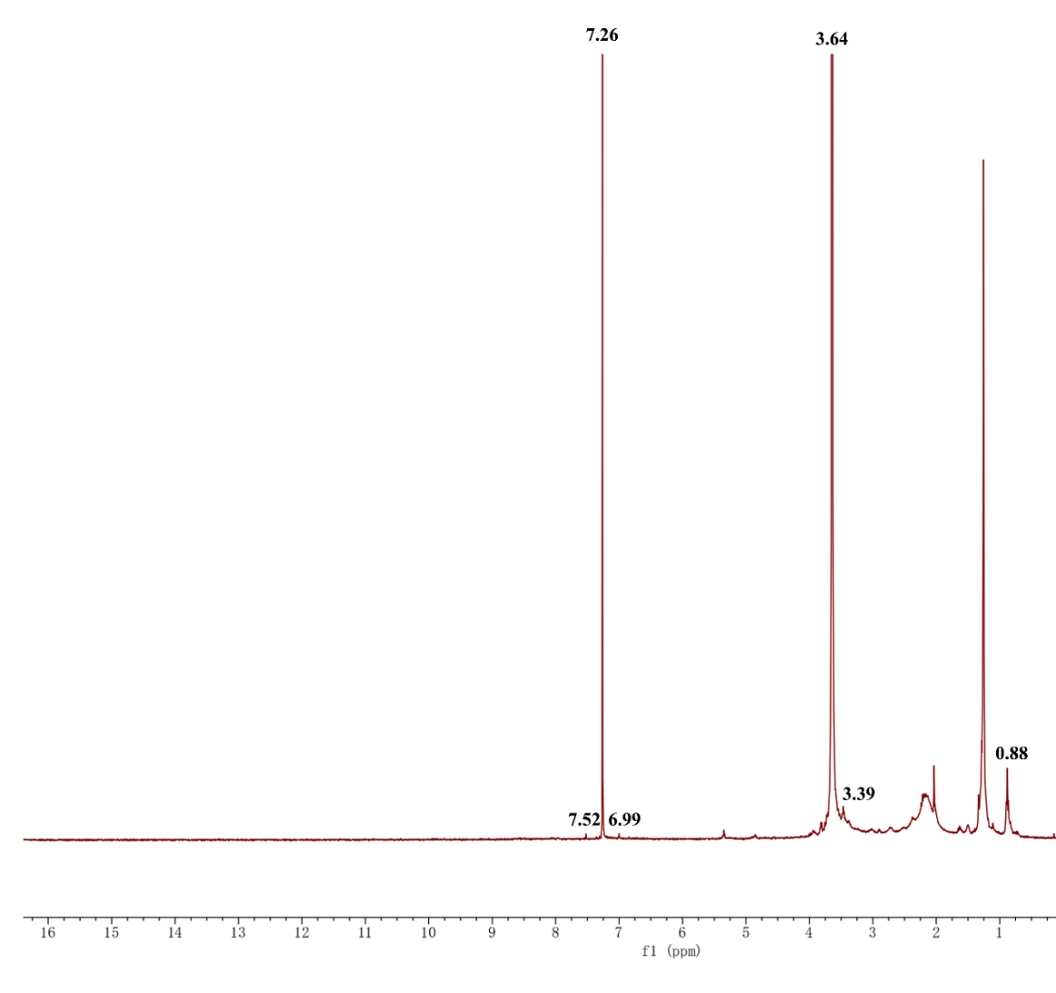
Figure S1. ¹H NMR spectra of synthesized PPR.

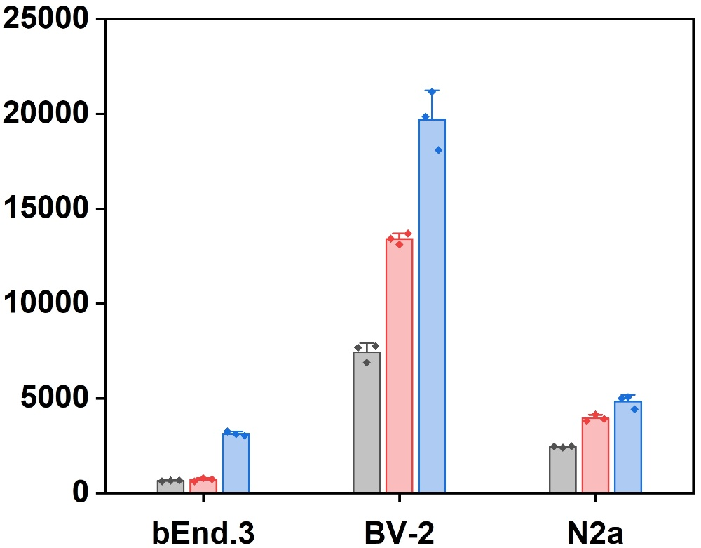
Fig. S2. Quantitative cellular uptake of different formulations by bEnd.3, N2a, and BV-2 cells at 3 h determined from flow cytometry.

Fig. S3. All Western blot of BACE1 protein expression levels in both N2a and BV-2 cells treated with different formulation.

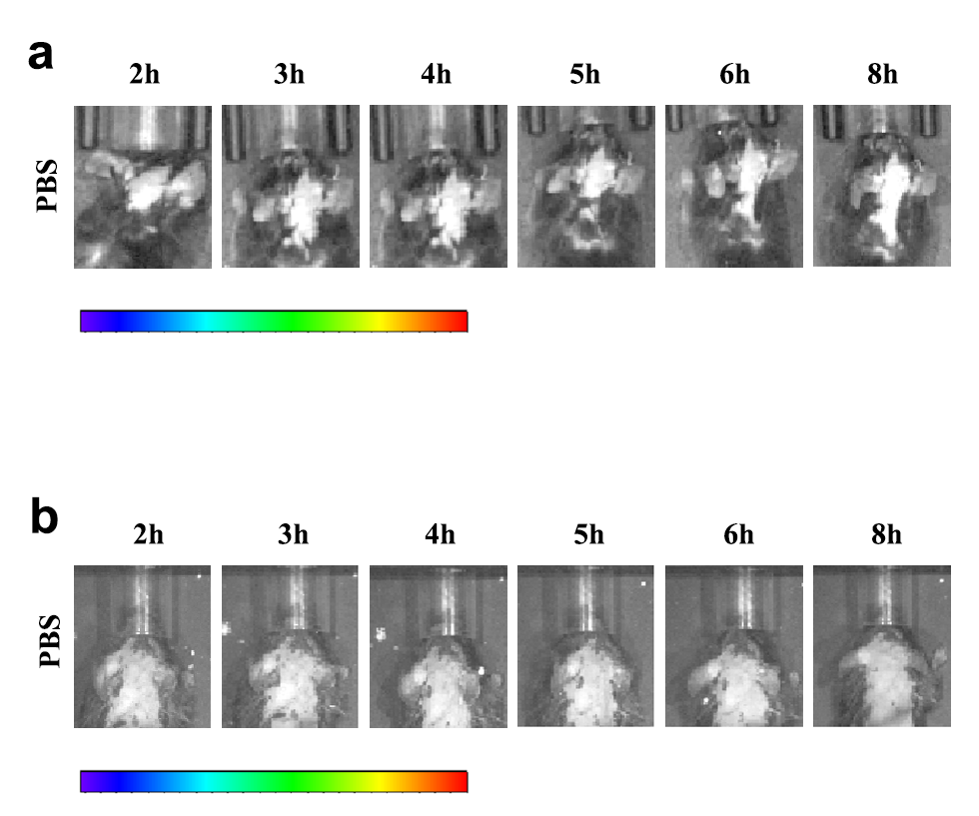Fig. S4. In vivo imaging of WT mice treated with different formulation. (a) In vivo imaging of WT mice after intravenous injection with PBS as control for Cy5-labeled PPR and PP at different time intervals, bar: 0.5×10⁹-3.0×10⁹ [p s⁻¹ cm⁻² sr⁻¹ ]/[μW cm⁻²]. (b) In vivo imaging of WT mice after intravenous injection with PBS as control for Cy5-labeled PPR@siRNA and PP@siRNA at different time intervals, bar: 2.0×10⁸-4.0×10⁸ [p s⁻¹ cm⁻² sr⁻¹ ]/[μW cm⁻²].

Fig. S5. Fluorescence determining the accumulation of PBS in the DG region of brain section where was immune-staining with Nissl and Iba. Scale bar, 100 μm.

Fig. S6. Fluorescence determining the accumulation of PBS in the CA1 region of brain section where was immune-staining with Nissl and Iba. Scale bar, 100 μm.

Fig. S7. Fluorescence determining the accumulation of PBS in the CA3 region of brain section where was immune-staining with Nissl and Iba. Scale bar, 100 μm.

Fig. S8. Fluorescence determining the accumulation of Cy5-labeled PPR@siRNA and PP@siRNA in the CA3 region of brain section where was immune-staining with Nissl and Iba. Scale bar, 100 μm.

Fig. S9. Time course of administration and therapeutic evaluation.

Fig. S10. Pictures of mouse nesting situation.

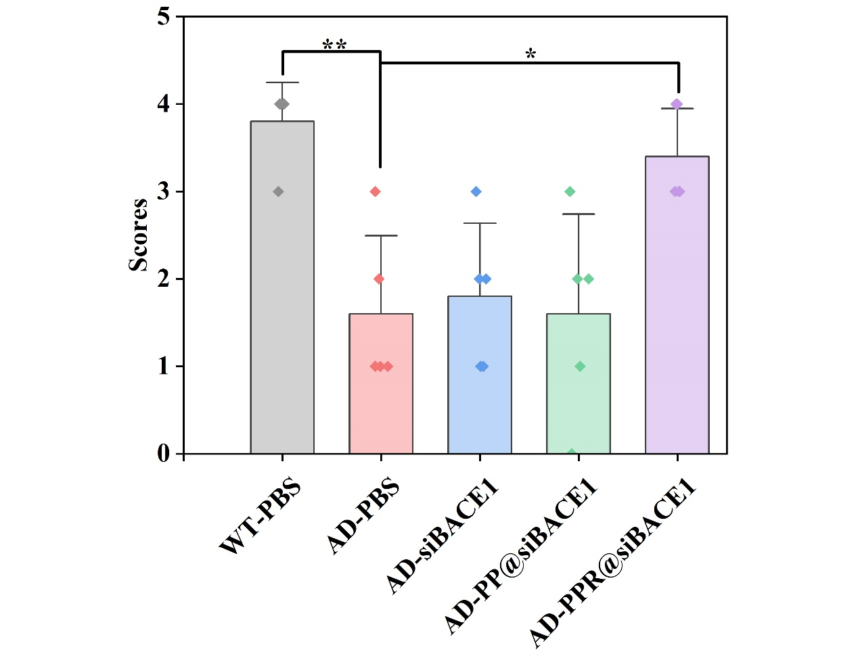
Fig. S11. Nesting experiment scores of different groups of mice. Graph: means ± SD, n = 5. *P < 0.05, **P < 0.01.

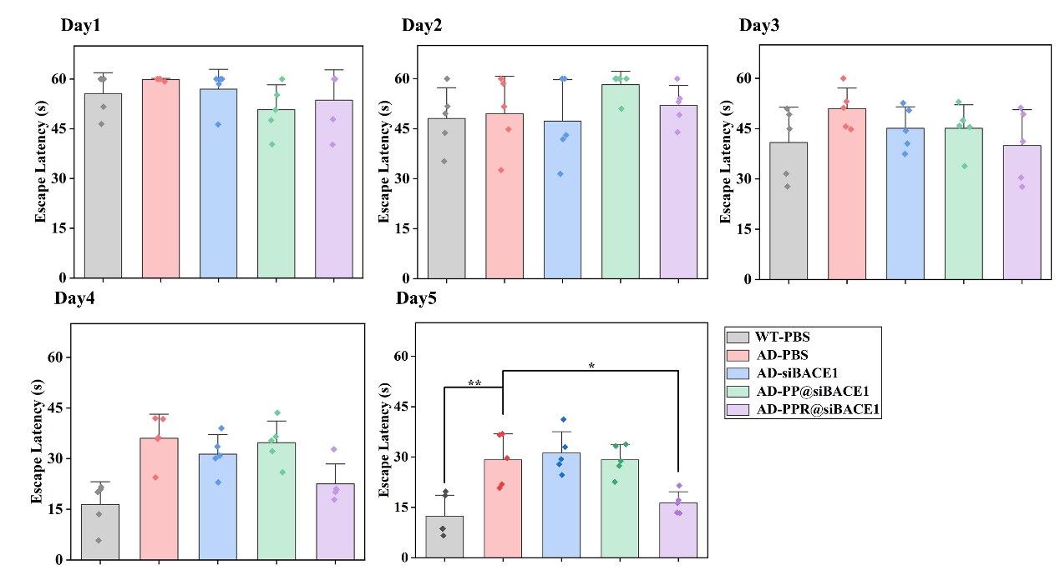
Fig. S12. MWM escape latencies in different groups of mice. Graphs: means ± SD, n = 5. *P < 0.05, **P < 0.01.
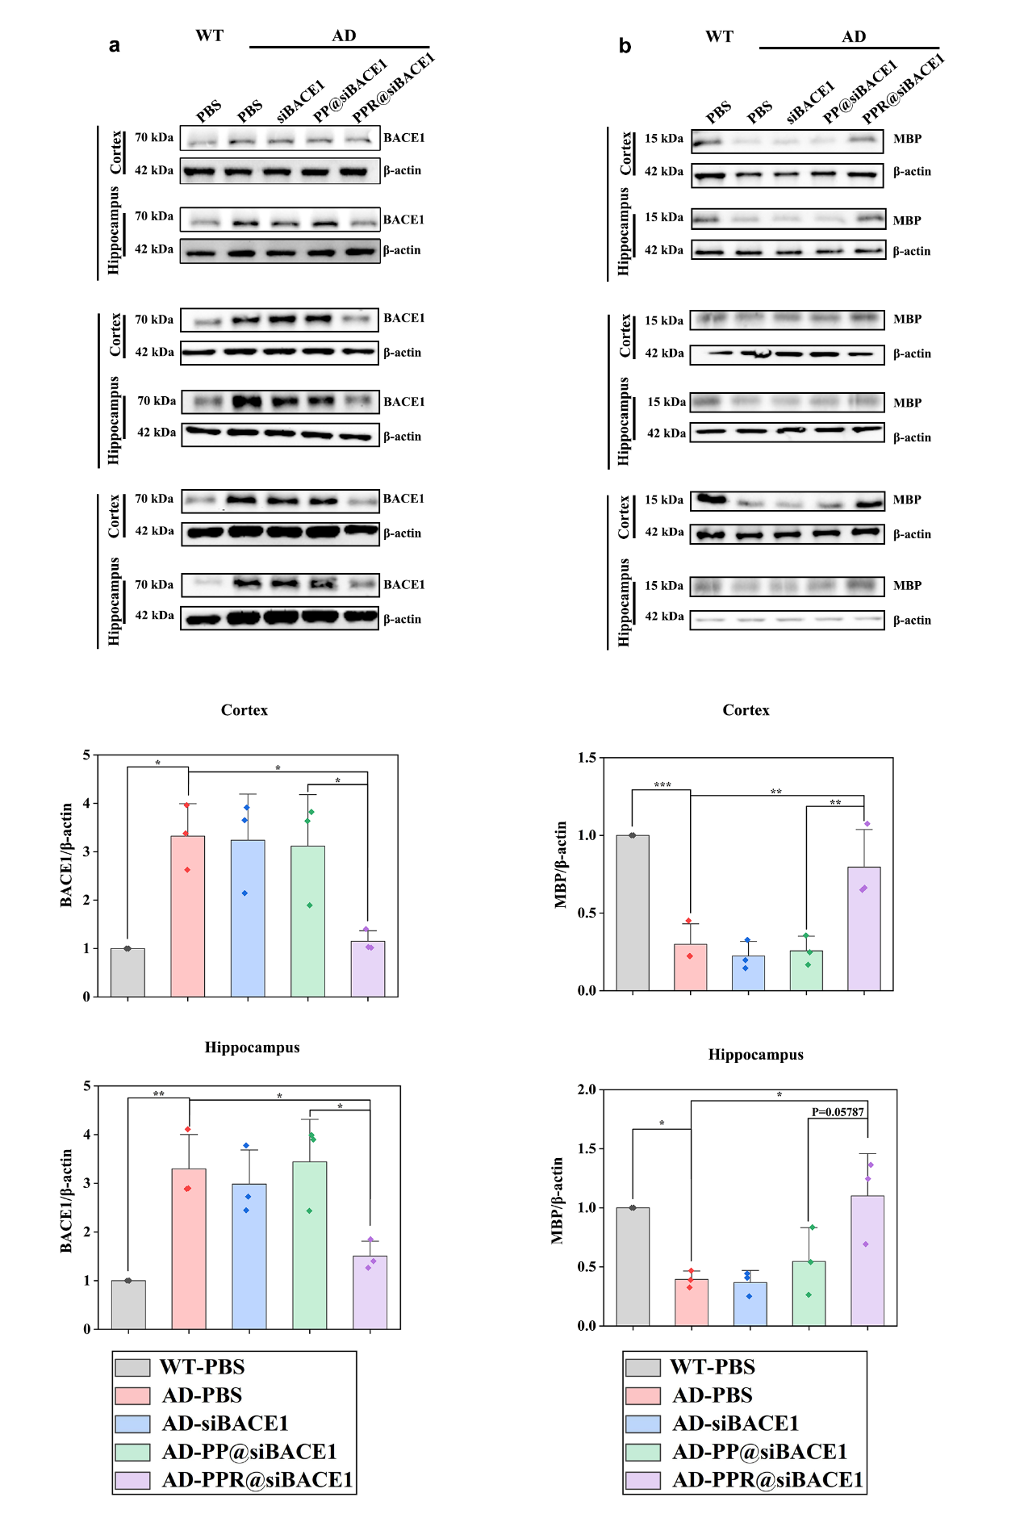 Fig. S13. All Western blot for BACE1 and MBP of mice. (a) Western blot data for BACE1 protein expression in hippocampus and cortex region of AD mice treated with different formulations, and WT mice treated with PBS were served as control. (b) Western blot data for MBP protein expression in hippocampus and cortex region of AD mice treated with different formulations, and WT mice treated with PBS were served as control. Graphs: means ± SD, n = 3. *P < 0.05, **P < 0.01, ***P < 0.001.

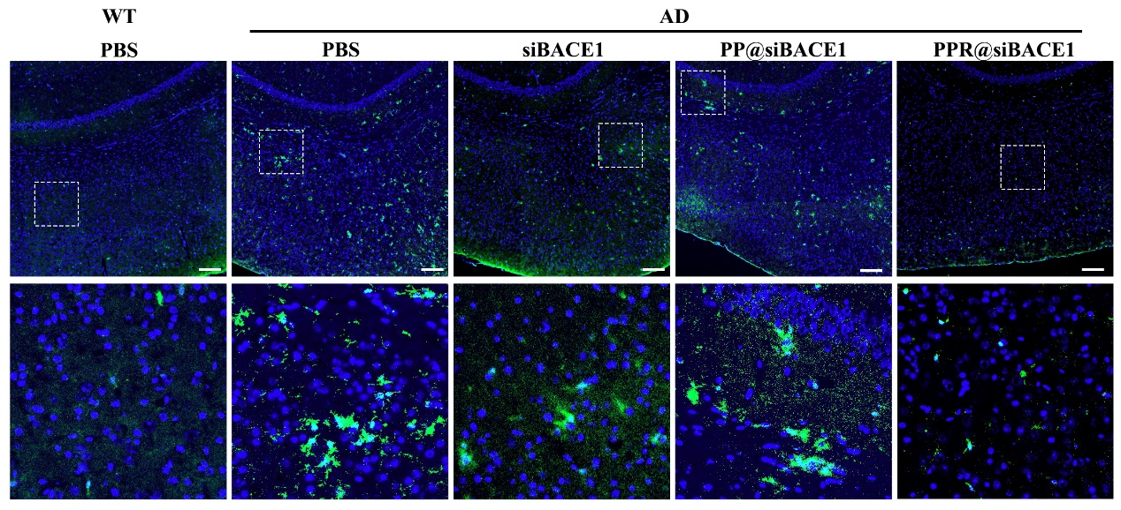
Fig. S14. Immunofluorescence staining of microglia with Iba1 (green) in the cortex region of mice from different groups. Scale bar, 100 μm.

Fig. S15. Immunofluorescence staining of astrocyte with GFAP (red) in the cortex region of mice from different groups. Scale bar, 100 μm.
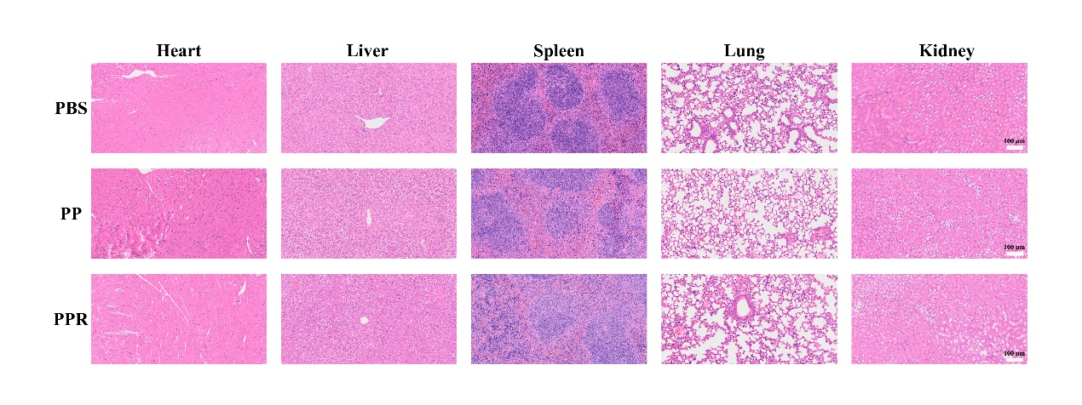
Fig. S16. Representative data for hematoxylin and eosin staining in major organs of mice from different groups. Scale bar, 100 μm.

Table S1. qPCR primer sequences

gene | Forward (5’-3) | Reverse (5’-3)
Bace1 | TACTACTGCCCGTGTCCACC | ACAACCTGAGGGGAAAGTCC
Gapdh | TTGATGGCAACAATCTCCA | CGTCCCGTAGACAAAATGGT
Il-1β | GAAATGCCACCTTTTGACAGTG | TGGATGCTCTCATCAGGACAG
Il-6 | TAGTCCTTCCTACCCCAATTTCC | TTGGTCCTTAGCCACTCCTTC
Tnf-α | TCTTCTCATTCCTGCTTGTGG | TCTTCTCATTCCTGCTTGTGG

