Supplementary Material

Formation of nitrated naphthol under freezing conditions

Kai Wuª, Peizeng Yangª, Wenlong Wangª, Yuefei Jiª, Jing Chen^{a, *}, Junhe Luª

ª Department of Environmental Science and Engineering, Nanjing Agricultural University, Nanjing, 210095, China

*Corresponding author: E-mail:
Telephone: +86-25-84395164; Fax: +86-25-84395210

Number of Texts: 6
Number of Tables: 4
Number of Figures: 6

Text. S1 Chemicals and Materials
Every chemical reagent was purchased at the highest purity available. 1-naphthol was supplied by Aladdin Industrial Corporation (Shanghai, China) with 99% purity. 2-nitro-1-naphthol, 4-nitro-1-naphthol, and 2,4-dinitro-1-naphthol were obtained from Sigma-Aldrich (St. Louis, MO, USA) with 99% purity. Suwannee River NOM was obtained from the International Humic Sub­stances Society (St. Paul, MN, USA). Sodium nitrite (NaNO₂) was supplied by XiLong Scientific (Shantou, China) at analytical grade. Sulfuric acid (H₂SO₄), sodium hydroxide (NaOH), and cresol red (CR) were purchased from Macklin (Shanghai, China) with 98% purity. HPLC-grade methanol and formic acid were supplied by J&K Chemical Ltd. (Shanghai, China). All stock solutions were prepared with Milli-Q water (resistance of 18 MΩ·cm) generated by a Millipore Milli-Q system (Milford, MA, USA).

Text. S2 HPLC-DAD analysis
The concentrations of 1-naphthol (Rt = 5.38 min), 2-nitro-1-naphthol (Rt = 11.68 min), 4-nitro-1-naphthol (Rt = 6.54 min), and 2,4-dinitro-1-naphthol (Rt = 6.18 min) in the samples were confirmed using a Shimazu LC-AD20 high-performance liquid chromatography (HPLC, Shimadzu, Japan), equipped with an SPD-M20A diode array detector and an Agilent Zorbax Eclipse Plus C18 column (250 × 4.6 mm i.d., 5 μm). The mobile phase consisted of 70% methanol and 30% water, containing 0.1% formic acid to improve peak shape. The flow rate was set at 1.0 mL/min. Quantification of 1-naphthol, 2-nitro-1-naphthol, 4-nitro-1-naphthol, and 2,4-dinitro-1-naphthol were performed at wavelengths of 295 nm, 267 nm, 257 nm, and 254 nm, respectively, corresponding to the peak absorbance bands of these compounds.
Text. S3 SPE extraction and LC-MS analysis
The intermediate products of the reaction between 1-naphthol and NO₂⁻ under freezing conditions were extracted using the solid-phase extraction (SPE) method. A 40 mL sample was concentrated to 2 mL using CNWBOND LC-C18 SPE cartridges (2. CA0955.0001, 1 g, 6 mL) (CNW, ANPEL Laboratory Technologies (Shanghai), Int, China). Transformation products of the 1-naphthol enriched samples were identified by an Agilent 1200 HPLC coupled with an Agilent 6410 triple-quadrupole mass spectrometer (HPLC-MS/MS, Santa Clara, USA). The instrument was equipped with an electrospray ionization (ESI) source, and the mass analyzer was operated at full scan mode (m/z 50-1000). An electrospray ion (ESI) source in negative ion mode was used for the MS and MS/MS measurement. The MS and MS/MS were operated at negative ionization and full scan (m/z 100-1500) mode. To obtain accurate masses of the transformation products, the samples were further analyzed using an AB Sciex ExionLCTM HPLC system equipped with a high-resolution hybrid quadrupole time-of-flight mass spectrometer (X500R QTOF, AB Sciex, Foster City, CA). The mobile phase comprised water (A) and methanol (B). The flow rate was 0.3 mL/min. The mobile phase was methanol (80%) and water (20%), and the flow rate was 0.3 mL/min. Instrumental parameters of the ESI source were as follows: ion spray voltage, -4500 V; source temperature, 550 ℃; gas I and II, 55 psi; curtain gas, 35 psi; declustering potential (DP) and collision energy (CE) were -80 V and -10 V. All data were processed using the Sciex OS program (Version 2.0, AB Sciex).

Text. S4 Nitrogen balance analysis
The determination of NO₂⁻ and NO₃⁻ concentrations was conducted using a Wanyi IC-6000 ion chromatograph (IC, Anhui, China), which was equipped with a SI-55 4E anion-exchange column (250 mm × 4.0 mm, 5 μm) and coupled with a conductivity detector. The chromatographic separation was achieved with a 3.6 mM sodium carbonate eluent at a flow rate of 0.8 mL/min, with the suppression current maintained at 40 mA. The quantification of total nitrogen (TN) was performed according to the alkaline potassium persulfate digestion UV spectrophotometric method, following the national standard method of China (HJ 636-2012, 2012). For detailed procedural descriptions, refer to the Supporting Information (Text S2). Total organic nitrogen (TON) was determined by calculating the difference between the TN and the total inorganic nitrogen (TIN, the sum of NO₂⁻ and NO₃⁻).

Text. S5 Theoretical computation
The Gaussian 16W program was used for all theoretical calculations. The molecular geometries of 1-naphthol, nitro-naphthol, and nitroso-naphthol were optimized using the M06-2x/6-31g+ (d, p) theoretical level. The calculation of spin density and charge density is conducted on the optimized molecular structure. All calculations accounted for solvent effects using the continuum solvation model density (SMD).

Text. S6 Luminescent bacteria test
The toxicity of 1-naphthol samples after freezing in the absence or presence of NO₂⁻ were assessed by the luminescent bacteria test according to the national standard method of China (GB/T 15441-1995,1995). P. phosphoreum T3 spp. obtained from the Institute of Soil Science, Chinese Academy of Sciences (Nanjing, China) was used as the source of luminescence. Sample solution (5 mL, pH 4.0) containing 10 μM 1-naphthol, 5 mg/L (as TOC) NOM, and 10 μM NO₂⁻ were frozen and removed at different time intervals. At pre-determined time points, the samples were melted and the pH was adjusted to neutral with 5 mM phosphate buffer. Then each sample was mixed with 0.15 g sodium chloride (NaCl) for toxicity test. A parallel sample without NOM was performed concurrently. The luminescent bacteria were activated in 1 mL of a 2% NaCl solution for 2 min, further diluted with 49 mL a 3% NaCl solution. After activation, 190 μL sample solution was mixed with 10 μL bacteria solution in a black 96-well cell culture plate for 15 min. Luminescence intensity was recorded by Ensight Multimode Microplate Reader coupled with Kaleido workflow software (PerkinElmer, Hopkinton, MA, USA). Control with only 3% NaCl was simultaneously conducted. The toxicity data were recorded as the luminescence intensity (%) versus the control. The toxicity test for each sample was carried out with eight replicates.

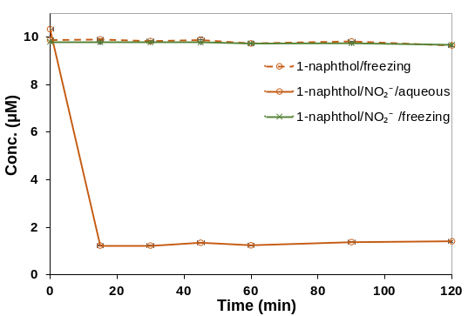
Fig. S1 Effects of freezing and the NO₂⁻ addition on the naphthol degradation. Reaction conditions: 1-naphthol 10 μM, NO₂⁻ 0 or 10 μM; pH 4; 4℃ or -20℃; reaction time 2 h. Results indicate that the formation of nitro-naphthol compounds only occurred in frozen samples containing NO₂⁻.

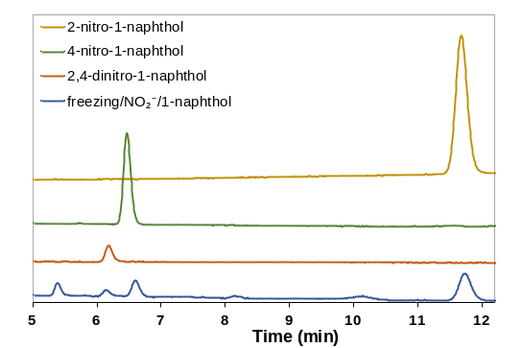
Fig. S2 HPLC spectra of 1-naphthol transformation in the freezing/NO₂⁻ system: Reaction conditions: 1-naphthol 10 μM; NO₂⁻ 10 μM; pH 4; -20 ℃; reaction time 2h. Results show that the formation of nitro-naphthol compounds in frozen samples containing NO₂⁻.

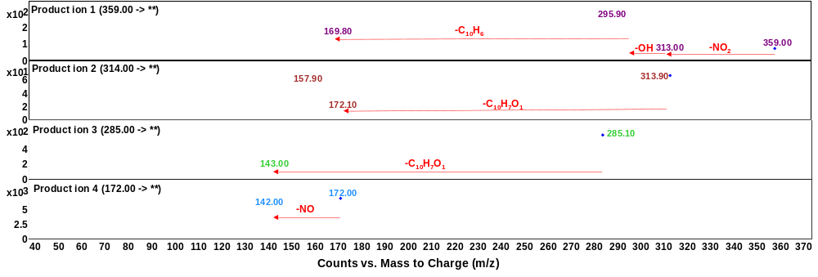
Fig. S3 Mass/Mass fragmentation patterns of identified products in the ice sample. Reaction conditions: 1-naphthol 10 μM, NO₂⁻ 10 μM, reaction time 2 h, -20℃.

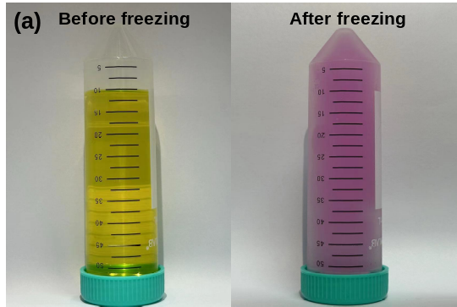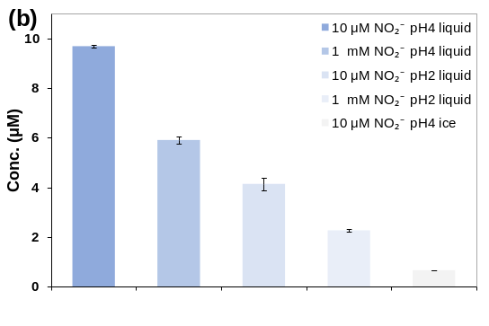
Fig. S4 Effects of NO₂⁻ concentration and pH on 1-naphthol removal in liquid water and ice. Reaction conditions: 1-naphthol 10 μM; NO₂⁻ 1 mM or 10 μM; pH 2 or 4; reaction time 2 h, -20 ℃. Results indicate that the transformation of 1-naphthol compounds is mainly caused by the freeze-concentration effect.

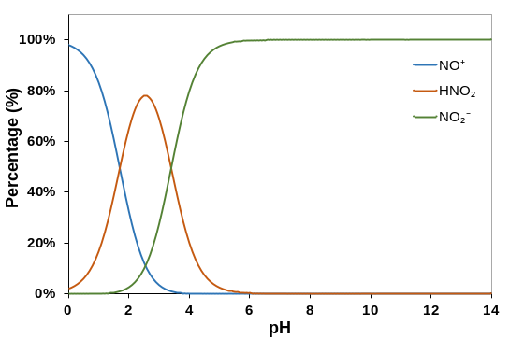
Fig. S5 Distribution of morphological species of nitrite (${{\text{NO}}_{\text{2}}}^{\text{–}}$) at different pH.

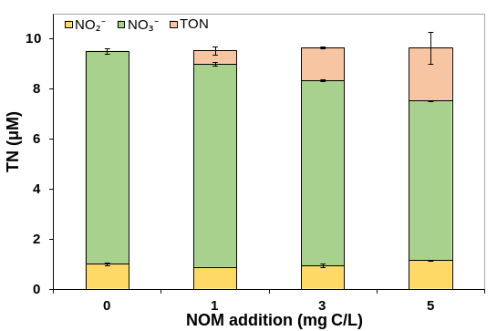
Fig S6. Concentrations of various nitrogen species in different concentrations of NOM under freezing conditions. Reaction conditions: NO₂⁻ 10 μM, reaction time 2 h, pH4, -20 ℃. Results show that NOM can react with NO₂⁻ to produce organic nitrogen in ice.

Table S1. Formula and structures of the products identified by HRMS
Products | Formula | Structure | m/z  Theoretical | m/z  Experimental | Error (ppm)
P1A | C₁₀H₇NO₃ | 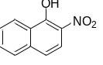 | 188.0353 | 188.0350 | -1.6
P1B | C₁₀H₇NO₃ | 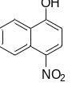 | 188.0353 | 188.0350 | -1.6
P2 | C₁₀H₆N₂O₅ | 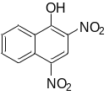 | 233.0204 | 233.0200 | -1.7
P3 | C₁₀H₇NO₂ | 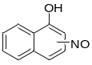 | 172.0404 | 172.0399 | -2.9
P4 | C₂₀H₁₄O₂ | 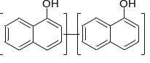 | 285.0921 | 285.0912 | -3.1
P5 | C₂₀H₁₃NO₃ | 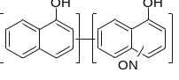 | 314.0823 | 314.0808 | -4.7
P6 | C₂₀H₁₂N₂O₅ | 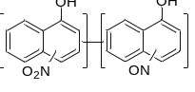 | 359.0673 | 359.0656 | -4.7

Table. S2 Spin densities on atoms of 1-naphthol were calculated by using Gaussian 16 program at the M06-2x/6-31g+ (d, p) level.
1-naphthol
Atom | No. | Charge density | Spin density
C | 1 | -0.240737 | 0.110377
C | 2 | 0.246289 | -0.00896
C | 3 | 0.05502 | 0.072601
C | 4 | -0.875419 | -0.23505
C | 5 | 0.212274 | 0.156161
C | 6 | -0.261746 | -0.0543
H | 7 | 0.203778 | -0.00476
H | 8 | 0.208225 | 0.00067
C | 9 | 0.200587 | -0.01058
C | 10 | 0.092659 | 0.546103
H | 11 | 0.208986 | -0.00457
H | 12 | 0.204642 | 0.00143
C | 13 | -0.380073 | -0.19286
C | 14 | 0.100013 | 0.398457
H | 15 | 0.220995 | -0.02089
H | 16 | 0.215305 | 0.00431
H | 17 | 0.211766 | -0.0174
O | 18 | -0.622562 | 0.25927

Table. S3 Spin densities on atoms of 2-nitro-1-naphthol and 4-nitro-1-naphthol were calculated by using Gaussian 16 program at the M06-2x/6-31g+ (d, p) level.
2-nitro-1-naphthol |  |  |  | 4-nitro-1-naphthol
Atom | No. | Charge density | Spin density | Atom | No. | Charge density |  | Spin density
C | 1 | -0.25528 | -0.07693 | C | 1 | -0.192833 | -0.07623
C | 2 | 0.236005 | 0.178365 | C | 2 | 0.30303 | 0.154749
C | 3 | -0.815877 | -0.22551 | C | 3 | 0.196968 | -0.17744
C | 4 | 0.022462 | 0.078045 | C | 4 | -0.424827 | 0.092136
C | 5 | 0.386866 | -0.01251 | C | 5 | 0.301043 | -0.02163
C | 6 | -0.231443 | 0.142713 | C | 6 | -0.196922 | 0.134113
H | 7 | 0.242167 | -0.01976 | H | 7 | 0.212718 | 0.002141
H | 8 | 0.212589 | 0.002143 | H | 8 | 0.216405 | -0.00567
H | 9 | 0.219116 | -0.00578 | C | 9 | -0.537365 | 0.461164
C | 10 | 0.094133 | 0.529364 | C | 10 | 0.036399 | -0.06611
C | 11 | 0.247406 | -0.00428 | H | 11 | 0.218409 | 0.00101
H | 12 | 0.218041 | 0.000834 | H | 12 | 0.213381 | -0.00553
H | 13 | 0.212622 | -0.00602 | C | 13 | 0.114718 | 0.422891
C | 14 | -0.131691 | 0.25506 | C | 14 | -0.059816 | -0.20543
C | 15 | 0.045152 | -0.08803 | H | 15 | 0.23424 | -0.01778
H | 16 | 0.247924 | 0.000451 | H | 16 | 0.246834 | 0.005659
O | 17 | -0.555191 | 0.211547 | O | 17 | -0.569428 | 0.242712
N | 18 | -0.163056 | -0.0135 | N | 18 | -0.135709 | -0.01461
O | 19 | -0.105312 | 0.031221 | O | 19 | -0.091494 | 0.037743
O | 20 | -0.126632 | 0.022575 | O | 20 | -0.085749 | 0.036083

Table. S4 Spin densities on atoms of 2-nitroso-1-naphthol and 4-nitroso-1-naphthol were calculated by using Gaussian 16 program at the M06-2x/6-31g+ (d, p) level.
2-nitroso-1-naphthol |  |  |  | 4-nitroso-1-naphthol
Atom | No. | Charge density | Spin density | Atom | No. | Charge density | Spin density
C | 1 | 0.047398 | -0.16049 | C | 1 | -0.223244 | -0.01883
C | 2 | -0.434012 | -0.0602 | C | 2 | 0.475045 | 0.007023
C | 3 | 0.640417 | -0.02661 | C | 3 | -1.465176 | -0.07554
C | 4 | -0.422193 | 0.122969 | C | 4 | 0.035224 | -0.07156
C | 5 | -0.176109 | -0.2439 | C | 5 | 0.56073 | 0.070961
C | 6 | 0.189002 | 0.259535 | C | 6 | -0.248271 | 0.039862
H | 7 | 0.215051 | 0.000635 | H | 7 | 0.2049 | 0.000873
C | 8 | -0.003342 | -0.02568 | H | 8 | 0.211311 | -0.00027
C | 9 | 0.008971 | -0.07388 | C | 9 | -0.096478 | 0.003306
H | 10 | 0.227918 | 0.011858 | C | 10 | 0.133437 | -0.06377
H | 11 | 0.220053 | -0.00702 | H | 11 | 0.207862 | -0.00141
C | 12 | -0.259748 | 0.021851 | H | 12 | 0.207907 | -0.00015
C | 13 | -0.215869 | -0.04006 | C | 13 | 0.237308 | 0.082972
H | 14 | 0.211785 | 0.002554 | C | 14 | 0.099559 | -0.05167
H | 15 | 0.207122 | -0.00052 | H | 15 | 0.232173 | -0.00441
H | 16 | 0.205128 | 0.00191 | H | 16 | 0.220888 | 0.006315
O | 17 | -0.667961 | -0.2767 | O | 17 | -0.59696 | -0.03661
N | 18 | -0.223809 | 0.720181 | N | 18 | -0.389899 | 0.515748
O | 19 | 0.230197 | 0.773547 | O | 19 | 0.193684 | 0.597125
References:
HJ 636-2012, 2012. Ministry of ecology and environment of the people’s republic of China, water quality-determination of total nitrogen-alkaline potassium persulfate digestion UV spectrophotometric method.
GB/T 15441-1995, 1995. Ministry of ecology and environment of the people’s republic of China, water quality-determination of the acute toxicity-luminescent bacteria test.
Jin H, Wang C, Shi J, Chen L (2014) Evaluation on joint toxicity of chlorinated anilines and cadmium to Photobacterium phosphoreum and QSAR analysis. J Hazard Mater 279, 156–162. https://doi.org/10.1016/j.jhazmat.2014.06.068.

