Global extrapolation drastically increases estimated economic costs of biological invasions
Gabriel Henrique de Oliveira Caetano^{GHOC}, Elena Angulo^{EA}, Laís Carneiro^{LC}, Ross N. Cuthbert^{RNC}, Thomas Evans^{TE}, Morgane Henry^{MH}, Emma Hudgins^{EH}, Elena Manfrini^{EM}, Ismael Soto^{IS}, Julia Touza^{JT}, Anna J. Turbelin^{AJT}, Ivan Jarić^{IJ}, Franck Courchamp^{FC}
^{GHOC, FC, IJ, LC}Université Paris-Saclay, CNRS, AgroParisTech, Ecologie Systématique et Evolution, 91190, Gif-sur-Yvette, France
^{EA}Estación Biológica de Doñana, CSIC, Avda. Américo Vespucio 26, 41092 Seville, Spain
^{RNC}Institute for Global Food Security, School of Biological Sciences, Queen's University Belfast, BT9 5DL, Belfast, UK
^{TE}Institute of Biology, Freie Universität Berlin, Berlin, Germany
^{MH}Department of Biology, McGill University, H3A 1B1, Montréal, QC, Canada
^{EH}School of Agriculture, Food and Ecosystem Sciences, The University of Melbourne, 3010, Parkville, Australia
^{EM}Unité Biologie des Organismes et Ecosystèmes Aquatiques (BOREA UMR 8067), Muséum National d'Histoire Naturelle, Sorbonne Universités, Université de Caen Normandie, Université Des Antilles, CNRS, IRD, Paris, France
^{IS}Faculty of Fisheries and Protection of Waters, South Bohemian Research Center of Aquaculture and Biodiversity of Hydrocenoses, University of South Bohemia in České Budějovice, Vodňany, Czech Republic
^{AJT}Great Lakes Forestry Centre, Natural Resources Canada, Canadian Forest Service, Sault Ste. Marie, Ontario P6A 2E5, Canada
^{JT}Department of Environment and Geography and York Environmental Sustainability Institute, University of York, YO10 5NG, York, UK
^{IJ}Biology Centre of the Czech Academy of Sciences, Institute of Hydrobiology, České Budějovice, Czech Republic
Supplemental material
Supplemental Methods and Results
Data filtering
We only selected entries in InvaCost that contained values for an entire country (i.e., country-scale costs - entries with the value Country in the Spatial_scale column of the database). We excluded entries in the database that were estimated (Potential costs, column Implementation in the database) or those of lower reliability (with methods deemed not transparent or reproducible, i.e., assigned Low in the columns Method_reliability and/or Method_reliability_refined in the database, see Diagne et al 2020¹). We also excluded entries for costs that could not be attributed to a single species or impacted sector (as the proportion of costs for each species or sector could not be discerned). The resulting data set had 144 entries with costs attributed to multiple years, so we divided these costs across the number of years attributed to each cost, using the function `expandYearlyCosts` from the R package `invacost`². This function simply divides the total value by the number of years associated with the cost and assigns the resulting value to each year. We then randomly chose one year out of each multi-year cost entry, to avoid temporal pseudoreplication. Finally, we excluded entries for the 2.5% highest and 2.5% lowest costs of the dataset after applying the filters mentioned above, to avoid any undue influence of outliers on our estimates.

Model training
We examined the stabilization of R² to evaluate if the number of bootstrap replicates was sufficient. This was done by consecutively calculating the median R² using 2 to 200 replicates, and observing at which number of replicates the variation in R² is smaller than 0.001 within 10 replicates. The R² was stable within three decimal points after 170 bootstrap replicates (Figure S5).
We examined the importance of model predictors using the Boruta package³, which creates control variables by duplicating the original predictors and randomly shuffling values between them, and then calculates the mean decrease in accuracy of Random Forest models after sequentially removing the original predictors and the control variables (see more details in Kursa et al. 2010⁴). A predictor is deemed relevant if its importance measure is higher than the maximum importance of the control variables.
To verify the plausibility of the assumption that species belonging to the same genus affect similar economic sectors, we calculated the average pairwise Jaccard similarity between the economic sectors affected by congeneric species in InvaCost and compared it to the same metric calculated using all species in InvaCost. The average pairwise Jaccard similarity for species sharing a genus was 0.66 (±0.32), while for all species in the data set the index was 0.37 (±0.38), indicating a higher similarity between species of the same genus.

Persisting biases and knowledge gaps
Undetected invasions can lead to severe underestimation of their impact and hamper management⁵. While some countries, like Australia, have a more complete characterization of the costs of invasive species established in their territory⁶, we show that the costs of most species still remain unknown in most countries. This knowledge gap is especially prevalent in Africa and Asia^{7,8}. For example, a recent study conducted a comprehensive literature review and confirmed 551 invasive species in Morocco⁹, compared to only 14 recorded in GRIIS. Many species are very widespread and cause economic damages in most places they have been introduced, but many of their invasions remain undetected, unreported or are not reported using invasion science terminology¹⁰. Such is the case of the black rat, which has been classified by GRIIS as an invasive species only in 60 countries. This species has occurrence records in nearly all countries worldwide based on the Global Biodiversity Information Facility¹¹, but these records do not distinguish if the species is native, invasive, or merely introduced at these locations. Other species, like the pearl wattle (Leucaena leucocephala), considered among the 100 of the worst invasive species¹², have records in the InvaCost database only for costs incurred to manage them, and thus have no records on their direct economic damages. This means that the pearl wattle had to be excluded from our training data, despite being recorded as invasive by GRIIS in 60 countries, since our sources do not detail which economic sectors they or their congenerics affect, if any. Some species do have quantified economic costs available in the scientific literature, but are not yet included in centralized databases such as InvaCost, as is the case for many plant species¹³. Moreover, we could not include management costs in our analysis, which have been increasing in the past few decades and are likely to increase even further in the near future, adding to the total burden of biological invasions worldwide.
A global effort to confirm the invasion status of widespread and costly invasive species in undersampled countries could lead to more complete estimates of the damages invasive species cause to their economy and globally, and this information could then be used to better mitigate these costs, especially in economically vulnerable countries. Our estimates were necessarily limited to species within genera that had reported invasion costs somewhere in their invaded range. Therefore, future approaches should aim to robustly estimate costs for more taxonomically distant species while including different spatial scales, to provide more comprehensive estimates towards the subset of the 37,000 known alien species globally¹⁴. Furthermore, at a basic level, confirming if common invasive species that have no recorded economic effects do in fact cause economic damages, and to which economic sectors (including the environment sector, through environmental economic estimation methods¹⁵), could lead to a more complete assessment of the global economic costs of invasive species. Large shares of invasion costs are not reported against specific sectors, taxa, or regions, and obtaining these data at higher granularity would improve model fitting through greater data inclusivity. Investment in obtaining this information could also lead to more informed management and prioritisations, alongside considerations of intervention feasibility, which can prevent substantial economic damages in the future^{16,17}.
Although the data used to train our models cover a variety of countries with a range of socioeconomic characteristics, in some exceptional cases, countries may fall outside the range of predictors used to train our models. For example, our cost estimates for three Pacific Island nations (Palau, Marshall Islands, and the Federated States of Micronesia) were higher than their GDP (Figure S6, Supplementary Data 1). These countries are more isolated, have smaller land area, population and GDP than the island nations represented in our training data set (Cuba, Indonesia, Jamaica, Japan, Philippines, Sri Lanka, New Zealand, United Kingdom, with the exception of Grenada, which is in the training data and has a similar profile). While it is likely that smaller economies do experience disproportionate burdens from invasive species, such high values relative to GDP could be due to our model failing to capture economic constraints present in these countries and absent in our training data. Nevertheless, these three countries have a high number of invasive species confirmed to cause economic damages (Palau: 48 species, Marshall Islands: 38 species, Federated States of Micronesia: 57 species), which indicates a very high cost to their economies, despite the limitations in our estimates. In any case, these countries were among the lowest predicted costs (Supplementary Data 1), and are unlikely to have much influence on global or regional patterns.

Supplemental Tables and Figures
Table S1. Taxonomic breakdown of global economic damage costs of invasive species between 1970 and 2020. Also denoted are the number of invasions (sum of the number of invasive species in each country) and species considered in the estimation of total costs, and the proportion between the two.
Taxonomic group | Total cost (± SD, billions USD) | Average species cost (± SD, billions USD) | Standard deviation of species cost (± SD, billions USD) | Number of invasions | Number of species | Countries/species
Fungi/microorganisms | 149.75 (±32.60) | 1.97 (±0.43) | 2.31 (±0.64) | 157 | 76 | 2.07
Invertebrates | 1,257.97 (±234.20) | 4.08 (±0.76) | 8.01 (±1.20) | 1,084 | 308 | 3.52
Plants | 7,098.65 (±1,275.72) | 7.71 (±1.39) | 14.12 (±1.98) | 3,610 | 921 | 3.92
Vertebrates | 1,703.16 (±290.84) | 14.81 (±2.53) | 32.33 (±5.40) | 814 | 115 | 7.08

Table S2. Economic sector breakdown of global economic damage costs of invasive species between 1970 and 2020. Also denoted are the number of species considered in the estimation as affecting each economic sector, and the number of countries in which at least one species affects each economic sector (from a total number of 1,419 species and 184 countries), and the number of biological invasions that affect each sector (sum of the number of invasive species in each country).
Sector | Total cost (± SD, billions USD) | Number of species | Number of countries | Number of invasions
Agriculture | 4,950.02 (±732.82) | 1,068 | 181 | 4,243
Authorities-stakeholders | 1,362.72 (±252.06) | 267 | 170 | 1,403
Environment | 1,444.87 (±337.88) | 465 | 171 | 1,996
Fishery | 512.28 (±134.23) | 230 | 136 | 1,060
Forestry | 758.87 (±279.34) | 331 | 142 | 1,107
Health | 332.51 (±71.91) | 102 | 165 | 901
Public and social welfare | 884.96 (±218.86) | 449 | 176 | 2,258

Table S3. Continent breakdown of global economic damage costs of invasive species between 1970 and 2020. Also denoted are the number of species considered in the estimation as affecting each continent, the number of countries affected in each region, and the number of biological invasions (sum of the number of invasive species in each country).
Continent | Total cost (± SD, billions USD) | Number of species | Number of countries | Number of invasions
Africa | 1012.25 (±236.2) | 272 | 49 | 680
Asia | 1,170.94 (±380.64) | 418 | 46 | 943
Europe | 2,282.13 (±345.07) | 552 | 41 | 1,634
North America | 3,266.51 (±1,125.53) | 654 | 23 | 1,015
Oceania | 742.15 (±244.72) | 467 | 14 | 869
South America | 1,570.16 (±269.39) | 289 | 12 | 525

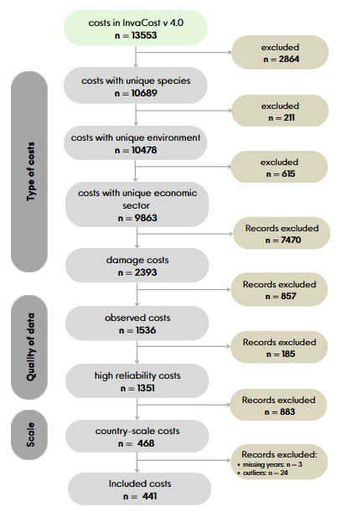
Figure S1. Data set filtering steps.

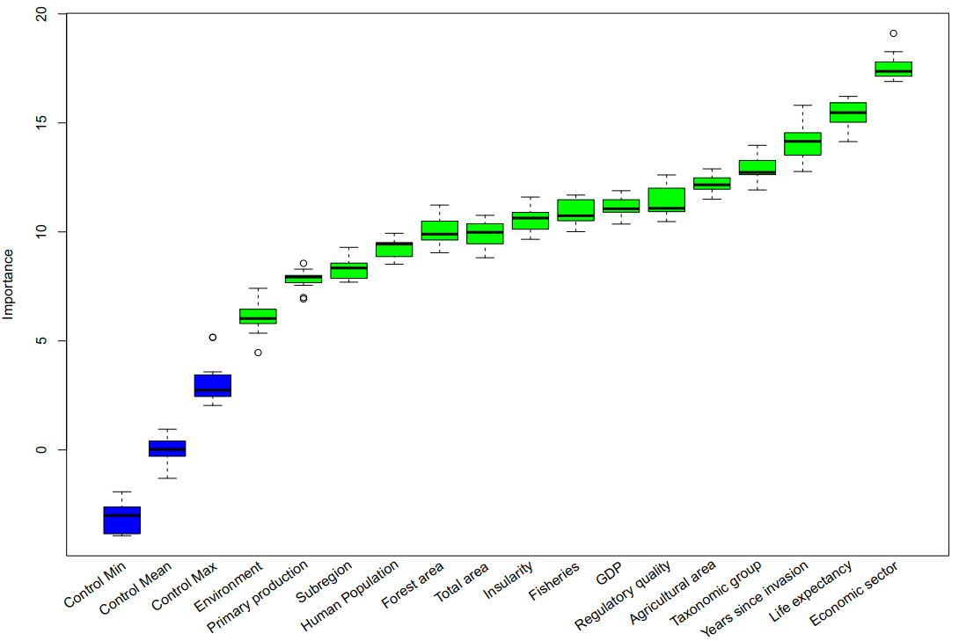
Figure S2. Predictor importance for estimating the global economic cost of invasive species. Increase in mean standard error calculated using the Boruta algorithm (Kursa et al. 2010). Blue boxes are control variables, obtained by randomly mixing the values of all predictors.

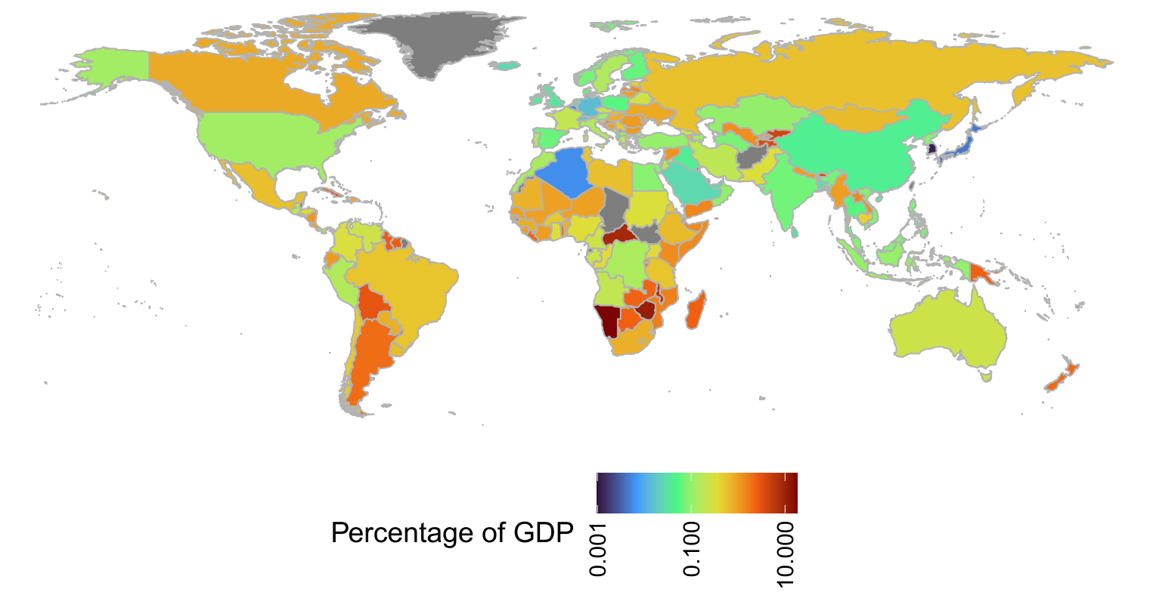
Figure S3 Global distribution of estimated mean annual economic damage costs of invasive species divided by country Gross Domestic Product. Countries depicted in gray lacked sufficient data for an estimation.

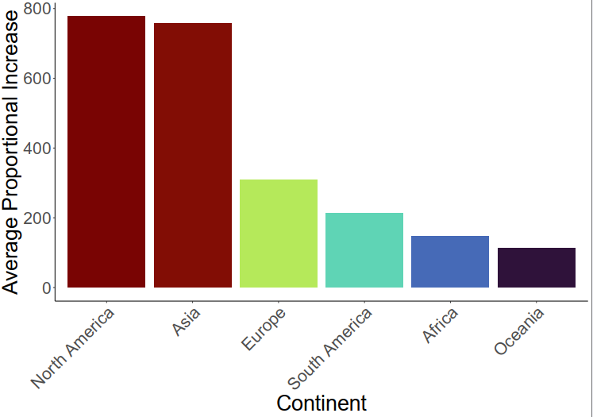
Figure S4 Average proportional cost augmentation by continent provided by our estimates of invasive species economic costs compared to initial costs used to train our models.

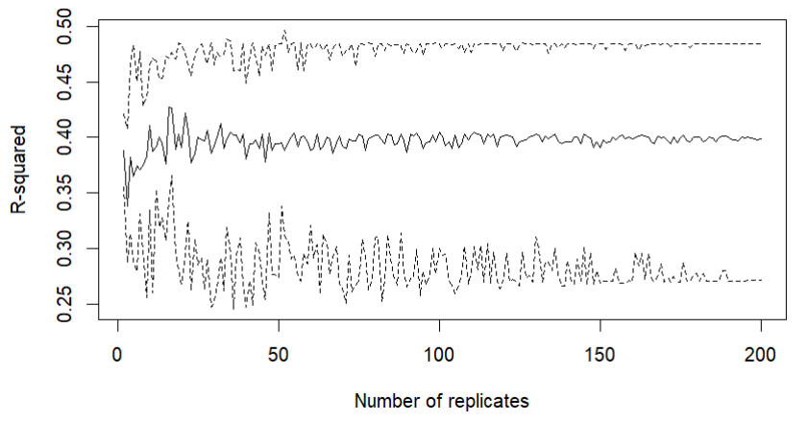
Figure S5. Median and confidence intervals of Random Forest R-squared, for one to 200 bootstrap replicates. Dashed lines represent the upper and lower 95% confidence intervals.

References

1. Diagne, C. et al. InvaCost, a public database of the economic costs of biological invasions worldwide. Scientific data 7, 277 (2020).
2. Leroy, B. et al. Analysing economic costs of invasive alien species with the invacost r package. Methods Ecol Evol 13, 1930–1937 (2022).
3. Kursa, M. B., Rudnicki, W. R. & Kursa, M. M. B. Package ‘Boruta’. The R Journal 15, (2018).
4. Kursa, M. B., Jankowski, A. & Rudnicki, W. R. Boruta–a system for feature selection. Fundamenta Informaticae 101, 271–285 (2010).
5. Jarić, I. et al. Crypticity in biological invasions. Trends in ecology & evolution 34, 291–302 (2019).
6. Bradshaw, C. J. et al. Comprehensive assessment of the economic costs of invasive species in Australia. NeoBiota. Special Issue “economic costs of invasive alien species worldwide (2021).
7. Pyšek, P. et al. Geographical and taxonomic biases in invasion ecology. Trends in ecology & evolution 23, 237–244 (2008).
8. Bellard, C. & Jeschke, J. M. A spatial mismatch between invader impacts and research publications. Conservation Biology 30, 230–232 (2016).
9. El Jamaai, J. et al. Biological invasions and their potential economic costs in Morocco. (2024).
10. Diagne, C. et al. Economic costs of invasive rodents worldwide: the tip of the iceberg. PeerJ 11, e14935 (2023).
11. Lane, M. A. & Edwards, J. L. The global biodiversity information facility (GBIF). Systematics Association special volume 73, 1 (2007).
12. Lowe, S., Browne, M., Boudjelas, S. & De Poorter, M. 100 of the World’s Worst Invasive Alien Species: A Selection from the Global Invasive Species Database. vol. 12 (Invasive Species Specialist Group Auckland, 2000).
13. Novoa, A. et al. Global costs of plant invasions must not be underestimated. (2021).
14. Roy, H. E., Pauchard, A. & Stoett, P. Thematic Assessment Report on Invasive Alien Species and their Control of the Intergovernmental Science-Policy Platform on Biodiversity and Ecosystem Services. (2023).
15. Vaissière, A.-C. et al. The nature of economic costs of biological invasions. Biol Invasions 24, 2081–2101 (2022).
16. Ahmed, D. A. et al. Managing biological invasions: the cost of inaction. Biol Invasions 24, 1927–1946 (2022).
17. Soto, I. et al. Monetary impacts should be considered in biological invasion risk assessments. Journal of Applied Ecology 60, 2309–2313 (2023).

