Supplementary figure 1 The APC of ASIR of injury in China,ASEAN countries and global from 1990 to 2021 (* means p-values < 0.05 and significant results).(a) Global; (b) China;(c) Brunei; (d) Cambodia; (e) Indonesia; (f) Laos; (g) Malaysia; (h) Myanmar; (i) Philippines; (j) Singapore; (k) Thailand; (l) Vietnam.
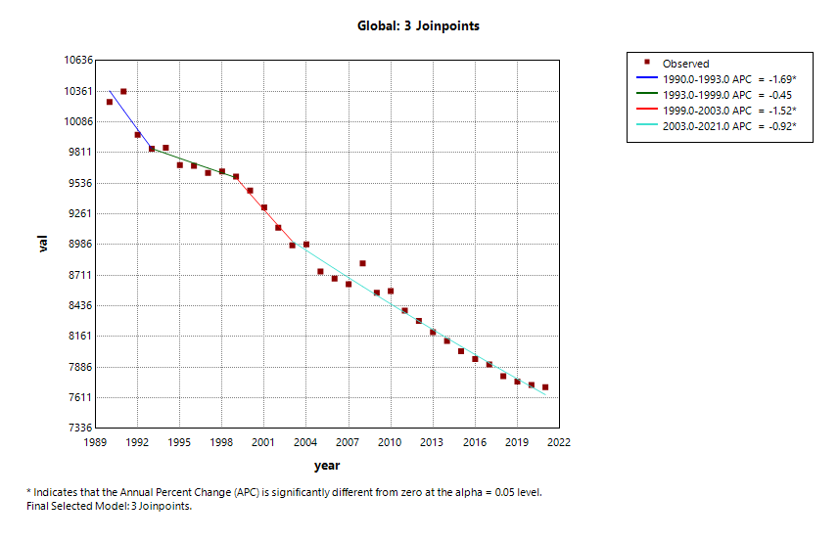 | 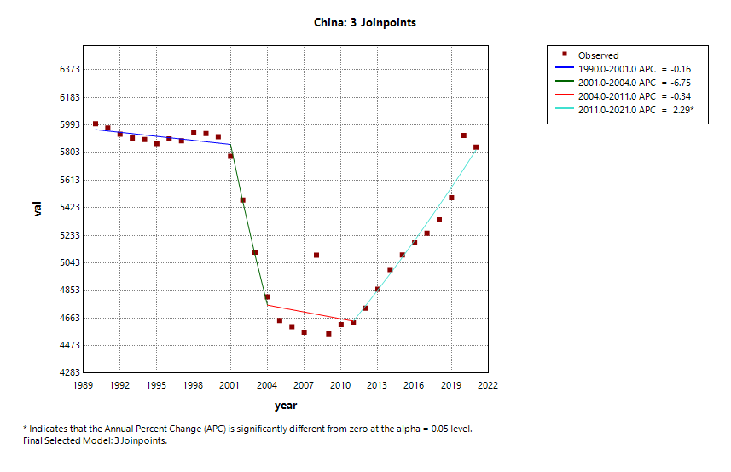
(a) | (b)
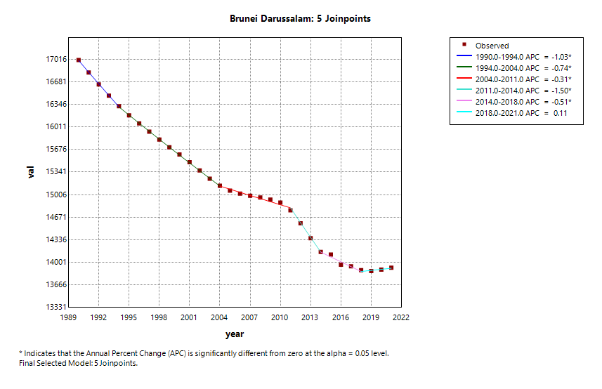 | 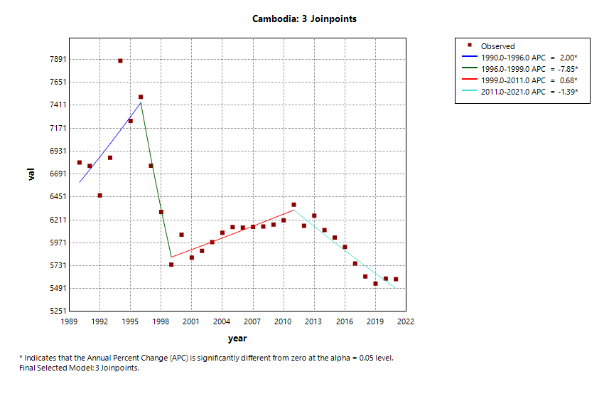
(c) | (d)
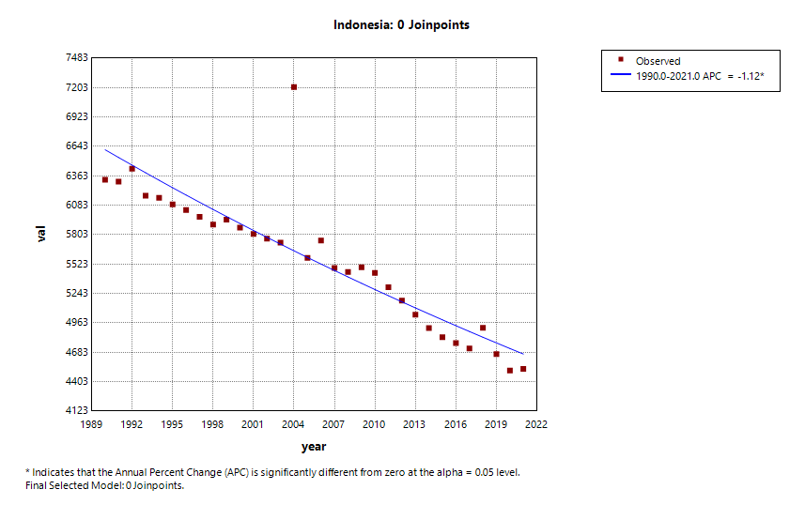 | 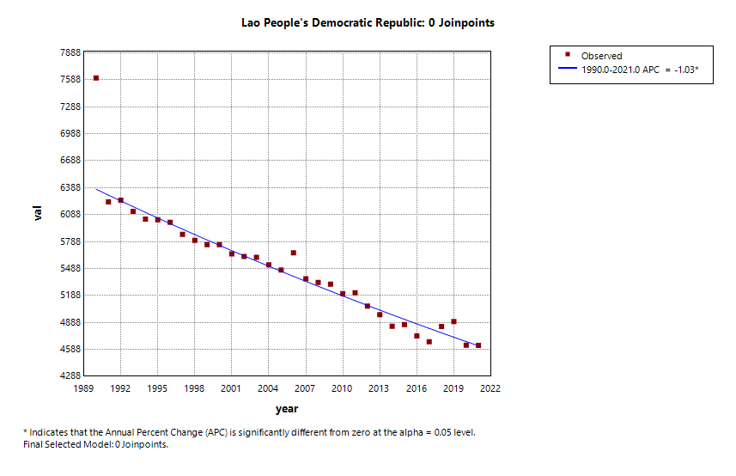
(e) | (f)
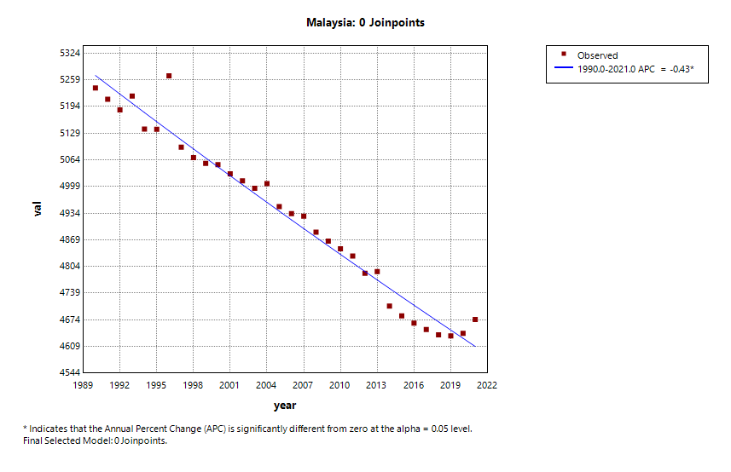 | 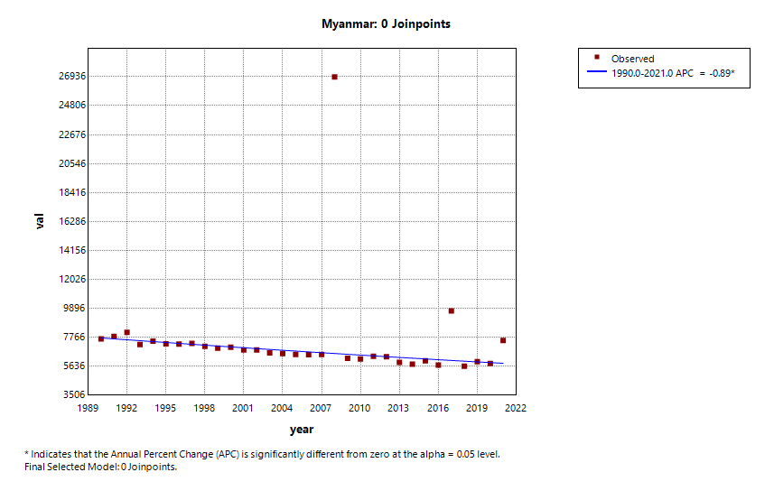
(g) | (h)
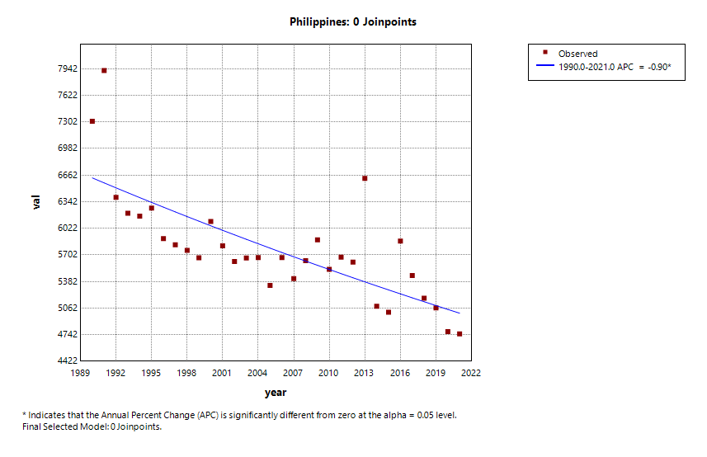 | 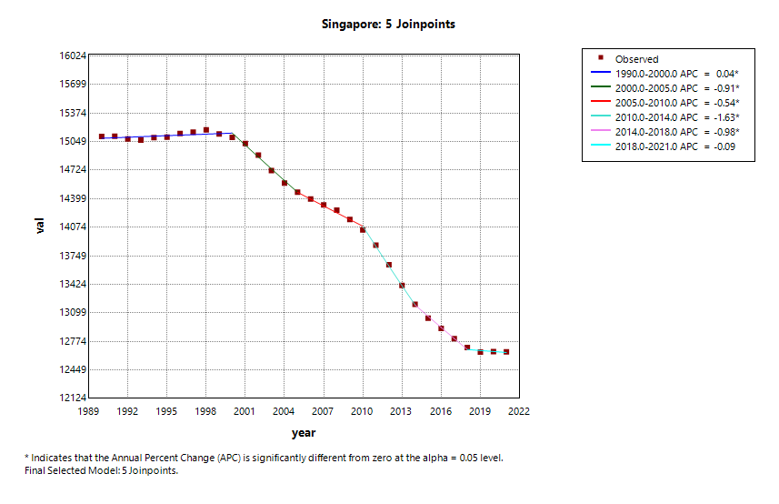
(i) | (j)
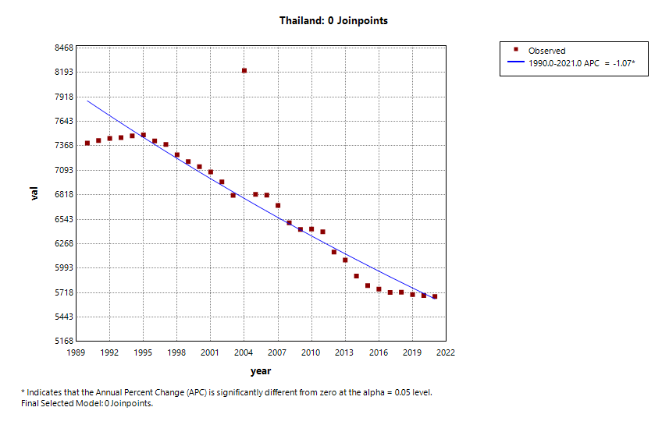 | 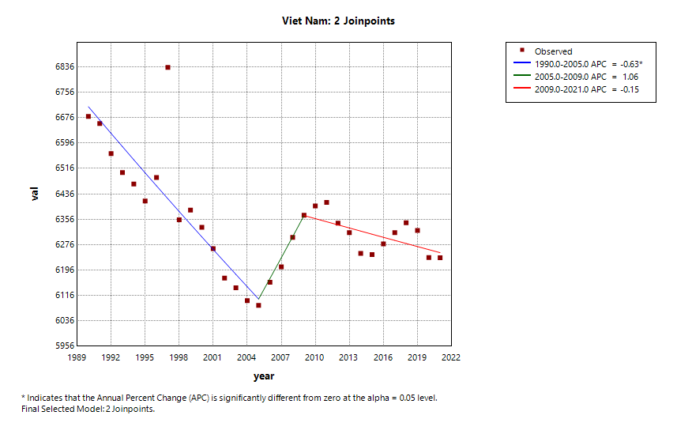
(k) | (l)

Supplementary figure 2 The APC of ASPR of injury in China,ASEAN countries and global from 1990 to 2021 (* means p-values < 0.05 and significant results).(a) Global; (b) China;(c) Brunei; (d) Cambodia; (e) Indonesia; (f) Laos; (g) Malaysia; (h) Myanmar; (i) Philippines; (j) Singapore; (k) Thailand; (l) Vietnam.
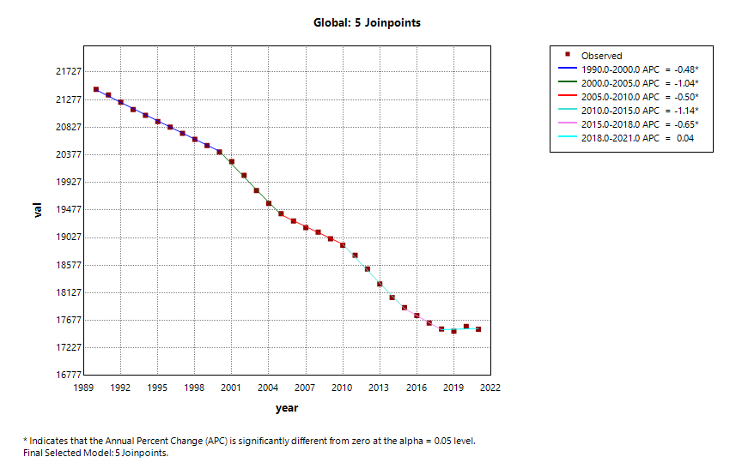 | 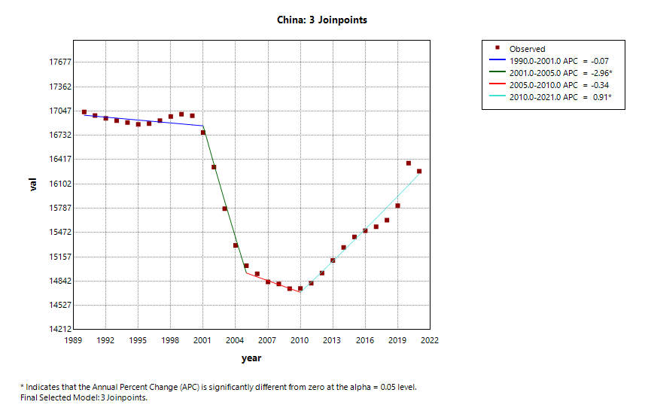
(a) | (b)
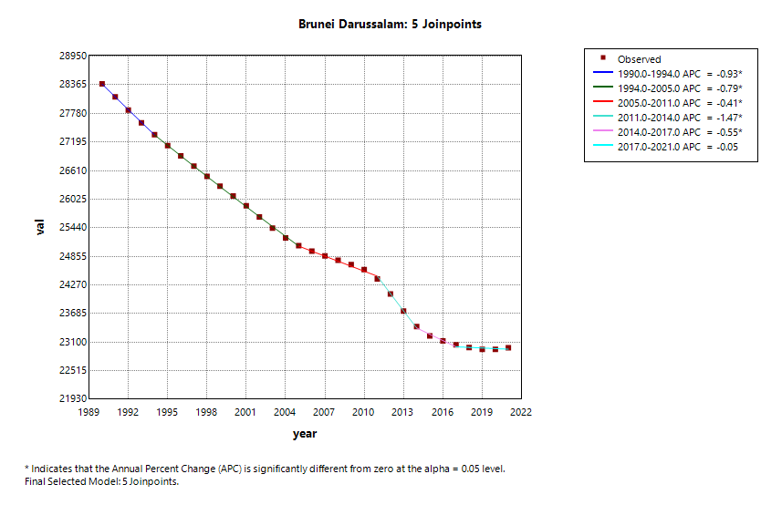 | 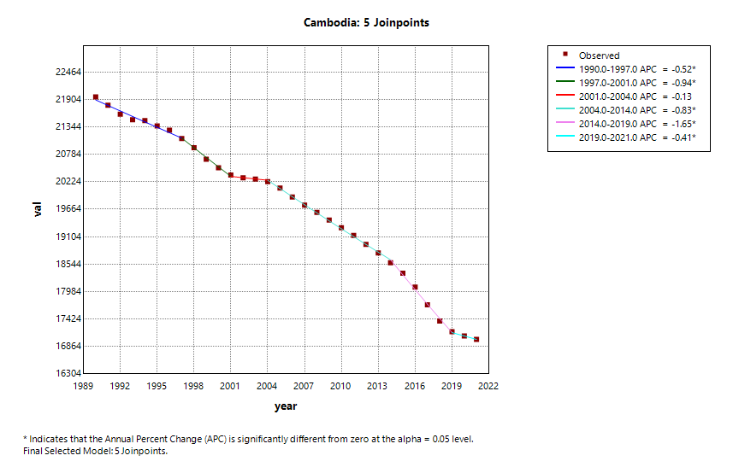
(c) | (d)
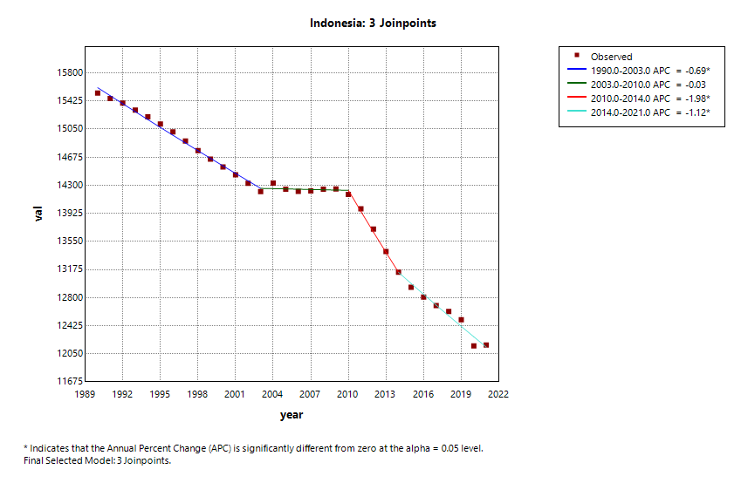 | 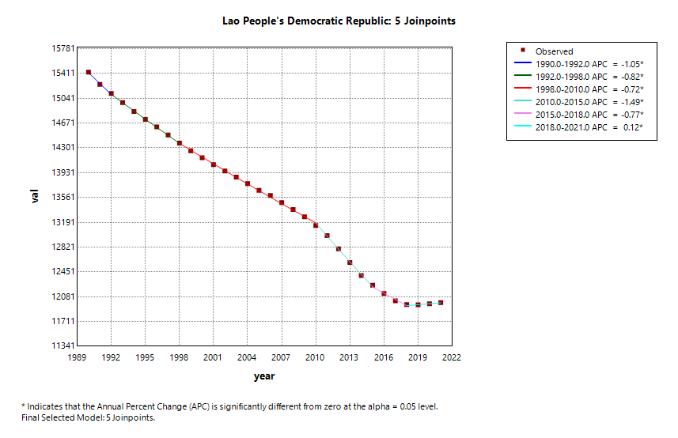
(e) | (f)
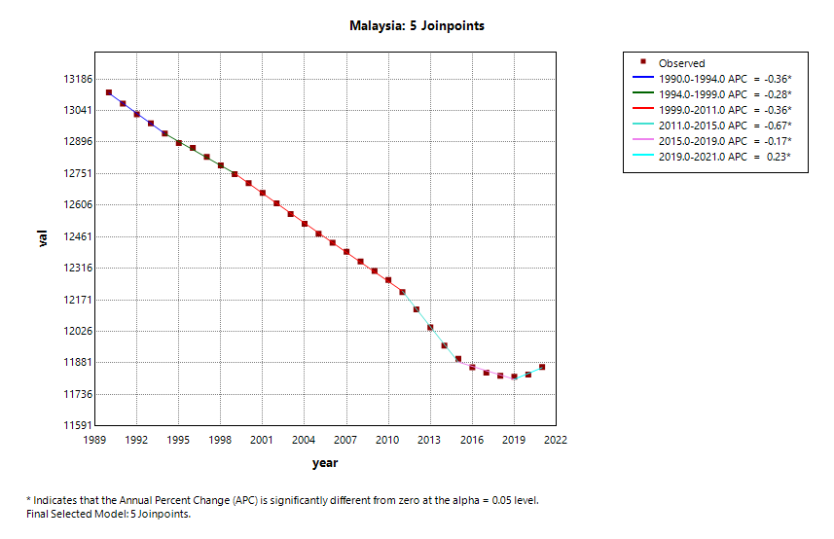 | 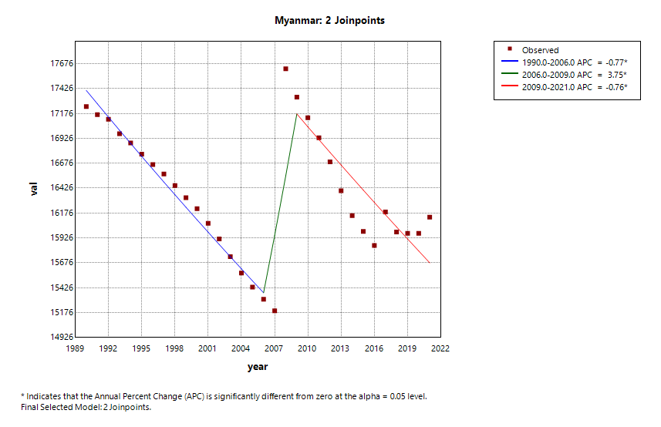
(g) | (h)
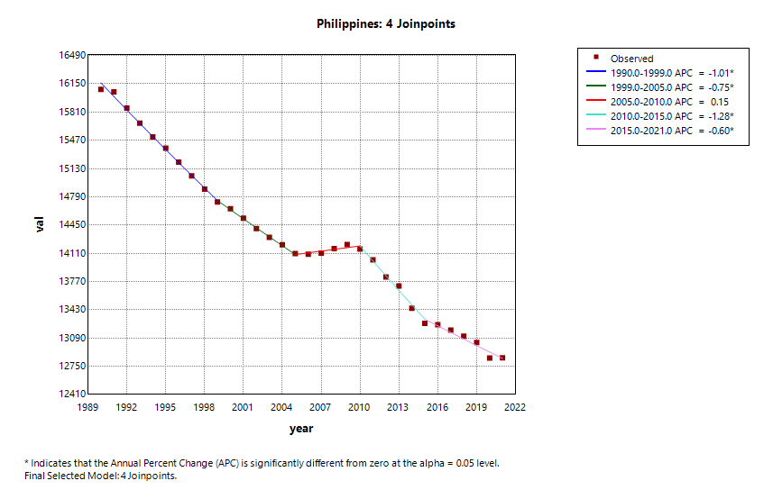 | 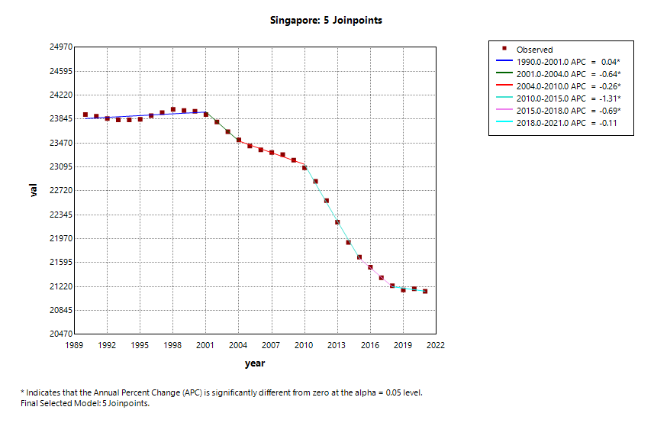
(i) | (j)
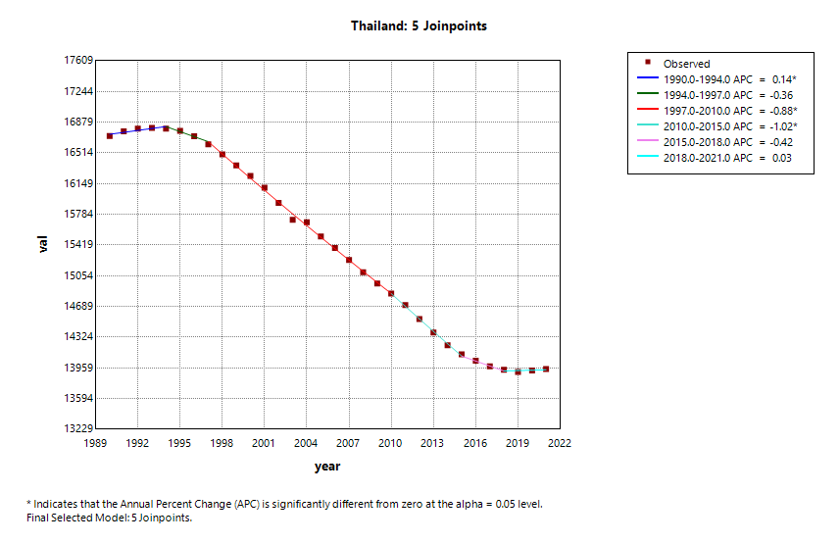 | 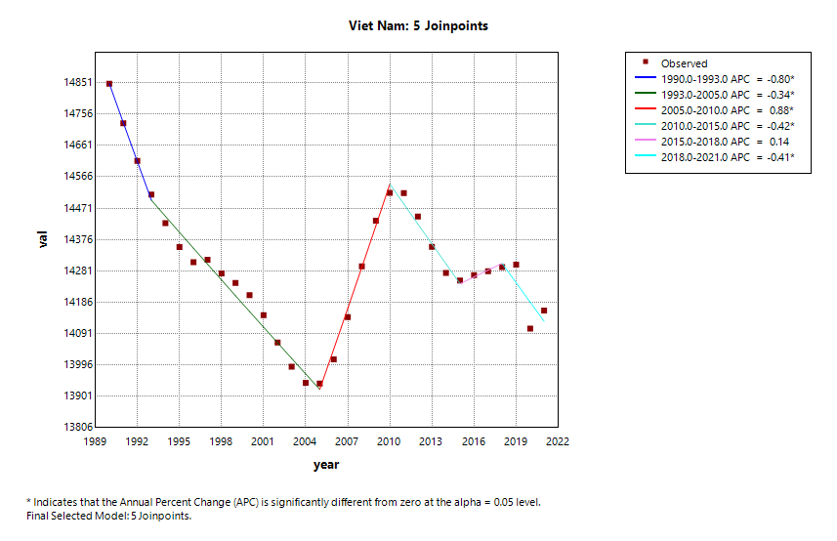
(k) | (l)

Supplementary figure 3 The APC of ASMR of injury in China,ASEAN countries and global from 1990 to 2021 (* means p-values < 0.05 and significant results).(a) Global; (b) China;(c) Brunei; (d) Cambodia; (e) Indonesia; (f) Laos; (g) Malaysia; (h) Myanmar; (i) Philippines; (j) Singapore; (k) Thailand; (l) Vietnam.
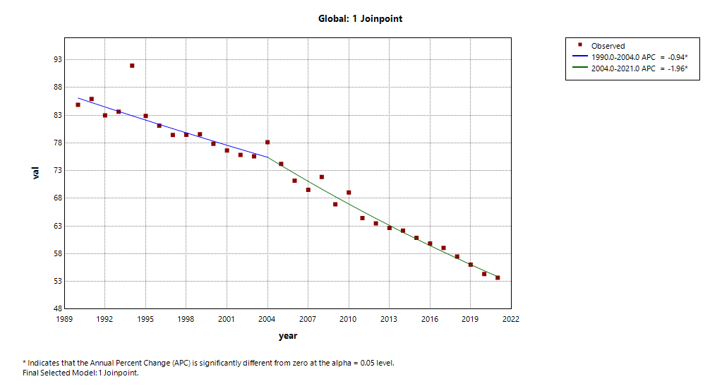 | 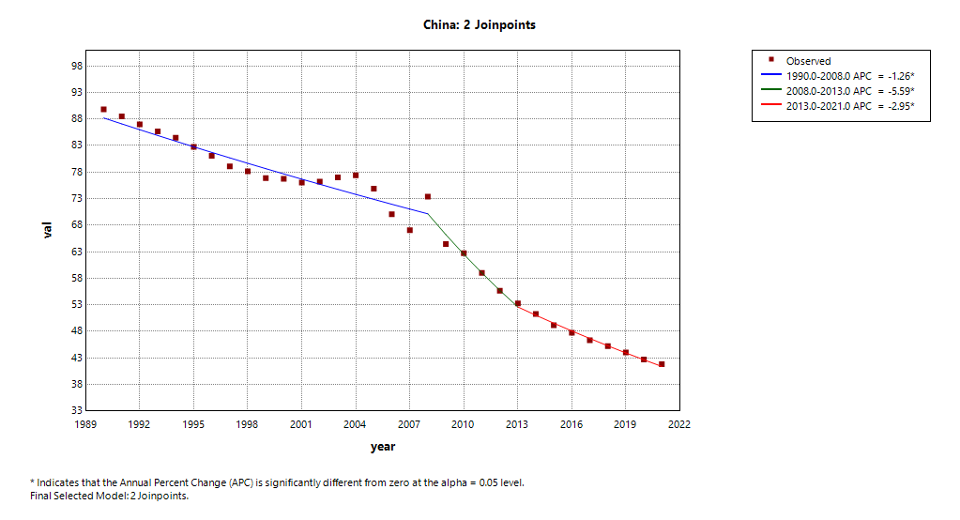
(a) | (b)
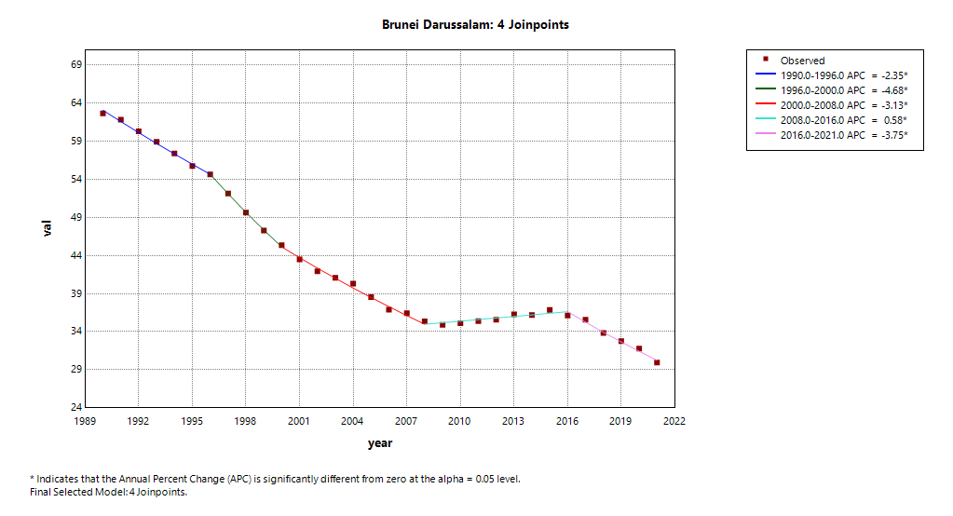 | 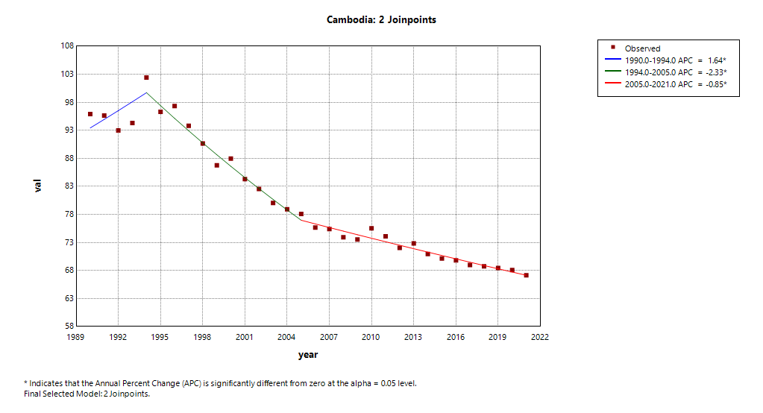
(c) | (d)
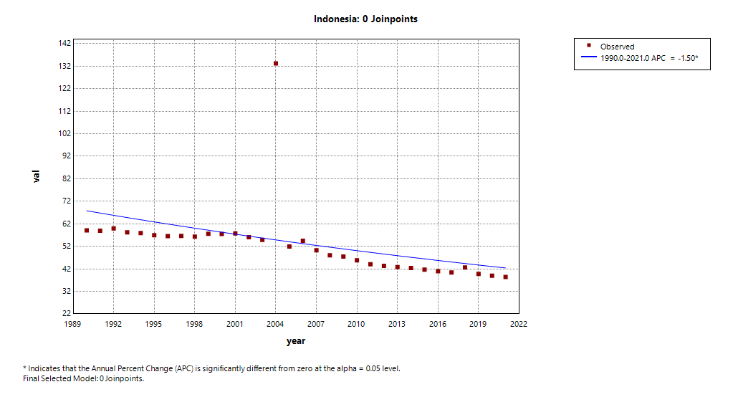 | 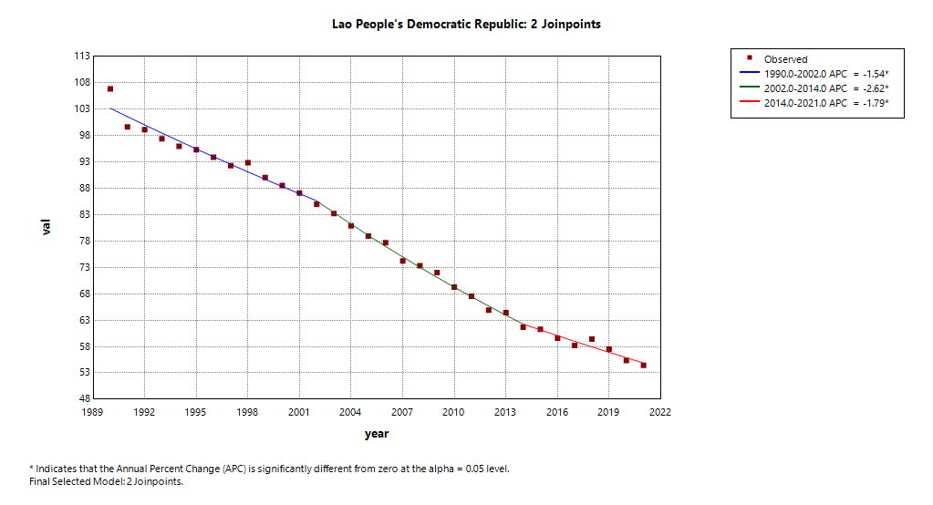
(e) | (f)
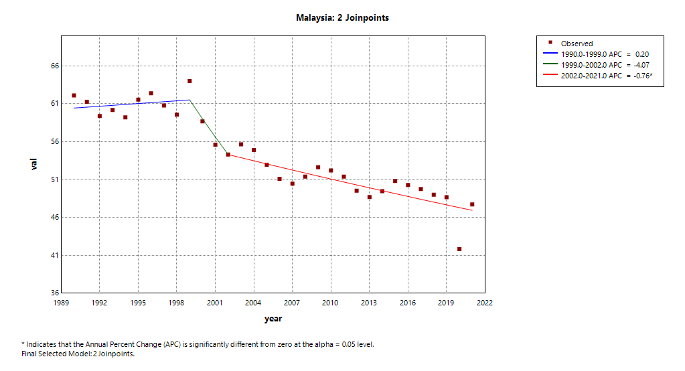 | 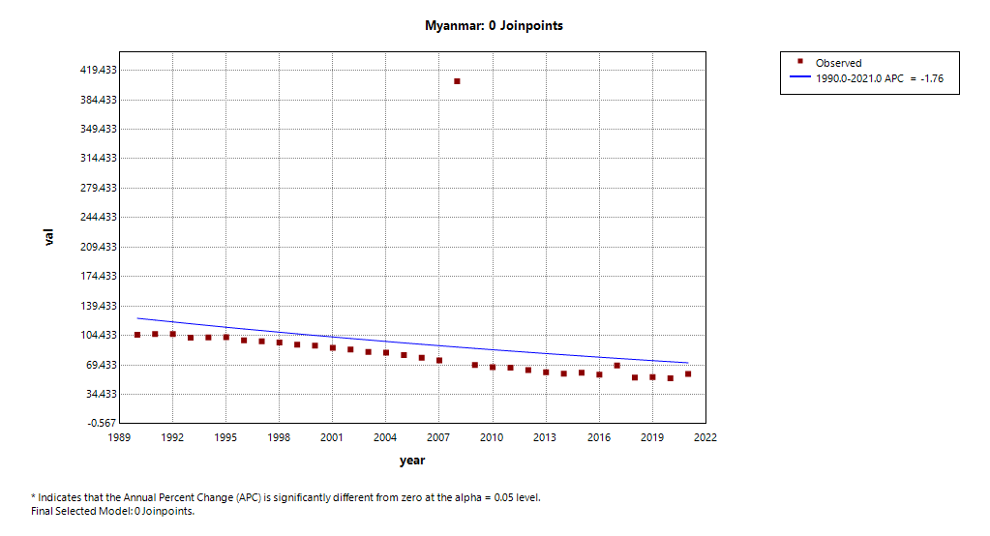
(g) | (h)
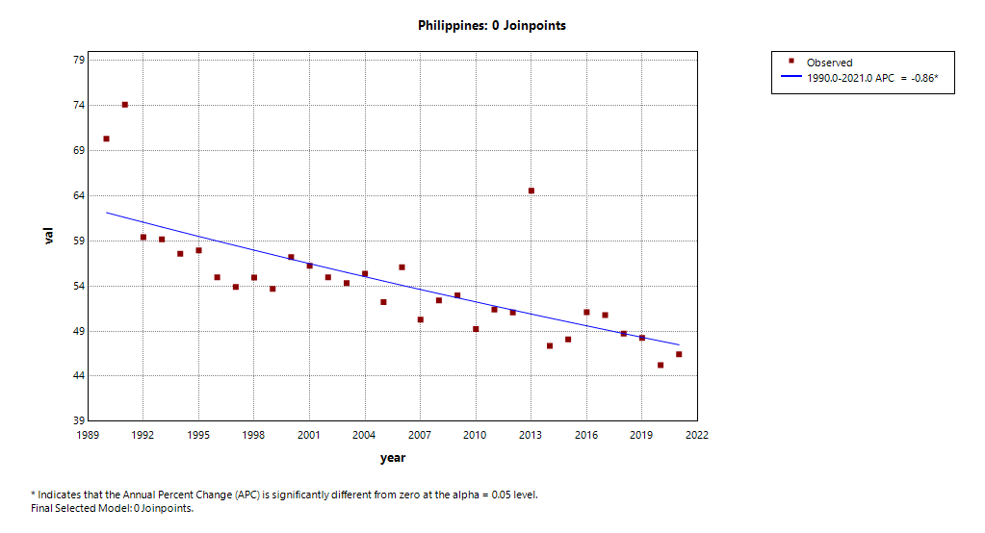 | 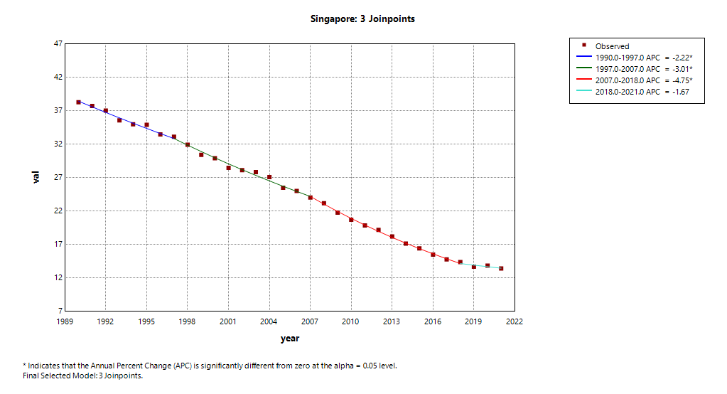
(i) | (j)
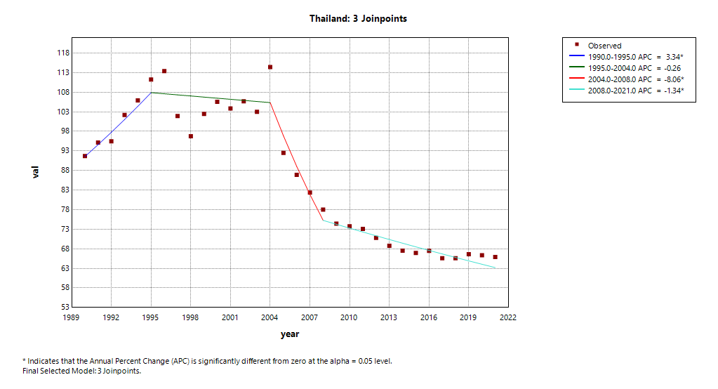 | 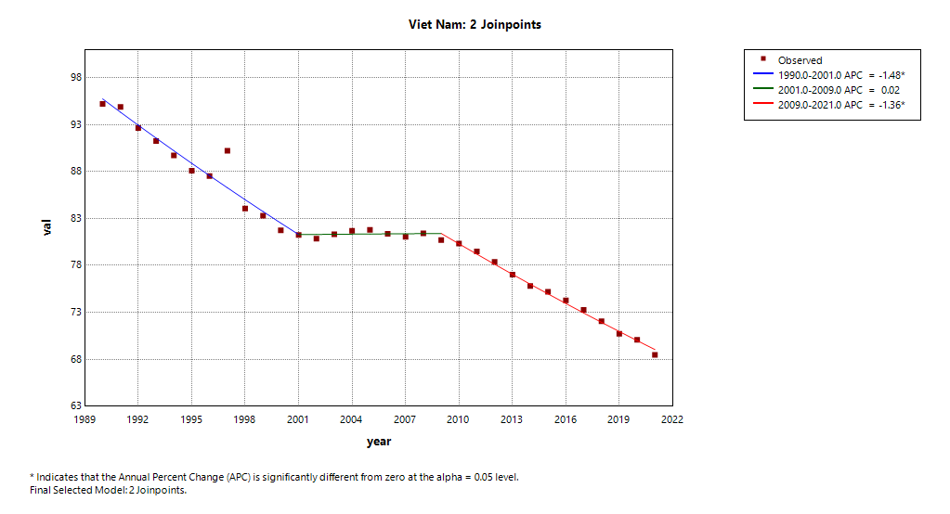
(k) | (l)

Supplementary figure 4 The APC of ASDR of injury in China,ASEAN countries and global from 1990 to 2021 (* means p-values < 0.05 and significant results).(a) Global; (b) China;(c) Brunei; (d) Cambodia; (e) Indonesia; (f) Laos; (g) Malaysia; (h) Myanmar; (i) Philippines; (j) Singapore; (k) Thailand; (l) Vietnam.
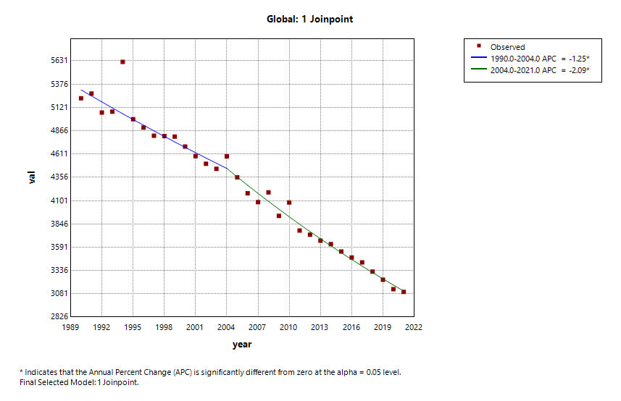 | 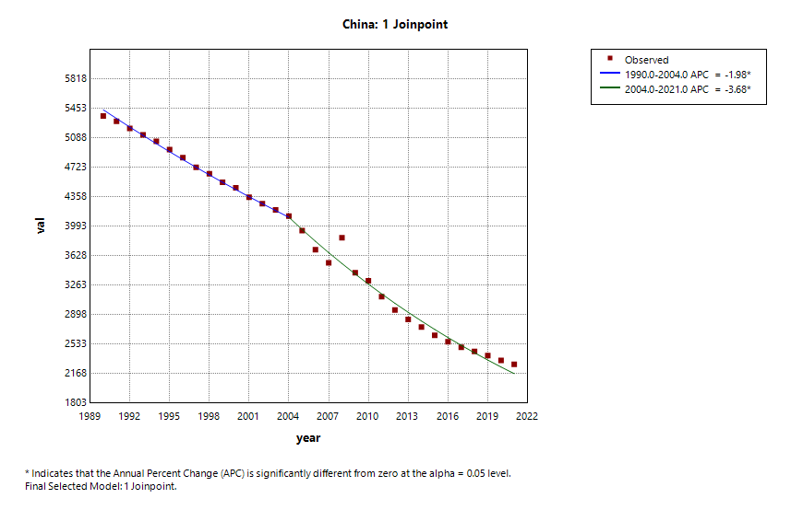
(a) | (b)
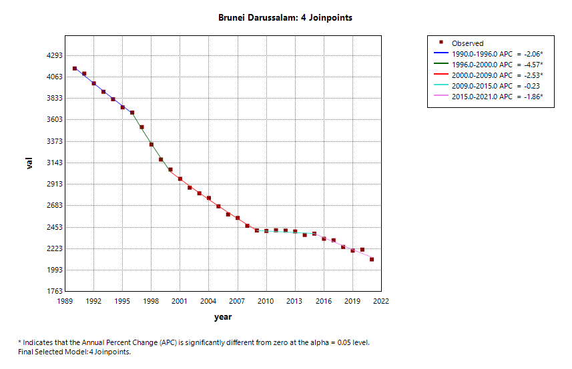 | 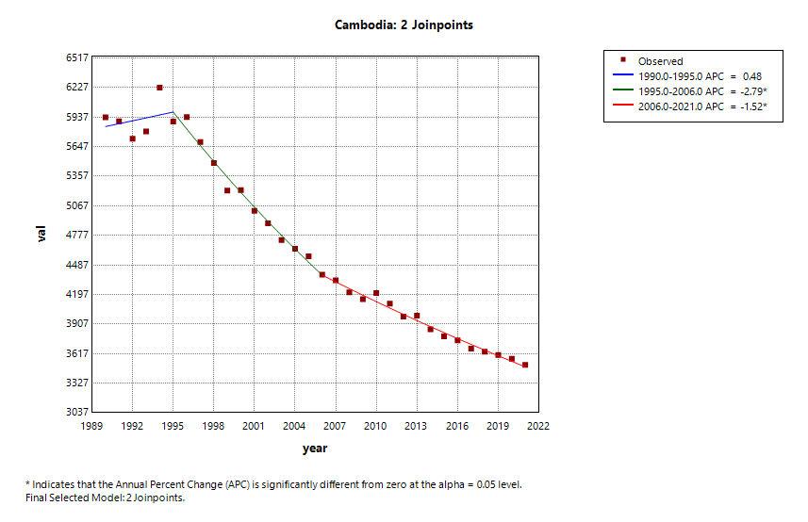
(c) | (d)
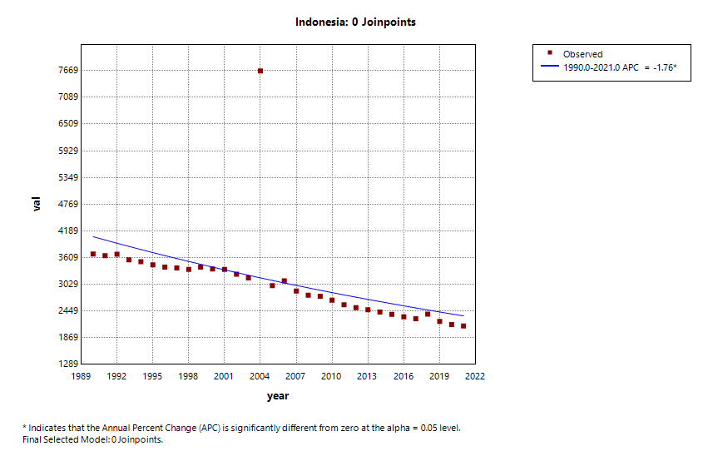 | 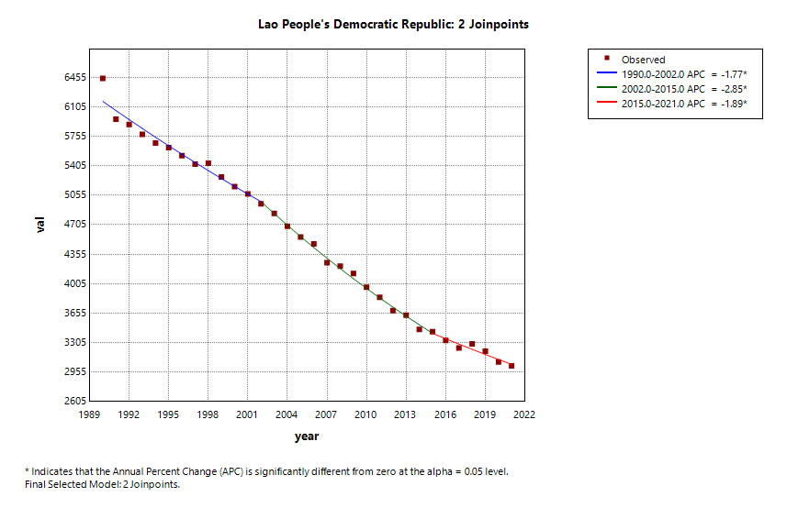
(e) | (f)
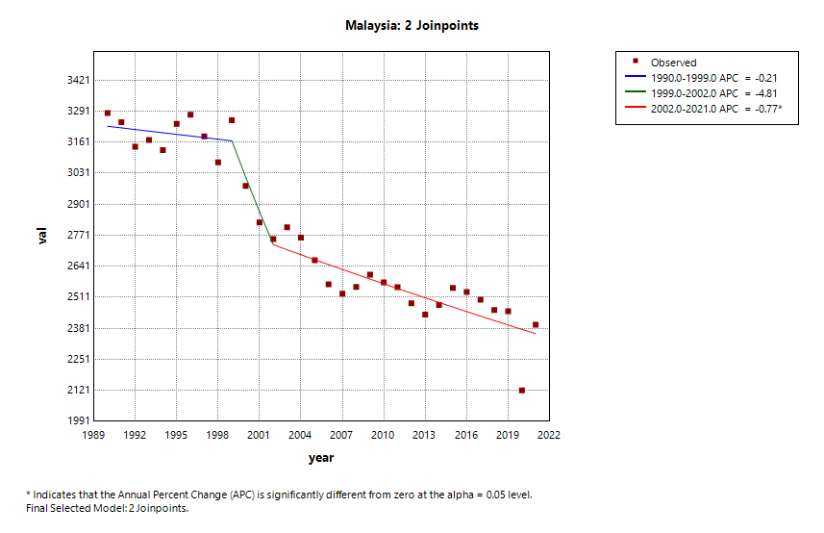 | 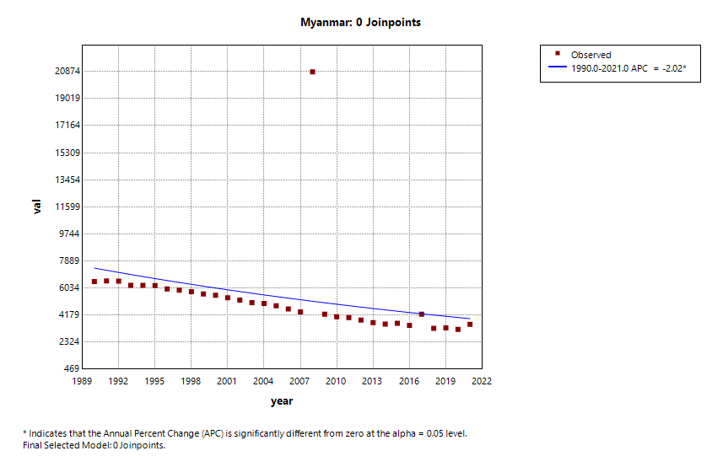
(g) | (h)
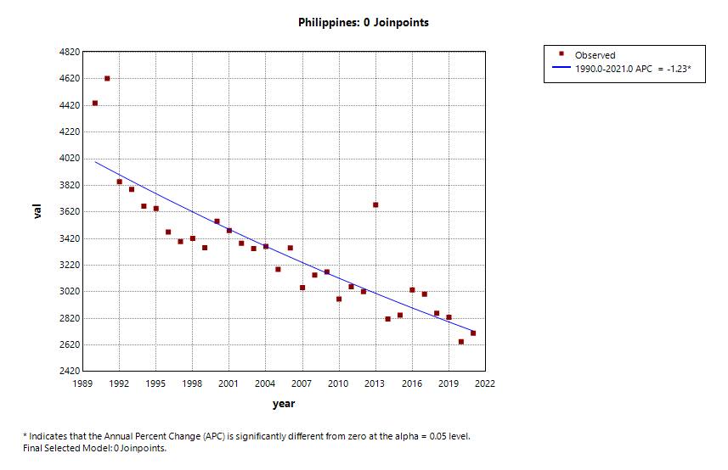 | 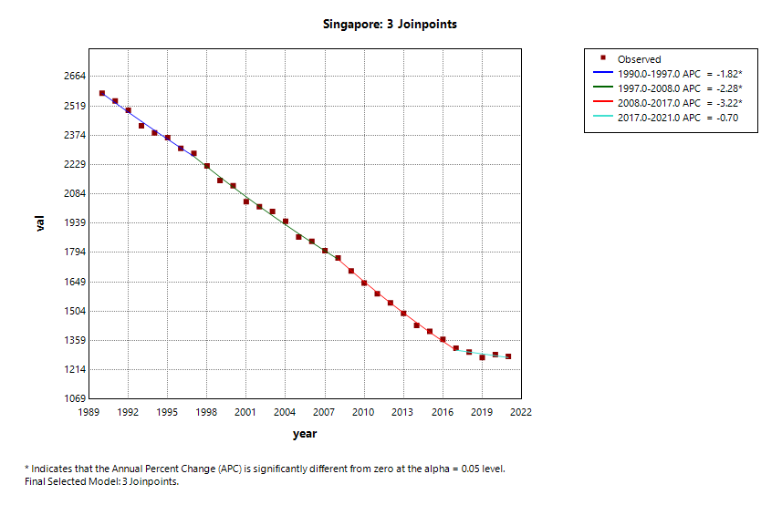
(i) | (j)
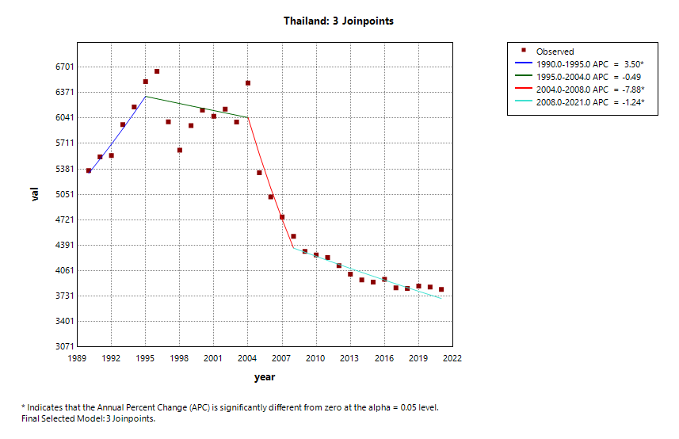 | 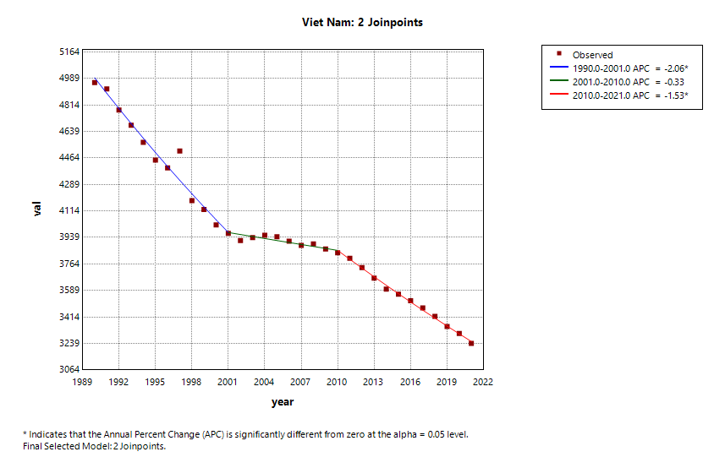
(k) | (l)

