Mass spectrometry-based thermostability profiling of virus-derived MHC peptide complexes serves as an effective predictor of immunogenicity

Mohammad Shahbazy ^{1,2,3}, Sri H. Ramarathinam ^{1,2}, David C. Tscharke ⁴, Chen Li ^{1,2}, Pouya Faridi ^{5,6}, Nathan P. Croft ^{1,2,}*, Anthony W. Purcell ^{1,2,}*
¹ Infection and Immunity Program, Biomedicine Discovery Institute, Monash University, Melbourne, VIC 3800, Australia
² Department of Biochemistry and Molecular Biology, School of Biomedical Sciences, Monash University, Melbourne, VIC 3800, Australia
³ Department of Immunobiology, Yale School of Medicine, Yale University, New Haven, CT, United States
⁴ John Curtin School of Medical Research, Australian National University, Canberra, ACT, Australia
⁵ Centre for Cancer Research, Hudson Institute of Medical Research, Clayton, VIC 3168, Australia
⁶ Monash Proteomics and Metabolomics Platform, Department of Medicine, School of Clinical Sciences, Monash University, Clayton, VIC 3800, Australia

* Corresponding authors. Email addresses: anthony.purcell@monash.edu (A.W.P.); nathan.croft@monash.edu (N.P.C.).

Supplemental Data
Please find the supplementary materials, including table sheets (calculated T_{m} values, predicted binding affinities, etc.) and thermostability (denaturation profiles) for the VACV peptides.

Supplementary Material
- S1: DDA database search results (from MSFragger search engine) from DC2.4 cells and VACV synthetic peptides:
S1_DBsearch_MSFragger_MSBooster_DC24_VACV.xlsx

- S2: Spectral library generated from DC2.4 cells and VACV synthetic peptides by DDA database search using MSFragger:
S2_SpectralLibrary_MSFragger_DC24_VACV.xlsx

- S3: Results outlined from SWATH-DIA thermostability data processing by Skyline (data acquired from small-scale IP of DC2.4 cells pulsed with VACV peptides):
S3_Skyline_ZenoSWATH_SL-MSFrgg_DC24_VACV_rawoutput.xlsx

- S4: Results outlined from SWATH-DIA thermostability data processing by DIA-NN (data acquired from small-scale IP of DC2.4 cells pulsed with VACV peptides):
S4_DIA-NN_ZenoSWATH_SL-MSFrgg_DC24_VACV_rawoutput.xlsx

- S4: Results derived from thermostability profiling to calculate T_{m} values by SWATH-DIA data analysis alongside predicted binding affinities by NetMHCpan4.1 for the thermostability-profiled endogenous H-2Db/Kb and VACV peptides:
S4_H2DbKb_VACV_Tm_BA_ZenoSWATHdata_NetMHCpan.xlsx

- S6: Results derived from thermostability profiling to calculate T_{m} values by SWATH-DIA and MRMHR assays alongside other used features for ML modelling, e.g., experimental binding affinities (IC50), immunogenicity profiles/category, and measured CD8+ T cell responses, for the thermostability-profiled VACV peptides: S6_VACV_Tm_BA_ZenoSWATH&MRMhr.xlsx

- S7: Results outlined from MRM^{HR} thermostability data processing by Skyline (data acquired from small-scale IP of DC2.4 cells pulsed with VACV peptides):
S7_Skyline_MRMHR_SearchResults_VACV_rawreport.xlsx

Database: DBuniprot-reviewed_Mus-musculus_Mouse_VACV-WR_iRTs_19102022.fasta
A combined database of the mouse (Mus musculus; UP000000589) and vaccinia virus strain Western Reserve (VACV-WR; UP000000344) proteomes (UniProtKB/SwissProt v.19102022; 17,560 entries).
Datasets availability:
For DDA data acquired from the DC2.4 dendritic cell line and synthetic VACV by DDA LC-MS/MS (n = 27), the accession code is PXD057866 (Username: reviewer_pxd057866@ebi.ac.uk - Password: kYZxYytIptVf). DC2.4 cells pulsed by VACV peptides Zeno SWATH-DIA LC-MS/MS (n = 30) and LC-MRM^{HR} (n = 30) data were deposited under the dataset identifier PXD057919 (Username: reviewer_pxd057919@ebi.ac.uk - Password: wBb44QKOBrA0) and PXD058188 (Username: reviewer_pxd058188@ebi.ac.uk - Password: EKCLoDDnM01e), respectively. All search and results summaries were deposited (also provided as Supplementary Data) with the corresponding datasets.

Supplementary Results
Regular immunopeptidomics data analyses were performed to examine the sequenced peptides, confirm their sequence motifs, and exclude contaminant sequences from the spectral library (Figure S1 – Supplemental Data). This spectral library, containing the endogenous murine peptides and the VACV peptides, was utilised to match the peptides sequenced by DIA data in each temperature treatment to monitor the thermostability of pMHC complexes. Thus, the spectral library of 10,056 H-2Db and H-2Kb endogenous peptide binders (expressed on DC2.4 dendritic mouse cells) as well as 119 VACV exogenous MHCI peptides with confident spectra (out of 122 VACV synthetic peptides). This means this MS-immunopeptidomics identification workflow yielded a 97.5% recovery, and three peptides were missed due to low-quality spectra.
The GibbsCluster (ver. 2.0) tool was used for cluster analysis of immunopeptides eluted from the DC2.4 cell line. Through the calculated KLD scores, the optimal number of allelic-based clusters was determined (n = 2; Figure S1A – Supplemental Data). The generated sequence motifs corresponding to these two clusters were evaluated and demonstrated the presence of the H-2D^{b} and -2K^{b} MHCI peptide ligands in accordance with the expected sequence logo in the literature (Figure S1B-C – Supplemental Data). The length distribution of the identified peptides in the DDA spectral repertoire shows the main proportion of MHCI peptide data (sequence length of 8-to-14-mer) isolated using antibodies immunoaffinity purification where most H-2D^{b} and H-2K^{b} peptide ligands are 9-mer and 8-mer, respectively (Figure S1D – Supplemental Data). We utilised NetMHCpan-4.1 to predict the binding of peptides to the two H-2^{b} MHC alleles, which indicated roughly equal numbers of H-2D^{b} (5,181 IDs, 52.28%) and H-2K^{b} (4,729 IDs, 47.42%) MHCI ligands in the generated spectral library (Figure S1D – Supplemental Data). The binding prediction analysis showed that the proportion of EL% rank-based classified binders of H-2D^{b} (3,913 strong and 1,192 weak binders) and H-2K^{b} (3,478 strong and 1,671 weak binders) alleles as the identified MHC ligands with a similar portion of peptide ligands as the weak binders for both alleles (Figure S5F – Supplemental Data). Based on the previous study results for MHC-specific binding of VACV peptides ¹, this set of identified peptides includes 66 H-2D^{b} and 53 H-2K^{b} viral ligands (Figure S1G-H – Supplemental Data).

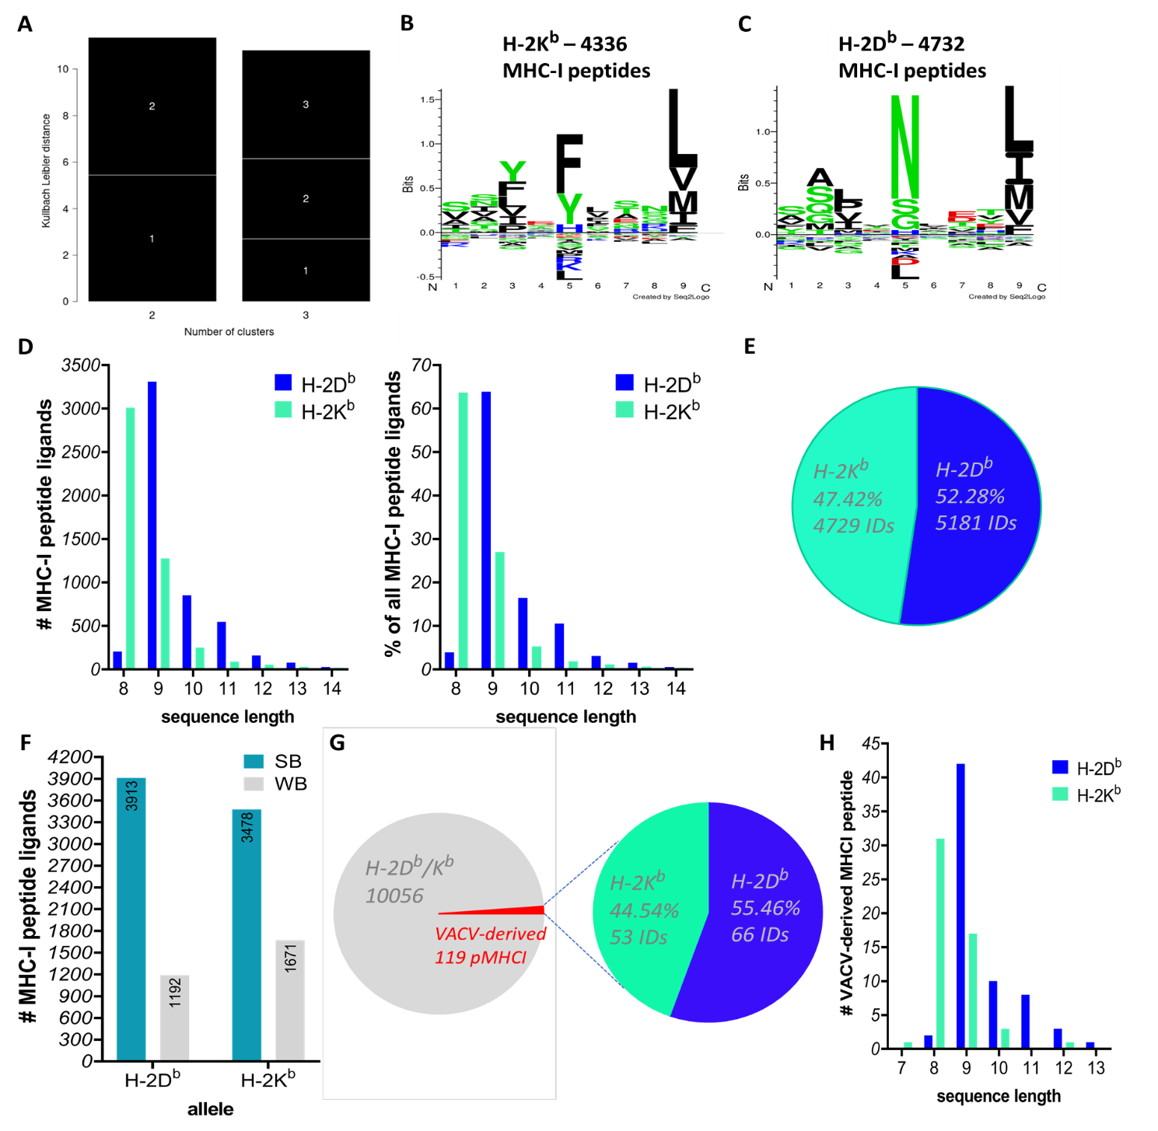
Figure S1. Analysis of the H-2^{b} and VACV MHCI peptide repertoire identified by the MS-immunopeptidomics discovery workflow to generate a spectral library from the DDA dataset. Cluster analysis of immunopeptidomes (H-2D^{b}/-2K^{b} MHCI peptides) eluted from the DC2.4 cell line by GibbsCluster (ver. 2.0) tool. (A) The calculated KLD scores identify the optimal number of allelic-based clusters (n = 2). (B)-(C) The generated sequence motifs from the GibbsCluster were assessed to approve the presence of the specific MHCI peptide ligands (H-2D^{b} and H-2K^{b} binders) in accordance with the expected sequence logo in the literature. (D-E) The spectral library contains 10,056 MHCI-restricted peptide ligands eluted from DC2.4 cells containing H-2D^{b} and H-2K^{b} binders. (D) Length distribution of the identified peptides in the DDA spectral repertoire shows the main proportion of MHCI peptide ligands (sequence length of 8-to-14-mer) data isolated using the Y-3 and 28-14-8S antibodies. Most peptides are 9-mer and 8-mer in length for H-2D^{b} and H-2K^{b} alleles, respectively. (E) NetMHCpan-4.1 was utilised to predict the binding likelihood of peptides to MHCI alleles with known sequences through the ANN model, confirming the main portion of the spectral library is the repertoire of H-2D^{b} ligands (52.28%) and H-2K^{b} (47.42%). (F) Assessment of the proportion of 1192 weak and 3913 strong binders of the H-2D^{b} allele compared with 1671 weak and 3478 strong ligands of the H-2K^{b} allotype. (G) The proportion of VACV peptides (119 MHCI peptides out of 10,056 IDs) in the spectral library contains 66 H-2D^{b} (55.46%) and 53 H-2K^{b} (44.54%) binders. (H) Length distribution for 119 identified VACV-derived MHCI peptides per allele ranging from 7- to 13-mer.

The impact of the temperature treatments on cell lysate was monitored by analysing the number of identified peptides across thermal treatments from 37℃ to 73℃, which shows the logical depletion trend throughout the data points (Figure S2A – Supplemental Data). To further analyse the overall effect of thermal treatments across data points in the SWATH-MS data, we analysed the identified precursors integrated through extracted peak areas to demonstrate the visual differences in thermally-treated pMHC complexes. A heatmap of the normalised peak areas of the precursors (fold-changes relative to the reference temperature 37℃) (Figure S2B – Supplemental Data) demonstrated that, generally, at either 57℃ or 61℃, the thermal incubation resulted in the complete dissociation of most pMHC complexes, showing a consistent dissociation of pMHC complexes and subsequent decreased peptide-specific quantities upon applying the thermal gradient. A summary of the identification results shows at least ~2,400 MHCI peptides (up to ~3,600 by merging Skyline- and DIA-NN-derived thermostability profiles) at FDR of 5% have the potential for thermostability profiling across the temperature gradient incorporating the programmed computational workflow (Figure S2C – Supplemental Data).
To highlight significant differences between pMHC complexes quantified at 57℃ compared to 37℃, we analysed the quantities of the corresponding protein groups through a Volcano plot showing t-test derived p-values (-log₁₀) versus fold change differences (log₂) (Figure S2D). Although most of the protein groups (protein accessions corresponding with MHCI peptides) showed higher fold-change and signal intensities, several protein groups (this set may include degraded proteins that are not related to MHCI peptides) have higher background signals upon treatment with higher temperature (57℃). Since most of the pMHC complexes were dissociated between 57℃-61℃, we analysed intensities of the precursors identified through SWATH-MS data in 57℃ and 61℃ using Volcano analysis (based on Z-scores). We observed that most endogenous H-2^{b} and VACV peptides possess significantly higher precursor signals at 37℃ than higher temperatures. We assessed the significance of top-ten immunogenic VACV peptides (based on the work by Croft et al. ¹), where all peptides except ITYRFYLINL (H-2K^{b} MHCI peptide) showed a higher MS signal at 37℃ (Figure S2E-F).

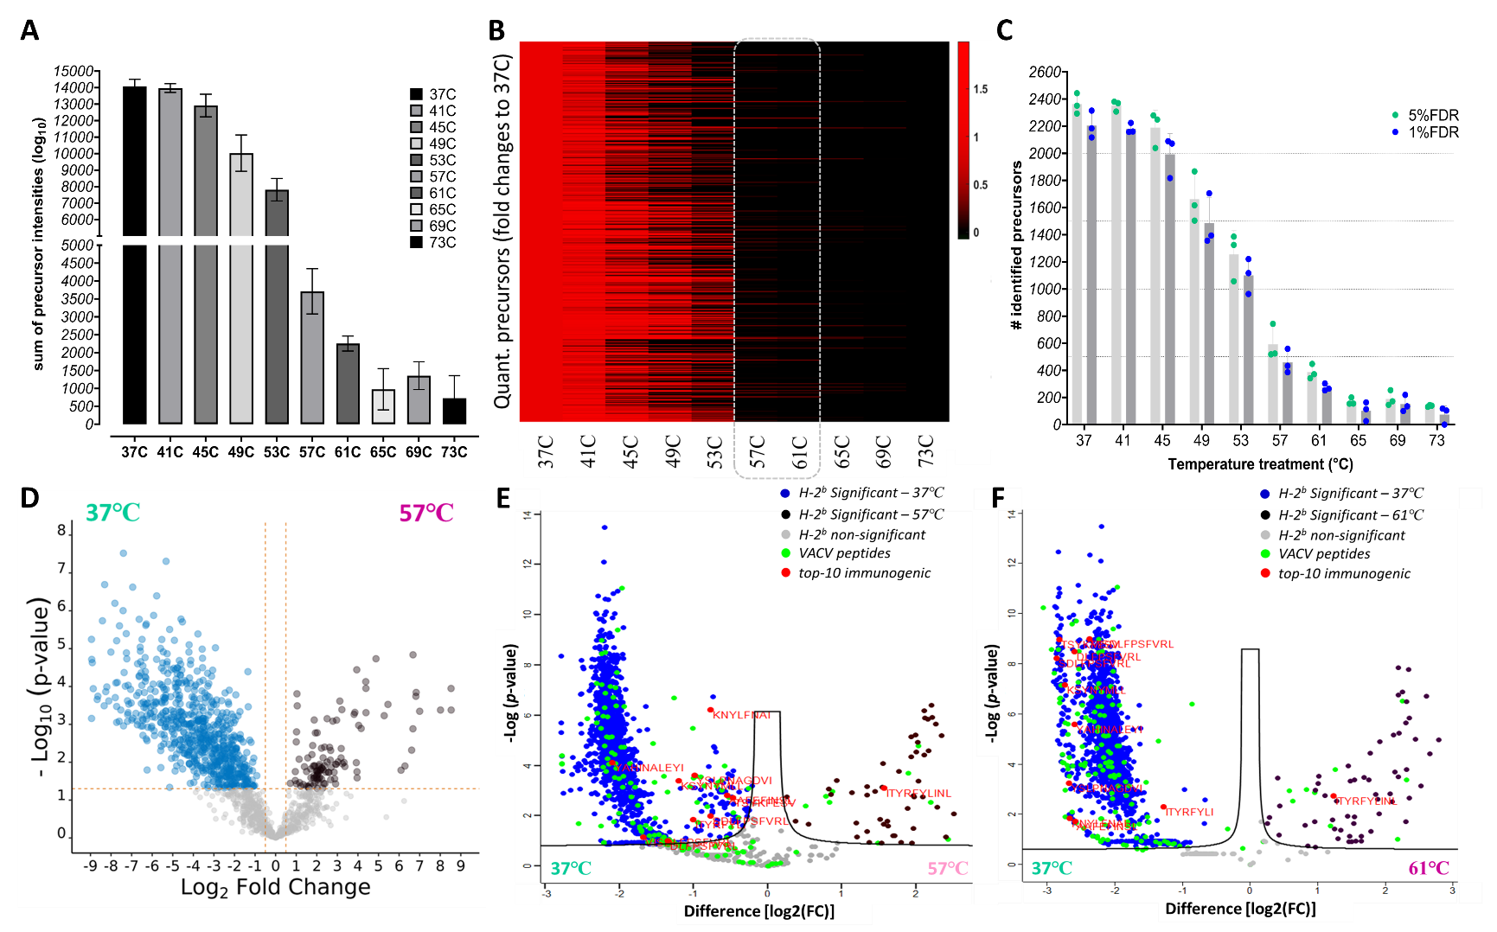
Figure S2. Data visualisation of the SWATH-MS thermostability data and an analysis of identification and the intensities of precursors across different temperatures.
(A) The sum of precursor MS signals (log₁₀) demonstrates a decreasing trend across temperature treatments. (B) A heatmap of the normalised peak area of the precursors after pre-processing for pMHC quantification over different temperatures. (C) The identification results from SWATH-MS data (at both FDR cut-off of 5% and 1%) where at least ~2,400 MHCI H-2D^{b}/K^{b} peptides (eluted from the DC2.4 cells) can be analysed for thermostability profiling across the temperature gradient (for the data at 5% FDR). (D) A Volcano plot shows significant differences between pMHC complexes quantified at 57℃ (compared to 37℃ as the reference temperature) through the quantities of the corresponding protein groups as t-test p-values versus fold change differences (log₂). The Volcano plot was generated by the “ggVolcanoR” Shiny App ². (E-F) Volcano analysis at the precursor level to demonstrate significant differences in 57℃ and 61℃. The Volcano analysis (based on Z-scores) assessed intensities of the precursors identified in SWATH-MS data at (E) 57℃ and (F) 61℃ compared with 37℃ as the reference data point. This analysis showed that most H-2^{b} and VACV peptides have significantly higher precursor signals at 37℃ than either 57℃ or (especially) 61℃.

We implemented the hierarchical clustering analysis on 1907 H-2b MHCI peptide-derived precursors. We assessed error bands per temperature-treated replicate by minimal and maximal Z-scores (whole-range scale) in each data point to confirm the categorisation of these profiles as non-, semi-, and (highly)-stable (Figure S3A – Supplemental Data). We also evaluated the band errors based on 95% confidence intervals per replicate throughout the gradient to validate the bands statistically and compare the profiles more effectively (Figure S3B – Supplemental Data).
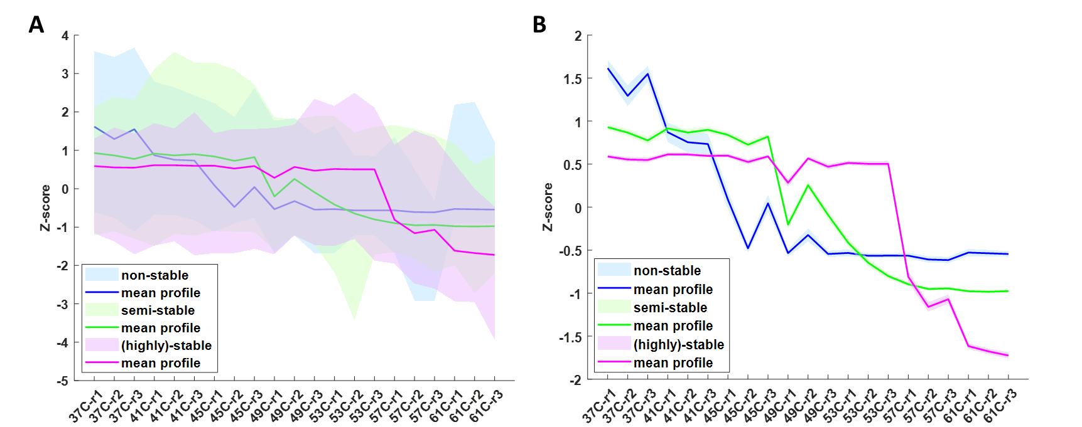
Figure S3. Analysis of error bands across the temperature-treated replicates in the thermostability profiles derived from the hierarchical clustering analysis of 1907 H-2^{b} MHCI peptide-derived precursors. (A) The error bands, per each temperature-treated replicate, by minimal and maximal Z-scores (whole-range scale) in each data point to compare the categories of these profiles as non-, semi-, and (highly)-stable. (B) The band errors of the derived-stability profiles, based on 95% confidence intervals per replicate throughout the gradient, were used to compare the profiles statistically.

We implemented the hierarchical clustering analysis on 159 VACV peptide-derived singly- and doubly-charged precursors (corresponding to 119 unique VACV peptide sequences). We again observed three overall thermostability profiles for the VACV peptides in row-wise clusters. This assessment demonstrated the top-three clusters as non-stable, semi-stable, and (highly)-stable profiles (Figure S4A – Supplemental Data). We analysed these profiles through the error bands as whole-range scales and 95% confidence intervals (Figure S4B-C – Supplemental Data).

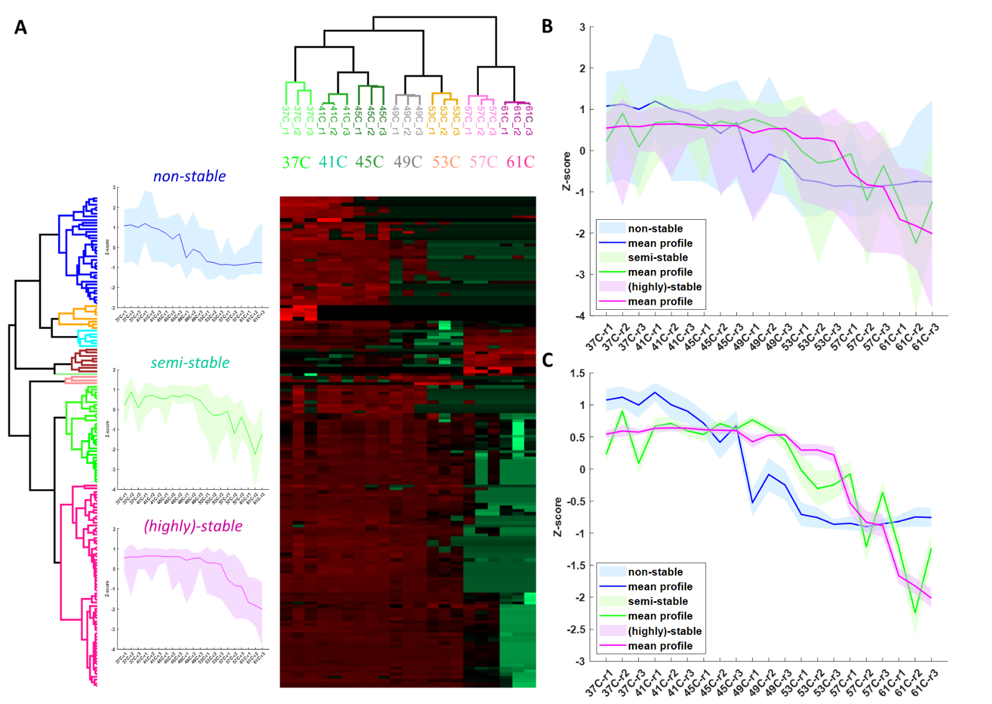

Figure S4. Hierarchical clustering analysis of the thermostability MS data of VACV MHCI peptides.
(A) The hierarchical clustering in both data directions (the precursors as the rows and the replicates as the columns) to visualise the thermostability data of 119 VACV MHCI peptides. This analysis shows the clear segregation of replicates in the column direction and the overall dedicated thermostability profiles as non-, semi-, and (highly)-stable profiles corresponding with the top three clusters. (B) The error bands per temperature-treated replicate by minimal and maximal Z-scores (whole-range scale) in each data point to compare the categories of these profiles as non-, semi-, and (highly)-stable. (C) The band errors of the derived-stability profiles based on 95% confidence intervals per replicate throughout the gradient.
The T_{m} values for these two alleles show very similar distribution; therefore, we utilised the F-test (which evaluates inter-allele and intra-allele variations of T_{m} values) to assess the significance between their variances (p-value of 0.0017) as well as the significance in the t-test statistics with a p-value of 0.0386 (Figure 2B Figure S5A – Supplemental Data). We initially profiled the thermostability for 98 of the pulsed VACV peptides using only the DIA-MS method. These peptides had a slightly higher median distribution than the endogenous repertoire, with a median of 48.06℃ (Figure 2D Figure S5B – Supplemental Data). We compared the distribution of T_{m} values of endogenous H-2b MHCI ligands and VACV peptides. This statistical analysis demonstrated a significant difference (by one-sample t-test, p-value < 0.0001), and the difference between variances was significant (p-value < 0.0001) (Figure 2D Figure S5B – Supplemental Data). The distribution of the calculated T_{m} values was assessed for the commonly profiled and unique peptides exclusively profiled by DIA and MRMHR thermostability assays (Figure S5C – Supplemental Data). This analysis shows a slight difference between the T_{m} distribution for the VACV peptides profiled uniquely by DIA (9 IDs) and MRMHR (12 IDs) data.
Croft et al. examined the distribution of T_{m} values for these peptides against the immunogenicity class established by T cell assay (Figure S5D – Supplemental Data), which reveals a consistent increase in the T_{m} values with immunogenicity. The T_{m} values of non-immunogenic VACV pMHCIs significantly differ from those in the major-immunogenic category. Significant differences were also found between T_{m} values of minor- and major-immunogenic peptides (Figure S5D – Supplemental Data). As a different representation, Figure S5E (Supplemental Data) shows the distribution of calculated T_{m} values for all 110 profiled VACV peptides, categorised based on immunogenicity class, revealing a positive shift in the T_{m} values for the major immunogenic peptides.
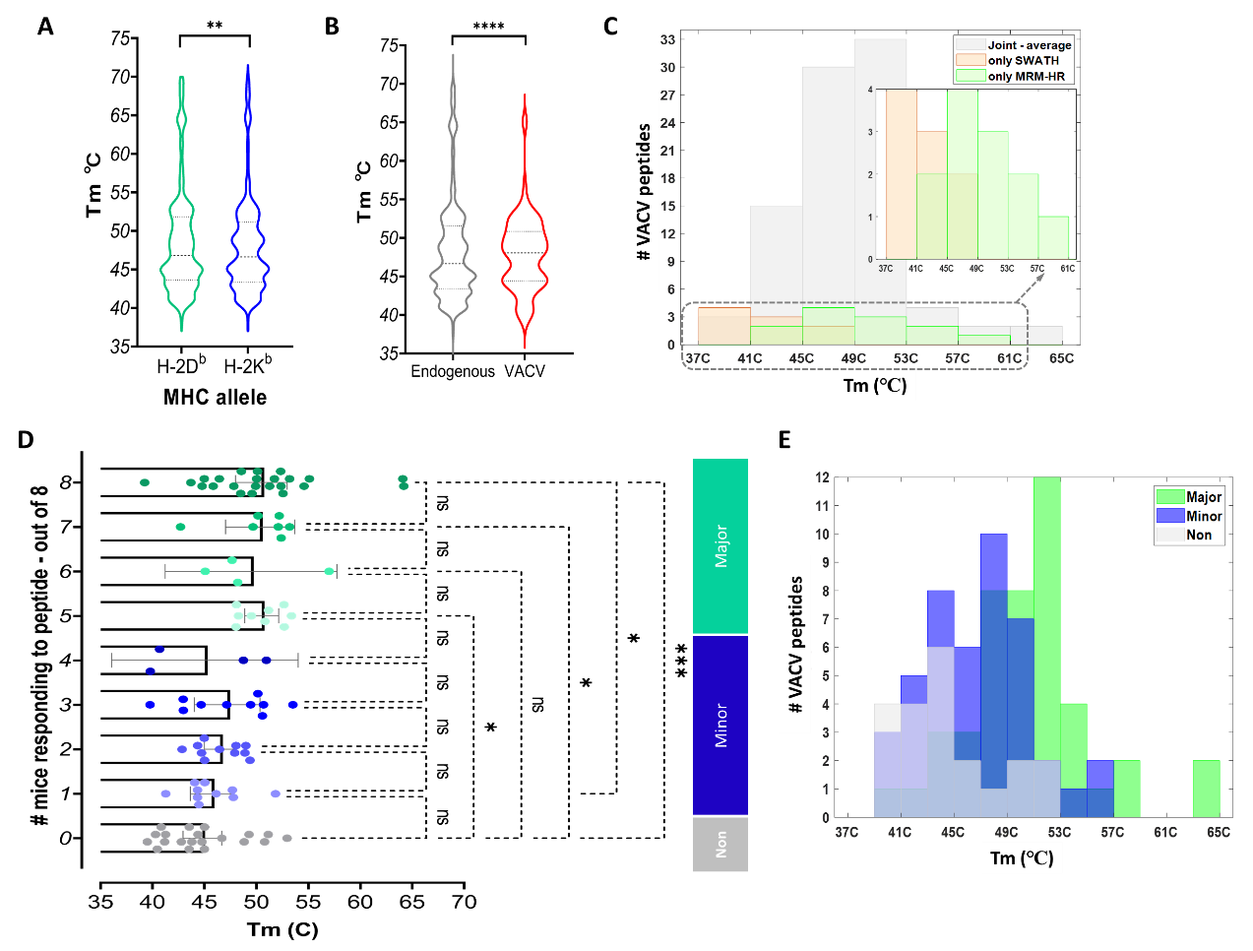
Figure S5. Analysis of MS-thermostability assay-derived thermostability profiles for H-2^{b} MHCI and VACV peptides, and association of T_{m} values with immunogenicity degree for VACV-derived pMHCs.
(A) The comparison between the variation of the calculated T_{m} values for H-2D^{b} and H-2K^{b} MHCI ligands (F-test with p-value of 0.0017 and t-test with p-value of 0.0386). (B) Comparison of the distribution of T_{m} values of endogenous H-2^{b} MHCI ligands and VACV peptides (one-sample t-test and F-test with p-value < 0.0001). (C) The distribution of the T_{m} values for the commonly profiled VACV peptides and unique peptides (exclusively profiled by MS-thermostability assays). (D) The distribution of T_{m} values for viral pMHC complexes across the number of mice responding positively to each VACV peptide revealed a gradual increase in the T_{m} values across the reactivity level of peptides out of eight immunogenicity measurements. (E) The distribution of the T_{m} values for 110 immunogenicity-ranked VACV peptides shows the shifts in the distribution to the higher T_{m} values for major and minor immunogenic VACV peptides. The ordinary one-way ANOVA (D) multiple comparison tests were used to determine the significance of the pairs. ns, not significant; *p-value < 0.05; **p-value < 0.01; ***p-value < 0.001; and ****p-value < 0.0001.
We analysed the Pearson correlations between the calculated T_{m} values in this study and measured anti-VACV CD8⁺ T cell responses for SWATH-DIA MS-thermostability assay (PCC = 0.509 for 98 VACV IDs, Figure S6A – Supplemental Data). We averaged T_{m} values for 89 commonly-profiled VACV peptides calculated across two MS thermostability assays (regarding their high correlation revealed in Figure 2D). Subsequently, we assessed the correlation between the averaged T_{m} values and anti-VACV CD8⁺ T cell responses with a PCC of 0.425 for all 110 profiled VACV pMHCIs. Within the major immunogenicity category, more stable peptides are identified as major epitopes than non- and semi-stable peptides, further confirming the relationship between thermostability and immunogenicity (Figure S6B-C – Supplemental Data). Within the major immunogenicity category, more highly stable peptides are identified as major epitopes than non- and semi-stable peptides, further confirming the relationship between thermostability and immunogenicity (Figure S6B-C – Supplemental Data). Besides, we evaluated the range of the calculated T_{m} values across three replicates (T_{m} bounds). The T_{m} bounds calculated for the joint VACV peptides profiled by both MS thermostability assays (i.e., SWATH-DIA and MRM^{HR}) and the bound profiles showed good accordance in most VACV peptides (Figure S6D – Supplemental Data).

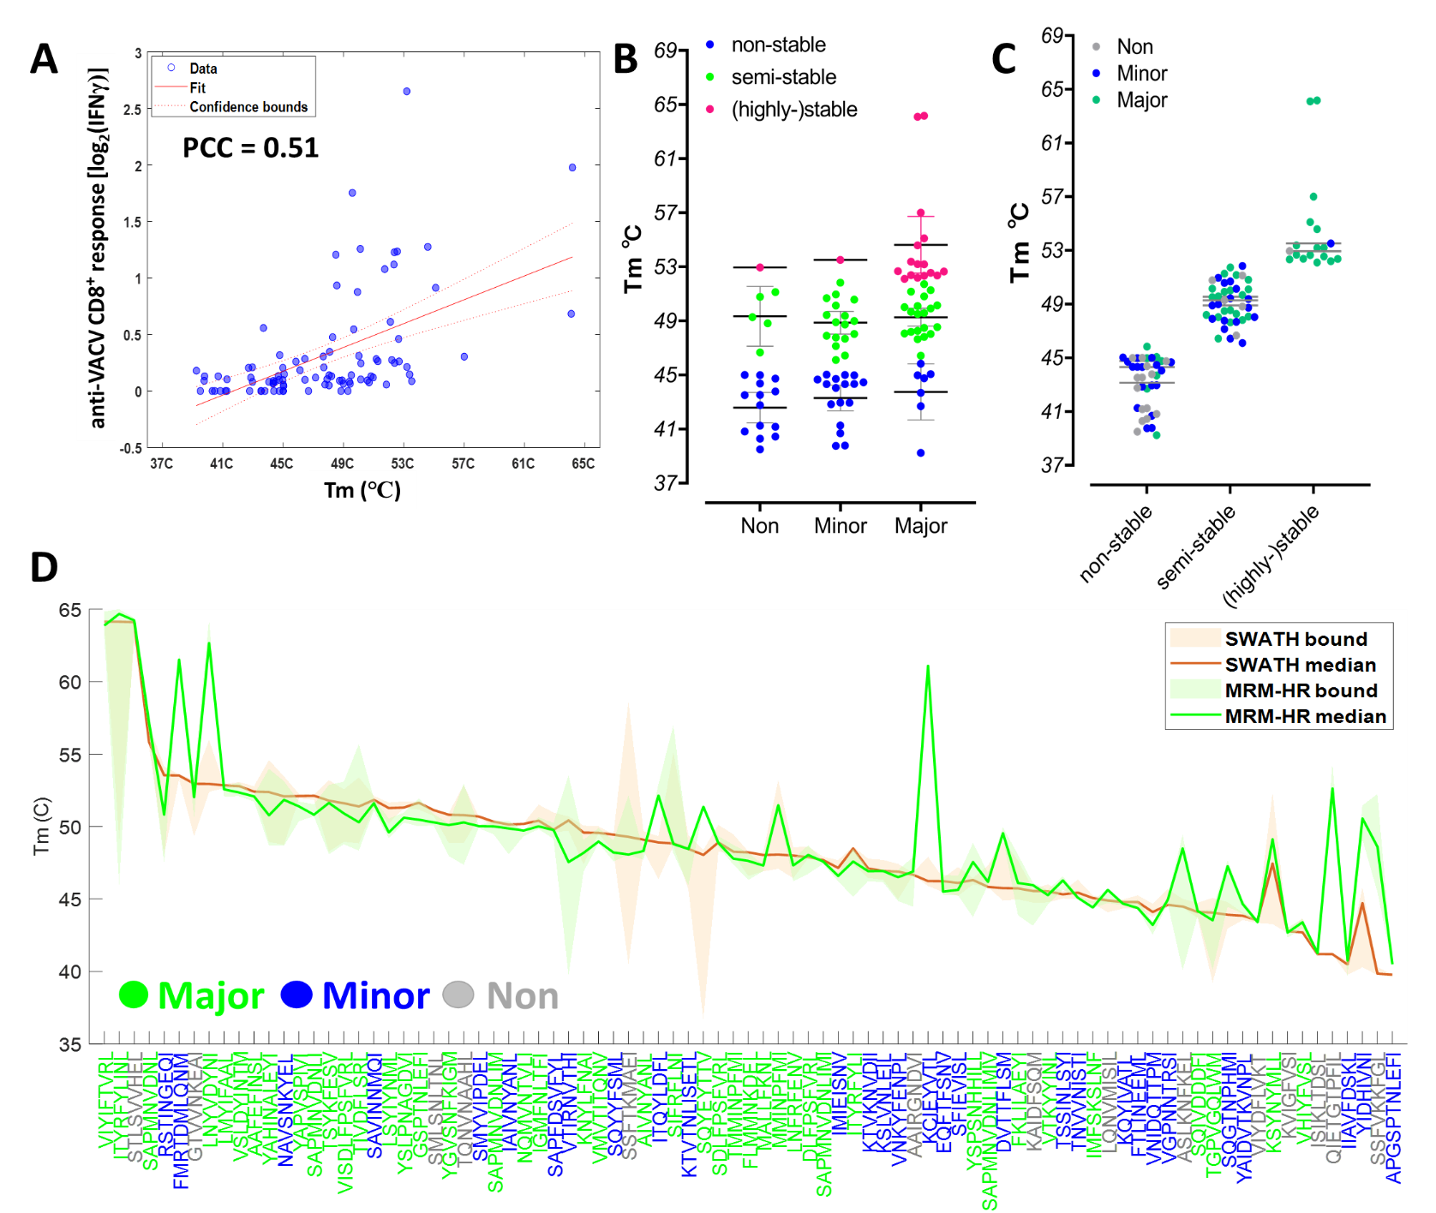

Figure S6. Correlation between thermostability and immunogenicity profiles and assessment of thermostability association with immunogenicity for VACV-derived pMHCs.
(A) The correlation for the T_{m} values was measured by Zeno SWATH-DIA data in this study, and anti-VACV CD8+ T cell responses were measured (PCC = 0.509 for 98 VACV IDs). (B) The VACV peptides were classified as non-stable, semi-stable, and (highly-)stable within each immunogenicity category to demonstrate the presence of more stable or highly stable peptides among the major epitopes. (C) More major epitopes were classified as (highly-)stable, which insists on the observed trend between thermostability and immunogenicity levels. (D) The T_{m} values for three replicates were calculated, and the ranges of the calculated T_{m} values (T_{m} bounds) were analysed. These T_{m} bounds were calculated for the joint VACV peptides profiled by both MS thermostability assays (i.e., Zeno SWATH and MRM^{HR}), and the bound profiles showed very good accordance in most VACV peptides. PCC, Pearson correlation coefficient.

We also assessed the robustness of the model over 300 iterations (Supplemental Data – Figure S7A-B) for the models with and without thermostability, revealing a significant improvement (p-value of <0.0001) in the model performance upon the inclusion of thermostability predictors. Due to the low amount of peptide data for this quantitative immunogenicity model, there can be a probability of the model overfitting. There is a demonstrated approach to test for overfitting in the models, which is an unbalanced model performance in training and validation steps. Thus, we analysed loss over the iterations of training and external validation (test), where a clear gap was obvious between the training and test validations (Supplemental Data – Figure S7C). Therefore, these results suggested that overfitting occurs in this model.

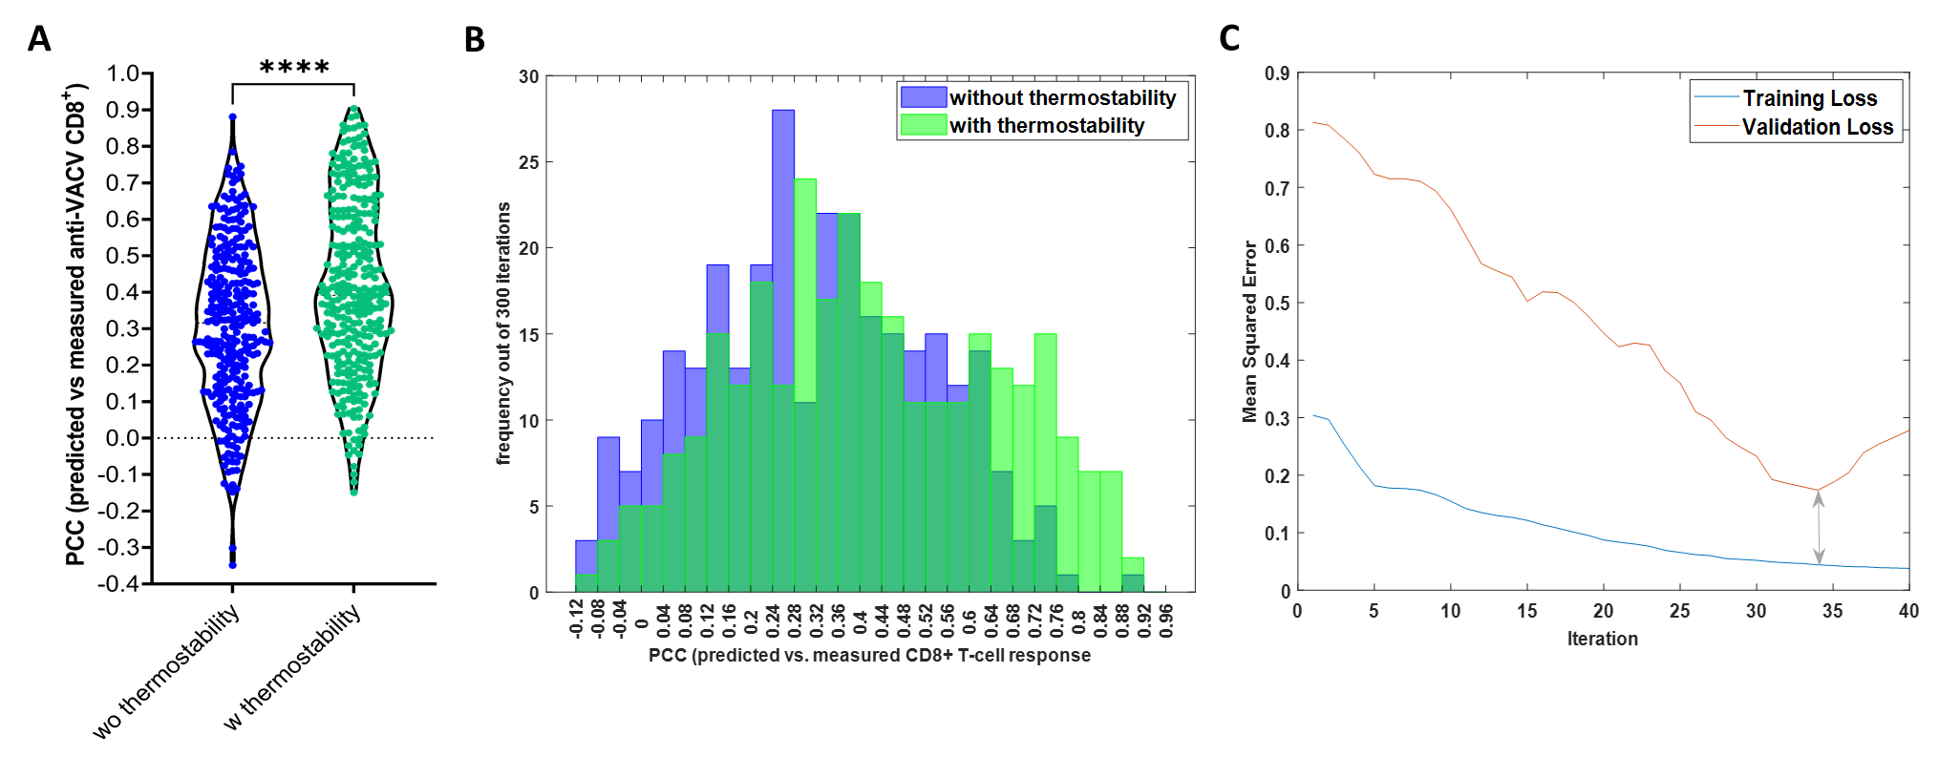
Figure S7. Analysis of the robustness and overfitting in the models for predicting anti-VACV CD8+ T cell responses. (A-B) The performance of the regression model in predicting T cell responses over 300 iterations, revealing a significant improvement in the PCC values of predicted versus measured T cell responses (p-value of <0.0001, Mann-Whitney statistical test). (B) A positive shift in the distribution of the PCC values for 300 iterations of the immunogenicity model in the model with the inclusion of thermostability predictors compared the model without. (C) The examination of overfitting in the model by the analysis of the loss (mean squared error) over the iterations of training and external validation (test), showing a gap between the training and test validations. PCC, Pearson correlation coefiecient.

To reduce the risk of overfitting, we expanded the training set by adding the 12 unique VACV peptides profiled exclusively by MRM^{HR}. We assessed the ML regression model to predict anti-VACV CD8⁺ T cell responses, without (only SWATH with 98 IDs) and with 12 unique peptides which were profiled by MRM^{HR} thermostability assay (SWATH & MRM with 110 IDs) to show the impact of the expanded thermostability dataset by MRM^{HR} method on the immunogenicity model that we developed for the VACV peptides as a primitive model. Once we involved the T_{m} values from those 12 additional MRM^{HR}-profiled VACV peptides, we observed a significant improvement in the developed model predicting anti-VACV CD8⁺ T cell responses with a higher correlation between the predicted (by our model) and empirically measured values (Supplemental Data – Figure S8A). Moreover, this expanded model showed significantly lower error (root mean squared error (RMSE)) compared with the model developed with only SWATH-derived predictors (Supplemental Data – Figure S8B). Therefore, the expanded MS-thermostability dataset could improve the predictive model even more in predicting CD8⁺ T cell responses by expanding the number of VACV peptides used for training. As discussed above, increasing the training data size would be an improvement to reduce this risk of overfitting. Furthermore, using feature selection methods for variable selection might help reduce the number of predictors and, consequently, the risk of encountering overfitting.

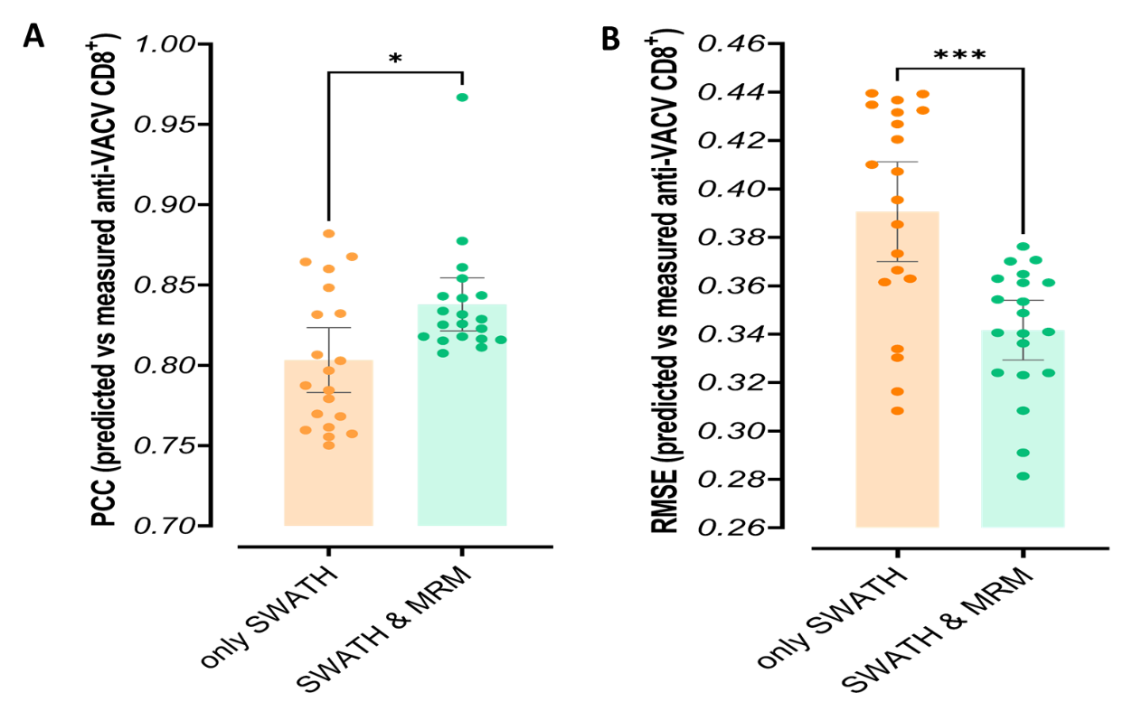
Figure S8. Expansion of the predictive models by the MRM^{HR} thermostability assay. Assessment of the ML regression model in predicting anti-VACV CD8⁺ T cell responses without (only SWATH-DIA with 98 VACV peptides) and with 12 unique peptides profiled by MRM^{HR} thermostability assay (SWATH & MRM with 110 VACV peptides). Adding T_{m} values of 12 VACV peptides that the MRM^{HR} thermostability assay profiled showed a significant improvement in the developed model in predicting anti-VACV CD8⁺ T cell responses. (F) PCC and (G) RMSE error between the predicted (by our model) and empirically measured values of CD8+ T cell responses.

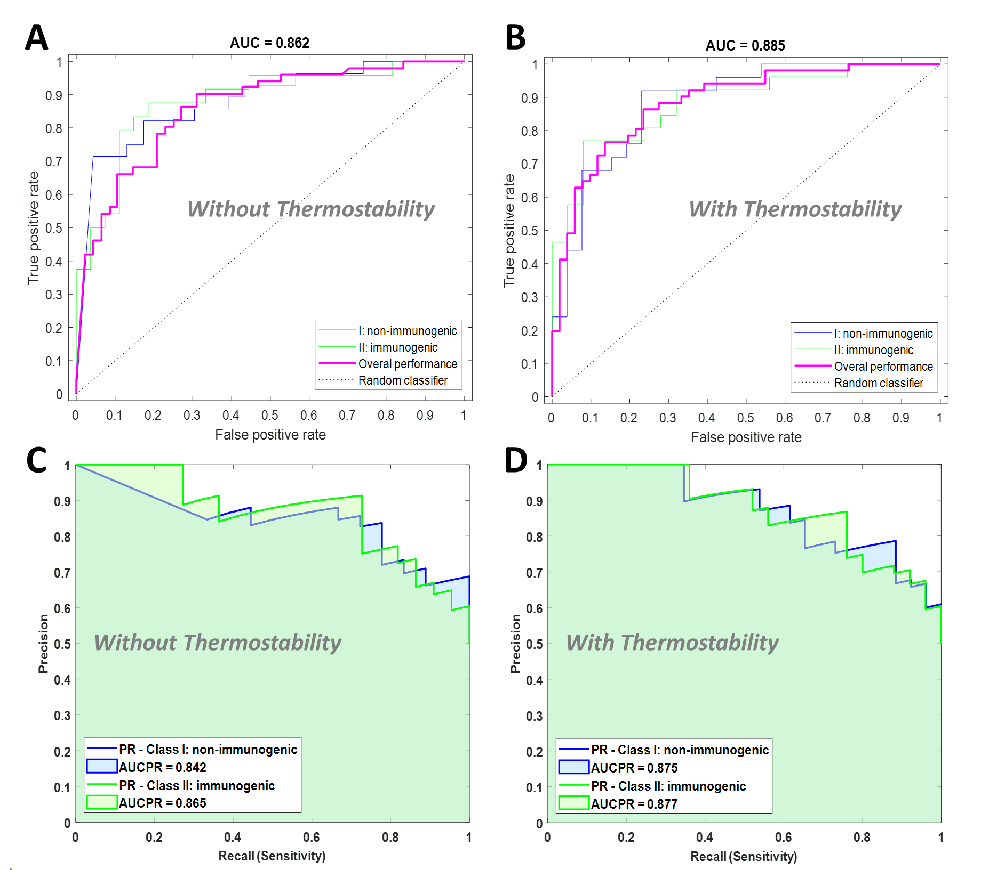
Figure S9. Analysis of the differences between ROC and Precision-Recall curves in the classification models to distinguish immunogenic from non-immunogenic MHCI VACV peptides.
(A-B) The ROC curves (true positive versus false positive rates) are derived from two classification models without (A) and with (B) thermostability predictors. This analysis revealed slightly higher AUC values for the model with thermostability (for the non-immunogenic class; AUC = 0.8881 ± 0.0071 and 0.8604 ± 0.0075 and for the immunogenic class; AUC = 0.8793 ± 0.0070 vs. 0.8615 ± 0.0073). (C-D) The PR curves for the classification models without (C) and with (D) thermostability predictors. The PR curves showed slightly higher AUCPR values for the model with thermostability (for the non-immunogenic class, AUCPR = 0.8738 ± 0.0088 vs. 0.8708 ± 0.0114 and for the immunogenic class; AUCPR = 0.8660 ± 0.0090 vs. 0.8450 ± 0.0152). ROC, Receiver operating characteristic; PR, Precision-recall; AUC, Area under the ROC curve; AUCPR, Area under the PR curve.

Four metrics revealing the classification model performance were assessed to compare the two models under study, including AUC, precision, sensitivity, and specificity (the parameters are defined in Methods). For the first class, non-immunogenic peptides, the AUC values significantly differed between the model without and with thermostability, where higher AUC values were found for the model with the inclusion of T_{m} values (p-value of 0.0492) (Supplemental Data – Figure S10A). For the second class, immunogenic peptides, we found no significant differences (p-value of 0.0728) between AUC values for the models without and with thermostability (with higher AUC values) (Supplemental Data – Figure S10B). The model precision, showing the capability of the models to predict the positive (targeted) class, was comparable between the model without and with thermostability for both classes (Supplemental Data – Figure S10C-D).
We calculated sensitivity (recall), showing the true positive rate (how well the models predict the positive class compared with the actual response) per class for both models. Moreover, the model specificity (demonstrating the true negative rate) was also assessed to evaluate the models. The sensitivities (Mann Whitney test, p-value < 0.0001 and = 0.0003, for non-immunogenic and immunogenic classes, respectively) and specificities (Mann Whitney test, p-value = 0.0003 and < 0.0001, for non-immunogenic and immunogenic classes, respectively) were compared for both classes, where significant differences were found between the models without and with thermostability (Supplemental Data – Figure S10E-H).

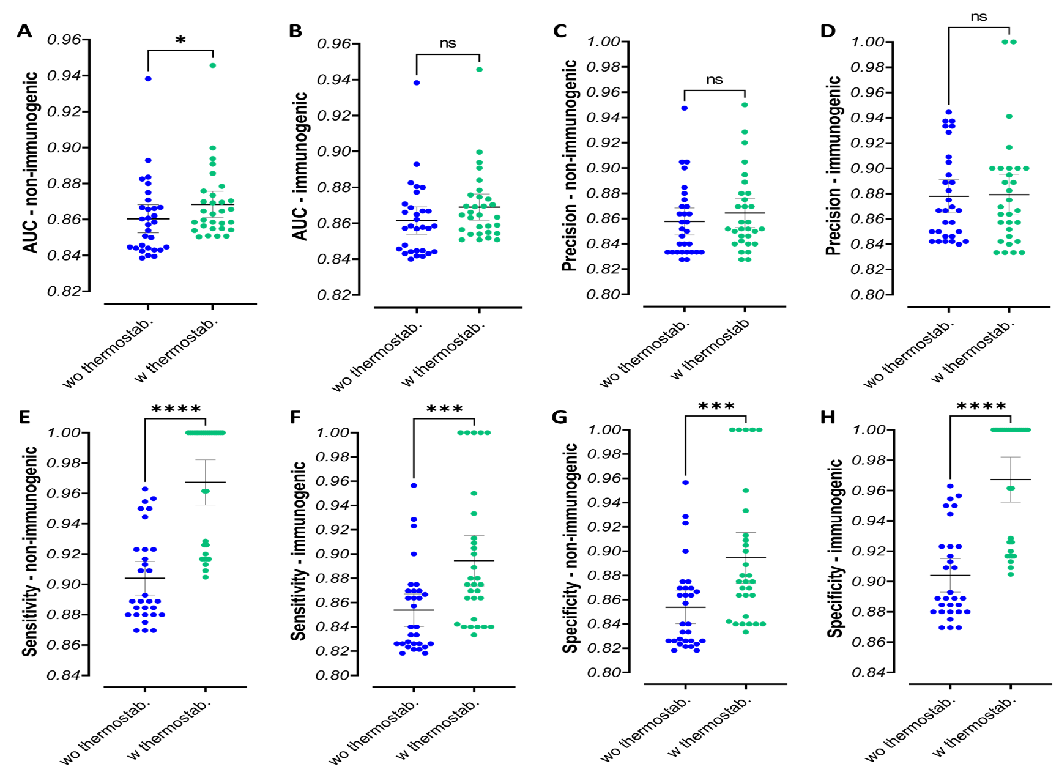

Figure S10. Evaluation metrics of the classification model.
(A-B) Comparing the calculated AUC values (derived from ROC curves) shows classification model performance in distinguishing immunogenic from non-immunogenic peptides. (A) For the non-immunogenic class, the AUC for the model with thermostability was slightly higher than the model without thermostability (p-value of 0.0492). (B) For the immunogenic class, the AUC for the model with thermostability showed no significant difference compared with the model without thermostability (p-value of 0.0728). (C-D) The model precisions for both classes were comparable between the model without and with thermostability for (C) the non-immunogenic class (p-value = 0.3029) and (D) the immunogenic class (p-value = 0.8744). (E-F) The comparison of sensitivity achieved by the models without and with thermostability shows significant differences for the (E) non-immunogenic class (p-value < 0.0001) and (F) immunogenic class (p-value = 0.0003). (G-H) The comparison of specificity calculated from the models without and with thermostability reveals significant differences for the (G) non-immunogenic class (p-value = 0.0003) and (H) immunogenic class (p-value < 0.0001). The Mann-Whitney statistical t-test was used to determine the significance. ns, not significant; *p-value < 0.05; **p-value < 0.01; ***p-value < 0.001; and ****p-value < 0.0001. AUC, Area under the ROC curve.

Moreover, we trained the model using a support vector machine (SVM) classifier, another commonly used ML algorithm with the same dataset, to examine the model by changing the ML algorithm. We observed similar performance (e.g., model accuracy) from the SVM models compared with ANN, where PTCs could significantly improve the model for distinguishing immunogenic VACV- and IAV-derived peptides (Supplemental Data—Figure S11B).
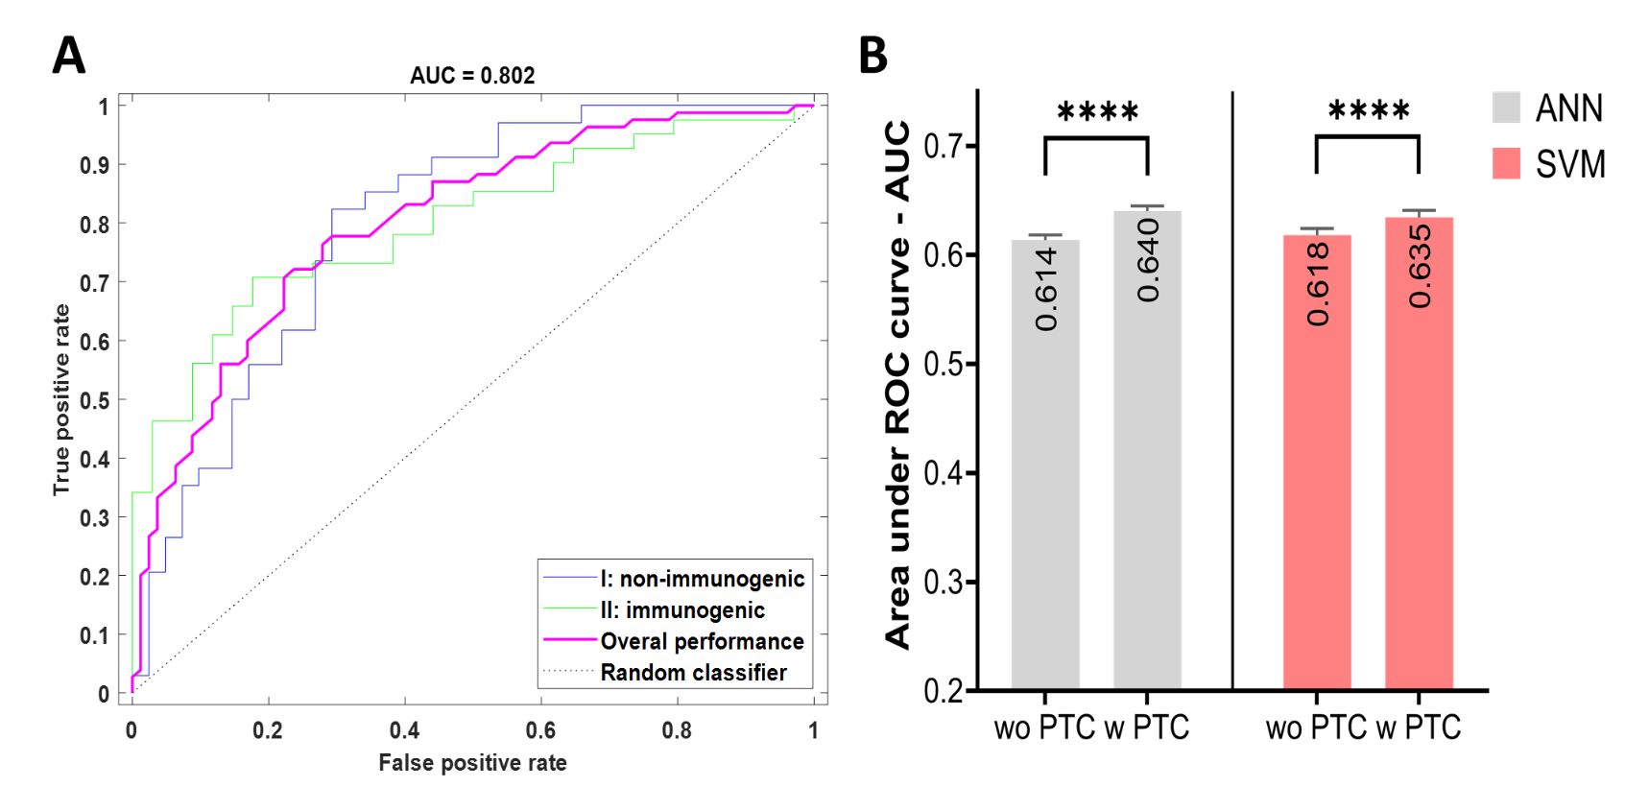

Figure S11. ROC curve and the comparison of AUC values for the ANN and SVM models with and without PTC predictor.
(A) The ROC curves are shown for the non-immunogenic and immunogenic peptide classes alongside the overall ROC for the best model without the involvement of the PTC predictor (AUC = 0.802). (B) Comparison between the ANN and SVM (as another commonly used ML algorithm) models with and without the inclusion of PTC predictor, showing a very similar performance from the SVM models compared with ANN where PTCs could improve the model significantly (p-value < 0.0001) in distinguishing immunogenic peptides derived from VACV and IAV. The Mann-Whitney test statistical test was used to determine the significance. ns, not significant; *p-value < 0.05; **p-value < 0.01; ***p-value < 0.001; and ****p-value < 0.0001. ANN, artificial neural network; Support vector machine (SVM); ROC, Receiver operating characteristic; AUC, Area under the ROC curve.

References
1. Croft, N.P. et al. Most viral peptides displayed by class I MHC on infected cells are immunogenic. Proceedings of the National Academy of Sciences 116, 3112 (2019).
2. Mullan, K.A. et al. ggVolcanoR: A Shiny app for customisable visualisation of differential expression datasets. Computational and Structural Biotechnology Journal 19, 5735-5740 (2021).

