Supplementary Material

Sensor with strong solid emission for fluorescence colormetric detection of 1,4 dioxane in Water and vapor based on the
Keto-Enol isomerisation
Jing Wang¹, Zi-Ao Zong², Shi-Fu Huang¹, Mohd. Muddassir⁴, Zhi-Yong Xing¹, Na-Na Li^{2,3,}* Wen-Qiong Jiang^{5, 6,}*
¹Modern Industrial College of Biomedicine and Great Health, Youjiang Medical University for Nationalities, Baise 533000, China

²Key Laboratory of Research on Environment and Population Health in aluminium mining areas (Youjiang Medical University for Nationalities), Education Department of Guangxi Zhuang Autonomous Region, Baise, China
³Department of Chemistry, Xinzhou Normal University, Xinzhou, Shanxi 034000, PR China
⁴Department of Chemistry, College of Science, King Saud University, Riyadh 11451, Saudi Arabia
⁵Affiliated Hospital of Youjiang Medical University for Nationalities, Baise 533000 Guangxi, PR China
⁶Guangxi Key Laboratory for Biomedical Material Research, Baise 533000 Guangxi, PR China
*Correspondence: LMT13643562571@126.com (N.-N. Li); 2901058890@qq.com (Wen Qiong Jiang)
† These authors contributed equally to this work.

Materials and analysis.
¹H NMR spectra were recorded on a Bruck AV-600 spectrometer in d₆-DMSO. IR spectra were performed with a Perkin-Elmer IR spectrophotometer. Pgeneral TU-2550 UV-vis spectrophotometer and Perkin Elmer LS55 fluorescence spectrometer were employed to measure absorption and fluorescence spectra, respectively. Mass spectrum was acquired with an Agilent 6220 Quadruple LC/MS (Agilent Co, USA). Elemental analyses (C, H, N and S) were conducted with a 2400 model Perkin-Elmer analyzer.
For fluorescence measurements, excitation wavelength was 360 nm and the excitation and emission wavelength band passes were both set at 5 nm and 5 nm.
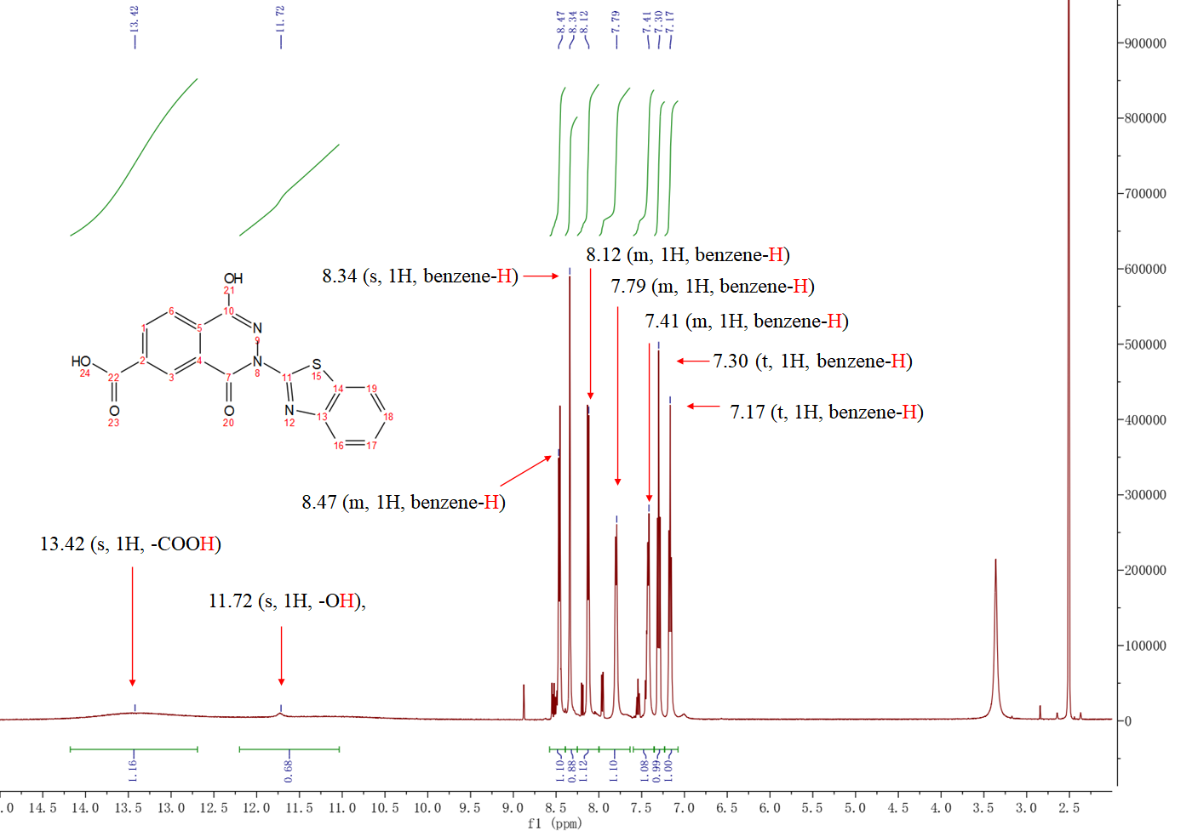
Fig. S1. ¹H NMR (DMSO-d₆, 600 MHz) spectra of BPCA.

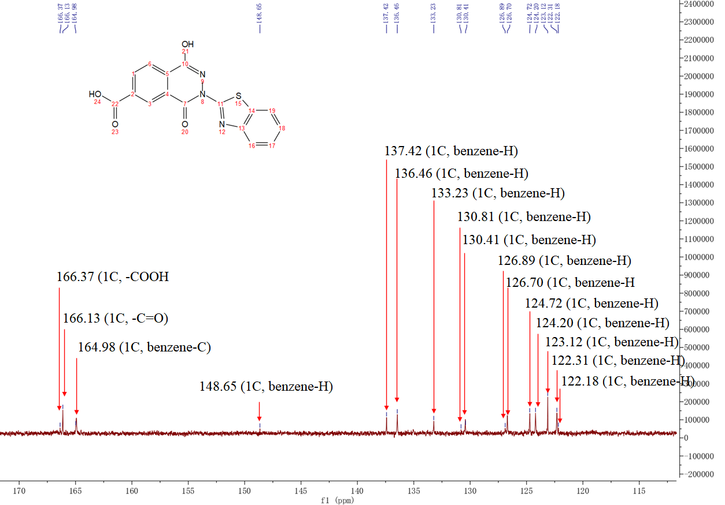
Fig. S2. ¹³C NMR (DMSO-d₆, 600 MHz) spectra of BPCA.

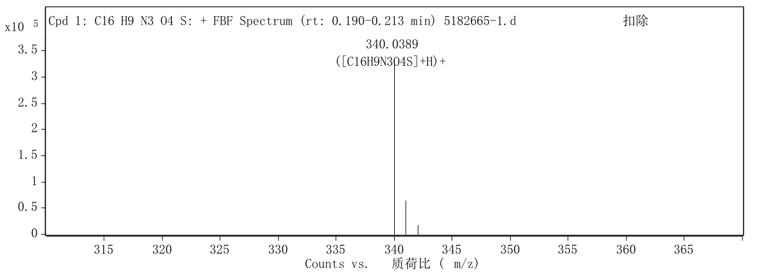
Fig. S3. ESI-MS spectrum of BPCA.
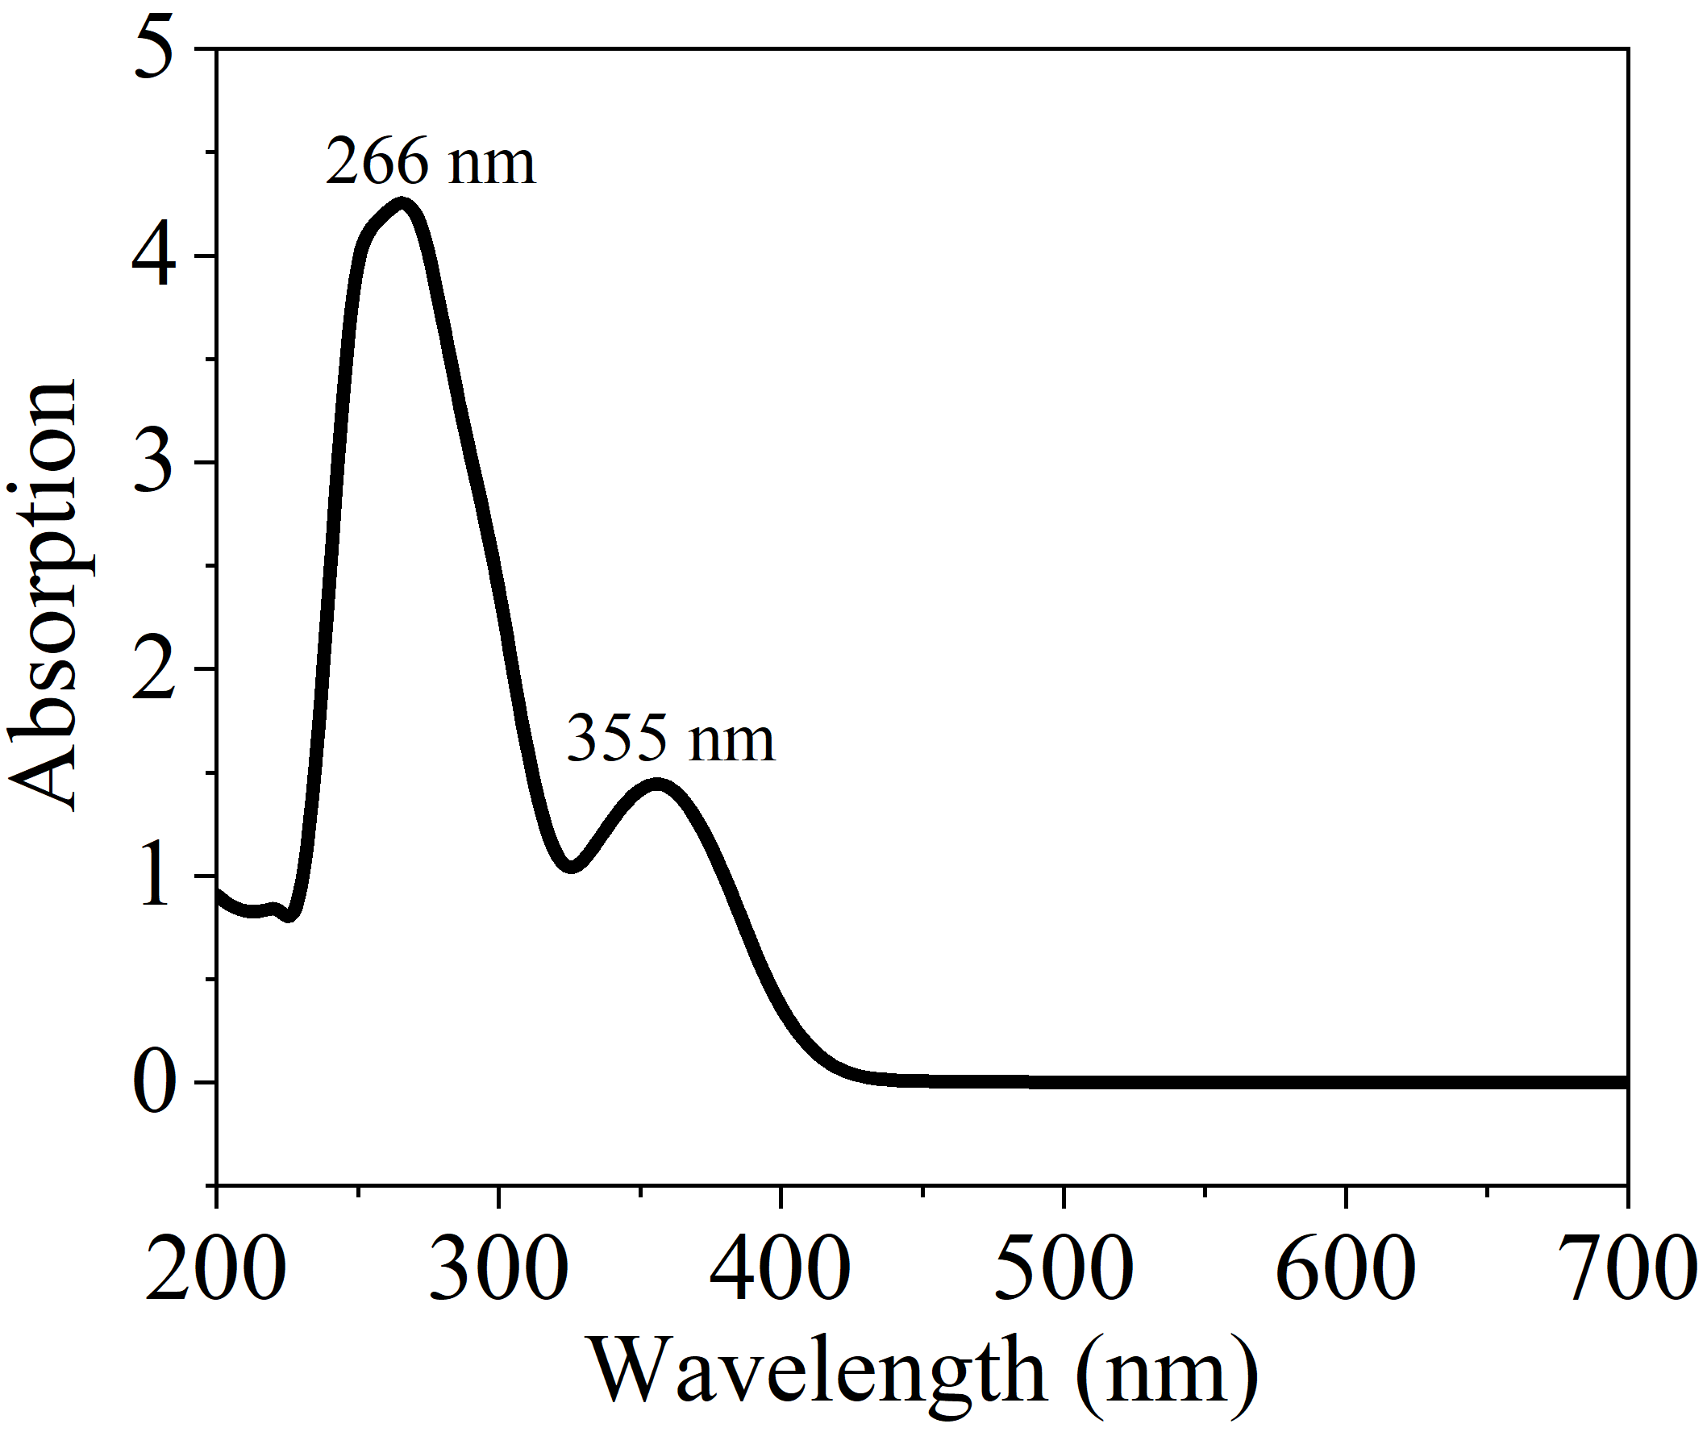
Fig. S4. The UV-vis spectrum of BPCA in 1, 4-dioxane.
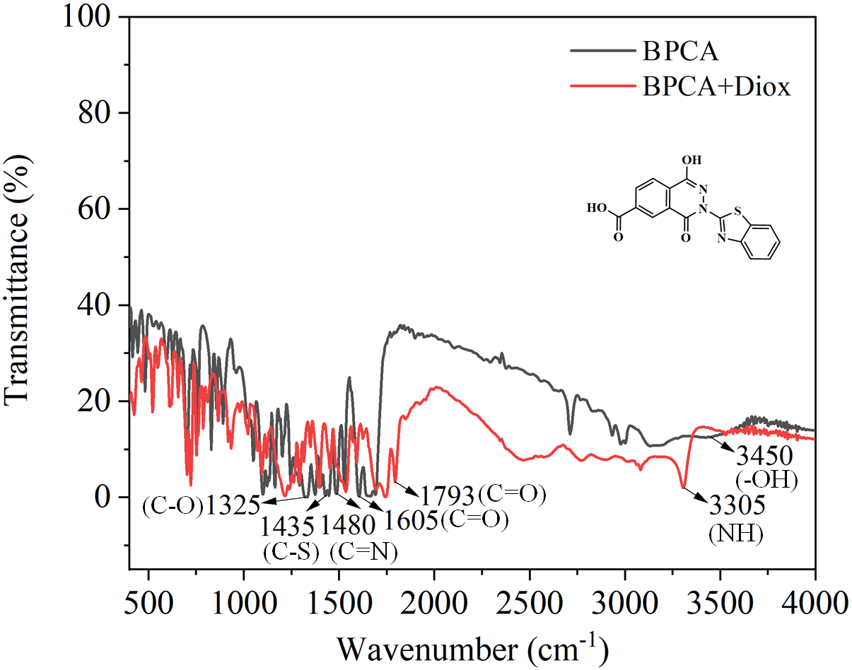
Fig. S5. FT-IR spectra of BPCA, BPCA/1, 4-dioxane system.

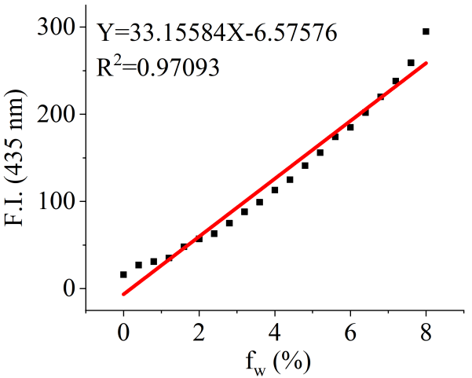
Fig. S6. Plot of fluorescence intensity value at 435 nm in different content of 1, 4-dioxane. λ_{ex} = 360 nm, slit: 5 nm/5 nm.

Determination of binding constants
Assuming a 1: n stoichiometry for interaction between BPCA and 1, 4-dioxane., the equilibrium is given by the following equation:

BPCA+n1, 4-dioxaneBPCA1, 4-dioxane_{n} (2)

The association constant, K, is therefore expressed as:

$$K=\frac{[BPCA{1,4−Diox}_{n}]}{[BPCA]{[1,4−Diox]}^{n}}=\frac{[BPCA{1,4−Diox}_{n}]}{({[BPCA]}_{0}−{1,4−Diox}_{n}){({[1,4−Diox]}_{0}−n[BPCA{1,4−Diox}_{n}])}^{n}}$$
(3)

$[BPCA{1,4−Diox}_{n}]$, [BPCA] and [1, 4-dioxane] represent the equilibrium concentrations of the complex, free BPCA, and free 1, 4-dioxane, respectively. ${[BPCA]}_{0}$ and ${[1,4−Diox]}_{0}$ are the initial concentrations of BPCA and 1, 4-dioxane, respectively. If ${[1,4−Diox]}_{0}$≫$[BPCA{1,4−Diox}_{n}]$, the Eq. (3) can be simplified as follows:

$K=\frac{[BPCA{1,4−Diox}_{n}]}{({[BPCA]}_{0}−{1,4−Diox}_{n}){{[1,4−Diox]}_{0}}^{n}}$ (4)

Then it can be transformed to:

$K[{1,4−Diox]}_{0}^{n}=\frac{[BPCA{1,4−Diox}_{n}]}{{[BPCA]}_{0}−[BPCA{1,4−Diox}_{n}]}$ (5)

Fluorescence intensity is given by following equations:

$\frac{F−F_{min}}{F_{max}−F}=\frac{[BPCA{1,4−Diox}_{n}]}{{[BPCA{1,4−Diox}_{n}]}_{max}−[BPCA{1,4−Diox}_{n}]}=\frac{[BPCA{1,4−Diox}_{n}]}{{[BPCA]}_{0}−[BPCA{1,4−Diox}_{n}]}$ (6)

F_{min} is the fluorescence intensity of BPCA without cations, F is the fluorescence intensity of BPCA obtained with 1, 4-dioxane, F_{max} is the fluorescence intensity of BPCA in the presence of excess amount of 1, 4-dioxane. In the presence of excess amount of 1, 4-dioxane, ${[BPCA{1,4−Diox}_{n}]}_{max}$ is almost equal to ${[BPCA]}_{0}$. Using Eqs. (5) and (6), the following equation is given:

$\frac{F−F_{min}}{F_{max}−F}=K[{1,4−Diox]}_{0}^{n}$ （7）

$\lg{\frac{F−F_{min}}{F_{max}−F} }=\lg{K}+n\lg{{[1,4−Diox]}_{0}}$ (8)

When assuming the 1:1 stoichiometry (n = 1), Eq. (1) is obtained.

$\lg{\frac{F−F_{min}}{F_{max}−F} }=\lg{K}+\lg{[1,4−Diox]}$ (1)

Fig. S7. The non-linear fitting (fluorescent emission at 435 nm) of BPCA lg[(F-F_{min})/(F_{max}-F)] = lgK+lg[1, 4-dioxane]. K is the association constant, F_{min} is the fluorescence intensity of BPCA without any cations, F is the fluorescence intensity of BPCA obtained with 1, 4-dioxane, F_{max} is the fluorescence intensity of BPCA in the presence of excess amount of 1, 4-dioxane.

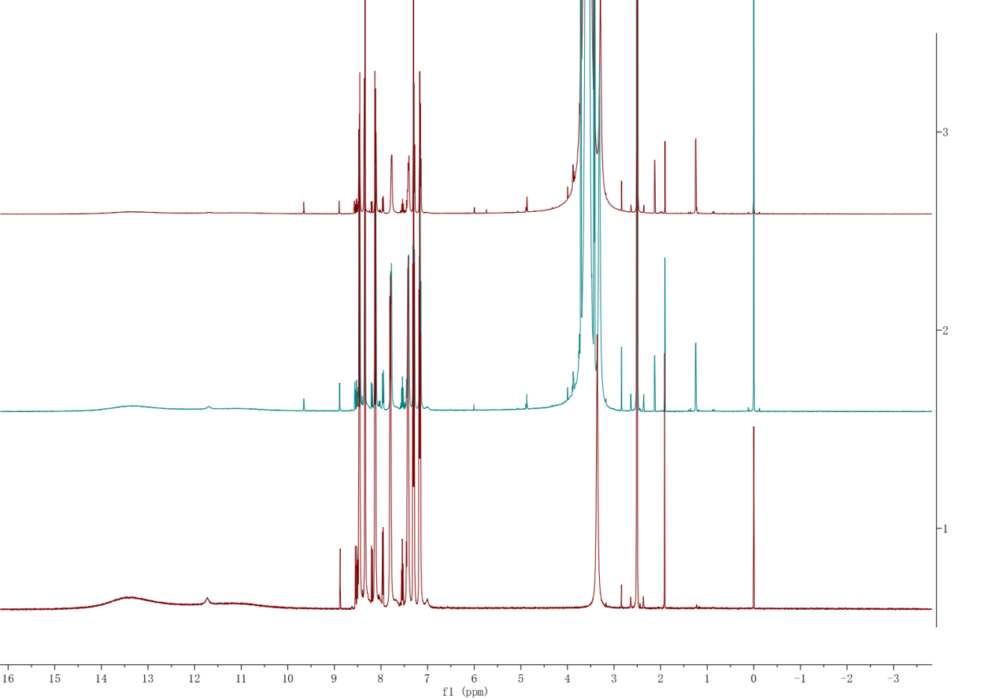
Fig. S8. ¹H NMR spectra of BPCA and BPCA/Diox system (DMSO-d₆, 600 MHz).

Table S1 Probe BPCA for the determination of 1, 4-dioxane in water samples from tap and lake water
Water samples  studied | Amount of standard 1, 4-dioxane added (f_{w}) | Total 1, 4-dioxane found  (n=3) (μM) | Recovery of 1, 4-dioxane (n=3) added (%) | RSD  (%) | Relative  error  （%）
Tap water | 2% | 2.11% | 105.50 | 2.20 | 2.75
Tap water | 3% | 3.03% | 101.00 | 0.50 | 2.17
Tap water | 4% | 4.21% | 105.25 | 3.57 | 0.63
Tap water | 5% | 5.12% | 104.20 | 1.50 | 1.82
Tap water | 6% | 6.15% | 102.50 | 2.56 | 3.12
Tap water | 7% | 6.98% | 99.71 | 0.20 | -2.63

