Scheme 1. Schematic representation of C. acnes as the "accomplice" of ZnO NPs to delay acne tissue healing and promote scar hyperplasia.
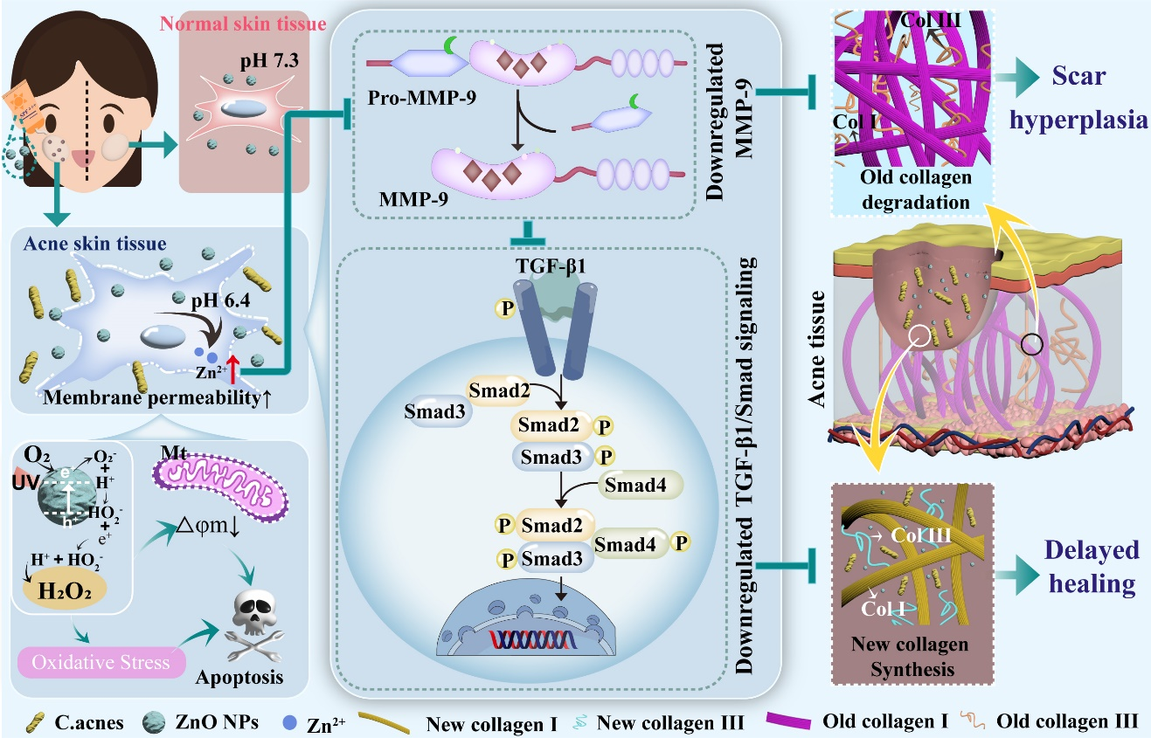
C. acne induces the increase of membrane permeability and acidification of adjacent fibroblasts through the up-regulation of lipase and lipid peroxidation, which provides the necessary conditions for the opportunistic entry and ionization of ZnO NPs. ZnO NPs damage skin cells in the acne environment through direct and indirect effects: on the one hand, ZnO NPs directly induce pyroptosis through ROS generation and interference with mitochondrial function under UVB irradiation. On the other hand, the Zn²⁺ obtained from the decomposition of ZnO NPs in the acne environment inhibits the activation of MMP-9, thereby inhibiting the expression of TGF-β1 and the downstream TGF-β1/Smad signaling pathway, which ultimately leads to the reduction of α-SMA and collagen synthesis and the delay of acne wound healing. Non-activated MMP-9 precursors do not induce collagen degradation, which leads to deposition of the original collagen as well as scar hyperplasia.

Fig. 1. Effects of C. acnes on skin cell membrane and pH and mechanism analysis.
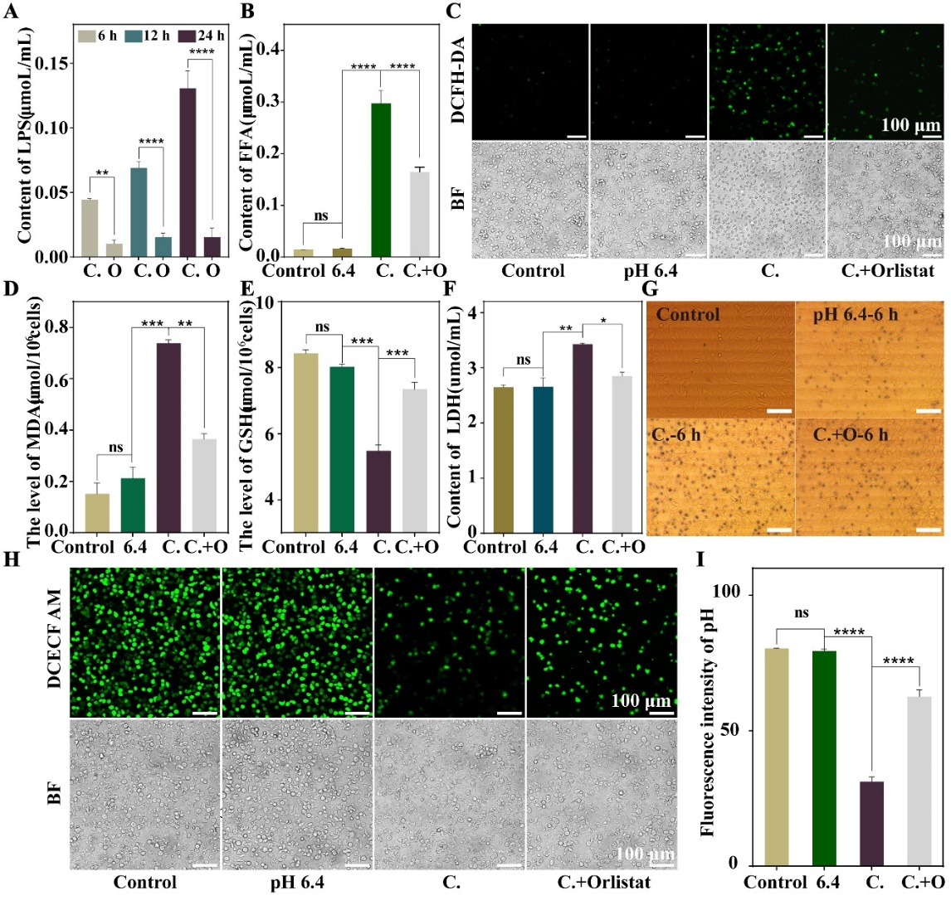
(A) Lipase content of C. acnes supernatant. (B) Free fatty acid content of L929 cell supernatant. (C) Laser confocal images of L929 cells stained with DCFH-DA. (D-F) ELISA results of MDA (D), GSH (E) and LDH (F) in L929 cells. (G) Trypan blue staining images of L929 cells (scale bar: 50 μm). (H) L929 cell BCECF/AM dye laser confocal images (scale bar: 100 μm). (I) Fluorescence relative quantification results from laser confocal images of intracellular BCECF/AM staining.

Fig. 2. Analysis of the damage mechanism of ZnO NPs on L929 cells in the acne environment.
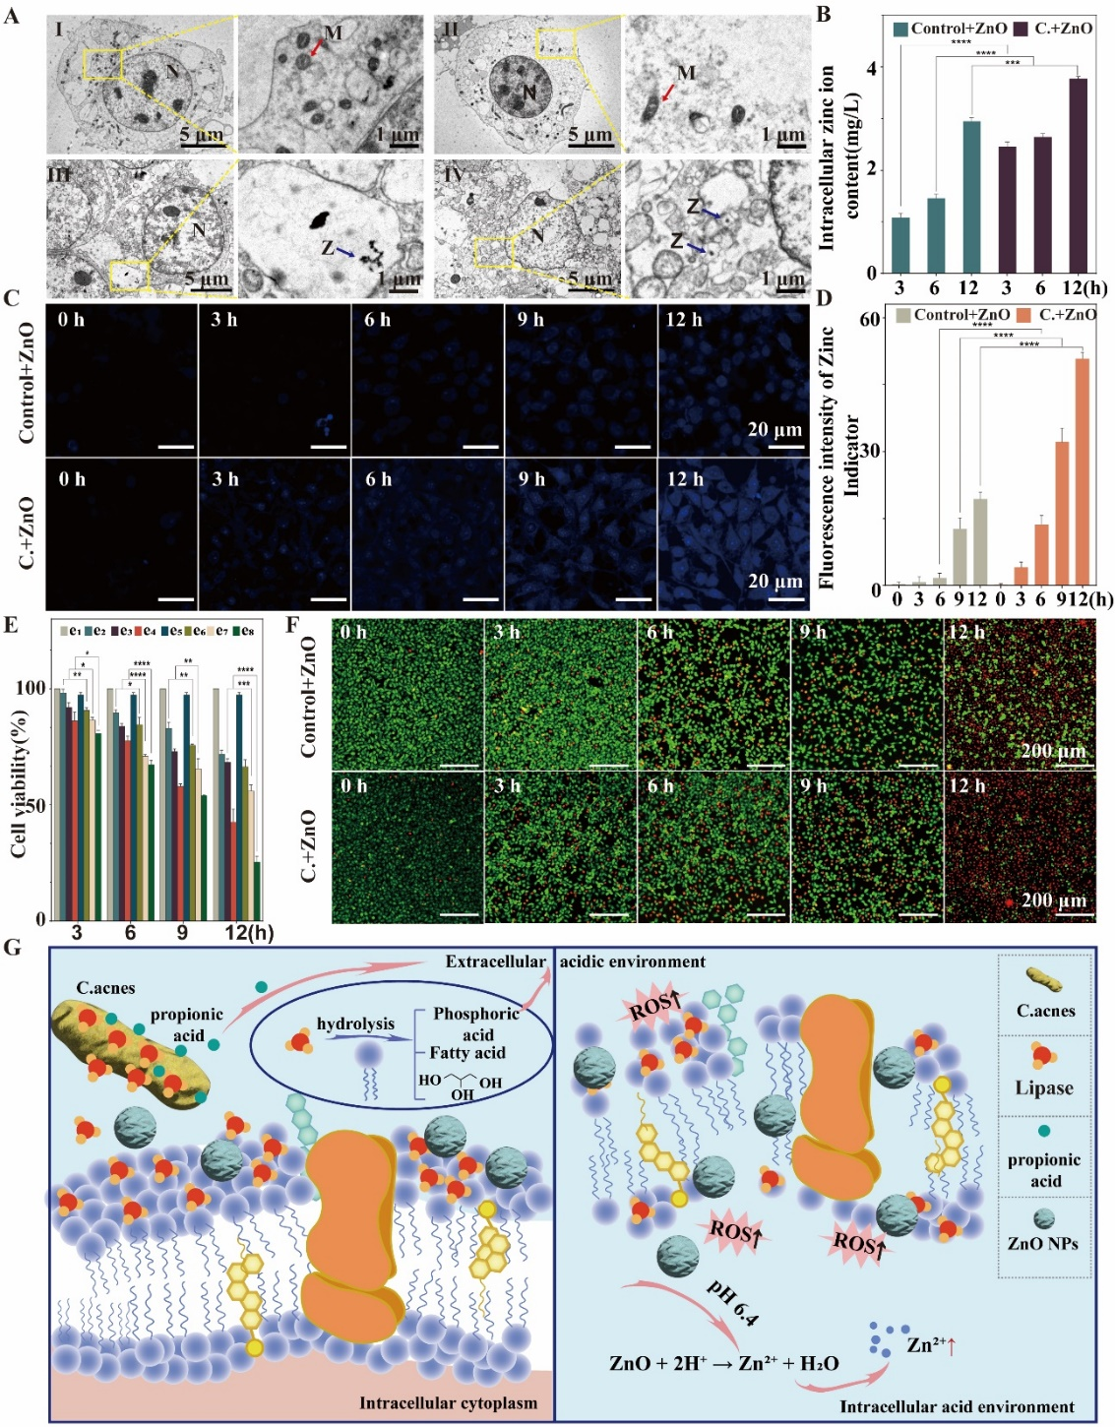
(A) Biological transmission electron microscopy of L929 cells after different treatments (I: Control; II: 50 μg/mL ZnO NPs; III: C.; IV: C. + 50 μg/mL ZnO NPs). (B) Results of ICP analysis of intracellular Zn. (C) L929 cell by Zinquin ethyl ester CLSM image after dyeing (scale: 20 microns). (D) Fluorescence relative quantitative results of CLSM images after Zinquin ethyl ester staining. (E) ZnO NPs L929 cell toxicity to normal and acne environment analysis (E1: Control; E2: 12.5 μg/mL ZnO NPs; E3: 25 μg/mL ZnO NPs; E4: 50 μg/mL ZnO NPs; E5: C.; E6: C. + 12.5 μg/mL ZnO NPs; E7: C.+25 μg/mL ZnO NPs; E8: C.+50 μg/mL ZnO NPs). (F) CLSM images of L929 cells after AM and PI staining (scale bar: 200 μm). (G) Diagram of the cell membrane permeability mechanism of C. acne disrupting L929 cells.
Fig. 3. Changes in oxidative stress levels in L929 cells by the combined treatment of C. acnes and ZnO NPs.
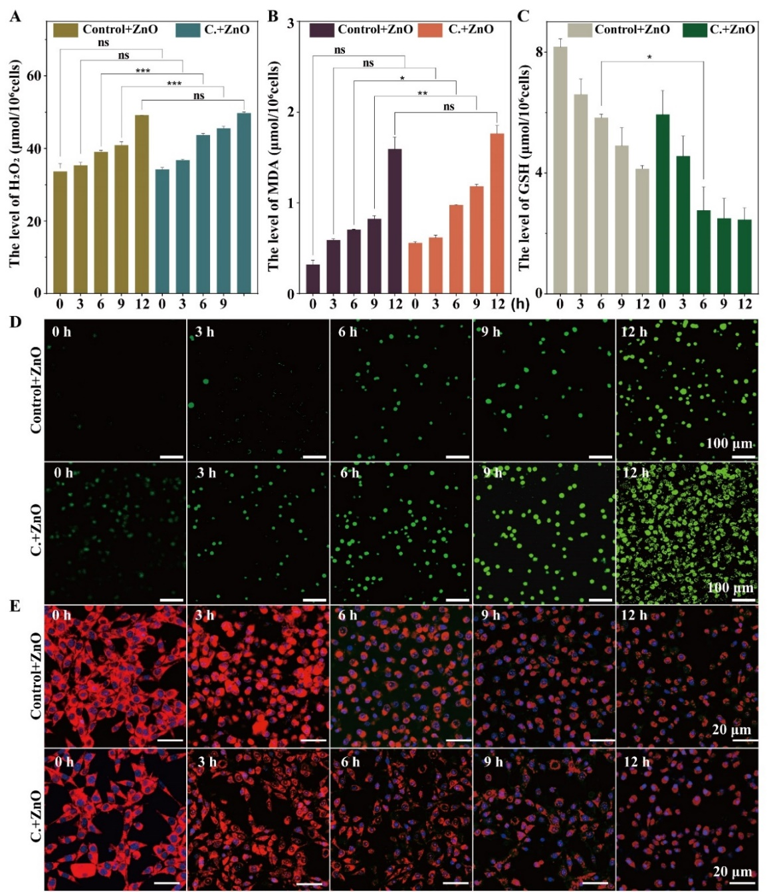
(A-C) Contents of H₂O₂ (A), MDA (B) and GSH (C) in L929 cells. (D) CLSM image of L929 cells stained with DCFH-DA (scale bar: 100 μm). (E) CLSM image of L929 cells stained with Mito Tracker Red CMXRos (scale scale: 20 μm).

Fig. 4. Transcriptome analysis of normal and acne skin cells treated with ZnO NPs.
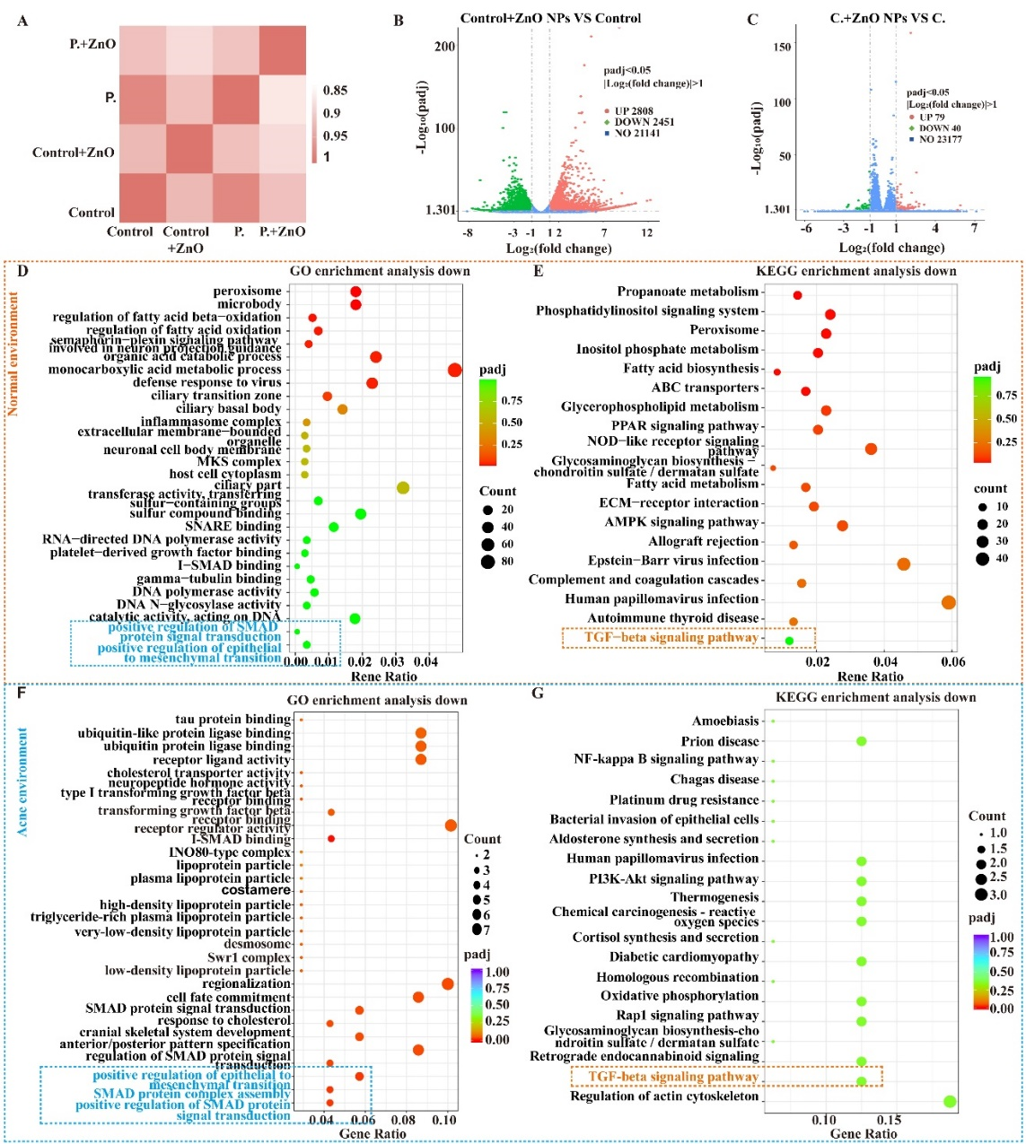
(A) Correlation heat map between groups. (B) Volcano plot of differentially expressed genes of normal skin cells before and after ZnO NPs treatment. Red dots represent up-regulated genes, and green dots represent down-regulated genes, and blue dots represent genes with no difference. (C) Volcano plot of differentially expressed genes of acne skin cells before and after ZnO NPs treatment. (D, E) GO enrichment analysis (D) and KEGG enrichment analysis (E) of differentially expressed genes of normal skin cells before and after ZnO NPs treatment. (F, G) GO enrichment analysis (F) and KEGG enrichment analysis (G) of differentially expressed genes of acne skin cells before and after ZnO NPs treatment.

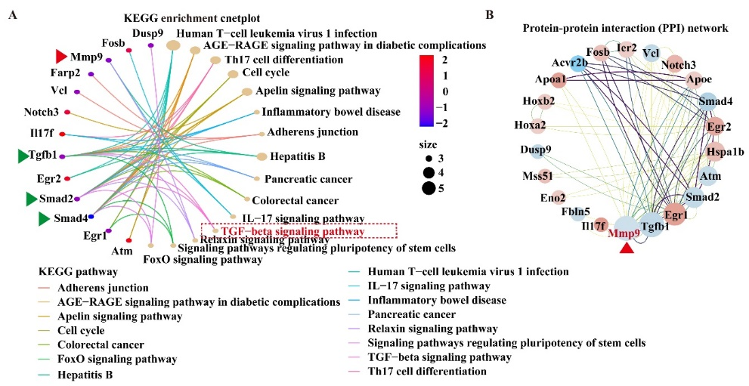
Fig. 5. KEGG enrichment network diagram (A) and protein-protein interaction (PPI) network analysis (B) of differentially expressed genes of acne skin cells before and after ZnO NPs treatment. The density of connecting lines is positively correlated with the degree of interaction association.

Fig. 6. In vitro analysis of the mechanism by which ZnO NPs delayed wound healing in the acne environment.
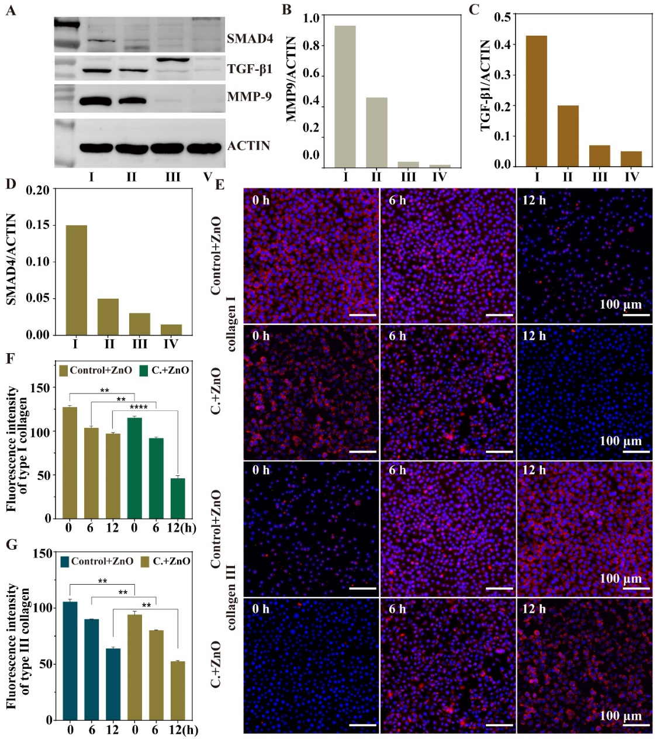
(A) Western-blotting of MMP9, TGF-β1 and SMAD4 (I: Control; II: C.; III: Control +ZnO NPs; V: C.+ ZnO NPs). (B-D) Relative quantitative results of Western-blotting for TGF-β1 (B), MMP9 (C), and SMAD4 (D) Immunofluorescence images of collagen type I and III. (F, G) Immunofluorescence relative quantification results of type I collagen (F) and type III collagen (G).

Fig. 7. In vivo evaluation of the effect of ZnO NPs on acne wounds.
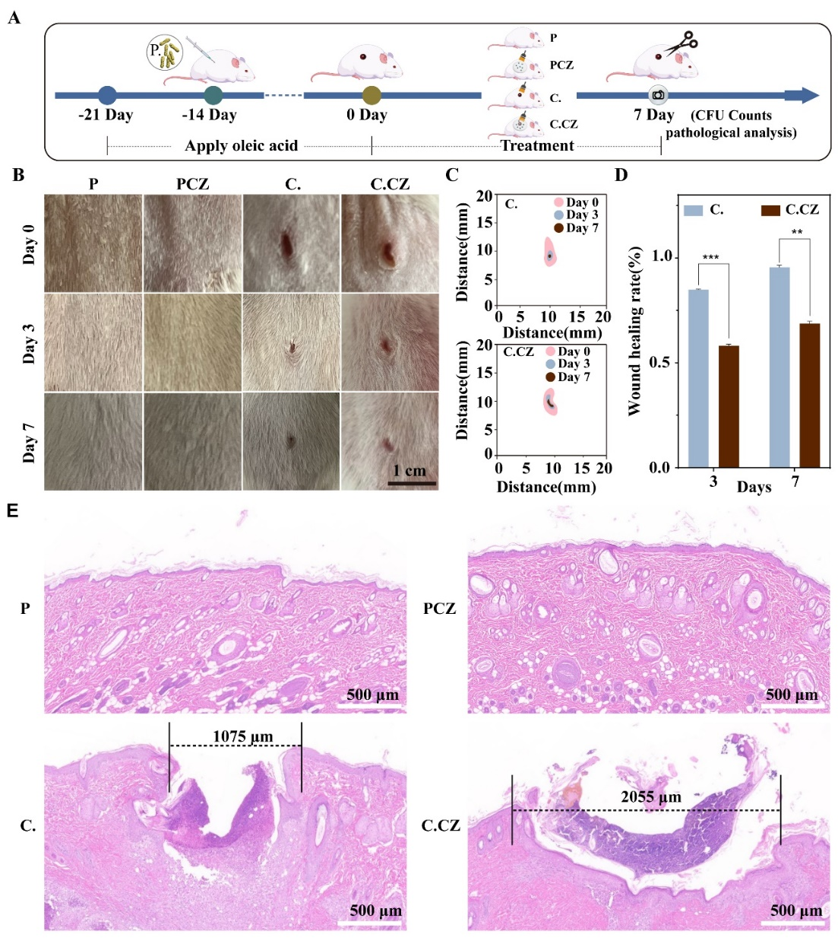
(A) Schematic of the animal model and in vivo treatment design. (B) Picture of acne wound (scale: 1 cm). (C, D) Wound healing trace and wound healing rate analysis. (E) H&E plot of normal skins and acne skins before and after ZnO NPs treatment (P: PBS; PCZ: PBS+ Carbomer + ZnO NPs; C.: C. acnes; C: C. acnes+ Carbomer + ZnO NPs).

Fig. 8. In vivo evaluation of histological staining.
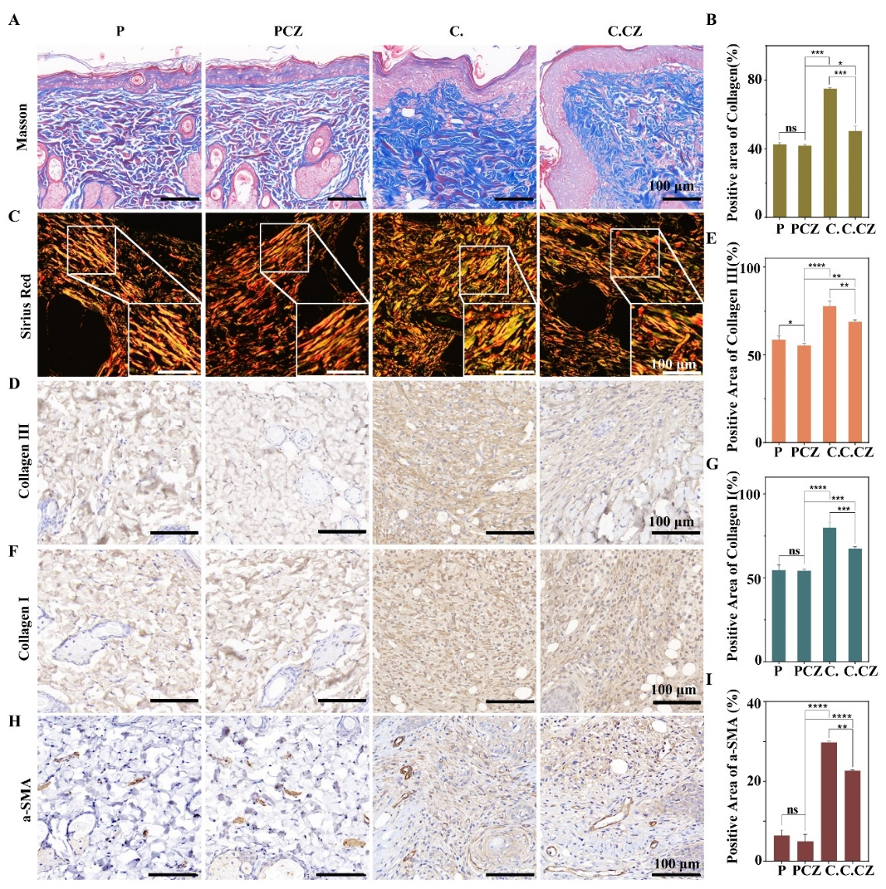
(A) Mason Trichromatic dyeing. (B) Relative quantitative analysis of collagen fibers. (C) Sirius red staining. (D) Immunohistochemical staining of collagen type III. (E) Relative quantitative analysis of collagen type III immunohistochemistry. (F) Immunohistochemical staining of collagen type I. (G) Relative quantitative analysis of type I collagen immunohistochemistry. (H) a-SMA immunohistochemical staining. (I) Relative quantitative analysis of a-SMA immunohistochemistry.

Fig. 9. Effect of MMP9 inhibitor and MMP9 activator on the healing of acne wounds treated with ZnO NPs.
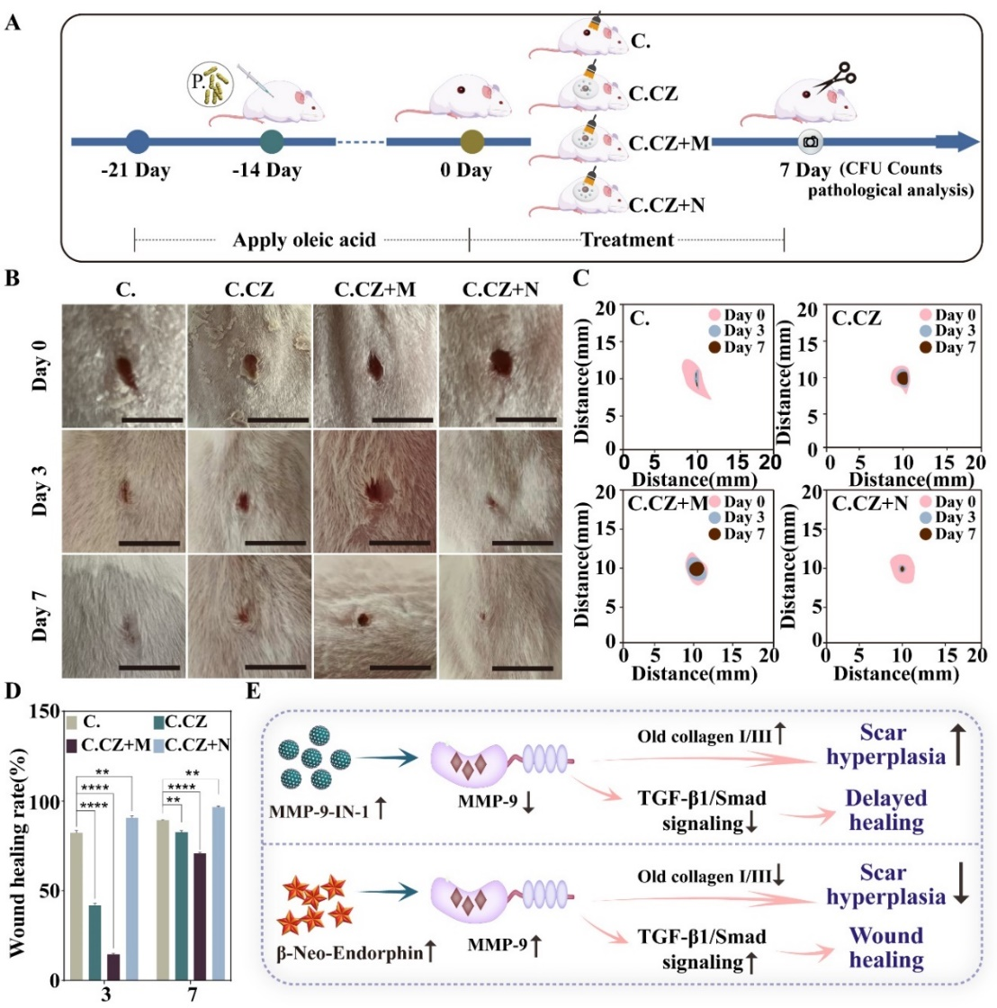
(A) Schematic diagram of the in vivo experimental procedure. (B) Images of rat acne after different treatments (scale: 1 cm). (C, D) Analysis of acne wound healing traces and wound healing rates after different treatments (C.: C. acnes; C.CZ: C. acnes+ Carbomer + ZnO NPs; C.CZ+M: C. acnes+ Carbomer + ZnO NPs + MMP-9-IN-1; C.CZ+N: C. acnes + Carbomer +ZnO NPs + β-Neo-Endorphin). (E) Analysis of the mechanism of MMP9 inhibitor and MMP9 activator on acne healing.

