ZnO colludes with C.acnes in healing delay and scar hyperplasia by barrier destruction

Fenglan Zhang, Tianyi Wang et al.

* Xiaoying Kong. Email: xykong51@aliyun.com
*Changyuan Wang. Email: changyuanwang2008@163.com
*Jinsheng Shi. Email: shijinsheng@uor.edu.cn

This PDF file includes:

Supplementary Text
Figures. S1 to S13

Supplementary Text
The pH value of bacterial supernatant under different cultivation times.
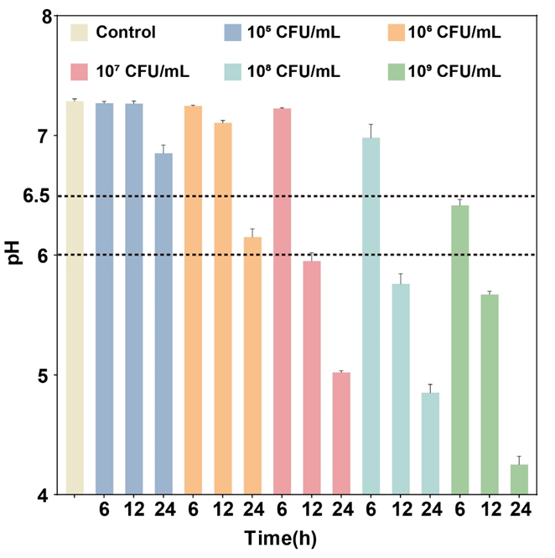

Figure. S1.

LDH content in the supernatant of L929 cells under different cultivation times.
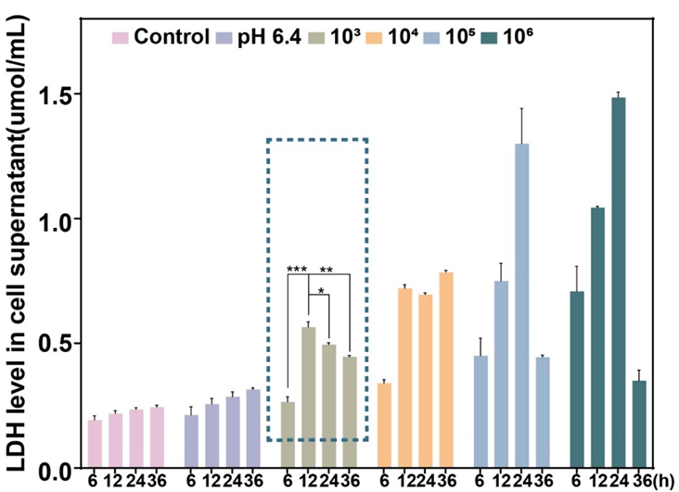

Figure. S2.

Trypan blue staining images of L929 cells under different cultivation times (scale: 100 μm).
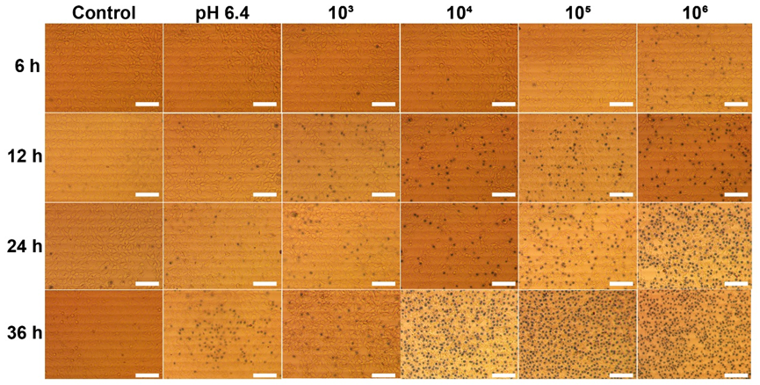

Figure. S3.

Cell viability of L929 cells under different culture times.
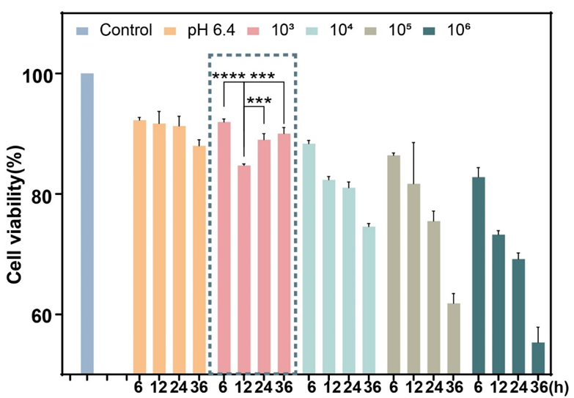

Figure. S4.

SEM image of ZnO NPs (scale: 200 nm).
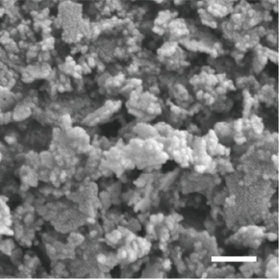

Figure. S5.

TEM images of ZnO NPs (scale: 50 nm).
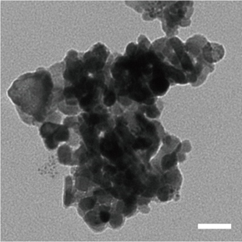

Figure. S6.

Particle size analysis of ZnO NPs.
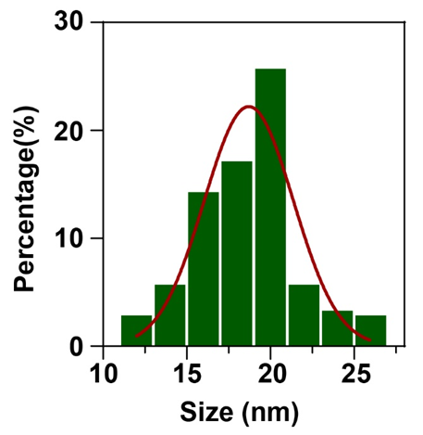

Figure. S7.

XRD images of ZnO NPs.
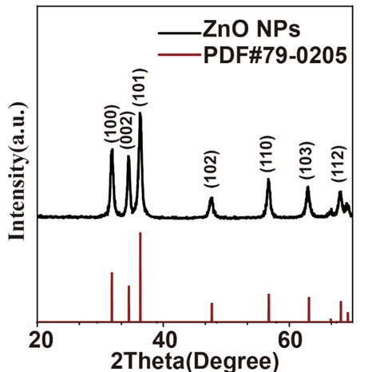

Figure. S8.

Fluorescence quantification of DCFH-DA staining laser confocal images.
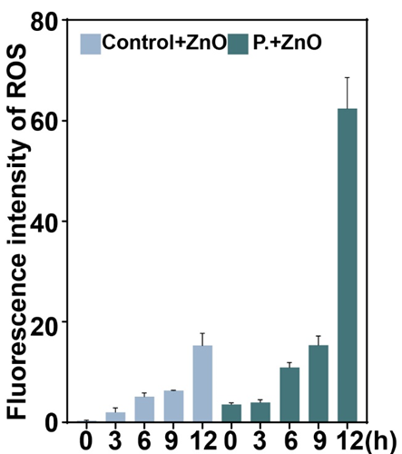

Figure. S9.

Fluorescence quantification of CLSM images stained with Mito Tracker Red CMXRos.
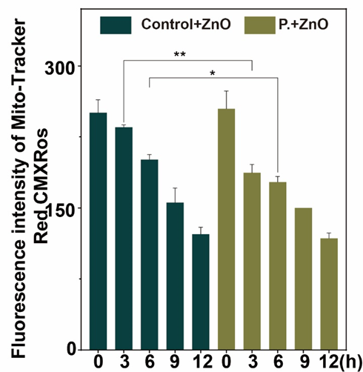

Figure. S10.

Zinc ion content in the skin of rats with acne. (I:PBS; II:PBS + carbomer + ZnO NPs; III:P.; IV:P.+ carbomer +ZnO NPs).
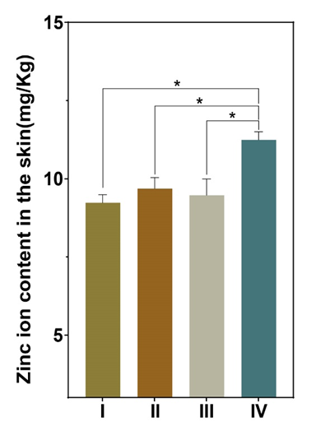

Figure. S11.

Colony diagram of acne tissue in rats.
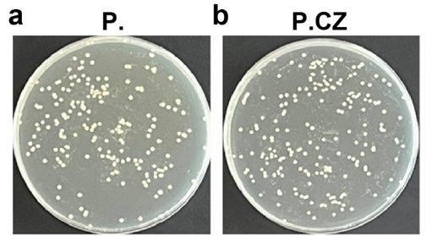

Figure. S12.

Quantitative colony analysis of acne tissue in rats.
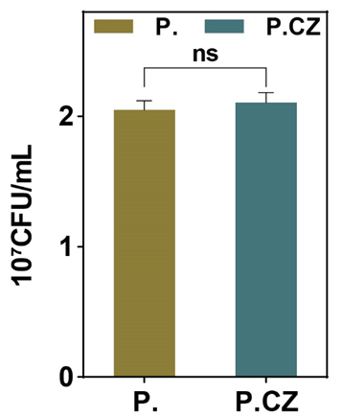

Figure. S13.

