Fig. S1. The genomic phylogenetic tree based on orthologous protein and gene sequences derived using UBCG tool.
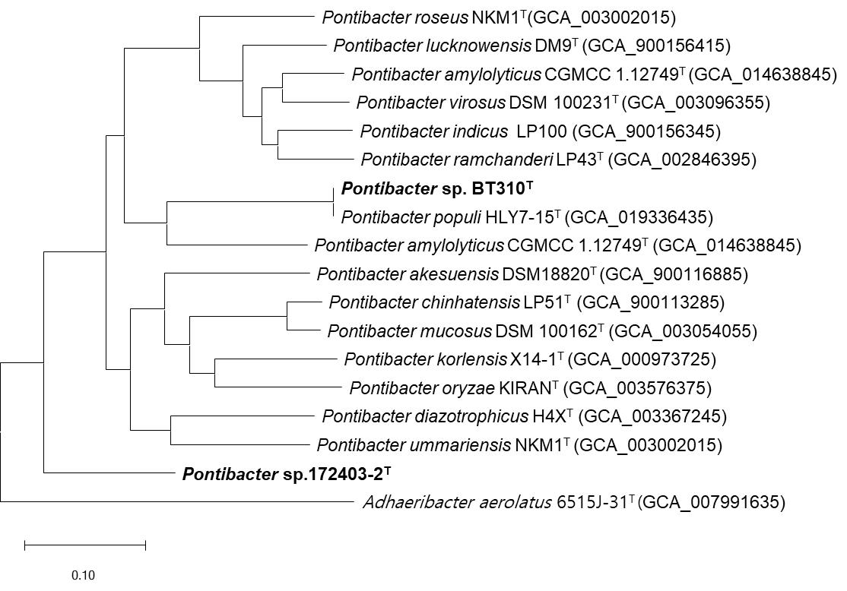

Fig. S2. Polar lipid profile of strain 172403-2^{T}, after two dimensional chromatography.
(a), total lipids; (b), phospholipids; (c), aminolipids; (d), glycolipids.

Abbreviations: L, lipid; PL, phospholipid; APL, aminophospholipid; PE, phosphatidylethanolamine; AL, aminolipid; GL, glycolipid.
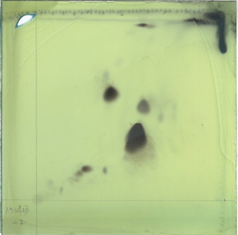
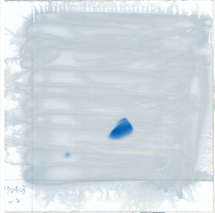
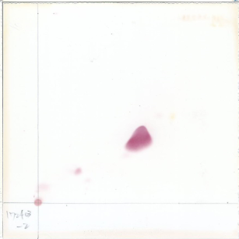
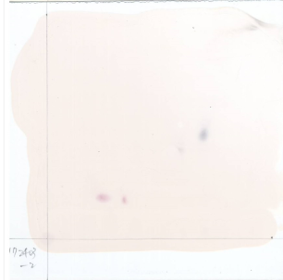
L1
L2
AL
PE
GL2
GL1
APL
PE
APL
AL
PE
APL
GL2
GL1
(a)
(b)
(c)
(d)
Fig. S3. Polar lipid profile of strain BT310^{T}, after two-dimensional chromatography.
(a), total lipids; (b), phospholipids; (c), aminolipids; (d), glycolipids.

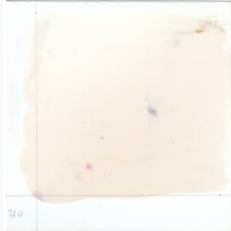
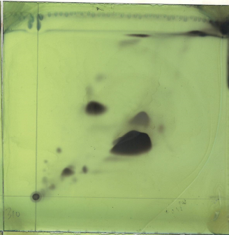
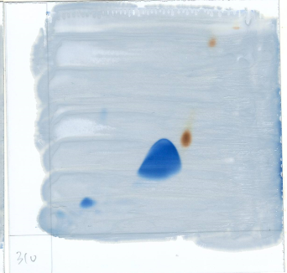
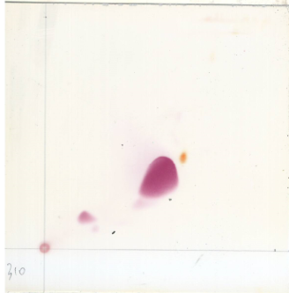
Abbreviations: L, lipid; PL, phospholipid; APL, aminophospholipid; PE, phosphatidylethanolamine; AL, aminolipid; GL, glycolipid.
L1
L2
PL1
L3
L4
PE
L5
GL
APL
L6
PL2
L7
AL
PL1
PE
APL
PL2
PE
APL
AL
(a)
(b)
(c)
(d)

