UVC devices specification
 |  | UV source | UV light wave range (nm) | UV light power  (W) | Other considerations | Product
- UV-C disinfection desk lamp | M6 | Low pressure mercury | 253.7 | 24 | Recommendation  Disinfection time  Bathroom/kitchen 15 min  Bedroom 30 min  Living room 45 min | 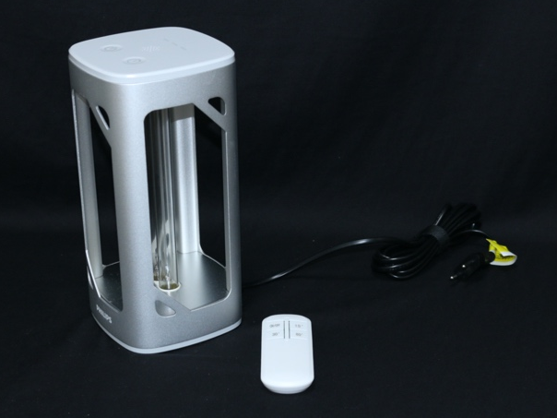
- Uadisinfecting table lamp | M5 | Low pressure mercury |  | 38 | Sanitary ware, smaller room 15 min  Master bedroom, small living room 30 min  Main living room, larger room 60 min | 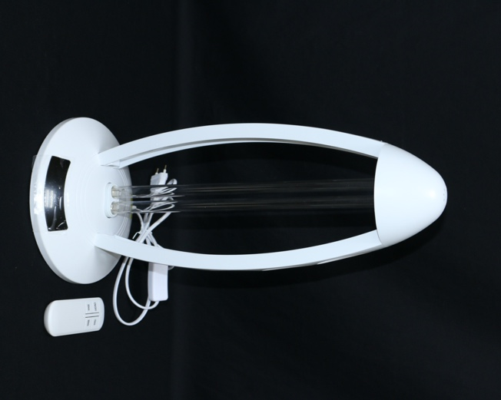
- UVC germicidal lamp (G8 T5) | M7 | Low pressure mercury | 253.7 | 8 | NA | 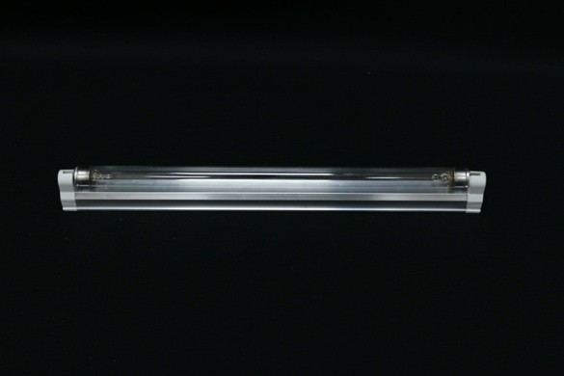
- Multi-functional UV sterilizing box (SUV-006) | L3 | LED | 270-285 | 5-8 | 180 seconds per cycle | 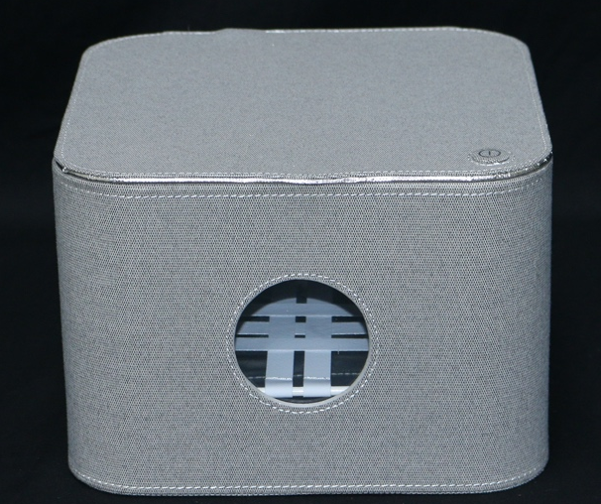
- Multifunctional bactericidal bag L3 | L2 | LED | 265 | 8 | NA | 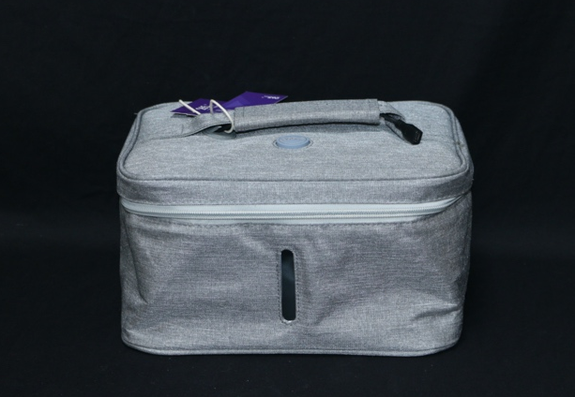
- Pocket UV germicidal lamp | M1 | Low pressure mercury |  | 2.5 | Dual mode: 15 and 30 min  Range of application: < 2m² | 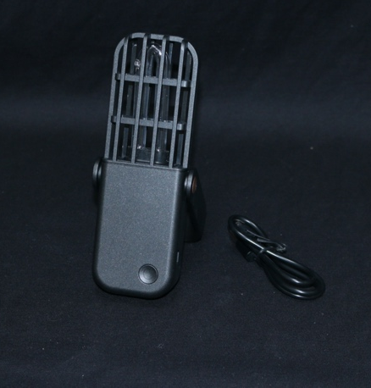
- Portable UV Sterilizer | M2 | Low pressure mercury | 253.7 | 2 | Distance 3-5 cm  30 seconds | 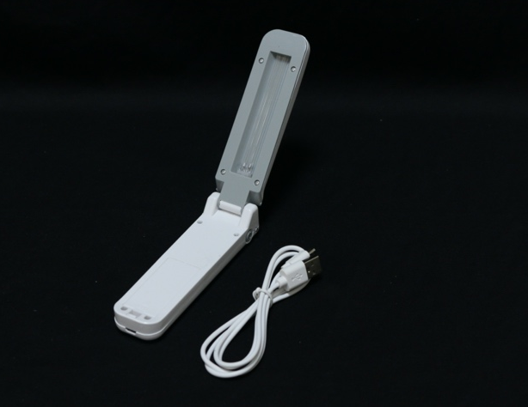
- Mini USB Ultraviolet Lamp model: US-ZB158 | L1 | LED | UVC 265-280  UVA 395-400 | 4.5 | - It is recommended to keep 3 cm and sweep and hold for 2s evenly over objects.  - It is recommended to use for 1-3 minutes each time, tend to get heat after using for a long time. | 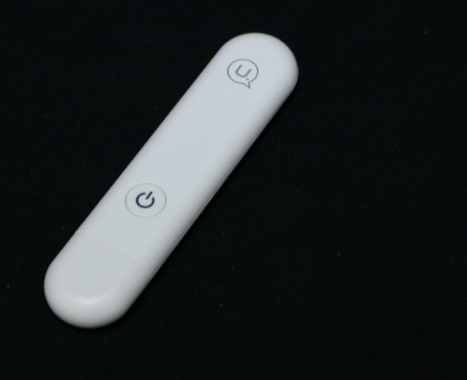
 | M3 | Low pressure mercury |  | 24 | Local made | NA
- Baby miniUV | M4 | Low pressure mercury | 253.7 | 8 | 11/16/21 minutes | 