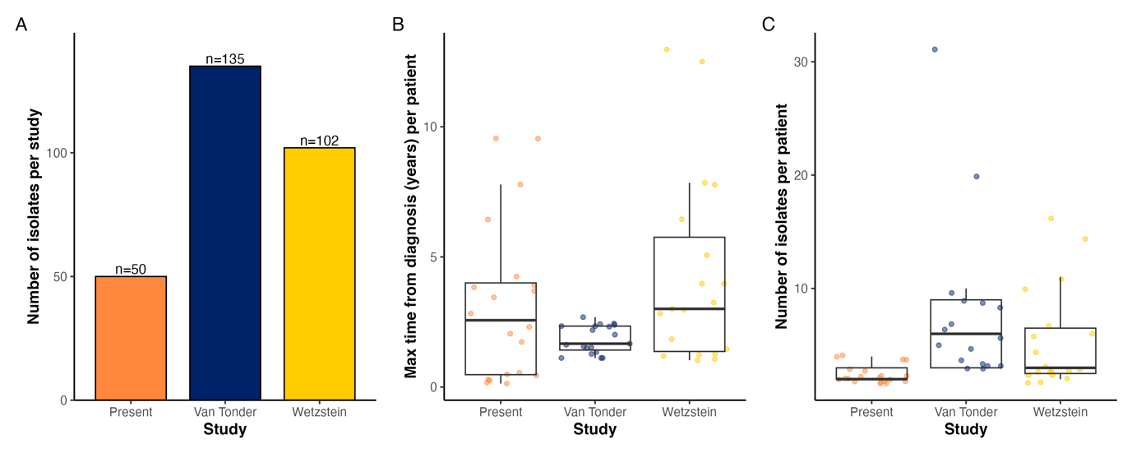
Supplementary Figure S1. Overview of the datasets analysed in this study. For each dataset, the following statistics are visualised: (A) the total number of isolates that were included in our analysis; (B) the maximum time from diagnosis (years) per included patient; and (C) the number of isolates per included patient.

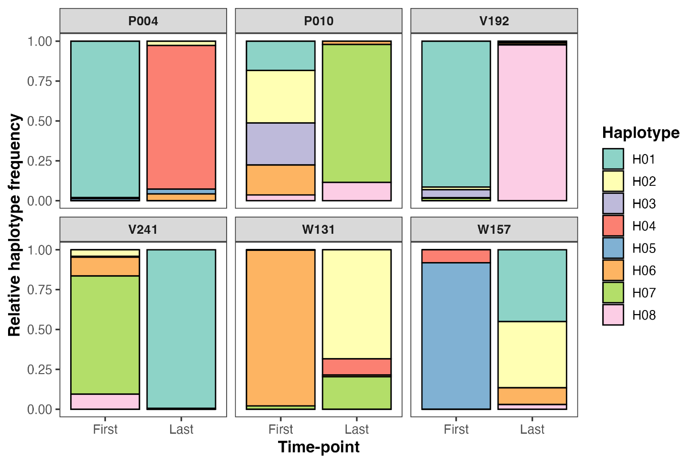
Supplementary Figure S2. Haplotype abundances at the first and last time-points. In the 6 patients shown here, acquired haplotypes accounted for more than half of the community at the last time-point.

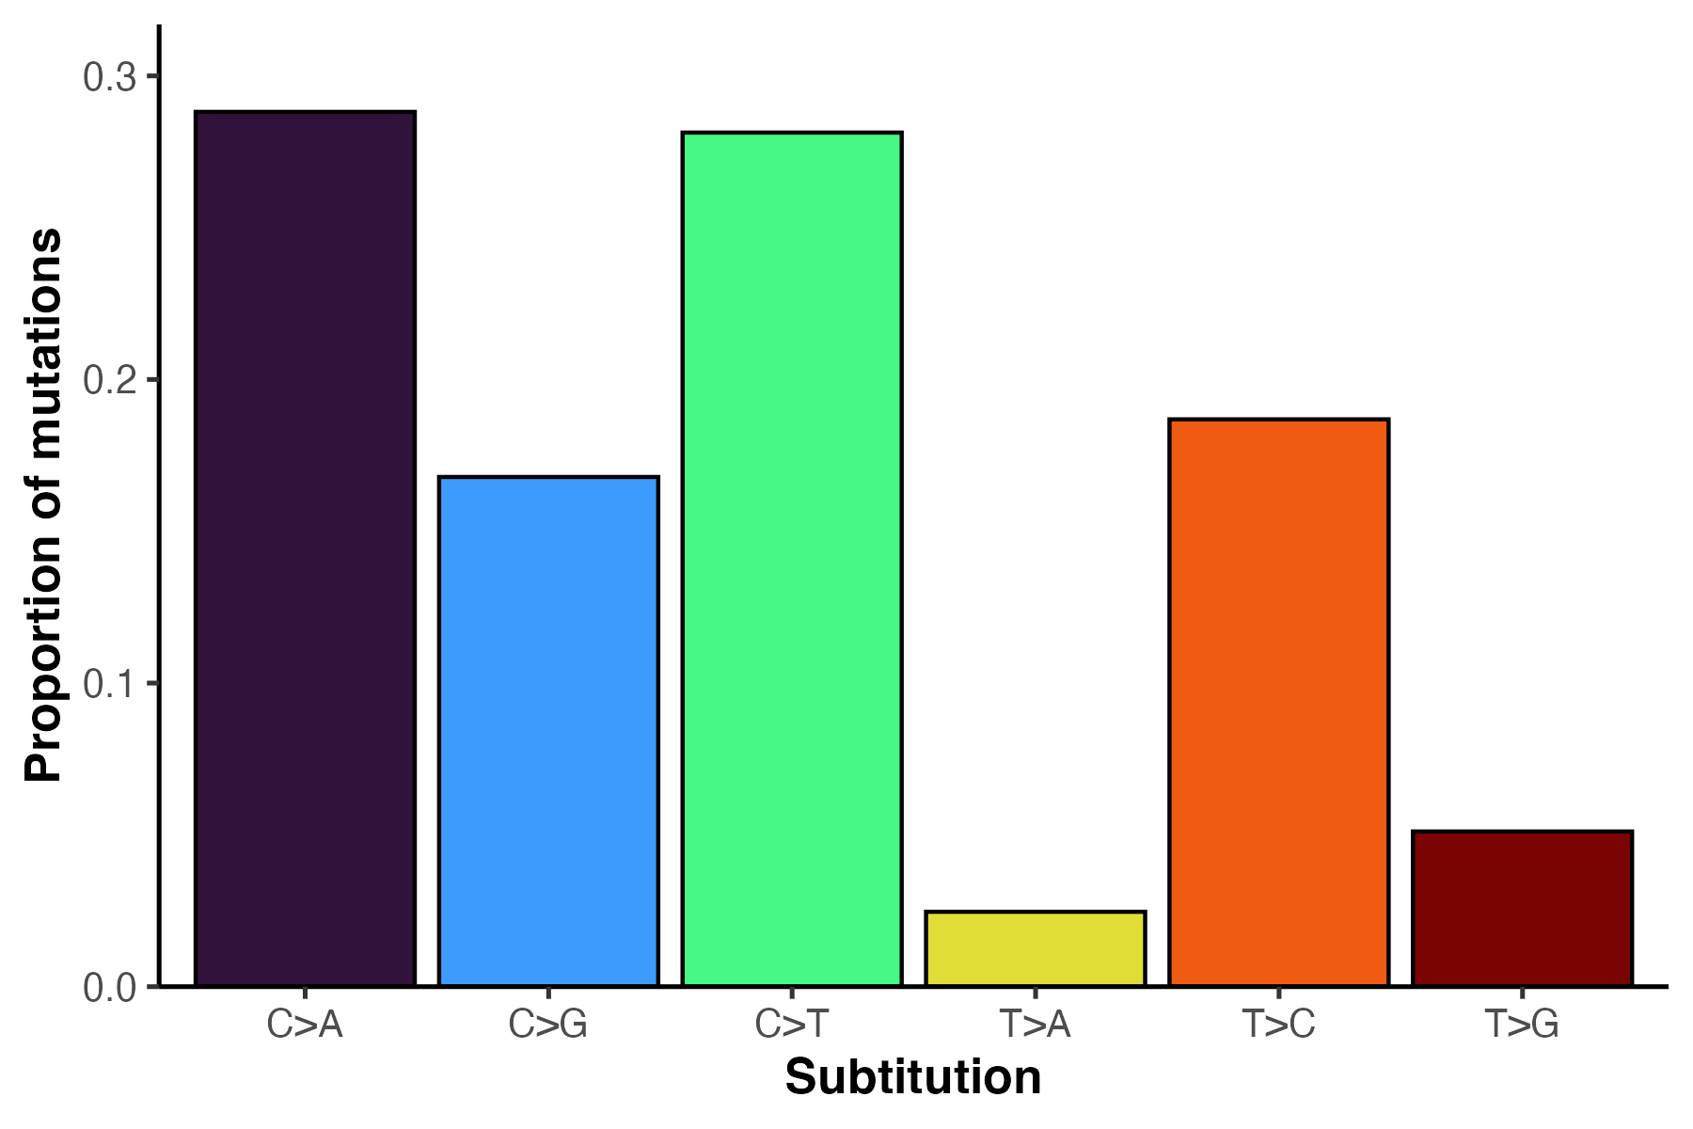
Supplementary Figure S3. The within-host mutational spectrum of M. avium, as determined using MutTui.

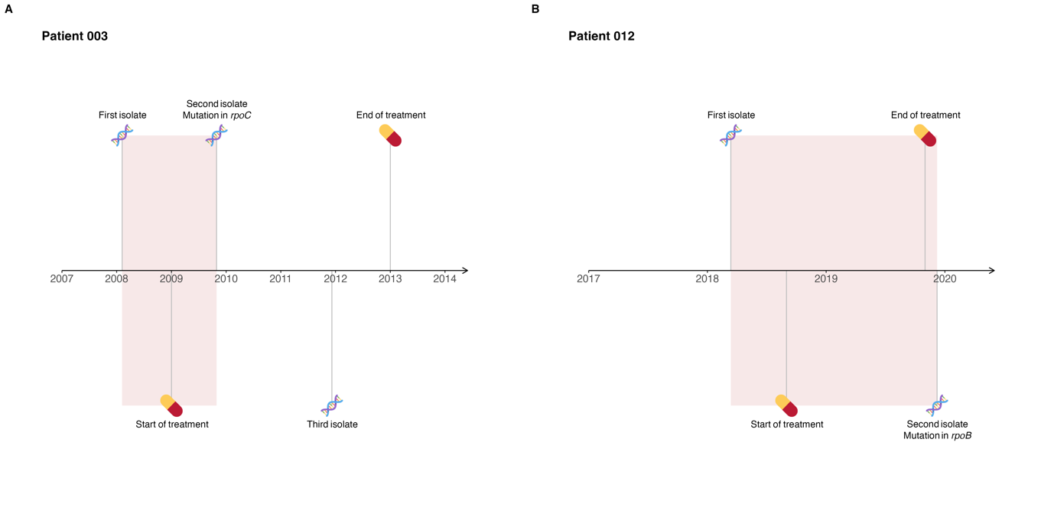
Supplementary Figure S4. Timeline for the acquisition of nonsynonymous mutations in antibiotic resistance genes during the treatment of patients P003 and P012 from the Irish cohort.

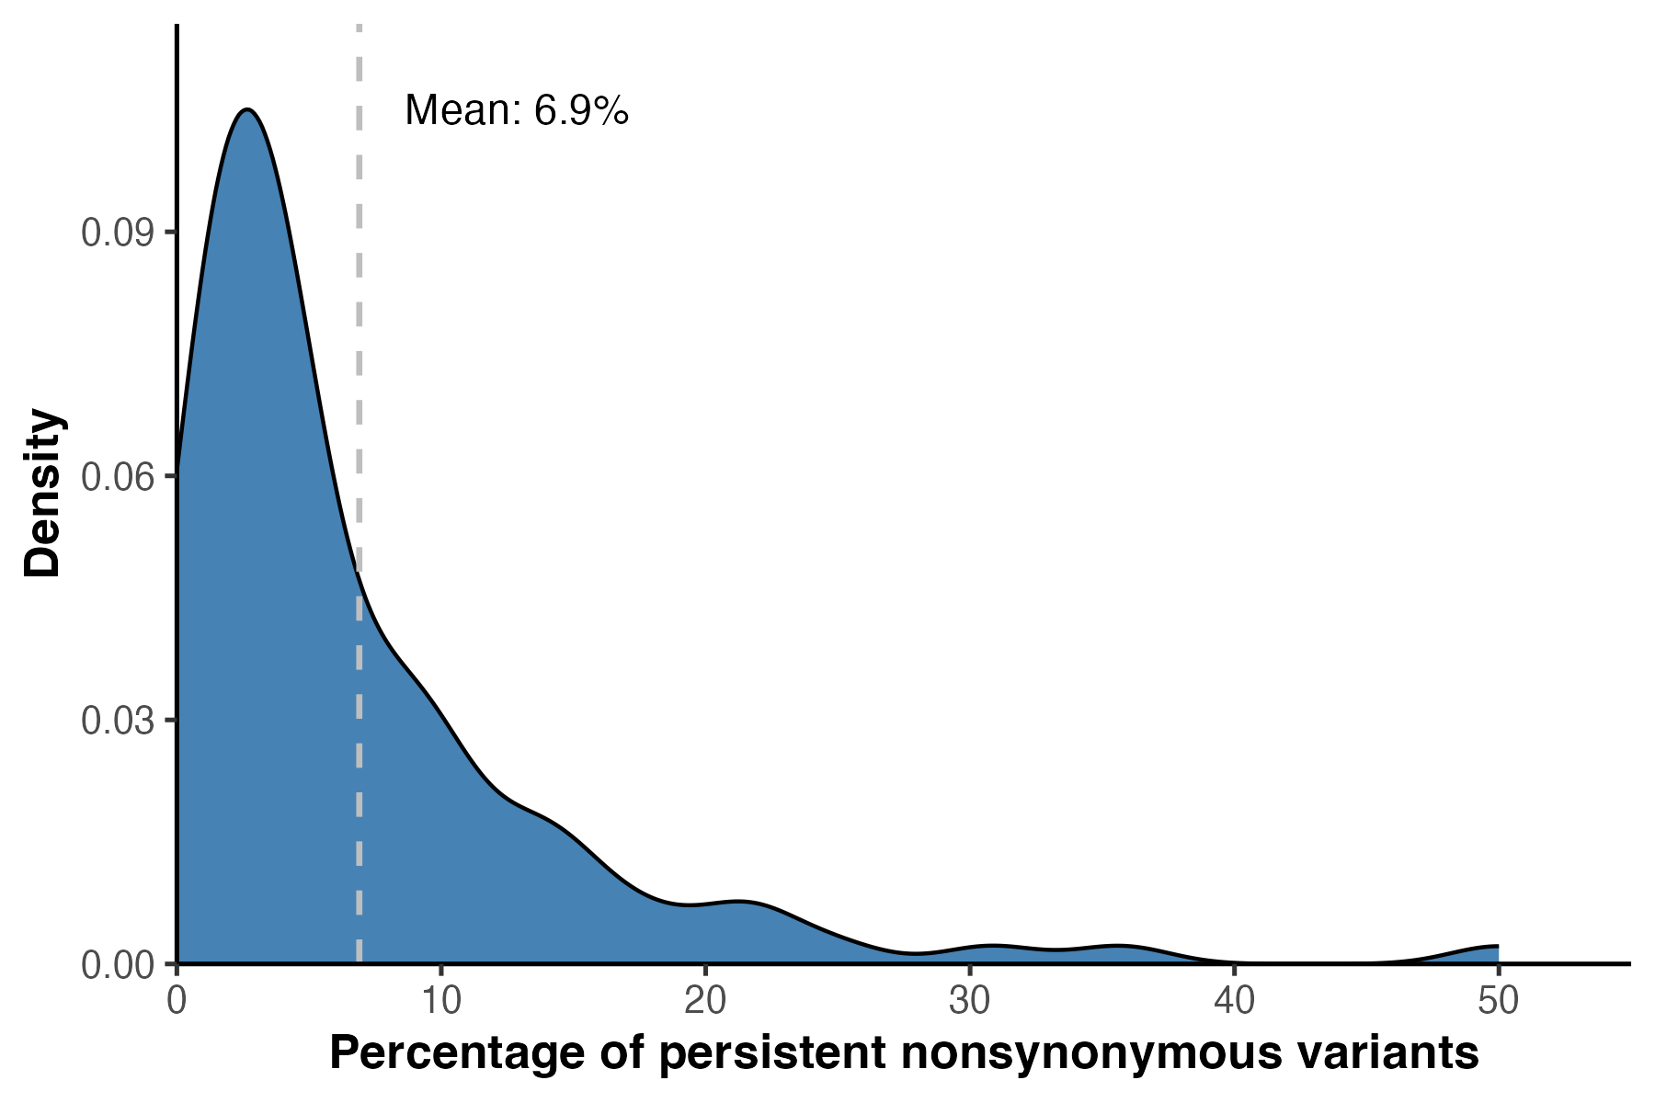
Supplementary Figure S5. The percentage of nonsynonymous variants that persisted to the next time-point. The dashed line on the density plot indicates the mean.

