Construction of The Heterojunction with Basic Bismuth Nitrates and CuCr-Cl-LDH for Enhanced Photocatalytic Degradation of Tetracycline Under Visible-light

Brazilian Journal of Chemical Engineering

Yin-Yan Dou¹, Yan-Ming Shen^{*1}, Jun-Hua Wen¹, Lei Yang¹

¹Department of Chemical Engineering, Shenyang University of Chemical Technology, Shenyang, China

*Corresponding author, e-mail: sym6821@sina.com.cn

Text S1
Stability test for the photocatalyst
The BBN/LDH-2 photocatalyst was selected to test the stability of photocatalyst. After photocatalytic degradation of TC, the used photocatalyst particles were collected by filtration and separation, and washed with distillated water and ethanol for three times, then dried at 60 ºC at vacuum for 12 h. The obtained photocatalyst particles were used for the next photcatalytic degradation test. The photocatalytic degradation condition was set as catalyst dosage of 0.5 g/L, TC concention of 20 mg/L.

Figures:
Fig.S1 EDS element maps and composition of sample BBN/LDH-2.

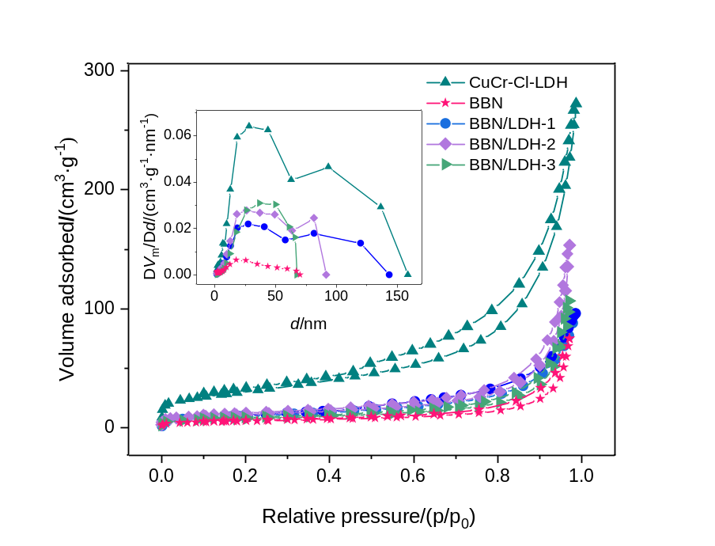
Fig. S2 N₂ adsorption-desorption isotherms and pore size distribution curves of samples.

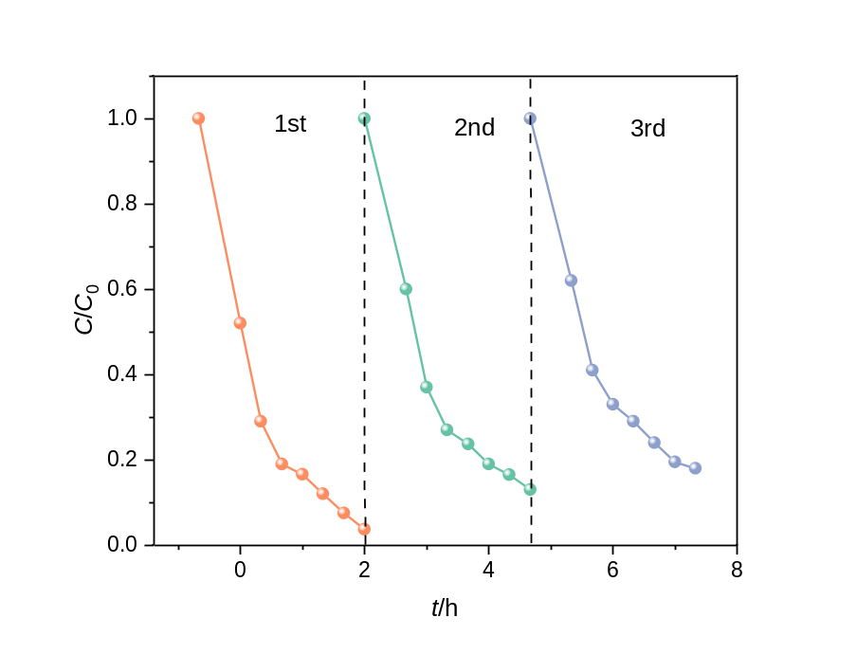
Fig. S3 Results of stability experiment

Fig. S4 The schematic diagram for photocatalytic reaction process on BBN/CuCr-Cl-LDH composite.

Tables:

Table S1 TOC degradation effects of different catalystsª
Photocatalyst | TOC/mg·L⁻¹
Photocatalyst | After adsorption | Irradiation time of 120 min
CuCr-Cl-LDH | 11.01 | 9.738
BBN | 11.04 | 8.712
BBN/LDH-1 | 8.210 | 2.703
BBN/LDH-2 | 6.256 | 1.670
BBN/LDH-3 | 6.465 | 1.877
ª Note: TOC value of initial TC concentration was 11.57 mg·L⁻¹.

Table S2 complete list of all acronyms used within the manuscript
Full name | acronym
Basic Bismuth Nitrates | BBN
tetracycline | TC
advanced oxidation processes | AOPs
layered doubled hydroxides | LDHs
Isopropyl alcohol | IPA
p-benzoquinone | BQ
disodium ethylenediaminetetraacetic acid | EDTA-2Na
X-ray diffraction | XRD
scanning electron microscope | SEM
transmission electron microscope | TEM
energy dispersive spectrometer | EDS
UV-vis diffuse reflectance spectra | UV-vis DRS
X-ray photoelectron spectroscopy | XPS
electrochemical impedance spectroscopy | EIS
Mott-Schottky | MS
Total Organic Carbon | TOC
electron paramagnetic resonance | EPR

