Supplementary material

Impact of reducing meat and dairy consumption on nutrient intake, health, cost of diets and the environment: A simulation among adults in Scotland
Joe Kennedy, Michael Clark, Cristina Stewart, Ricki Runions, Alexander Vonderschmidt, Sarah M. Frank, Peter Scarborough, Fiona Comrie, Alana McDonald, Geraldine McNeill, Peter Alexander, Lindsay M. Jaacks

Contents
Modelling the impact on nutrient intake 2
Modelling the impact on environmental outcomes and cost of diets 12
Environmental impact adjusted for usual dietary intake 14
Uncertainty estimation 15
Food category contributions to baseline impacts 17
Modelling the impact on chronic diseases, mortality and obesity 18
References 36

Modelling the impact on nutrient intake
Dietary data were from the 2021 Scottish Health Survey (SHeS) (1). All respondents (n=3,447) reported the food and drink items consumed across either one day or two days of recall, with most of the sample (88.3%) providing two days of recall. The nutrient content of all reported items in SHeS are calculated from data in the UK Nutrient Databank (NDB) (2), a standardised dataset with estimates for the nutrient content per 100g of each item across 54 macro and micronutrients. Baseline intake of each nutrient per individual was calculated by summing up the nutrient content in all reported items and dividing by the number of days of recall for that individual.

In addition to the nutrient content, estimates of the disaggregated gram weight of different foods per 100g were also provided in the NDB (3). Disaggregated meat in the NDB includes “Beef”, “Lamb”, “Pork”, “Processed red meat”, “Other red meat”, “Burgers”, “Sausages”, “Offal”, “Poultry”, “Processed poultry” and “Game birds”. Unprocessed red meat was defined as “Beef”, “Pork”, “Lamb”, “Burgers” and “Other red meat”. Processed red meat was defined as “Processed red meat”, “Sausages” and “Offal”. In the pathways CCC 2030 and CCC 2050, we also applied reductions to the food groups “Poultry”, “Processed poultry” and “Game birds”. Baseline daily intake of each meat type was calculated in the same manner as for nutrients, by summing the gram weight of the meat type consumed in every reported item and dividing by the number of days of recall. Daily consumption of all meat, unprocessed red meat and processed red meat was then calculated by summing the daily intakes of each of the associated meat types. There were three poultry containing items in the “Sausages” and “Offal” food groups: “Chicken and vegetable soup, homemade”, “Chicken liver” and “Chicken/turkey sausage”. In estimating baseline red and red processed meat intake, the contribution from these three poultry containing items to “Sausages” and “Offal” intake were excluded.

Once the daily consumption of red and red processed meat was calculated it was possible to calculate the percentage reduction in all meat (including “Poultry”, “Processed poultry” and “Game birds”) that corresponds to a chosen maximum daily intake threshold (herein maximum threshold) of red and red processed meat (herein red meat) as follows. If an individual consumed greater than the specified maximum threshold, then the required reduction was calculated as the difference between their current red meat intake and the maximum threshold. After multiplying by the sample weights and summing over the entire population, we derived the total gram weight of the red meat reduction for a given maximum threshold. By taking the ratio between this red meat reduction and the sample weighted sum of the consumption of all meat across all individuals we can derive the percentage level reduction in all meat that corresponds to different maximum thresholds. In Figure S1 we show this relationship for different values of the maximum thresholds. From this relationship, we derived the maximum intake of red meat to achieve both of the CCC meat reduction pathways—60g/day for CCC 2030 and 31g/day for CCC 2050—as well as the percent reduction in all meat should the current Scottish Dietary goal of 70g per day of red meat be met, namely 16%.

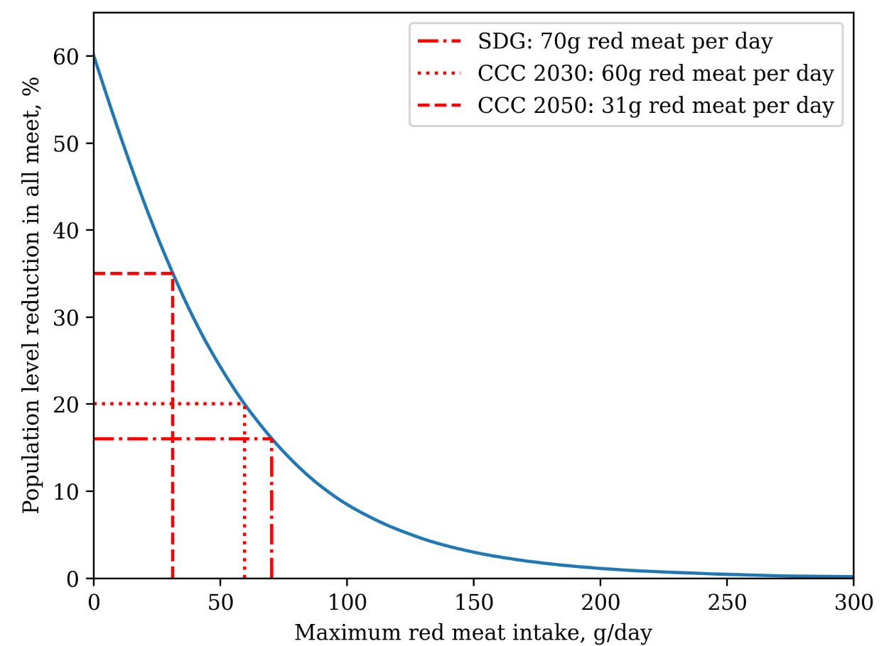

Figure S1. Relation between the maximum daily intake of red meat with the associated percentage reduction in all meat. The three reduction pathways are highlighted to demonstrate how the percentage reduction in all meat leads to each maximum daily intake threshold set in the simulation pathways. CCC: Climate Change Committee, SDG: Scottish Dietary Goal.

Disaggregated dairy was not available in the NDB. In this instance, we used data from a separate analysis (4) to estimate the gram weight per 100g of “Milk skimmed”, “Milk, semi-skimmed”, “Milk Whole”, “Cream skimmed”, “Cream whole”, “Cheese skimmed”, “Cheese semi-skimmed”, “Cheese whole”, “Yoghurt skimmed”, “Yoghurt semi-skimmed”, “Yoghurt whole” and “Butter”.

In all simulation pathways, reductions in meat and dairy were applied to each of the disaggregated meat and dairy types. In pathways CCC 2030 and CCC 2050, percent level reductions were applied to each meat and dairy type regardless of consumption level. These reductions applied to both composite (e.g. “Beef lasagne”) and non-composite items (e.g. “Minced beef”). For example, in pathway CCC 2030, which required a 20% reduction in all meat, if the disaggregated pork content in a reported item was 100g, then the reduction in pork consumption associated with that item would be 20g. If the same food item also contained 50g of poultry then, in pathways CCC 2030 and CCC 2050, the reduction in poultry consumption associated with that item was 10g.

In the pathways focusing on high red meat consumers, meat reductions were applied to the disaggregated red meat types such that the total red meat intake averaged across both days of recall did not exceed a specified maximum intake level. For example, if the maximum intake was 70g red meat per day, then an individual with two days of recall who consumed greater than 70g per day when averaged across both days, could not consume more than 140g of red meat after summing across both days of recall. As there are multiple pathways to reach this maximum intake for high red meat consumers depending on what disaggregated red meat types to reduce, an iterative process was applied to each high consumer. The first step was to randomly select a disaggregated red meat type among all disaggregated red meat types that were consumed and reduce the intake of that disaggregated red meat type by 10g. This process was then repeated until the individual’s total intake of red meat was less than 10g away from the maximum intake. Finally, the remaining reduction was applied to a randomly selected disaggregated red meat type if the intake of that disaggregated red meat type was greater than the remainder.

For example, consider an individual who consumed 100g of beef, 50g of pork and 64g of sausages across two days of recall and a maximum threshold of 70g. In total, this individual consumed 214g of red meat and so to meet the pathway requirements they need to reduce their intake by 74g. After randomly sampling the beef, pork and sausages disaggregated red meat types and applying the reductions in 10g increments, one possible realisation is a reduction in beef of 30g, a reduction in pork of 30g and a reduction in sausages of 10g. The additional 4 g required to meet the threshold is then randomly added to one of these disaggregated red meat types. For example, after applying the reductions, the individual’s new intake is 34g of beef, 30g of pork and 10g of sausages. This process was then repeated for 50 iterations to ensure that the variation in the impact of each outcome across nutrient intake, health, diet costs and the environment, also accounts for the variable impact of reducing different disaggregated red meat types to meet the maximum threshold. In Table S1 we provide the sample weighted percentages of the number of respondents who consumed above each maximum threshold considered in this study.

Table S1. Sample weighted percentage of respondents in SHeS 2021 that consumed more than the three maximum thresholds of daily red meat intake examined in this study.
Maximum daily red meat intake | % sample above threshold
70g | 27.6%
60g | 32.8%
31g | 53.7%

A 20% dairy reduction was then applied in these pathways regardless of consumption level (i.e. to all consumers).

Once the gram weight of the reductions in disaggregated meat and dairy types were derived for each respondent, the impact on nutrient intake for all 54 nutrients was derived. For non-composite meat and dairy items, the new nutrient intake levels were calculated by multiplying the nutrients per gram of the entire item by the gram weight of the reduction and subtracting this value from the baseline nutrient intake. The new nutrient intake level was then calculated by subtracting this reduction from their baseline nutrient intake. For example, a respondent who reported consuming 100g of semi-skimmed milk would then consume 80g after applying the 20% dairy reduction, with the change in nutrient intake derived from subtracting the nutrient content of 20g of semi-skimmed milk for each nutrient.

For composite meat and dairy items, the nutrients of the meat and dairy ingredients were subtracted from their total nutrient intake, rather than the nutrient content of the entire item. In the case of all disaggregated meat types other than offal, each meat containing item was assigned a non-composite meat item to each meat group the item contained. These meat ingredients were chosen from all non-composite meat items in SHeS with the assigned ingredients verified independently by two members of the research team. For example, the food item “Chilli con carne” contains beef, with the non-composite beef food item chosen as “Minced beef, stewed”. Therefore, if a respondent reported consuming “Chilli con carne” with 100g of beef and the final beef reduction for that item in a particular pathway was 30g, then the nutrients in 30g of “Minced beef, stewed” were subtracted from the total nutrient content of the entire item. A single meat ingredient was assigned to each meat food group for each meat containing item. In the case of offal items, the nutrient content of the entire food item was reduced under the assumption that offal meat was unlikely to be consumed in the absence of the composite ingredients.

We provide the full mapping of meat ingredients assigned to meat containing items in the Supplementary data file S6. Due to this matching, we found that for some individuals who had a particularly low baseline nutrient intake for certain nutrients, after applying the reductions, the nutrient intake became negative due to differences in the nutrient content of the matched meat item and that used to derive the original nutrient content of the meat containing item. For example, the meat containing item “Beef burger/hamburger, in a bun, not quarter pounder” does not contain vitamin D, while the matched non-composite meat item “Beef burger, grilled (no bun)” contained 0.005mg of vitamin D per gram. In instances of negative nutrient intake, intake was manually set to zero.

For composite dairy items, the Food Standards Agency (FSA) recipe database (5) was used to assess the nutrient contribution of each dairy ingredient in each food type. In instances where there were multiple dairy ingredients in a single dairy food type, the reduction was applied in proportion to the contribution of each dairy ingredient to gram weight of the total gram weight of the food type in the item. Some ingredients in the FSA recipe database were unavailable in the version of the 2022 version of the NDB. The nutrient content of these ingredients was then assigned to be that of a similar dairy ingredient. The details of the assumptions made in this assignment can be found in the supplementary material of (4).

Gram-for-gram replacements for each disaggregated meat and dairy type were then applied. Meat was replaced with pulses and legumes, vegetables, eggs, oily fish, plant-based meat alternatives or chicken. Dairy milks were replaced with plant-based milks, dairy yoghurts with plant-based yoghurts and dairy solid fats with plant-based solid fats. The nutritional composition of each replacement was calculated as a weighted average of the nutritional composition of foods in each food group, with each weight corresponding to the frequency of consumption of the food item in SHeS 2021. In the case of the chicken and yoghurt replacement, a single item from the NDB was chosen as the replacement. An overview of the criteria for the inclusion of different food items in each replacement food group is provided in Table S2. In the case of pulses and legumes and plant-based meat alternatives, due to the limited number of non-composite items in these food groups, we included the nutrient contribution of all ingredients of the composite food item. For example, only 44% of the pulse and legume composite replacement consisted of the NDB beans disaggregated food group, due to the presence of other ingredients such as the sugar in baked beans. Items that were consumed by <1% of the population were not included in the weighted composite. The foods contributing to the weighted composite replacement in each food group are provided in Figures S2-S8. In Table S3 we provide the nutrient content of the foods included in the plant-based milk replacements along with the nutrient content of the weighed composite plant-based milk implemented in each simulated pathway.

Table S2. Summary of the selection criteria for food and drink items included in each of the meat and dairy replacements.
Replacement | Strategy for inclusion in replacement
Meat
Pulses and legumes | All items with non-zero disaggregated Beans, excluding all items that also contain meat or fish or are soya-based (e.g. Tofu)
Vegetables | All non-composite items in the disaggregated variables Brassicaceae, Yellow Red Green, Tomatoes and Other Veg
Plant-based meat alternatives | All food items within the SHeS Recipe Sub Food Group Code 37K, excluding “Vegetarian Sausage, cheese based” to ensure no additional dairy intake
Egg | String search for “egg” in the food description and subsequent selection process for non-composite egg items. Only four items contributed >1% to total intake: “Fried egg”, “Poached egg”, “Boiled egg” and “Scrambled egg”
Oily fish | Based on a manual search of oily fish items in SHeS. All items that included the description “smoked” were excluded
Chicken | Single item replacement with food item “Roast/grilled chicken breast (skin not eaten)”
Dairy
Plant-based milks | Based on manual search of plant-based milk items available in SHeS.
Plant-based yoghurt | Single item replacement: “Soya yoghurt, plain (e.g. Alpro Soya)”
Plant-based solid fats | Based on manual search of plant-based solid fat items available in SHeS

Table S3. Nutrient content per 100g of the plant-based milks included in the plant-based milk composite replacement along with the associated weighting for the weighted average for four select nutrients. All data are taken from the UK Nutrient Databank.
 | Iodine (µg) | Protein (g) | Calcium (mg) | Free sugars (g) | Weight (% consumption)
SHeS food item
Oat milk | 0 | 0.94 | 52.33 | 1.69 | 48.8
Almond milk/ hazelnut milk | 0 | 0.50 | 120.0 | 0.10 | 20.6
Soya milk, unsweetened | 11.00 | 2.70 | 13.0 | 0.50 | 14.3
Soya milk, sweetened | 11.00 | 3.00 | 120.0 | 2.80 | 10.5
Coconut milk, fresh (e.g. Alpro) | 0 | 0.20 | 120.0 | 2.1 | 2.7
Soya milk, light | 11.00 | 2.0 | 120.0 | 0.10 | 2.1
Rice milk | 0 | 0.80 | 3.0 | 0 | 1.0
Composite plant-based milk replacement | 2.96 | 1.31 | 70.44 | 1.27 | -

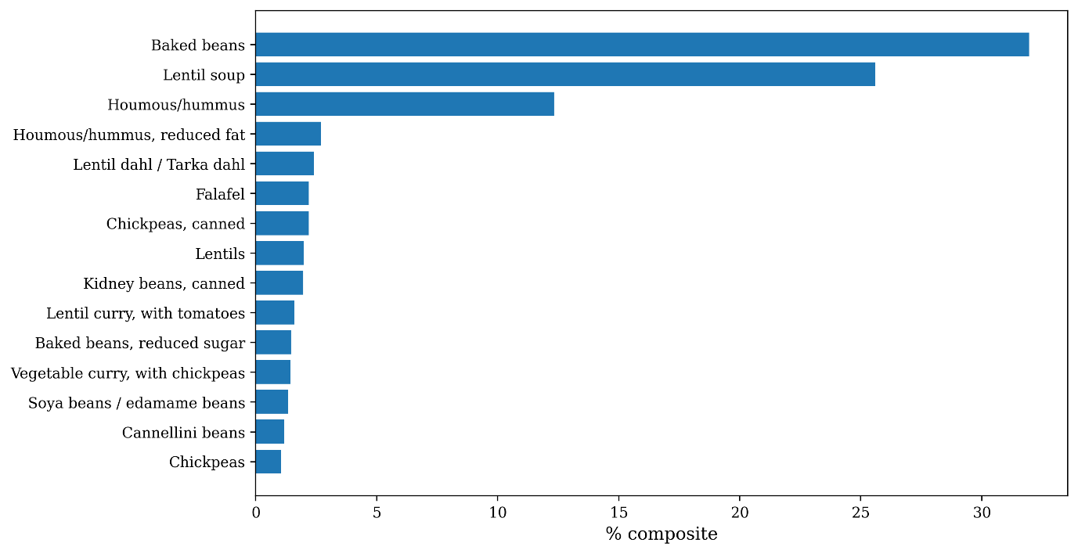
Figure S2. Pulse and legume containing items included in the weighted composite pulse and legume replacement.

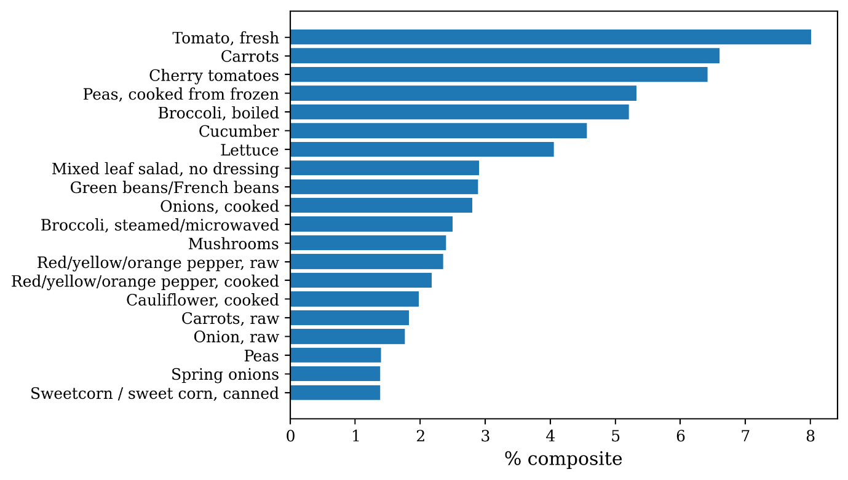
Figure S3. Vegetable items included in the weighted composite vegetable replacement.

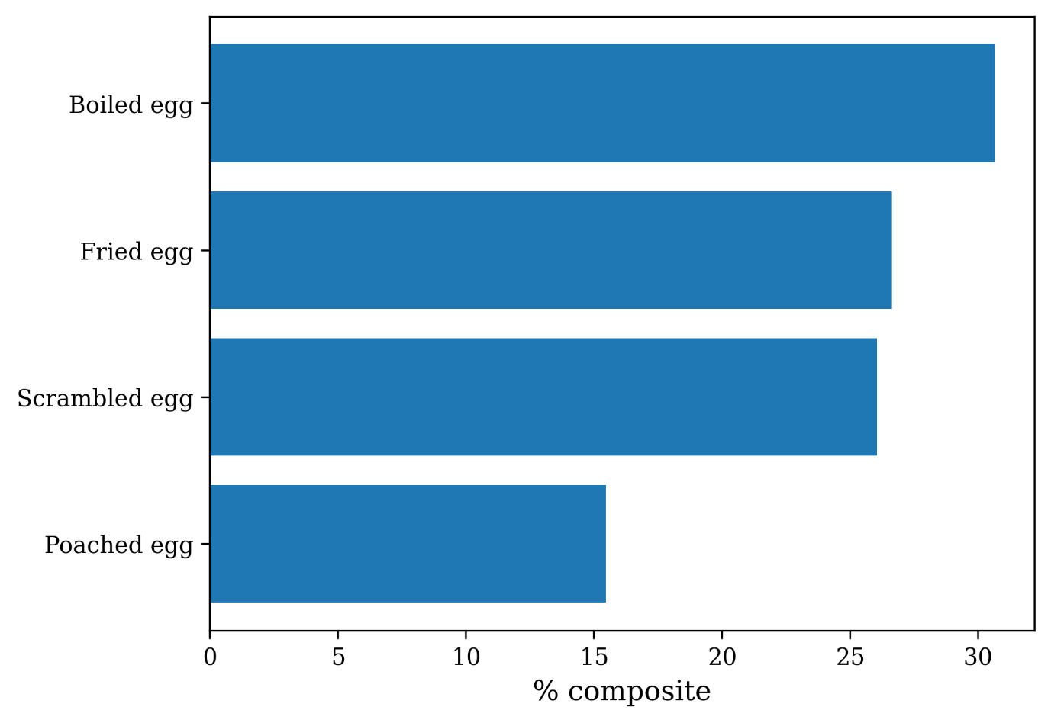
Figure S4. Egg items included in the weighted egg composite replacement.

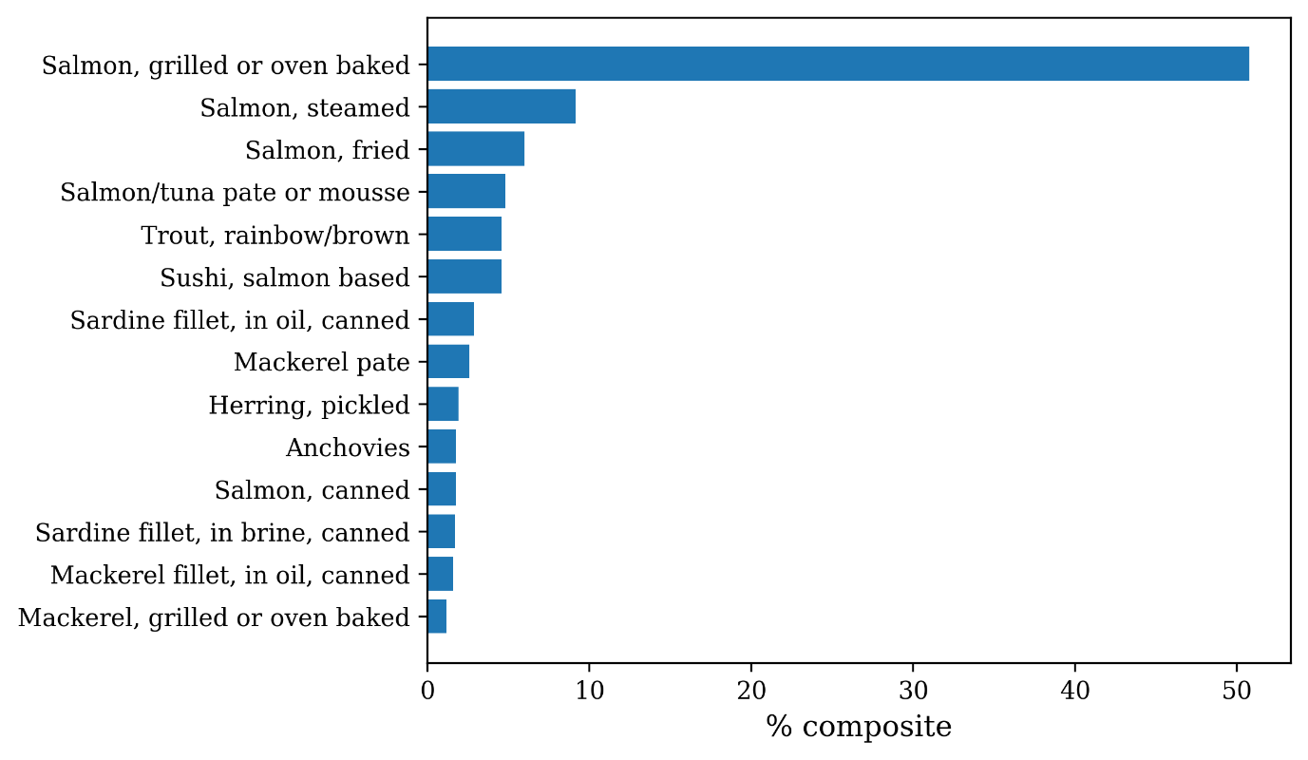
Figure S5. Non-smoked oily fish items included in the weighted composite oily fish replacement.

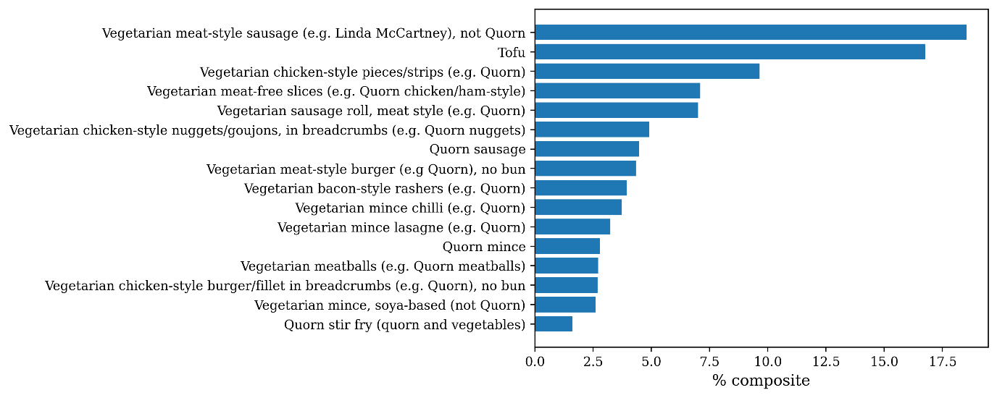
Figure S6. Plant-based meat alternative food items included in the weighted composite of the plant-based meat replacement.

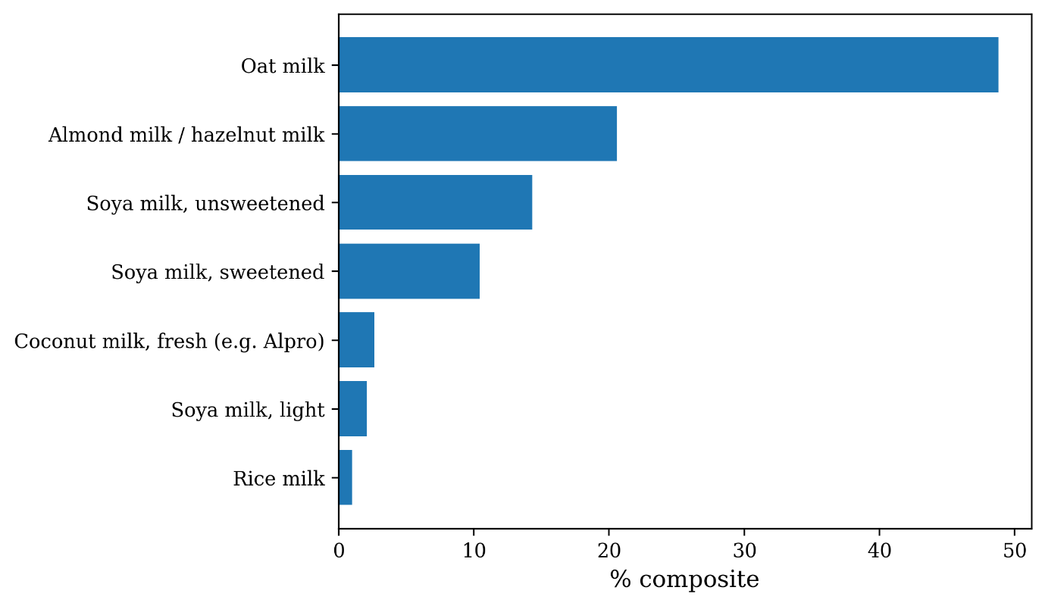
Figure S7. Plant-based milks included in the weighted composite plant-based milk replacement.

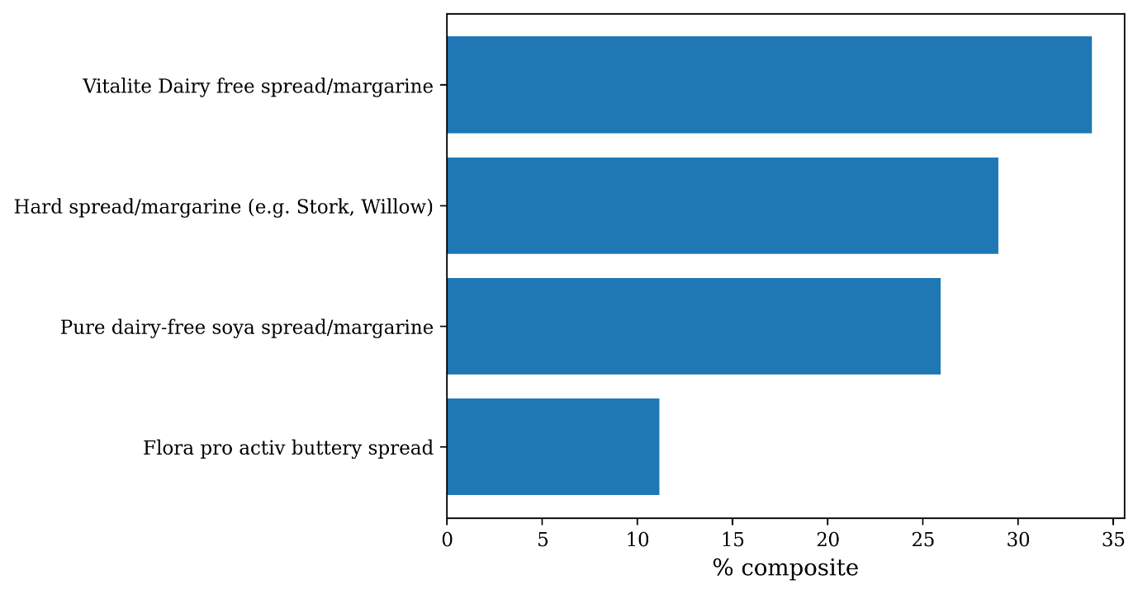
Figure S8. Plant based solid fats included in the weighted composite plant-based solid fat replacement.

Modelling the impact on environmental outcomes and cost of diets
To estimate the impacts on environmental outcomes we matched all items in the NDB (n=2,930) to appropriate matches in foodDB, a large dataset containing the environmental impact per 100g of ~70,000 food and drink items available for purchase in major UK supermarkets (6,7), including greenhouse gas emissions, land use, water use and eutrophication. This mapping was one to many, for example, a single item “Oat milk” in the NDB was matched to all oat milks available in foodDB. Each item in foodDB is associated with a distribution of impacts for each indicator to account for the distribution of environmental impacts in the production of a single food commodity (8). The median of this impact distribution for each indicator was taken for each matched foodDB item rather than the mean to avoid oversensitivity to outliers. The subsequent impact of the NDB item was then calculated as the average of all impacts of the matched foodDB items.

The environmental impact per gram of each NDB item was multiplied by the gram weight of the consumed item to obtain the total impact of the consumption of that item. As with nutrient intake, the total impact at the individual level was then calculated by summing over all items in the self-reported dietary data and dividing by the individual’s number of recall days. In instances were the item description in the NDB and SHeS did not match, the associated food code was used to provide impact estimates for the SHeS item. If the food code was associated with multiple SHeS items, then the impact was calculated as the average of the impact of each SHeS item.

Conversion factors were also applied between the gram weight of certain drink items to account for the fact that the impacts per gram in foodDB do not include additional water. For example, the impact per gram of tea in foodDB is the impact of the tea leaves, while the impact in SHeS includes the water associated with the consumed tea. The conversion factors used in the analysis to convert between the foodDB impact and the associated consumption impacts in SHeS are provided in Table S4.

Table S4. Conversion factors applied to convert the environmental impacts per gram of items in foodDB to the corresponding impacts per gram of the reported items in SHeS 2021
SHeS food item | Conversion factor
“Tea”, “Herbal/ Fruit tea”, “Decaf tea”, “Green Tea” | 0.008
“Coffee, fresh”, “Decaf coffee, fresh” | 0.06
“Coffee, instant”, “Decaf coffee, instant” | 0.01
“Hot / drinking chocolate, made with water, low calorie” | 0.02
Diluted juice drink, e.g. “Orange squash, no added sugar, diluted” | 0.2

As foodDB also contains price information it was possible to estimate total daily expenditure in SHeS along with the associated impact on expenditure in each simulation pathway. In foodDB price data were taken from 2022, 2021 and 2019. Price data from 2022 were chosen, if available. For items that did not have 2022 price data, 2021 price data were assigned (n=53), while if 2021 price data were not available then 2019 price data were assigned (n=6). In addition, any items that were priced greater than £5 per 100g were excluded from the NDB to foodDB mapping in estimating the price of NDB items (n=1,238). This cutoff was chosen as it was the 96th percentile in the distribution of prices in foodDB and ensured that any items that overestimated the price due to parsing errors or mislabelling were excluded from the analysis.

Environmental impact adjusted for usual dietary intake
Self-reported dietary data is typically under-reported (9) and, as a result, all estimates for per capita impacts, cost and nutrient intake should be considered conservative. To obtain a more reliable estimate for the environmental impact of each indicator at the population level we combined the number of calories which were likely to be under-reported for each individual (based on recommended daily intake) with the environmental impact per calorie of that individual. This approach assumes that the under-reported food and drinks are similar to the self-reported items. For example, if an individual had a total daily dietary GHG of 5kg $CO_{2}e/$day based on 1500 kcal, their emissions per calorie would be 0.003 kg$CO_{2}e$/kcal. Recommended daily calorie intakes were then used to adjust the daily emissions estimates, with a recommended daily intake of 2500kcal for males and 2000kcal for females. In this example, if the individual is male, then their adjusted daily emissions estimate is given by 5 + (0.003 $×$1000) = $8.33$kg$CO_{2}e$. The total yearly estimate is then computed by taking the individual’s adjusted daily impact, multiplying by the sample weight, summing over the whole population and multiplying by 365. As the sample weight provided in SHeS is a relative sample weight, before taking the summation each sample weight was multiplied by a scale factor derived from Scottish Census Data (10) to ensure that the sum of the sample weights was equal to the Scottish adult (16+) population size in 2021. The calorie adjusted total yearly impact for each indicator is given in Table S5.

Table S5. Estimated total environmental impacts over a year for the Scottish adult population, adjusted for under-reported calorie intake.
Indicator | Yearly impact, adjusted for daily caloric intake (95% Uncertainty Interval)
GHG, Mt$CO_{2}e$ | 9.6 (9.5, 9.7)
Land use, ${10}^{3}×km^{2}$ | 12.5 (12.3, 12.6)
Water use, $10^{11}×$ litres | $9.4$ (9.3, 9.6)
Eutrophication, $10^{9}×$ gP$O_{4}e$ | 37.7 (37.2, 38.2)

Uncertainty estimation
The uncertainty intervals in the per capita outcomes and changes in outcomes in all simulation pathways were computed by combining several sources of uncertainty (uncertainty estimation for health outcomes is described at the end of the “Modelling the impact on chronic diseases, mortality and obesity” section below). For all nutrients, standard errors were calculated using the R “survey” package (11) to account for the complex survey design, with the upper and lower uncertainty range estimated as +/- 1.96 multiplied by the standard error. In the case of environmental outcome and expenditure, we further accounted for the within-item uncertainty for each NDB item from the standard deviation of the median impact values of all matched foodDB items.

In instances were a SHeS food code corresponded to multiple items in the NDB, the within-item impact uncertainty for that item was calculated as follows. If there are M items in the NDB corresponding to a single food code in SHeS, the combined error on the impact per gram of indicator I is estimated by
$$σ_{I}=\frac{1}{M}⋅\sqrt{{\sum_{j=1}^{M}{σ_{Ij}}}^{2}}$$
where $σ_{Ij}$ is the standard error in the impact per gram of item j. The final estimate for the baseline standard error of the indicator associated with the consumption of each item in the dietary data was calculated by multiplying the standard error per gram by the gram weight of consumption. Standard errors were combined at each simulation stage as follows.
For all non-composite meat and dairy items and meat and dairy containing items with a non-zero reduction of a disaggregated meat or dairy type, the standard error of the item’s impact after removing meat and dairy was computed as $\sqrt{σ_{item}^{2}+ σ_{ingredient}^{2} }$ where $σ_{item}$ is the standard error of item’s impact prior to applying the reductions (e.g. the standard error of impact of “Beef lasagne”) and $σ_{ingredient}$ is the standard error of the impact of the meat or dairy ingredient that being deducted from the original item (e.g. “Minced beef, stewed”). The value of $σ_{ingredient}$ was calculated by taking the standard error of the impact per gram of the ingredient, multiplied by the gram weight of the reduction. For non-composite items, $σ_{item}$ and $σ_{ingredient}$ are related by $σ_{ingredient}=α×σ_{item}$ , where $α$ is the ratio between the gram weight of the reduction and the original gram weight of the item. For example, if the original consumption level of a non-composite meat or dairy item was 100g and the reduction was 20g in a particular scenario, then $α=0.2$.

The standard error of the impact of all items consumed per individual in SHeS was then calculated as
$$σ_{Individual}=\frac{1}{N}⋅\sqrt{\sum_{j=1}^{M}{σ_{j}^{2}}}$$
where N is the number of days of recall, M is the total number of food and drink items consumed across both days of recall and $σ_{j}$ is the standard error of the indicator of item j.

In the three pathways were the CCC targets are met through reduction in red meat alone, there was additional uncertainty associated with the variable impact of achieving the reduction via reductions in different red meat food groups. As the process was repeated for 50 iterations there were 50 different values for $σ_{Individual}$ for different realisations of red meat reduction combinations per individual. The final estimate for the impact uncertainty for each individual prior to substitution was calculated as
$$σ_{Individual, pre sub}=\frac{1}{50}\sqrt{\sum_{j=1}^{50}{σ_{Individual, j}^{2}}}$$
where $σ_{Individual, j}^{}$ is the standard error of the individual’s total impact for Monte Carlo iteration j.

As each meat and dairy replacement other than chicken and plant-yoghurts consisted of a weighted composite of different food items within that food group, with weights associated with consumption frequency in SHeS, the standard error of the replacement’s impact also must account for these weights. The final standard error per gram of the substitute was calculated as
$$σ_{Sub per gram}=\frac{1}{\sum_{i=1}^{N}{w_{i}}}\sqrt{\sum_{i=1}^{N}{{\left(w_{i}×σ_{i}\right)}^{2}}}$$
where $w_{i}$ is the weight of the food item i in the weighted average of N total items included in the composite replacement, each with a standard error of the impact per gram $σ_{i}$. In all substitution pathways the standard error on the environmental impact in each of the substitution pathways is computed by combining the individual standard error post reduction with the standard error of the meat or dairy replacement as follows
$$σ_{Individual, post sub}=\sqrt{σ_{Individual, pre sub}^{2}+σ_{Sub}^{2}}$$
where $σ_{Sub}$ is $σ_{Sub per gram}$ multiplied by the gram weight of the total meat or dairy reduction that the substitute replaces. For example, should an individual experience a 20g reduction in red meat across all red meat food types and replace the red meat with eggs, then $σ_{Sub}$for a given indicator would be 20 multiplied by $σ_{Sub per gram}$of the corresponding indicator. Each individual now has a standard error for each indicator associated with the simulated diet.

The standard per capita error of each indicator of the baseline diet were computed in the same manner as $σ_{Individual}$, but without any of the steps involving meat and dairy reductions and substitutions. The standard within-item error of the per capita impact for each indicator X can then be calculated as
$$σ_{X}=\frac{1}{\sum_{i=1}^{N}{{sw}_{i}}}\sqrt{\sum_{i=1}^{N}{{\left({sw}_{i}×σ_{i,X}\right)}^{2}}}$$
where N is the number of individuals in SHeS, $sw_{i}$ is the survey sample weight of individual i and $σ_{i,X}$is the standard error of indicator X for individual i. The within item standard error $σ_{X}$ for indicator X can then be combined with the standard error on the per capita impact associated with the complex survey design $σ_{X, survey}$to obtain the standard error of per capita impacts as $\sqrt{σ_{X}^{2}+σ_{X, survey}^{2}}$ .

The outcome after following each of these steps for all simulation pathways is the standard error on the per capita impacts for each indicator. The standard error on the difference of each outcome between the baseline and each simulated pathway was computed as the square root of the sum of the squares of the standard error in the baseline and the simulated pathways. The uncertainty intervals in the Supplementary data files S2-S5 were computed as +/- 1.96 multiplied by the standard error of the difference.

Food category contributions to baseline impacts
After estimating the nutrient intake, environmental impact and cost of all food and drink items in SHeS, it was possible to estimate the relative contribution of each major food group in SHeS. Food group refers to the high-level food categories provided in SHeS (e.g. “Meat and meat products”), rather than the disaggregated meat and dairy types employed in the simulation (e.g. “Beef”). Therefore, the contribution of each food group includes that of all ingredients in that food group. For example, the contribution to dietary GHGs from the SHeS food group “Non-alcoholic beverages” includes both hot drinks such as lattes and all sweetened and sugary beverages.

This calculation of the relative contribution differed between nutrient intake and environmental outcomes and expenditure. In the case of nutrients, the relative contribution of each food group to each individual’s total nutrient intake was calculated separately for both days of recall, before taking the average over both ratios. Finally, the population level contributions of each food group were obtained by taking a sample weighted average of all individual ratios. In the case of environmental impacts and expenditure, food group contributions were calculated by summing the impacts of all items belonging to the food group for each individual, dividing by the number of days of recall and performing a sample weighted sum of the resultant impacts across all individuals in the population. The relative contribution of each food group to the total impact was then estimated by taking the ratio between the food group total and the total impact across all food groups. The final contribution of each food group to each outcome is provided in Supplementary data file S1.

Modelling the impact on chronic diseases, mortality and obesity
To derive estimates for the impact on type 2 diabetes (herein diabetes), cardiovascular disease (CVD), all-cause mortality and obesity, we adapted a microsimulation model previously developed for the US, micro Simulation of the Health Impact of Food Transformation, (mSHIFT) (12) to the SHeS 2021 data. While a comprehensive discussion of the methodology used in calculating disease incidence is provided in the supplementary material of (12), in this section we provide an overview of the model as well as details on how the model was adapted for this study.

A combination of demographic and health data in SHeS were used as input to previously developed risk models for diabetes and CVD to estimate each individual’s baseline disease risk (13,14). This baseline risk was then adjusted to account for each respondent’s unprocessed red meat, processed red meat and total dairy intake by multiplying the baseline risk by a relative risk associated with the intake of each respective food group. Unprocessed red meat and processed red meat intake were all assigned a dose-response relative risk association for diabetes and CVD risk, taken from a meta-analysis and an analysis of six large US-based cohort studies (15,16), with higher intakes of both food groups being associated with a higher risk of developing each disease. Total dairy intake was assigned a relative risk association with diabetes only (17), with higher total dairy consumption being associated with a reduced risk of diabetes. Sampling distributions were assigned based on the published relative risk associations for different levels of intake to estimate the mean and confidence interval at each intake level. In this study, the sampling distributions used to calculate the relative risk of each disease associated with unprocessed red and processed red meat were the same as those implemented in (12). The relative risk of diabetes associated with total dairy intake was further estimated by fitting a beta distribution to the relative risk for different total dairy intake levels.

Mortality risk were estimated based on age and sex specific yearly mortality estimates for 2019 from National Records Scotland (18).

mSHIFT requires that the sample weights used in the model are scaled such that the sum over all the sample weights is equal to the population size rather than the sample size. The sample weights used in this analysis were the weights assigned to individuals with self-reported dietary intake data “SHeS_Intake24_wt_sc”, which were provided in SHeS as relative sample weights such that their sum is equal to the sample size (n=3,447). Census data from the National Records of Scotland (10) were used to calculate the total adult population size (16y+) in 2021 resulting in 4,563,378 individuals. The scale factor needed to transform the relative sample weights to absolute sample weights can then be calculated by taking the ratio of the total population size to the sample size resulting in 1325.32. The relative sample weights in SHeS were then all multiplied by 1325.32 to obtain an estimate of their absolute size. All respondents who reported being pregnant (n=16) were removed from the analysis.

A summary of all variables required by mSHIFT to estimate is provided in Table S6, including the health outcome for which each variable is required, the prevalence of missing data for each variable and, in the case of missing data, the approach taken to impute the missing data. As SHeS 2021 does not contain data on parental history of diabetes, we used the variable indicating if the respondent has a parent, sibling or child with diabetes in its place.

Table S6. Summary of the SHeS variables used in mSHIFT to predict health outcomes.
Simulation Module | Individual Characteristic | Variable Specification | SHeS Variable(s) | Proportion of Simulated Population Missing Values | Imputation strategy
Diabetes, CVD,  Mortality | Age | Continuous years | age | 0% | N/A
Diabetes, CVD,  mortality, weight | Sex | Categorical:1/0, female/ male | Sex | 0% | N/A
Diabetes | Ethnicity | Categorical: 1/0. Five ethnicity variables, with 1 assigned to one and only one of ‘White: Scottish’, ‘White: Other British’, ‘Asian’, ‘White: Other’, ‘Other minority ethnic’ and 0 otherwise for each ethnicity variable. | Ethnic05 | 0.9% | No ethnicity assigned to those who did not report an ethnicity
Diabetes,  CVD | Smoking status | Categorical: 1/0, smoker/non-smoker | Cignow | 0%, | N/A
CVD | Type-2 diabetes status | Categorical: 1/0, diabetes/no diabetes | Type2 | 0.3% | Respondents who reported “Don’t know” were assigned a value of 0
Diabetes, weight | Weight | Continuous kg | SlfWtDV_adj | 8.1% | Bayesian symbolic regression*
Diabetes, weight | Height | Continuous cm | SlfWtDV_adj | 4.6% | Bayesian symbolic regression*
CVD | Taking blood pressure medication | Categorical: 1/0, taking blood pressure medication/ not taking blood pressure medication | Medcinbp | 0.06% | Respondents who reported “Don’t know” were assigned a value of 0
Diabetes | High systolic blood pressure | Categorical: 1/0, high blood pressure (>140mmHg)/no high blood pressure | Currbp | 0.4% | Respondents who reported “Don’t know” were assigned a value of 0
Diabetes | Parental history of diabetes | Categorical: 1/0, yes/no | FamDB | 0.8% | Respondents who reported “Don’t know” or “refused” were assigned a value of 0
Weight | Minutes of moderate physical activity per day | Continuous, minutes | hrwalk10R, actwktime | 0.08%, 0.3% | Respondents who reported “Don’t know” or were “Non-applicable” were assigned a value of 0
Weight | Minutes of vigorous physical activity per day | Continuous, minutes | MVPA10wk, hrshwk10,  Hrsman10 | 0%, 0%,  0% | N/A
Diabetes, CVD | Systolic blood pressure | Continuous mmHg | N/A | 100%† | Bayesian symbolic regression*
Diabetes, CVD | Total cholesterol | Continuous mg/dL | N/A | 100%† | Bayesian symbolic regression*
CVD | HDL cholesterol | Continuous mg/dL | N/A | 100%† | Bayesian symbolic regression*
* The full details of how Bayesian symbolic regression was used as an imputation model are provided later in this section
† These data are imputed using a model developed using data from three rounds of the US based National Health and Nutrition Examination Survey, with details provided later in this section.

Yearly incidence estimates were obtained by multiplying each respondent’s disease risk by their sample weight and summing the result over all individuals. Where available, observed incidence estimates for different demographic groups were used to calibrate the final risk estimate to ensure that predicted incidence matches observed incidence in the first simulation year in that demographic group, while ensuring that the relative incidence between individuals with different risk profiles within that group remained consistent with their individual risk profiles. Data diabetes incidence in 2021 from the 2021 Scottish Diabetes Survey (see Table 4 in Ref 19) were used to calibrate diabetes risk in 10-year age bands. As an approximation we assumed that the diabetes incidence in the youngest age group 16-19 was equal to that of the age group 10-19 and was the average of the 2018 and 2020 values. CVD incidence data were taken from open access Public Health Scotland heart disease and stroke incidence data for 2021-2022 (20). In Table S7 and Table S8 we provide the number of diabetes and CVD cases in each demographic group recorded from the national statistics and that predicted in the first year of the simulation.

Table S7. Estimated number of new diabetes cases in 2021 from (19), along with that predicted by mSHIFT after dividing the final risk the calibration constant in the final column, averaged over 50 computations of the disease incidence.
Age Group (years) | Estimated diabetes incidence | Average predicted diabetes incidence after one year of the simulation, post calibration $±$ standard error | Calibration constant
16-19 | 20 | 20 $±$2 | 75.71
20-29 | 293 | 293 $±$ 20 | 16.19
30-39 | 1254 | 1255 $±$ 75 | 5.44
40-49 | 3010 | 3025 $±$ 175 | 1.74
50-59 | 5976 | 5975 $±$ 370 | 1.73
60-69 | 5884 | 5878 $±$ 373 | 1.75
70+ | 5773 | 5780 $±$ 345 | 1.21

Table S8. Estimated number of new CVD cases per year from public health Scotland data (20), along with that predicted by mSHIFT after dividing the final risk the calibration constant in the final column, averaged over 50 computations of the disease incidence.
Age Group (years) | Estimated CVD incidence | Average predicted CVD incidence after one year of the simulation, post calibration $±$ standard error | Calibration constant
Males
0-44 | 593 | 648 $±$ 26 | 3.4
45-64 | 5582 | 6025 $±$ 237 | 1.8
65-74 | 4349 | 4558 $±$ 167 | 1.7
75+ | 5709 | 6162 $±$ 285 | 1.0
Females
0-44 | 260 | 282 $±$ 11 | 4.7
45-64 | 2519 | 2672 $±$ 99 | 2.1
65-74 | 2610 | 2676 $±$ 99 | 1.5
75+ | 6389 | 6693 $±$ 370 | 0.7

We further estimated the impact of the pathways with no replacement on each individual’s body mass index (BMI). Following the reduction in meat and dairy intake each individual experiences a decrease in the average daily caloric intake. This change in caloric intake was then used as an input to an established model that estimates the change in body weight for a given change in caloric intake, taking into account other variables such as age, sex and physical activity levels (21). As the change in diet was assumed to occur in the first year, the age used as input to the BMI model was the participant’s age at baseline. Physical activity levels were estimated using the methods in (22), with physical activity divided into four main daily categories: daily minutes of vigorous physical activity, moderate physical activity, sedentary, not sleep/light physical activity and sedentary sleep. The SHeS variables that were assigned to each physical activity category are provided in Table S6, with the total daily minutes of physical activity being the sum over all the variables in each physical activity category. The BMI model (21) accounts for the differential impact of each physical activity category on body weight via the metabolic equivalent (MET) scores associated to each physical activity. Given that MET scores are assigned to specific physical activities and that the physical activity questionnaire in SHeS is defined more broadly, we estimated a range of MET scores for each physical activity category in SHeS based on random sampling from a uniform distribution of MET scores, provided in Table S9. The ranges of the uniform distributions were estimated from published MET scores of different physical activities (23). The sampling of the MET score distribution was performed for each individual and updated each year. The MET score for sedentary sleep was assumed to be one, with an additional assumption that each respondent slept seven hours per night. If a respondent did not include data on a particular moderate or vigorous physical activity then these data were assumed to be zero (n=12 respondents). We assumed that the daily minutes of physical activity remained constant over time.

Table S9. Metabolic equivalent (MET) scores assigned to each level of physical activity reported by participants in SHeS
Physical activity | MET score uniform sampling distribution
Vigorous physical activity | (6.0, 10)
Moderate physical activity | (3.0, 5.9)
Sedentary, not sleep | (1.0, 2.9)

Three biomarker variables required for both the diabetes and CVD risk prediction models were not available in SHeS: systolic blood pressure, low-density lipoprotein (LDL) cholesterol and high-density lipoprotein (HDL) cholesterol which were not collected in SHeS, while height and height data were missing for <10% of individuals (Table S6). Following a review of various imputation strategies we decided to employ Bayesian Symbolic Regression (BSR) (24). After assigning a target variable and a set of predictive variables, BSR performs a stochastic search among viable analytic closed-form mathematical expressions of the predictive variables that describe their relationship to the target variable. The cost function associated with each model is given by the description length, which penalises overly complex models. The output provides a series of closed form mathematical models obtained from a stochastic search of the viable model space, with model with the minimum description length after 10,000 Monte Carlo samples used to impute the missing data.

BSR has been shown to outperform other regression approaches such as Gaussian Processes, as well as performing well on noisy and sparse datasets (24). It is also able to capture potential nonlinear relationships between the source and target variables. However, a key motivation for using BSR was the interpretability of the imputation model. Furthermore, as the imputation model is an analytical function, imputed values for missing variables can be updated in the simulation throughout each simulation year in a way that is both interpretable and quantifiable. This method has been applied to various domains such as carbon capture technology (25) and the prediction of country-level energy use based on socioeconomic data (26), with the full details of the algorithm as well as the source code available from (24).

To develop the biomarker imputation models, it was necessary to obtain a dataset that contained both the missing biomarker data and variables that were also available in SHeS. To this end, we combined data from the 2013, 2015 and 2017 rounds of the US based National Health and Nutrition Examination Survey (NHANES) (n=18,362) to be used as training data for the BSR algorithm. After excluding individuals that did not have data for all training variables the final dataset included 14,291 unique individuals. As a smaller number of individuals were missing height data (n=157) and weight data (n=280) in SHeS, data from other SHeS participants with height and weight data were used as input to the BSR algorithm for these two variables.

As the output of the algorithm fits a fixed value of each model parameter, for a given set of input variables the predictions are completely deterministic. To provide uncertainty estimates in the imputation model prediction, the model with the minimum description length was used in Markov Chain Monte Carlo (MCMC) algorithm implemented using python’s PyMC library (27) to derive a posterior distribution for the model parameters. Then, for a given iteration of the simulation, the samples from the imputation model’s posterior distribution were fixed throughout the ten-year period with the parameter posteriors re-sampled for each subsequent iteration. The uncertainty interval associated with each health outcome therefore accounts for the additional uncertainty associated with the missing biomarker data by marginalising over plausible values of each missing variable for each individual. In Table S10 we provide a summary of the notation used in each imputation model. Although SHeS 2021 does not contain systolic blood pressure data, there were data on whether the individual had high blood pressure, defined as a systolic blood pressure greater than 140mmHg. This was used to define the new variable $X_{HBP}$ in the NHANES training dataset based on the systolic blood pressure data in NHANES. We did not include income, education or ethnicity data in the BSR algorithm due to potential demographic differences between the US and Scotland.

Table S10 Overview of the variables used as input to the Bayesian Symbolic Regression (BSR) algorithm and those that BSR included in the final imputation models.
Variable | Notation |  | Data type, unit
Variables available in both SHeS and NHANES
High blood pressure | $$X_{HBP}$$ |  | Binary (1: systolic blood pressure > 140mmHG, 0: otherwise)
Taking medication for high blood pressure | $$X_{MBP}$$ |  | Binary (0: No; 1: Yes)
Age | $$X_{A}$$ |  | Integer, years
Sex | $$X_{S}$$ |  | Binary (0: Male, 1: Female)
Body mass index (BMI) | $$X_{BMI}$$ |  | Continuous, $\frac{kg}{m^{2}}$
Weight* | $$X_{W}$$ |  | Continuous, kg
Height* | $$X_{H}$$ |  | Continuous, cm
Smoker | $$X_{Sm}$$ |  | Binary (0: Non-smoker, 1: Smoker)
Diabetes | $$X_{D}$$ |  | Binary (0: No diabetes, 1: diabetes)
Daily minutes of moderate or vigorous physical activity | $$X_{MVPA}$$ |  | Continuous, minutes
Daily minutes sedentary activity | $$X_{MSA}$$ |  | Continuous, minutes
“White, Other British” ethnicity** | $$X_{WOB}$$ |  | Binary (0: No; 1: Yes)
“White, Scottish” ethnicity** | $$X_{WS}$$ |  | Binary (0: No; 1: Yes)
Imputed variables (available in NHANES and not in SHeS)
Systolic blood pressure (SBP) | $$X_{SBP}$$ |  | Continuous, mmHg
High-density lipoprotein cholesterol (HDL) | $$X_{HDL}$$ |  | Continuous, mg/dL
Total cholesterol (TC) | $$X_{TC}$$ |  | Continuous, mg/dL
*Missing data on height and weight were imputed by using the available height and weight data in SHeS to train the BSR algorithm.
** We only label ethnicities that appeared in the final imputation model. All ethnicities were included in the height and weight imputation model search.

The systolic blood pressure model with the minimum description length was a five-parameter model with five independent variables, given by

$X_{SBP}= β_{0}+{β_{1}⋅\left(β_{2}⋅\frac{X_{HBP}}{X_{H}}+β_{3}⋅ X_{S}+\frac{X_{A} \left(X_{A}+X_{BMI}\right)}{X_{W}}+X_{W}\right)}^{β_{4}}$ ,

with parameter values given by $β_{0}=74.7$, $β_{1}=6.1$, $β_{2}=63,857.0$, $β_{3}=$-15.0 and $β_{4}=0.4$. A comparison between the predictions of this model and the training data in NHANES is provided in Figure S9. The $R^{2}$ of the model was 0.68. The step change for those with a systolic blood pressure greater than 140mmHg is encoded in the $X_{HBP}$ variable, which adds a factor of $\frac{β_{2}}{X_{H}}$ within the summation if the person reports high blood pressure. Females typically have a lower systolic blood pressure than males, encoded in the negative value of $β_{3}$.
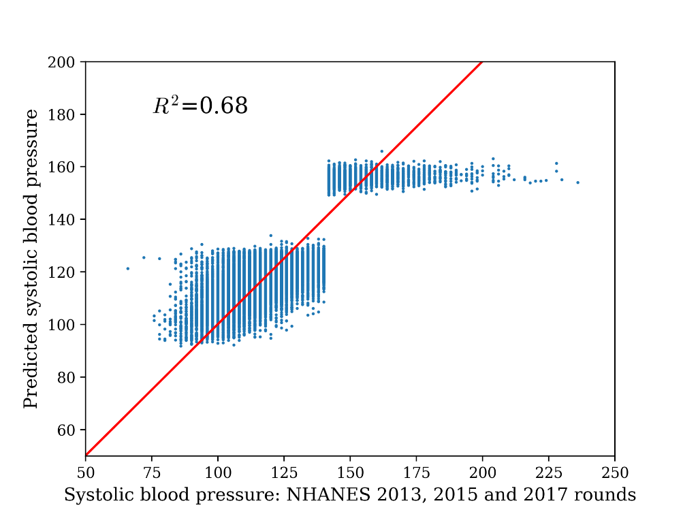

Figure S9. Comparison between the predicted values for systolic blood pressure and the measured values from the NHANES training set used in the BSR model.

In Figure S10 we show the distribution of predicted systolic blood pressure sampled from the posterior distribution of the model parameters for three individuals in SHeS 2021, one aged 32 and two aged 64 with and without high systolic blood pressure. There is significant variability in the predictions for each individual, however the distributions shift in accordance with what would be expected from the model, increasing with both age and information on whether they have high blood pressure. The fact that the shape of each distribution is similar indicates that the variability in the model prediction is dominated by the observational error in the likelihood rather than variation in the model parameters. Each simulation run takes a random sample from the posterior to obtain values for both the model error and the observational error which are then fixed for the duration of each Monte Carlo realisation of the simulation before being resampled for the next iteration. Although systolic blood pressure is a covariate in both disease risk models, the uncertainty estimates in the simulation output encode the uncertainty in the blood pressure prediction based on available data.

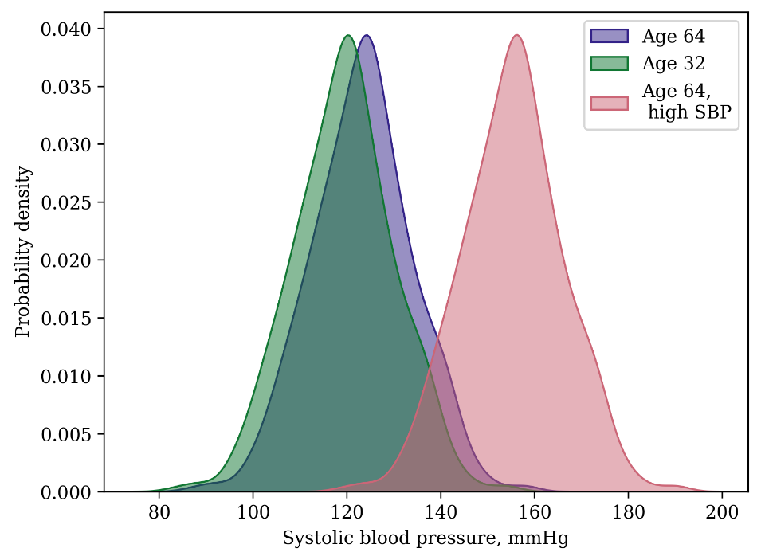
Figure S10. Distribution of predicted values for systolic blood pressure for three individuals in SHeS after taking samples from the parameter posterior distribution of the systolic blood pressure imputation model. SBP: Systolic blood pressure

To demonstrate how the model predictions vary for different participants in each simulation year, Figure S11 shows the variation of systolic blood pressure with age for different values of the categorical input variables and the model parameters set to their maximum likelihood values. In all instances, systolic blood pressure increases with age, although the rate of increase is larger for those that do not already have high systolic blood pressure. Blood pressure is also greater for those individuals with a higher weight with all other variables fixed for all ages until age 70, where changes in age increase blood pressure more for individuals in a lower weight than those at a higher weight.

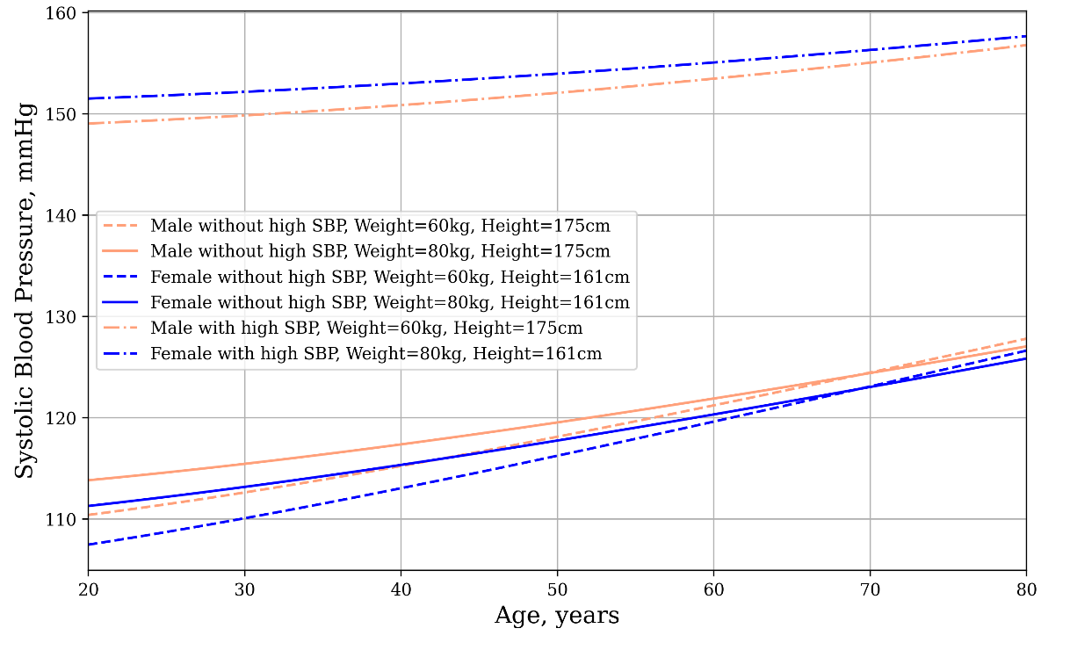
Figure S11. Variation of systolic blood pressure with age according to the systolic blood pressure imputation model for six individuals in SHeS. The imputation model parameters are set to their maximum likelihood values. SBP: Systolic blood pressure

The final prediction model with the minimum description length for HDL cholesterol was given by the following six-parameter model with five variables

$X_{HDL}={\left[β_{1}⋅\left(β_{2}^{X_{A}}+β_{3}^{\tilde{X} -1} \right)\right]}^{β_{4}^{X_{D}}}- β_{0}-X_{Sm}$ ,

where
$\tilde{X}={\left(β_{1}⋅X_{S}\right)}^{Exp\left[β_{5}⋅X_{BMI}\right]}$ .

The corresponding values for each parameter are given by $β_{0}=74.5$, $β_{1}=8×{10}^{-15}$, $β_{2}=0.98$, $β_{3}=0.48$, $β_{4}=-0.15$ and $β_{5}=-0.15$. The performance of this model was inferior to the systolic blood pressure prediction model with a $R^{2}$ of 0.21, indicating that the health and demographic data used to impute HDL cholesterol are less informative than those of systolic blood pressure (Figure S12).

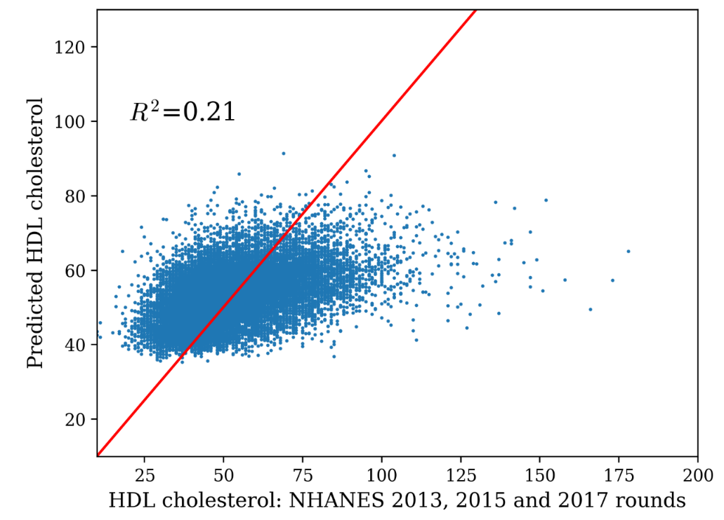

Figure S12. Predicted levels of HDL cholesterol from the imputation model against the NHANES data used as input the BSR algorithm.

In Figure S13 we show how the model varies with age for six different demographic groups. On average, as age increased so did HDL cholesterol levels. Females also have higher HDL cholesterol levels regardless of differences in smoking status and BMI, with a female with BMI=30kg/m² having a higher level of HDL cholesterol than a male with BMI=25kg/m² across all ages. Smokers of the same sex have lower HDL cholesterol levels in the model relative to non-smokers.

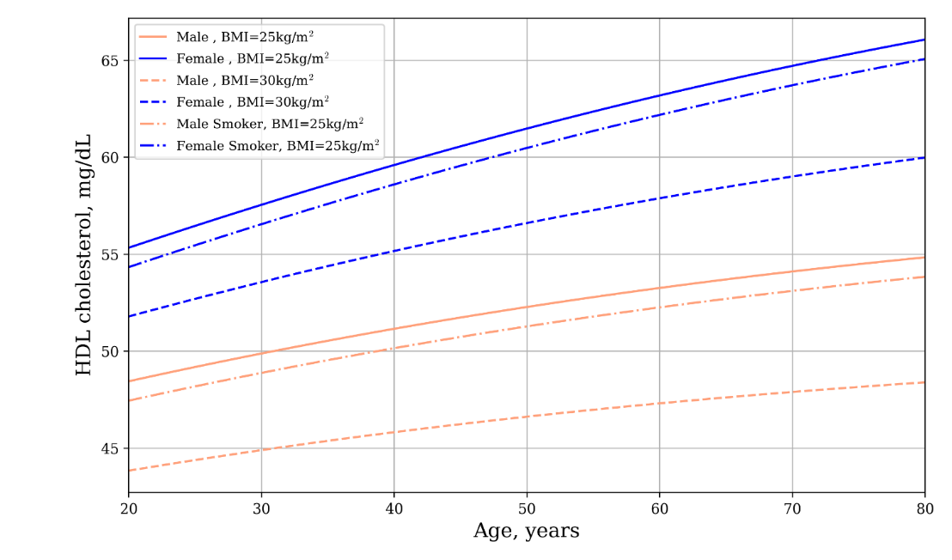
Figure S13. Variation of HDL cholesterol levels with age according to the HDL imputation model for six participants in SHeS, demonstrating the difference by sex, BMI and for smokers vs non-smokers.

The model for total cholesterol with the minimum description length was given by the following nine-parameter model with nine variables

$$X_{TC}=\frac{β_{0}}{X_{A}^{\tilde{X} } }⋅{\left[β_{1}+β_{2}⋅\left(β_{3}+β_{4}^{X_{S}}\right)⋅\left(X_{MBP}+X_{D}\right)\right]}^{\tilde{X}}$$
where

$$\tilde{X}= β_{5}+β_{6}⋅X_{A}⋅{\left[β_{7}⋅\left(X_{MHP}+X_{D}\right)\right]}^{β_{8}+β_{9}⋅X_{HDL}}$$

The maximum likelihood parameter values for each parameter were $β_{0}=4.7$, $β_{1}=-6.4$, $β_{2}=-4755.1$, $β_{3}=0.04$, $β_{4}=-0.05β_{1}$, $β_{5}=0.8$, $β_{6}=0.04$, $β_{7}=0.004$, $β_{8}=0.1$ and $β_{9}=-0.001$. The performance of this model is comparable to that of HDL cholesterol with a $R^{2}$ of 0.22 (Figure S14). HDL cholesterol biomarker data in NHANES were included in the training data for the total cholesterol model. Aa a result, total cholesterol also depends on the imputed HDL cholesterol model and was therefore imputed after the HDL cholesterol imputation for each individual. This approach ensured that the imputed values for total cholesterol were consistent with the imputed values of HDL cholesterol, at the expense of including extra uncertainty in the final total cholesterol model predictions from the variability in the uncertainty in HDL cholesterol.
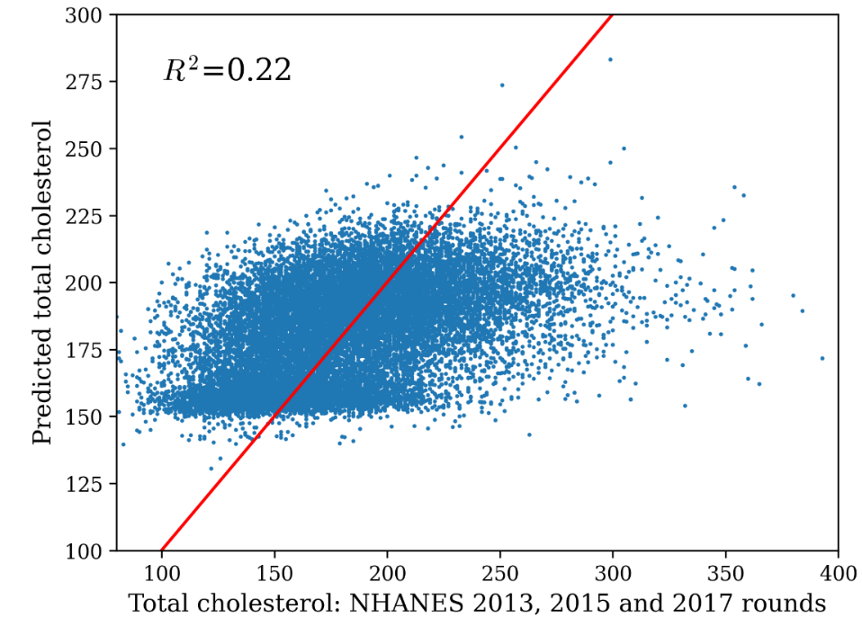
Figure S14 Predicted values of total cholesterol compared to the biomarker data in the NHANES data used as input the BSR algorithm.

In Figure S15 we show the variation of total cholesterol with age for the maximum likelihood estimates for the posterior parameters for six individuals. The model captures a nonlinear association between age and total cholesterol, increasing with age until approximately 55yr before subsequently decreasing with age. Females typically have higher total cholesterol levels than males. In addition, those that report taking blood pressure medication have lower total cholesterol levels than those of the same age, sex and weight that do not take blood pressure medication.

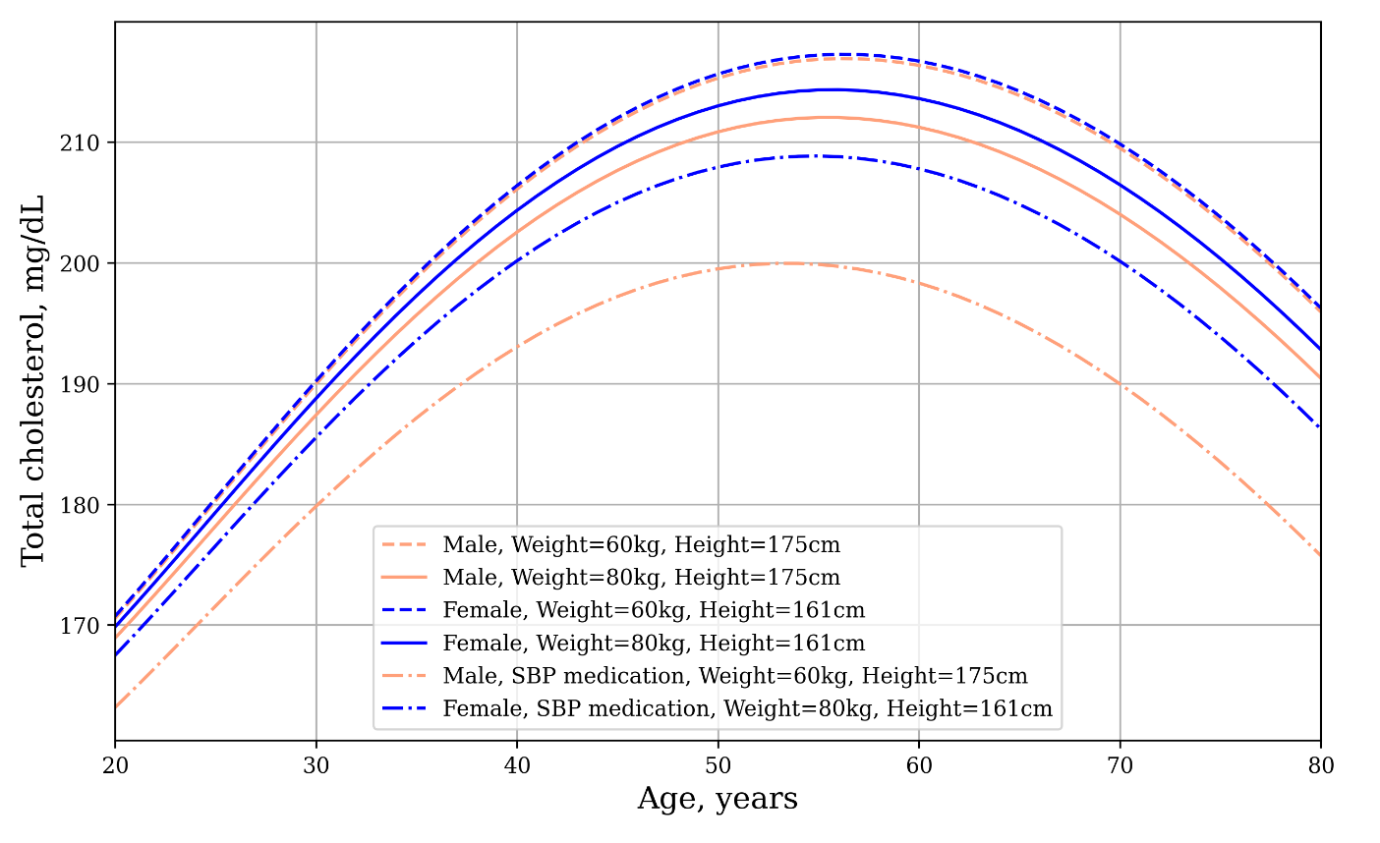
Figure S15. Variation of total cholesterol with age for six SHeS participants, showing the difference for different ages, weights and whether the respondent reports taking blood pressure medication. SBP: Systolic blood pressure

Height and weight data were missing for 157 and 280 respondents in SHeS 2021, respectively. Given that height and weight data were available for the remaining respondents in SHeS, these data were used as input to the BSR algorithm to develop an imputation model for those missing height and weight data. As these data were taken from respondents in Scotland, in this instance we included ethnicity and SIMD (Scottish Index of Multiple Deprivation) data as the input to the BSR algorithm. Missing values for height and weight were imputed at the start of the simulation and the imputation models were not used to update their values in different simulation years. The height model with the minimum description length was given by the following three-parameter model with three variables

$$X_{H}= {β_{0}+β}_{1}⋅X_{A}^{2}+X_{S}\left(β_{2}+X_{WOB}\right)$$

where $X_{WOB}$ equals one if the respondent reports an ethnicity of “White, Other British” and zero otherwise. The parameter values at the minimum description length were given by $β_{0}=180.15$, $β_{1}=-0.001$ and $β_{2}=-13.96$. The negative value of $β_{1}$ indicates that height is lower in older individuals and the negative value of $β_{2}$ indicates that females have a smaller height value than males on average. This model performs reasonably well with $R^{2}$equal to 0.58 (Figure S16, Panel A).

The weight imputation model with the minimum description length was given by the following seven-parameter model of five variables

$$X_{W}=\left(β_{0}+β_{1}{⋅X}_{A}+β_{2}⋅X_{HBP}\right)\left(β_{3}+X_{S}+β_{4}⋅β_{5}^{X_{MVPA}} \right)\left(β_{6}+X_{A}+X_{WS}\right)$$

where $X_{WS}$ indicates a binary variable which is equal to one if the respondent reports a “White, Scottish” ethnicity. The parameter values are given by $β_{0}=-0.25$, $β_{1}=0.002$, $β_{2}=-0.009$, $β_{3}=-6.13$, $β_{4}=-0.67$, $β_{5}=-0.997$ and $β_{6}=40.8$. The model performs poorly relative to the height imputation model with an $R^{2}$of 0.22 (Figure S16, Panel B).

(A)
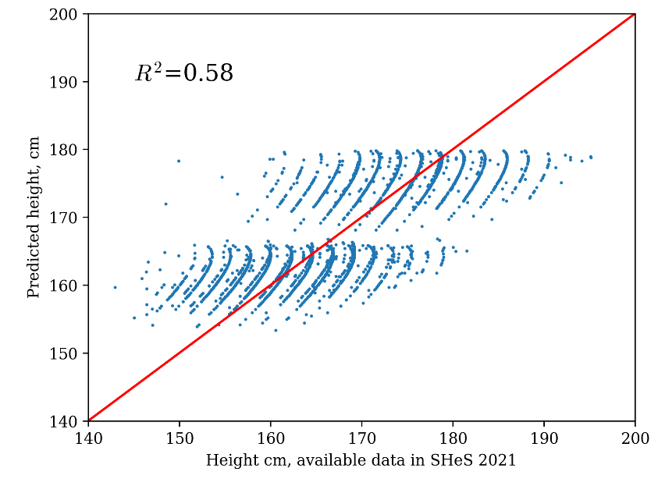

(B)
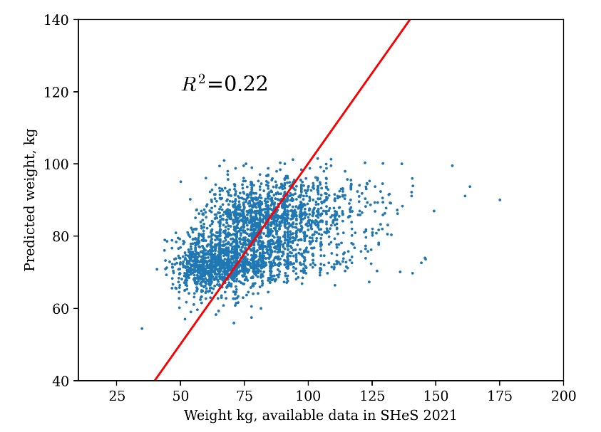

Figure S16 Predicted height (A) and weight (B) compared to the height and weight data available in SHeS 2021.

At the end of each simulation year each individual’s age, systolic blood pressure, total cholesterol and HDL cholesterol were updated. Disease risk in each subsequent year was calculated according to these updated values as well as each individual’s new BMI from the BMI model. Prevented cases of each health outcome were calculated by taking the difference between the yearly incidence in the baseline pathway with no meat or dairy reduction to that in each pathway with a meat and dairy reduction, before summing this difference over the ten simulation years. This process was then repeated for 50 iterations, resampling over sources of uncertainty. Sources of uncertainty included:
- the model parameters in the imputation models for systolic blood pressure, HDL cholesterol and total cholesterol,
- the relative risk associations between meat and dairy intake and disease risk and
- the relative risk of mortality for individuals with diabetes, CVD or both.

The choice of 50 iterations was motivated by the finding that the width of the uncertainty interval in the prevented cases of each disease did not substantially decrease beyond ~40 iterations, as shown in the case of prevented diabetes cases in the CCC 2030 pathway in Figure S17. To obtain uncertainty estimates for the health outcomes, both the lower 2.5% and the upper 97.5% were taken from the distribution of prevented cases over all simulation runs.
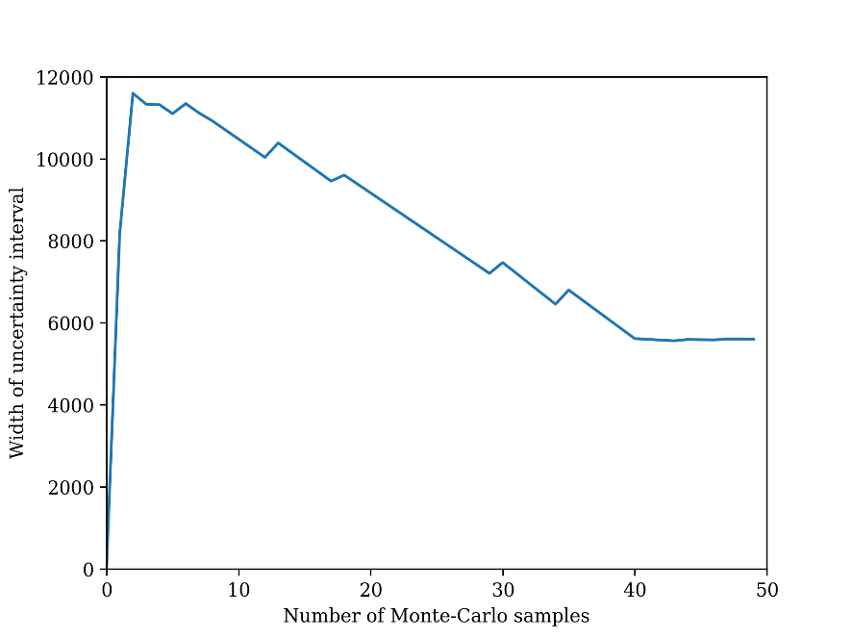
Figure S17. Relationship between the width of the uncertainty interval in the prevented cases of diabetes over ten years in the CCC 2030 pathway with the number of Monte-Carlo iterations of the simulation. The width flattens at approximately 40 samples.

References
1. The Scottish Health Survey 2021 - volume 2: technical report [Internet]. [cited 2024 Oct 3]. Available from: https://www.gov.scot/publications/scottish-health-survey-2021-volume-2-technical-report/
2. Amoutzopoulos B, Steer T, Roberts C, Collins D, Trigg K, Barratt R, et al. Rationalisation of the UK Nutrient Databank for Incorporation in a Web-Based Dietary Recall for Implementation in the UK National Diet and Nutrition Survey Rolling Programme. Nutrients. 2022 Oct 28;14(21):4551.
3. Fitt E, Mak TN, Stephen AM, Prynne C, Roberts C, Swan G, et al. Disaggregating composite food codes in the UK National Diet and Nutrition Survey food composition databank. Eur J Clin Nutr. 2010 Nov;64 Suppl 3:S32-36.
4. Jaacks LM, Amoutzopoulos B, Runions R, Vonderschmidt A, McNeill G, Comrie F, et al. Disaggregation of Dairy in Composite Foods in the UK. Current Developments in Nutrition [Internet]. 2024 May 16 [cited 2024 Jun 2];0(0). Available from: https://cdn.nutrition.org/article/S2475-2991(24)01708-6/fulltext
5. Page P, Steer T, Amoutzopoulos B, Harvey A, Holmes L. Rebuild of the Food Standards Agency Recipes Database, Final Report [Internet]. [cited 2025 Jan 8]. Available from: http://doc.ukdataservice.ac.uk/doc/8159/mrdoc/pdf/8159_fsa_ recipes_database_rebuild_final_report.pdf (2015).
6. Harrington RA, Adhikari V, Rayner M, Scarborough P. Nutrient composition databases in the age of big data: foodDB, a comprehensive, real-time database infrastructure. BMJ Open. 2019 Jun 1;9(6):e026652.
7. Clark M, Springmann M, Rayner M, Scarborough P, Hill J, Tilman D, et al. Estimating the environmental impacts of 57,000 food products. Proceedings of the National Academy of Sciences. 2022 Aug 16;119(33):e2120584119.
8. Poore J, Nemecek T. Reducing food’s environmental impacts through producers and consumers. Science. 2018 Jun;360(6392):987–92.
9. Lennox A, Bluck L, Page P, Pell D, Cole D, Steer T, et al. Misreporting in the National Diet and Nutrition Survey Rolling Programme (NDNS RP): summary of results and their interpretation. London: Public Health England and Food Standards Agency; 2014.
10. National Records of Scotland. National Records of Scotland. National Records of Scotland; [cited 2024 May 31]. National Records of Scotland. Available from: https://www.nrscotland.gov.uk/statistics-and-data/statistics/statistics-by-theme/population/population-estimates/mid-year-population-estimates/mid-2021
11. Lumley T. Complex Surveys: A Guide to Analysis Using R: A Guide to Analysis Using R. John Wiley and Sons; 2010.
12. Kennedy J, Alexander P, Taillie LS, Jaacks LM. Estimated effects of reductions in processed meat consumption and unprocessed red meat consumption on occurrences of type 2 diabetes, cardiovascular disease, colorectal cancer, and mortality in the USA: a microsimulation study. The Lancet Planetary Health. 2024 Jul 1;8(7):e441–51.
13. Alva ML, Hoerger TJ, Zhang P, Gregg EW. Identifying risk for type 2 diabetes in different age cohorts: does one size fit all? BMJ Open Diabetes Res Care. 2017;5(1):e000447.
14. D’Agostino RB, Vasan RS, Pencina MJ, Wolf PA, Cobain M, Massaro JM, et al. General Cardiovascular Risk Profile for Use in Primary Care. Circulation. 2008;117(6):743–53.
15. Yang X, Li Y, Wang C, Mao Z, Zhou W, Zhang L, et al. Meat and fish intake and type 2 diabetes: Dose–response meta-analysis of prospective cohort studies. Diabetes & Metabolism. 2020 Oct 1;46(5):345–52.
16. Zhong VW, Van Horn L, Greenland P, Carnethon MR, Ning H, Wilkins JT, et al. Associations of Processed Meat, Unprocessed Red Meat, Poultry, or Fish Intake With Incident Cardiovascular Disease and All-Cause Mortality. JAMA Internal Medicine. 2020 Apr 1;180(4):503–12.
17. Feng Y, Zhao Y, Liu J, Huang Z, Yang X, Qin P, et al. Consumption of Dairy Products and the Risk of Overweight or Obesity, Hypertension, and Type 2 Diabetes Mellitus: A Dose–Response Meta-Analysis and Systematic Review of Cohort Studies. Advances in Nutrition. 2022 Nov 1;13(6):2165–79.
18. Team NR of SW. National Records of Scotland. National Records of Scotland; 2013 [cited 2024 Jun 18]. National Records of Scotland. Available from: https://www.nrscotland.gov.uk/statistics-and-data/statistics/statistics-by-theme/vital-events/general-publications/monthly-mortality-analysis-scotland
19. Diabetes-Scottish-Diabetes-Survey-2021-final-version.pdf [Internet]. [cited 2023 Sep 1]. Available from: https://www.diabetesinscotland.org.uk/wp-content/uploads/2023/02/Diabetes-Scottish-Diabetes-Survey-2021-final-version.pdf
20. Scottish heart disease statistics - Year ending 31 March 2022 - Scottish heart disease statistics - Publications - Public Health Scotland [Internet]. [cited 2024 Jun 18]. Available from: https://publichealthscotland.scot/publications/scottish-heart-disease-statistics/scottish-heart-disease-statistics-year-ending-31-march-2022/
21. Hall KD, Sacks G, Chandramohan D, Chow CC, Wang YC, Gortmaker SL, et al. Quantification of the effect of energy imbalance on bodyweight. The Lancet. 2011 Aug;378(9793):826–37.
22. Gerrior S, Juan W, Basiotis P. An Easy Approach to Calculating Estimated Energy Requirements. 2006;3(4).
23. Ainsworth BE, Haskell WL, Herrmann SD, Meckes N, Bassett DRJ, Tudor-Locke C, et al. 2011 Compendium of Physical Activities: A Second Update of Codes and MET Values. Medicine & Science in Sports & Exercise. 2011 Aug;43(8):1575.
24. Guimerà R, Reichardt I, Aguilar-Mogas A, Massucci FA, Miranda M, Pallarès J, et al. A Bayesian machine scientist to aid in the solution of challenging scientific problems. Science Advances. 2020 Jan 31;6(5):eaav6971.
25. Negri V, Vázquez D, Sales-Pardo M, Guimerà R, Guillén-Gosálbez G. Bayesian Symbolic Learning to Build Analytical Correlations from Rigorous Process Simulations: Application to CO2 Capture Technologies. ACS Omega. 2022 Nov 15;7(45):41147–64.
26. Vázquez D, Guimerà R, Sales-Pardo M, Guillén-Gosálbez G. Automatic modeling of socioeconomic drivers of energy consumption and pollution using Bayesian symbolic regression. Sustainable Production and Consumption. 2022 Mar 1;30:596–607.
27. Abril-Pla O, Andreani V, Carroll C, Dong L, Fonnesbeck CJ, Kochurov M, et al. PyMC: a modern, and comprehensive probabilistic programming framework in Python. PeerJ Comput Sci. 2023 Sep 1;9:e1516.

