Performance Enhancement of Trimetallic Nanoparticles in Photocatalysis through Chemical Etching
Yu-Chun Cheng¹, Yun-Qi Dou¹, Tian-Song Deng^{1,*}
¹School of Electronics and Information Engineering, Hangzhou Dianzi University, Hangzhou 310018, P. R. China
* Corresponding author. E-mail: dengts@pku.edu.cn

Figure S1 The TEM images of Au@Pt synthesized by varying the amount of added K₂PtCl₄ solution. TEM images of (a) Au@Pt₂₅, (b) Au@Pt₅₀, (c) Au@Pt₁₀₀, (d) Au@Pt₂₀₀, where the corresponding scale in the bottom right corner is 100 nm, and (f) is their corresponding spectral diagrams.
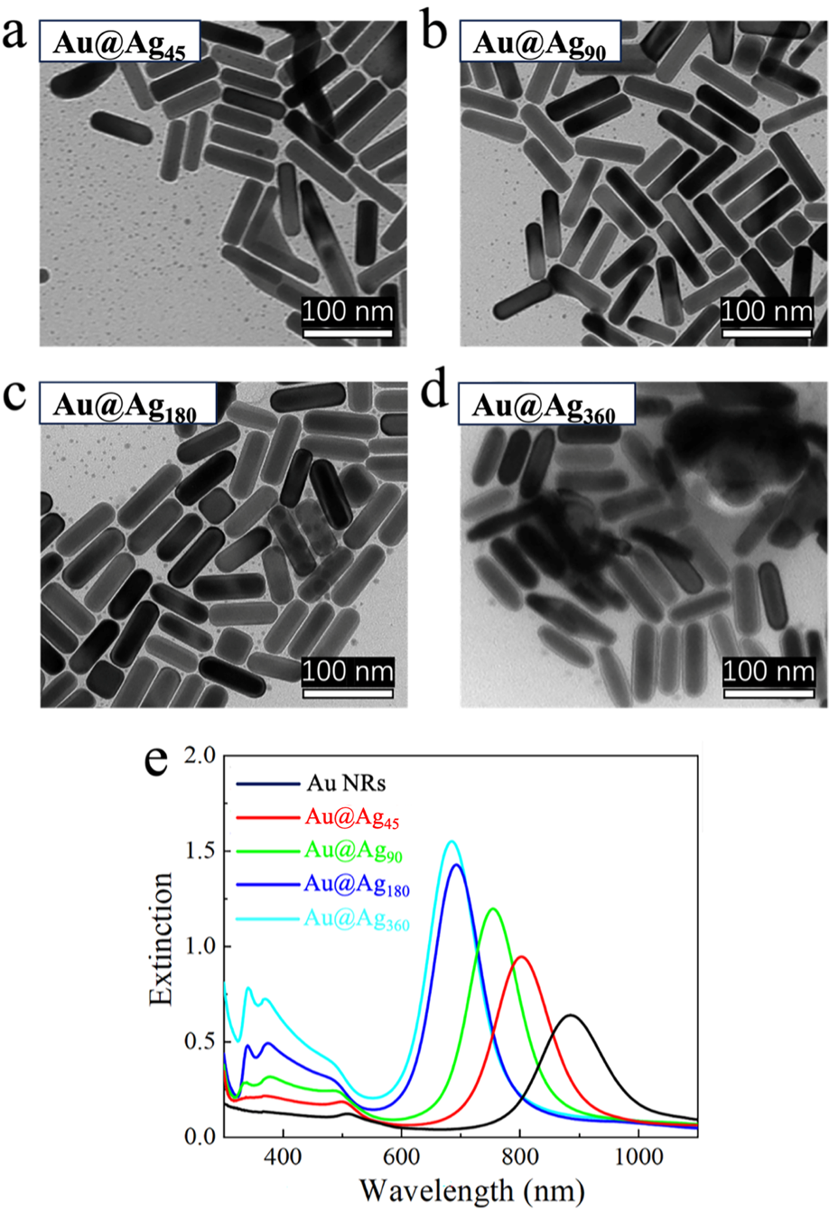
Figure S2 The TEM images of Au@Ag synthesized by varying the amount of added AgNO₃ solution. TEM images of (a) Au@Ag₄₅, (b) Au@Ag₉₀, (c) Au@Ag₁₈₀, (d) Au@Ag₃₆₀, where the corresponding scale in the bottom right corner is 100 nm, and (f) is their corresponding spectral diagrams.
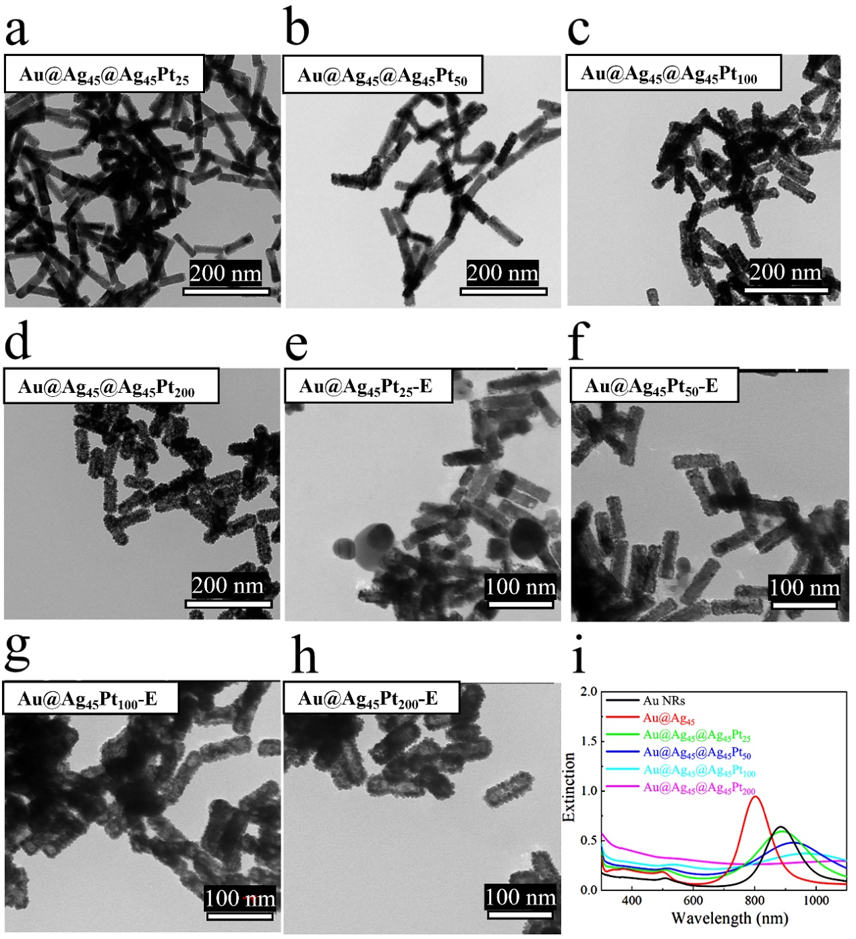Figure S3 The TEM images of Au@Ag@AgPt synthesized by keeping the amount of added AgNO₃ solution constant at 0.01 mL while varying the amount of added K₂PtCl₄ solution, along with corresponding TEM images of the etched nanomaterials. TEM images of (a) Au@Ag₄₅@Ag₄₅Pt₂₅, (b) Au@Ag₄₅@Ag₄₅Pt₅₀, (c) Au@Ag₄₅@Ag₄₅Pt₁₀₀, (d) Au@Ag₄₅@Ag₄₅Pt₂₀₀, (e) Au@Ag₄₅Pt₂₅-E, (f) Au@Ag₄₅Pt₅₀-E, (g) Au@Ag₄₅Pt₁₀₀-E, (h) Au@Ag₄₅Pt₂₀₀-E, where the corresponding scale bars are located at the bottom right corner of the images, and (i) is the non-etched materials corresponding spectral diagrams.
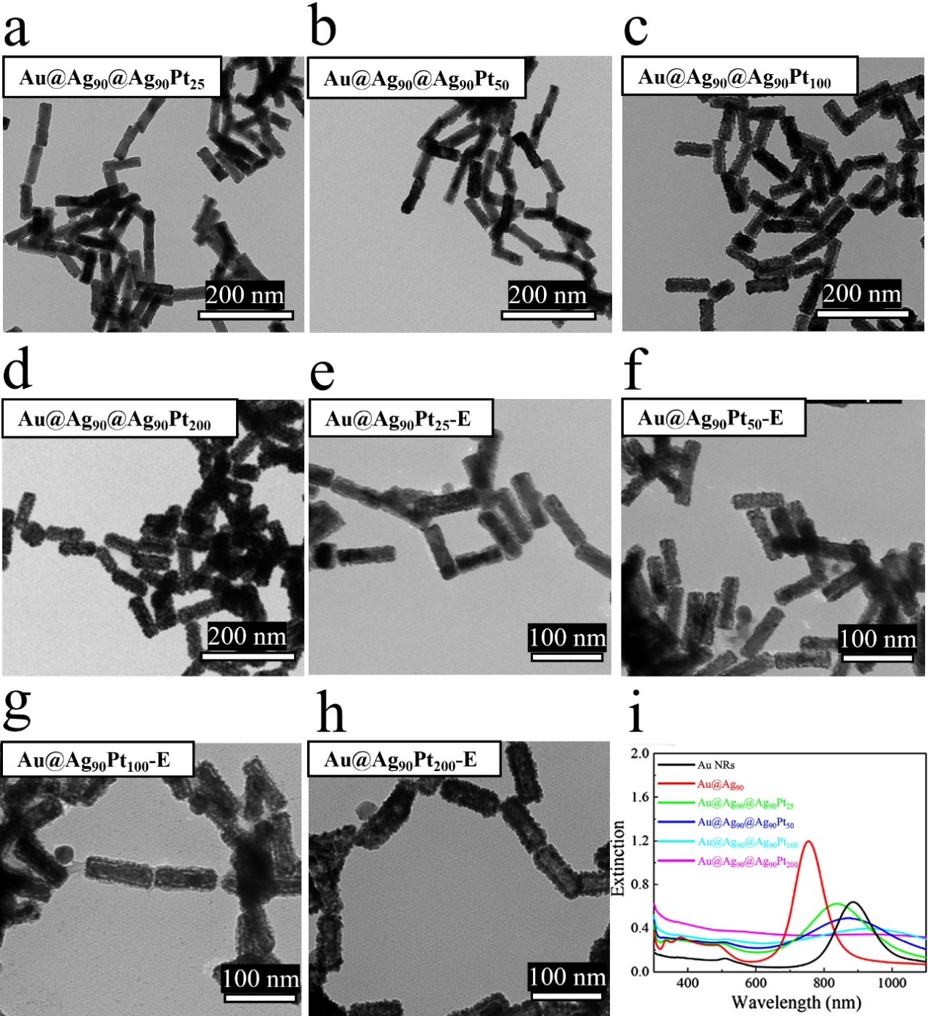Figure S4 The TEM images of Au@Ag@AgPt synthesized by keeping the amount of added AgNO₃ solution constant at 0.02 mL while varying the amount of added K₂PtCl₄ solution, along with corresponding TEM images of the etched nanomaterials. TEM images of (a) Au@Ag₉₀@Ag₉₀Pt₂₅, (b) Au@Ag₉₀@Ag₉₀Pt₅₀, (c) Au@Ag₉₀@Ag₉₀Pt₁₀₀, (d) Au@Ag₉₀@Ag₉₀Pt₂₀₀, (e) Au@Ag₉₀Pt₂₅-E, (f) Au@Ag₉₀Pt₅₀-E, (g) Au@Ag₉₀Pt₁₀₀-E, (h) Au@Ag₉₀Pt₂₀₀-E, where the corresponding scale bars are located at the bottom right corner of the images, and (i) is the non-etched materials corresponding spectral diagrams.
Figure S5 The TEM images of Au@Ag@AgPt synthesized by keeping the amount of added AgNO₃ solution constant at 0.04 mL while varying the amount of added K₂PtCl₄ solution, along with corresponding TEM images of the etched nanomaterials. TEM images of (a) Au@Ag₁₈₀@Ag₁₈₀Pt₂₅, (b) Au@Ag₁₈₀@Ag₁₈₀Pt₅₀, (c) Au@Ag₁₈₀@Ag₁₈₀Pt₁₀₀, (d) Au@Ag₁₈₀@Ag₁₈₀Pt₂₀₀, (e) Au@Ag₁₈₀Pt₂₅-E, (f) Au@Ag₁₈₀Pt₅₀-E, (g) Au@Ag₁₈₀Pt₁₀₀-E, (h) Au@Ag₁₈₀Pt₂₀₀-E, where the corresponding scale bars are located at the bottom right corner of the images, and (i) is the non-etched materials corresponding spectral diagrams.
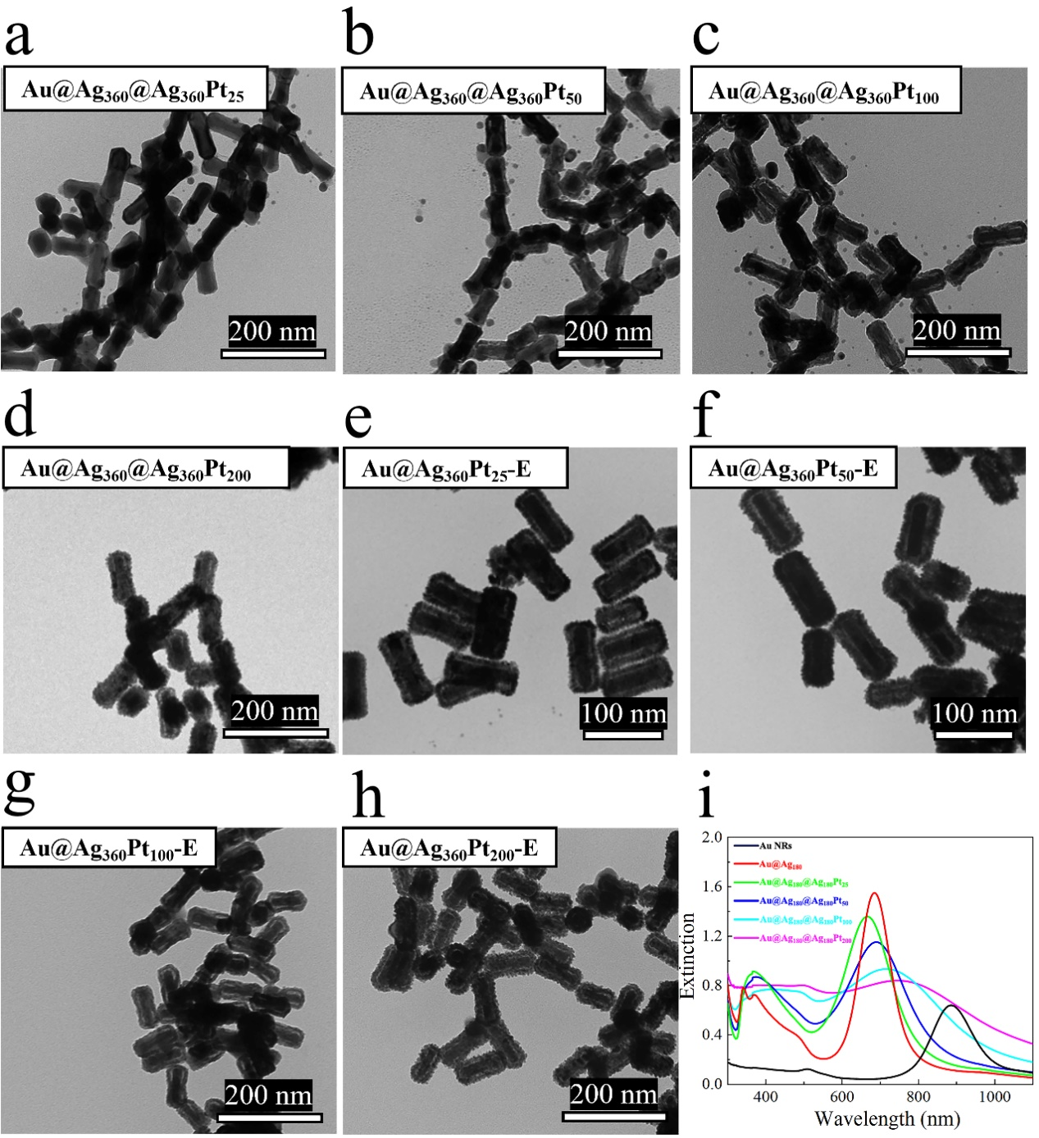Figure S6 The TEM images of Au@Ag@AgPt synthesized by keeping the amount of added AgNO₃ solution constant at 0.08 mL while varying the amount of added K₂PtCl₄ solution, along with corresponding TEM images of the etched nanomaterials. (a) Au@Ag₃₆₀@Ag₃₆₀Pt₂₅, (b) Au@Ag₃₆₀@Ag₃₆₀Pt₅₀, (c) Au@Ag₃₆₀@Ag₃₆₀Pt₁₀₀, (d) Au@Ag₃₆₀@Ag₃₆₀Pt₂₀₀, (e) Au@Ag₃₆₀Pt₂₅-E, (f) Au@Ag₃₆₀Pt₅₀-E, (g) Au@Ag₃₆₀Pt₁₀₀-E, (h) Au@Ag₃₆₀Pt₂₀₀-E, where the corresponding scale bars are located at the bottom right corner of the images, and (i) is the non-etched materials corresponding spectral diagrams.
Figure S7 The spectrum of Methylene Blue (MB) during the photocatalytic process of (a) Au NRs, (b) Au@Ag₄₅, (c) Au@Ag₉₀, (d) Au@Ag₁₈₀, (e) Au@Ag₃₆₀, (f) Au@Pt₂₅, (g) Au@Pt₅₀, (h) Au@Pt₁₀₀, (i) Au@Pt₂₀₀.
Figure S8 The spectrum of Methylene Blue (MB) during the photocatalytic process of (a) Au@Ag₄₅@Ag₄₅Pt₂₅, (b) Au@Ag₄₅@Ag₄₅Pt₅₀, (c) Au@Ag₄₅@Ag₄₅Pt₁₀₀, (d) Au@Ag₄₅@Ag₄₅Pt₂₀₀, (e) Au@Ag₄₅Pt₂₅-E, (f) Au@Ag₄₅Pt₅₀-E, (g) Au@Ag₄₅Pt₁₀₀-E, (h) Au@Ag₄₅Pt₂₀₀-E. (i) – (l) The photocatalytic rate graphs of the corresponding materials before and after etching.
Figure S9 The spectrum of Methylene Blue (MB) during the photocatalytic process of (a) Au@Ag₉₀@Ag₉₀Pt₂₅, (b) Au@Ag₉₀@Ag₉₀Pt₅₀, (c) Au@Ag₉₀@Ag₉₀Pt₁₀₀, (d) Au@Ag₉₀@Ag₉₀Pt₂₀₀, (e) Au@Ag₉₀Pt₂₅-E, (f) Au@Ag₉₀Pt₅₀-E, (g) Au@Ag₉₀Pt₁₀₀-E, (h) Au@Ag₉₀Pt₂₀₀-E. (i) – (l) The photocatalytic rate graphs of the corresponding materials before and after etching.
Figure S10 The spectrum of Methylene Blue (MB) during the photocatalytic process of (a) Au@Ag₁₈₀@Ag₁₈₀Pt₂₅, (b) Au@Ag₁₈₀@Ag₁₈₀Pt₅₀, (c) Au@Ag₁₈₀@Ag₁₈₀Pt₁₀₀, (d) Au@Ag₁₈₀@Ag₁₈₀Pt₂₀₀, (e) Au@Ag₁₈₀Pt₂₅-E, (f) Au@Ag₁₈₀Pt₅₀-E, (g) Au@Ag₁₈₀Pt₁₀₀-E, (h) Au@Ag₁₈₀Pt₂₀₀-E. (i) – (l) The photocatalytic rate graphs of the corresponding materials before and after etching.
Figure S11 The spectrum of Methylene Blue (MB) during the photocatalytic process of (a) Au@Ag₃₆₀@Ag₃₆₀Pt₂₅, (b) Au@Ag₃₆₀@Ag₃₆₀Pt₅₀, (c) Au@Ag₃₆₀@Ag₃₆₀Pt₁₀₀, (d) Au@Ag₃₆₀@Ag₃₆₀Pt₂₀₀, (e) Au@Ag₃₆₀Pt₂₅-E, (f) Au@Ag₃₆₀Pt₅₀-E, (g) Au@Ag₃₆₀Pt₁₀₀-E, (h) Au@Ag₃₆₀Pt₂₀₀-E. (i) – (l) The photocatalytic rate graphs of the corresponding materials before and after etching.
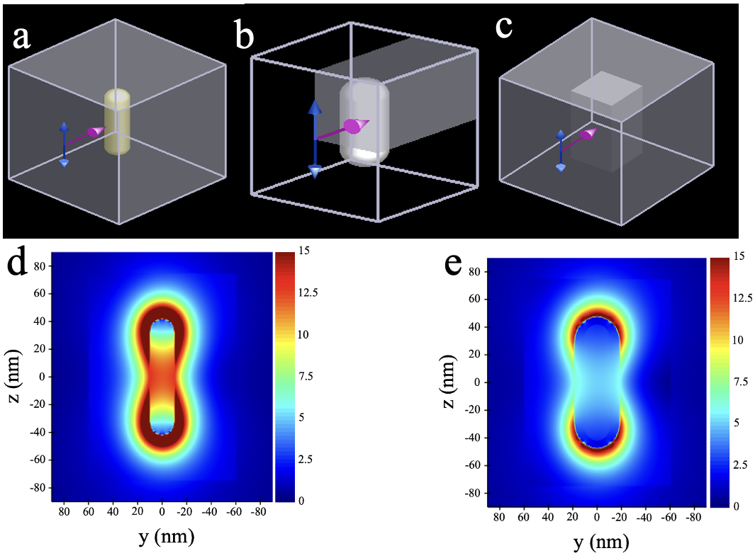
Figure S12 Model diagrams and the FDTD electric field diagrams. (a), (b), and (c) are model diagrams of Au NRs, Au@Ag₃₆₀, and Au@Ag₃₆₀@A₃₆₀P₂₅, respectively. (d) and (e) are the FDTD electric field diagrams of Au NRs and Au@Ag₃₆₀, respectively.

Table S1 The length and diameter of Au NRs, Au@Pt₂₅, Au@Ag₃₆₀, Au@Ag₃₆₀@A₃₆₀P₂₅, and Au@A₃₆₀P₂₅-E.
Material | Length | Diameter
Au NRs | 84.4 ± 8.7 | 20.4 ± 2.6
Au@Pt₂₅ | 90.0 ± 8.9 | 26.6 ± 2.4
Au@Ag₃₆₀ | 95.2 ± 6.0 | 33.6 ± 3.6
Au@Ag₃₆₀@Ag₃₆₀Pt₂₅ | 97.2 ± 8.2 | 38.3 ± 5.6
Au@Ag₃₆₀Pt₂₅-E | 96.5 ± 6.4 | 37.4 ± 4.8

Table S2 The length and diameter of Au@Ag₄₅@Ag₄₅Pt₂₅, Au@Ag₉₀@Ag₉₀Pt₂₅, Au@Ag₁₈₀@Ag₁₈₀Pt₂₅, Au@Ag₉₀@Ag₉₀Pt₅₀, Au@Ag₉₀@Ag₉₀Pt₁₀₀, Au@Ag₉₀@Ag₉₀Pt₂₀₀.
Material | Length | Diameter
Au@Ag₄₅@Ag₄₅Pt₂₅ | 91.6 ± 7.3 | 27.4± 5.2
Au@Ag₉₀@Ag₉₀Pt₂₅ | 93.0 ± 9.2 | 29.4± 4.5
Au@Ag₁₈₀@Ag₁₈₀Pt₂₅ | 94.3 ± 7.4 | 33.5± 3.7
Au@Ag₉₀@Ag₉₀Pt₅₀ | 93.4 ± 9.2 | 29.4± 7.3
Au@Ag₉₀@Ag₉₀Pt₁₀₀ | 94.1 ± 10.6 | 33.8± 9.2
Au@Ag₉₀@Ag₉₀Pt₂₀₀ | 103.5 ± 12.4 | 40.5± 8.3

Table S3 Multiples of the catalytic rates of different etched materials relative to Au NRs.
etched | Ag 45 μM | Ag 90 μM | Ag 180 μM | Ag 360 μM
Pt 25 μM | 3.67 | 5 | 7.67 | 7
Pt 50 μM | 7.6 | 6 | 7 | 5
Pt 100 μM | 5.67 | 5 | 4.67 | 4.33
Pt 200 μM | 7 | 7.33 | 4 | 5.33

Table S4 Multiples of the catalytic rates of different non-etched materials relative to Au NRs.
non-etched | Ag 0 μM | Ag 45 μM | Ag 90 μM | Ag 180 μM | Ag 360 μM
Pt 0 μM | 1 | 1.67 | 2.33 | 1 | 0.67
Pt 25 μM | 1 | 3.33 | 3.67 | 4.67 | 1.67
Pt 50 μM | 4 | 4.67 | 2.67 | 5.33 | 5
Pt 100 μM | 2.33 | 5 | 3.3 | 3.67 | 4
Pt 200 μM | 1.33 | 4.33 | 7.67 | 3.33 | 4.67

Table S5 Multiples of the catalytic rates of non-etched materials relative to etched materials.
Multiple | Ag 45 μM | Ag 90 μM | Ag 180 μM | Ag 360 μM
Pt 25 μM | 1.10 | 1.36 | 1.64 | 4.19
Pt 50 μM | 1.64 | 2.24 | 1.31 | 1
Pt 100 μM | 1.12 | 1.50 | 1.27 | 1.08
Pt 200 μM | 1.62 | 0.96 | 1.20 | 1.14

