Supplementary material
Unspecified Pain, Chronic Pain and High-Impact Chronic Pain in Lesotho, Southern Africa: a Population-based Cross-sectional study
Emmanuel Firima^{1,2}, Lucia Gonzalez¹, Molulela Manthabiseng³, Mamoronts’sane P. Sematle³, Matumaole Bane³, Makhebe Khomolishoele³, Tristan Lee¹, Frédérique Chammartin¹, Ravi Gupta³, Stephen McCrosky¹, Maja Weisser ^{4,5}, Alain Amstutz^{1,6,7}, Niklaus Daniel Labhardt¹
- Division of Clinical Epidemiology, Department of Clinical Research, University Hospital Basel, University of Basel, Basel, Switzerland
- Division of Clinical Medicine, University of Sheffield, Sheffield, United Kingdom
- SolidarMed, Partnerships for Health, Maseru, Lesotho

- Division of Infectious Diseases and Hospital Epidemiology, University Hospital Basel, Basel, Switzerland
- Ifakara Health Institute, Ifakara, Tanzania
- Oslo Center for Biostatistics and Epidemiology, Oslo University Hospital, Oslo, Norway
- Population Health Sciences, Bristol Medical School, University of Bristol, Bristol, United Kingdom

S1 Table . Sociodemographic characteristics of study participants by presence of pain, chronic pain and high-impact chronic pain
Variables | Enrolled  N= 6039 | Pain  n=1194 | Chronic pain  n=909 | High-impact chronic pain  n= 428
Age, years, n(%)
18-24 | 1162(19.2) | 76(6.4) | 45(4.9) | 18(4.2)
25-34 | 1362(22.6) | 145(12.1) | 97(10.7) | 41(9.6)
35-44 | 996(16.5) | 151(12.7) | 104(11.4) | 51(11.9)
45-54 | 778(12.9) | 173(14.5) | 127(14.0) | 52(12.2)
55-64 | 726(12.0) | 220(18.4) | 177(19.5) | 86(20.1)
≥65 | 1015(16.8) | 429(35.9) | 359(39.5) | 180(42.1)
Median age, (IQR) | 39 (27-58) | 58(41-69) | 60(43-71) | 61(44-73)
Sex
Female | 3153(52.2) | 706(59.1) | 513(56.4) | 247(57.7)
Male | 2886(47.8) | 488(40.9) | 396(43.6) | 186(42.3)
BMI, Kg/m²
<18 | 533(8.8) | 107(9.0) | 90(9.9) | 46(10.8)
18 – 24.9 | 3057(50.6) | 539(45.1) | 406(44.7) | 197(46.0)
25 – 29.9 | 1300(21.5) | 258(21.6) | 202(22.2) | 84(19.6)
≥30 | 1092(18.1) | 261(21.9) | 187(20.6) | 86(20.1)
Missing | 57(0.9) | 29(2.4) | 24(2.6) | 15(3.5)
Median BMI, (IQR) | 23.4(20.5-27.9) | 24.2(21.0-29.2) | 24.0(20.8-28.9) | 23.8(20.7-29.1)
Settlement
Rural | 2888(47.8) | 590(49.4) | 443(48.7) | 215(50.2)
Urban | 3151(52.2) | 604(50.6) | 466(51.3) | 213(49.8)
District
Butha Buthe | 3162(52.4) | 451(37.8) | 310(34.1) | 181(42.3)
Mokhotlong | 2877(47.6) | 743(62.2) | 599(65.9) | 247(57.7)
Education
None | 607(10.1) | 186(15.6) | 155(17.1) | 80(18.7)
Primary | 2817(46.6) | 658(55.1) | 509(56.0) | 245(57.2)
Secondary | 2172(36.0) | 273(22.9) | 188(20.7) | 82(19.2)
Tertiary | 442(7.3) | 76(6.4) | 56(6.2) | 20(4.7)
Refused to say | 1(0.02) | 1(0.1) | 1(0.1) | 1(0.2)
Marital status
Single | 1325(21.9) | 114(9.6) | 86(9.5) | 34(7.9)
In a committed relationship | 3529(58.4) | 675(56.5) | 487(53.6) | 237(55.4)
Divorced/separated/widowed | 1181(19.6) | 404(33.8) | 335(36.8) | 156(36.5)
Refused to say | 4(0.1) | 1(0.1) | 1(0.1) | 1(0.2)
Employment
Employed | 3063(50.7) | 541(45.3) | 417 (45.9) | 187(43.7)
Not employed | 2952(48.9) | 644(53.9) | 486(53.5) | 240(56.1)
Missing | 24(0.4) | 9(0.8) | 6(0.7) | 1(0.2)
Wealth index
First quintile | 1230(20.4) | 223(18.7) | 176(19.4) | 84(19.6)
Second quintile | 1211(20.1) | 261(21.9) | 198(21.8) | 95(22.2)
Third quintile | 1220(20.2) | 261(21.9) | 197(21.7) | 95(22.2)
Fourth quintile | 1197(19.8) | 234(19.6) | 180(19.8) | 96(22.4)
Fifth quintile | 1164(19.3) | 215(18.0) | 158(17.4) | 58(13.6)
Missing | 17(0.3) | 0 | 0 | 0
Physically active*
Yes | 4180(69.2) | 705(59.0) | 555(61.1) | 258(60.3)
No | 1851(30.7) | 489(41.0) | 354(38.9) | 170(39.7)
Missing | 8(0.1) | 0 | 0 | 0
Smoker
Yes | 1509(25.0) | 374(31.3) | 298(32.8) | 140(32.7)
No | 4525(74.9) | 819(68.6) | 611(67.2) | 288(67.3)
Missing | 5(0.1) | 1(0.1) | 0 | 0
Alcohol
Yes | 1575(26.1) | 322(27.0) | 260(28.6) | 123(28.7)
No | 4464(73.9) | 872(73.0) | 649(71.4) | 305(71.3)
Fruits and vegetables
Yes | 468(7.8) | 74(6.2) | 51(5.6) | 36(8.4)
No | 5563(92.1) | 1120(93.8) | 858(94.4) | 392(91.6)
Missing | 8(0.1) | 0 | 0 | 0
IQR: interquartile range;

S2 Table . Chronic conditions stratified by pain, chronic pain and high impact chronic pain
Variable | Enrolled  N= 6039 | Pain  n=1194 | Chronic pain  n=909 | High impact chronic pain  n=428
HTN  - Yes  - No  - Missing | 1302(21.5)  4726(78.3)  11(0.2) | 460(38.5)  731(61.2)  3(0.3) | 377(41.5)  530(58.3)  2(0.2) | 187(43.7)  239(55.8)  2(0.5)
DM  - Diabetes  - Pre-diabetes  - No  - Missing | 257(4.3)  36(0.6)  5210(86.3)  536(8.9) | 92(7.7)  13(1.1)  994(83.2)  95(8.0) | 74(8.1)  11(1.2)  744(81.9)  80(8.8) | 46(10.8)  6(1.4)  345(80.6)  31(7.2)
Depression (PHQ-9)  - Moderate to high risk  - Minimum to low risk  - Missing | 98(1.6)  5930(98.2)  11(0.2) | 47(3.9)  1144(95.8)  3(0.3) | 39(4.3)  867(95.4)  3(0.3) | 32(7.5)  395(92.3)  1(0.2)
Anxiety (GAD-7)  - Moderate to high risk  - Minimum to low risk  - Missing | 43(0.7)  5990(99.2)  6(0.1) | 21(1.8)  1171(98.1)  2(0.2) | 18(2.0)  890(97.9)  1(0.1) | 15(3.5)  412(96.3)  1(0.2)
Living with HIV  - Yes  - No  - Missing | 923(15.3)  5113(84.7)  3(0.1) | 209(17.5)  985(82.5) | 152(16.7)  757(83.3) | 64(15.0)  364(85.0)
GAD-7: generalized anxiety disorder questionnaire; PHQ-9: patient health questionnaire; HIV: human immune deficiency virus.

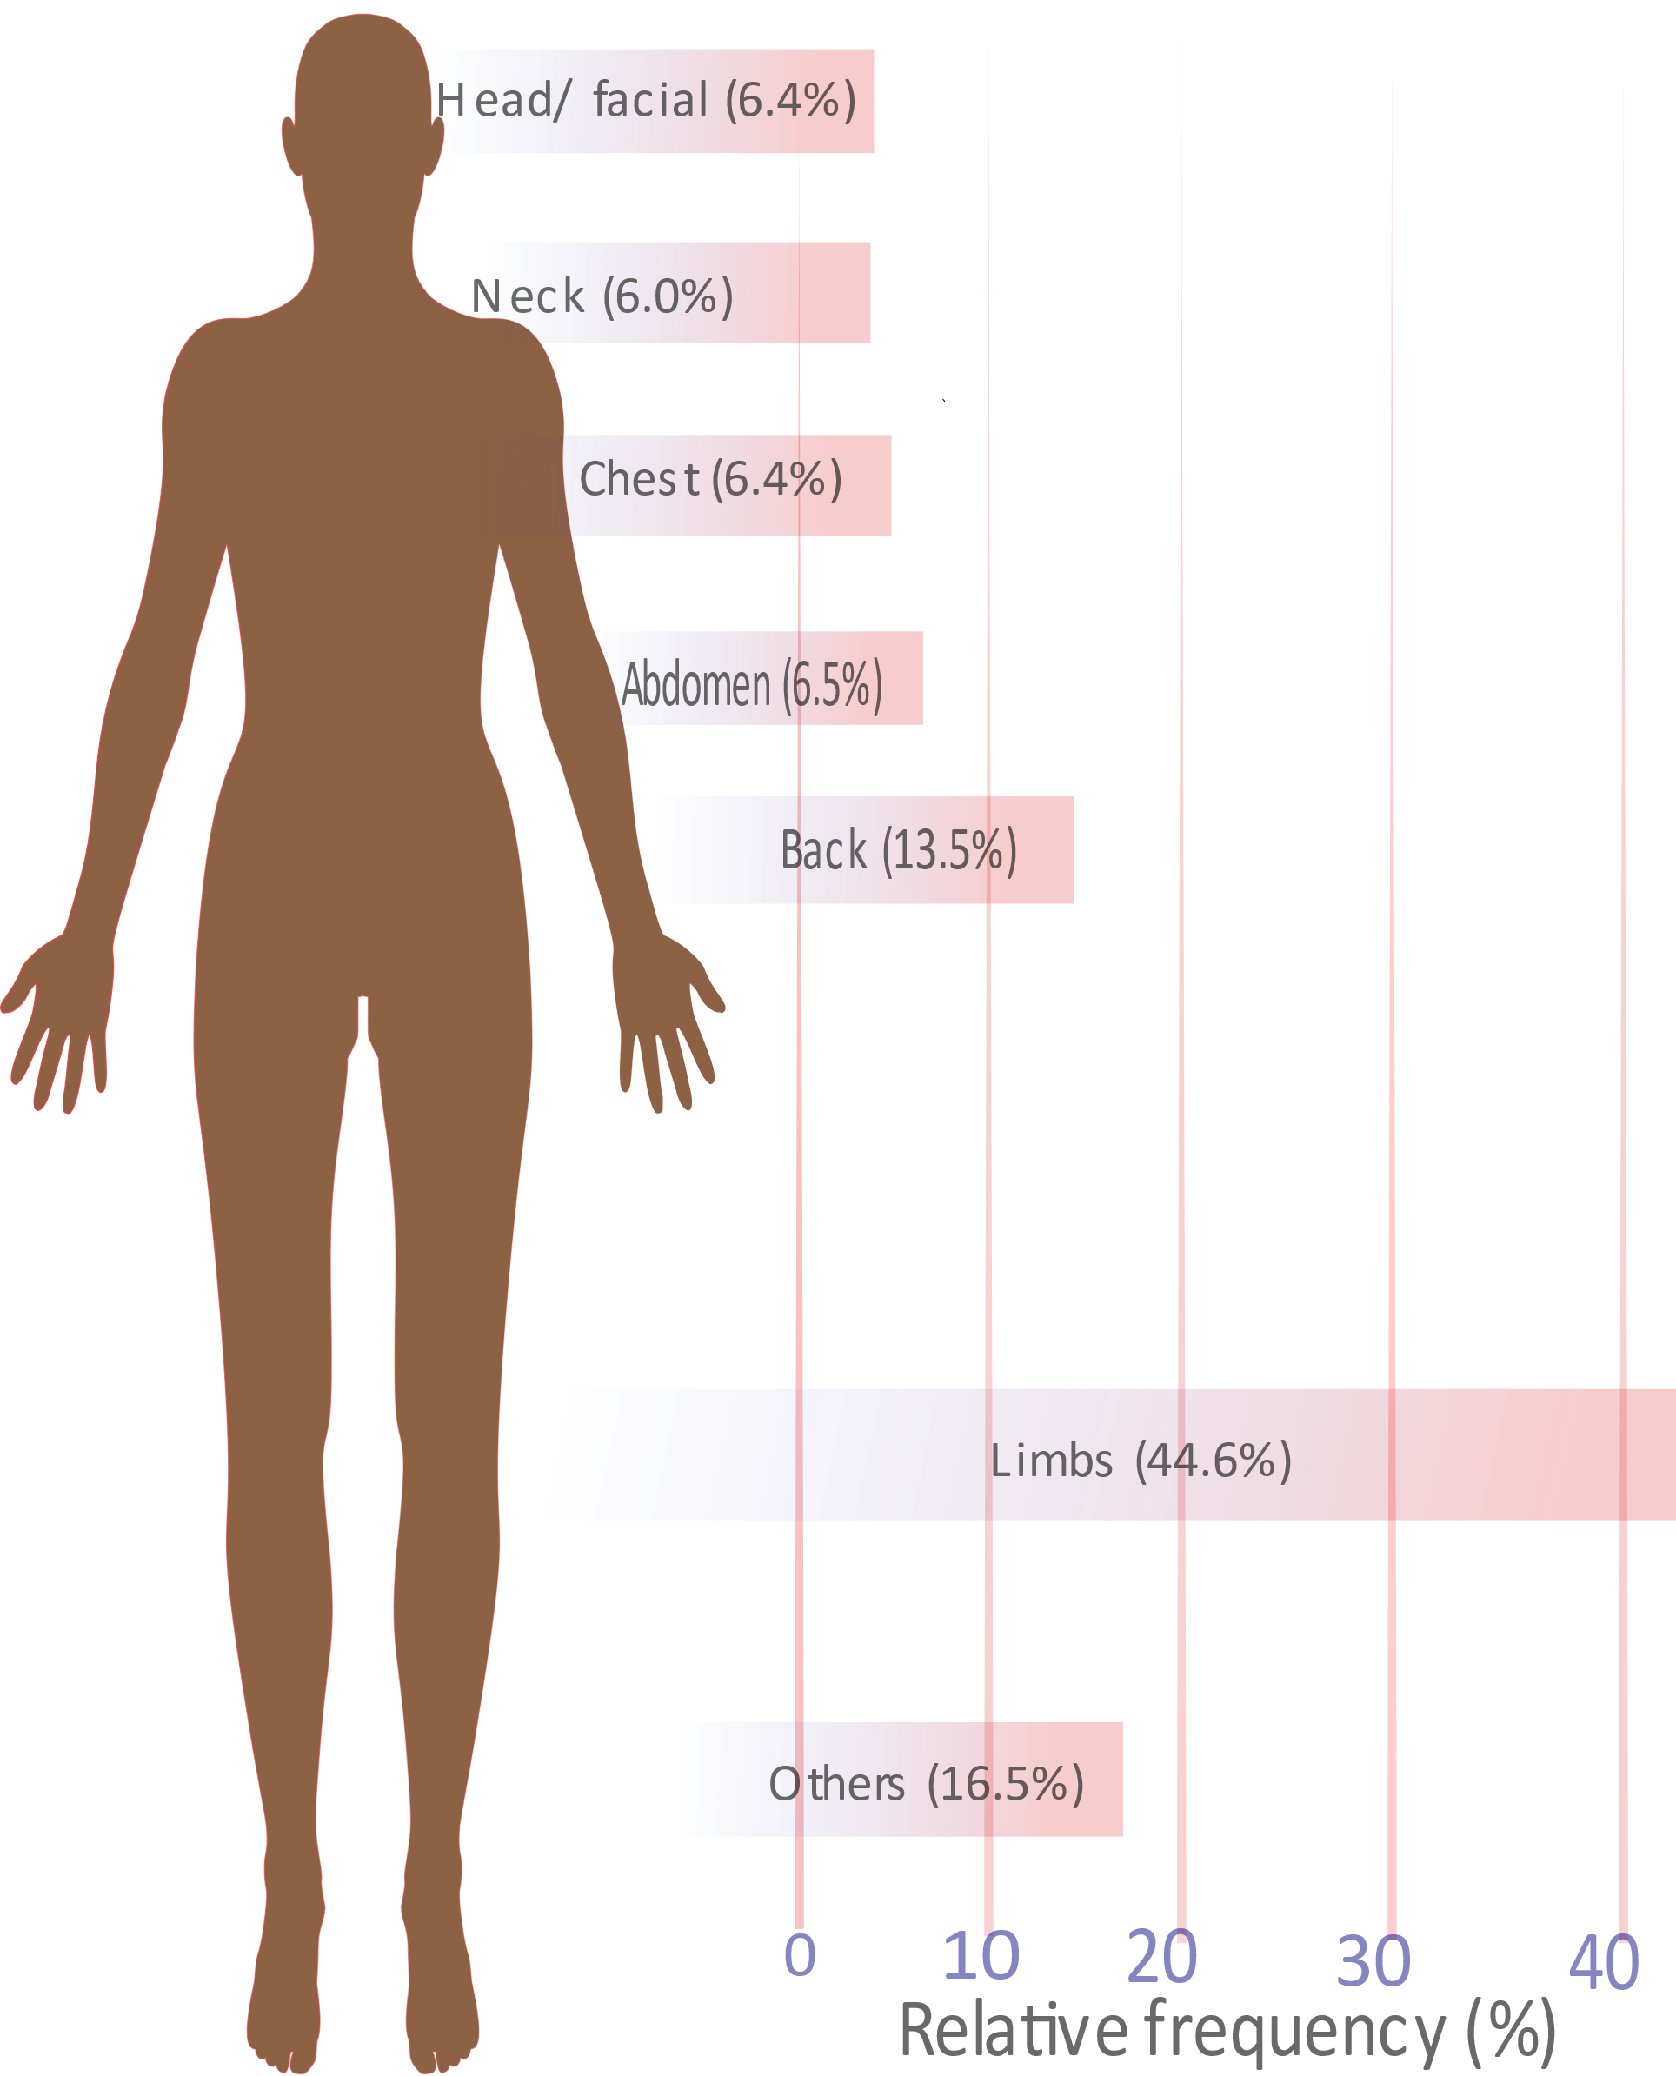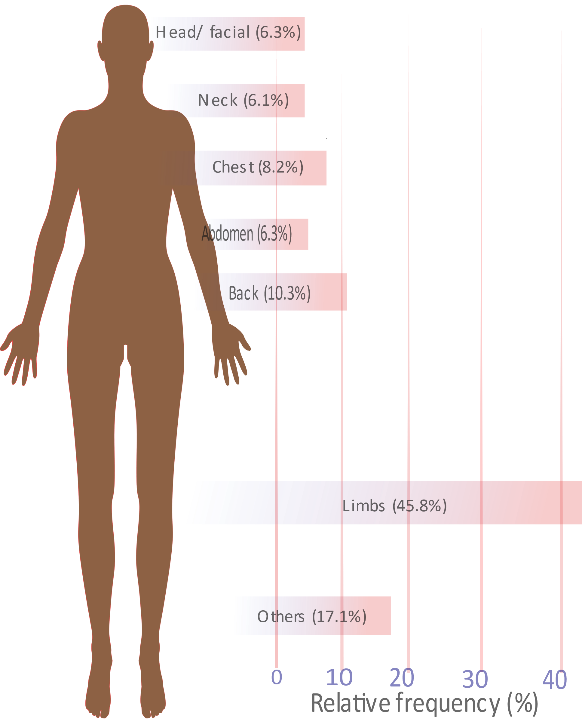
- (b)
S1 figure. Common body locations affected by (a) chronic pain, and (b) high-impact chronic pain.

