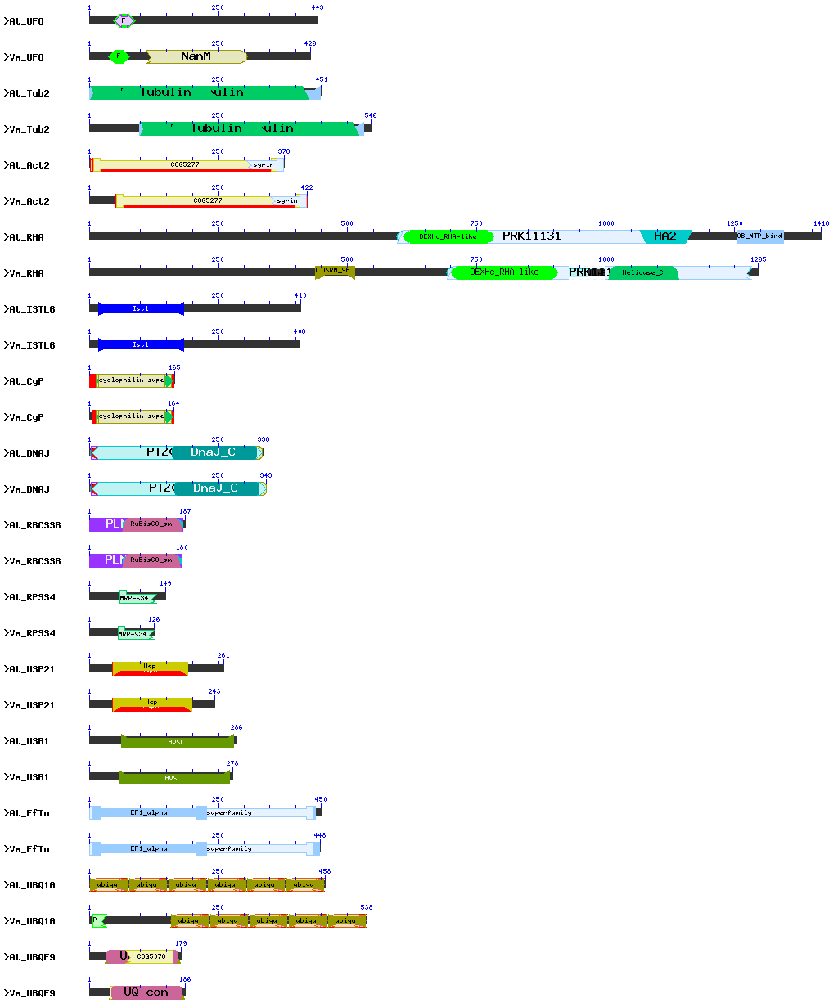
Figure S1: The NCBI batch CD analysis reflects the conservation of the functional domains in the HKGs from Vigna mungo (Vm) and their Arabidopsis (At) homologs besides having variable percent similarity among them
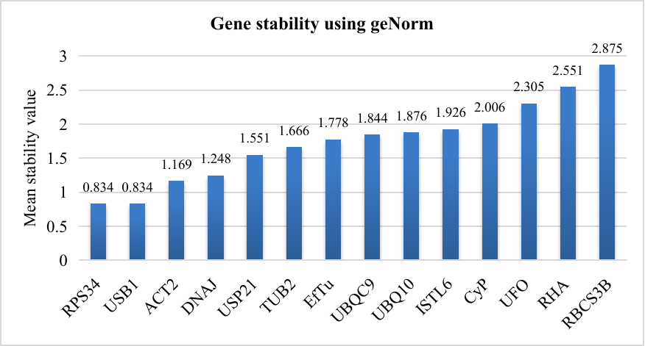
Figure S2: Gene stability analysis using the geNorm algorithm identifies RPS34 and USB1 as most suitable gene for normalization of qRT-PCR data under different stress conditions
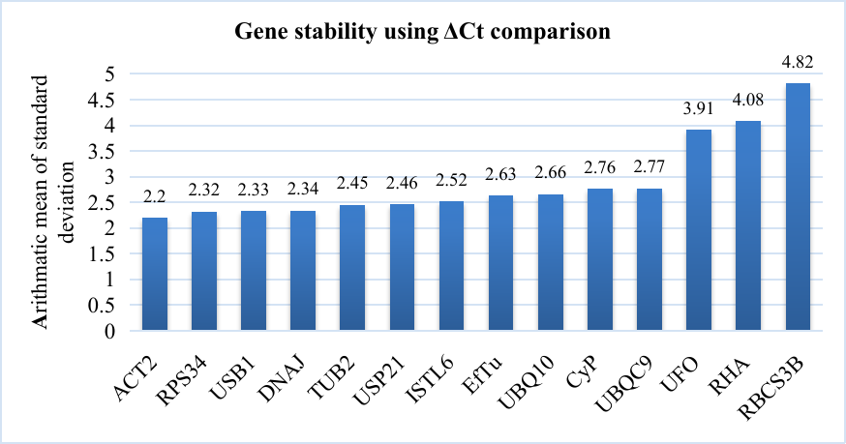
Figure S3: Gene stability analysis using the ΔCt comparison algorithm identifies ACT2 and RPS34 as most suitable gene for normalization of qRT-PCR data under different stress conditions
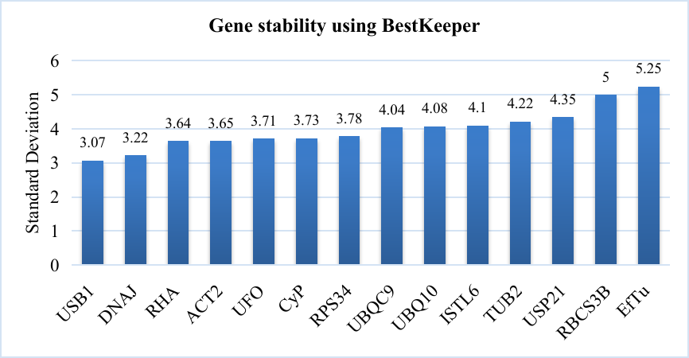
Figure S4: Gene stability analysis using the BestKeeper algorithm suggest USB1 and DNAJ as most suitable for normalization of qRT-PCR data under different stress conditions
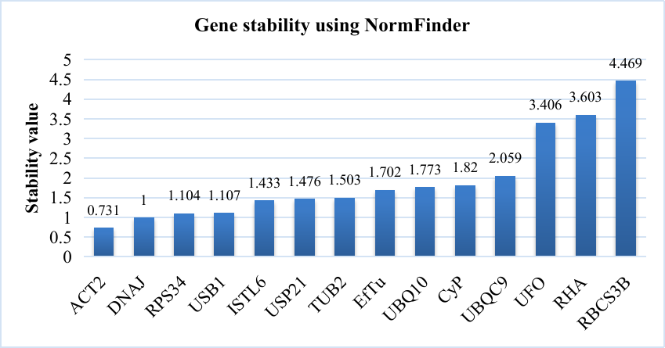
Figure S5: Gene stability analysis using the NormFinder algorithm infers ACT2 and DNAJ as most suitable for normalization of qRT-PCR data under different stress conditions
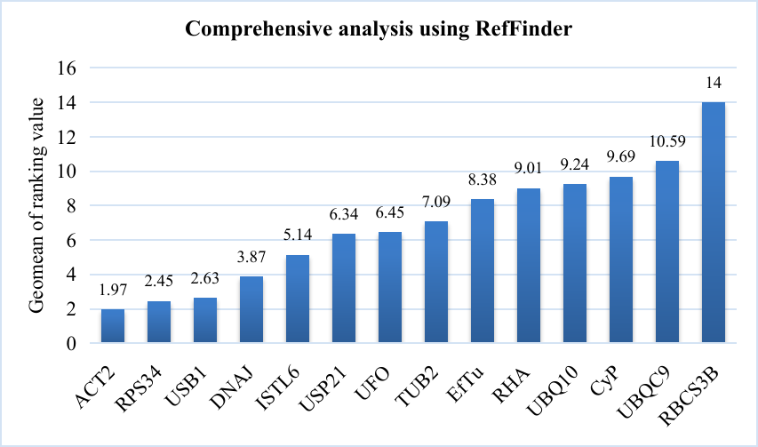
Figure S6: Gene stability analysis using the RefFinder algorithm infers ACT2 and RPS34 as most suitable for normalization of qRT-PCR data under different stress conditions

