Supplementary figures
Figure S1
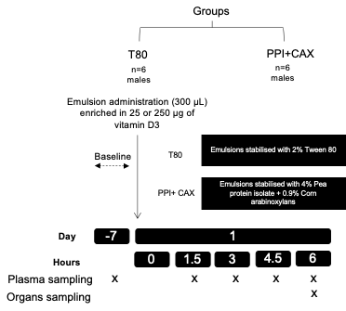
Figure S1. Experimental design for postprandial experiments.
See associated Figure 1.

Figure S2
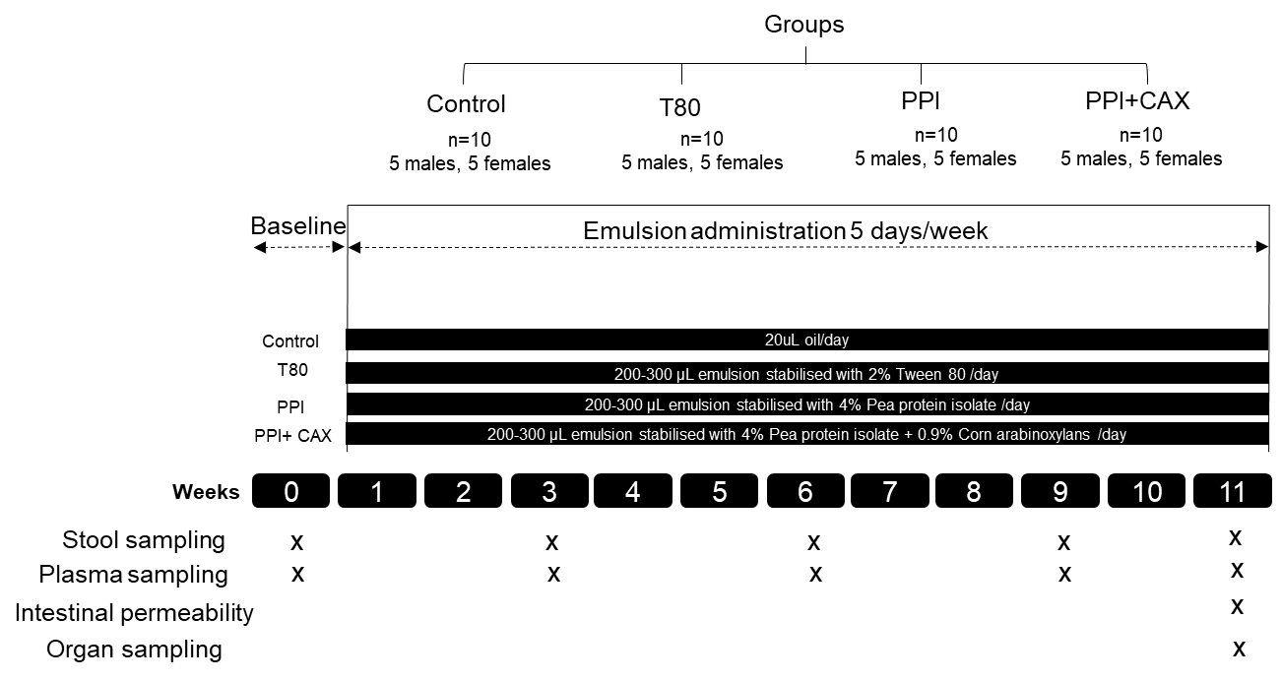
Figure S2. Experimental design for in vivo chronic exposure intervention.
See associated Figures 2-6.

Figure S3
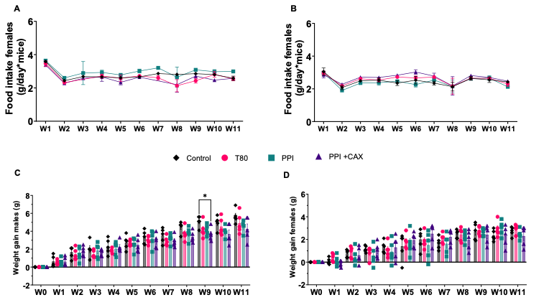
Figure S3. Mice weight gain and food intake during the chronic exposure intervention.
Control group (Control, diamonds), 2% Tween80 group (T80, circles), 4%PPI (PPI, squares), 4%PPI+0.9%CAX (PPI+CAX, triangles).
Growth of A) male and B) female mice from week 0 (W0) to week 11 (W11). Food intake (g/ mouse) of C) male and D) female mice from W0 to W11.
All graphic values are represented as mean ± SEM with n=10 mice/group including 5 males and 5 females. An asterisk indicates significant differences between groups (* p<0.05).

Figure S4
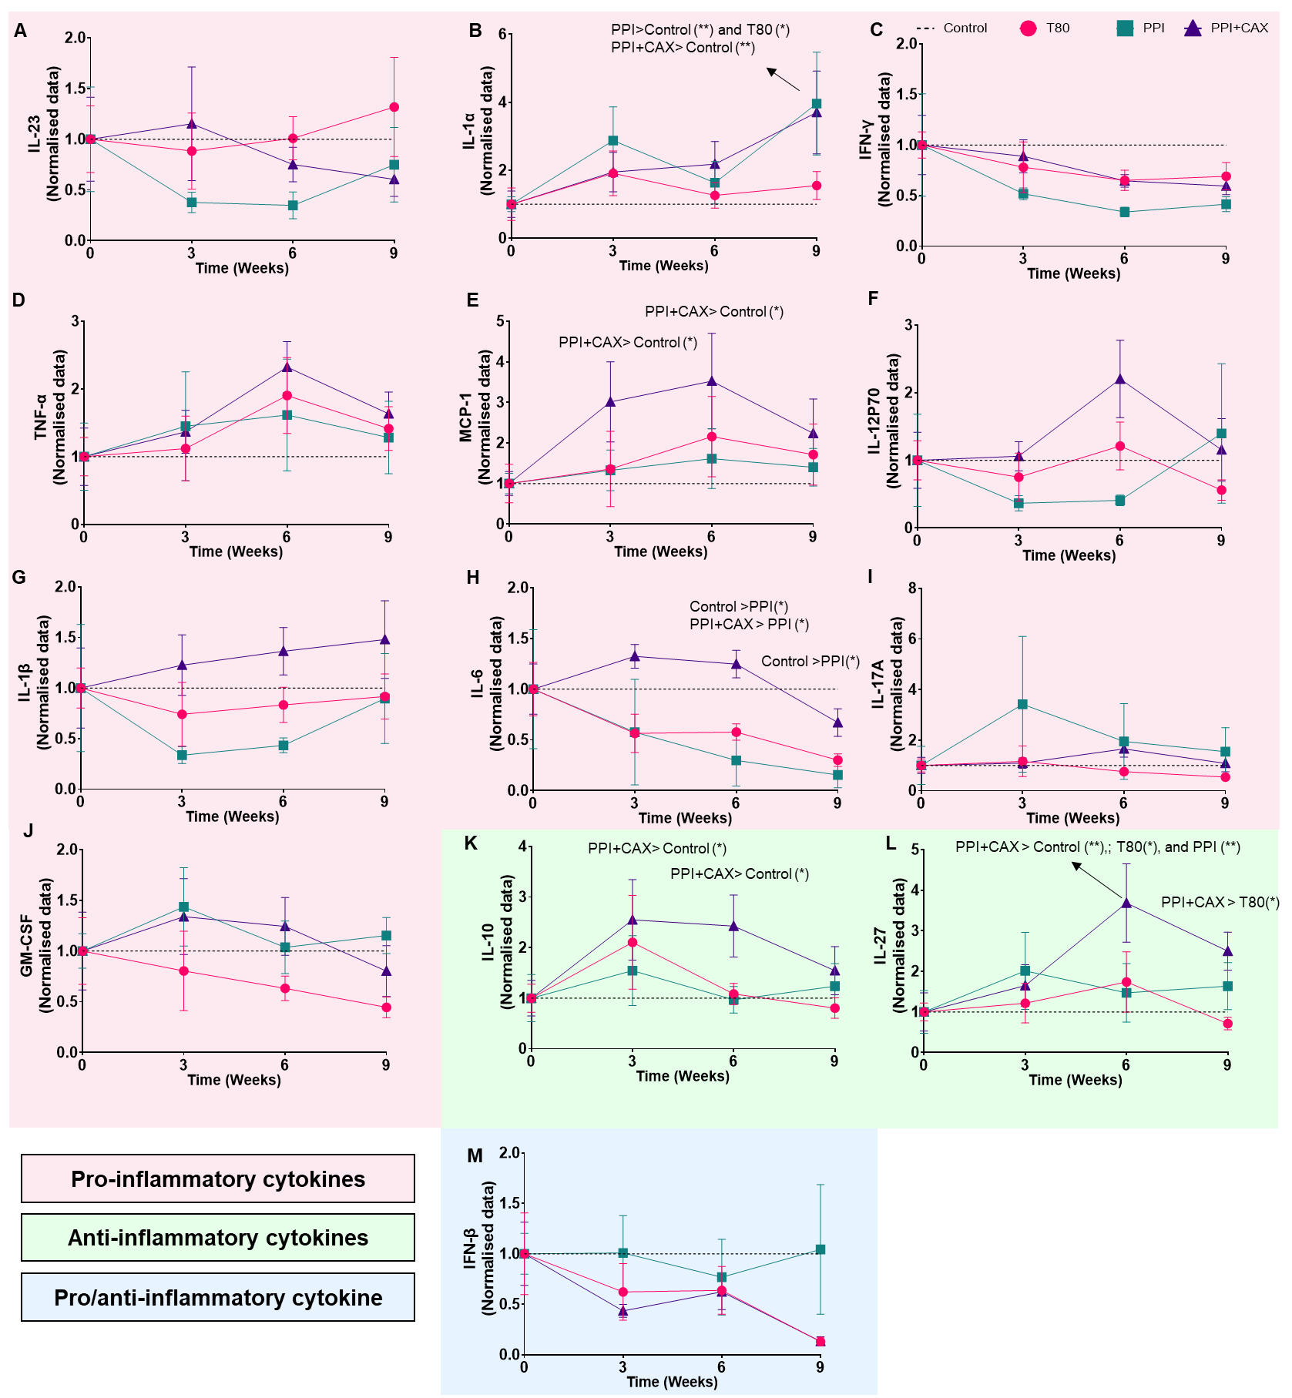
Figure S4. Plasma cytokine profiles after chronic exposure of mice to emulsifier-stabilized emulsions at dietary doses.
Normalized levels of plasmatic cytokines compared to control group including both males and females from weeks 0 to 11. Control group (dashed line), 2% Tween80 group (T80, circles), 4%PPI (PPI, squares), 4%PPI+0.9%CAX (PPI+CAX, triangles).
All graphic values are represented as mean ± SEM with n=10 mice/group including 5 males and 5 females. An asterisk indicates significant differences between groups (* p<0.05; ** p<0.01).
See associated Figure 3.
Figure S5
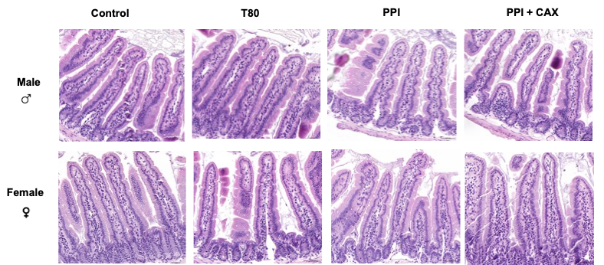
Figure S5. Jejunal characteristic and intestinal gene expression analyses related to mucosal defense systems after chronic exposure of mice to emulsifier-stabilized emulsions at dietary doses.
Representative images of median jejunum from week 11 mice stained by hematoxylin and eosin stain (HE). Mice were euthanized at fast.
See associated Figures 4 and 5.

Figure S6
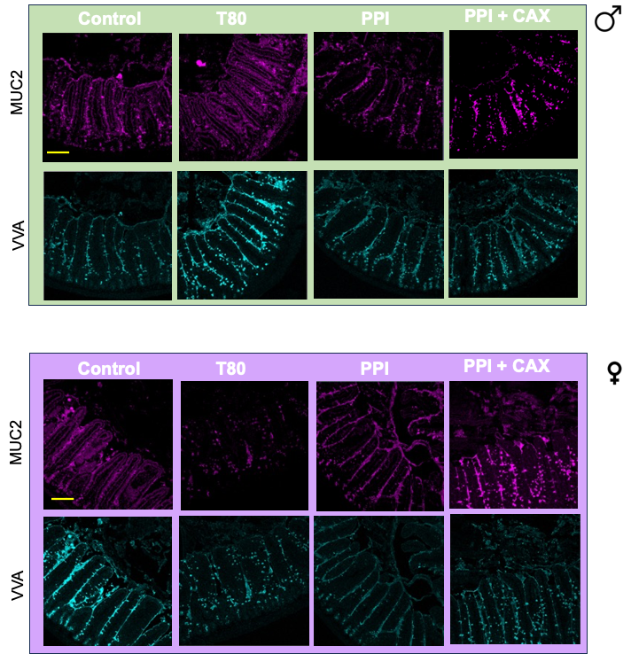

Figure S6. Jejunal characteristics of MUC2 and VVA after chronic exposure of mice to emulsifier-stabilized emulsions at dietary doses.
Representative spectral confocal imaging projections of median jejunum from week 11 mice stained by Fluorescence in situ Hybridization (FISH) for MUC2 (magenta) and Vicia Villosa Agglutinin (VVA, cyan). Mice were euthanized at fast. Bars, 50 µm separated by sex.
See associated Figure 4.
Figure S7
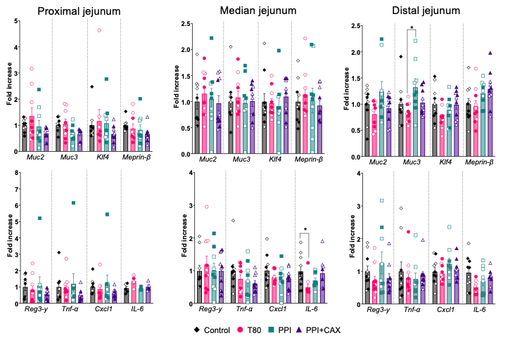

Figure S7. Intestinal gene expression analyses of selected genes related to mucosal defense.
Control group (Control, diamonds), 2% Tween80 group (T80, circles), 4%PPI (PPI, squares), 4%PPI+0.9%CAX (PPI+CAX, triangles). Mice were euthanized at fast. Males are represented by full symbols and females by empty symbols. All graphic values are represented as mean ± SEM with n=10 mice/group including 5 males and 5 females. An asterisk indicates significant differences between groups (* p<0.05).
See associated Figure 5.

Figure S8
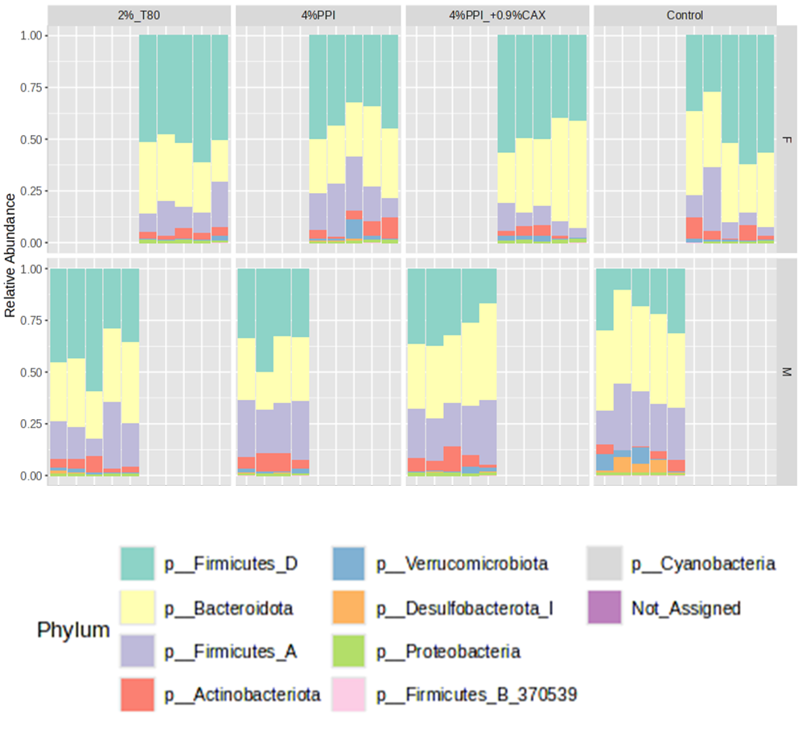
Figure S8. Individual fecal microbiota analyses after chronic exposure of mice to emulsifier-stabilized emulsions at dietary doses by sex.
Feces were collected at week 11 in ARN-free tubes.
Bar plot representation of individual composition of fecal content at the phylum level for females (top) and males (bottom).
See associated Figure 6.

