Figures list
Fig S1. The length distribution of assembled unigenes of the cultured C. paliurus cells
Fig S2. Unigenes homology searches against the NR databas
Fig S3. Function annotations of unigenes from the C. paliurus cells by RNA-seq
Fig S4. Scatter plot of three samples differentially expressed genes among the CK, E_{20h} and E_{60h}
Fig S5. Vene picture of significant differently expressed genes among the CK, E_{20h} and E_{60h}
Fig.S1
Fig.S1 The length distribution of assembled unigenes of the cultured C. paliurus cells

Fig.S2
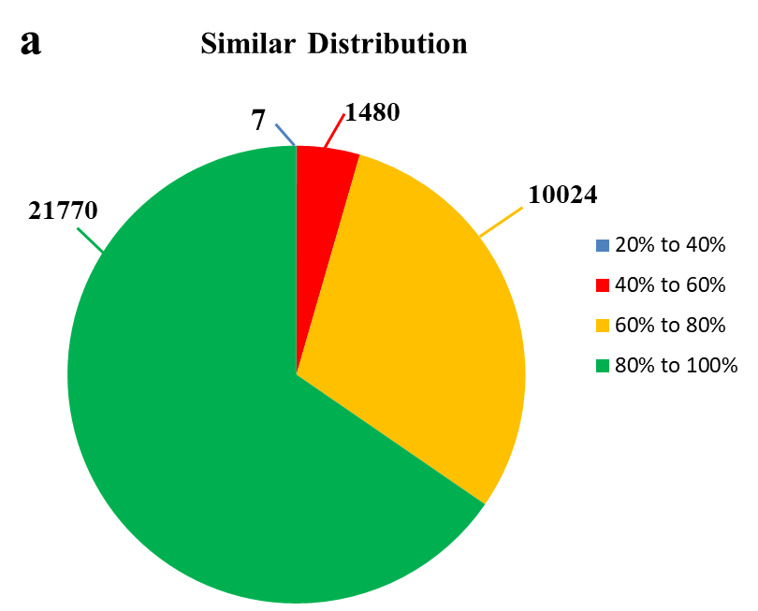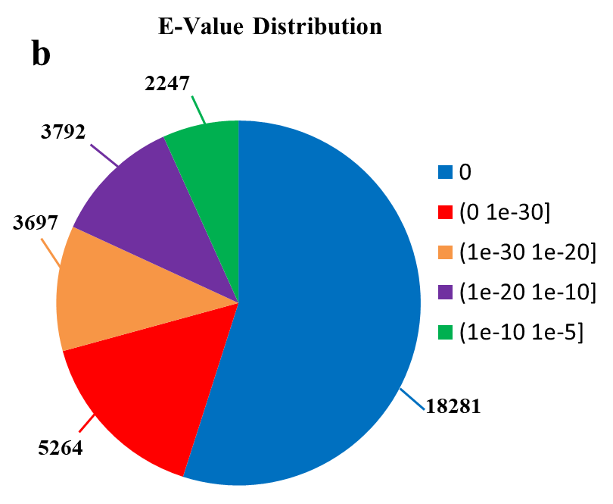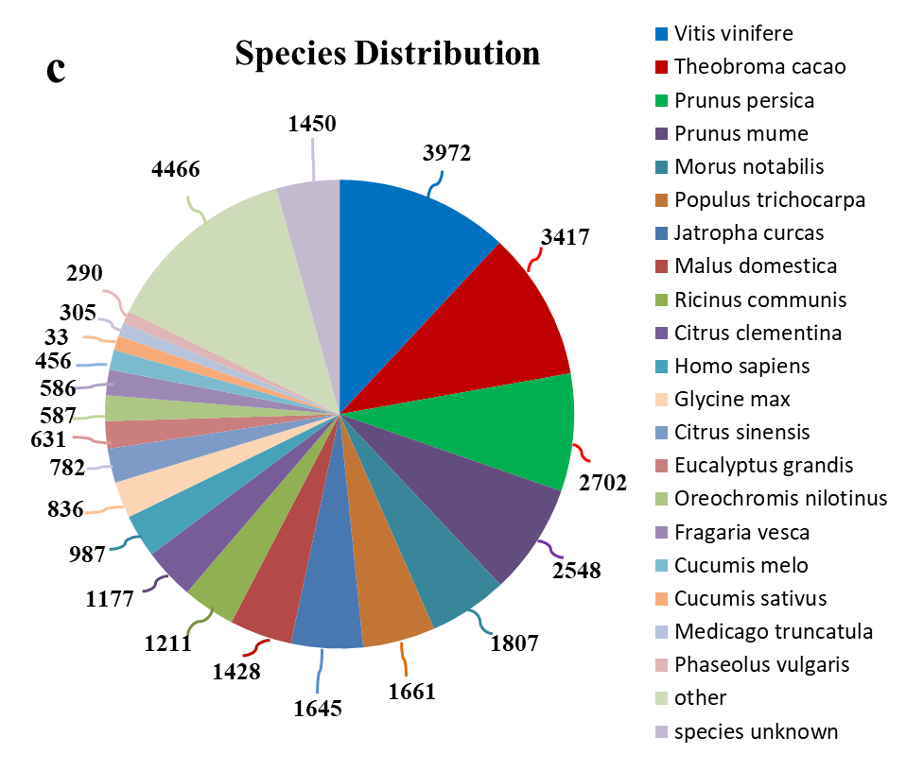
Fig.S2 Unigenes homology searches against the NR database. (a) The similar distribution of BLAST hits. (b) The E-value distribution of BLAST hits. (c) Species distribution of the top BLASTX hits.

Fig.S3
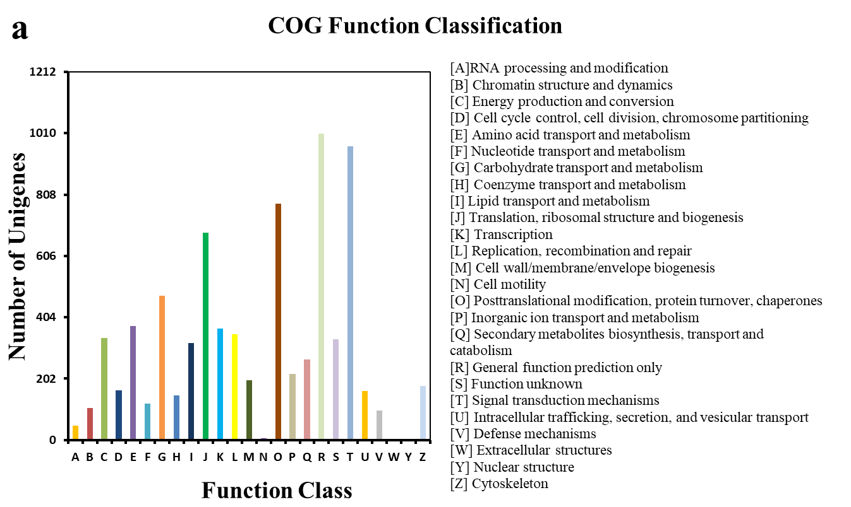
b
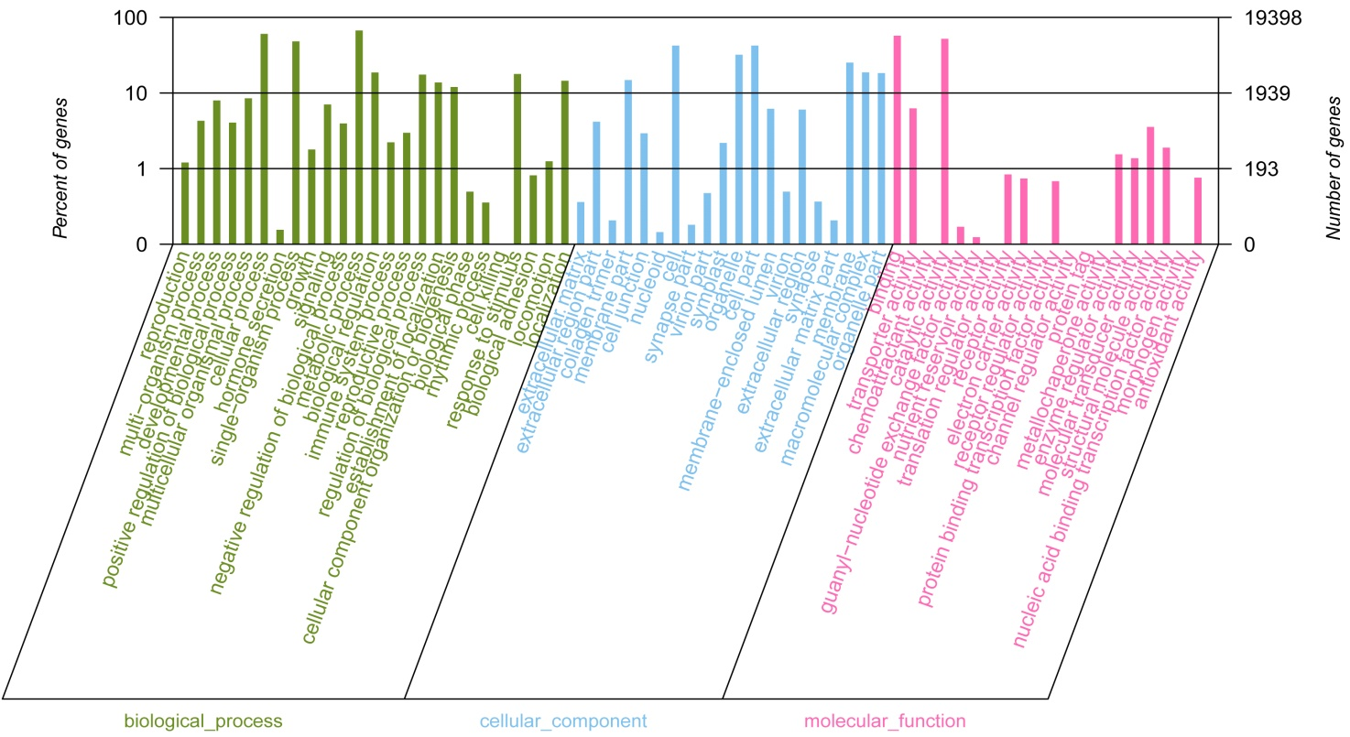
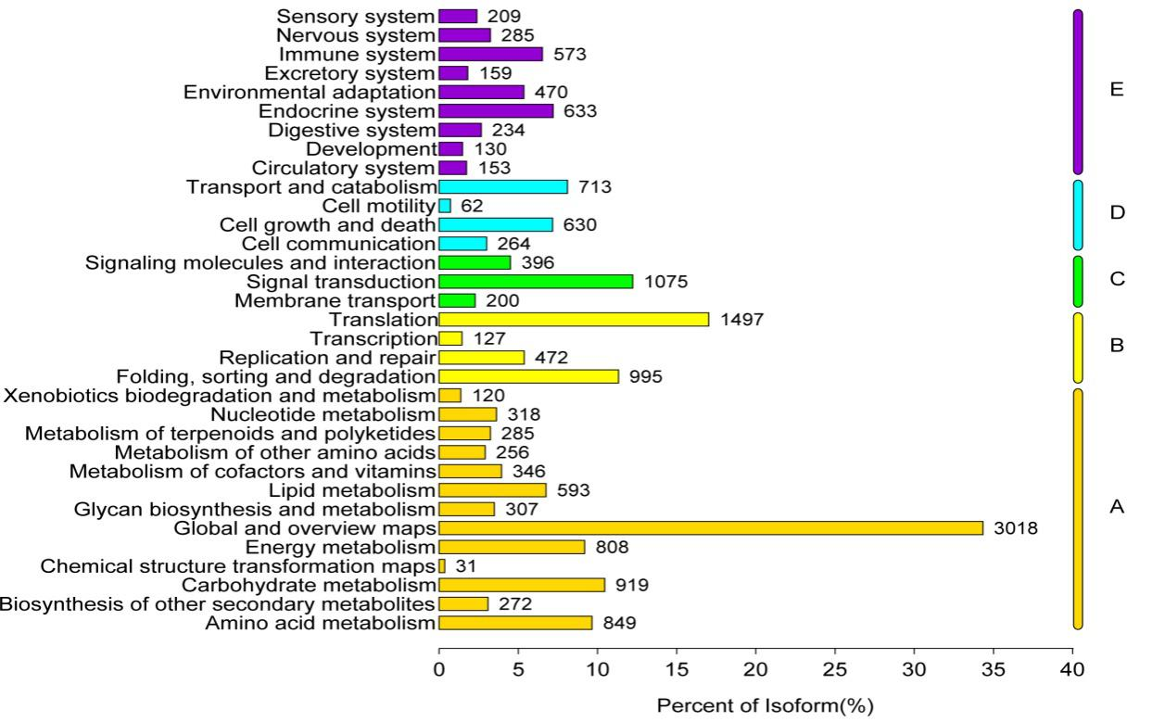
c
Fig.S3 Function annotations of unigenes from the C. paliurus cells by RNA-seq.（a）The COG function classification. (b) The GO function classification. (c) The KEGG function classification

Fig.S4
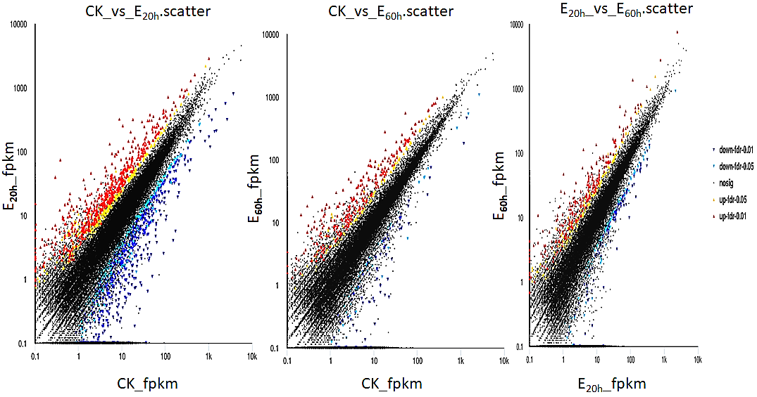
Fig.S4 Scatter plot of differentially expressed genes among the CK, E_{20h} and E_{60h}. The cell samples elicited by ANE for 0, 20, and 60 h were designated as “CK”, “E_{20h}”, and “E_{60h}”, respectively. CK vs E_{20h}: comparision between CK and E_{20h}; CK vs E_{60h}: comparision between CK and E_{60h}; E_{20h} vs E_{60h}: comparision between E_{20h} and E_{60h}.

Fig.S5
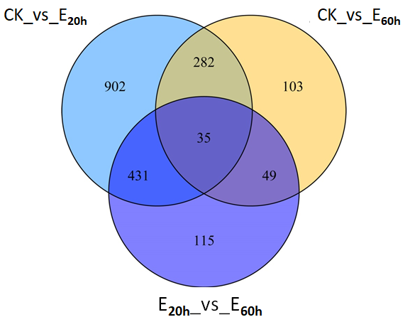
Fig.S5 Vene picture of significant differently expressed genes among the CK, E_{20h} and E_{60h}. The cell samples elicited by ANE for 0, 20, and 60 h were designated as “CK”, “E_{20h}”, and “E_{60h}”, respectively. CK vs E_{20h}: comparision between CK and E_{20h}; CK vs E_{60h}: comparision between CK and E_{60h}; E_{20h} vs E_{60h}: comparision between E_{20h} and E_{60h}.

