APPENDIX 1

These exercises are explained to the patient to be executed at home.

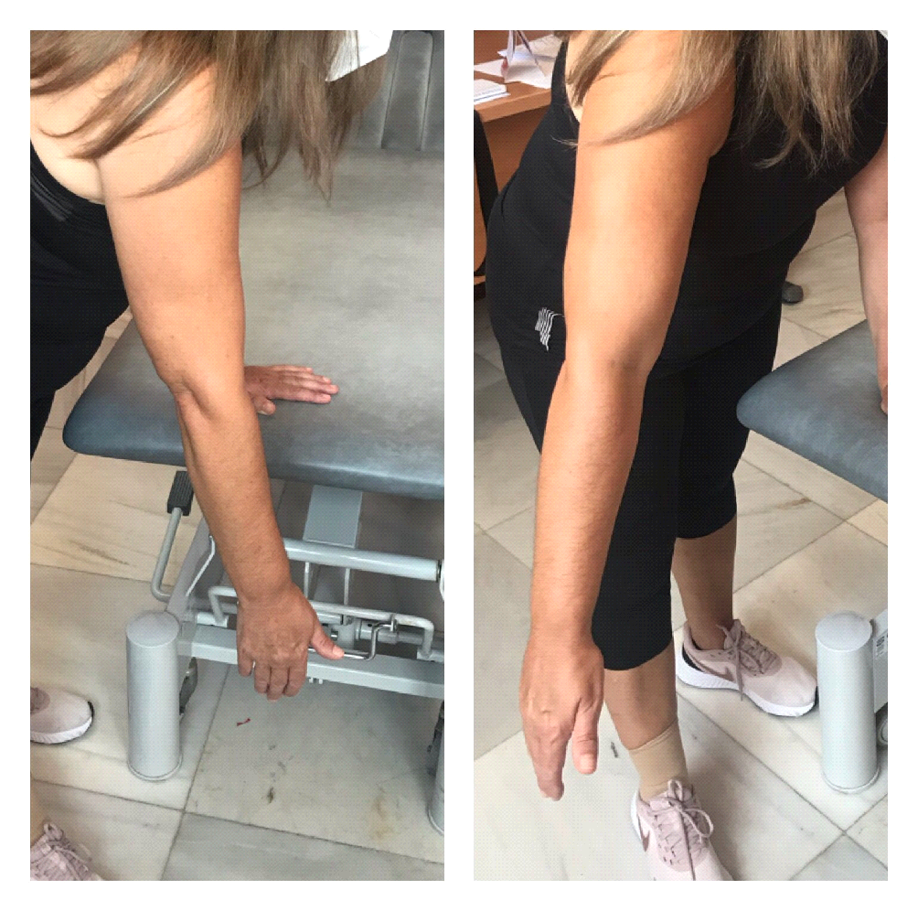

Exercise 1.- Codman Pendulum exercises.
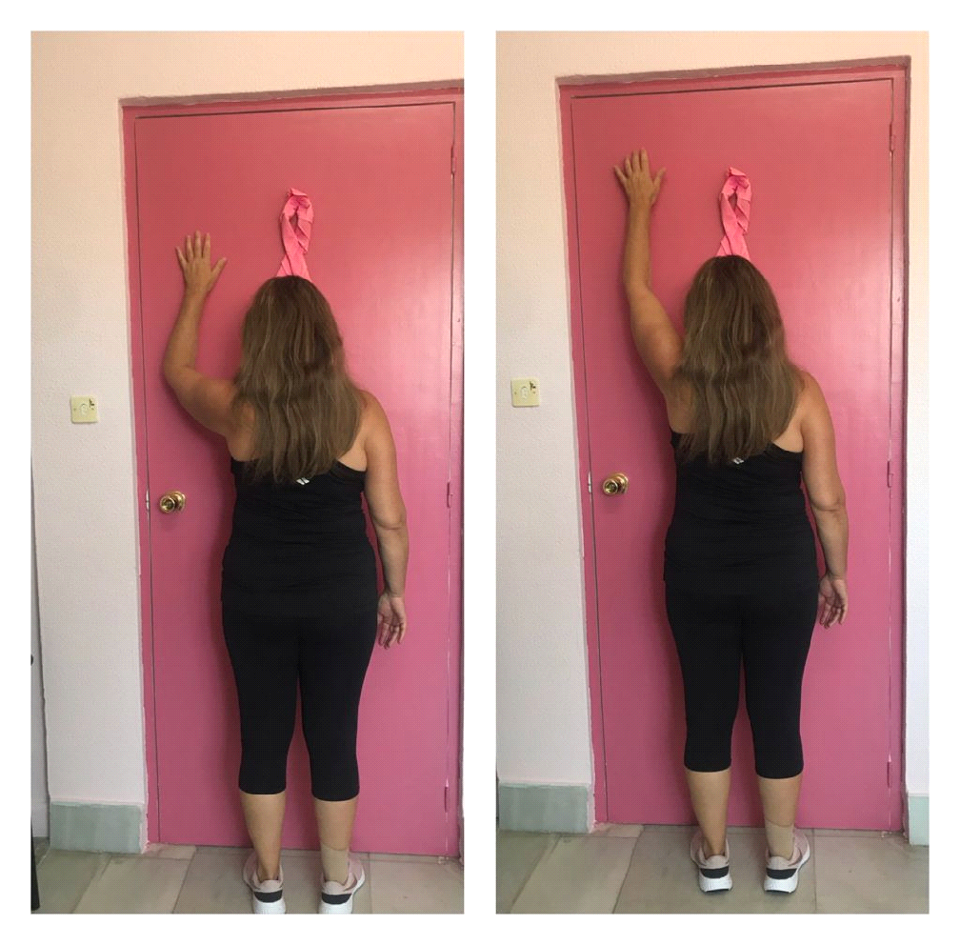

Exercise 2.- Standing, affected shoulder flex sliding palm of the hand on the wall, up and down. Keeping maximum flexion during 15 seconds.

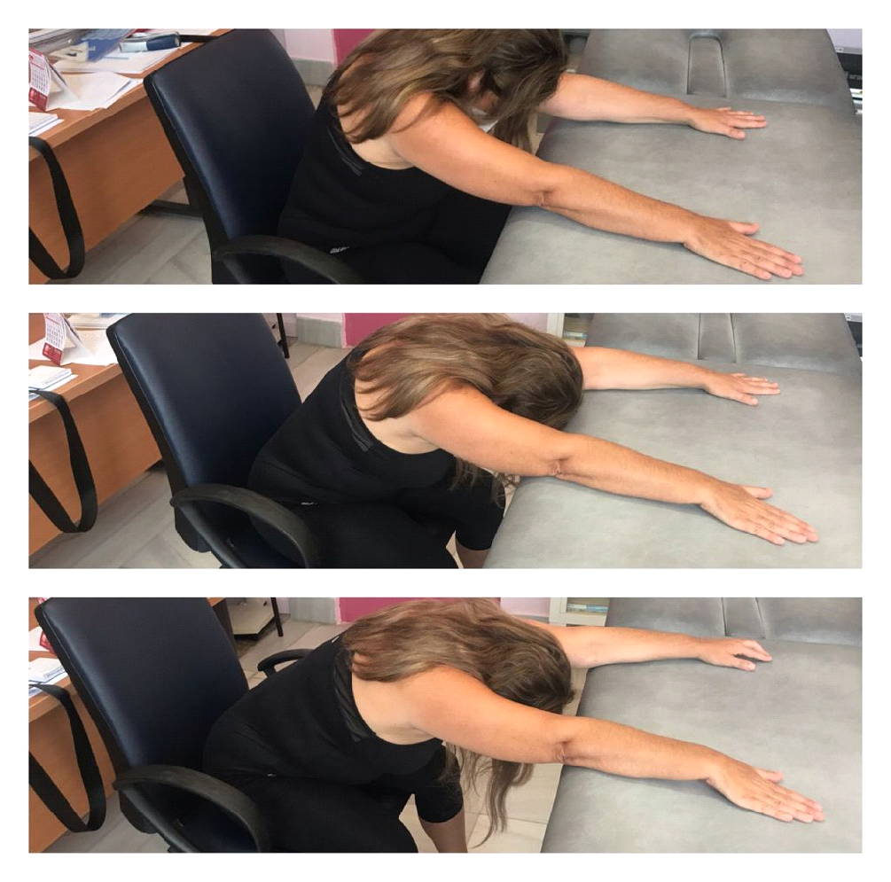

Exercise 3.- Seated, affected shoulder flexion. Seated on a wheeled chair, leaning elbow on a table. Shoulder flexion sliding chair, backwards and forwards.
Lymphoedema prevention exercises (please visit our YouTube channel “Unidad Linfedema Algeciras”).

Signed consent was given by the patients for the publication of the photographs in which they appear.

APPENDIX 2

Manual Therapy, Scar Massage and exercises for the Intervention Group.

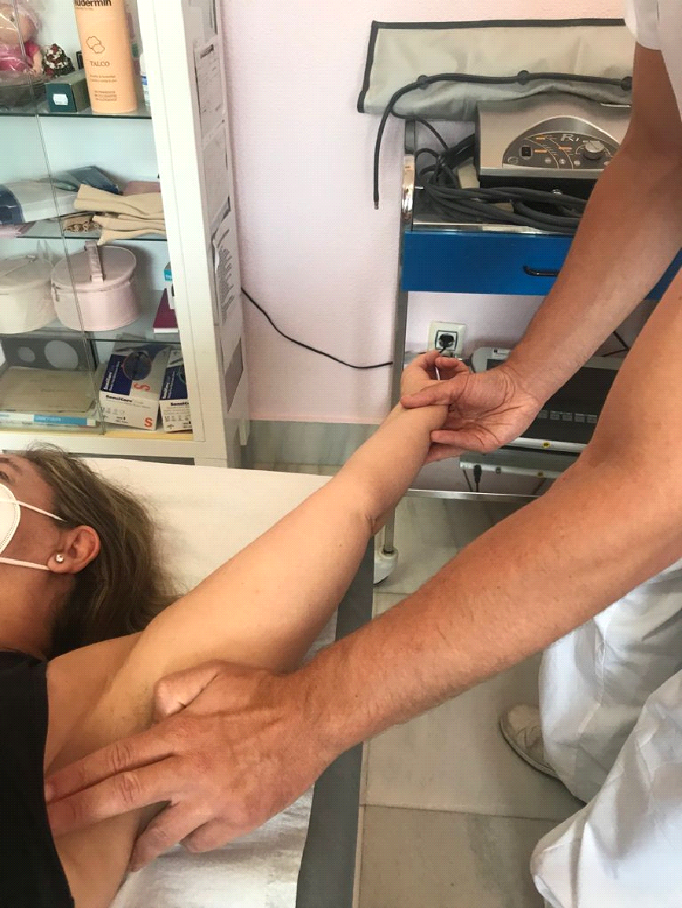

Exercise 4.- The Physiotherapist rests the affected limb diagonal to regular movement only if pain due to stretching is moderate.

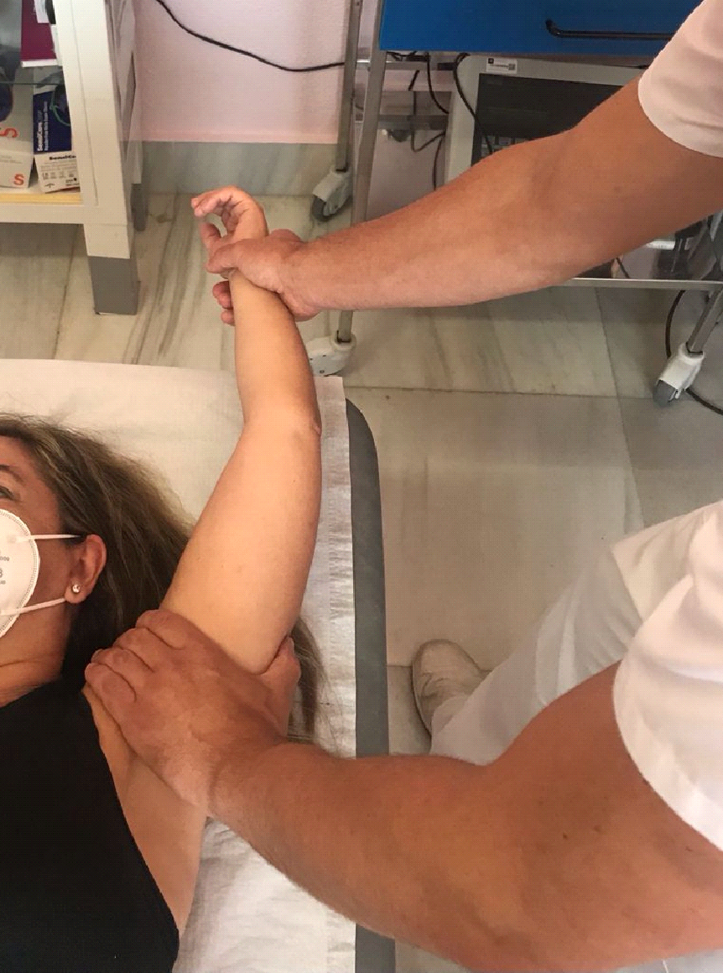

Exercise 5.- The Physiotherapist rests the limb in shoulder flexion following elbow extension.

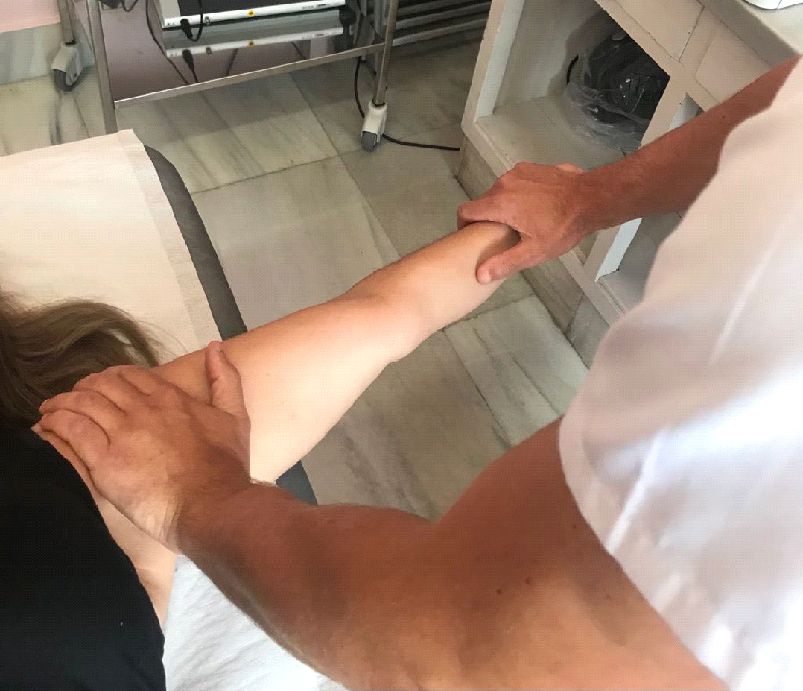

Exercise 6.- The Physiotherapist places the limb in abduction position while the patient can tolerate discomfort.

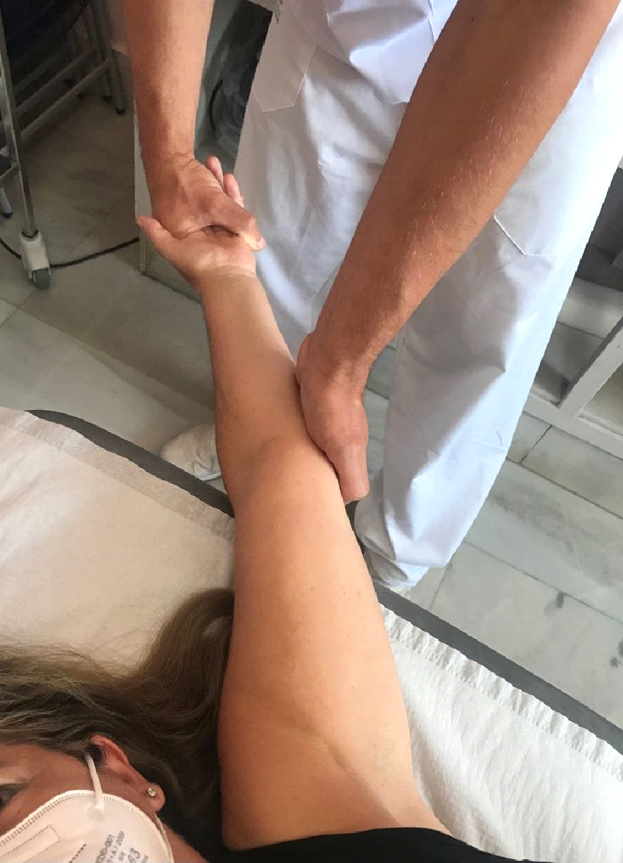

Exercise 7.- In case the cord reaches the elbow, the Physiotherapist holds the elbow extension combined with supination of the limb. The shoulder will be kept in flexed position as long as pain is moderate to keep the tension of the cord.

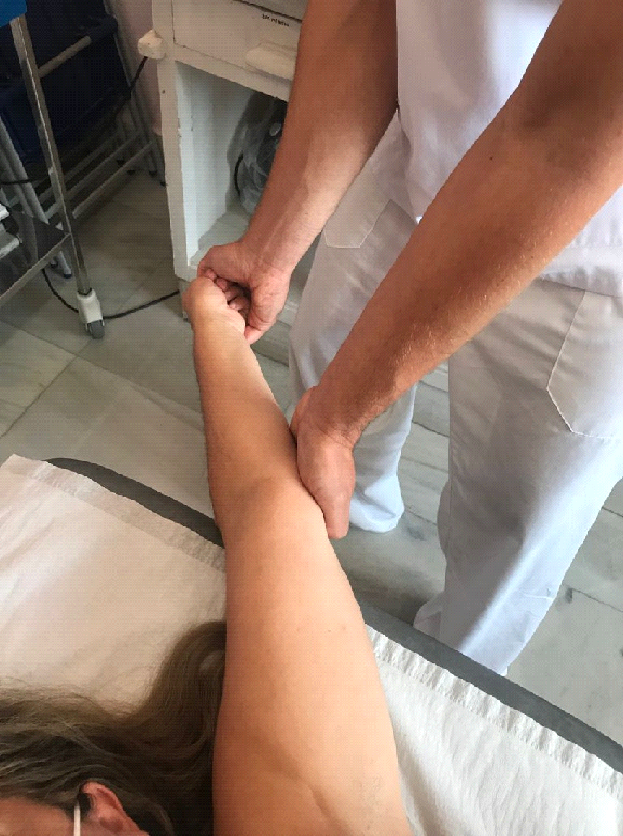

Exercise 8.- If the thrombus reaches the first finger, the Physiotherapist will try to reach the ulnar deviation of the wrist together with the flexion of the thumb. The shoulder will be kept in a flexed position and the elbow in an extended supination position.

