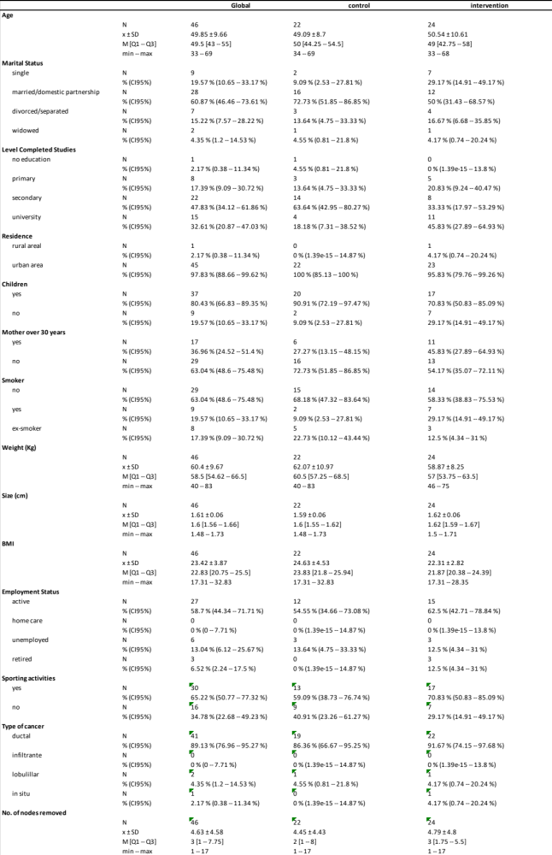
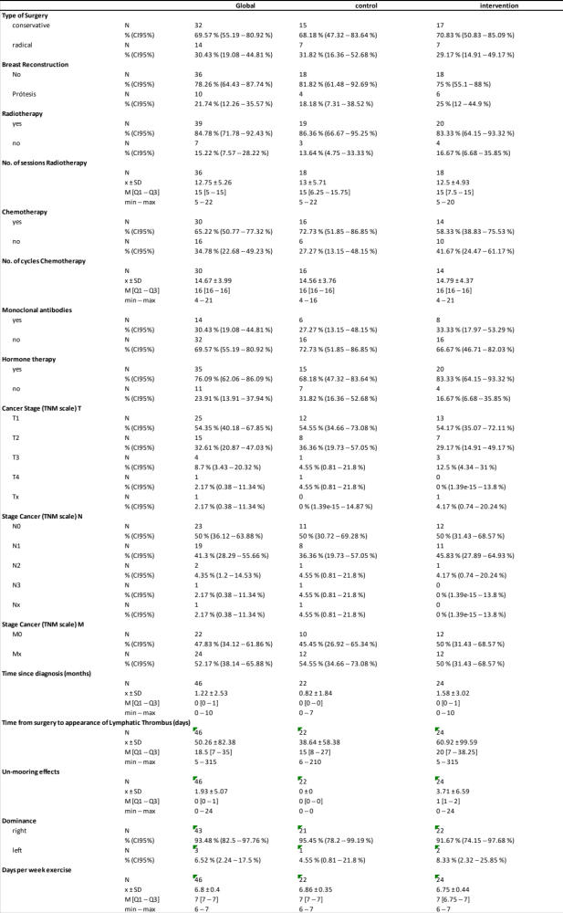
Table 1. Descriptive analysis of the variables included in the study. For quantitative variables, mean +- standar deviation, median [Q1-Q3] and minimum and maximum are shown. For qualitative variables, the percentage of cases and 95% confidence intervals are shown.

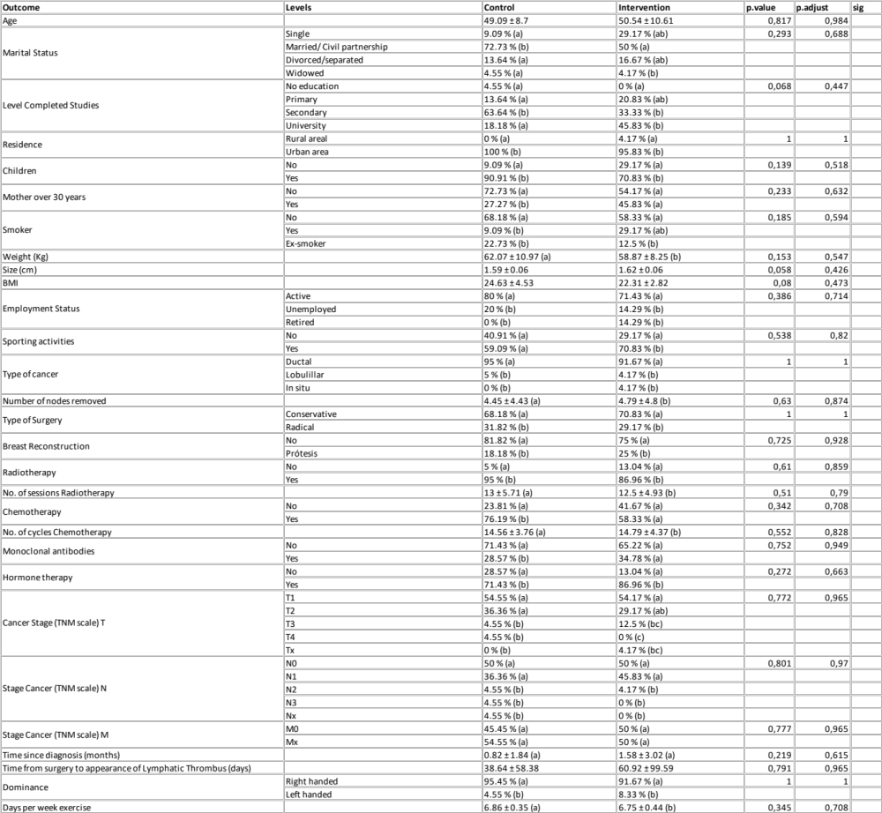

Table 2. Baseline bio-demographic and clinical characteristics of study participants.

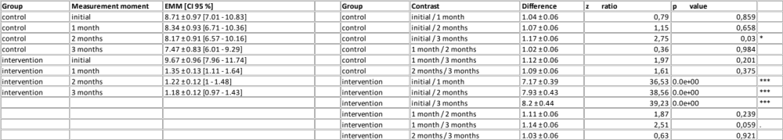
Table 3: Estimated marginal means of VAS score as a function of study group and time of measurement. Significant results are indicated by asterisks: p < 0.001: ***; p < 0.01: **; p < 0.05: *; p < 0.1: ·

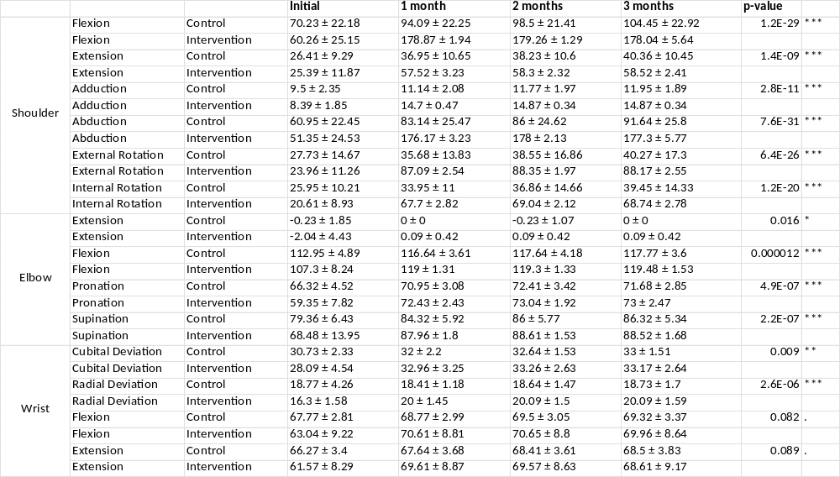

Table 4: Range of motion of the affected upper limb for control group and intervention group, at baseline, first month, second month and third month.

