Extended data figures

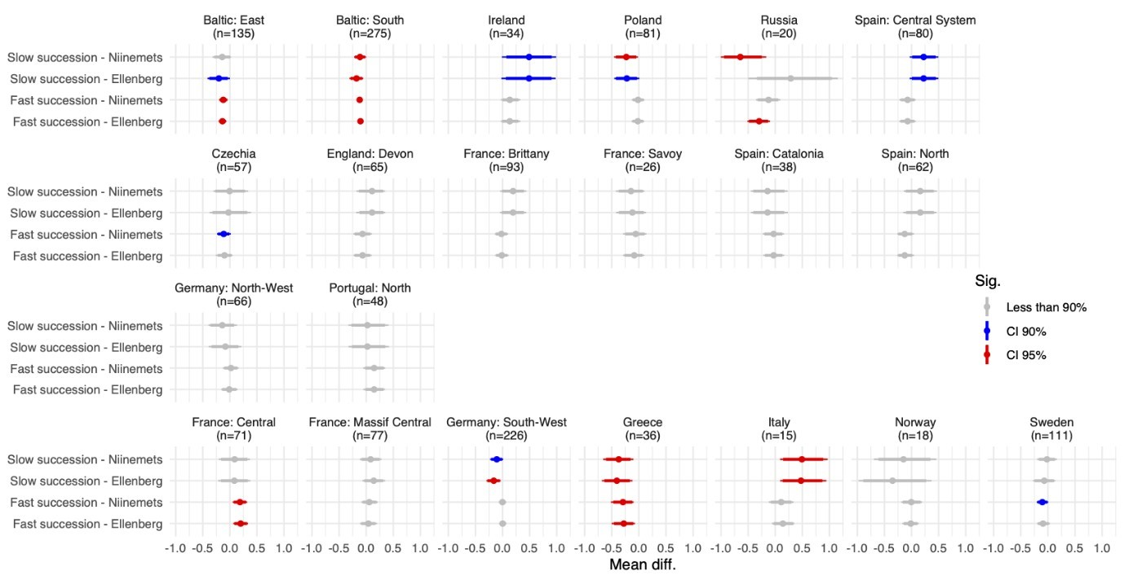
Extended Data Figure 1. Region-by-region comparison of Ellenberg and Niinemets indicators.
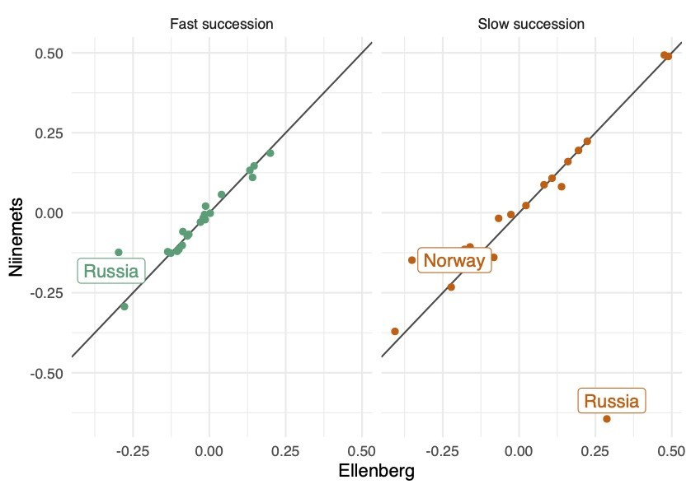
Extended Data Figure 2. Outlier analysis of Ellenberg and Niinemets indicators.
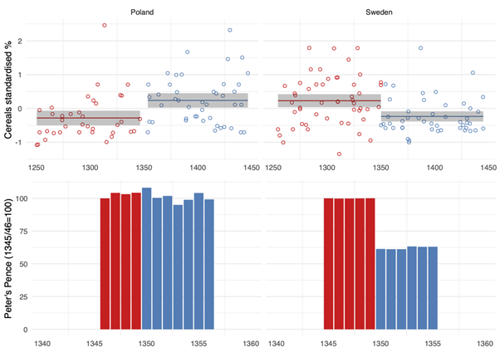
Extended Data Figure 3: Comparison of historical and paleoenvironmental indicators of the demographic impact of the Black Death in Poland and Sweden. Top panel: pollen data (cereal pollen, standardised % values from individual sites and 100-yr mean with standard deviation), see Supplementary Data 2; Bottom Panel: Peter’s Pence tax^{27–29}.

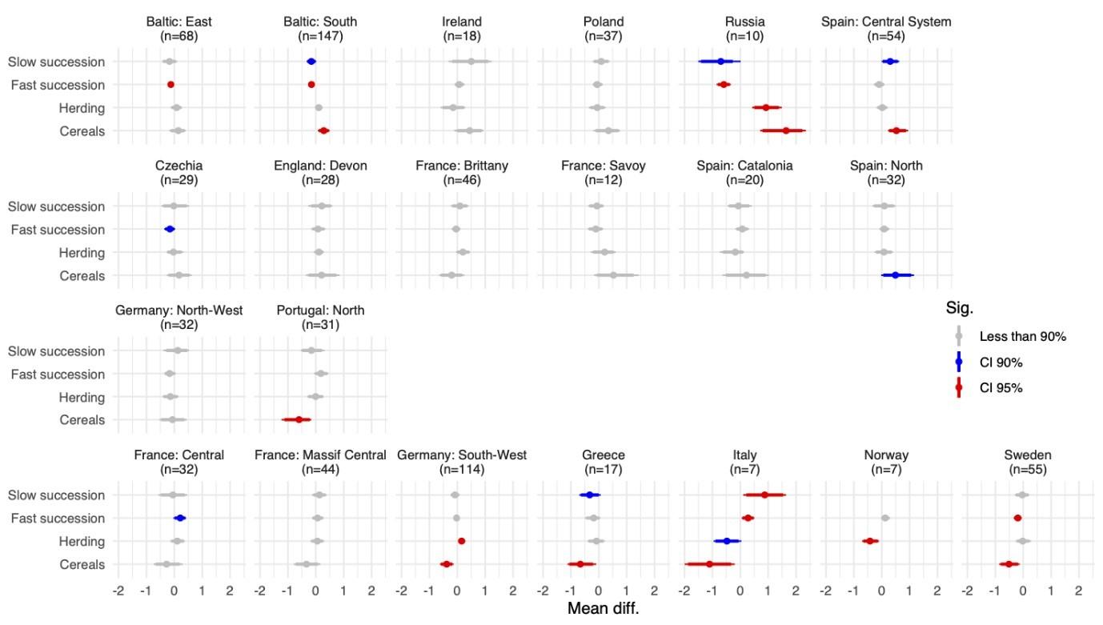
Extended Data Figure 4. Post-Black Death regional-scale changes in four BDP pollen indicators. Difference between the means of 50-yr periods of 1301-1350 to 1351-1400 CE, with the standard deviation. Statistical significance is based on bootstrap estimates. Regions arranged as in Fig. 2.

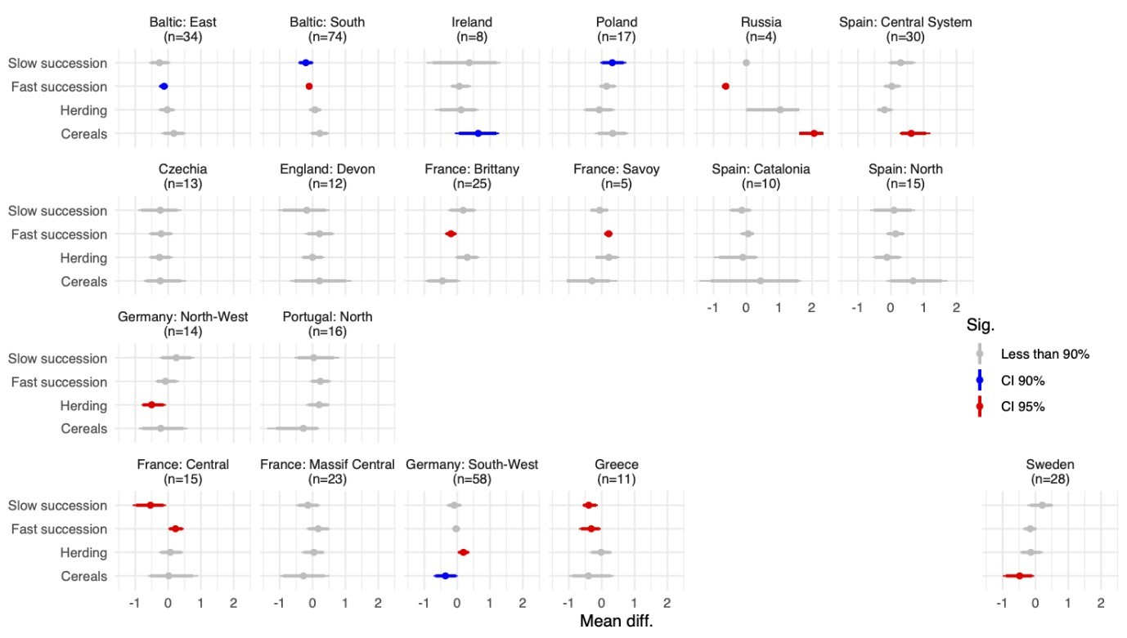
Extended Data Figure 5. Post-Black Death regional-scale changes in four BDP pollen indicators. Difference between the means of 25-yr periods of 1325-1350 to 1351-1375 CE, with the standard deviation. Statistical significance is based on bootstrap estimates. Regions arranged as in Fig. 2.

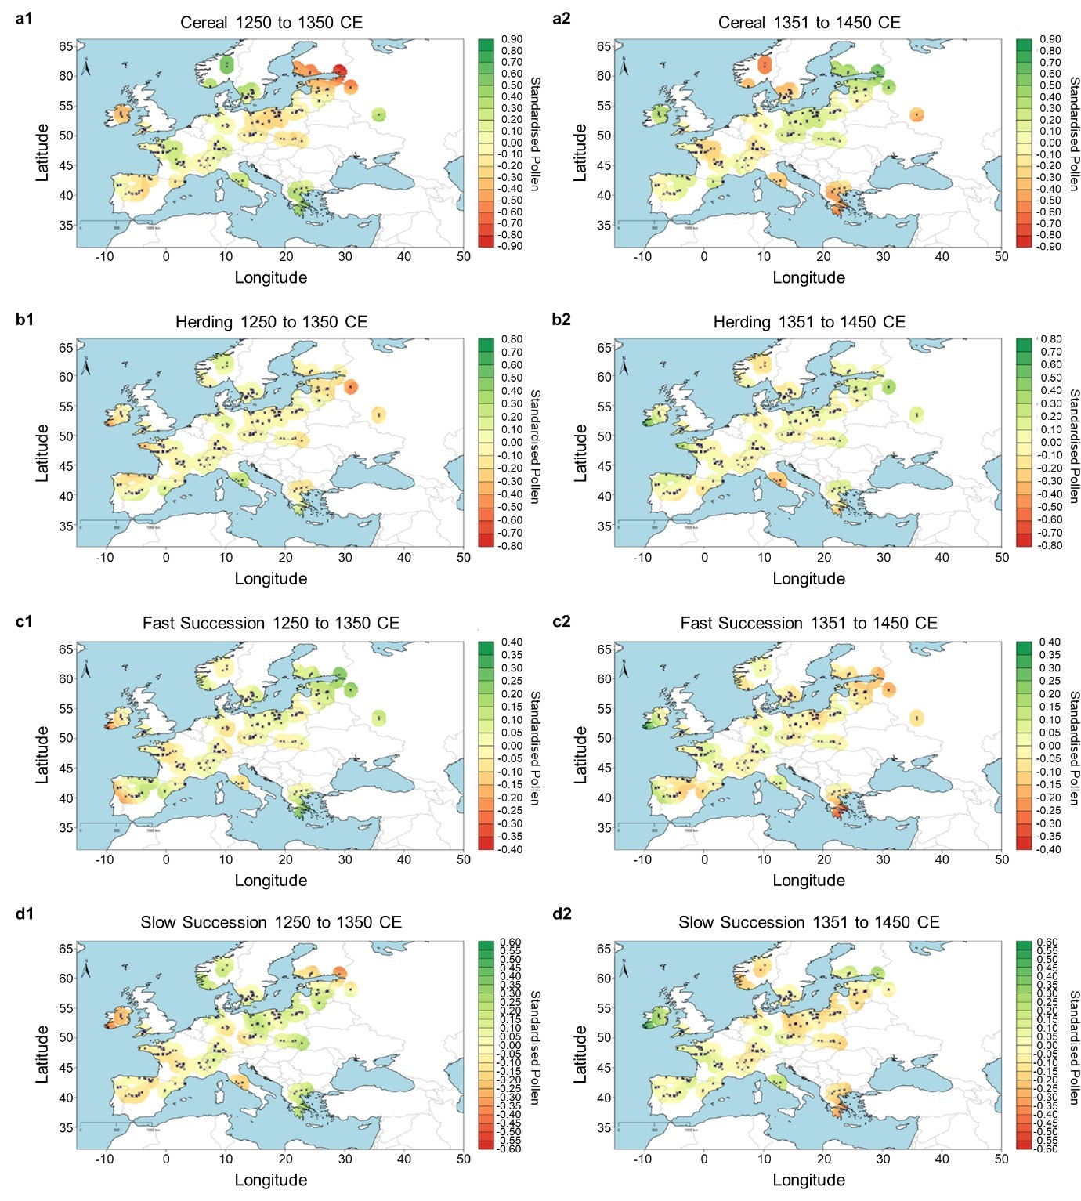
Extended Data Figure 6. Spatial extrapolation for all four indicators c. 100 years before and after the Black Death. a) Cereal 1250-1350 CE (1) and 1351-1450 CE (2) b) Herding 1250-1350 CE (1) and 1351-1450 CE (2) c) Fast Succession 1250-1350 CE (1) and 1351-1450 CE (2) d) Slow Succession 1250-1350 CE (1) and 1351-1450 CE (2).

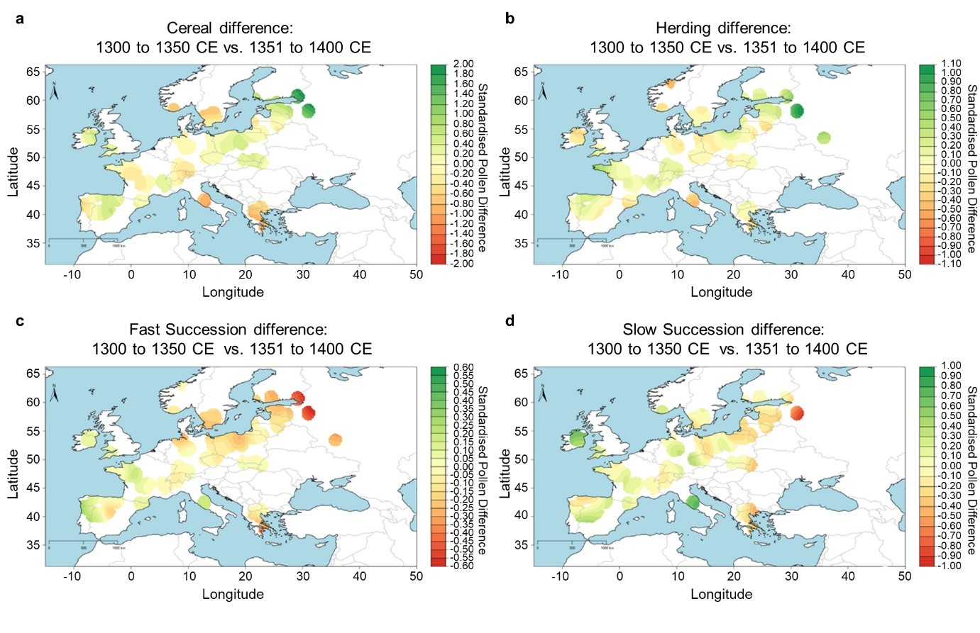
Extended Data Figure 7. Spatial extrapolation showing 1301-1350 vs 1351-1400 CE temporal variation in the BDP pollen indicators a) Cereal b) Herding c) Fast Succession d) Slow Succession. Based on results from Extended Data Fig. 8.

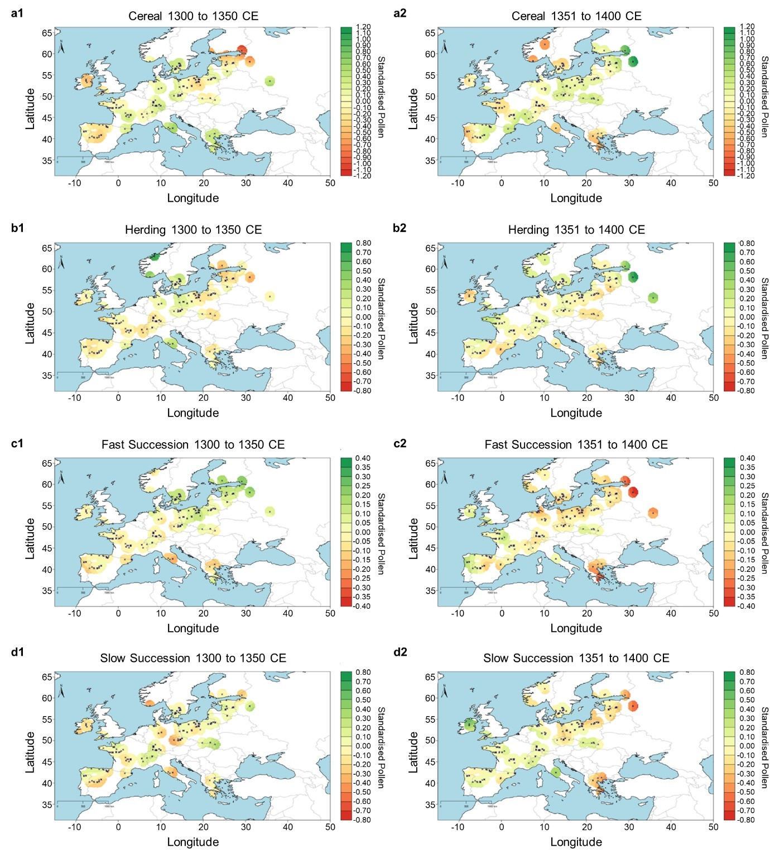
Extended Data Figure 8. Spatial extrapolation for all four indicators c. 50 years before and after the Black Death. a) Cereal 1301-1350 CE (1) and 1351-1400 CE (2) b) Herding 1301-1350 CE (1) and 1351-1400 CE (2) c) Fast Succession 1301-1350 CE (1) and 1351-1400 CE (2) d) Slow Succession 1301-1350 CE (1) and 1351-1400 CE (2).

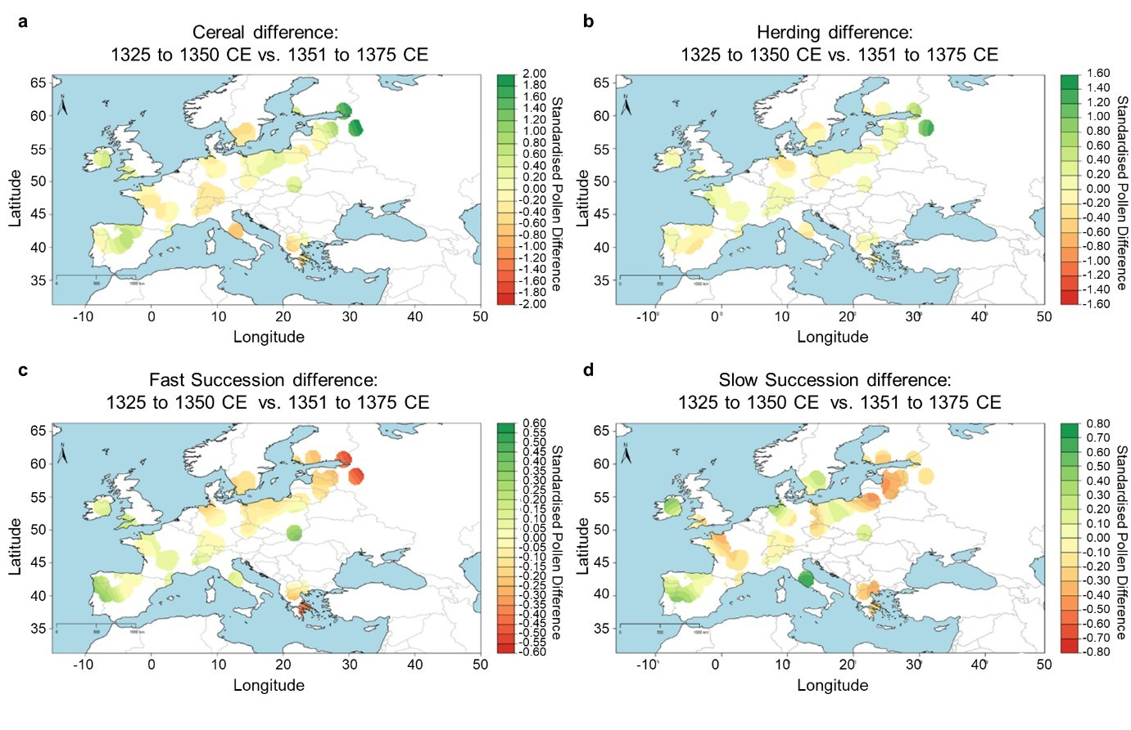
Extended Data Figure 9. Spatial extrapolation showing 1325-1350 vs 1351-1375 CE temporal variation in the BDP pollen indicators a) Cereal b) Herding c) Fast Succession d) Slow Succession. Based on results from Extended Data Fig. 10.
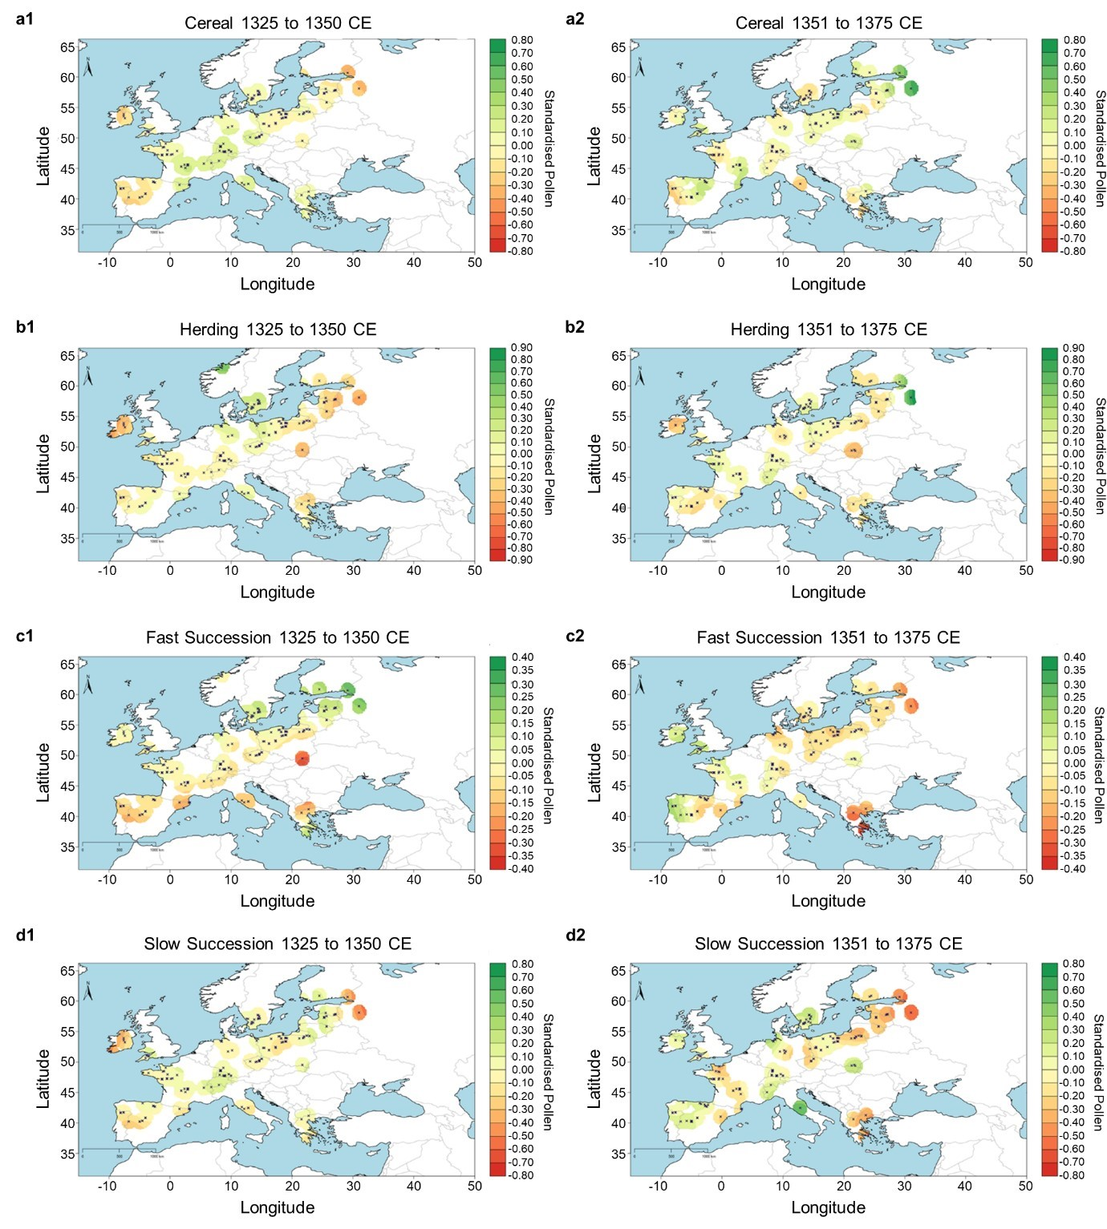
Extended Data Figure 10. Spatial extrapolation for all four indicators c. 25 years before and after the Black Death. a) Cereal 1325-1350 CE (1) and 1351-1375 CE (2) b) Herding 1325-1350 CE (1) and 1351-1375 CE (2) c) Fast Succession 1325-1350 CE (1) and 1351-1375 CE (2) d) Slow Succession 1325-1350 CE (1) and 1351-1375 CE (2).

