Constitutive silencing of LRRK2 kinase activity leads to early glucocerebrosidase deregulation and late impairment of autophagy in vivo

Albanese F.¹, Mercatelli D.^{1,2}, Finetti L.³, Lamonaca G.⁴, Pizzi S.⁴, Shimshek D. ⁵, Bernacchia G.³, Morari M.¹

Supplementary Material

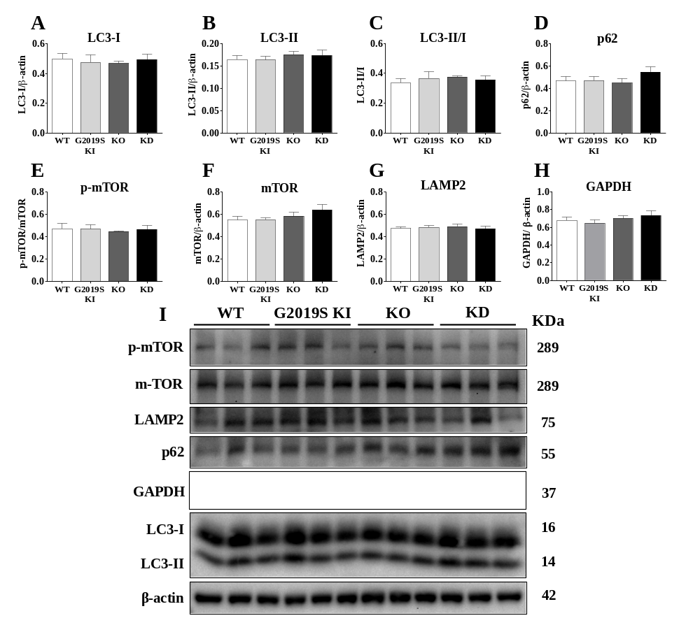
Figure S1. Immunoblot analysis of autophagy and lysosomal markers in 3-month-old LRRK2-mutant mice. Striatal lysates from 3-month-old WT, G2019S KI, KO and KD mice. Semi-quantitative analysis of macroautophagy markers levels: LC3-I (A), LC3-II (B), LC3-II/I (C), p62 (D), p-mTOR normalized on total mTOR (E) and total mTOR (F). Semi-quantitative analysis of chaperone-mediated autophagy marker levels: LAMP2 (G) and GAPDH (H). Representative immunoblots of macroautophagy and chaperone-mediated autophagy markers in 3-month-old LRRK2-mutant mice (I). β-actin was used as housekeeping protein. Data are mean ± SEM of 6 mice per group and were analyzed using one-way ANOVA followed by the Bonferroni’s test for multiple comparisons.

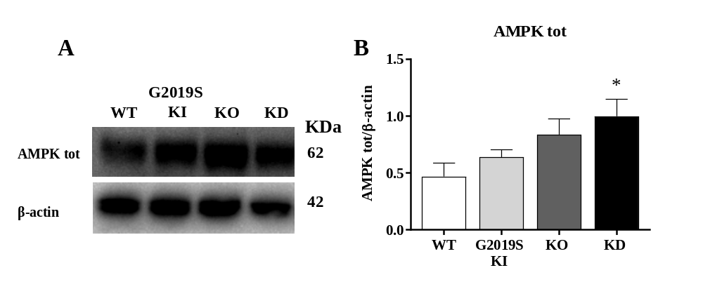Figure S2. Immunoblot analysis of AMPK levels in 3-month-old LRRK2-mutant mice. Striatum lysates from 12-month-old WT, G2019S KI, KO and KD mice were collected to perform WB analysis. A) Representative immunoblots of AMPK markers. B) Semi-quantitative analysis of total AMPK levels. β-actin was used as housekeeping protein. Data are mean ± SEM of 6 mice per group and were analyzed using one-way ANOVA followed by the Bonferroni’s test for multiple comparisons. *p<0.05 different from WT mice.

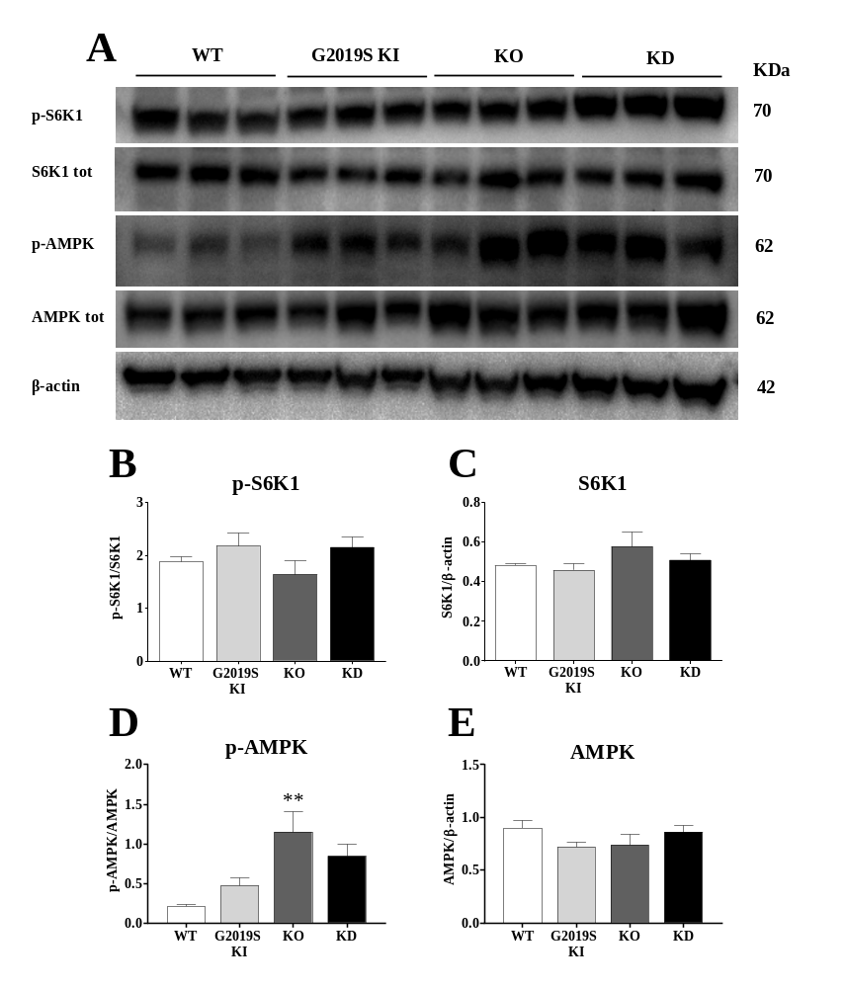
Figure S3. Immunoblot analysis of autophagy in 20-month-old LRRK2-mutant mice. Striatum lysates from 20-month-old WT, G2019S KI, KO and KD mice were collected to perform WB analysis. A) Representative immunoblots of macroautophagy markers. B) Semi-quantitative analysis of p-S6K1 normalized on total S6K1 levels C) Semi-quantitative analysis of total S6K1 levels D) Semi-quantitative analysis of p-AMPK normalized on total AMPK levels. E) Semi-quantitative analysis of AMPK levels. β-actin was used as housekeeping protein. Data are mean ± SEM of 6 mice per group and were analyzed using one-way ANOVA followed by Bonferroni test for multiple comparisons. **p<0,01 different from saline-treated mice.

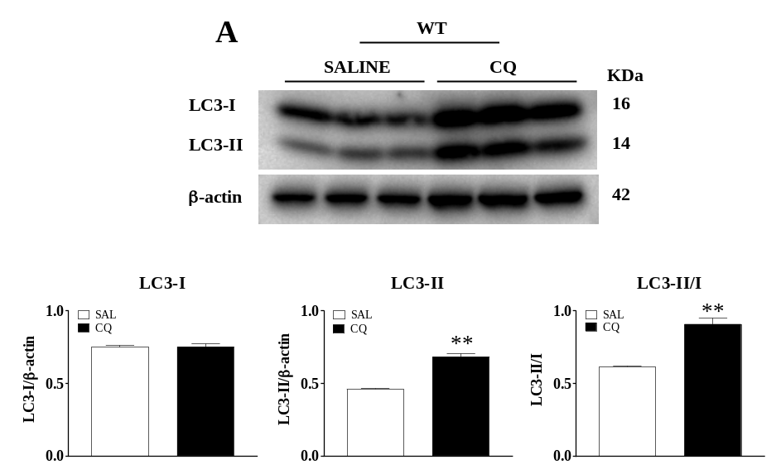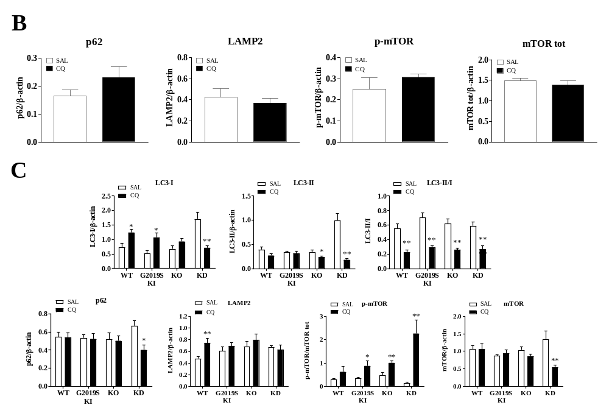
Figure S4. Autophagic flux assessment using chloroquine in 3-month-old WT and 12-month-old LRRK2 mice. A) Validation of CQ administration protocol in 3-month-old WT mice. Representative immunoblots and semi-quantitative analysis of LC3-I, LC3-II and LC3-II/I ratio in 3-month-old WT mice (n=6) after CQ and saline administration. B) Semi-quantitative analysis of p62, LAMP2, p-mTOR (normalized to total mTOR levels) and total mTOR levels. C) CQ administration in 12-month-old LRRK2-mutant mice. Semi-quantitative analysis of LC3-I, LC3-II, LC3-II/I ratio, p62, LAMP2, p-mTOR (normalized to total mTOR levels) and total mTOR levels upon CQ treatment. β-actin was used as housekeeping protein. Data are mean ± SEM. Statistical analysis was performed using the Student’s t-test, two tailed for unpaired data. *p<0.05, ** p<0.01 different from saline-treated mice.
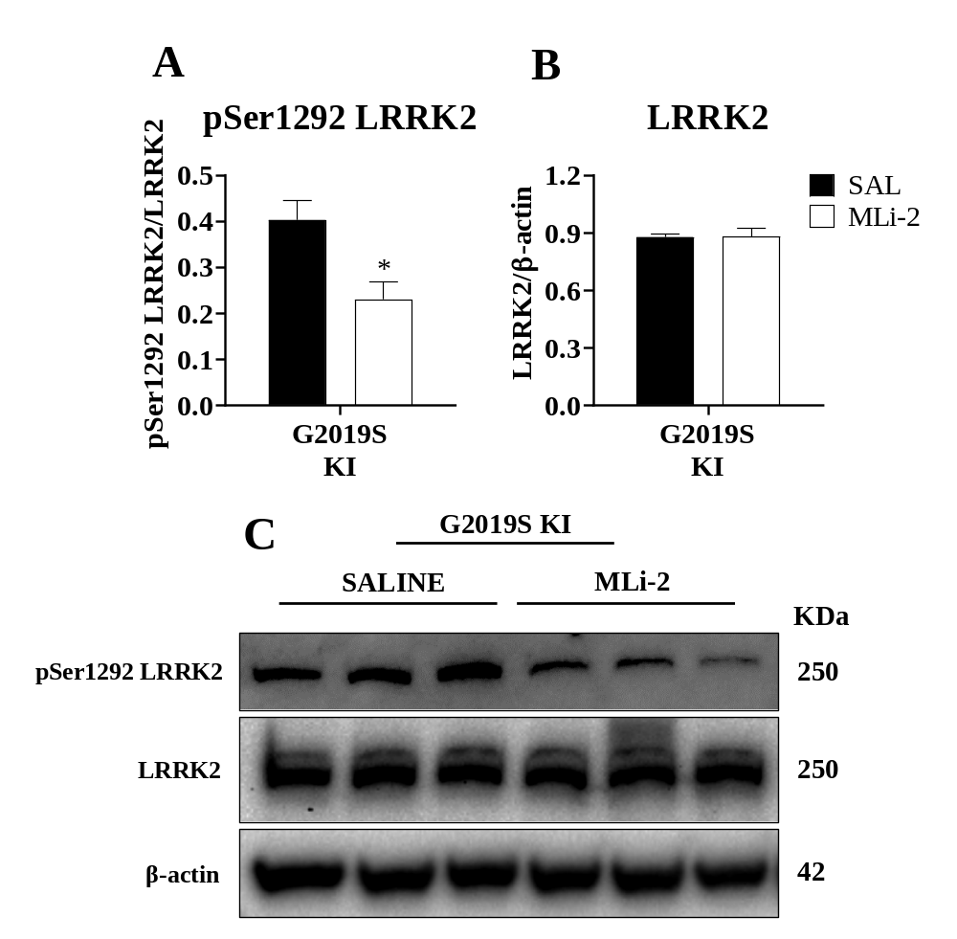
Figure S5. In vivo LRRK2 targeting of MLi-2. Striatum lysates were collected from 12-month-old G2019S KI mice administered with saline or MLi-2 (5 mg/Kg i.p.) once a day for seven days, and processed for WB analysis. A) Semi-quantitative analysis of pSer1292 LRRK2 normalized to total LRRK2 levels. B) Semi-quantitative analysis of total LRRK2 levels. C) Representative immunoblots. β-actin was used as housekeeping protein. Data are mean ± SEM. Statistical analysis was performed using the Student’s t-test, two tailed for unpaired data. *p<0.05 different from saline.

MAP1LC3 | Forward: 5’-ACGGCTTCCTGTACATGGTTT - 3’  Reverse: 5’- GGAGTCTTACACAGCCATTGC - 3’
TFEB | Forward: 5’- GACTCAGAAGCGAGAGCTAACA - 3’  Reverse: 5’- GTGATTGTCTTTCTTCTGCCG - 3’
mTOR | Forward: 5’-AGAAGGGTCTCCAAGGACG - 3’  Reverse: 5’- CAGGACACAAAGGCAGCAT - 3’
LAMP2 | Forward: 5’- TAGGAGCCGTTCAGTCCAAT - 3’  Reverse: 5’- GTGTGTCGCCTTGTCAGGTA - 3’
p62 | Forward: 5’- GCTGCCCTATACCCACATCT - 3’  Reverse: 5’- CGCCTTCATCCGAGAAAC - 3’
GBA1 | Forward: 5’- GACCAACGCTTGCTGCTAC - 3’  Reverse: 5’- ACAGCAATGCCATGAACGTA - 3’
ACTB | Forward: 5’- GCTGTATTCCCCTCCATCG-3’  Reverse: 5’- CCAGTTGGTAACAATGCCATG-3’
HPRT | Forward: 5’- AGTGTTGGATACAGGCCAGAC -3’  Reverse: 5’- CGTGATTCAAATCCCTGAAGT - 3’

Table S1. Primers used for RT-qPCR analysis.

