Supplementary Material

- Corotational beam model: the elementary stiffness matrix K

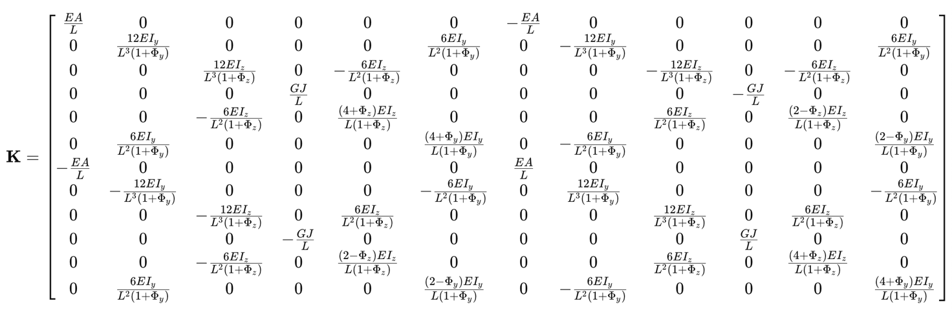

With $G = \frac{E}{2(1+ν)}$ . E is the Young’s modulus and $ν$ is the Poisson’s ratio.
Furthermore, $ϕ_{y} = \frac{12EI_{z}}{GA_{sy}l^{2}}$ and $ϕ_{z} = \frac{12EI_{y}}{GA_{sz}l^{2}}$ represent the parameter of the shear deformation. A is the cross-sectional area, l the length, I_{z} and I_{y} are the cross-section moments of inertia. A_{sy} and A_{sz} are the shear area in y and z directions.

- Catheter modeling

To derive the transformation matrix that defines the relationship between the element displacement $\overline{u}$in the local coordinate system and the element displacement $u$ in the global coordinate system, we consider displacements measured from the initial configuration to the deformed configuration. For the displacements the following relationship holds:
$$\overline{u}-\overline{u_{0}}=Au \text{(1)}$$

where A is a matrix of coefficients derived from the direction cosines of the angles between the local and global coordinate systems, $\overline{u_{0}}$ reflects the initial configuration of the beam, $u$ represents the configuration in the global reference frame and $\overline{u}$the configuration in the local reference frame.
To ensure that the resulting virtual work remains independent of the coordinate system [17], the following relationship must hold:

$$δ\overline{u^{T}\overline{f}}-δu^{T}f=0⟺δu^{T}\left(A^{T}\overline{f}-f\right)⟺A^{T}\overline{f}-f=0 \text{(2)}$$

Considering equation (1), we derive:

$$f=\left[AK_{e}A\right]u \text{(3)}$$

where $K_{e}$ is the stiffness matrix in local coordinates. For the entire catheter model, composed of a series of beam elements linked in sequence (Fig. 1b), the global stiffness matrix $K$ is computed by summing the contributions of each individual element. Consequently, the relationship between force and displacement in global coordinates is represented by the equilibrium equation:

$$Ku=f \text{(4)}$$

The dynamics of the catheter model are governed by Newton's second law of motion, that is:

$$M\left(x\right)\ddot{x}=F\left(t\right)-f\left(x,\dot{x}\right)+W\left(x,\dot{x}\right) \text{(5)}$$

where $x$, $\dot{x}$ and $\ddot{x}$represent the state (position, velocity, and acceleration) of the catheter model's nodes; $M\left(x\right)$ and $f\left(x, \dot{x}\right)$denote the inertia matrix and internal forces; $F(t)$represents the external forces and $W\left(x, \dot{x}\right)$ the boundary conditions applied to the model. The boundary conditions, including collision constraints, will be detailed subsequently.
The Euler method was employed to obtain approximate solutions to the ordinary differential equations governing the system's behavior.
After linearizing the nonlinear terms using a first-order Taylor expansion, and combining this with equation (5), the implicit velocity update is computed as:

$$\left(M-T\frac{∂f}{∂v}-T^{2}\frac{∂f}{∂x}\right)Δv=T\left(f+T\frac{∂f}{∂x}v\right)+TJ^{T}λ \text{(6)}$$

where T is the time step and $J^{T}λ$accounts for the linearized contacts.
In the simulation, boundary conditions are defined by interactions between the catheter and vessel walls. Contact detection is achieved using the LocalMinDistance method (Fig. 2a) integrated within SOFA (Fig. 2b), which identifies potential contacts when the distance between collision elements falls below a specified alarm threshold (alarmDistance). If the distance decreases further, crossing a second threshold (contactDistance), a contact is established.
The LocalMinDistance method enhances contact determination efficiency by constructing cones on collision model nodes, focusing solely on geometrically closest contacts. This approach is particularly effective for convex surfaces. For each identified contact point, the closest surface point is determined, and the interior normal direction is incorporated into the Jacobian matrix, represented as the Jacobian transpose:

$$J^{T}=\frac{∂W}{∂x}\text{ (7)}$$

which linearizes the contact constraints.
After potential contact detection, the simulation determines actual contact occurrence and defines the corresponding response. Unlike conventional tissue-tool interaction models that often neglect friction, this study incorporates a friction-inclusive contact model, as the phantom's dry and textured material would render frictionless assumptions inaccurate. The model is based on Signorini's contact law and Coulomb's friction law [18].
Signorini's contact law aims to prevent penetration between contacting objects by correcting any existing overlap at contact points. Its expression is as follows:

$$\left\{\begin{aligned}δ_{n}≥0 \\ λ_{n}≥0 \\ δ_{n}λ_{n}=0\end{aligned}\right. (8)$$

where $δ_{n}$ is the distance between the colliding objects and $λ_{n}$ is the force applied on the contact point, both along the normal direction.
Considering the roughness of the contact surface, Coulomb's friction law defines the tangential response due to friction. It is expressed as:

$$λ_{T}=-μ\frac{\left|\left|λ_{n}\right|\right|δ_{t}}{\left|\left|δ_{t}\right|\right|}\text{ (9)}$$

where $μ$ is the friction parameter dependent on the materials in contact. To solve the dynamics of two constrained objects, a Lagrange Multipliers approach with a single linearization per time step is used. The constraint problem is simplified as:

$$AΔv=b+dt J^{T}λ \text{(10)}$$

where $J^{T}λ$ represents the vector of constraint forces, with $J$ containing the constraint directions and $λ$ as the Lagrange multipliers.
For each constraint, the unilateral interaction law is assigned based on the relative position of the interacting objects:

$$Ψ\left(x_{1}, x_{2}, …\right) ≥ 0 \text{(11)}$$

For two interacting objects, the constrained system from equation (6) is represented as:

$$A_{i}Δv_{i}=b_{i}+dt J_{i}^{T} \text{(12)}$$

with $i =1,2.$ Within SOFA, this system is solved in two steps:

- Free Motion: Each object is solved independently, assuming no constraints, to find the change in velocity $Δv_{i}^{\text{free}},$using the equations:

$$A_{i}Δv_{i}^{\text{free}}=b_{i} \text{(13)}$$

- Corrective Motion: The constraints are then applied, with $b_{i}=0$ to find the corrective change in velocity $Δv_{i}^{\text{corr}}$using:

$$A_{i}Δv_{i}^{\text{corr}}=dt J_{i}^{T} \text{(14)}$$

The final motion correction is determined using the Gauss-Seidel algorithm. The constrained system is represented as:

$$\dot{δ}=J_{i}v_{i}^{\text{free}}-J_{i}v_{i}^{\text{corr}}+dt \left[J_{i}A_{i}^{-1}J_{i}^{T}+J_{i}A_{i}^{-1}J_{i}^{T}\right] \text{(15)}$$

where $\dot{δ}$ is the constraint violation and the final corrected positions are given by:

$$x_{i}=x_{i}^{\text{free}}+dt Δv_{i}^{\text{corr}} \left(16\right)$$

with:
$$Δv_{i}^{\text{corr}}=dt A_{i}^{-1}J_{i} \text{(17)}$$

- Supplementary figures: Plots with results

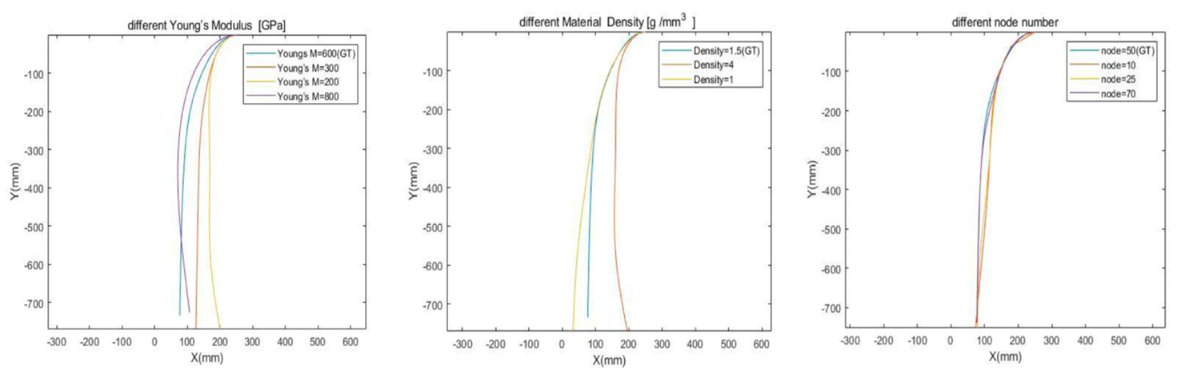
Figure 1-A: Catheter model shape configuration according to different Young’s Modulus (a), Material Density (b) and number of nodes (c).

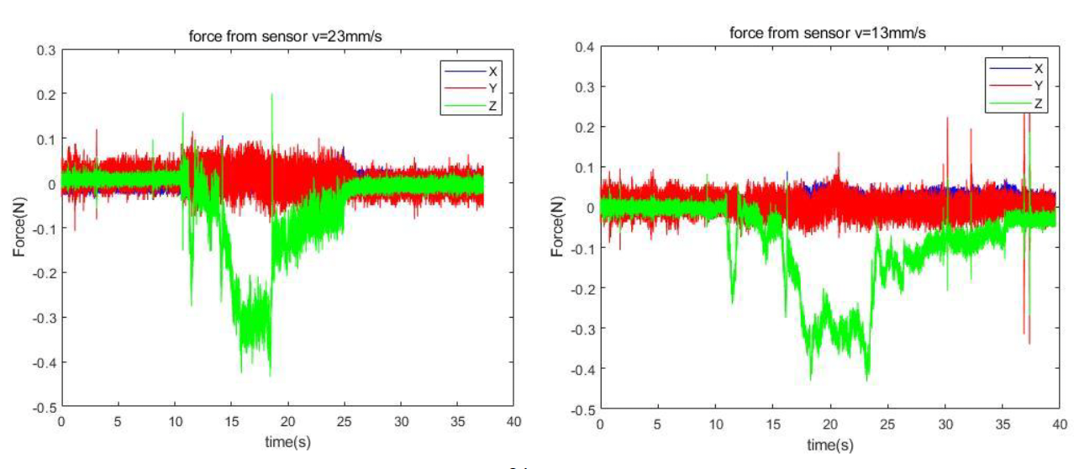

Figure 2-A: Profiles of the variation of the forces recorded with the ATI cell during the experiments, with a constant insertion speed of 23 mm/s (a) and 13 mm/s (b) respectively.

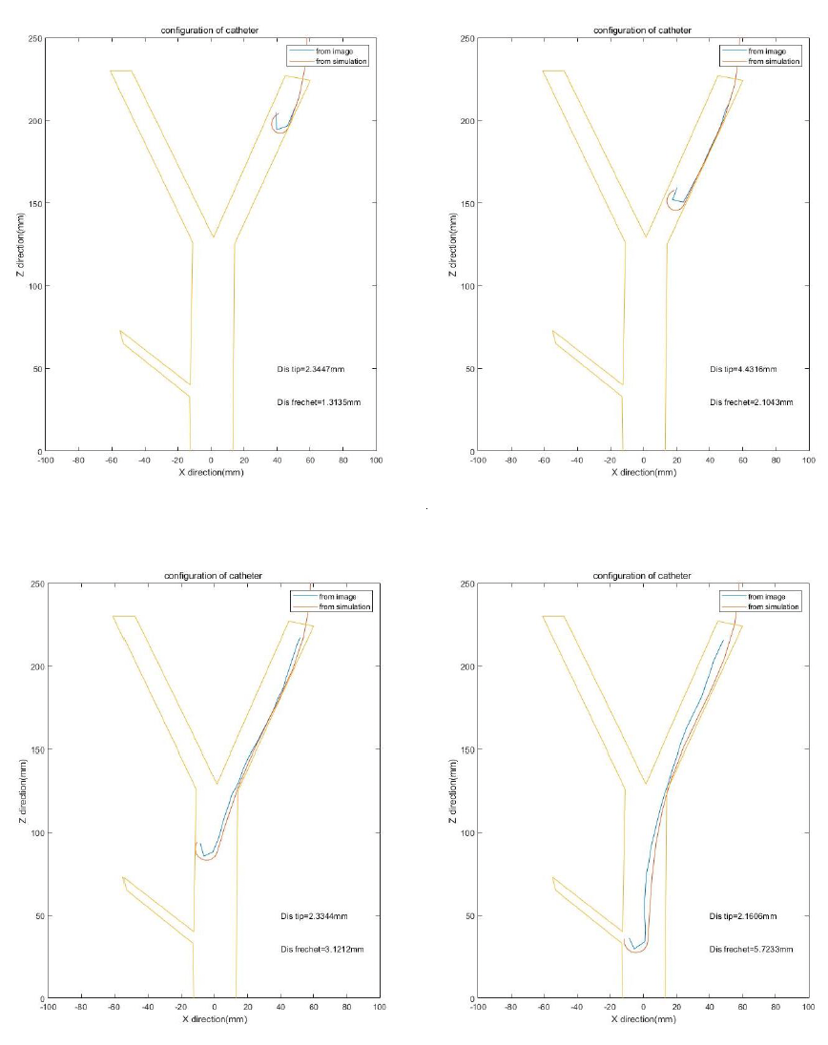
Figure 4-A: Evolution of the catheter movement (time interval = 4s) within the phantom, both from simulation scenario (orange line) and real experiment (blue line).

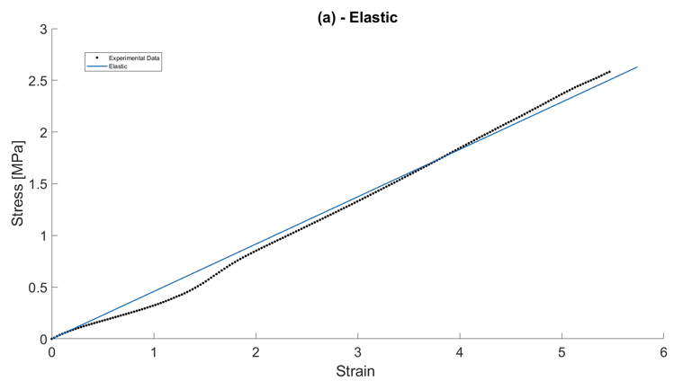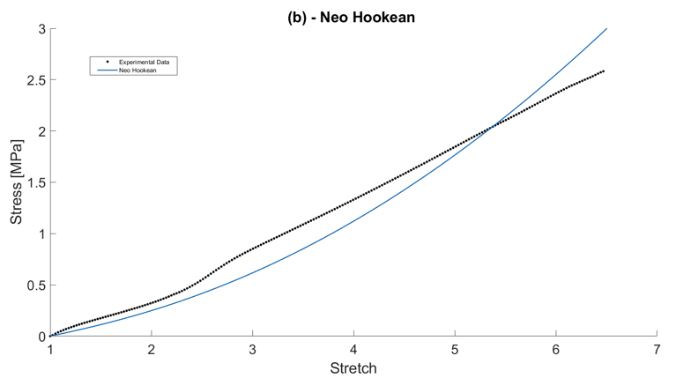

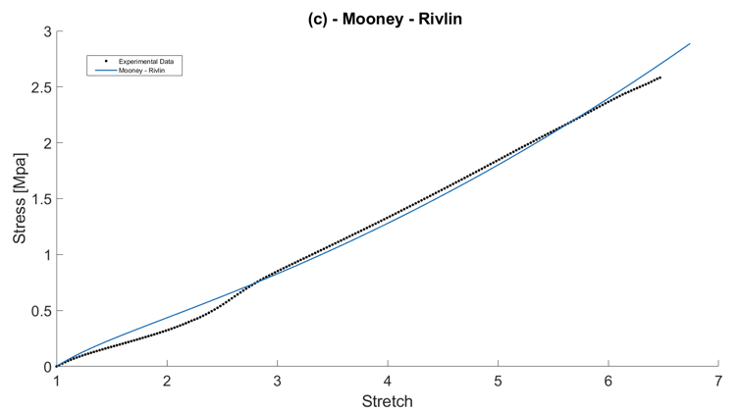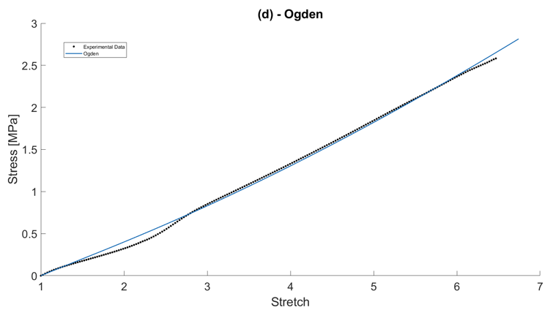

Figure 5-A: Plots of the model equations interpolated with the experimental data. The black dotted curve represents the experimental values of stress [MPa]/strain (or stress [MPa]/stretch in the case of hyperelastic materials) obtained by the Instron machine. The curves in blue represent the equations of the interpolating models, respectively the Elastic (a), Neo Hookean (b), Mooney-Rivlin(c), Ogden(d).

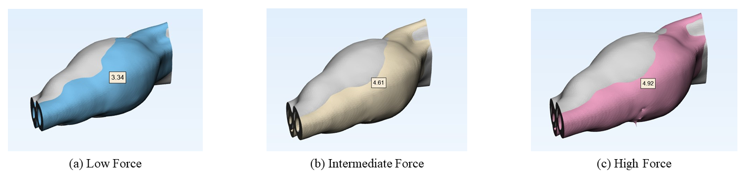
Figure 6-A: Deformations of the iliac artery according to (a) Low, (b) Intermediate, (c) High forces.

