Supplementary
Table S1. Ethanol production in engineered strains. All data represent the mean ± SD of biological triplicates.
 | YJZ08 | PDH1 | ZS01 | PDH2
Ethanol yield (g/g glucose) | 0.35±0.07 | 0.27±0.03 | 0.46±0.12 | 0.46±0.09

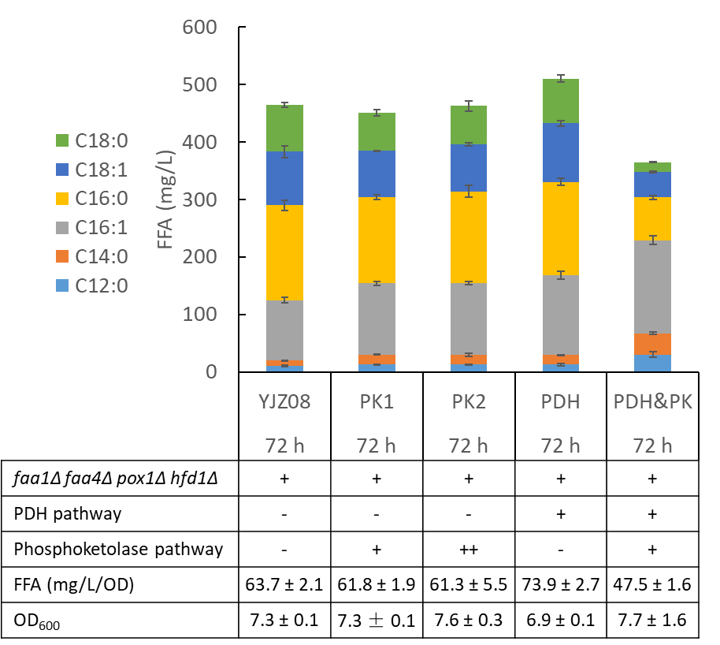
Figure S1. FFA production with phosphoketolase pathway expressed in YJZ08 and PDH1. Phosphoketolase enzymes xylulose-5-phosphate phosphoketolase and phosphotransacetylase were integrated into YJZ08 with a single copy or two copies, resulting in the strains PK1 and PK2, respectively. Phosphoketolase pathway was integrated into PDH1, resulting in the strain PDH&PK.

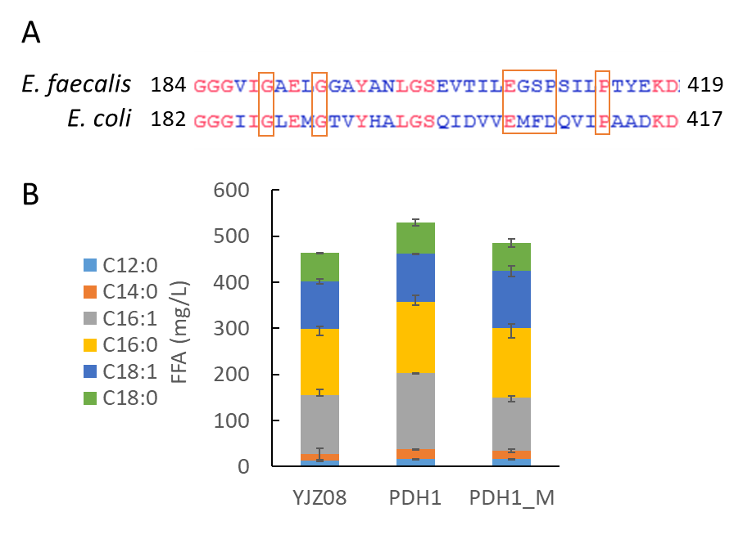
Figure S2. Mutations in E3 resulted in decreased FFA production. A) Alignment results of E3 proteins from E. faecalis and E. coli. Mutated amino acids were marked in red boxes. B) FFA production with mutated PDH complex expressed in YJZ08.

