Supplementary
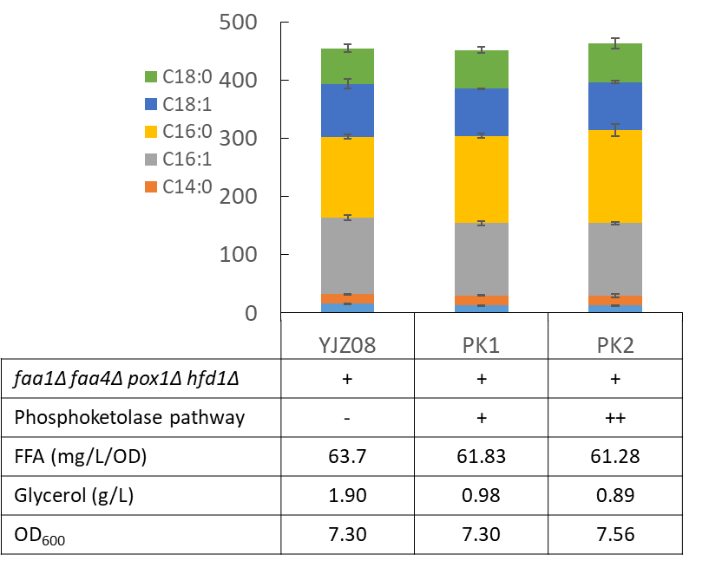
Figure 1. FFA production with phosphoketolase pathway expressed in YJZ08. Phosphoketolase enzymes xylulose-5-phosphate phosphoketolase and phosphotransacetylase were integrated into YJZ08 with a single copy or two copies, resulting in the strains PK1 and PK2, respectively.
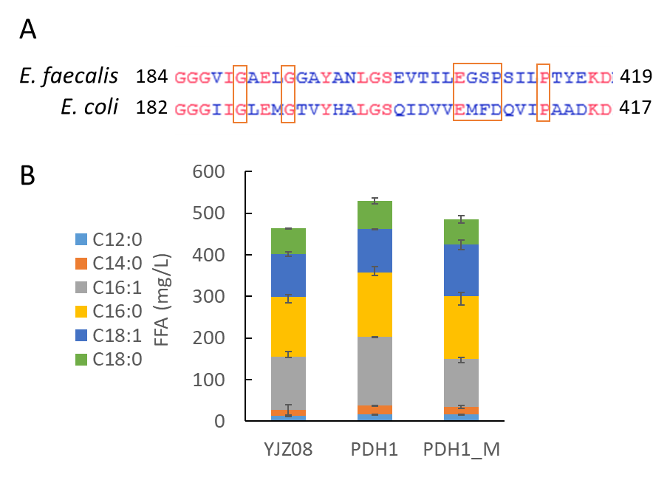
Figure 2. Mutations in E3 resulted in decreased FFA production. A) Alignment results of E3 proteins from E. faecalis and E. coli. Mutated amino acids were marked in red boxes. B) FFA production with mutated PDH complex expressed in YJZ08.

