Supplementary Figures
Figure S1: (a) Differential expression of tRFs in Arabidopsis thaliana under various biotic stresses. The bar plots depict the number of upregulated and downregulated tRFs in response to (i) bacteria, (ii) fungi, (iii) virus, (iv) nematode, and (v) oomycetes in Arabidopsis thaliana. (b) Differential expression of tRFs in Oryza sativa under various biotic stress. The bar plots depict the number of upregulated and downregulated tRFs in response to (i) bacteria, (ii) fungi, (iii) insect, (iv) nematode, and (v) virus in Oryza sativa. (c) Differential expression of tRFs in Solanum lycopersicum under various biotic stress. The bar plots depict the number of upregulated and downregulated tRFs in response to (i) fungi, (ii) nematode, and (iii) virus in Solanum lycopersicum.
Figure S2: a. Differential expression of tRFs in Arabidopsis thaliana under various pathogen infections. The bar plots represent the number of upregulated and downregulated tRFs in Arabidopsis thaliana in response to infections caused by (i) Alternaria brassicicola, (ii) Botrytis cinerea, (ii) Geminivirus, (iv) Heterodera schachtii, (v) Phytophthora capsici, (vi) Pseudomonas putida, (vii) Sclerotinia sclerotiorum, (viii) Tobacco rattle virus, (ix) Turnip crinkle virus, and (x) Turnip mosaic virus. b. Differential expression of tRFs in Oryza sativa under various pathogen infections. The bar plots depict the number of upregulated and downregulated tRFs in Oryza sativa in response to infections caused by (i) African Xanthomonas, (ii) Brown planthopper, (iii) Magnaporthe oryzae, (iv) Magnaporthe oryzae Fusarium fujikuroi, (v) Meloidogyne graminicola, (vi) Rice stripe virus, and (vii) Xanthomonas oryzae. c. Differential expression of tRFs in Solanum lycopersicum under various pathogen infections. The bar plots represent the number of upregulated and downregulated tRFs in Solanum lycopersicum in response to infections caused by (i) Alternaria, (ii) Fusarium oxysporum (iii) Meloidogyne incognita, and (iv) Tomato mosaic virus.
Figure S3: Stacked bar plots depicting the abundance of tRF subclasses based on differential expression in three species: (a) Arabidopsis thaliana (b) Oryza sativa and (c) Solanum lycopersicum.
Figure S4: Pie charts illustrating the distribution of top 10 upregulated and downregulated parental tRNAs across species. (a) Upregulated (b) Downregulated.
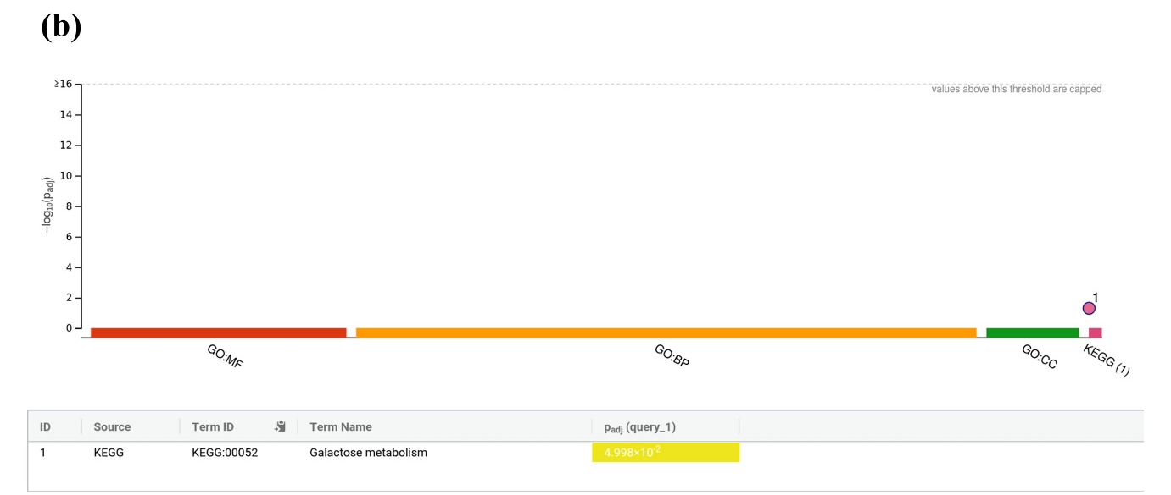Figure S5: GO enrichment of the mRNA targets of the tRFs generated from GluTTC in two species: (a) Arabidopsis thaliana (b) Oryza sativa.
Figure S6: Functional enrichment analysis of mRNA targets across three species, categorized into: (a) Molecular Functions, (b) Biological Processes, and (c) Cellular Components.
Figure S7: Stacked bar plots representing Gene Ontology (GO) enrichment analysis for mRNA targets in three species: (a) Arabidopsis thaliana, (b) Oryza sativa, and (c) Solanum lycopersicum.
Figure S8: Venn diagram visualizes the overlap of differentially expressed genes across various biotic stress in three species: (a) Arabidopsis thaliana, (b) Oryza sativa, and (c) Solanum lycopersicum.
Figure S9: GO enrichment analysis of the overlapping genes in three species: (a) Arabidopsis thaliana from g: profiler (https://biit.cs.ut.ee/gprofiler/gost), (b) Oryza sativa from g: profiler (https://biit.cs.ut.ee/gprofiler/gost), and (c) Solanum lycopersicum from DAVID (https://davidbioinformatics.nih.gov/).
Figure S10: Flowchart illustrating the mRNA-miRNA interaction across two species: (a) Arabidopsis thaliana, and (b) Oryza sativa.

