Supplementary data for
Fall dormancy seasonally drives alfalfa–soil interactions by modulating soil nutrient status and microbial community on the Loess Plateau, China
Shengzhican Li ª, Kanzhuo Zan ª, Yitong Chenª, Kezhen Wang ^{b}, Yang Qu ^{b}, Mingxiu Long ª, Shubin He ^{a,*}

ª College of Grassland Agriculture, Northwest A&F University, Shaanxi, China
b Baoji Academy of Agricultural Sciences, Qishan, Shaanxi, China.
* Corresponding author. E-mail address: heshubin@nwsuaf.edu.cn (S. He)

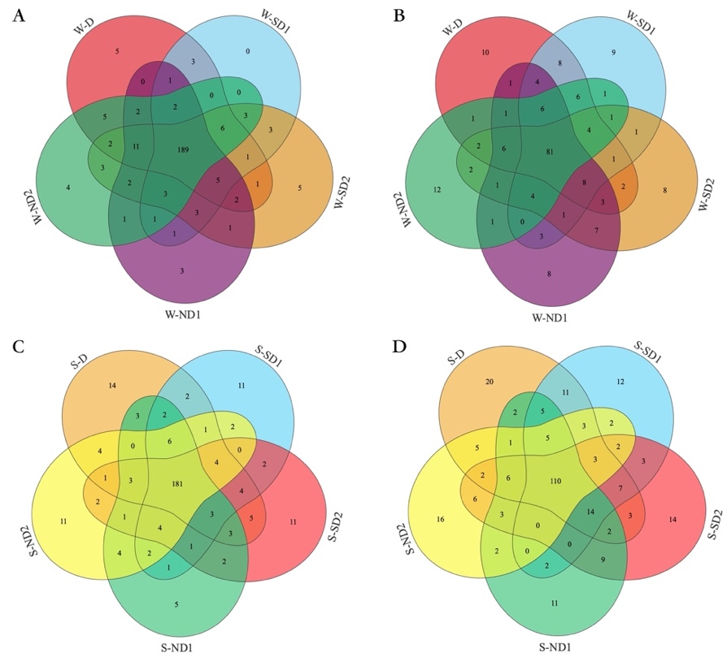
Figure S1 Veen plot of bacteria (A, C) and fungi (B, D) genus in rhizosphere soil of alfalfa with different FD levels.
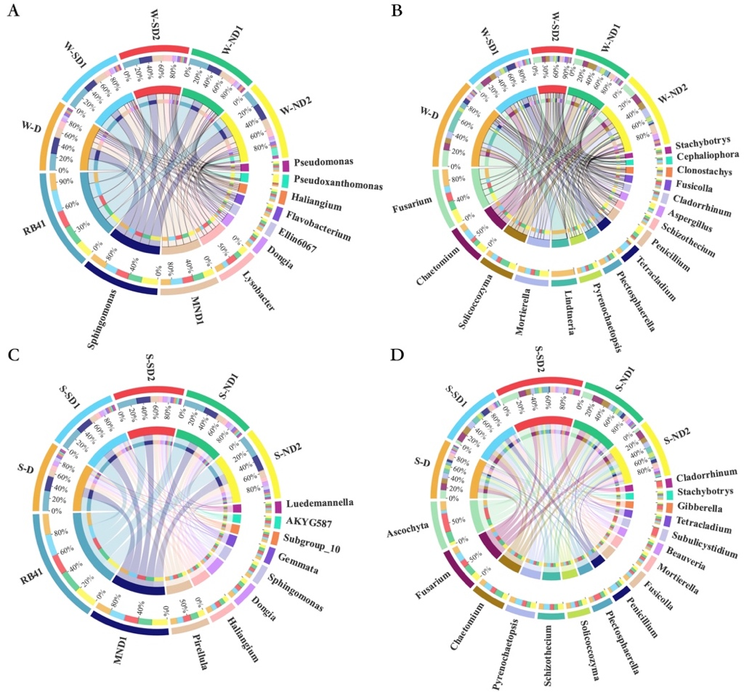
Figure S2 Circos of bacteria (A, C) and fungi (B, D) genus in rhizosphere soil of alfalfa with different FD levels.
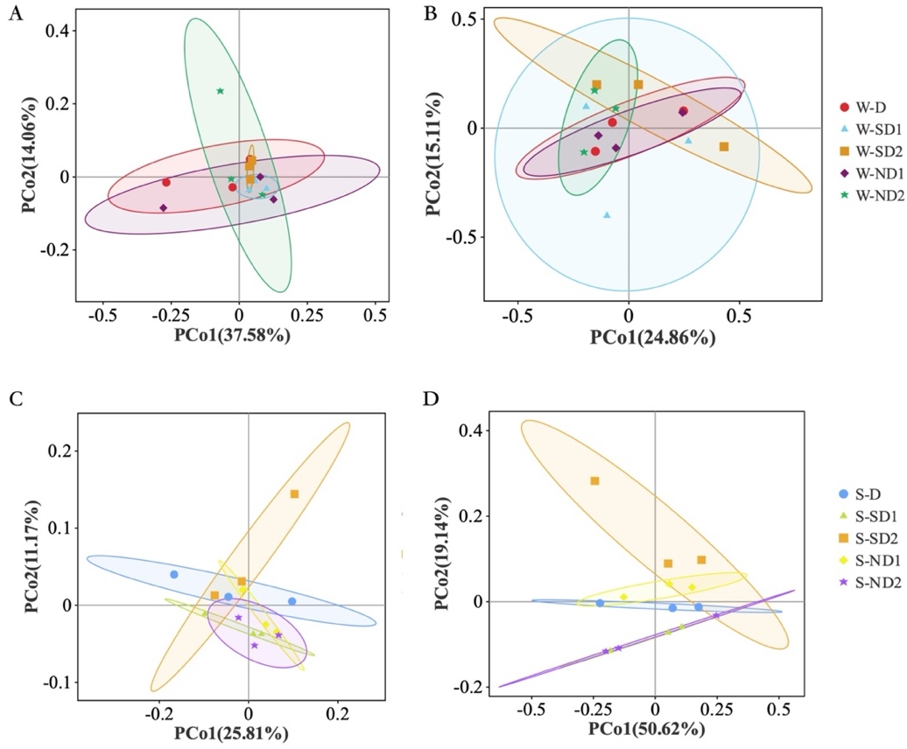
Figure S3 PCoA analysis of bacteria (A, C) and fungi (B, D) in rhizosphere soil of alfalfa with different FD levels.
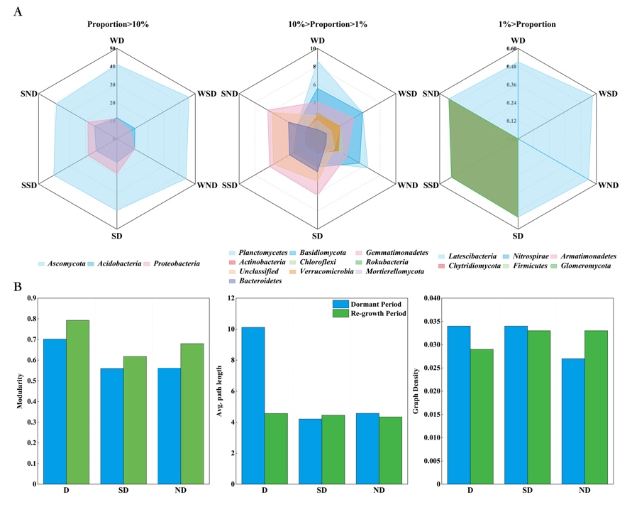
Figure S4 The proportion of different phylum (A) and network parameters (B) in the co-occurrence network in different FD types.
Table S1 Root nutrients of alfalfa with different FD types in dormant season and growing season.
Season | No. | ROC | RTN | RTP | C/N | N/P | C/P
Dormant season | W-D | 344.20±5.34b | 32.18±0.16a | 3.94±0.08d | 10.70±0.13b | 8.18±0.21a | 87.53±3.17a
Dormant season | W-SD1 | 390.66±4.23d | 38.37±0.24d | 3.88±0.05d | 10.18±0.25b | 9.90±0.05b | 100.82±2.62b
Dormant season | W-SD2 | 319.36±0.89a | 36.28±0.06c | 3.07±0.04b | 8.80±0.12a | 11.83±0.15c | 104.14±2.66b
Dormant season | W-ND1 | 361.57±0.55c | 39.11±0.15e | 2.36±0.02a | 9.25±0.13a | 16.55±0.20d | 152.97±0.59d
Dormant season | W-ND2 | 424.74±1.96e | 34.11±0.08b | 3.30±0.02c | 12.45±0.19c | 10.32±0.08b | 128.57±2.59c
Growing season | S-D | 375.68±0.57c | 23.78±0.67a | 3.32±0.16ab | 15.83±0.48c | 7.18±0.20b | 113.78±5.37a
Growing season | S-SD1 | 346.74±1.81a | 26.40±0.69b | 3.82±0.17b | 13.15±0.39a | 6.95±0.38b | 91.17±3.72b
Growing season | S-SD2 | 362.96±2.56b | 26.38±0.45b | 4.59±0.16c | 13.76±0.15ab | 5.75±0.10a | 79.22±2.21b
Growing season | S-ND1 | 373.47±0.25c | 26.29±0.38b | 2.88±0.14a | 14.21±0.20b | 9.16±0.42c | 130.20±6.81c
Growing season | S-ND2 | 377.87±0.45c | 27.45±0.22b | 3.08±0.20a | 13.77±0.12ab | 8.99±0.51c | 123.87±7.72c

Table S2 Yield of alfalfa with different FD types in 2021.
Yield  (kg•hm⁻²) | Fall Dormancy Types
Yield  (kg•hm⁻²) | D | SD1 | SD2 | ND1 | ND2
May | 4140.3±313.4 a | 3770.0±199.1 ab | 3546.8±393.5 ab | 3617.3±210.7 ab | 2892.2±342.8 b
July | 43432.5±602.7 a | 3514.2±747.6 a | 3917.0±757.2 a | 3473.3±588.4 a | 3820.5±411.6 a
November | 1207.2±245.3 a | 1250.3±70.3 a | 988.2±221.6 a | 993.3±202.2 a | 770.0±90.7 a
Notes: Different letters indicate significant differences between FD types (P < 0.05).

